**Superstore Sales Report**

**Sales by Region**

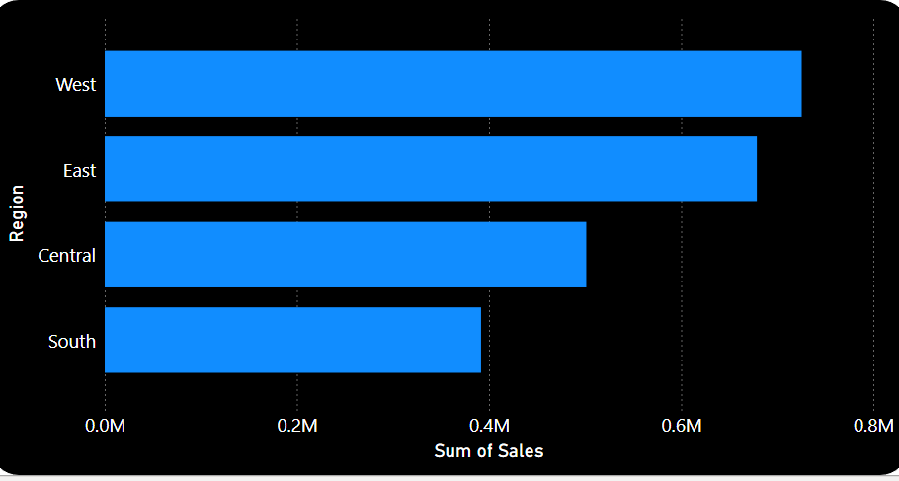

Sales by Quarter

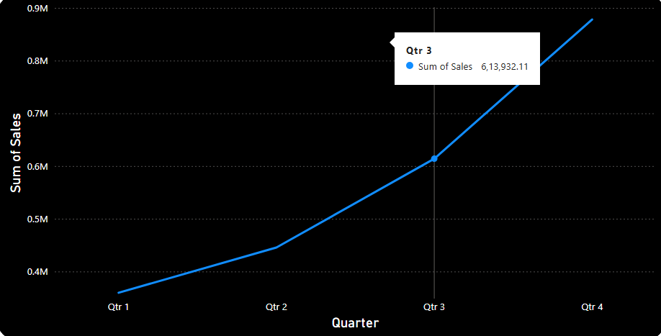

Sales by Category

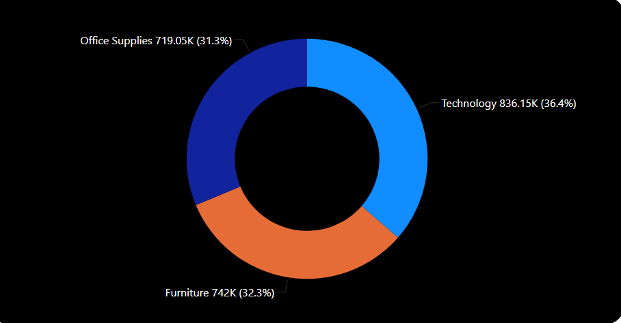

Sales over Month

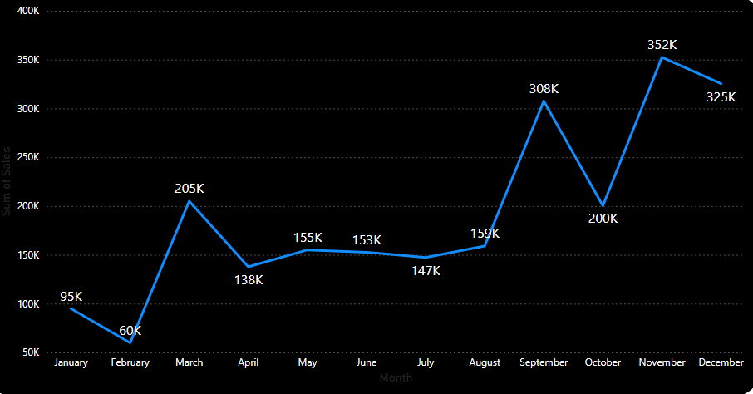

Overall Dashboard Superstore Sales

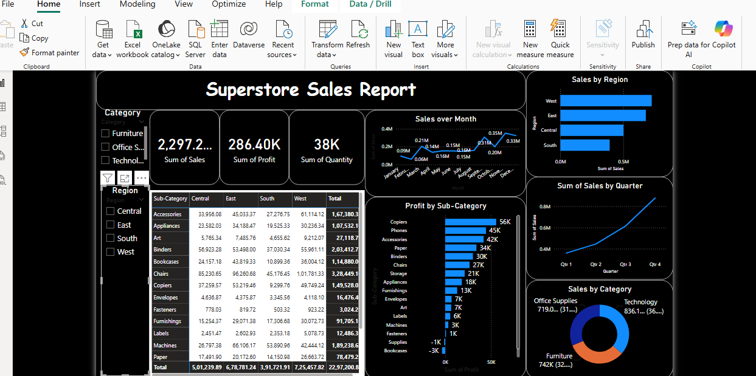

**Insights**

1.West region had the highest sales in Q4

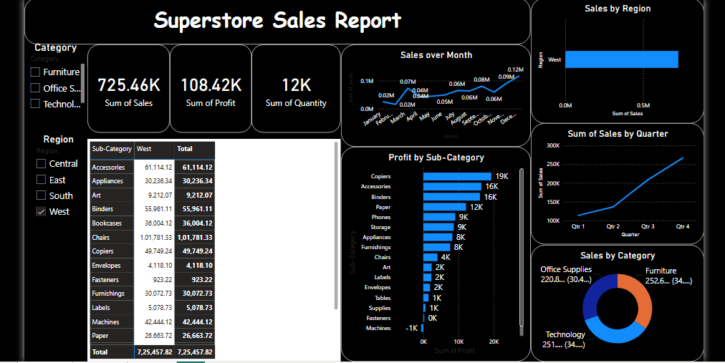

2. Central region had the highest sales in Q4

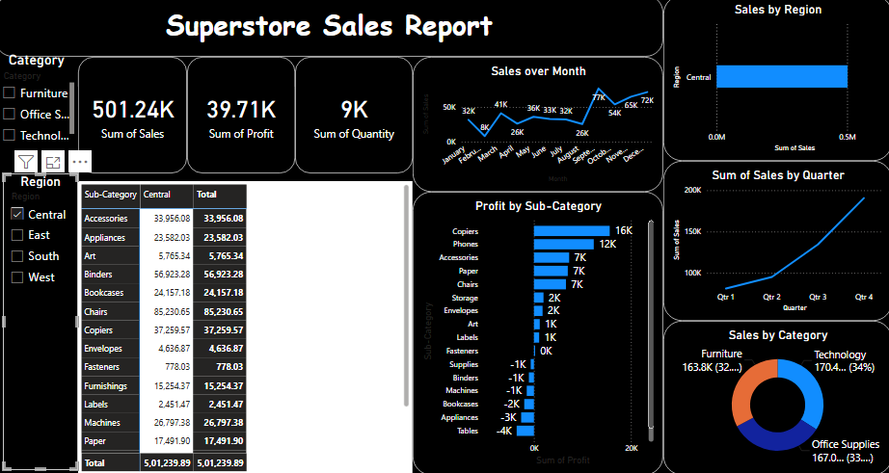

3.Sales over Month(Highest Sales in the November Month, East Region)

