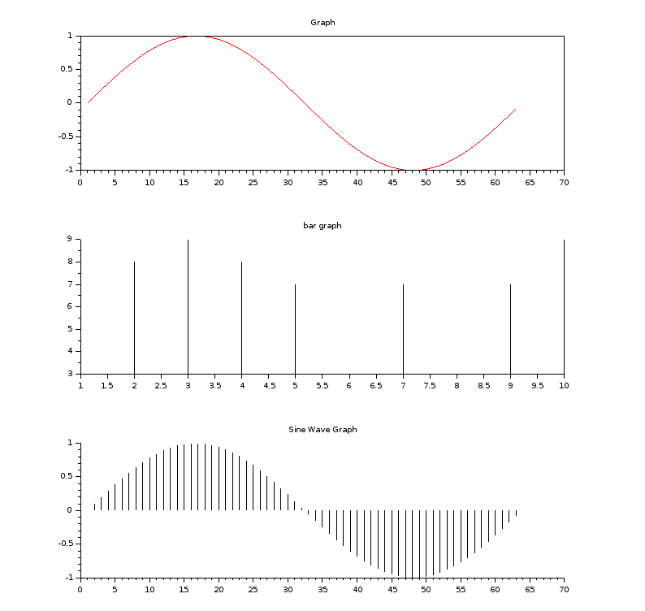
Experiment No : 1
Aim :

clc()
clf()
b=[8 8 9 8 7 3 7 3 7 9]

c=[0:0.1:2*%pi]

subplot(311)
plot(sin(c),'colo','red')
xtitle('Graph')

subplot(312)
plot2d3(b)
xtitle('bar graph')

subplot(313)
plot2d3(sin(c))
xtitle('Sine Wave Graph')

