**Experiment - 5**

**Name : Shaikh Tanveer Rollno : 16DCO79**

**Class : BE.CO Batch : 03**

**Aim : Develop an application that uses GUI Component**

**#Theory**

* Components:

An android component is simply a piece of code that has a well-defined life cycle e.g. Activity, Receiver, Service etc. The core building blocks or fundamental components of android are activities, views, intents, services, content providers, fragments and AndroidManifest.xml.

1. Activity - It is a class that represents a single screen. It is like a Frame in AWT.
2. View - This is the UI element such as button, label, text field etc. Anything that you see is a view.
3. Intent - It is used to invoke components. It is mainly used to: Start the service,

Launch an activity, display a web page, display a list of contacts, broadcast a message, Dial a phone call etc.

1. Service - This is a background process that can run for a long time. There are two types of services local and remote. Local service is accessed from within the application whereas remote service is accessed remotely from other applications running on the same device.
2. Content Provider – These are used to share data between the applications.
3. Fragments – It is like parts of activity. An activity can display one or more fragments on the screen at the same time.
4. AndroidManifest.xml - It contains information about activities, content providers, permissions etc. It is like the web.xml file in Java EE.
5. Android Virtual Device (AVD) - It is used to test the android application without the need for mobile or tablet etc. It can be created in different configurations to emulate different types of real devices.

* Android GUI Component

In android ui or input controls are the interactive or View components which are used to design the user interface of an application. In android we have a wide variety of UI or input controls available, those are TextView, EditText, Email, Password, Buttons, Checkbox, MultiLineText, Numbers, etc.

Following is the pictorial representation of user interface (UI) or input controls in android application.

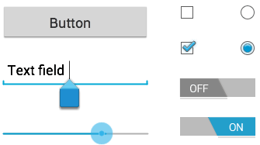

* Android UI Controls

1. TextView - This control is used to display text to the user.
2. EditText - a predefined subclass of TextView that includes rich editing capabilities.
3. Button - It can be pressed, or clicked, by the user to perform an action.
4. CheckBox - An on/off switch that can be toggled by the user. We should use check box when presenting users with a group of selectable options that are not mutually exclusive.
5. RadioButton - has two states: either checked or unchecked.
6. RadioGroup - used to group together one or more RadioButtons.

* UI Elements

A View is an object that draws something on the screen that the user can interact with and a ViewGroup is an object that holds other View (and ViewGroup) objects in order to define the layout of the user interface.

We define our layout in an XML file which offers a human-readable structure for the layout, similar to HTML.

* Layout

A layout defines the structure for a user interface in our app, such as in an activity. All elements in the layout are built using a hierarchy of View and ViewGroup objects.

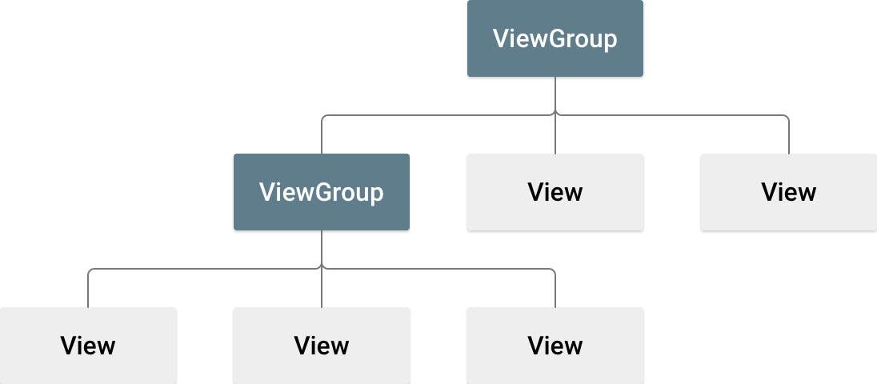

The View objects are usually called "widgets" and can be one of many subclasses, such as Button or TextView. The ViewGroup objects are usually called "layouts" can be one of many types that provide a different layout structure, such as LinearLayout or ConstraintLayout.

* ConstraintLayout

It allows us to create large and complex layouts with a flat view hierarchy (no nested view groups). It's similar to RelativeLayout in that all views are laid out according to relationships between sibling views and the parent layout, but it's more flexible than RelativeLayout and easier to use with Android Studio's Layout Editor.