SQL SERVER ON-PREMISES TO AZURE
MIGRATION TECHNICAL REFERENCE GUIDE — Version 10.0
April 2026 | Appendices N · O · P (New Content Added April 8, 2026)
This file contains the three new appendices added in version 10. The full Bible (Sections 1–12 + Appendices A–M) is in v9. Appendix O now includes the validated KQL screenshot from April 8, 2026, confirming ADFSandboxActivityRun as the correct Log Analytics table for ADF activity data.

Appendix O: POC — Azure Monitor, Log Analytics & Alerting

O.1 POC Overview
Date: April 8, 2026. This POC implements enterprise-grade observability for Azure SQL Managed Instance and Azure Data Factory using Azure Monitor, Log Analytics workspace, diagnostic settings, and metric-based alert rules. Mirrors production monitoring patterns required in PCI DSS and SOX environments.

O.2 Resources Created
Resource | Name | Region | Status
Log Analytics Workspace | usha-loganalytics-poc | West US 2 | ✅ Active
SQL MI Diagnostic Settings | allLogs → Log Analytics | West US 2 | ✅ Configured
ADF Diagnostic Settings | PipelineRuns + ActivityRuns → Log Analytics | East US | ✅ Configured
Alert Rule — SQL MI CPU | Alert-SQLMI-HighCPU | West US 2 | ✅ Active
Alert Rule — ADF Failure | Alert-ADF-PipelineFailure | East US | ✅ Active
KQL Query — Activity Runs | ADFSandboxActivityRun table confirmed live | — | ✅ Validated

O.3 Log Analytics Workspace
- Portal → Log Analytics workspaces → + Create
- Name: usha-loganalytics-poc | Region: West US 2 | Resource Group: UshaADF-POC
- Pricing tier: Pay-as-you-go (default) — minimal cost for POC data volumes
- Deployment succeeded — Workspace ID confirmed

O.4 Diagnostic Settings

O.4.1 SQL MI Diagnostic Settings
Configured SQL MI to stream all logs to the Log Analytics workspace. This enables KQL queries against SQL MI execution logs, login activity, and performance counters.
- Portal → SQL Managed Instance → usha-sqlmi-poc → Monitoring → Diagnostic settings
- + Add diagnostic setting → Name: SQLMI-Diagnostics
- Log category: allLogs (captures all available SQL MI log categories)
- Destination: Send to Log Analytics workspace → usha-loganalytics-poc (West US 2)
- Save — diagnostic data begins flowing within 5–15 minutes

O.4.2 ADF Diagnostic Settings
Configured ADF to stream pipeline and activity run logs to Log Analytics. This enables alerting on pipeline failures and query-based analysis of pipeline performance.
- Portal → Data factories → usha-adf-poc → Monitoring → Diagnostic settings
- + Add diagnostic setting → Name: ADF-Diagnostics
- Log categories: PipelineRuns, ActivityRuns
- Destination: Send to Log Analytics workspace → usha-loganalytics-poc

O.5 Alert Rules

O.5.1 Alert-SQLMI-HighCPU
Setting | Value
Alert name | Alert-SQLMI-HighCPU
Signal | CPU percentage (metric)
Condition | CPU > 80%, evaluation every 5 minutes, lookback 5 minutes
Severity | 2 — Warning
Scope | Azure SQL Managed Instance — usha-sqlmi-poc

O.5.2 Alert-ADF-PipelineFailure
Setting | Value
Alert name | Alert-ADF-PipelineFailure
Signal | Failed pipeline runs metrics
Condition | Count > 0, evaluation every 5 minutes, lookback 5 minutes
Severity | 2 — Warning
Scope | Azure Data Factory — usha-adf-poc

O.6 KQL Queries — Validated April 8, 2026
Logs confirmed propagating to Log Analytics workspace. The correct table for ADF activity data is ADFSandboxActivityRun (not AzureDiagnostics). This is the Log Analytics table populated when ADF diagnostic settings route ActivityRuns to a Log Analytics workspace.

O.6.1 ADF Activity Run History — Validated Query
Query confirmed returning live results on April 8, 2026. Returns TimeGenerated, PipelineName, ActivityName, and Status for all ADF activities in the last 24 hours.

ADFSandboxActivityRun
| project TimeGenerated, PipelineName, ActivityName, Status
| order by TimeGenerated desc

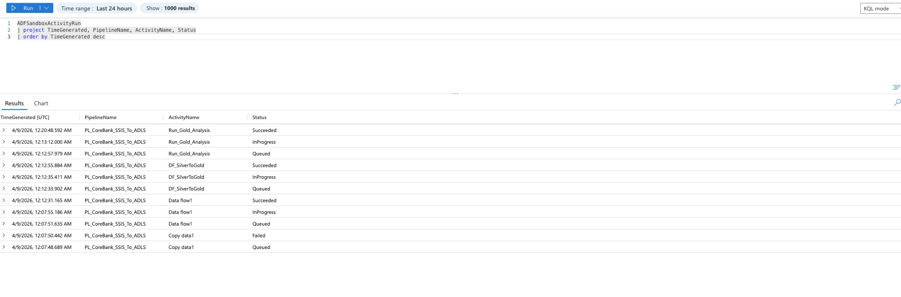
Figure O.1 — Log Analytics KQL query (ADFSandboxActivityRun) returning ADF activity run data for PL_CoreBank_SSIS_To_ADLS. Results show Run_Gold_Analysis (Succeeded), DF_SilverToGold (Succeeded), Data flow1 (Succeeded), and Copy data1 (Failed) — April 8, 2026.

O.6.2 Query Results Analysis
ActivityName | Status Observed | Notes
Run_Gold_Analysis | Succeeded | Databricks notebook triggered via ADF — completed successfully
DF_SilverToGold | Succeeded | Silver-to-Gold Mapping Data Flow — completed successfully
Data flow1 | Succeeded | Bronze-to-Silver Mapping Data Flow — completed successfully
Copy data1 | Failed | SHIR copy from Node5 — intermittent clock drift issue (see Appendix P)

Key Finding: The correct Log Analytics table for ADF activity data is ADFSandboxActivityRun — not AzureDiagnostics as documented in some Microsoft guides. Always verify table names in Log Analytics → Tables before writing KQL queries against a new resource type.

O.6.3 ADF Pipeline Failures Filter
ADFSandboxActivityRun
| where Status == 'Failed'
| where TimeGenerated >= ago(24h)
| project TimeGenerated, PipelineName, ActivityName, Status
| order by TimeGenerated desc

O.6.4 Activity Duration Analysis
ADFSandboxActivityRun
| where Status == 'Succeeded'
| extend DurationSeconds = datetime_diff('second', End, Start)
| project TimeGenerated, PipelineName, ActivityName, DurationSeconds
| summarize AvgDuration=avg(DurationSeconds), MaxDuration=max(DurationSeconds)
by PipelineName, ActivityName
| order by AvgDuration desc

O.6.5 SQL MI High CPU Events
AzureMetrics
| where ResourceType == 'MANAGEDINSTANCES'
| where MetricName == 'cpu_percent'
| where Maximum > 80
| project TimeGenerated, MetricName, Maximum, Average
| order by TimeGenerated desc

O.7 Key Lessons Learned

O.7.1 ADFSandboxActivityRun vs AzureDiagnostics
ADF routes activity run data to the ADFSandboxActivityRun table in Log Analytics — not the generic AzureDiagnostics table used by many other Azure resources. The column names also differ: PipelineName and ActivityName (not pipelineName_s and activityName_s). Always check the actual table names in Log Analytics → Tables after enabling diagnostic settings before writing queries.

O.7.2 Log Analytics Propagation Delay
After saving diagnostic settings, there is a 15–60 minute delay before logs appear in Log Analytics. This is normal. Always wait at least 30 minutes and trigger a test event (run a pipeline, execute a query on SQL MI) before troubleshooting missing logs.

O.7.3 SQL Server Analogy for Azure Monitor
Azure Monitor + Log Analytics is the cloud equivalent of SQL Server monitoring with SolarWinds, Datadog, and SQL Agent alerts combined. Diagnostic settings = enabling SQL Server Audit. Alert rules = SQL Agent alerts on performance counters. KQL = querying sys.dm_exec_requests and the Windows Event Log. The concepts are identical — only the tooling and query language differ.

O.8 Resume Bullets Earned
- Implemented Azure Monitor observability for SQL MI and ADF: configured Log Analytics workspace (usha-loganalytics-poc), SQL MI allLogs diagnostic settings, and ADF ActivityRuns diagnostic routing — validated live KQL queries against ADFSandboxActivityRun table confirming activity-level pipeline telemetry (Run_Gold_Analysis, DF_SilverToGold, Data flow1 statuses).
- Created metric-based alert rules for Azure SQL Managed Instance (CPU > 80%, Severity 2) and Azure Data Factory (PipelineFailedRuns > 0, Severity 2) — establishing automated failure notification aligned with PCI DSS monitoring requirements.

