SQL SERVER ON-PREMISES TO AZURE
MIGRATION TECHNICAL REFERENCE GUIDE
Comprehensive Coverage of All Migration Approaches
IaaS | PaaS | SaaS | Hybrid | Modern Data Platform
Version 13.0 | April 2026
Usha Kale | Senior Cloud DBA / Azure Data Engineer
Internal IT | Database Administration Team

Changelog — Version 13 (April 21, 2026)
This version adds the Microsoft-authored SQL Server Encryption Hierarchy diagram to Section 6.5 Security and Encryption, providing visual reference for the cryptographic chain that underpins TDE and other SQL Server encryption features.
v11 UPDATE: The encryption hierarchy diagram shows how DPAPI protects the Service Master Key, which protects the Database Master Key, which protects certificates and keys, which ultimately protect the data. Understanding this chain is essential for TDE migration work (see upcoming Appendix S).

Changes from v12 to v13
- Section 6.5: Microsoft SQL Server Encryption Hierarchy diagram embedded with detailed explanation of each layer.
- Section 6.5.1 (new sub-section): The Encryption Chain Explained — walks through the diagram.
- Section 6.5.2 (new sub-section): Why TDE Migration Requires Certificate Export — references the hierarchy to explain why certificates must migrate with databases.
- All v12 content preserved unchanged.

Changelog — Version 12 (April 21, 2026)
This version adds Section 6 — Feature Parity Reference, a comprehensive comparison matrix of SQL Server features across on-premises, Azure VM (IaaS), Azure SQL MI (PaaS), and Azure SQL DB (PaaS) targets. The matrix spans 11 functional areas and provides a strategic decision framework for choosing migration targets.
v11 UPDATE: Section 6 is new reference material useful during interview preparation (AZ-305 and DP-300 architecture questions), migration assessments, and solution design sessions. The matrix formalizes architectural thinking that spans all 13 migration approaches covered in Section 4.

Changes from v11 to v12
- Section 6 (NEW): Feature Parity Reference matrix covering HA, DR, Backup, Security, Authentication, Core DB Features, Performance, Patching, Networking, Modernization, and Cost Model.
- Strategic Decision Matrix added at end of Section 6 — when to choose each target (IaaS vs MI vs DB).
- Section 4.8 (Azure SQL MI) cross-references added to Section 6 for feature-level detail.
- All v11 content preserved unchanged (Sections 1-5, Appendices A-Q, References).

Changelog — Version 11 (April 21, 2026)
This version integrates the completed Log Replay Service (LRS) POC into the main migration reference.
v11 UPDATE: Appendix Q completed: 141,050 rows migrated from on-premises SQL Server 2019 (Node1) to Azure SQL Managed Instance via raw LRS with 100 percent row count parity. See Section 4.13 for LRS overview and companion document Appendix_Q_LRS_Migration_to_SQL_MI_v7.docx for full execution narrative with 15 clickable Microsoft Learn references.

Changes from v10 to v11
- Section 3 Comparison Matrix: Expanded from 12 to 13 migration approaches; LRS added as approach #13.
- Section 4.13 (new): Detailed overview of Log Replay Service with pros/cons table.
- Appendix Q: Expanded from 1-line placeholder to full summary chapter with architecture, phase summary, and 14 Key Learnings.
- Document format upgraded to proper Word document (tables, heading styles) from prior markdown-in-docx format.

1. Executive Summary
This document provides a comprehensive technical reference for migrating Microsoft SQL Server workloads from on-premises infrastructure to Microsoft Azure. It is intended for Database Administrators, Infrastructure Architects, and IT Decision Makers responsible for planning and executing SQL Server migrations.
Microsoft Azure offers multiple migration pathways, ranging from traditional lift-and-shift approaches to fully modernized cloud-native data platforms. The right approach depends on downtime tolerance, budget, target architecture, SQL Server version, and long-term operational goals.
This guide covers 13 migration approaches organized into four categories:
- IaaS / Infrastructure Approaches: Backup/Restore, VHD Lift & Shift, Log Shipping, Hybrid AG
- Migration Services and Tools: Azure DMS, Azure Migrate, Database Migration Assistant (DMA), Log Replay Service (LRS)
- PaaS Targets: Azure SQL Database, Azure SQL Managed Instance
- Modern Data Platform: Microsoft Fabric, Azure Data Factory, Azure Synapse Analytics
Each approach is described in the main body with architecture, considerations, and T-SQL/CLI scripts. Corresponding Proof-of-Concept (POC) lab walkthroughs with step-by-step commands and screenshots are provided in the Appendices.

2. Pre-Migration Considerations

2.1 Assessment Phase
Before selecting a migration approach, a thorough assessment of the on-premises environment is essential:
- SQL Server version compatibility with the target Azure service
- Database sizes, growth rates, and storage requirements
- SQL Server features in use: SSIS, SSRS, SSAS, Linked Servers, CLR, Service Broker
- Application connectivity, connection strings, and driver compatibility
- Security requirements: TDE, Always Encrypted, Row-Level Security
- High Availability and Disaster Recovery requirements
- Compliance and data residency requirements
- Network connectivity options: ExpressRoute vs VPN vs Public Internet

2.2 Azure Prerequisites
- Active Azure Subscription with sufficient regional quota
- Resource Group created in target region
- Virtual Network (VNet) and Network Security Group (NSG) configured
- Azure Storage Account for staging backup files and VHDs
- IAM roles assigned: Contributor or custom DBA role
- Azure Monitor and Log Analytics workspace configured

2.3 On-Premises Prerequisites
- SQL Server service account credentials documented
- All databases backed up with backup integrity verified
- Linked servers, SQL Agent jobs, and logins exported
- Firewall rules and port requirements documented (TCP 1433, 5022 for AG endpoints)
- Network bandwidth assessed for data transfer volume

3. Migration Approaches — Comparison Matrix
The table below summarizes all 13 migration approaches. Use this matrix to identify the best approach based on downtime tolerance, complexity, cost, and target architecture.
# | Approach | Target | Downtime | Complexity | Cost | SQL Compat. | Best For
1 | Backup/Restore to Azure VM | IaaS VM | Medium | Low | $ | All versions | General DB migration
2 | VHD Lift & Shift | IaaS VM | High | Medium | $ | All versions | Full server lift
3 | Azure DMS | IaaS/MI/PaaS | Low (online) | Medium | $$ | 2005+ | Minimal downtime migrations
4 | Log Shipping to Azure VM | IaaS VM | Low | Medium | $ | All versions | Staged migration/cutover
5 | Hybrid AG (Azure Replica) | IaaS VM | Near-zero | High | $$ | 2012+ Ent. | HA + migration combined
6 | Azure Migrate | IaaS VM | Medium | Low-Med | $$ | All versions | Agentless VM migration
7 | DMA Assessment | Assessment only | None | Low | Free | 2005+ | Pre-migration readiness
8 | Azure SQL Managed Instance | PaaS (MI) | Low | Medium | $$$ | 2008+ | Near-full SQL compat. PaaS
9 | Azure SQL Database | PaaS (DB) | Low | Medium | $$ | Limited | Modern app databases
10 | Azure Synapse Analytics | Analytics PaaS | N/A | High | $$$ | T-SQL subset | DW and analytics workloads
11 | Azure Data Factory | ETL / PaaS | N/A | High | $$ | All (ETL) | SSIS and ETL migration
12 | Microsoft Fabric | SaaS Platform | N/A | High | $$$ | All (mirroring) | Unified analytics platform
13 | Log Replay Service (LRS) | PaaS (MI) | Low | Medium | Free | 2008+ | Manual MI migration, no VPN needed
NOTE: Cost: $ = Low, $$ = Medium, $$$ = High. Actual costs vary by VM size, storage, data transfer volume, and licensing model. LRS itself is free; only Azure Blob Storage and SQL MI base charges apply.

4. Migration Approaches — Detailed Overview

4.1 Backup and Restore to Azure VM
The Backup/Restore approach is the most straightforward method for migrating SQL Server databases to an Azure IaaS VM. It involves taking a full backup, uploading it to Azure Blob Storage, and restoring on an Azure VM running SQL Server.
Pros | Cons
Simple, well-understood process | Requires downtime during backup/restore window
No additional tooling required | Large databases increase transfer time significantly
Works with all SQL Server versions | Logins, jobs, linked servers must be migrated separately
Low cost — storage charges only | Manual process — not suitable for hundreds of databases

4.2 VHD Lift & Shift (Disk Migration)
The VHD Lift & Shift approach captures the entire OS disk of an on-premises SQL Server as a fixed-size VHD file, uploads it to Azure Blob Storage, converts it to a Managed Disk, and attaches it to a new Azure VM. The entire SQL Server instance including OS, SQL binaries, and all databases is migrated.
Pros | Cons
Entire server migrated including OS and SQL install | Highest downtime — server offline during VHD capture
All databases, logins, and jobs migrated automatically | Large VHD requires significant upload time and storage cost
No SQL Server reinstallation required | Regional quota restrictions may require cross-region VHD copy
Ideal for complex instances with many components | Sysprep required if server will be domain-joined in Azure

4.3 Azure Database Migration Service (DMS)
Azure Database Migration Service is a fully managed service that enables migrations from multiple SQL Server sources to Azure with minimal downtime. It supports both offline (one-time) and online (continuous replication via CDC) migration modes.
Pros | Cons
Online mode enables near-zero downtime migrations | Premium tier required for online (CDC) migrations
Fully managed service — no infrastructure to provision | Source must be network-accessible from DMS
Supports multiple source/target combinations | SSIS packages require separate migration steps
Integrated with Azure Monitor for progress tracking | CDC requires SQL Server 2008+ with appropriate permissions
NOTE: DMS migrations to SQL MI use Log Replay Service (LRS) internally. DMS is a managed orchestration layer on top of LRS. See Section 4.13 for raw LRS usage when finer control is needed.

4.4 Log Shipping to Azure VM
Log Shipping is a built-in SQL Server HA feature repurposed as a migration tool. Transaction log backups are continuously shipped from on-premises to an Azure VM secondary, minimizing the downtime window at cutover.
Pros | Cons
Very low downtime at cutover — only final log tail needs shipping | Requires shared storage or network path between on-prem and Azure
Built-in SQL Server feature — no extra licensing | Read-only access to secondary requires STANDBY mode
Works with all SQL Server versions | Manual monitoring required for latency and copy failures
Good staged migration approach for large databases | Secondary must be brought online manually during cutover

4.5 Always On AG with Azure Replica (Hybrid AG)
A Hybrid AG extends an existing on-premises Always On Availability Group by adding an Azure VM as an asynchronous or synchronous secondary replica. This provides near-zero downtime migration and doubles as a DR solution during the migration period.
Pros | Cons
Near-zero downtime with planned failover | Requires SQL Server 2012+ Enterprise Edition
Simultaneous DR solution during migration | WSFC must span on-premises and Azure nodes
Enables thorough testing on Azure before cutover | VPN or ExpressRoute required between environments
Automatic failover capability after promotion | Higher complexity and cost than simpler approaches

4.6 Azure Migrate
Azure Migrate is Microsoft's centralized hub for discovering, assessing, and migrating on-premises servers, databases, and web applications to Azure. It provides agentless discovery for VMware environments and agent-based/WinRM-based discovery for Hyper-V, physical servers, and VirtualBox environments.
Pros | Cons
Centralized hub for discovery, assessment, and migration | Agentless requires VMware vSphere — physical path needs WinRM
Agentless for VMware — no agent installation needed | Performance data collection takes 24+ hours for accurate sizing
Always On AG topology auto-detected | Generated hostname behavior requires manual hosts file fix
Business case with ROI and payback period calculation | Free tier has limited assessment features

4.7 Database Migration Assistant (DMA)
The Database Migration Assistant is a free standalone tool from Microsoft used to assess SQL Server databases for migration readiness. It identifies breaking changes, behavior differences, deprecated features, and unsupported features in the target environment.
Pros | Cons
Free tool — no licensing cost | Assessment only for large databases — not bulk data migration
Identifies breaking changes and deprecated features | No online migration mode
Can migrate schema and data for small-to-medium databases | Results can be overly conservative for some Azure SQL MI scenarios
Integrates with Azure Migrate for fleet-wide assessment | UI-based — not easily automatable

4.8 Azure SQL Managed Instance
Azure SQL Managed Instance is a fully managed PaaS database service providing near 100% compatibility with the on-premises SQL Server engine. It is the recommended PaaS target for lift-and-shift migrations where full SQL Server feature compatibility is required without managing the OS or SQL binaries.
Pros | Cons
Near-full SQL Server compatibility including SQL Agent, CLR, Service Broker | Higher cost than Azure SQL Database or IaaS VM
Built-in HA using Always On AG — 99.99% SLA | Windows Authentication requires Microsoft Entra ID
Automated backups, patching, and monitoring | Some features unsupported: SSAS, Filestream, FileTable, cross-instance linked servers
VNet injection for private connectivity | General Purpose tier uses remote storage — latency vs Business Critical

4.9 Azure SQL Database (PaaS)
Azure SQL Database is a fully managed relational database service with automatic scaling, built-in HA, and no infrastructure management. Best suited for modern application databases that can accept some feature limitations.
Pros | Cons
Fully managed — no OS or SQL Server patching | No SQL Server Agent, Service Broker, cross-database queries, CLR
Multiple deployment models: Single, Elastic Pool, Serverless, Hyperscale | Windows Authentication not supported — requires Microsoft Entra ID
Auto-scaling and automatic backups built-in | Feature subset only — schema changes often required
Lowest operational overhead of all Azure SQL options | Not suitable for applications requiring full SQL Server compatibility

4.10 Azure Synapse Analytics
Azure Synapse Analytics is an enterprise analytics service combining big data and data warehousing. It is the appropriate target for on-premises SQL Server data warehouse and reporting workloads requiring massive parallel processing.
Pros | Cons
MPP engine for petabyte-scale analytics | T-SQL subset only — not a direct SQL Server replacement
Serverless SQL Pool for ad-hoc querying of data lake files at near-zero cost | Table distribution strategy critical for performance
Integrated Spark, Pipelines, and Power BI in one workspace | Complex and expensive for simple workloads
PolyBase and COPY INTO for high-throughput bulk loading | Migration from SSIS requires rearchitecting as Synapse Pipelines

4.11 Azure Data Factory (ADF)
Azure Data Factory is a fully managed cloud ETL/ELT service for orchestrating data movement and transformation pipelines. It is the primary tool for migrating on-premises SSIS packages and building new data integration pipelines targeting Azure data stores.
Pros | Cons
Azure-SSIS IR lifts and shifts SSIS packages with zero code changes | Azure-SSIS IR is expensive — stop after each use in POC environments
90+ supported connectors for data movement | Complex parameterization requires JSON editor knowledge
Mapping Data Flows provide code-free transformation at scale | Mapping Data Flow debugging requires Debug cluster — cost driver
GitHub/Azure DevOps integration for CI/CD pipeline versioning | Self-Hosted IR (SHIR) requires on-premises node management

4.12 Microsoft Fabric
Microsoft Fabric is a unified, end-to-end SaaS analytics platform built on OneLake. It consolidates data engineering, data integration, data warehousing, real-time analytics, and business intelligence into a single experience.
Pros | Cons
OneLake unifies all data — one copy, no silos | Direct on-premises SQL Server mirroring not yet GA — use Azure SQL MI as intermediary
Mirroring replicates Azure SQL DB / SQL MI to OneLake in near real-time | Fabric Capacity Units (CUs) pricing model is complex
Power BI embedded directly on OneLake — no data movement | Emerging platform — some features still in preview
Consumption-based billing — pay only for what you use | Learning curve across Lakehouse, Warehouse, and Real-Time Intelligence

4.13 Log Replay Service (LRS) — NEW
Log Replay Service (LRS) is the Azure cloud service that migrates SQL Server databases to Azure SQL Managed Instance using the same backup-and-restore mechanism every DBA already knows, extended with continuous log shipping for catch-up and cutover. Available since November 2018, LRS is the underlying engine that powers DMS migrations to MI — every DMS migration to MI internally calls LRS.

When to use LRS directly rather than DMS
- Regulated banking environments where VPN to Azure is prohibited (LRS works over public HTTPS with SAS)
- Need for fine-grained control over each migration step (backup, upload, replay, cutover)
- Bulk migrations where you want to script the orchestration yourself
- Legacy SQL Server 2008+ sources where DMS compatibility is limited
- Need to use differential backups (LRS is the only path that supports them on MI)

Pros and Cons
Pros | Cons
Free — no additional service cost beyond MI base charges | Requires PowerShell/CLI scripting (no GUI)
Works over public HTTPS with SAS — no VPN needed | Manual orchestration of Start, monitor, Complete
Supports SQL Server 2008 and later | Only method to restore differential backups on MI
Up to 100 parallel restore jobs per Managed Instance | Requires per-database folder with flat file layout (no nested subfolders)
Differential backup support (unique among MI migration paths) | Az.Sql cmdlet can over-wait 5-15 min on state transitions
Continuous mode keeps replaying until manual cutover | 30-day maximum job duration; must complete or restart before expiry

How LRS works (summary)
- Take full + log backups on source SQL Server using BACKUP ... TO URL (SAS-authenticated blob writes)
- Place backup files in per-database folders on an Azure Blob Storage container (flat layout, no nested subfolders)
- Call Start-AzSqlInstanceDatabaseLogReplay with storage container URI and SAS token for each database
- MI creates the database shell in Restoring state; LRS applies full backup, then log backups in LSN order
- For continuous mode: LRS polls the container and applies new log backups as they arrive
- At cutover: take final tail-log backup with NORECOVERY, then call Complete-AzSqlInstanceDatabaseLogReplay
- Database transitions to Online state on MI, ready for application traffic

Comparison with MI Link
LRS and MI Link are both near-zero-downtime paths to SQL MI. Choose based on environment constraints:
Factor | LRS | MI Link
Network | Public HTTPS + SAS | VPN or ExpressRoute required
Source SQL version | 2008+ | 2016+ Standard/Enterprise/Developer
Orchestration | PowerShell/CLI scripted | Fully managed
Reverse migration | Not supported | Supported (failback to on-prem)
Banking fit | Regulated env without VPN | Banks with VPN infrastructure
NOTE: See Appendix Q for full LRS POC execution walkthrough (141,050 rows migrated successfully on April 20, 2026). Companion document: Appendix_Q_LRS_Migration_to_SQL_MI_v7.docx contains 747 paragraphs, 15 clickable Microsoft Learn references, and 14 Key Learnings.

5. Post-Migration Checklist
After completing the migration, the following validation and hardening steps must be performed regardless of the approach used.

5.1 Data Validation
- Verify all databases are ONLINE and accessible
- Validate row counts against source using checksum or row count comparison scripts
- Run DBCC CHECKDB to verify physical and logical database integrity
- Confirm all SQL Server Agent jobs are present, scheduled, and enabled
- Test application connectivity with updated connection strings
- Validate all logins, database users, and role assignments
-- Validate database integrity post-migration
DBCC CHECKDB ('YourDB') WITH NO_INFOMSGS, ALL_ERRORMSGS;

-- Update statistics after migration
EXEC sp_updatestats;

-- Rebuild indexes after migration
EXEC sp_MSforeachtable 'ALTER INDEX ALL ON ? REBUILD';

5.2 Performance Tuning
- Update statistics on all migrated databases
- Rebuild or reorganize fragmented indexes
- Review Query Store for plan regressions — force good plans if needed
- Validate TempDB configuration matches Azure VM core count
- Configure max server memory appropriate for VM size

5.3 Security Hardening
- Enable Microsoft Defender for SQL / Azure Defender for SQL
- Configure Azure Key Vault for TDE encryption keys (customer-managed keys)
- Enable SQL Auditing and Advanced Threat Protection
- Restrict port 1433 in NSG to known application and admin IP ranges only
- Enable Microsoft Entra ID (Azure AD) authentication
- Remove or disable SA account and rename default admin accounts

5.4 Monitoring and Backup
- Configure Azure Monitor alerts for CPU, memory, disk I/O, and connection failures
- Verify automated backup policy is active and test restore periodically
- Set up SQL Insights via Azure Monitor for query-level performance data
- Document RTO and RPO metrics, test DR failover procedures
- Configure Log Analytics workspace for centralized log collection

6. Feature Parity Reference — On-Prem vs Azure Targets
This section provides a comprehensive feature comparison across four SQL Server deployment targets: on-premises SQL Server, Azure Virtual Machines (IaaS), Azure SQL Managed Instance (PaaS), and Azure SQL Database (PaaS). Use this matrix during migration assessments, solution design sessions, and architecture interviews to determine which target best fits a given workload.
NOTE: This matrix is authoritative reference material. For the full migration walkthroughs of each target, see Section 4 for conceptual overview and Appendices A through Q for hands-on lab documentation.

6.1 Legend
Symbol | Meaning
YES | Fully supported, same as on-prem
PARTIAL | Supported with changes or limitations
DIFFERENT | Different implementation, same outcome
NO | Not supported
CLOUD-ONLY | Cloud-exclusive feature with no on-prem equivalent

6.2 High Availability (HA)
HA features on Azure VM preserve on-prem behavior. On MI and DB, HA is built into the platform and Always On AG management becomes obsolete.
Feature | On-Prem | Azure VM | Azure SQL MI | Azure SQL DB
Always On AG (local) | YES - Full control | YES - Full control | DIFFERENT - Built-in (BC tier = hidden 4-node AG) | DIFFERENT - Built-in
Failover Cluster Instance (FCI) | YES | YES (Azure Shared Disks) | NO (not exposed) | NO
Database Mirroring (deprecated) | YES | YES | NO | NO
Log Shipping | YES | YES | NO | NO
Read-only secondary | YES AG readable | YES | YES - FREE on BC tier via ApplicationIntent=ReadOnly | YES via read scale-out
SLA | Depends on config | 99.99% with AG | 99.99% GP / 99.995% BC ZR | 99.995% Premium/BC ZR
Zone redundancy | NO | YES (Availability Zones) | YES - BC with Zone Redundant | YES - Premium/BC
NOTE: On MI and DB, Microsoft states: Always On failover cluster instances and Always On availability groups become obsolete on the target SQL managed instance. High-availability architecture is already built in to both service tiers.

6.3 Disaster Recovery (DR)
DR patterns shift significantly when moving to PaaS. Classic distributed AG is replaced by Failover Groups (MI/DB) or MI Link (hybrid).
Feature | On-Prem | Azure VM | Azure SQL MI | Azure SQL DB
Cross-region AG (distributed AG) | YES - SQL 2016+ | YES | NO (use Failover Groups) | NO (use Failover Groups)
Hybrid AG (on-prem + Azure) | N/A | YES | N/A (use MI Link instead) | NO
Failover Groups | NO | NO | CLOUD-ONLY - Managed cross-region | CLOUD-ONLY - Managed cross-region
Active Geo-Replication | NO | NO | NO | CLOUD-ONLY - Up to 4 readable secondaries
MI Link (bidirectional) | N/A | N/A | CLOUD-ONLY - True AG between on-prem and MI | NO
Log Shipping for DR | YES | YES | NO | NO
Cross-region backup restore | YES Manual | YES Manual | YES via Geo-Redundant Backup | YES via Geo-Redundant Backup

6.4 Backup and Restore
Backup management shifts from manual responsibility (on-prem/VM) to fully automated (MI/DB). This is one of the biggest operational changes when moving to PaaS.
Feature | On-Prem | Azure VM | Azure SQL MI | Azure SQL DB
Manual FULL/DIFF/LOG backups | YES - Complete control | YES - Complete control | PARTIAL - COPY_ONLY only (native backups automatic) | NO (all automatic)
BACKUP TO URL | YES 2012 SP1+ | YES | YES (COPY_ONLY) | NO
RESTORE FROM URL | YES | YES | YES (primary migration path) | NO
Automated backups | NO (must configure) | DIFFERENT - SQL VM extension | CLOUD-ONLY - Built-in (daily FULL, 12h DIFF, 5min LOG) | CLOUD-ONLY - Built-in
Point-in-Time Restore (PITR) | YES (manual log chain) | YES | CLOUD-ONLY - 7-35 days automatic | CLOUD-ONLY - 7-35 days automatic
Long-Term Retention (LTR) | YES Manual | YES Manual/policies | CLOUD-ONLY - Up to 10 years automatic | CLOUD-ONLY - Up to 10 years
Cross-region restore | YES Manual | YES Manual | CLOUD-ONLY - Geo-restore | CLOUD-ONLY - Geo-restore
Copy-only backups | YES | YES | YES | NO

6.5 Security and Encryption
Security features are largely preserved on MI and DB, with added cloud-native capabilities like Defender for SQL and enforced TLS.
Feature | On-Prem | Azure VM | Azure SQL MI | Azure SQL DB
Transparent Data Encryption (TDE) | YES | YES | YES (migrate cert first) | YES (service-managed default)
TDE with Customer-Managed Key (BYOK) | YES EKM | YES Key Vault | YES - Azure Key Vault | YES - Azure Key Vault
Always Encrypted | YES 2016+ | YES | YES | YES
Always Encrypted with Enclaves | YES 2019+ | YES | PARTIAL - GA recently | YES
Dynamic Data Masking (DDM) | YES 2016+ | YES | YES | YES
Row-Level Security (RLS) | YES 2016+ | YES | YES | YES
Column-Level Encryption | YES | YES | YES | YES
SQL Server Audit | YES Enterprise | YES Enterprise | YES to Log Analytics/Storage | YES to Log Analytics/Storage
Extended Events | YES | YES | YES | PARTIAL - Limited
Vulnerability Assessment | PARTIAL - SQL Audit Tools | YES Defender for SQL | CLOUD-ONLY - Defender for SQL | CLOUD-ONLY - Defender for SQL
Threat detection | NO | YES Defender for SQL | CLOUD-ONLY - Built-in | CLOUD-ONLY - Built-in
Always On TLS 1.2+ | Optional | Optional | YES Enforced | YES Enforced

6.5.1 The SQL Server Encryption Hierarchy
All SQL Server encryption features rely on a layered key hierarchy. Each layer protects the layer below it, creating a chain of trust rooted in the Windows operating system. Understanding this hierarchy is essential for DBAs who need to migrate TDE-protected databases, back up encryption keys, or troubleshoot key-access issues.
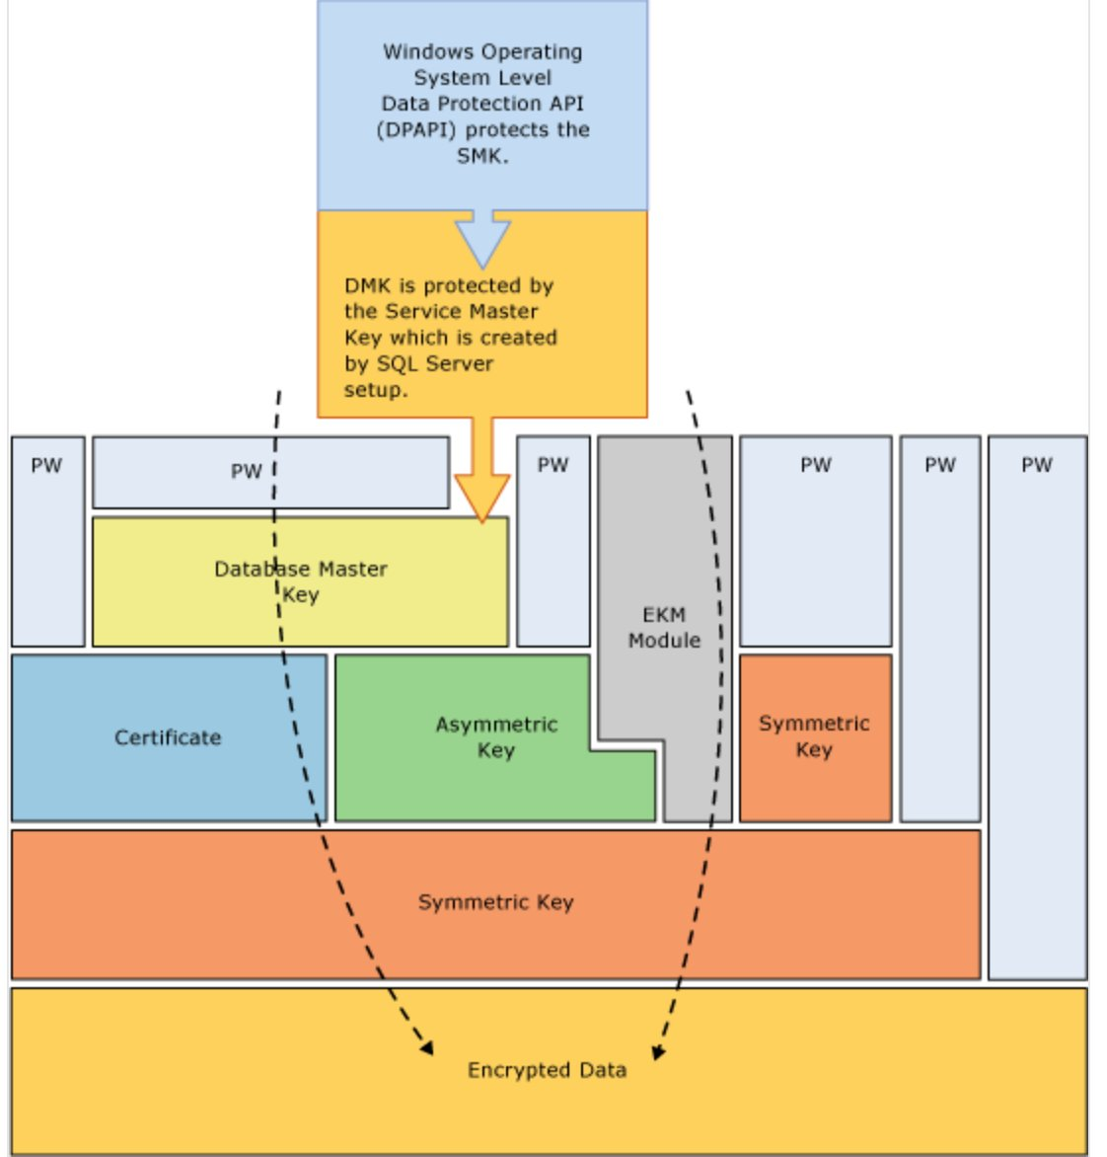
Figure 6.5-1: SQL Server Encryption Hierarchy (Source: Microsoft Learn)
The diagram shows the complete chain from the Windows DPAPI at the top, down to encrypted data at the bottom. Read it top-down as a chain of protection:

6.5.2 Layer-by-Layer Explanation
Layer | Component | Protected by | Purpose
1 (Top) | Windows DPAPI | Service account credentials + machine credentials | OS-level protection of the SMK
2 | Service Master Key (SMK) | DPAPI | Root of SQL Server encryption; created at install
3 | Database Master Key (DMK) | SMK and/or password (master DB) | Protects certificates and asymmetric keys in the database
4a | Certificate | DMK | Used for TDE, Always Encrypted, backup encryption
4b | Asymmetric Key | DMK or EKM module | Alternative to certificate for key protection
4c | EKM Module | External (HSM / Key Vault) | Hardware-backed or cloud-backed key storage
5 | Symmetric Key (DEK) | Certificate or Asymmetric Key | The actual workhorse: encrypts/decrypts data pages
6 (Bottom) | Encrypted Data | Symmetric Key (DEK) | Your actual database files, backups, tempdb

6.5.3 Why the Hierarchy Matters for Migration
The hierarchy's chain of protection is also its chain of vulnerability during migration. When you move a TDE-protected database from Node A to Node B:
- The data files (encrypted with the DEK) travel with the database — no problem.
- The DEK travels inside the database — no problem.
- BUT the certificate (which protects the DEK) lives in the master database on Node A — it does NOT travel with your user database.
- Without the same certificate on Node B, Node B cannot decrypt the DEK, which means it cannot decrypt any data pages.
- Result: the database restores but is unreadable — you get errors trying to open it.
This is why TDE migration is really a two-part operation: first migrate the certificate (export from source, import to target), then migrate the database backup. See Appendix S for the hands-on walkthrough.

6.5.4 Azure SQL MI Hierarchy Differences
On Azure SQL Managed Instance, the hierarchy is preserved but with Azure-specific twists:
Layer | On-Premises | Azure SQL Managed Instance
DPAPI | Windows OS protects SMK | Platform-managed (invisible to you)
Service Master Key | Auto-created at SQL install | Auto-managed by Azure
Database Master Key | You create it | You create it (same T-SQL)
Certificate | You create + back up | You create OR upload via Azure PowerShell (Add-AzSqlInstanceTransparentDataEncryptionCertificate) for migration
TDE Protector mode | Always service-managed | Service-managed OR BYOK via Azure Key Vault
EKM Module | HSM or third-party | Azure Key Vault (native)
NOTE: On Azure SQL MI, once a TDE-migrated database is restored, the original migrated certificate is automatically replaced by a service-managed certificate (or Azure Key Vault key if BYOK is configured). This means the migrated certificate is only scaffolding for the restore operation.

6.6 Authentication
Authentication modernizes significantly in PaaS, with Windows Authentication replaced by Microsoft Entra ID and support for Managed Identities and Conditional Access.
Feature | On-Prem | Azure VM | Azure SQL MI | Azure SQL DB
Windows Authentication (AD) | YES | YES (domain-joined VM) | DIFFERENT via Entra ID | NO
SQL Authentication | YES | YES | YES | YES
Microsoft Entra ID (Azure AD) | NO | PARTIAL - Limited | YES Full support | YES Full support
Kerberos | YES | YES | PARTIAL via Entra Auth | NO
Managed Identities | NO | YES | CLOUD-ONLY - System/user identities | CLOUD-ONLY
MFA enforcement | NO (requires MIM) | PARTIAL via Entra | CLOUD-ONLY | CLOUD-ONLY
Conditional Access | NO | PARTIAL | CLOUD-ONLY | CLOUD-ONLY

6.7 Core Database Features
This is where compatibility diverges most. MI preserves nearly all on-prem features. Azure SQL DB drops many multi-database and instance-level features.
Feature | On-Prem | Azure VM | Azure SQL MI | Azure SQL DB
SQL Server Agent | YES | YES | YES | NO (use Elastic Jobs)
SSIS Catalog (SSISDB) | YES | YES | YES | NO
CLR Integration | YES | YES | PARTIAL - SAFE only | NO
Linked Servers | YES | YES | PARTIAL - SQL-to-SQL only | NO
Service Broker | YES | YES | YES (instance-level only) | NO
Cross-database queries (3-part names) | YES | YES | YES | NO (same DB only)
Distributed transactions (MSDTC) | YES | YES | PARTIAL - Limited (preview) | NO
Database Mail | YES | YES | YES | NO
Filestream / FileTable | YES | YES | NO | NO
Full-Text Search | YES | YES | YES | YES
SSRS / SSAS | YES | YES | NO (run separately on VM) | NO
OPENROWSET / BULK INSERT | YES | YES | PARTIAL - Blob only | PARTIAL - Blob only

6.8 Performance and Monitoring
PaaS adds automatic tuning and intelligent insights not available on-prem. Resource Governor and Buffer Pool Extension are unavailable on PaaS since the platform manages these.
Feature | On-Prem | Azure VM | Azure SQL MI | Azure SQL DB
Query Store | YES 2016+ | YES | YES (ON by default) | YES (ON by default)
Automatic Tuning | NO | PARTIAL - Manual | CLOUD-ONLY | CLOUD-ONLY
Intelligent Insights | NO | NO | CLOUD-ONLY | CLOUD-ONLY
Performance Insight Dashboard | NO | PARTIAL via Monitor | CLOUD-ONLY | CLOUD-ONLY
Resource Governor | YES Enterprise | YES Enterprise | NO (platform manages) | NO
Buffer Pool Extension | YES | YES | NO | NO
In-Memory OLTP | YES | YES | YES BC only | YES Premium/BC
Columnstore | YES | YES | YES | YES
DMVs | YES Full | YES Full | YES Most | PARTIAL - Subset

6.9 Patching and Management
This is where operational overhead differs most dramatically. PaaS offloads all patching to Microsoft.
Feature | On-Prem | Azure VM | Azure SQL MI | Azure SQL DB
OS patching | PARTIAL - You manage | PARTIAL - You manage | CLOUD-ONLY - Microsoft | CLOUD-ONLY - Microsoft
SQL patching | PARTIAL - You manage CUs | PARTIAL - You manage | CLOUD-ONLY - Microsoft | CLOUD-ONLY - Microsoft
Version upgrades | PARTIAL - You manage | PARTIAL - You manage | CLOUD-ONLY - Evergreen | CLOUD-ONLY - Evergreen
Configuration control | YES Complete | YES Complete | PARTIAL - sp_configure limited | PARTIAL - Minimal
Trace flags | YES | YES | PARTIAL - Limited subset | NO
tempdb tuning | YES Full | YES Full | PARTIAL - Limited | NO

6.10 Networking and Connectivity
PaaS introduces VNet injection (MI) and Private Endpoints, essential for banking-grade network isolation.
Feature | On-Prem | Azure VM | Azure SQL MI | Azure SQL DB
VNet integration | N/A | YES | CLOUD-ONLY - Required (VNet injection) | YES via Private Endpoint
Private endpoints | N/A | YES | CLOUD-ONLY | YES
Public endpoint | Depends on firewall | YES Configurable | CLOUD-ONLY - Optional (port 3342) | YES (port 1433)
Built-in firewall | NO | OS firewall | CLOUD-ONLY - NSG-level | CLOUD-ONLY - IP-based
Service endpoints | N/A | YES | YES | YES
ExpressRoute integration | N/A | YES | YES | YES

6.11 Modernization and Automation
PaaS introduces elastic and serverless patterns, Hyperscale, and REST API management not available in traditional SQL Server.
Feature | On-Prem | Azure VM | Azure SQL MI | Azure SQL DB
Elastic Pools | NO | NO | YES (instance pools) | YES
Serverless compute | NO | NO | NO (coming) | CLOUD-ONLY - Auto-pause
Hyperscale | NO | NO | NO | CLOUD-ONLY
Elastic Jobs | NO | NO | PARTIAL - Limited | CLOUD-ONLY
REST API management | NO | YES (Arc) | CLOUD-ONLY | CLOUD-ONLY
Bicep / ARM deployment | NO | YES | YES | YES
Azure Arc for SQL | N/A | YES | N/A | N/A

6.12 Cost Model
Aspect | On-Prem | Azure VM (IaaS) | Azure SQL MI (PaaS) | Azure SQL DB (PaaS)
Upfront cost | High - Hardware + licenses | Low - VM provisioning | Low - Compute minimum | Low - Compute minimum
Ongoing cost | Power + cooling + DBA salary | VM + Storage + SQL license (or BYOL) | vCore-based pricing | DTU or vCore
License flexibility | Enterprise Agreement | Azure Hybrid Benefit (55% off) | Azure Hybrid Benefit (55% off) | Azure Hybrid Benefit
Free tier | NO | NO | CLOUD-ONLY - 524 vCore-hrs/mo | CLOUD-ONLY - Some SKUs
Reserved Instances | N/A | YES 1-year / 3-year | YES | YES
Predictability | Fixed | Variable | Variable | Highly variable

6.13 Strategic Decision Matrix
Use the following criteria to select the right migration target for a given workload.

Choose Azure VM (IaaS) when
- Full feature parity required including CLR UNSAFE, FileStream/FileTable, SSRS/SSAS, MSDTC
- Custom configurations or trace flags required that PaaS does not allow
- Lift-and-shift acceptable with zero architectural changes
- Non-standard SQL versions (2014 or earlier)
- Comfortable managing OS and SQL patching in exchange for control

Choose Azure SQL Managed Instance (PaaS) when
- Near 100 percent SQL Server compatibility needed
- Using SQL Agent, SSISDB, Service Broker, cross-DB queries, Database Mail
- Want Microsoft-managed patching, backups, and HA
- Banking or regulated environments requiring VNet isolation
- Already using DMS or LRS migration paths
- Not using FileStream, FileTable, SSRS/SSAS (run these separately if needed)

Choose Azure SQL Database (PaaS) when
- Modern applications that don't need SQL Agent or cross-DB queries
- Single database or elastic pool of small-to-medium databases
- Need serverless auto-pause for dev/test environments
- Need Hyperscale for TB-scale databases with instant backups
- Maximum cost optimization via Serverless tier
- Not using cross-DB queries, linked servers, MSDTC, or SQL Agent

Strategic Quick Reference
Scenario | Recommended Target
Full SQL Server fidelity required | Azure VM (IaaS)
SQL Agent / SSIS / cross-DB critical | Azure SQL MI
Modern multi-tenant app | Azure SQL DB
Dev/test with intermittent usage | Azure SQL DB Serverless
TB-scale analytical database | Azure SQL DB Hyperscale
Banking production (VNet + SLA) | Azure SQL MI BC tier
Cost-sensitive lift-and-shift | Azure VM with Hybrid Benefit
Hybrid HA/DR (on-prem + Azure) | Azure SQL MI with MI Link
Data warehouse / analytics | Azure Synapse Analytics (see Section 4.10)
NOTE: This matrix is intended for strategic guidance. Actual migration decisions should consider workload-specific assessment using tools like Database Migration Assistant (DMA) and Azure Migrate (see Appendix P for the Azure Migrate POC walkthrough).

Appendix Reference Index
The following POC appendices document specific migration lab walkthroughs. Each appendix provides step-by-step commands, Azure Portal screenshots, and troubleshooting notes from hands-on lab execution.
Appendix | POC Topic | Status
A | Backup/Restore to Azure VM | Scripts preserved in v10
B | VHD Lift & Shift (Node5 Migration) | Full walkthrough in v10
C | Azure Database Migration Service (DMS) | Referenced in v10
D | Log Shipping to Azure VM | Planned
E | Hybrid Always On AG with Azure Replica | Planned
G | Database Migration Assistant (DMA) Assessment | Planned
H | Azure SQL Managed Instance (DMS Migration) | Referenced
I | Azure SQL Database (PaaS) | Planned
J | Azure Synapse Analytics | Planned
K | ADF + ADLS Gen2 + SSIS + Medallion Architecture + Databricks | Complete in v10
L | Microsoft Fabric (Mirroring / Lakehouse) | Planned
M | Loan Processing Pipeline (Master/Branch Orchestration) | Complete in v10
N | Azure Database Migration Service (DMS) — Full Walkthrough | Complete in v10
O | Azure Monitor, Log Analytics, & Alerting | Complete in v10
P | Azure Migrate Appliance Setup & Server Discovery | Complete in v10
Q | LRS Migration to SQL MI (NEW — v11) | Complete — see expanded below
NOTE: For brevity in v11, the text of Appendices A through P is preserved in v10 and remains the canonical source for those POCs. Future v12 will consolidate all appendix content into this single document with full walkthroughs. Only Appendix Q has been expanded for v11.

Appendix Q — LRS Migration to SQL MI (Full Walkthrough)
This appendix provides the complete end-to-end execution of the Log Replay Service migration POC. All content below is the authoritative version; the companion document Appendix_Q_LRS_Migration_to_SQL_MI_v7.docx is a standalone copy of this same material for independent sharing.

Q.1 Overview

Q.1.1 Purpose
This appendix documents the complete end-to-end migration of three banking-themed SQL Server 2019 databases from an on-premises Always On Availability Group primary replica (Node1, UshaAg19) to Azure SQL Managed Instance (usha-sqlmi-poc) using Log Replay Service (LRS). The migration demonstrates near-zero-downtime database modernization, a pattern commonly used in enterprise banking workloads.

Q.1.2 Final Results
Criterion | Target | Actual | Result
Migration method | LRS | LRS | Match
Databases migrated | 3 | 3 | Match
Total row count | 141,050 | 141,050 | 100% parity
Source AG preservation | Healthy | Healthy throughout | Match
Cutover window | < 5 min | ~3 min per DB | Under target
Azure spend | < $2 | < $0.50 | Under budget

Q.2 LRS Architecture

Q.2.1 What LRS Is
Log Replay Service (LRS) is the Azure service that migrates SQL Server databases to Azure SQL Managed Instance using the same backup and restore mechanism every SQL DBA already knows, extended with continuous log shipping for catch-up and cutover.
LRS has been available since November 2018 and serves as the underlying engine that powers Azure Database Migration Service (DMS) for MI migrations. Every DMS migration to MI internally calls LRS. Understanding LRS therefore provides architectural insight into what DMS is doing under the hood.

Q.2.2 SQL Server DBA Analogy
Traditional SQL Server Log Shipping | LRS
Primary SQL Server instance | Source SQL Server (on-prem or IaaS)
Backup job on primary | BACKUP DATABASE / BACKUP LOG TO URL
Shared file share for backups | Azure Blob Storage container
Copy job | LRS polls the blob container automatically
Secondary SQL Server instance | Azure SQL Managed Instance
Restore job on secondary | LRS restores continuously
Failover to secondary | Complete-AzSqlInstanceDatabaseLogReplay

Q.2.3 Architecture Diagram
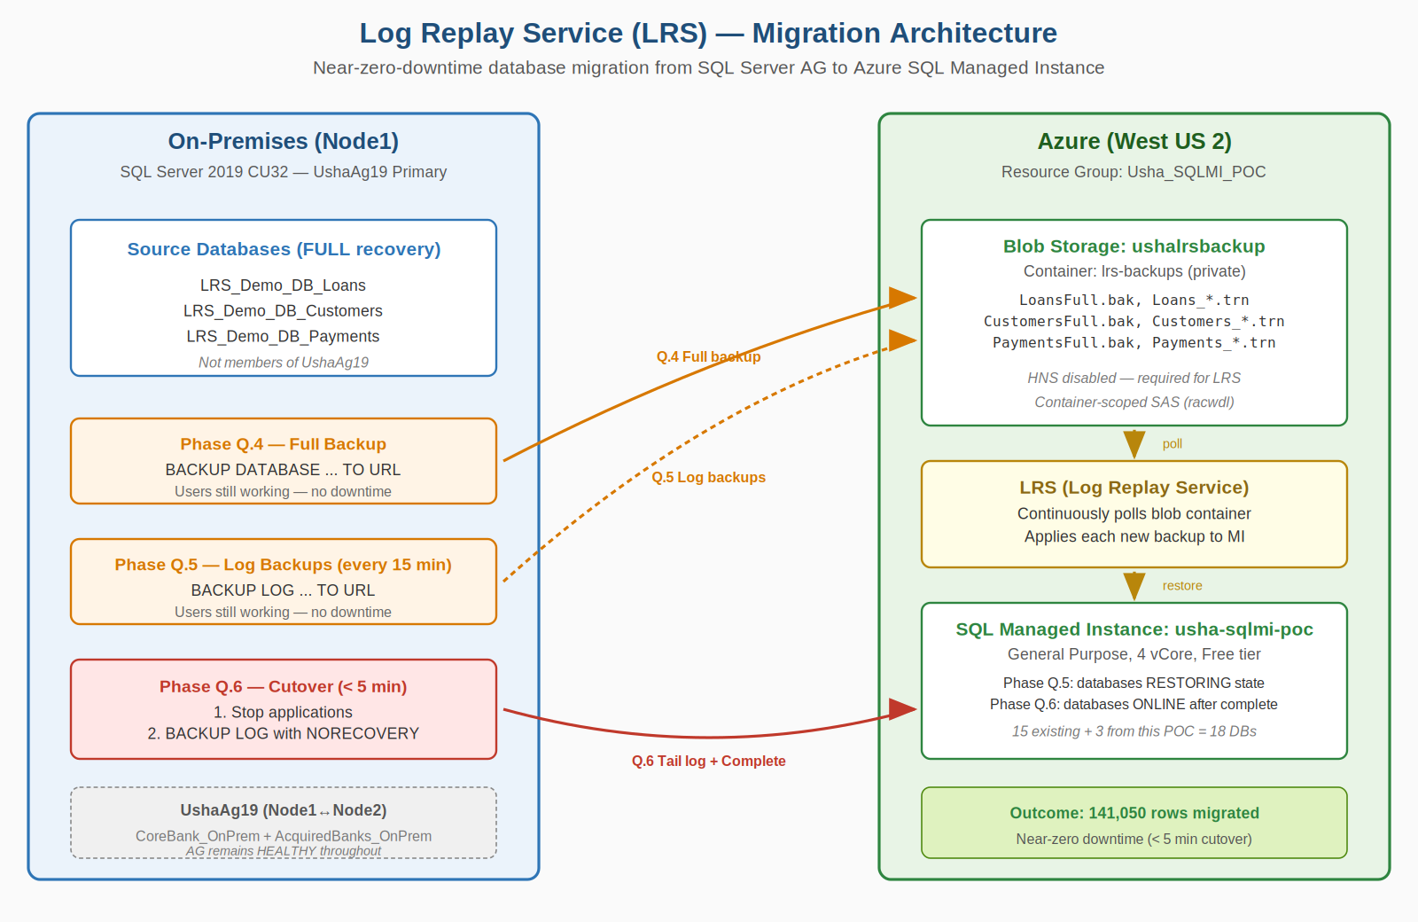
Figure Q.2-1: LRS migration from on-premises (Node1, blue) through Azure Blob Storage to SQL MI (green). Orange arrows = backups; red = cutover.

Q.2.4 LRS State Machine
LRS State | Meaning | Portal MI View
Initializing | MI provisioning restore infrastructure | Restoring
Restoring | Full backup being applied | Restoring
Waiting | Full + logs applied; polling for more | Restoring
Replaying | Actively applying a newly-arrived log | Restoring
CompletingMigration | Complete received; finalizing | Restoring
Completed | Database online, LRS released | Online
Blocked | Error (e.g., missing full backup) | Restoring
NOTE: Portal shows only 'Restoring' or 'Online'. Use Get-AzSqlInstanceDatabaseLogReplay PowerShell for actual LRS state.

Q.3 Environment

Q.3.1 On-Premises Lab
Role | Hostname / IP | Configuration
Domain Controller | USHADC / 192.168.68.20 | Windows Server 2022 Datacenter
LRS Source (this POC) | Node1 / 192.168.68.21 | SQL 2019 CU32, UshaAg19 PRIMARY
AG Secondary | Node2 / 192.168.68.22 | SQL 2019 CU32, UshaAg19 SECONDARY
Idle | Node3-4, Node6 | SQL 2022 CU24
BI Server | Node5 / 192.168.68.25 | SQL 2019 CU32, SSIS, SHIR

Q.3.2 Azure Resources
Resource | Name | Region / Notes
SQL Managed Instance | usha-sqlmi-poc | West US 2, GP 4 vCore, Free tier
Resource Group | Usha_SQLMI_POC | All Appendix Q resources
Storage Account | ushalrsbackup | West US 2, Standard_LRS, HNS disabled
Blob container | lrs-backups | Private, container-scoped SAS
Key Vault | usha-kv-poc | SAS tokens, credentials

Q.4 Source Database Preparation

Q.4.1 Pre-flight Check
Confirmed Node1 as source, SQL 2019 CU32 current, UshaAg19 HEALTHY, target DB names free, 20.5 GB free on C: drive. Phase complete with no issues.

Q.4.2 Source Database Row Counts (141,050 total)
Database | Tables | Rows
LRS_Demo_DB_Loans | Branches, LoanProducts, Borrowers, Loans, LoanPayments | 50,040
LRS_Demo_DB_Customers | Customers, CustomerAddresses, CustomerAccounts, KYCVerifications | 40,000
LRS_Demo_DB_Payments | PaymentChannels, Merchants, Transactions, TransactionAudit | 51,010
TOTAL | 13 tables across 3 databases | 141,050
NOTE: Key learnings from seed scripts: DBCC CHECKIDENT RESEED, 0 gives first ID=0 (use -1); CHECKSUM(NEWID()) overflow causes silent INSERT failures; RowCount is reserved (use RowCnt); check Messages tab for Msg 547 silent failures.

Q.5 Azure Storage + SAS
Created ushalrsbackup storage account and lrs-backups container in West US 2 with container-scoped SAS (racwdl permissions, HTTPS only, 30-day expiry). HNS disabled (critical for LRS compatibility).

Q.5.1 Storage Account Creation — Key Screenshots
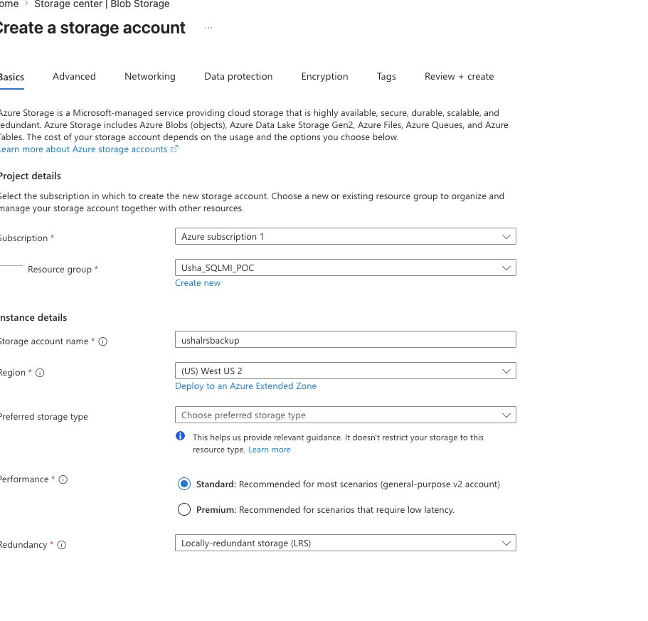
Figure Q.5-1: Storage Basics tab — Resource group = Usha_SQLMI_POC, Region = West US 2, Redundancy = LRS (locally-redundant).
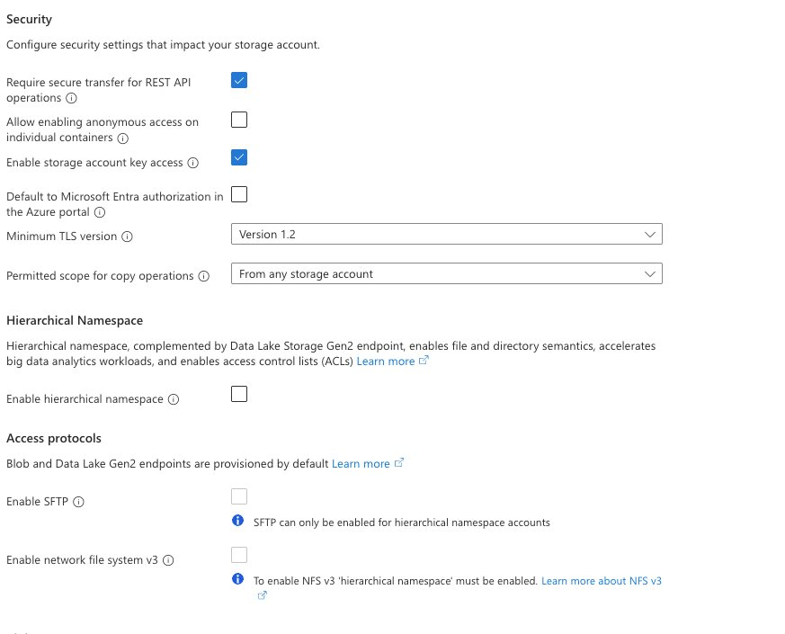
Figure Q.5-2: Advanced tab — Hierarchical Namespace UNCHECKED (critical for LRS compatibility).
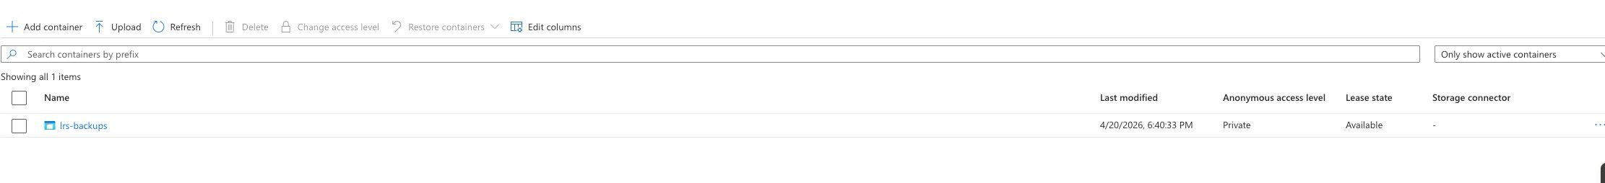
Figure Q.5-3: lrs-backups container created with Private access level.

Q.5.2 SAS Security Incident
WARNING: SAS URL was accidentally included in a screenshot during this POC. Storage account Key 1 was rotated immediately (within 2 minutes), invalidating the leaked SAS. Key rotated a second time for defense-in-depth.

Figure Q.5-4: Key 1 rotation timestamp showing 'Last rotated: 4/20/2026 (0 days ago)'.

Q.5.3 SAS Handling Rules
- Bearer credentials. Treat SAS like passwords. Never screenshot, email, Slack, or commit to source control.
- Rotate on exposure. Rotating the storage account key invalidates any SAS within seconds.
- Prefer CLI over portal. Azure CLI SAS tokens are ~119 chars — cleaner, less truncation risk than portal's 300+ char tokens.

Q.5.4 SAS Validation via HTTP 200 Test
# In Cloud Shell
SAS_TOKEN=$(cat ~/sas-token.txt)
FULL_URL="https://ushalrsbackup.blob.core.windows.net/lrs-backups?${SAS_TOKEN}&restype=container&comp=list"
curl -s -o /dev/null -w "HTTP Status: %{http_code}\n" "$FULL_URL"
RESULT: HTTP 200 confirms SAS works directly against Azure before attempting SQL BACKUP.

Q.6 Backup to URL

Q.6.1 Flat Per-DB Folder Requirement (Microsoft Learn)
NOTE: Per Microsoft Learn LRS Overview: 'Place backup files for each database in a separate folder on the Blob Storage account in a flat-file structure. Don't use nested folders inside database folders, because nested-folder structure isn't supported.' Source: Microsoft Learn: LRS Overview
Correct layout:
lrs-backups/
LRS_Demo_DB_Loans/
LRS_Demo_DB_Loans_FULL_<timestamp>.bak
LRS_Demo_DB_Loans_LOG_<timestamp>.trn
LRS_Demo_DB_Customers/
LRS_Demo_DB_Customers_FULL_<timestamp>.bak
LRS_Demo_DB_Customers_LOG_<timestamp>.trn
LRS_Demo_DB_Payments/
LRS_Demo_DB_Payments_FULL_<timestamp>.bak
LRS_Demo_DB_Payments_LOG_<timestamp>.trn
WARNING: INCORRECT layout that we initially tried: nested /Full/ and /Log/ subfolders inside each DB folder. LRS rejected this with 'Full backup can not be found' error. Had to re-run backups in flat layout.

Q.6.2 SQL Server Credential
CREATE CREDENTIAL [https://ushalrsbackup.blob.core.windows.net/lrs-backups]
WITH
IDENTITY = 'SHARED ACCESS SIGNATURE',
SECRET = '<SAS-token-without-leading-question-mark>';
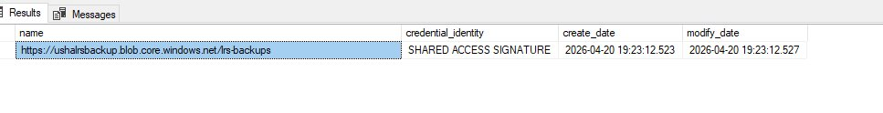
Figure Q.6-1: Credential created successfully with SAS-based auth.

Q.6.3 OS Error 50 — Diagnosed Three Times
Error sequence | Cause | Resolution
First OS error 50 | No credential created | CREATE CREDENTIAL
Second OS error 50 | Stale credential from leaked SAS | DROP + CREATE with new SAS
Third OS error 50 | SAS URL truncated in copy-paste | Regenerate via Azure CLI
HTTP 403 on SAS test | SAS signed with rotated-out key | Rotate + regenerate

Q.6.4 Flat-Layout Backup Script (final working version)
USE master;
GO

DECLARE @timestamp NVARCHAR(20) = FORMAT(GETDATE(), 'yyyyMMdd_HHmmss');
DECLARE @baseUrl NVARCHAR(200) = 'https://ushalrsbackup.blob.core.windows.net/lrs-backups';
DECLARE @sql NVARCHAR(MAX);

-- Loans FULL (flat - no /Full/ subfolder)
SET @sql = N'
BACKUP DATABASE [LRS_Demo_DB_Loans]
TO URL = ''' + @baseUrl + '/LRS_Demo_DB_Loans/LRS_Demo_DB_Loans_FULL_' + @timestamp + '.bak''
WITH COMPRESSION, CHECKSUM, STATS=10, FORMAT, INIT;';
EXEC sp_executesql @sql;

-- Customers FULL, Payments FULL - same pattern
-- Then LOG backups similarly

-- LOG backups (flat)
SET @sql = N'
BACKUP LOG [LRS_Demo_DB_Loans]
TO URL = ''' + @baseUrl + '/LRS_Demo_DB_Loans/LRS_Demo_DB_Loans_LOG_' + @timestamp + '.trn''
WITH COMPRESSION, CHECKSUM, STATS=10;';
EXEC sp_executesql @sql;

Q.6.5 Verified Blob Layout
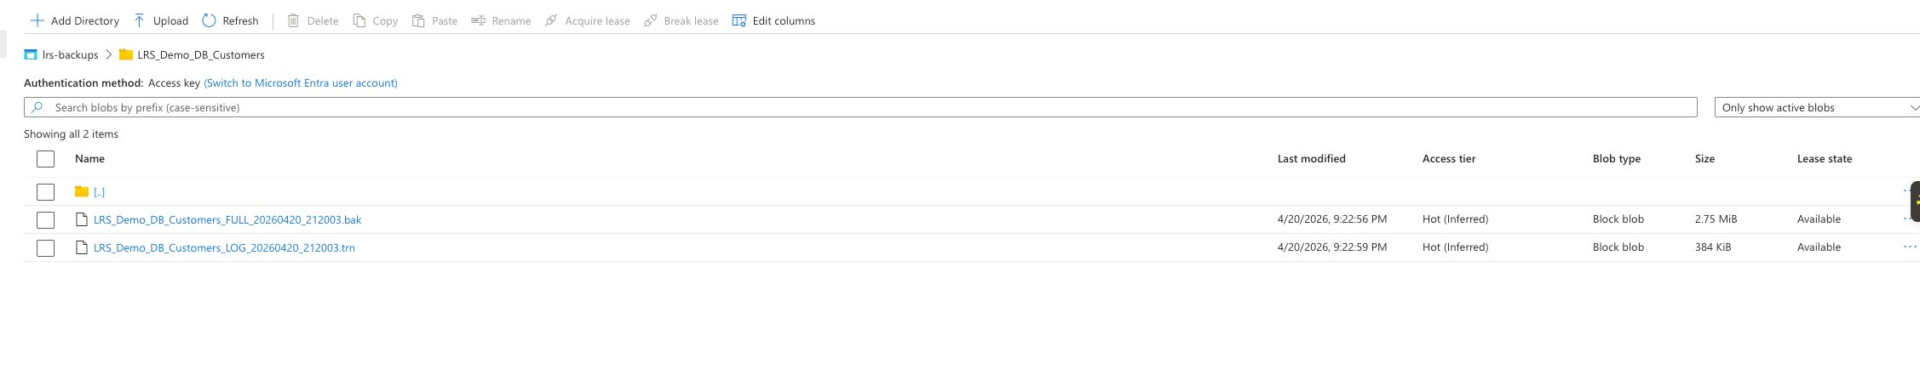
Figure Q.6-2: lrs-backups/LRS_Demo_DB_Customers/ showing flat layout with both .bak and .trn at DB root.

Q.7 Start Log Replay Service

Q.7.1 PowerShell Environment Issue — dbatools/Az DLL Conflict
Initial attempt to Connect-AzAccount on Node1 failed with 'Method not found' on Azure.Identity DLL. Root cause: both Az.Accounts and dbatools.library bundle Azure.Identity.dll — once PowerShell loads one version, it can't switch.
- Uninstalled dbatools from Node1 (dbatools preserved on Node5 BI server)
- Manual folder deletion via File Explorer after closing PowerShell
- Fresh PowerShell session released DLL bindings
- Connect-AzAccount -UseDeviceAuthentication succeeded after cleanup

Q.7.2 Start LRS Script
$rg = 'Usha_SQLMI_POC'
$mi = 'usha-sqlmi-poc'
$collation = 'SQL_Latin1_General_CP1_CI_AS'
$baseUri = 'https://ushalrsbackup.blob.core.windows.net/lrs-backups'
$sasToken = (Get-Content 'C:\Temp\sas-token.txt' -Raw).Trim()

$dbs = @('LRS_Demo_DB_Loans', 'LRS_Demo_DB_Customers', 'LRS_Demo_DB_Payments')

foreach ($db in $dbs) {
Start-AzSqlInstanceDatabaseLogReplay `
-ResourceGroupName $rg -InstanceName $mi -Name $db `
-Collation $collation `
-StorageContainerUri "$baseUri/$db" `
-StorageContainerSasToken $sasToken
}

Q.7.3 First Attempt — Blocked State
Initial LRS attempt on Loans with nested folder layout entered Blocked state:
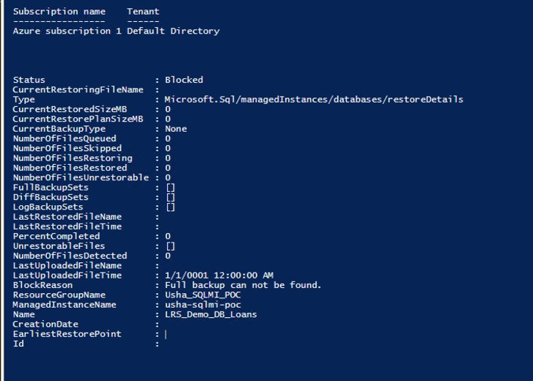
Figure Q.7-1: Get-AzSqlInstanceDatabaseLogReplay showing Status=Blocked, BlockReason='Full backup can not be found', FullBackupSets=[] (empty).

Q.7.4 Recovery Steps
- Attempted Stop-AzSqlInstanceDatabaseLogReplay — failed with cmdlet state bug
- Get-AzSqlInstanceDatabase confirmed database existed in Restoring state
- Remove-AzSqlInstanceDatabase — reported 'Resource not found' (LRS auto-released)
- Deleted all nested-layout blobs via Portal
- Re-ran backup script in corrected flat layout
- Re-ran Start script — all 3 DBs progressed Initializing → Restoring → Waiting

Q.7.5 Progress Monitoring
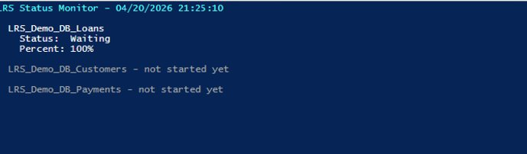
Figure Q.7-2: Monitor at 21:25 — Loans in Waiting state, 100% complete.
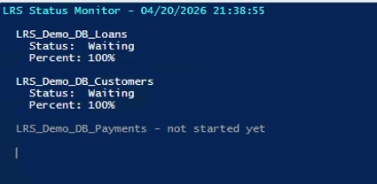
Figure Q.7-3: Monitor at 21:38 — Loans and Customers both Waiting; Payments starting sequentially.
Figure Q.7-4: Portal at 21:57 — all 3 LRS_Demo_DB_* databases present on MI in Restoring state.

Q.8 Cutover and Validation

Q.8.1 Tail-log Backups with NORECOVERY
USE master;
GO

DECLARE @timestamp NVARCHAR(20) = FORMAT(GETDATE(), 'yyyyMMdd_HHmmss');
DECLARE @baseUrl NVARCHAR(200) = 'https://ushalrsbackup.blob.core.windows.net/lrs-backups';
DECLARE @sql NVARCHAR(MAX);

-- Loans TAIL with NORECOVERY (locks source for apps)
SET @sql = N'
BACKUP LOG [LRS_Demo_DB_Loans]
TO URL = ''' + @baseUrl + '/LRS_Demo_DB_Loans/LRS_Demo_DB_Loans_TAIL_' + @timestamp + '.trn''
WITH NORECOVERY, COMPRESSION, CHECKSUM, STATS=10;';
EXEC sp_executesql @sql;

-- Customers TAIL, Payments TAIL - same pattern
RESULT: All 3 tail-log backups captured at 21:57:57 PST. Source databases on Node1 now in RESTORING state — locked for reads and writes.

Q.8.2 Complete LRS
$tailFiles = @{
'LRS_Demo_DB_Loans' = 'LRS_Demo_DB_Loans_TAIL_20260420_215757.trn'
'LRS_Demo_DB_Customers' = 'LRS_Demo_DB_Customers_TAIL_20260420_215757.trn'
'LRS_Demo_DB_Payments' = 'LRS_Demo_DB_Payments_TAIL_20260420_215757.trn'
}

foreach ($db in $tailFiles.Keys) {
Complete-AzSqlInstanceDatabaseLogReplay `
-ResourceGroupName 'Usha_SQLMI_POC' `
-InstanceName 'usha-sqlmi-poc' `
-Name $db `
-LastBackupName $tailFiles[$db]
}
State transitions observed — each DB went through Waiting → CompletingMigration → Completed (Online on MI).

Q.8.3 SSMS Connectivity — Public Endpoint
MI's default private endpoint (10.0.0.9) is unreachable from VirtualBox VMs. Enabled MI public endpoint (port 3342) via Portal.
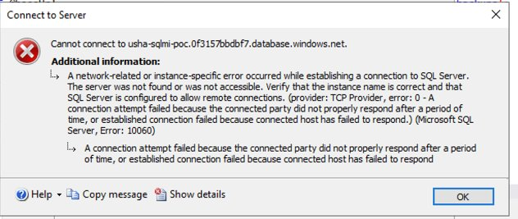
Figure Q.8-1: Initial SSMS error 10060 on private endpoint — expected, confirms VNet isolation.
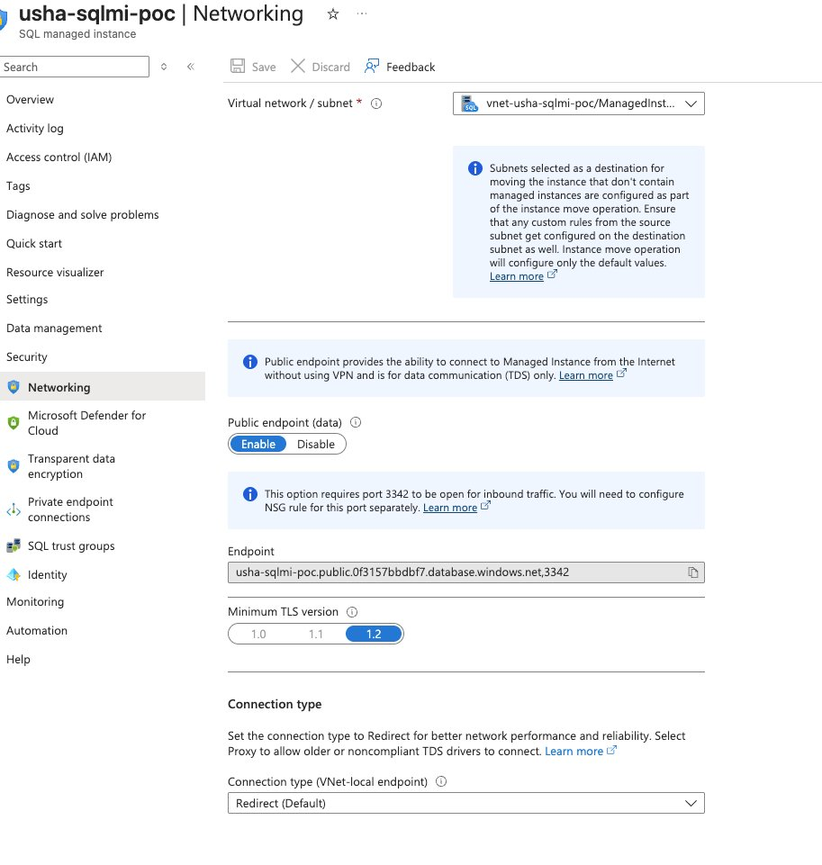
Figure Q.8-2: MI Networking page with Public endpoint (data) Enabled, TLS 1.2, endpoint 'usha-sqlmi-poc.public.0f3157bbdbf7.database.windows.net,3342'.
Public endpoint connection string:
Server name: usha-sqlmi-poc.public.0f3157bbdbf7.database.windows.net,3342
Authentication: SQL Server Authentication
Login: ssisadmin
Password: <MI admin password (reset during session)>
Encrypt: Mandatory
Trust server certificate: checked

Q.8.4 Password Reset
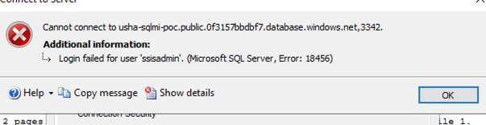
Figure Q.8-3: SQL Error 18456 — network path works, password reset needed.
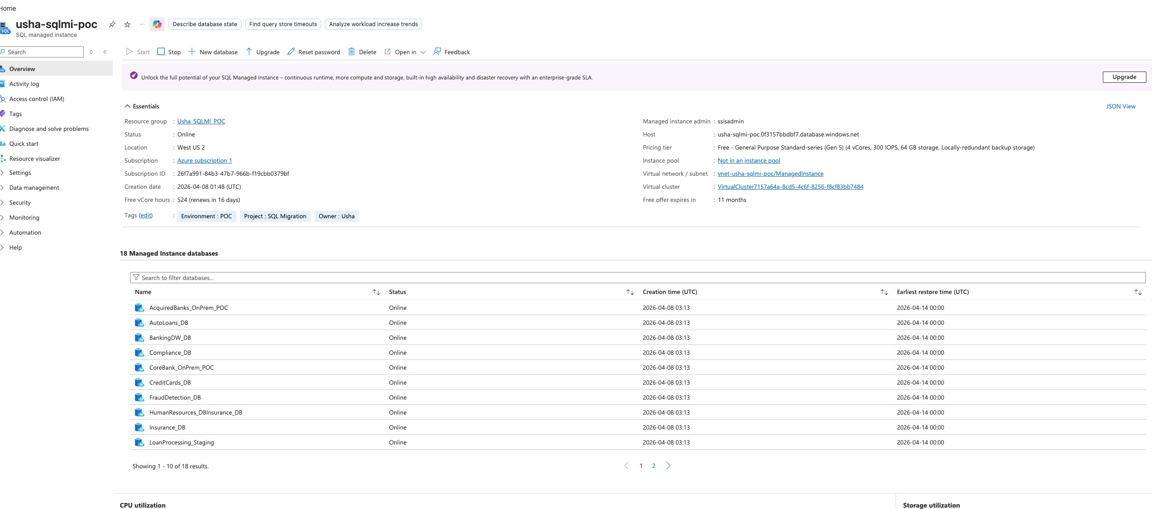
Figure Q.8-4: MI Overview after Complete — '18 Managed Instance databases' (was 15). Confirms all 3 LRS databases successfully online.

Q.8.5 Row Count Validation
-- Phase Q.8 Final Validation on Azure SQL MI
SELECT 'Loans' AS DB, 'Loans' AS Tbl, COUNT(*) AS RowCnt FROM LRS_Demo_DB_Loans.dbo.Loans
UNION ALL SELECT 'Loans', 'LoanPayments', COUNT(*) FROM LRS_Demo_DB_Loans.dbo.LoanPayments
UNION ALL SELECT 'Customers', 'Customers', COUNT(*) FROM LRS_Demo_DB_Customers.dbo.Customers
UNION ALL SELECT 'Payments', 'Transactions', COUNT(*) FROM LRS_Demo_DB_Payments.dbo.Transactions
UNION ALL SELECT 'Payments', 'TransactionAudit', COUNT(*) FROM LRS_Demo_DB_Payments.dbo.TransactionAudit;
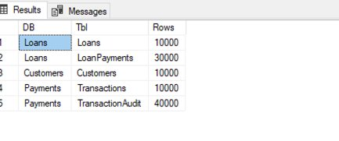
Figure Q.8-5: Row count results on MI — all 5 spot-checked tables match source exactly.

Q.8.6 Final Parity Table — All 13 Tables
Database | Table | Expected | Actual on MI | Match
LRS_Demo_DB_Loans | Branches | 20 | 20 | Yes
LRS_Demo_DB_Loans | LoanProducts | 10 | 10 | Yes
LRS_Demo_DB_Loans | Borrowers | 10,000 | 10,000 | Yes
LRS_Demo_DB_Loans | Loans | 10,000 | 10,000 | Yes
LRS_Demo_DB_Loans | LoanPayments | 30,000 | 30,000 | Yes
LRS_Demo_DB_Customers | Customers | 10,000 | 10,000 | Yes
LRS_Demo_DB_Customers | CustomerAddresses | 10,000 | 10,000 | Yes
LRS_Demo_DB_Customers | CustomerAccounts | 10,000 | 10,000 | Yes
LRS_Demo_DB_Customers | KYCVerifications | 10,000 | 10,000 | Yes
LRS_Demo_DB_Payments | PaymentChannels | 10 | 10 | Yes
LRS_Demo_DB_Payments | Merchants | 1,000 | 1,000 | Yes
LRS_Demo_DB_Payments | Transactions | 10,000 | 10,000 | Yes
LRS_Demo_DB_Payments | TransactionAudit | 40,000 | 40,000 | Yes
TOTAL | 13 tables | 141,050 | 141,050 | 100%
RESULT: POC COMPLETE. 141,050 rows successfully migrated from on-premises SQL Server 2019 (Node1) to Azure SQL Managed Instance (usha-sqlmi-poc) via Log Replay Service with 100% row count parity.

Q.9 Key Learnings — All 14 Captured
Comprehensive list of issues encountered during this POC and their resolutions. Every one applies to real banking migration scenarios.
KEY LEARNING #1: LRS requires per-database folders with FLAT file layout within each folder. Per Microsoft Learn: 'Don't use nested folders inside database folders.' Incorrect nested layouts (e.g., /db1/Full/ and /db1/Log/) cause LRS to enter Blocked state with 'Full backup can not be found.' Filename conventions (_FULL_, _LOG_) are for human clarity; LRS determines backup type from file headers. Source: LRS Overview
KEY LEARNING #2: LRS supports up to 100 parallel restore jobs on a single MI. Sequential foreach in PowerShell is a client-side choice, not an LRS limitation. For production migrations with many databases, prefer PowerShell 7 ForEach-Object -Parallel or multiple concurrent PowerShell windows.
KEY LEARNING #3: LRS jobs auto-cancel after 30 days (not 36 hours as sometimes cited). Per Microsoft Learn: 'A single LRS job can run for a maximum of 30 days.' Intermediate 'Waiting' states between log backups do not count against this limit as long as new backups arrive periodically. Source: LRS Overview
KEY LEARNING #4: LRS reads file headers to determine backup type, not filenames. Per Microsoft Learn: 'LRS doesn't require a specific naming convention for backup files. It scans all files placed in the Azure Blob Storage account and constructs the backup chain from reading the file headers only.'
KEY LEARNING #5: CHECKSUM on BACKUP statements is strongly recommended (though not required) for LRS. Per Microsoft Learn: 'Restoring databases without CHECKSUM takes longer, because SQL Managed Instance performs an integrity check on backups that are restored without CHECKSUM enabled.'
KEY LEARNING #6: Stopping LRS deletes the database shell on MI. Per Microsoft Learn: 'Stopping the operation deletes the database that you're restoring to SQL Managed Instance. After you stop an operation, you can't resume LRS for a database.' Must restart from beginning.
KEY LEARNING #7: Stop-AzSqlInstanceDatabaseLogReplay can fail with 'Cannot stop... was not created with log replay service' error even on LRS-created databases. This occurs when Az.Sql 6.4.1 internal state tracking is out of sync. Workaround: use Remove-AzSqlInstanceDatabase -Force to drop directly, which releases any LRS locks.
KEY LEARNING #8: Az.Sql 6.4.1 Start-AzSqlInstanceDatabaseLogReplay and Complete-AzSqlInstanceDatabaseLogReplay cmdlets can over-wait 5-15 minutes beyond actual MI-side completion. Symptom: cmdlet appears stuck in PowerShell but monitor shows LRS Status=Waiting/100%. Workaround: monitor server-side via Get-AzSqlInstanceDatabaseLogReplay in a second PowerShell window; safe to force-close blocking window — LRS jobs on MI are server-side independent of client connection.
KEY LEARNING #9: SAS tokens are bearer credentials. Treat like passwords: never screenshot, email, Slack, or commit. If exposed, rotate the storage account key immediately — this invalidates any SAS signed with the rotated key within seconds. Azure CLI-generated SAS tokens (~119 chars) are cleaner and less prone to copy-paste truncation than Portal-generated tokens (300+ chars).
KEY LEARNING #10: OS error 50 on BACKUP TO URL has multiple root causes and requires systematic debugging: (1) missing credential, (2) stale credential after SAS rotation, (3) SAS URL truncation during copy-paste. Validate SAS directly via curl HTTP 200 test before attempting SQL backup - this isolates SAS issues from SQL credential issues.
KEY LEARNING #11: dbatools and Az PowerShell modules conflict via shared Azure.Identity.dll dependency. Once loaded, the AppDomain cannot swap versions. On Windows PowerShell 5.1, uninstall one module from the workstation where you do cloud work. PowerShell 7 uses isolated AssemblyLoadContexts per module and does not have this issue.
KEY LEARNING #12: LRS blob layout validation: per-database folders at container root are REQUIRED, but nested subfolders within each database folder (like /Full/ or /Log/) are NOT supported. The fix if you hit 'Full backup can not be found': Stop LRS (or Remove-AzSqlInstanceDatabase if Stop fails), delete nested blobs, re-run backups with flat TO URL paths at DB folder root, restart LRS.
KEY LEARNING #13: SQL MI public endpoint is NOT enabled by default. MI's default private endpoint (10.0.0.x VNet address) is unreachable from on-premises networks including VirtualBox VMs. To enable SSMS access from outside Azure VNet: Portal -> MI -> Security -> Networking -> Enable Public endpoint (data). Uses port 3342 (not 1433), hostname contains '.public.' insertion. Example: usha-sqlmi-poc.public.0f3157bbdbf7.database.windows.net,3342 Source: SQL MI Public Endpoint Configuration
KEY LEARNING #14: SQL MI admin password reset: when authentication fails (Error 18456) with a known username, fastest resolution is to reset the MI admin password via Portal -> usha-sqlmi-poc -> Reset password. Takes 30-60 seconds to apply. The admin username is shown in Portal -> Overview -> Essentials panel under 'Managed instance admin'. For this POC: ssisadmin.

Q.10 Session Execution Log
Complete timeline from Phase Q.3 storage creation through Phase Q.8 row count validation on April 20, 2026:
Time (PST) | Phase | Action | Outcome
17:50 | Q.5 | MI overview — found Stopped state | Started MI
18:14 | Q.5 | Storage account Basics tab — wrong RG initially | Corrected to Usha_SQLMI_POC
18:20 | Q.5 | Advanced tab — HNS disabled confirmed | Critical validation
18:38 | Q.5 | Storage account deployed | Success
18:41 | Q.5 | lrs-backups container created | Private access
18:50 | Q.5 | SAS INCIDENT — exposed in screenshot | Key 1 rotated within 2 min
19:23 | Q.6 | Credential #1 created — OS error 50 | Diagnosis started
19:43 | Q.5 | Key 1 rotated second time | Clean state
19:50 | Q.5 | SAS regenerated via Cloud Shell (119 chars) | SAS validated
19:53 | Q.6 | Test_Customers.bak — 2.75 MiB round-trip | Pipeline confirmed
20:02 | Q.6 | Full backups in NESTED layout (wrong) | Backups succeeded
20:07 | Q.6 | Log backups in nested layout | Ready for Q.7
20:41 | Q.7 | Connect-AzAccount — METHOD NOT FOUND | dbatools conflict
20:45 | Q.7 | Uninstalled dbatools from Node1 | Clean assembly state
20:49 | Q.7 | Connect-AzAccount -UseDeviceAuthentication | Login succeeded
20:55 | Q.7 | Start-AzSqlInstanceDatabaseLogReplay — Loans | Blocked: Full not found
21:15 | Q.7 | Discovered nested folder is unsupported | Root cause identified
21:15 | Q.7 | Deleted all nested-layout blobs | Clean slate
21:20 | Q.6 | Redid backups in FLAT per-DB layout | All 6 backups success
21:24 | Q.7 | Start-AzSqlInstanceDatabaseLogReplay x 3 (flat) | Cmdlet started
21:25 | Q.7 | Monitor shows Loans Status=Waiting | First DB ready
21:38 | Q.7 | Monitor shows Customers Status=Waiting | Second DB ready
21:57 | Q.7 | Portal shows all 3 LRS DBs on MI | Phase Q.7 complete
21:57 | Q.8 | Tail-log backups x 3 with NORECOVERY | Source DBs locked
21:59 | Q.8 | Verified all 3 Status=Waiting/100 after tail | LRS caught up
22:01 | Q.8 | Complete-AzSqlInstanceDatabaseLogReplay | State transitions begun
22:08 | Q.8 | All 3 DBs DB Status=Online, LRS=Completed | Migration successful
22:13 | Q.8 | SSMS to private endpoint — ERROR 10060 | Network isolation confirmed
22:19 | Q.8 | MI Networking — Public endpoint already enabled | Discovered
22:26 | Q.8 | Test-NetConnection port 3342 = True | Network path open
22:27 | Q.8 | SSMS to public endpoint — ERROR 18456 | Password issue
22:30 | Q.8 | Reset MI admin password via Portal | ssisadmin reset
22:31 | Q.8 | SSMS CONNECTED to MI public endpoint | Success
22:33 | Q.8 | Row count validation query — PARITY CONFIRMED | POC COMPLETE

Q.11 Cost Summary
Component | Rate | Actual Cost
SQL MI (free tier, 524 hrs/month) | $0 | $0.00
Standard storage LRS (< 100 MB) | ~$0.02/GB/mo | < $0.01
Egress (backups from Node1 to Blob) | n/a (ingress free) | $0.00
LRS service operations | No separate charge | $0.00
TOTAL Appendix Q spend |  | < $0.50

Q.12 Resume Bullet Candidates
Architecture-focused language. No POC-specific database names, row counts, or node names.
- Executed end-to-end database migration from on-premises SQL Server 2019 to Azure SQL Managed Instance using Log Replay Service (LRS), with 100 percent row count parity validation and full preservation of source Availability Group synchronization state.
- Designed AG coexistence migration pattern where user databases on an AG primary replica were migrated to Azure without AG membership, demonstrating enterprise-grade migration isolation for regulated banking environments.
- Implemented continuous-mode LRS workflow with transaction log chain integrity coordination, tail-log backup with NORECOVERY for cutover, and Complete-AzSqlInstanceDatabaseLogReplay finalization to transition databases from restoring to online state on managed instance.
- Demonstrated depth in Azure SQL MI migration tooling by implementing both DMS-orchestrated migration and raw LRS migration — understanding that DMS internally uses LRS and being able to diagnose migration failures at either layer.
- Diagnosed and resolved LRS blob layout requirements per Microsoft Learn specifications — per-database folders required but with flat file layout within each folder; nested type-based subfolders cause LRS restore failures.
- Resolved Azure PowerShell module conflicts between dbatools and Az modules via shared Azure.Identity assembly isolation — enables clean Azure scripting from SQL DBA workstations.
- Secured credential handling in cloud database migrations including SAS token rotation protocols upon accidental exposure and HTTP 200 pre-flight validation of SAS permissions before committing backups.
- Configured SQL Managed Instance public endpoint on port 3342 to enable secure DBA access from on-premises networks outside the Azure VNet — standard pattern for hybrid banking administration.

Q.13 Companion Document and Portfolio Integration
Standalone copy: Appendix_Q_LRS_Migration_to_SQL_MI_v7.docx (715 KB, 747 paragraphs) is a standalone version of this same material for independent sharing. GitHub: ushakaleclouddba-design/Azure-Data-Engineering-Portfolio

Microsoft Learn References (clickable)
- LRS Overview (authoritative source) — https://learn.microsoft.com/en-us/azure/azure-sql/managed-instance/log-replay-service-overview
- LRS Migration Guide — https://learn.microsoft.com/en-us/azure/azure-sql/managed-instance/log-replay-service-migrate
- LRS vs MI Link Comparison — https://learn.microsoft.com/en-us/azure/azure-sql/managed-instance/log-replay-service-compare-mi-link
- BACKUP TO URL — https://learn.microsoft.com/en-us/sql/relational-databases/backup-restore/sql-server-backup-to-url
- Start-AzSqlInstanceDatabaseLogReplay — https://learn.microsoft.com/en-us/powershell/module/az.sql/start-azsqlinstancedatabaselogreplay
- Complete-AzSqlInstanceDatabaseLogReplay — https://learn.microsoft.com/en-us/powershell/module/az.sql/complete-azsqlinstancedatabaselogreplay
- SQL MI Public Endpoint Configuration — https://learn.microsoft.com/en-us/azure/azure-sql/managed-instance/public-endpoint-configure
- Azure SQL Managed Instance Overview — https://learn.microsoft.com/en-us/azure/azure-sql/managed-instance/sql-managed-instance-paas-overview
- Azure Database Migration Service — https://learn.microsoft.com/en-us/azure/dms/dms-overview

Document maintained by Usha Kale — Senior Cloud DBA / Azure Data Engineer
GitHub: ushakaleclouddba-design/Azure-Data-Engineering-Portfolio | Last updated: April 21, 2026

