1. Problem : <https://leetcode.com/problems/department-highest-salary/>

Solution:

Select a.Department, a.Employee, a.Salary from

(SELECT department.Name AS Department, employee.Name AS Employee, employee.salary as Salary,

rank() over(partition by department.Name order by employee.salary desc) as Ranking

FROM employee JOIN department ON employee.departmentId = department.id

order by employee.Salary desc) as a

where a.Ranking = 1;

**Output Screenshot** :-

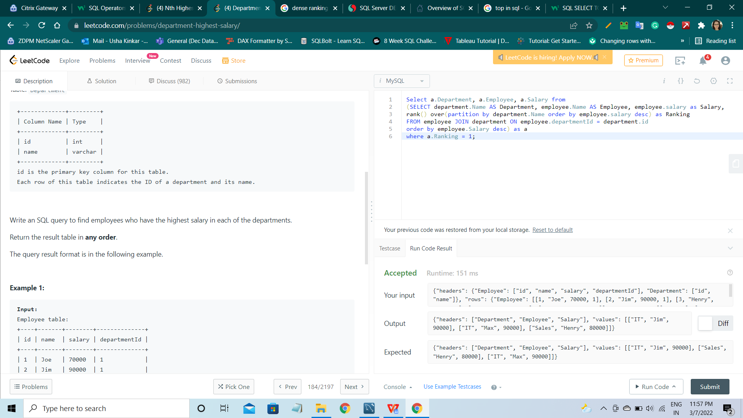

1. Problem: <https://leetcode.com/problems/rank-scores/>

Solution:

select Score, dense_rank() over(order by Score desc) as 'Rank'

from Scores

**Output Screenshot** :-

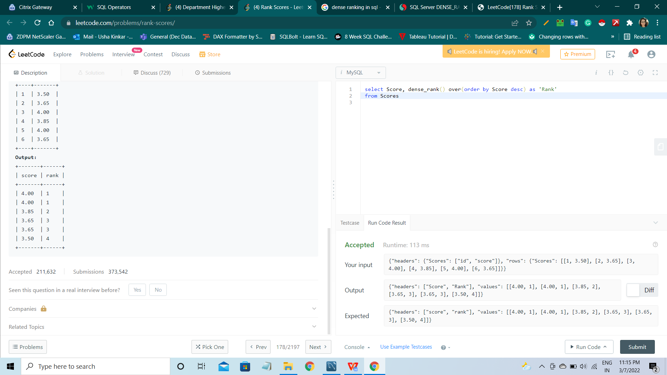

1. Problem: <https://leetcode.com/problems/nth-highest-salary/>

Solution:

CREATE FUNCTION getNthHighestSalary(N INT) RETURNS INT

BEGIN

SET N = N - 1;

RETURN (select distinct Employee.Salary from Employee order by Employee .Salary desc limit N, 1);

END

**Output Screenshot** :-

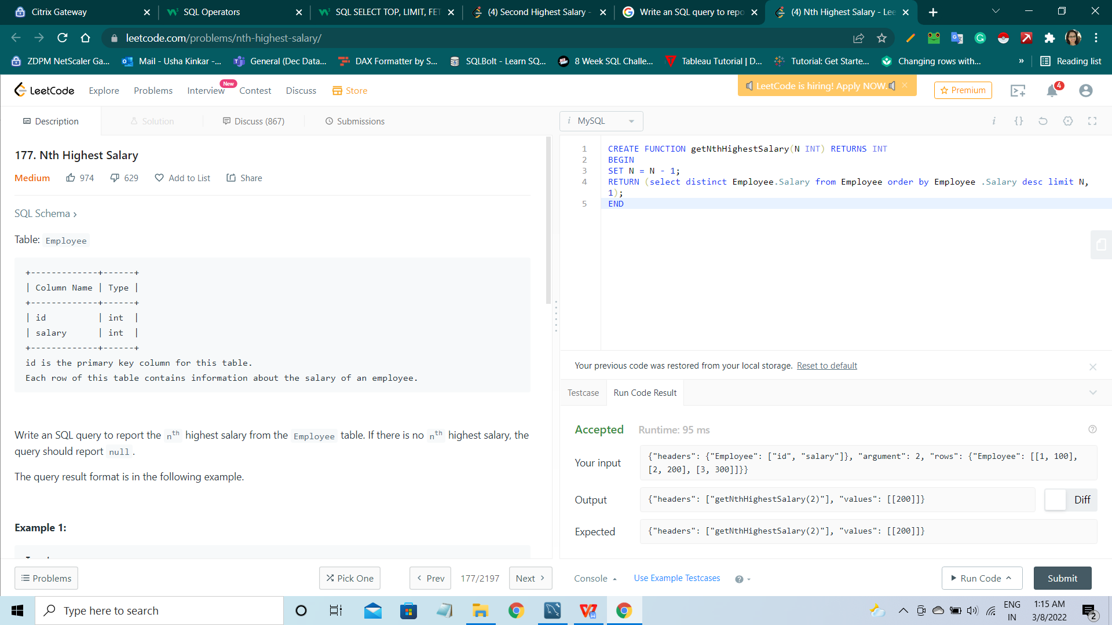

1. Problem: <https://leetcode.com/problems/second-highest-salary/>

Solution:

SELECT (SELECT DISTINCT Salary FROM Employee1

ORDER BY Salary DESC

LIMIT 1 OFFSET 1) AS SecondHighestSalary;

**Output Screenshot** :-

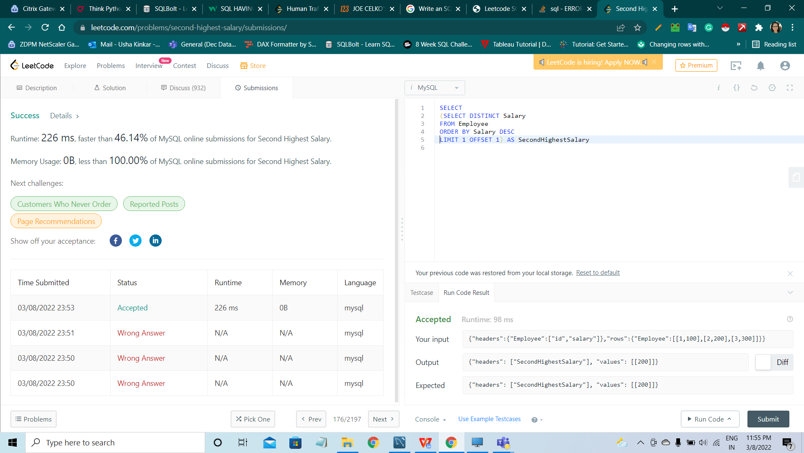

1. Problem: <https://leetcode.com/problems/trips-and-users/>

Solution:

select a.Request_at as Day, round(1 - sum(a.status = "Completed") / a.all_count, 2) as "Cancellation Rate"

from

(

select *, count(status) over (partition by request_at) as all_count from Trips where client_id in

(select users_id from Users where banned = "No") and driver_id in (select users_id from Users where banned = "No")

) as a

where a.request_at in ('2013-10-01','2013-10-02','2013-10-03')

group by a.request_at

**Output Screenshot** :-

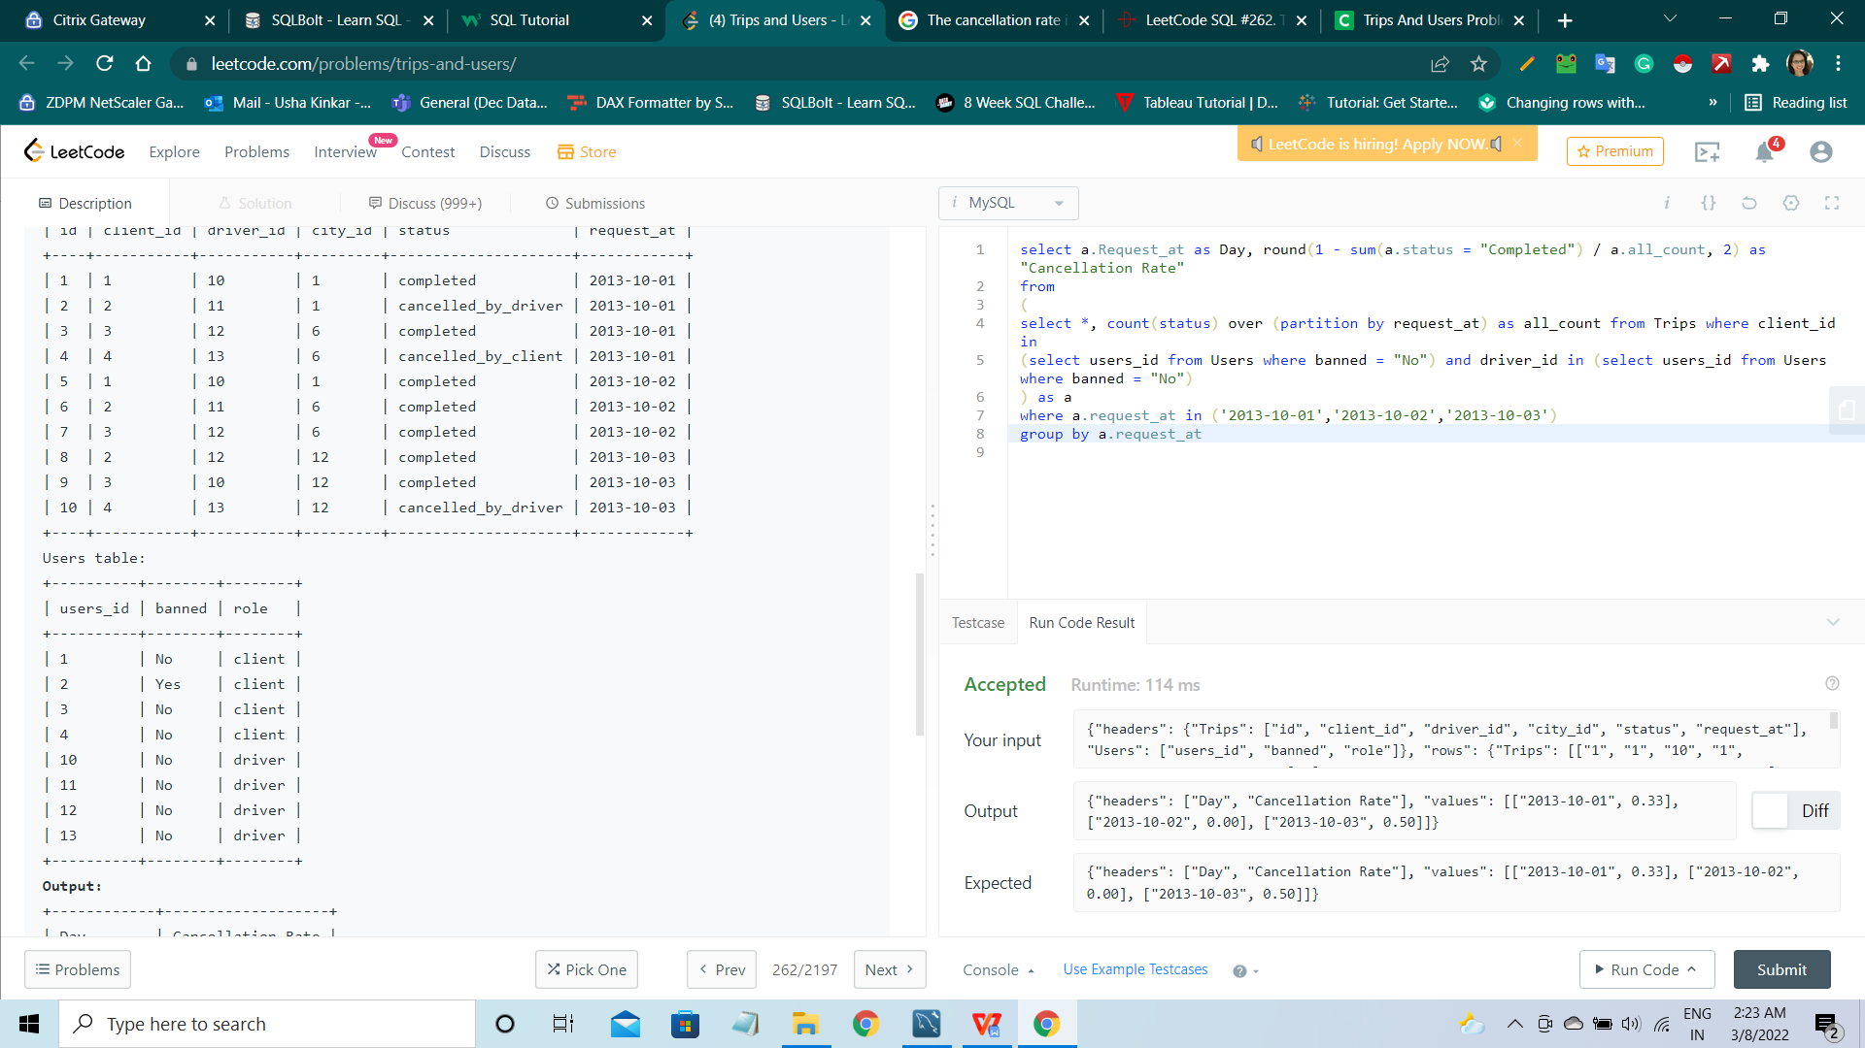

1. Problem: <https://leetcode.com/problems/rank-scores/>

Solution:

select Score, dense_rank() over(order by Score desc) as 'Rank'

from Scores

**Output Screenshot** :-



1. Problem: <https://leetcode.com/problems/department-top-three-salaries/>

Solution:

Select a.Department, a.Employee, a.Salary from

(SELECT Department1.Name AS Department, Employee3.Name AS Employee, Employee3.salary as Salary,

dense_rank() over(partition by Department1.Name order by Department1.Name, Employee3.salary desc) as Ranking

FROM Employee3 JOIN Department1 ON Employee3.departmentId = Department1.id

order by Department1.Name Asc) as a

where a.Ranking <=3

**Output Screenshot** :-

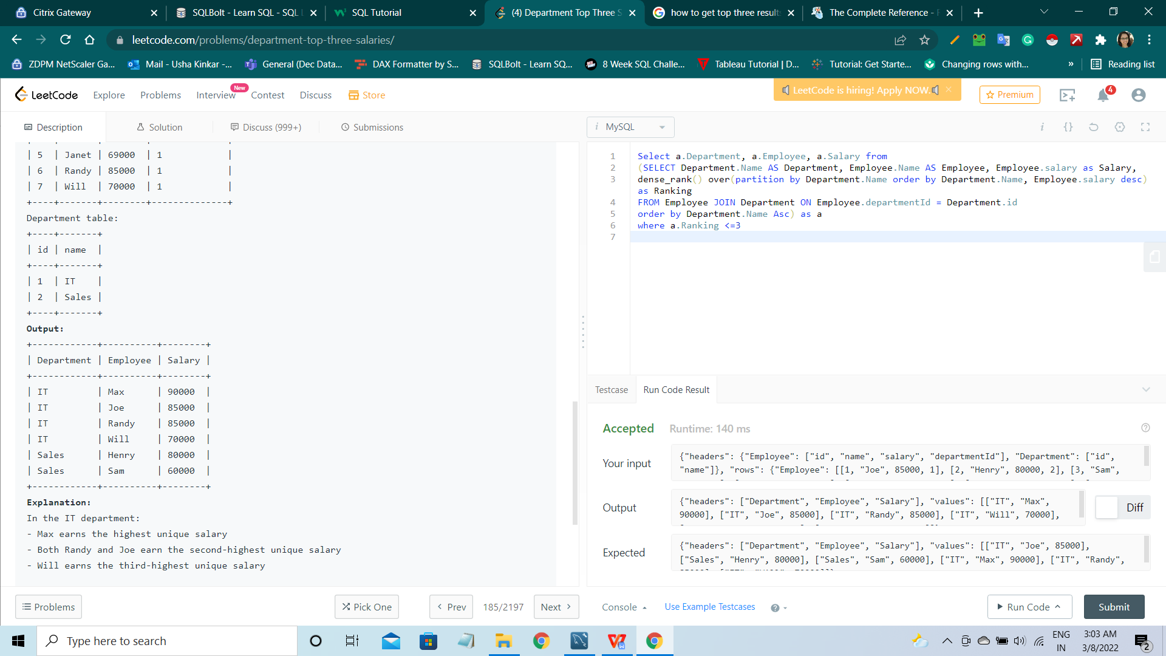

1. Problem: <https://leetcode.com/problems/human-traffic-of-stadium/>

Solution:

select id, visit_date, people from

(select id, visit_date, people, count(*) over(partition by difference) as a from

(select id, visit_date, people, (id - row_number() over(order by visit_date)) as difference

from Stadium

where people >= 100) b

)c

where a >= 3

**Output Screenshot** :-

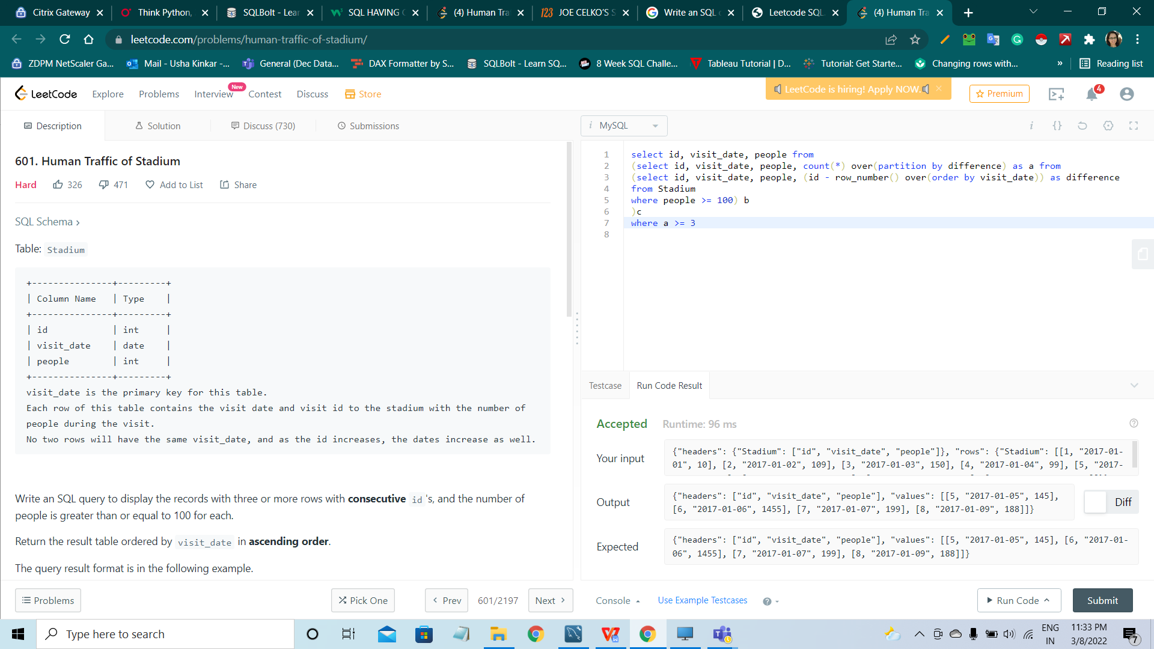

Following questions are marked 5 marks each

1. Let’s write some CREATE TABLE statements that are as complete as possible. This little exercise is important because SQL is a declarative language and you need to learn how to specify things in the database instead of in the code. The table looks like this:

CREATE TABLE FiscalYearTable1 (fiscal_year INTEGER, start_date DATE, end_date DATE);

It stores date ranges for determining what fiscal year any given date belongs to. For example, the federal government runs its fiscal year from October 1 until the end of September.

The scalar subquery you would use to do this table lookup is:

(SELECT F1.fiscal_year FROM FiscalYearTable1 AS F1 WHERE outside_date BETWEEN F1.start_date AND F1.end_date)

Your assignment is to add all the constraints you can think of to the table to guarantee that it contains only correct information.

While vendors all have different date and time functions, let’s assume that all we have is the SQL-92 temporal arithmetic and the function EXTRACT ([YEAR | MONTH | DAY] FROM ), which returns an integer that represents a field within a date.

Solution:

drop table FiscalYearTable1;

CREATE TABLE FiscalYearTable1

(fiscal_year INTEGER NOT NULL PRIMary KEY UNIqUE,

start_date DATE NOT NULL UNIqUE,

end_date DATE NOT NULL UNIqUE );

alter table FiscalYearTable1

add Constraint vstart_date CHECK (start_date < End_date);

alter table FiscalYearTable1

add Constraint vend_date CHECK (End_date > start_date);

ALTER TABLE FISCALYEARTABLE1

ADD Constraint valid_start_date_1

Check ( YEAR(start_date) = fiscal_year - 1) ;

ALTER TABLE FISCALYEARTABLE1

ADD Constraint valid_start_date_2

CHECK ( MONTH(start_date) = 10 ) ;

ALTER TABLE FISCALYEARTABLE1

ADD Constraint valid_start_date_3

CHECK (DAY(start_date) = 01);

ALTER TABLE FISCALYEARTABLE1

ADD Constraint valid_end_date_1

Check ( YEAR(end_date) = fiscal_year );

ALTER TABLE FISCALYEARTABLE1

ADD Constraint valid_end_date_2

Check (MONTH(end_date) = 09);

ALTER TABLE FISCALYEARTABLE1

ADD Constraint valid_end_date_3

Check ( DAY(end_date) = 30) ;

Insert Into FiscalYearTable1 Values (2010,'2009-10-01','2010-09-30') ;

SELECT * FROM FISCALYEARTABLE1;

1. In a factory, a project is described in a work order, which has a series of steps that it must go through.

A step_nbr on the work order is either completed or awaiting the completion of one or more of the steps that come before it.

Table looks like this:

CREATE TABLE Projects (workorder_id CHAR(5) NOT NULL,

step_nbr INTEGER NOT NULL CHECK (step_nbr BETWEEN 0 AND 1000), step_status CHAR(1) NOT NULL CHECK (step_status IN ('C', 'W')), -- complete, waiting

PRIMARY KEY (workorder_id, step_nbr));

With some sample data like this:

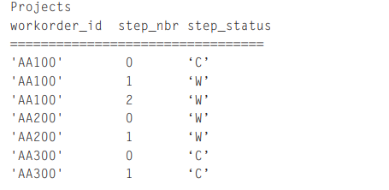

We would like to get the work orders where the step_nbr is zero and the step_status is ‘C’, but all other legs for that work order have a step_status of ‘W’.

For example, the query should return only 'AA100' in the sample data.

Solution:

CREATE TABLE Projects (workorder_id CHAR(5) NOT NULL,

step_nbr INTEGER NOT NULL CHECK (step_nbr BETWEEN 0 AND 1000), step_status CHAR(1) NOT NULL CHECK (step_status IN ('C', 'W')), -- complete, waiting

PRIMARY KEY (workorder_id, step_nbr));

INSERT INTO Projects VALUES ('AA100',0,'C');

INSERT INTO Projects VALUES ('AA100',1,'W');

INSERT INTO Projects VALUES ('AA100',2,'W');

INSERT INTO Projects VALUES ('AA200',0,'W');

INSERT INTO Projects VALUES ('AA200',1,'W');

INSERT INTO Projects VALUES ('AA300',0,'C');

INSERT INTO Projects VALUES ('AA300',1,'C');

SELECT workorder_id

FROM Projects

WHERE step_status = 'C'

GROUP BY workorder_id

HAVING sum(step_nbr) = 0;

**Output Screenshot** :-

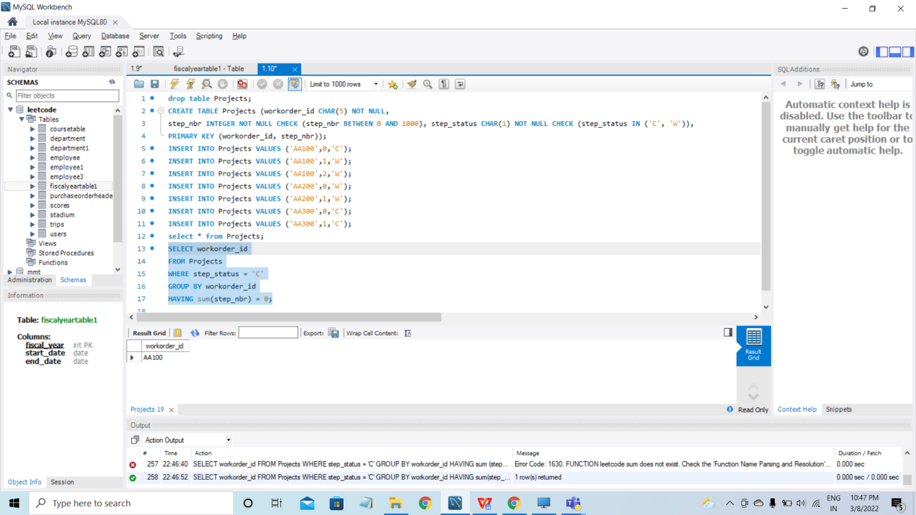

1. Create the following table

Create Table coursetable

(

CourseName varchar(50),

CourseCategory varchar(50),

Price int

)

Insert into coursetable values('C', 'PROGRAMMING', 5000) ;

Insert into coursetable values('JAVA', 'PROGRAMMING', 6000) ;

Insert into coursetable values('PYTHON', 'PROGRAMMING', 8000) ;

Insert into coursetable values('PLACEMENT 100', 'INTERVIEWPREPARATION', 5000) ;

SELECT * FROM coursetable ;

Following will be the output

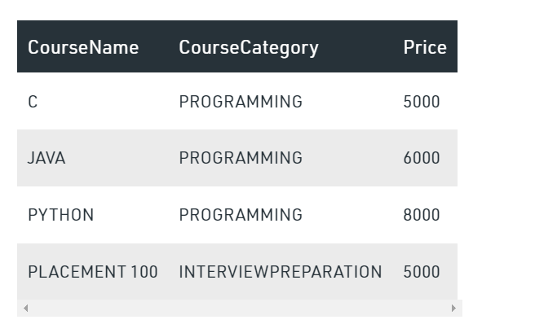

What query can you write to get the following output ?

Hint : Use pivot table

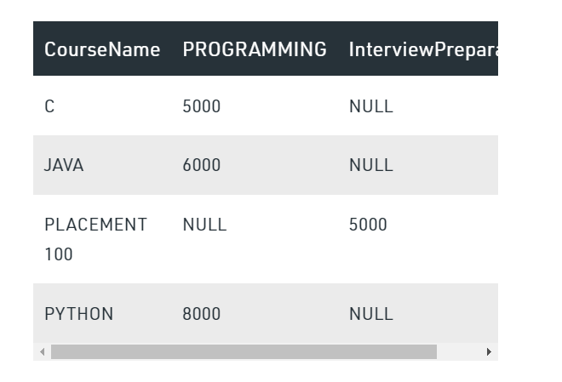

Solution:

SELECT CourseName,

(case

when CourseCategory='PROGRAMMING' and price=5000 then 5000

when CourseCategory='PROGRAMMING' and price=6000 then 6000

when CourseCategory='PROGRAMMING' and price=8000 then 8000

else 'null'

end ) as PROGRAMMING,

(case when CourseCategory='INTERVIEWPREPARATION' and price=5000 then 5000 else null end) as INTERVIEWPREPARATION

FROM coursetable

**Output Screenshot** :-

