SDA-Pro Comprehensive Project Report
Security Incident Response & Threat Mitigation Platform
Generated from implemented project evidence | 2026-06-01

Executive Summary
This report documents the implemented SDA-Pro university semester project: a demo-ready Security Incident Response and Threat Mitigation Platform. The system focuses on Software Design and Architecture evidence: design patterns, architecture styles, service boundaries, API contracts, asynchronous events, database schema, frontend screens, UML diagrams, and tests. External cybersecurity products are intentionally mocked so the demo can run locally without real API keys.
Implementation note: the backend features are packaged into a Spring Boot composition root for reliable local demo execution, while the repository, contracts, diagrams, and documentation preserve clear SOA-style service boundaries. This is appropriate for a semester architecture demonstration, but it is not claimed to be a production microservices deployment.

Final Tech Stack
Layer | Technology | Proof
Backend | Java 21, Spring Boot 3, Maven | services/alert-ingestion-service
Frontend | React, TypeScript, Vite | soc-dashboard
Database | PostgreSQL 16 | docker-compose service postgres
Cache | Redis 7 | Threat intelligence proxy cache
Message broker | RabbitMQ 3 | Event publishing/subscribing
Realtime | Server-Sent Events dashboard stream | /dashboard/events
Docs/UML | PlantUML and ADR markdown | docs/uml diagrams, docs/adr
Deployment | Docker Compose | docker-compose.yml

System Architecture
The project is organized as a local SOA demonstration. Alerts enter through ingestion APIs, are normalized, enriched, correlated into incidents, advanced through lifecycle states, responded to using strategy-selected actions, published as events, pushed to the dashboard, and written to audit storage.
- Controllers expose required API endpoints and route requests into application services.
- Application services coordinate normalization, enrichment, correlation, state transitions, response execution, notification, and audit.
- Domain classes contain incident states, alert composites, response strategies, and event models.
- Adapters and proxies isolate mock Splunk, Firewall, VirusTotal, MISP, Slack, PagerDuty, Email, and Active Directory behavior.
- PostgreSQL stores durable records, Redis caches threat intelligence, RabbitMQ represents event-driven communication, and SSE updates the SOC dashboard.
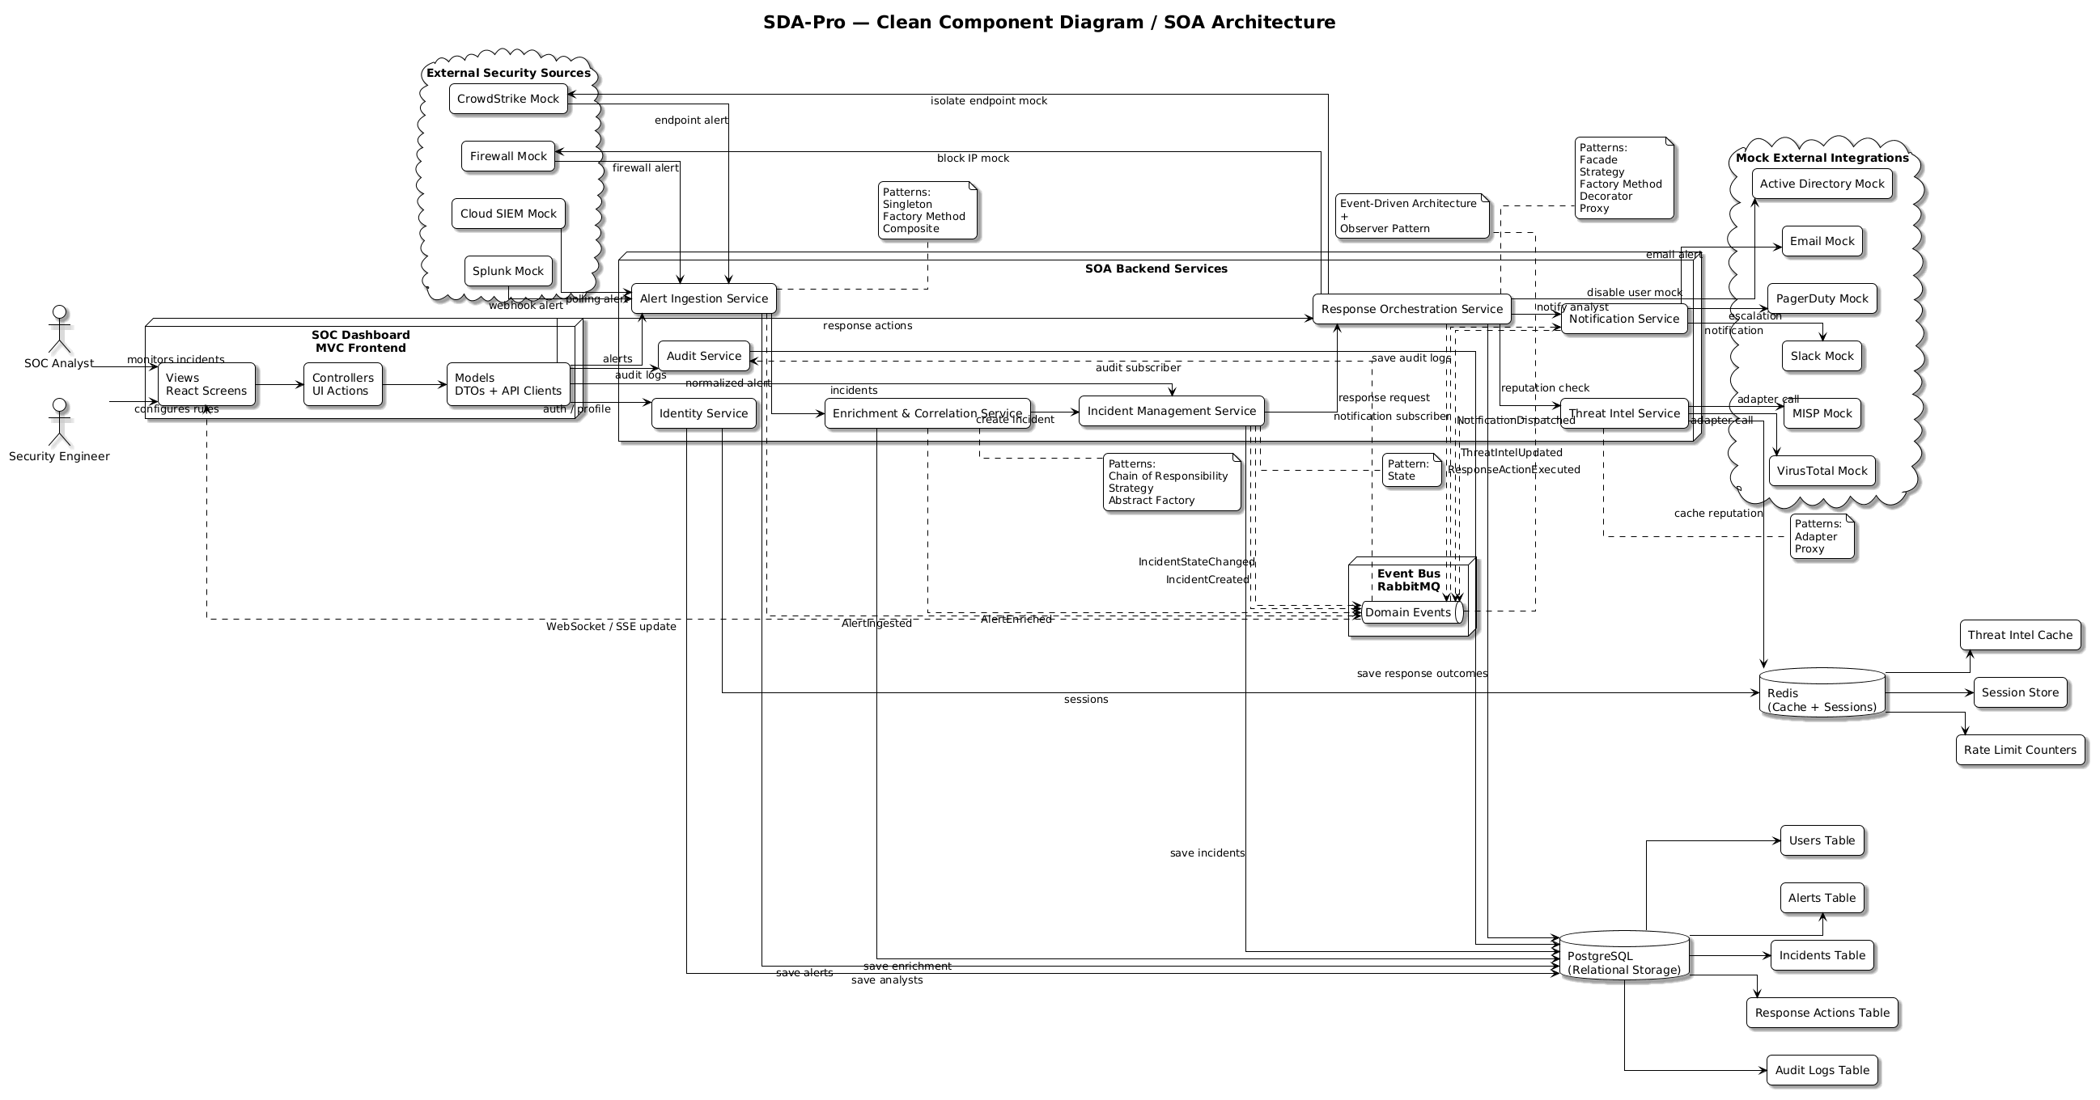
Figure 1. PlantUML component diagram showing SOA boundaries.

Folder Structure
SDA Project/
docker-compose.yml
README.md
services/alert-ingestion-service/ Spring Boot backend composition root
soc-dashboard/ React + TypeScript frontend
shared/contracts/ API/event shared contracts
docs/adr/ Architecture Decision Records
docs/api/ OpenAPI and AsyncAPI contracts
docs/plantuml codes/ PlantUML source diagrams
docs/uml diagrams/ Rendered PNG diagrams
reports/assets/ Screenshots, proof files, copied diagrams

Database Schema
Table | Purpose
analysts | Mock SOC analyst identity and role data.
alert_sources | Configured mock Splunk, Firewall, and other source definitions.
alerts | Normalized alert records and severity metadata.
alert_groups | Composite grouping of related alerts.
alert_group_members | Membership join table for alert composites.
enrichment_results | Geo, asset criticality, threat intel, and enrichment evidence.
incidents | Incident records, severity, status, and lifecycle state.
incident_alerts | Incident-to-alert correlation join table.
incident_state_transitions | History of incident state movement.
response_actions | Planned response actions such as isolate host or block IP.
response_action_outcomes | Execution results for response actions.
threat_indicators | Indicators and reputation data.
notifications | Mock Slack, PagerDuty, and Email dispatch records.
audit_logs | Security and system audit trail.

Service Boundaries
Service | Responsibility
alert-ingestion-service | Webhook/poll intake, source-specific normalization, AlertIngested event.
enrichment-correlation-service | Enrichment pipeline, threat scoring, alert grouping, incident creation.
incident-management-service | Incident CRUD and state machine transitions.
response-orchestration-service | Strategy selection, response factory, decorators, proxy execution.
threat-intel-service | Mock reputation lookup through adapters and Redis proxy cache.
notification-service | Mock Slack, PagerDuty, and Email dispatch adapters.
audit-service | Audit event creation and query API.
identity-service | Mock login/signup/profile flow for demo analysts.
soc-dashboard | Modern React dashboard and realtime monitoring screens.
shared contracts | OpenAPI, AsyncAPI, event DTOs, and shared documentation.

API Endpoints
Endpoint | Purpose
POST /ingest/webhook/{sourceType} | Accept mock Splunk/Firewall webhook alerts.
POST /ingest/poll/{sourceId} | Simulate polling an alert source.
GET /alerts, GET /alerts/{id} | List and inspect normalized alerts.
POST /enrichment/process | Run enrichment chain on an alert.
GET /incidents, POST /incidents, GET /incidents/{id} | Incident queue and incident detail support.
PATCH /incidents/{id}/state | Move incident through lifecycle states.
POST /incidents/{id}/respond | Select and execute response strategy.
POST /incidents/{id}/actions | Execute explicit response actions.
POST /threat-intel/reputation | Mock reputation lookup through adapter/proxy cache.
POST /notifications/dispatch | Mock notification dispatch.
GET /audit/events | Retrieve audit logs.
POST /auth/login, POST /auth/signup, GET /identity/me | Mock authentication and profile endpoints.
GET /dashboard/metrics, GET /dashboard/events | Dashboard metrics and realtime stream.

Event Definitions
Event | When Published
AlertIngested | A source alert is accepted and normalized.
AlertEnriched | The enrichment pipeline completes.
IncidentCreated | Correlation creates a new incident.
IncidentStateChanged | An incident moves lifecycle state.
ResponseActionExecuted | A response action finishes.
ThreatIntelUpdated | Threat reputation is looked up or cached.
NotificationDispatched | A mock notification adapter dispatches a message.
AuditLogCreated | A durable audit record is stored.

Required Demo Flow Evidence
- Mock Splunk or Firewall alert enters /ingest/webhook/{sourceType}.
- AlertNormalizerFactory selects a source normalizer.
- EnrichmentChain runs geo, asset criticality, and threat intel handlers.
- Threat intelligence is looked up through adapter classes and cached through the proxy.
- Related alerts are grouped using the Composite pattern.
- Correlation creates an incident in New state.
- Incident moves through triage and containment using State pattern classes.
- ResponseStrategy selects containment or eradication behavior.
- ResponseActionFactory creates actions; decorators and proxies add audit and approval behavior.
- RabbitMQ/EventBus publishes events; SSE updates dashboard panels in realtime.
- Audit log is stored and visible in the Audit Logs screen.
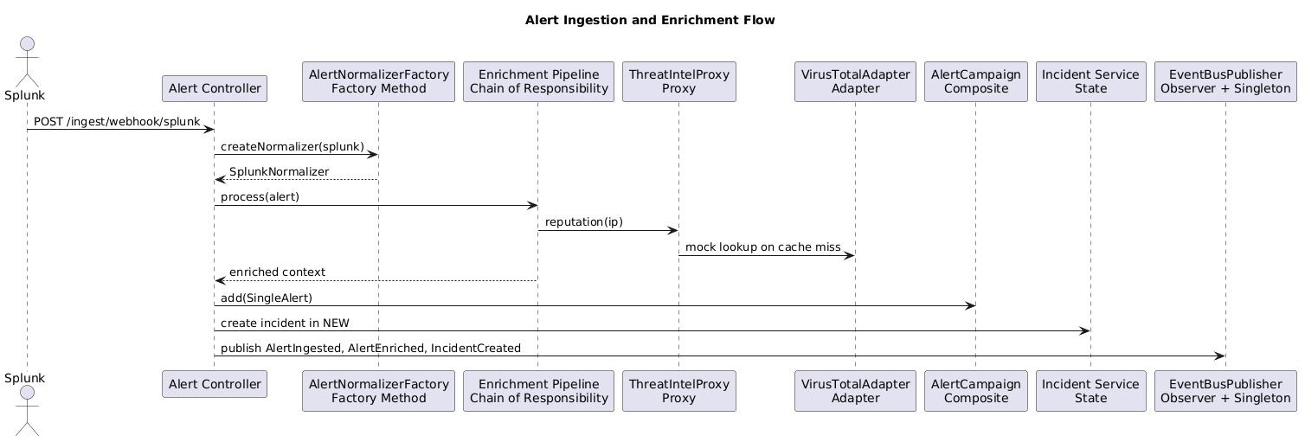
Figure 2. Alert ingestion sequence diagram.
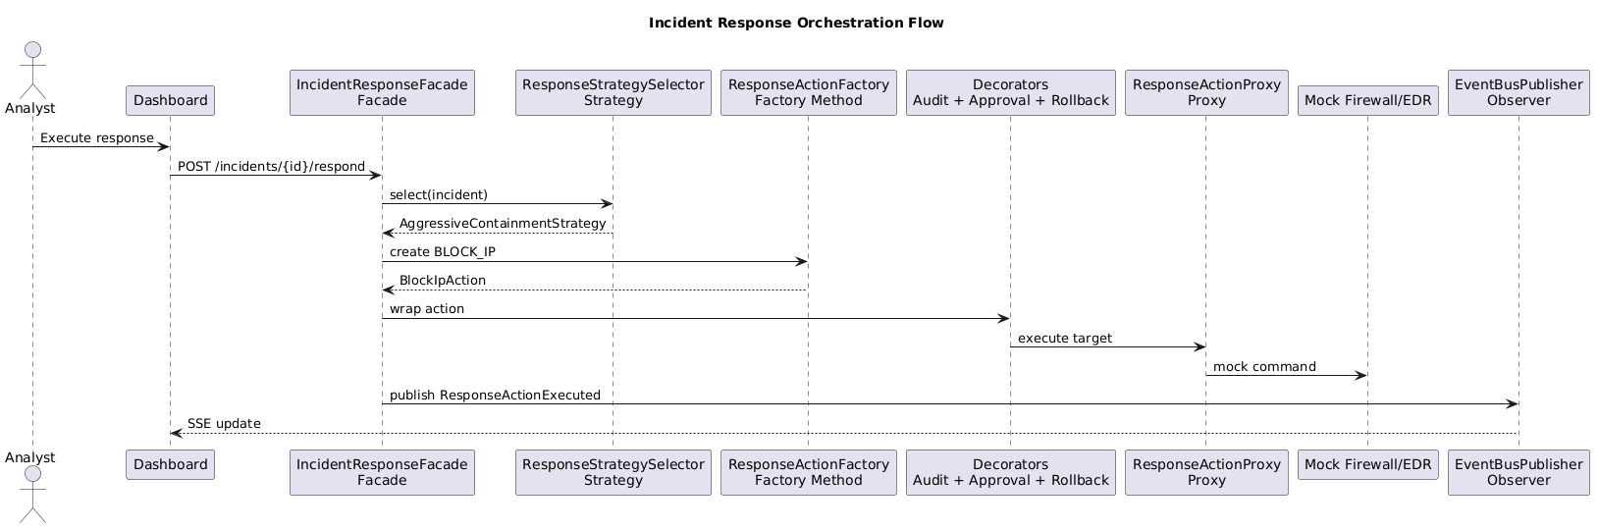
Figure 3. Incident response sequence diagram.

Frontend Screens
The frontend was modernized for demo readiness: authentication is separated from the dashboard, signup is present, logout is available, raw backend identifiers and integration keys are masked, and each operational panel has a clean SOC-style layout.
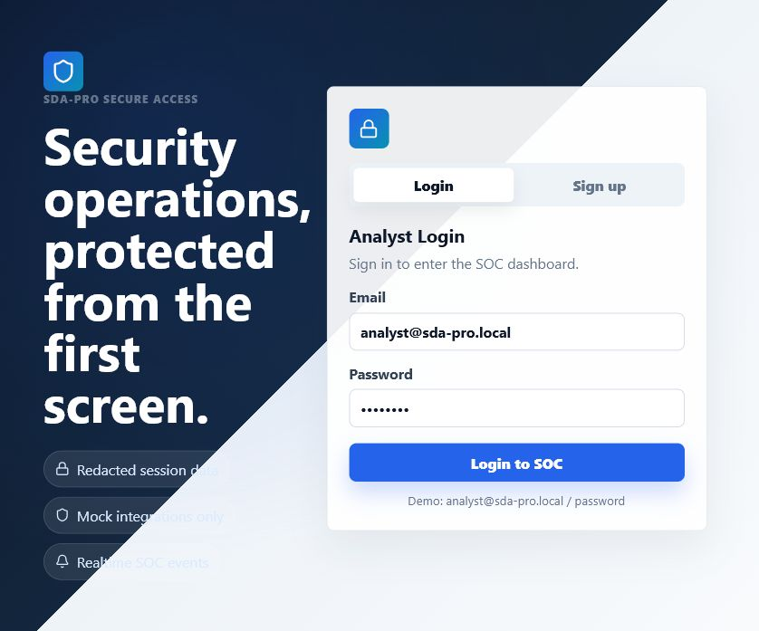
Figure 4. Login screen.
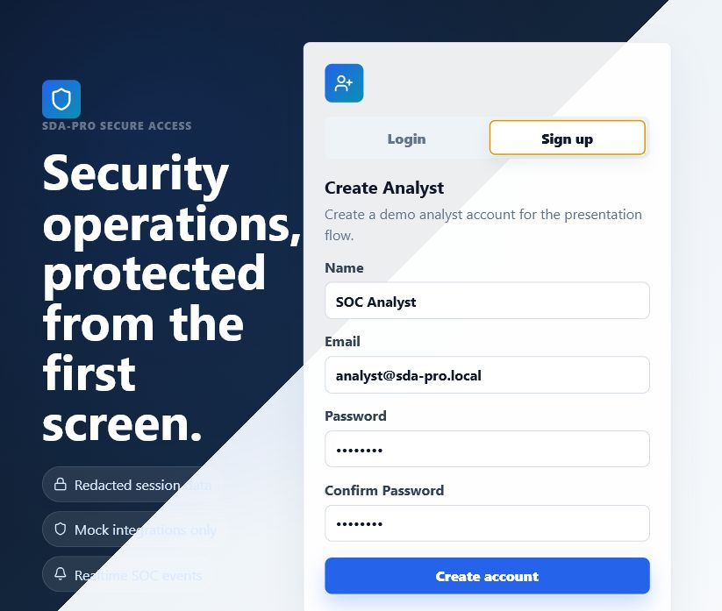
Figure 5. Signup screen.
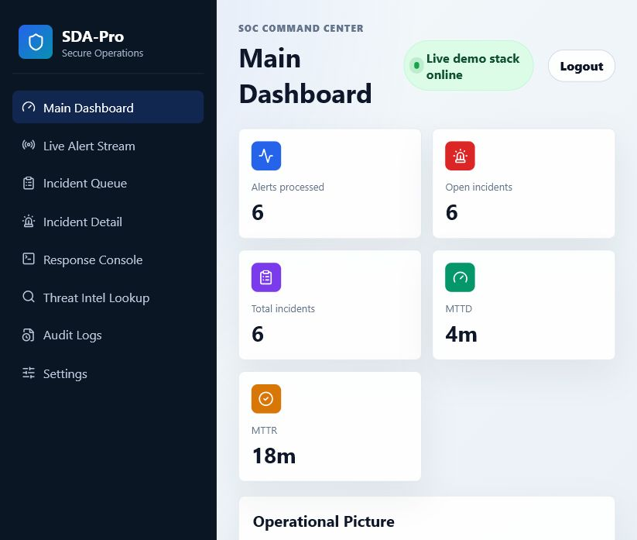
Figure 6. Main dashboard.
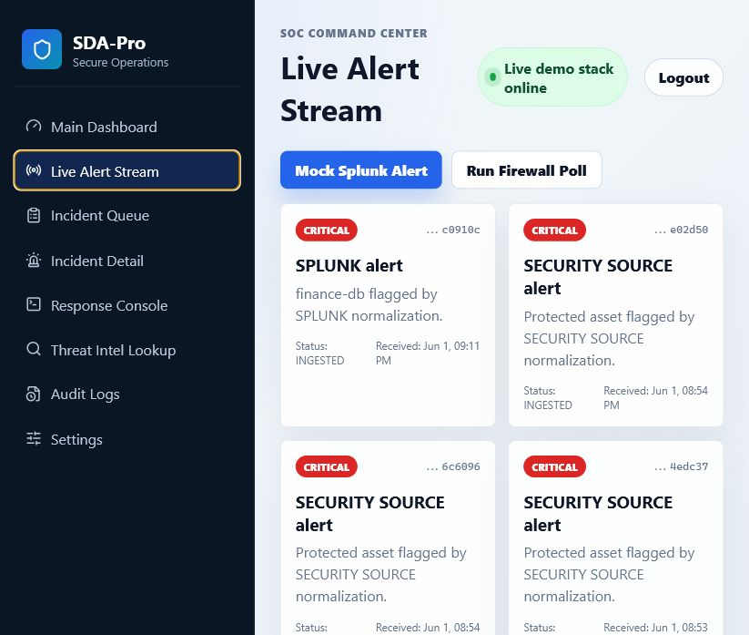
Figure 7. Live alert stream.
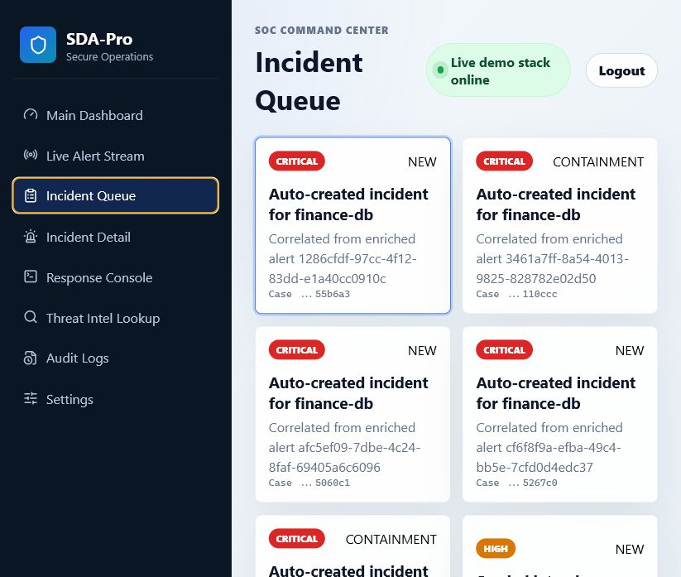
Figure 8. Incident queue.
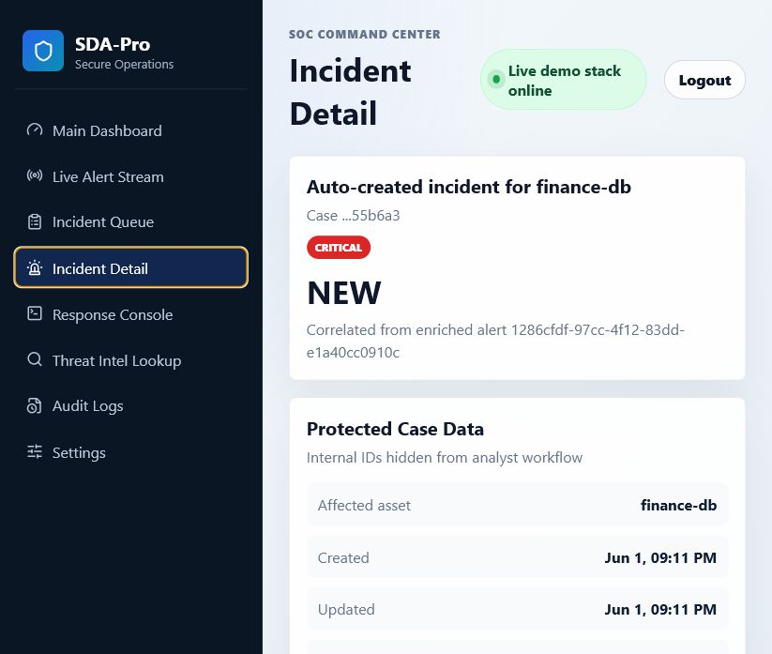
Figure 9. Incident detail.
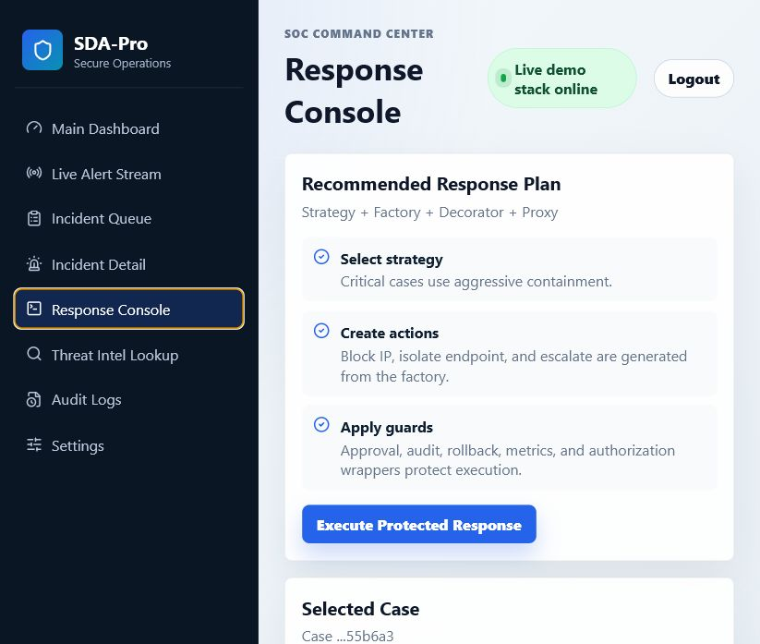
Figure 10. Response console.
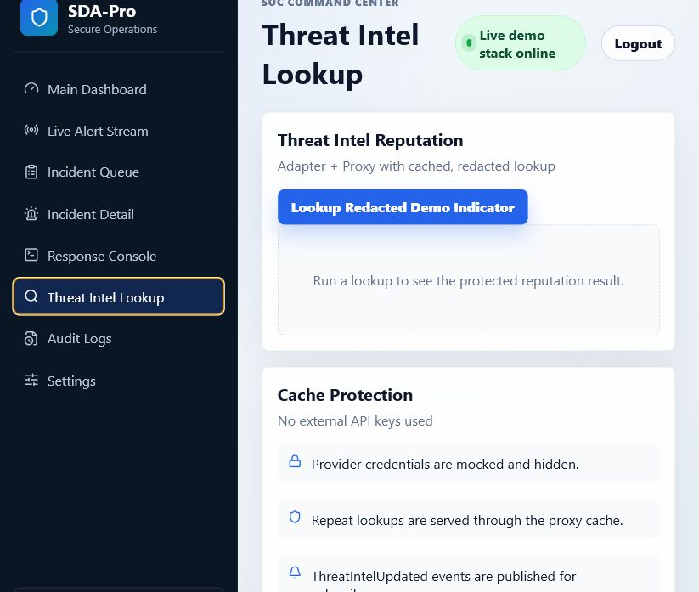
Figure 11. Threat intel lookup.
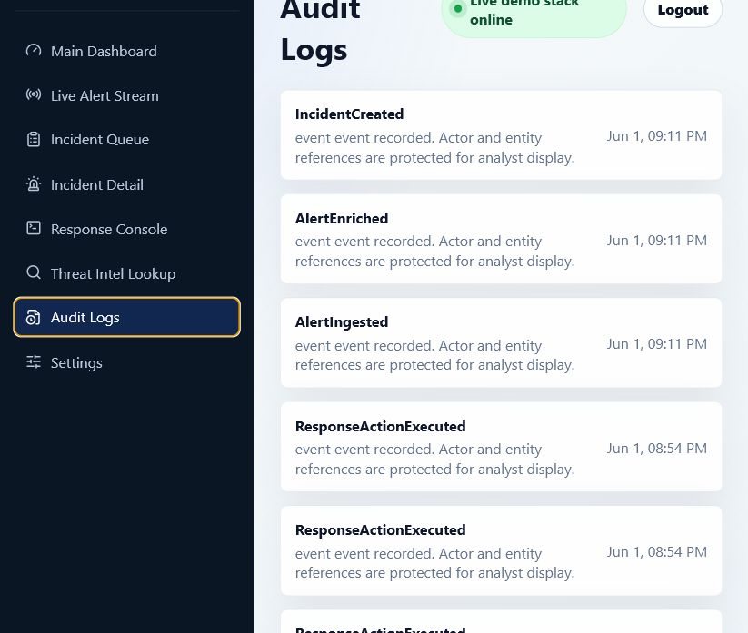
Figure 12. Audit logs.
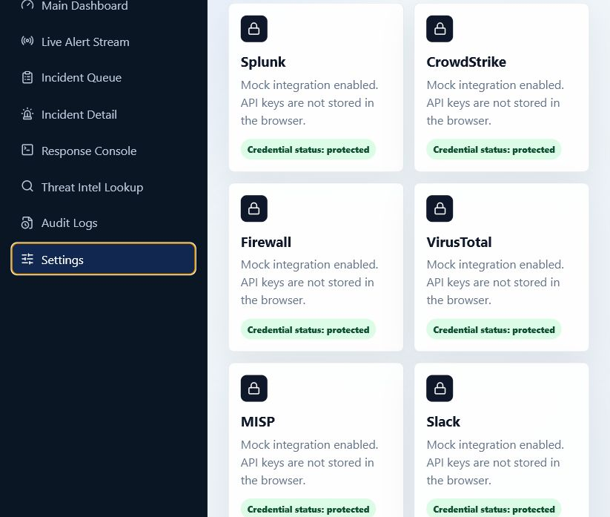
Figure 13. Settings.

Design Pattern Mapping
Pattern | Implementation Evidence | Rationale
Singleton | IngestionConfigManager, EventBusPublisher | One shared configuration/event publishing component.
Factory Method | AlertNormalizerFactory, ResponseActionFactory | Create normalizers/actions without controller coupling.
Abstract Factory | EnrichmentProviderFactory, NotificationFactory | Create related provider families for mock integrations.
Composite | AlertComponent | Group alerts and individual alerts under a common interface.
Facade | IncidentResponseFacade | Simplify response orchestration into one use-case entry point.
Adapter | ThreatAdapters | Wrap mock VirusTotal/MISP style APIs behind one interface.
Decorator | Decorators | Add audit/logging/approval behavior around response action execution.
Proxy | ThreatIntelProxy, ResponseActionProxy | Cache lookups and simulate approval/rate-limit control.
State | IncidentState | Incident behavior changes by lifecycle phase.
Chain of Responsibility | EnrichmentHandler | Run enrichment handlers in sequence.
Observer | EventBusPublisher | Publish domain events to subscribers/dashboard.
Strategy | ResponseStrategy | Select response behavior by incident severity/context.

Code annotation proof extracted from the repository:
﻿C:\Users\HP\Desktop\SDA Project\services\alert-ingestion-service\src\main\java\edu\sdapro\domain\alert\AlertComponent.java:7: // PATTERN: Composite
C:\Users\HP\Desktop\SDA Project\services\alert-ingestion-service\src\main\java\edu\sdapro\domain\incident\IncidentState.java:5: // PATTERN: State
C:\Users\HP\Desktop\SDA Project\services\alert-ingestion-service\src\main\java\edu\sdapro\enrichment\EnrichmentHandler.java:7: // PATTERN: Chain of Responsibility
C:\Users\HP\Desktop\SDA Project\services\alert-ingestion-service\src\main\java\edu\sdapro\enrichment\EnrichmentProviderFactory.java:3: // PATTERN: Abstract Factory
C:\Users\HP\Desktop\SDA Project\services\alert-ingestion-service\src\main\java\edu\sdapro\events\EventBusPublisher.java:13: // PATTERN: Observer
C:\Users\HP\Desktop\SDA Project\services\alert-ingestion-service\src\main\java\edu\sdapro\events\EventBusPublisher.java:15: // PATTERN: Singleton
C:\Users\HP\Desktop\SDA Project\services\alert-ingestion-service\src\main\java\edu\sdapro\ingestion\AlertNormalizerFactory.java:5: // PATTERN: Factory Method
C:\Users\HP\Desktop\SDA Project\services\alert-ingestion-service\src\main\java\edu\sdapro\ingestion\IngestionConfigManager.java:5: // PATTERN: Singleton
C:\Users\HP\Desktop\SDA Project\services\alert-ingestion-service\src\main\java\edu\sdapro\notification\NotificationFactory.java:3: // PATTERN: Abstract Factory
C:\Users\HP\Desktop\SDA Project\services\alert-ingestion-service\src\main\java\edu\sdapro\response\Decorators.java:3: // PATTERN: Decorator
C:\Users\HP\Desktop\SDA Project\services\alert-ingestion-service\src\main\java\edu\sdapro\response\IncidentResponseFacade.java:11: // PATTERN: Facade
C:\Users\HP\Desktop\SDA Project\services\alert-ingestion-service\src\main\java\edu\sdapro\response\ResponseActionFactory.java:3: // PATTERN: Factory Method
C:\Users\HP\Desktop\SDA Project\services\alert-ingestion-service\src\main\java\edu\sdapro\response\ResponseActionProxy.java:3: // PATTERN: Proxy
C:\Users\HP\Desktop\SDA Project\services\alert-ingestion-service\src\main\java\edu\sdapro\response\ResponseStrategy.java:6: // PATTERN: Strategy
C:\Users\HP\Desktop\SDA Project\services\alert-ingestion-service\src\main\java\edu\sdapro\threat\ThreatAdapters.java:3: // PATTERN: Adapter
C:\Users\HP\Desktop\SDA Project\services\alert-ingestion-service\src\main\java\edu\sdapro\threat\ThreatIntelProxy.java:6: // PATTERN: Proxy
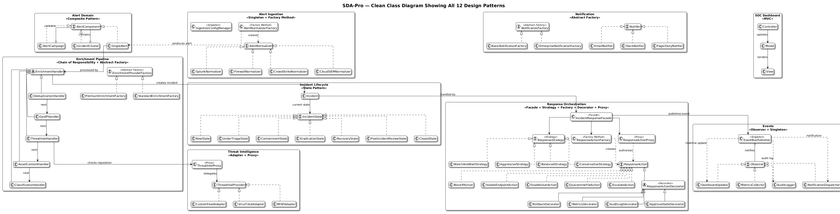
Figure 14. Class diagram showing all 12 design patterns.

Architecture Style Mapping
Architecture Style | Project Mapping
SOA | Documented service boundaries for ingestion, enrichment, incident, response, threat intel, notification, audit, identity, dashboard, and contracts.
MVC | Spring controllers expose APIs, services coordinate use cases, repositories persist data; React components render views from API state.
Layered Architecture | Controller/API layer, application/service layer, domain layer, integration/adapters layer, persistence layer, infrastructure layer.
Event-Driven Architecture | RabbitMQ/EventBus events for alert ingestion, enrichment, incident creation/state changes, response execution, notification, threat intel, and audit.

Backend Proof
The backend contains Java code for controllers, domain models, design patterns, repositories, events, security demo flows, mock integrations, tests, and Docker packaging.
- Java source files found: 39 in services/alert-ingestion-service/src/main/java.
- Test classes: AuditEventCreationTest, EndToEndDemoTest, PatternTests.
- OpenAPI contract: docs/api/openapi-sdapro.yaml.
- AsyncAPI event contract: docs/api/asyncapi-events.yaml.
- ADR decisions: five ADR markdown files under docs/adr.

Frontend Proof
The frontend implements the required login, dashboard, live alert stream, incident queue/detail, response console, threat intelligence lookup, audit logs, and settings views. It masks identifiers and avoids exposing raw integration secrets.

Docker and Runtime Proof
The Docker Desktop screenshot supplied by the student shows the sdaproject Compose stack running. The command-line proof below was captured from the same project and lists the active backend, frontend, database, cache, and broker containers.
﻿NAME IMAGE COMMAND SERVICE CREATED STATUS PORTS
sdaproject-alert-ingestion-service-1 sdaproject-alert-ingestion-service "java -jar app.jar" alert-ingestion-service 53 minutes ago Up 53 minutes 0.0.0.0:8080->8080/tcp, [::]:8080->8080/tcp
sdaproject-postgres-1 postgres:16-alpine "docker-entrypoint.s…" postgres 4 hours ago Up 54 minutes (healthy) 0.0.0.0:5432->5432/tcp, [::]:5432->5432/tcp
sdaproject-rabbitmq-1 rabbitmq:3-management-alpine "docker-entrypoint.s…" rabbitmq 4 hours ago Up 54 minutes 0.0.0.0:5672->5672/tcp, [::]:5672->5672/tcp, 0.0.0.0:15672->15672/tcp, [::]:15672->15672/tcp
sdaproject-redis-1 redis:7-alpine "docker-entrypoint.s…" redis 4 hours ago Up 54 minutes 0.0.0.0:6379->6379/tcp, [::]:6379->6379/tcp
sdaproject-soc-dashboard-1 sdaproject-soc-dashboard "docker-entrypoint.s…" soc-dashboard 53 minutes ago Up 53 minutes 0.0.0.0:5173->5173/tcp, [::]:5173->5173/tcp

API Response Proof
Dashboard metrics API response:
﻿{
"alerts": 6,
"openIncidents": 6,
"mttr": "18m",
"incidents": 6,
"mttd": "4m"
}
Threat intelligence lookup API response:
﻿{
"indicator": "203.0.113.10",
"score": 92,
"verdict": "MALICIOUS",
"provider": "VirusTotalMock"
}

Testing Evidence
Implemented test coverage includes normalizer factory, enrichment chain, incident state transitions, response strategy selection, threat intel proxy cache, audit event creation, and an end-to-end demo test.
﻿-------------------------------------------------------------------------------
Test set: edu.sdapro.AuditEventCreationTest
-------------------------------------------------------------------------------
Tests run: 1, Failures: 0, Errors: 0, Skipped: 0, Time elapsed: 7.993 s -- in edu.sdapro.AuditEventCreationTest
-------------------------------------------------------------------------------
Test set: edu.sdapro.EndToEndDemoTest
-------------------------------------------------------------------------------
Tests run: 1, Failures: 0, Errors: 0, Skipped: 0, Time elapsed: 33.61 s -- in edu.sdapro.EndToEndDemoTest
-------------------------------------------------------------------------------
Test set: edu.sdapro.PatternTests
-------------------------------------------------------------------------------
Tests run: 5, Failures: 0, Errors: 0, Skipped: 0, Time elapsed: 0.224 s -- in edu.sdapro.PatternTests

Required Documentation Evidence
Required Artifact | Location
README with setup/demo instructions | README.md
Docker Compose | docker-compose.yml
ADR-001 SOA vs Microservices vs Modular Monolith | docs/adr/ADR-001-soa-vs-microservices-vs-modular-monolith.md
ADR-002 Sync vs Async Communication | docs/adr/ADR-002-sync-vs-async-communication.md
ADR-003 Database Strategy | docs/adr/ADR-003-database-strategy.md
ADR-004 Threat Intel Cache Strategy | docs/adr/ADR-004-threat-intel-cache-strategy.md
ADR-005 Real-time Push Strategy | docs/adr/ADR-005-real-time-push-strategy.md
PlantUML class/component/sequence diagrams | docs/plantuml codes and docs/uml diagrams
OpenAPI and AsyncAPI | docs/api

Known Scope and Limitations
- External integrations are mocked by requirement; no real Splunk, CrowdStrike, Firewall, VirusTotal, MISP, Slack, PagerDuty, Email, or Active Directory keys are used.
- The implementation is demo-ready for SDA marking and local presentation, not hardened for production cybersecurity operations.
- Service boundaries are architecture/documentation boundaries inside a reliable local demo build, rather than independently deployed microservice artifacts for every named service.

Conclusion
The project satisfies the requested SDA-Pro deliverables: complete stack, required services, required APIs, required events, database schema, modern frontend screens, all 12 design patterns with code annotations, all 4 architecture styles, UML diagrams, ADR documentation, Docker Compose execution, seeded demo data, and automated tests.

