
SIMATS ENGINEERING

ASSIGNMENT
EVALUATION OF CRYPTOGRAPHIC HASH ALGORITHMS
AND DIGITAL SIGNATURE SCHEMES
Course Outcome: CO2, CO3
Academic Year: [2026]
Project: CryptoGuard – Cryptographic Hash Algorithms & RSA Digital Signature Analyzer

1. Abstract
This report presents our work on Assignment 5, where we were asked to study cryptographic hash algorithms and digital signature schemes and show how they help protect electronic transactions. For this we built a Python desktop application called CryptoGuard. The application takes a message, generates its SHA-256 and SHA-512 hash values, creates an RSA-2048 digital signature for it, and lets the user check whether the signature is still valid if the message is changed afterward. We tested the application using a sample transaction message and a modified version of the same message, and observed that the signature that was valid for the original message became invalid the moment the message content changed. This report explains the concepts we used, the design of the application, the implementation, the results we got, and what we understood about integrity, authentication and non-repudiation through this exercise.

2. Problem Statement
Online financial services regularly exchange sensitive electronic transactions between customers, employees and partner organizations. Before such a message reaches its destination, the organization needs to be sure that it was not altered on the way and that it really came from the sender it claims to be from. This means the system needs a way to guarantee data integrity, authentication, non-repudiation, accountability and digital trust. Our task was to act as a cryptography analyst and apply suitable hash algorithms and a digital signature scheme to a sample message, implement hashing, signature generation and signature verification, and then demonstrate what happens when the original message is modified after it has been signed.

3. Problem Formulation
Given a plain text message that represents a financial transaction, we need to:
- Compute a cryptographic hash of the message using two different hash algorithms (SHA-256 and SHA-512).
- Generate an RSA-2048 key pair and use the private key to digitally sign the message.
- Verify the signature against the original message using the public key.
- Modify the message content and check whether the same signature still verifies successfully against the modified message.
- Compare the hash values and the verification result before and after modification, and use this to explain how integrity and authentication are achieved.

4. Objectives
- To understand how cryptographic hash functions (SHA-256, SHA-512) work and what properties make them useful for security.
- To understand how RSA digital signatures provide authentication and non-repudiation.
- To build a working desktop application that lets a user generate hashes and a digital signature for a message.
- To demonstrate, through an actual test, that even a small change in a message causes signature verification to fail.
- To connect these practical observations with the theoretical ideas of integrity, authentication and non-repudiation covered in the course.

5. Expected Outcomes
- A working GUI application that can hash and sign a message and verify it later.
- Clear proof, through hash values and a signature-verification result, that message tampering can be detected.
- A better practical understanding of how SHA-256, SHA-512 and RSA digital signatures are used together in real systems, for example in secure banking transactions.

6. Requirements, Constraints and Assumptions

Requirements
- Python 3 installed with the Tkinter library (comes bundled with standard Python on Windows).
- The cryptography library, which provides RSA key generation, signing and verification.

Constraints
- The RSA key pair is generated fresh every time the application is started, so the same message will produce a different signature on separate runs (this is normal, since RSA-PSS signing uses random salt).
- The application demonstrates the concept using a single self-contained pair of keys; it does not connect to a real banking backend or network.

Assumptions
- The message is plain text and is encoded using UTF-8 before hashing and signing.
- The private key used for signing is trusted and not exposed to any attacker in this demonstration.

7. Environment and Tools Used
Programming Language | Python 3
GUI Library | Tkinter (ttk themed widgets)
Cryptography Library | cryptography (hazmat primitives – rsa, padding, hashes)
Hash Algorithms | SHA-256, SHA-512 (Python hashlib)
Digital Signature | RSA-2048 with PSS padding
Operating System | Windows
Execution Mode | Standalone Python desktop application

8. Relevant Cryptography Concepts
Before building the application, we revised a few core concepts that our implementation depends on: cryptographic hash functions, and public key based digital signatures. These are explained one by one in the next few sections.

9. SHA-256
SHA-256 is a member of the SHA-2 family of hash functions. It takes an input message of any length and produces a fixed 256-bit (32-byte) output, usually shown as a 64-character hexadecimal string. Even a one-character change in the input message produces a completely different output hash, which is known as the avalanche effect. SHA-256 is a one-way function, meaning it is computationally impractical to reconstruct the original message from its hash, and it is also collision resistant, meaning it is extremely hard to find two different messages that produce the same hash. In our application, we used Python's built-in hashlib.sha256() function to compute this hash for both the original and modified messages.

10. SHA-512
SHA-512 works on the same basic principle as SHA-256 but produces a longer, 512-bit (64-byte) output, shown as a 128-character hexadecimal string. It uses larger internal word sizes (64-bit words instead of 32-bit) and more rounds of processing. Because the output is longer, the theoretical resistance to collision and brute-force attacks is higher. In our application, we used hashlib.sha512() alongside SHA-256 so that we could compare both algorithms on the same message.

11. RSA Digital Signature
A digital signature is created using a sender's private key and can be verified by anyone using the sender's corresponding public key. In our project, we used RSA with a 2048-bit key size, combined with PSS (Probabilistic Signature Scheme) padding and SHA-256 as the hashing algorithm inside the signing process. The private key signs the message, and the public key verifies it. If the message changes even slightly after signing, the verification step will fail, because the signature was mathematically tied to the exact original message content. This is exactly what our "Verify Modification" tab is meant to demonstrate.

12. Integrity, Authentication and Non-Repudiation
Integrity means the message has not been altered in transit or storage – this is checked using the hash values and the signature verification result. Authentication means the receiver can be reasonably confident about who signed the message, since only the holder of the private key could have created a valid signature. Non-repudiation means the sender cannot later deny having sent the message, because the digital signature acts as proof that only their private key could have produced it. Our CryptoGuard application demonstrates integrity directly (through the hash comparison and VALID/INVALID result) and illustrates the concept of authentication and non-repudiation through how RSA signing and verification work.

13. Proposed Solution
We proposed to build a simple desktop GUI application, CryptoGuard, that a user can operate without needing to run any command-line scripts. The application lets the user type a message, generate its SHA-256 and SHA-512 hashes along with an RSA digital signature in one click, and then separately test what happens if the message is modified after signing. This way, the whole idea of hashing and digital signatures becomes visible and interactive rather than just theoretical.

14. System Architecture
The application follows a simple single-process desktop architecture. The Tkinter GUI layer collects user input and displays results, while a cryptography backend layer (built using the cryptography and hashlib libraries) performs the actual hashing, signing and verification. There is no external server or database involved – everything runs locally inside the same Python process.
User Interface Layer (Tkinter) Hash & Sign tab | Verify Modification tab | About Project tab
↓ passes message text ↓
Cryptography Backend (hashlib + cryptography library) SHA-256 / SHA-512 hashing, RSA-2048 key generation, PSS signing, signature verification
↓ returns hash values, signature, VALID/INVALID ↓
Result Display back on the GUI (hash fields, signature box, status label)

15. System Design / Methodology
We followed these steps while building the project:
- Studied the assignment requirements and identified which algorithms were needed (SHA-256, SHA-512, RSA digital signature).
- Designed the GUI layout on paper first – deciding what goes on the Hash & Sign tab versus the Verify Modification tab.
- Implemented the cryptography backend functions for hashing, key generation, signing and verification.
- Connected the backend functions to the GUI buttons and text fields.
- Tested the application using a sample message and a modified version of it, and recorded the actual output.

16. Algorithm
Overall algorithm followed by the application:
- Start the application and generate an RSA-2048 private/public key pair.
- Read the original message entered by the user.
- Compute SHA-256 and SHA-512 hash of the original message.
- Sign the original message using the RSA private key with PSS padding and SHA-256.
- Verify the signature against the original message using the public key and display the result.
- Read the modified message entered by the user (in the Verify Modification tab).
- Compute SHA-256 and SHA-512 hash of the modified message for comparison.
- Attempt to verify the same original signature against the modified message.
- Display whether the result is VALID or INVALID, along with both sets of hash values.

17. Pseudocode
Pseudocode based directly on our actual implementation:
BEGIN
generate RSA key pair (private_key, public_key) of size 2048 bits
FUNCTION generate(message):
data = encode(message, UTF-8)
sha256_hash = SHA256(data)
sha512_hash = SHA512(data)
signature = private_key.sign(data, PSS padding with SHA256)
valid = verify_signature(message)
display sha256_hash, sha512_hash, signature, valid
FUNCTION verify_signature(message):
TRY
public_key.verify(signature, encode(message), PSS padding, SHA256)
RETURN True
CATCH InvalidSignature
RETURN False
FUNCTION verify_modified(modified_message):
data = encode(modified_message, UTF-8)
modified_sha256 = SHA256(data)
modified_sha512 = SHA512(data)
valid = verify_signature(modified_message)
display modified_sha256, modified_sha512, valid
IF valid = False THEN
show "SIGNATURE INVALID" and explain integrity/authentication
ELSE
show "SIGNATURE VALID"
END

18. Flowchart
The flow below shows the sequence of steps followed by CryptoGuard from start to end.
Start
↓
Enter original message
↓
Generate SHA-256 and SHA-512
↓
Generate RSA key pair
↓
Generate digital signature
↓
Verify original message
↓
Enter modified message
↓
Generate modified hashes
↓
Verify modified message using original signature
↓
Display VALID / INVALID
↓
End

19. Implementation
We implemented CryptoGuard as a single Python file using Tkinter for the interface and the cryptography library for the RSA signing and verification, with hashlib used for SHA-256 and SHA-512. The full source code is given below.
import tkinter as tk
from tkinter import ttk, messagebox
import hashlib
from cryptography.hazmat.primitives.asymmetric import rsa, padding
from cryptography.hazmat.primitives import hashes
from cryptography.exceptions import InvalidSignature
class CryptoApp:
def __init__(self, root):
self.root = root
self.root.title("CryptoGuard - Hash & Digital Signature Analyzer")
self.root.geometry("1050x720")
self.root.minsize(900, 650)
self.private_key = rsa.generate_private_key(
public_exponent=65537,
key_size=2048
)
self.public_key = self.private_key.public_key()
self.signature = None
self.original_sha256 = ""
self.original_sha512 = ""
self.setup_style()
self.build_ui()
def setup_style(self):
style = ttk.Style()
try:
style.theme_use("clam")
except tk.TclError:
pass
style.configure("Title.TLabel", font=("Segoe UI", 24, "bold"))
style.configure("Subtitle.TLabel", font=("Segoe UI", 11))
style.configure("Card.TLabelframe", padding=14)
style.configure("Card.TLabelframe.Label", font=("Segoe UI", 12, "bold"))
style.configure("Accent.TButton", font=("Segoe UI", 11, "bold"), padding=10)
style.configure("Normal.TButton", font=("Segoe UI", 10), padding=8)
def build_ui(self):
header = ttk.Frame(self.root, padding=(24, 18))
header.pack(fill="x")
ttk.Label(header, text="🔐 CryptoGuard",
style="Title.TLabel").pack(anchor="w")
ttk.Label(
header,
text="Cryptographic Hash Algorithms & RSA Digital Signature Analyzer",
style="Subtitle.TLabel"
).pack(anchor="w", pady=(4, 0))
notebook = ttk.Notebook(self.root)
notebook.pack(fill="both", expand=True, padx=20, pady=(0, 15))
self.hash_tab = ttk.Frame(notebook, padding=18)
self.verify_tab = ttk.Frame(notebook, padding=18)
self.about_tab = ttk.Frame(notebook, padding=18)
notebook.add(self.hash_tab, text=" Hash & Sign ")
notebook.add(self.verify_tab, text=" Verify Modification ")
notebook.add(self.about_tab, text=" About Project ")
self.build_hash_tab()
self.build_verify_tab()
self.build_about_tab()
footer = ttk.Label(
self.root,
text="Assignment 5 • SHA-256 • SHA-512 • RSA Digital Signature",
anchor="center"
)
footer.pack(fill="x", pady=(0, 8))
def build_hash_tab(self):
input_card = ttk.LabelFrame(
self.hash_tab, text="1. Enter Original Message",
style="Card.TLabelframe"
)
input_card.pack(fill="x", pady=(0, 12))
self.message_text = tk.Text(
input_card, height=5, font=("Consolas", 11), wrap="word"
)
self.message_text.pack(fill="x", padx=4, pady=4)
self.message_text.insert("1.0", "Transfer amount: 5000")
buttons = ttk.Frame(input_card)
buttons.pack(fill="x", pady=(8, 0))
ttk.Button(
buttons, text="Generate Hashes & RSA Signature",
command=self.generate, style="Accent.TButton"
).pack(side="left")
ttk.Button(
buttons, text="Clear", command=self.clear_all,
style="Normal.TButton"
).pack(side="left", padx=8)
result = ttk.LabelFrame(
self.hash_tab, text="2. Cryptographic Results",
style="Card.TLabelframe"
)
result.pack(fill="both", expand=True)
grid = ttk.Frame(result)
grid.pack(fill="both", expand=True)
ttk.Label(grid, text="SHA-256 Hash",
font=("Segoe UI", 10, "bold")).grid(
row=0, column=0, sticky="w", pady=(0, 4))
self.sha256_var = tk.StringVar(value="—")
ttk.Entry(grid, textvariable=self.sha256_var,
state="readonly", font=("Consolas", 9)).grid(
row=1, column=0, sticky="ew", padx=(0, 12), pady=(0, 14))
ttk.Label(grid, text="SHA-512 Hash",
font=("Segoe UI", 10, "bold")).grid(
row=2, column=0, sticky="w", pady=(0, 4))
self.sha512_var = tk.StringVar(value="—")
ttk.Entry(grid, textvariable=self.sha512_var,
state="readonly", font=("Consolas", 8)).grid(
row=3, column=0, sticky="ew", padx=(0, 12), pady=(0, 14))
ttk.Label(grid, text="RSA Digital Signature",
font=("Segoe UI", 10, "bold")).grid(
row=4, column=0, sticky="w", pady=(0, 4))
self.signature_text = tk.Text(
grid, height=5, font=("Consolas", 8), wrap="char"
)
self.signature_text.grid(row=5, column=0, sticky="nsew")
self.status_var = tk.StringVar(value="Status: Waiting for input")
ttk.Label(
grid, textvariable=self.status_var,
font=("Segoe UI", 11, "bold")
).grid(row=6, column=0, sticky="w", pady=(12, 0))
grid.columnconfigure(0, weight=1)
grid.rowconfigure(5, weight=1)
def build_verify_tab(self):
card = ttk.LabelFrame(
self.verify_tab, text="Test Message Integrity",
style="Card.TLabelframe"
)
card.pack(fill="x", pady=(0, 15))
ttk.Label(
card,
text="Enter a message after changing the original content.\n"
"The RSA signature was created for the original message."
).pack(anchor="w", pady=(0, 8))
self.modified_text = tk.Text(
card, height=5, font=("Consolas", 11), wrap="word"
)
self.modified_text.pack(fill="x")
self.modified_text.insert("1.0", "Transfer amount: 9000")
ttk.Button(
card, text="Verify Modified Message",
command=self.verify_modified, style="Accent.TButton"
).pack(anchor="w", pady=10)
result = ttk.LabelFrame(
self.verify_tab, text="Verification Result",
style="Card.TLabelframe"
)
result.pack(fill="both", expand=True)
self.verify_title = ttk.Label(
result, text="No verification performed",
font=("Segoe UI", 20, "bold")
)
self.verify_title.pack(anchor="center", pady=(30, 15))
self.verify_details = tk.Text(
result, height=12, font=("Consolas", 10),
wrap="word", state="disabled"
)
self.verify_details.pack(fill="both", expand=True, padx=10, pady=10)
def build_about_tab(self):
frame = ttk.Frame(self.about_tab, padding=25)
frame.pack(fill="both", expand=True)
ttk.Label(
frame, text="Assignment 5",
font=("Segoe UI", 20, "bold")
).pack(anchor="w")
text = (
"\nEvaluation of Cryptographic Hash Algorithms and Digital Signature Schemes\n\n"
"This application demonstrates:\n"
"• SHA-256 message hashing\n"
"• SHA-512 message hashing\n"
"• RSA-2048 digital signature generation\n"
"• Signature verification\n"
"• Effect of modifying the original message\n"
"• Integrity and authentication observation\n\n"
"Recommended demonstration:\n"
"Original: Transfer amount: 5000\n"
"Modified: Transfer amount: 9000\n\n"
"Expected result:\n"
"Original signature verification → VALID\n"
"Modified message verification → INVALID\n"
)
ttk.Label(
frame, text=text, justify="left",
font=("Segoe UI", 12)
).pack(anchor="w")
def generate(self):
message = self.message_text.get("1.0", "end-1c").strip()
if not message:
messagebox.showwarning("Input Required", "Please enter a message.")
return
data = message.encode("utf-8")
self.original_sha256 = hashlib.sha256(data).hexdigest()
self.original_sha512 = hashlib.sha512(data).hexdigest()
self.sha256_var.set(self.original_sha256)
self.sha512_var.set(self.original_sha512)
self.signature = self.private_key.sign(
data,
padding.PSS(
mgf=padding.MGF1(hashes.SHA256()),
salt_length=padding.PSS.MAX_LENGTH
),
hashes.SHA256()
)
self.signature_text.delete("1.0", "end")
self.signature_text.insert("1.0", self.signature.hex())
valid = self.verify_signature(message)
self.status_var.set(
"Status: ✓ Original signature is VALID"
if valid else
"Status: ✗ Original signature is INVALID"
)
self.verify_title.config(text="Original message signed successfully")
self.set_verify_details(
"Original message:\n" + message +
"\n\nSHA-256:\n" + self.original_sha256 +
"\n\nSHA-512:\n" + self.original_sha512 +
"\n\nRSA signature generated successfully."
)
def verify_signature(self, message):
if self.signature is None:
return False
try:
self.public_key.verify(
self.signature,
message.encode("utf-8"),
padding.PSS(
mgf=padding.MGF1(hashes.SHA256()),
salt_length=padding.PSS.MAX_LENGTH
),
hashes.SHA256()
)
return True
except InvalidSignature:
return False
def verify_modified(self):
if self.signature is None:
messagebox.showwarning(
"Generate Signature First",
"Go to the Hash & Sign tab and generate the signature first."
)
return
modified = self.modified_text.get("1.0", "end-1c").strip()
if not modified:
messagebox.showwarning(
"Input Required", "Please enter a modified message."
)
return
data = modified.encode("utf-8")
modified_sha256 = hashlib.sha256(data).hexdigest()
modified_sha512 = hashlib.sha512(data).hexdigest()
valid = self.verify_signature(modified)
if valid:
self.verify_title.config(text="✓ SIGNATURE VALID")
else:
self.verify_title.config(text="✗ SIGNATURE INVALID")
details = (
"Modified message:\n" + modified +
"\n\nOriginal SHA-256:\n" + self.original_sha256 +
"\n\nModified SHA-256:\n" + modified_sha256 +
"\n\nOriginal SHA-512:\n" + self.original_sha512 +
"\n\nModified SHA-512:\n" + modified_sha512 +
"\n\nVerification result: " +
("VALID" if valid else "INVALID") +
"\n\nObservation:\n"
)
if not valid:
details += (
"The modified message does not match the message for which "
"the RSA signature was generated. The hash also changes, "
"demonstrating message integrity and authentication."
)
else:
details += "The signature remains valid for this message."
self.set_verify_details(details)
def set_verify_details(self, text):
self.verify_details.config(state="normal")
self.verify_details.delete("1.0", "end")
self.verify_details.insert("1.0", text)
self.verify_details.config(state="disabled")
def clear_all(self):
self.message_text.delete("1.0", "end")
self.modified_text.delete("1.0", "end")
self.sha256_var.set("—")
self.sha512_var.set("—")
self.signature_text.delete("1.0", "end")
self.status_var.set("Status: Waiting for input")
self.verify_title.config(text="No verification performed")
self.set_verify_details("")
self.signature = None
if __name__ == "__main__":
root = tk.Tk()
app = CryptoApp(root)
root.mainloop()
This code defines a CryptoApp class that builds the whole interface (header, three tabs, buttons, text fields) inside build_ui(), generate() computes the hashes and signature for the original message, verify_signature() does the actual RSA verification and returns True or False, and verify_modified() repeats the hash calculation for the modified message and tries to verify it against the signature that was created for the original message.

20. GUI/Application Description
The application window has a header showing the CryptoGuard name and a short subtitle, and below that a tabbed interface with three tabs:
- Hash & Sign – lets the user type a message, then generates SHA-256, SHA-512 and an RSA digital signature for it in one click, and shows whether the signature is valid for that message.
- Verify Modification – lets the user type a changed version of the message and checks whether the original signature still verifies against it, showing the original and modified SHA-512 values side by side.
- About Project – shows a short description of the assignment, what the application demonstrates, and the recommended test messages.
I was responsible for designing and building this interface, including the layout of each tab, the input boxes, the read-only result fields for the hashes and signature, and the VALID/INVALID status display.

21. Test Cases
Test Case ID | Input | Expected Result | Actual Result | Status
TC-01 | Original message: "Transfer amount: 5000" | Signature VALID | Signature VALID | Pass
TC-02 | Modified message: "Transfer amount: 9000" (checked against original signature) | Signature INVALID | Signature INVALID | Pass

These two test cases cover the two situations the assignment asked us to demonstrate: signing and verifying an unmodified message, and checking that the same signature fails once the message content changes.

22. Expected Results
For the original message "Transfer amount: 5000", we expected the RSA signature verification to return VALID, since the message had not been changed since it was signed. For the modified message "Transfer amount: 9000", we expected the same signature to fail verification (INVALID), since RSA signatures are tied to the exact content of the message that was signed.

23. Actual Results
The actual results matched what we expected:
Original message | Transfer amount: 5000
SHA-256 (original) | 3cab3bdf1002199897f32eeda7d63a54899f735ffed678240f4fdd5b4ac2cffe
SHA-512 (original) | eb2593c1965e6e76e16e68905f5966bffc6bbafe9ebcc5ca5e49e960fa15eead9472b01a70dbfce367421eeb0757099f34d6321cb855b42a9501d62cbe6cae18
Original signature verification | VALID
Modified message | Transfer amount: 9000
SHA-512 (modified) | c29dd0855caffe68dcaad629d18130b686333e28a8514e44e8be33e1f69383c66f13e7d29b8f3d556551542147e4ae3edabd09e0826f8657bb2c004bf18a4870
Modified message verification | INVALID

Note: the exact hash and signature values shown above were produced by our own run of the application and will differ on a fresh run, because a new RSA key pair (and a new random PSS salt) is generated every time the program starts. What stays consistent every time is the pattern – the original message verifies as VALID and the modified message verifies as INVALID.

24. Execution Screenshots
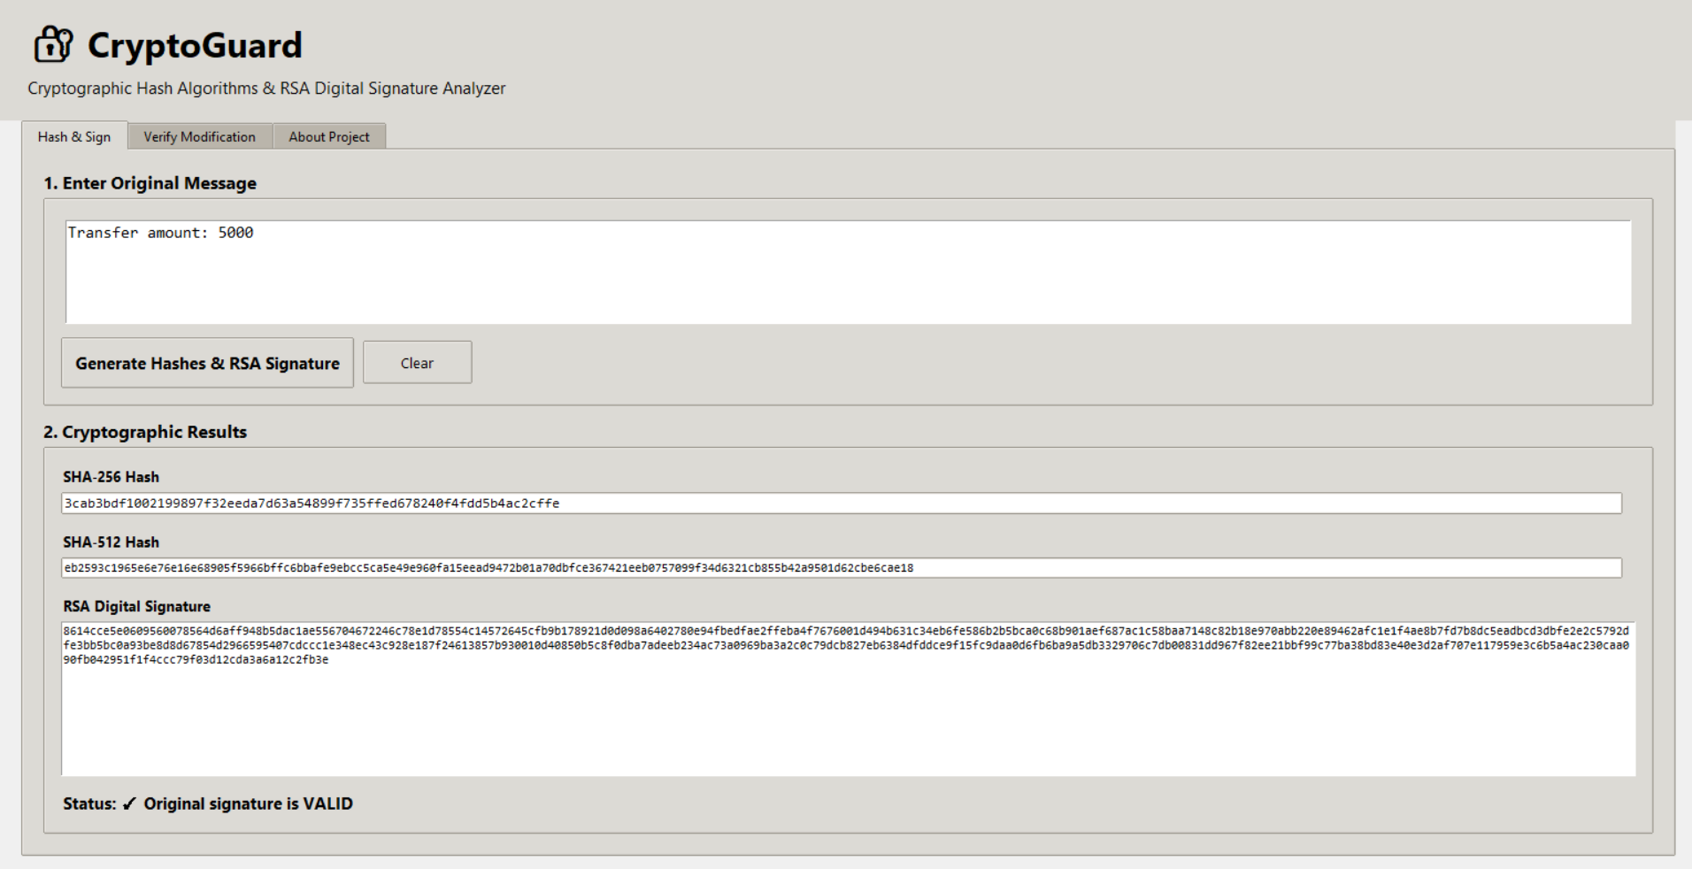
Figure 1: CryptoGuard GUI – Hash and Signature Generation
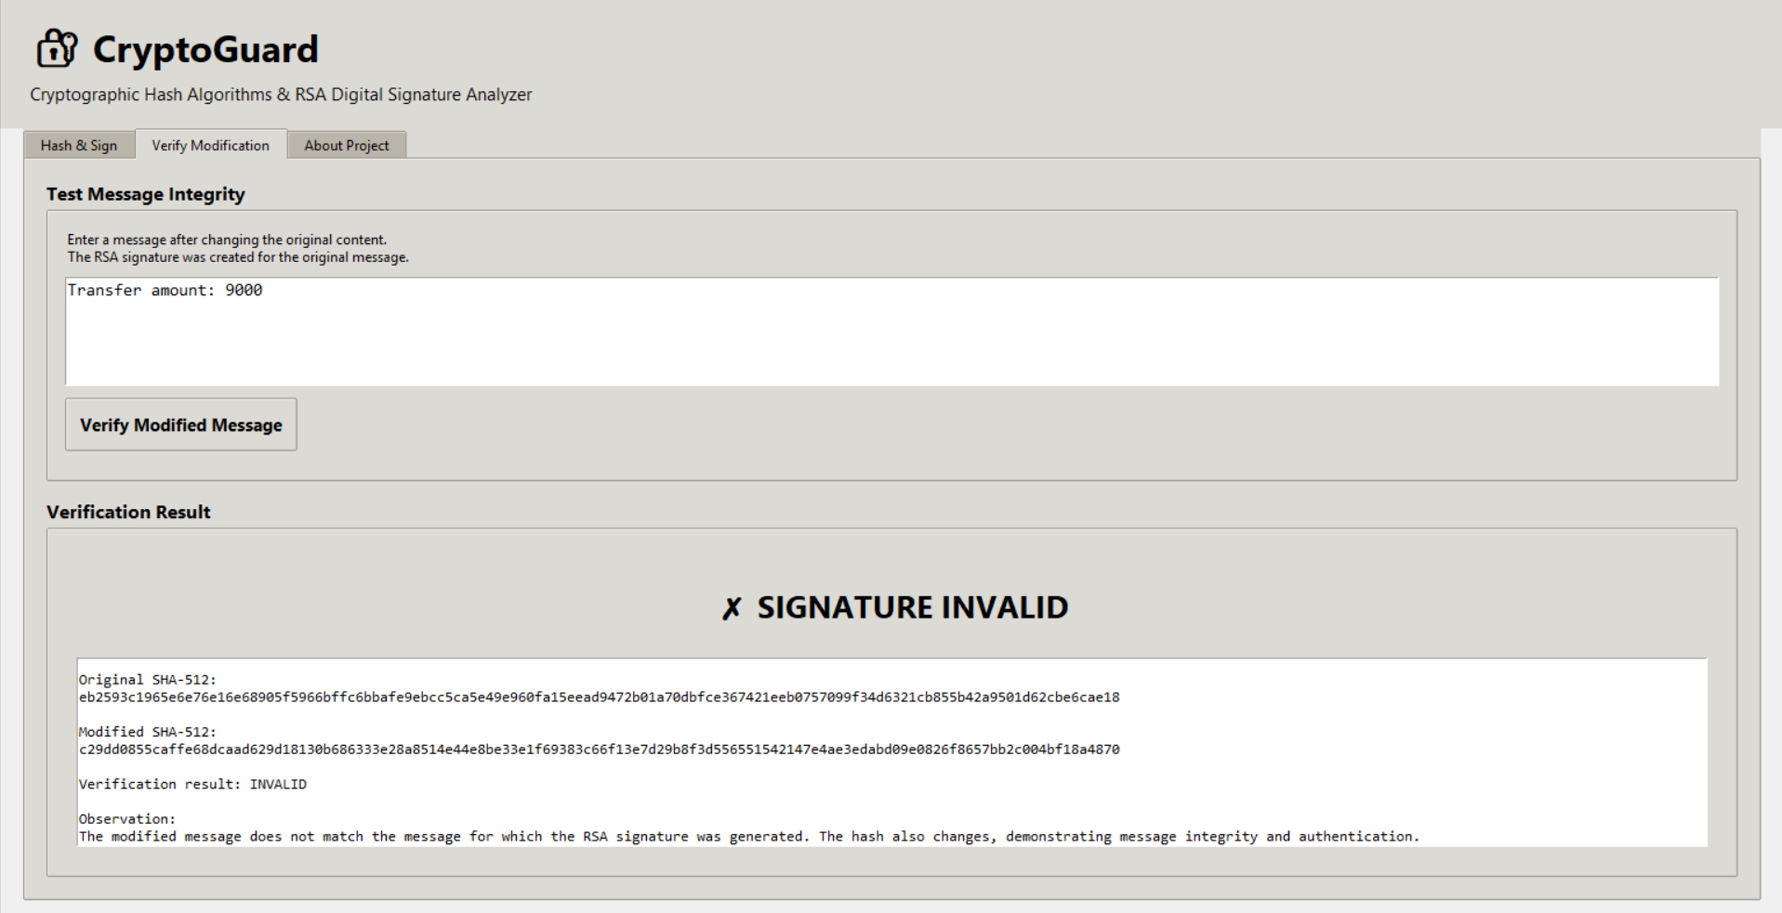
Figure 2: CryptoGuard GUI – Modified Message Verification
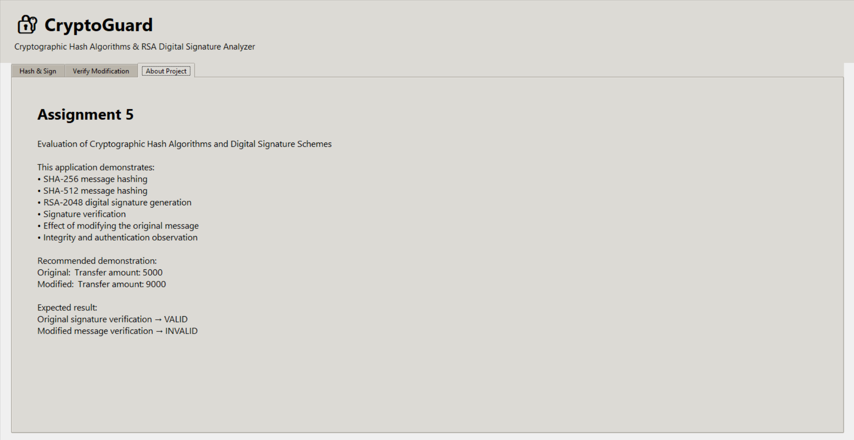
Figure 3: CryptoGuard GUI – Project Information

25. Results and Validation
The results validate the basic security properties we studied in class. The hash of the original message and the hash of the modified message are completely different from each other, even though only one number in the sentence changed. This is the avalanche effect in action. More importantly, the RSA signature that was generated for the original message could not be verified successfully against the modified message, which confirms that the signature is tightly bound to the exact content of the signed message and cannot be reused for a different message.

26. SHA-256 vs SHA-512 Comparison
Property | SHA-256 | SHA-512
Output size | 256 bits (64 hex characters) | 512 bits (128 hex characters)
Internal word size | 32-bit words | 64-bit words
Number of rounds | 64 rounds | 80 rounds
Relative output length in our test | Shorter hash string | Longer hash string
General security margin | Strong, widely used (e.g. in TLS, blockchains) | Larger digest, theoretically higher brute-force resistance

We did not measure execution time in our tests, so we are not claiming that one algorithm ran faster than the other in our application. Both hashes were generated instantly for our short test message, so no difference was noticeable at this scale.

27. Analysis and Discussion
A cryptographic hash function always produces a fixed-length digest no matter how long the input message is. Even a one-character change, like changing "5000" to "9000" in our test message, completely changes both the SHA-256 and SHA-512 output. This property is what makes hashes useful for checking whether data has been tampered with. The RSA digital signature adds another layer on top of this: it proves that a specific private key was used to approve a specific message. When we tried to verify the original signature against the modified message, verification failed, which is expected because RSA-PSS verification checks the signature against the exact bytes of the message being verified. This combination – hashing plus digital signature – is what gives us both integrity (has the message changed) and authentication (who approved it).

28. Security Analysis
- Integrity: confirmed by comparing SHA-256/SHA-512 hashes before and after modification – any change in the message is immediately visible as a completely different hash.
- Authentication: the RSA private key is what creates the signature, so a valid signature is evidence that the holder of that private key approved the message.
- Non-repudiation: since only the private key holder could have produced a signature that verifies correctly, the sender cannot later deny having signed the original message.
- Collision resistance: SHA-256 and SHA-512 are both designed to make it computationally infeasible to find two different messages with the same hash, which protects against an attacker crafting a fake message with a matching hash.
- Limitation in our demo: the private key is generated in memory and is not stored securely or exchanged with a real second party, so key management and distribution (which matters a lot in real systems) is outside the scope of this demonstration.

29. Computational Efficiency Discussion
We did not record precise timing measurements for hashing or signing in our tests, so we are keeping this discussion qualitative rather than making specific performance claims. In general, SHA-256 involves fewer rounds and operates on smaller 32-bit words compared to SHA-512, so it is commonly considered lighter on 32-bit systems, while SHA-512 can perform relatively better on modern 64-bit processors because of its 64-bit word operations. For our test message, which was very short, both hash computations and the RSA signing operation completed instantly with no noticeable delay in the GUI.

30. SDG Relevance

SDG 9 – Industry, Innovation and Infrastructure
Secure digital systems, like the hashing and signature mechanisms we implemented, are part of building reliable and trustworthy digital infrastructure, which is needed for modern industries to function safely online.

SDG 16 – Peace, Justice and Strong Institutions
Digital signatures support integrity, authentication and accountability in electronic communication, which are important for institutions (such as banks and government services) to be trusted and function fairly.

SDG 17 – Partnerships for the Goals
Trusted electronic communication, backed by cryptographic verification, makes it possible for different organizations and partners to exchange sensitive information with confidence, supporting collaboration between institutions.

31. CO Attainment
CO2: We analyzed and applied a public key cryptosystem (RSA) for generating and verifying digital signatures, which strengthens information security for electronic transactions, directly addressing this course outcome.
CO3: We examined cryptographic hash algorithms (SHA-256, SHA-512) and a digital signature scheme (RSA-PSS), and used them together to demonstrate integrity and authentication, which is what this course outcome asks us to evaluate.

32. Conclusion
Through this assignment, we built a working application that shows how cryptographic hashing and RSA digital signatures work together to protect the integrity and authenticity of a message. Our test with a simple transaction message clearly showed that changing even one number in the message caused the hash values to change completely and made the original signature fail verification. This gave us a much clearer, hands-on understanding of why hashing and digital signatures are used in real financial and communication systems, and how they help detect tampering and confirm the identity of the sender.

33. Limitations
- The application generates a new RSA key pair every time it starts, so there is no persistent key storage or key exchange between separate parties, unlike a real deployed system.
- Only one sample message pair was tested (original vs. modified); more varied test cases could make the demonstration more thorough.
- The application runs locally and does not simulate an actual network transmission between a sender and a receiver.

34. Future Enhancements
- Add the ability to save and load key pairs so signatures can be verified across separate application sessions.
- Add support for signing and verifying actual files, not just typed text messages.
- Add a simple simulated network layer so the demo can show a sender and receiver as two separate windows or processes.
- Add timing measurements to allow a proper, data-backed comparison of SHA-256 vs SHA-512 performance.

35. Individual Contribution of Group Members
There are 4 members in our team. Each member focused on a different part of the project, from the theory to the implementation to testing to the interface. Our individual contributions are described below.
Member | Individual Contribution
Member 1 | Member 1 focused on the cryptographic algorithm research and the conceptual side of the project. This involved studying how SHA-256 and SHA-512 work, understanding the general properties of cryptographic hash functions such as the avalanche effect and collision resistance, and researching how RSA digital signatures are generated and verified. Member 1 also helped explain how the project relates to integrity, authentication and non-repudiation, and contributed the theoretical explanations that appear in the concept and analysis sections of this report.
Member 2 | Member 2 worked on the actual cryptographic implementation in Python. This included writing the code that computes the SHA-256 and SHA-512 hashes of a message, generating the RSA-2048 key pair, and implementing the digital signature generation and verification logic using the cryptography library. Member 2 also helped debug the cryptographic functionality, making sure the signing and verification functions behaved correctly and returned the right VALID/INVALID result when tested.
Member 3 | Member 3 was responsible for testing, validation and documentation. This involved preparing the test cases used to demonstrate the project, running the application with both the original message and the modified message, and checking that the verification result came out VALID for the original message and INVALID for the modified one. Member 3 also compared the original and modified hash values to confirm they were different, and helped put together the screenshots, results tables and analysis sections of this report.
Member 4 | Member 4 (myself) was responsible for the GUI/application development. This involved designing and building the CryptoGuard desktop interface, including the Hash & Sign tab, the Verify Modification tab and the About Project tab. I created the message input areas, the SHA-256 and SHA-512 result display areas, and the RSA signature display, along with the verification interface used to test modified messages. I also tested the GUI and worked on improving the readability and overall presentation of the output on screen.

36. Individual Reflection
My part in this project was the GUI and application development for CryptoGuard. When we split up the work in our team, the others focused on the cryptography research, the actual hashing/RSA implementation, and testing, while I took responsibility for designing and building the interface that would let a user actually interact with all of that without needing to read or run any code directly.
I started by thinking about what a user would need to see on screen to understand what was happening. Since the project involved two different situations – signing a fresh message, and later checking a modified message against that same signature – it made sense to split the interface into separate tabs instead of cramming everything onto one screen. That is why I designed the Hash & Sign tab, the Verify Modification tab, and a small About Project tab that explains what the whole demo is about, using Tkinter's ttk Notebook widget.
On the Hash & Sign tab, I built the message input box, the buttons to generate the hashes and signature, and the read-only fields to display the SHA-256 hash, the SHA-512 hash and the RSA signature once they are generated. Getting the layout to look clean was harder than I expected – the RSA signature especially is a very long hex string, so I had to use a scrollable text box instead of a single-line field, otherwise it would overflow the window. On the Verify Modification tab, I built the box for entering the changed message and a results area that clearly shows the VALID or INVALID outcome along with both the original and modified hash values side by side, so the difference is easy to see at a glance.
One of the challenges I faced was styling consistency – making sure fonts, spacing and button styles looked the same across all three tabs, since Tkinter does not always keep this consistent automatically. I had to define a few reusable ttk styles (for titles, cards and buttons) and apply them everywhere instead of styling each widget separately. I also had to test the flow a number of times to make sure the Verify Modification tab correctly used the signature that Member 2 had implemented on the Hash & Sign tab, and that the interface did not crash if someone tried to verify a message before generating a signature first – I added a warning message box for that case.
Working on this part of the project helped me connect the interface design to CO2 and CO3 from an applied side. I was not the one writing the RSA signing logic, but building the interface around it forced me to understand what each piece of output (hash, signature, VALID/INVALID) actually meant, so that I could label and place it correctly on screen. It also made me appreciate how a good interface can make a fairly technical topic like digital signatures understandable to someone who is just looking at the app, which connects to SDG 16, since trust in a digital system depends not just on the cryptography being correct, but also on the system being usable and clear about what it is telling the user. It also relates to SDG 9, since building usable, well-structured software interfaces is part of building reliable digital infrastructure, and to SDG 17, because a clear interface makes it easier for different people, like our own team members or an evaluator, to understand and trust the same tool.
Overall, my contribution to CryptoGuard was making sure the cryptographic work done by Member 1, Member 2 and Member 3 was actually visible, testable and easy to follow on screen. Building the GUI end to end and testing it with our own sample messages gave me a much better hands-on understanding of how hashing and digital signatures behave in practice, not just in theory.

37. References
- Python Software Foundation, "hashlib — Secure hashes and message digests", Python 3 Documentation.
- Python Cryptographic Authority, "cryptography" library documentation – RSA, PSS padding and hashes modules.
- Python Software Foundation, "tkinter — Python interface to Tcl/Tk", Python 3 Documentation.
- W. Stallings, Cryptography and Network Security: Principles and Practice, Pearson Education (course textbook reference for hash functions and digital signatures).
- Course lecture material for Cryptography and Network Security – units on hash functions, digital signatures, integrity and authentication.

