**Execution Steps**

* Launch Eclipse and go to File menu
* From File menu import the project from Github using the URI.
* In the project ProQuestProject navigate to testng.xml file. Open the file and select Run as -- TestNG suite.
* Go to test-output folder -- emailable-report.html
* Right click on the file -- go to properties
* Copy the path and paste it in the web browser to see the output similar to the below:

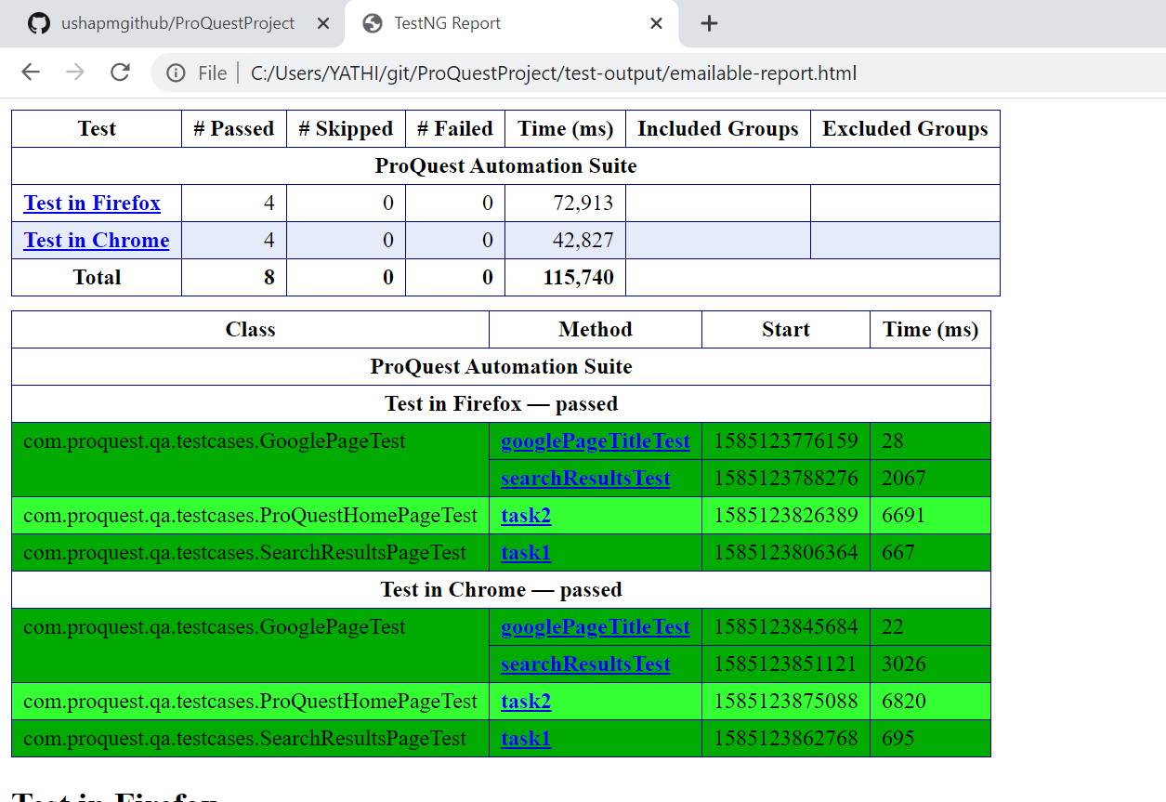

* The text file containing the titles of the search results and the screenshot of the ProQuest search for ‘QA’ is saved inside the folder ‘Results’ of the current project ProQuestProject.