*CREATE TABLE emp_old_91(empID INTEGER, ename VARCHAR(20), sal INTEGER, deptNo INTEGER)*

INSERT INTO emp_old_91 values(101, 'Venu', 90000, 10);

INSERT INTO emp_old_91 values(102, 'Mani', 80000, 20);

INSERT INTO emp_old_91 values(103, 'Shun', 70000, 30);

INSERT INTO emp_old_91 values(104, 'Saila', 60000, 20);

INSERT INTO emp_old_91 values(105, 'Ranga', 50000, 30);

**select** * **from** emp_old_91

**explain** **select** * **from** emp_old_91 **where** sal<70000

**CREATE** **TABLE** emp_91(

empID INTEGER,

ename VARCHAR(20),

sal INTEGER,

deptNo INTEGER)

**primary** **index**(empID)

**partition** **by** case_n(sal < 70000, sal< 80000, sal<100000, **no** **case**, **unknown**)

**select** * **from** emp_91

**INSERT** **INTO** emp_91 **values**(101, 'Venu', 90000, 10)**;**

**INSERT** **INTO** emp_91 **values**(102, 'Mani', 80000, 20)**;**

**INSERT** **INTO** emp_91 **values**(103, 'Shun', 70000, 30)**;**

**INSERT** **INTO** emp_91 **values**(104, 'Saila', 60000, 20)**;**

**INSERT** **INTO** emp_91 **values**(105, 'Ranga', 50000, 30)**;**

**explain** **select** * **from** emp_91 **where** sal<70000

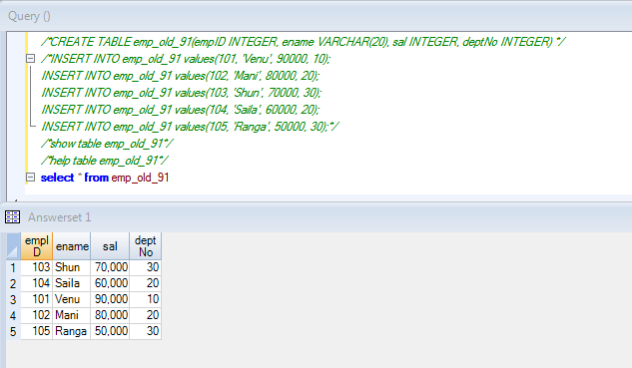

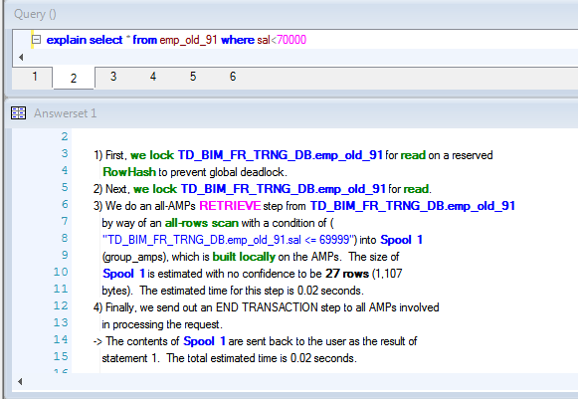

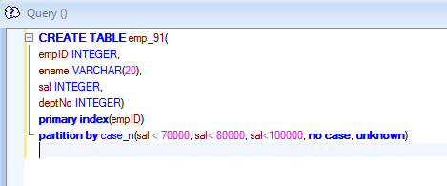

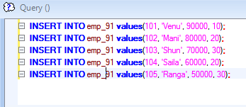

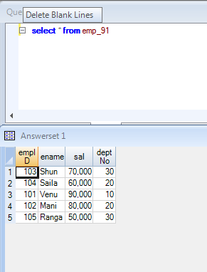

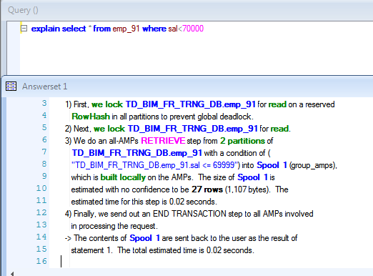

**CREATE** **TABLE** employee_91(empID INTEGER, ename VARCHAR(20), sal INTEGER, deptNo INTEGER, doj date)

**INSERT** **INTO** employee_91 **values**(101, 'Venu', 90000, 10, '2014-12-28')**;**

**INSERT** **INTO** employee_91 **values**(102, 'Mani', 80000, 20, '2015-12-28')**;**

**INSERT** **INTO** employee_91 **values**(103, 'Shun', 70000, 30, '2015-12-30')**;**

**INSERT** **INTO** employee_91 **values**(104, 'Saila', 60000, 20, '2016-12-23')**;**

**INSERT** **INTO** employee_91 **values**(105, 'Ranga', 50000, 30, '2017-12-30')**;**

**select** * **from** employee_91

**explain** **select** * **from** employee_91 **where** date='2016-12-23'

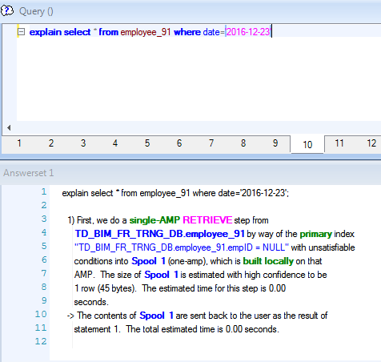

**CREATE** **TABLE** employees_91(empID INTEGER, ename VARCHAR(20), sal INTEGER, deptNo INTEGER, doj date)

**primary** **index**(empID) **partition** **by** range_n(doj between '2015-01-01' **and** '2017-12-31' **each** interval '1' year, **no** **range**, **unknown**)

**INSERT** **INTO** employees_91 **values**(101, 'Venu', 90000, 10, '2014-12-28')**;**

**INSERT** **INTO** employees_91 **values**(102, 'Mani', 80000, 20, '2015-12-28')**;**

**INSERT** **INTO** employees_91 **values**(103, 'Shun', 70000, 30, '2015-12-30')**;**

**INSERT** **INTO** employees_91 **values**(104, 'Saila', 60000, 20, '2016-12-23')**;**

**INSERT** **INTO** employees_91 **values**(105, 'Ranga', 50000, 30, '2017-12-30')**;**

**select** * **from** employees_91

**explain** **select** * **from** employee_91 **where** date='2016-12-23'

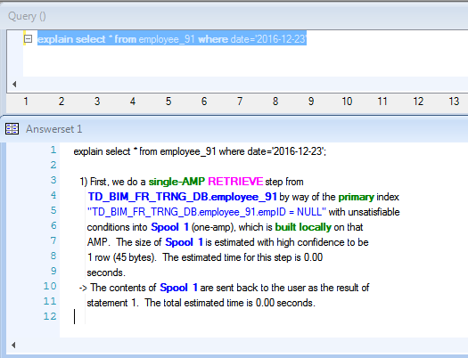

INPUT

D:\TeradataBasics

OUTPUT

D:\saranya\TeraPractice

In input click shift and right click, “Open command window here”

And execute like this D:\TeradataBasics>bteq<demo4.btq

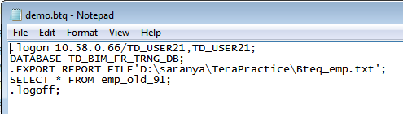

.logon 10.58.0.66/TD_USER21,TD_USER21;

DATABASE TD_BIM_FR_TRNG_DB;

.EXPORT REPORT FILE'D:\saranya\TeraPractice\Bteq_emp.txt';

SELECT * FROM emp_old_91;

.logoff;

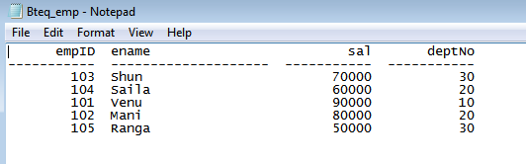

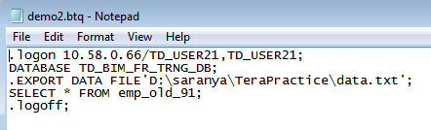

.logon 10.58.0.66/TD_USER21,TD_USER21;

DATABASE TD_BIM_FR_TRNG_DB;

.EXPORT DATA FILE'D:\saranya\TeraPractice\data.txt';

SELECT * FROM emp_old_91;

.logoff;



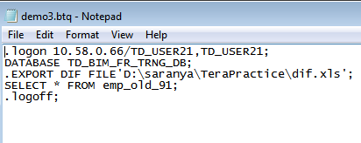

.logon 10.58.0.66/TD_USER21,TD_USER21;

DATABASE TD_BIM_FR_TRNG_DB;

.EXPORT DIF FILE'D:\saranya\TeraPractice\dif.xls';

SELECT * FROM emp_old_91;

.logoff

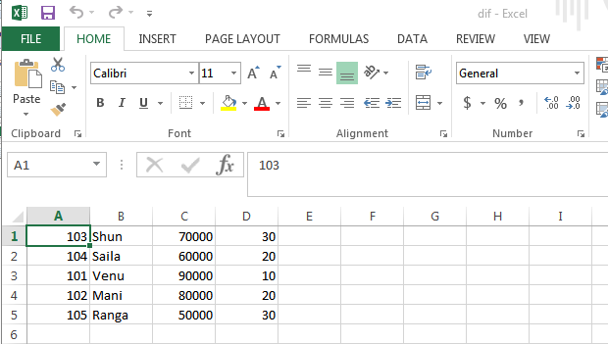

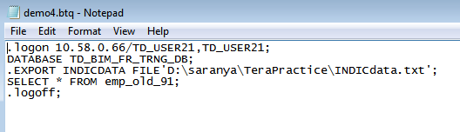

.logon 10.58.0.66/TD_USER21,TD_USER21;

DATABASE TD_BIM_FR_TRNG_DB;

.EXPORT INDICDATA FILE'D:\saranya\TeraPractice\INDICdata.txt';

SELECT * FROM emp_old_91;

.logoff;

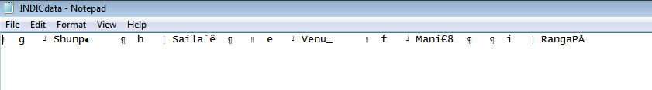

End….

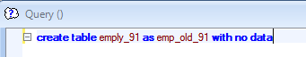

Create 2 notepads in input folder

emp.txt

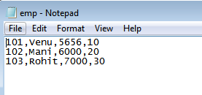

Emply_91.btq

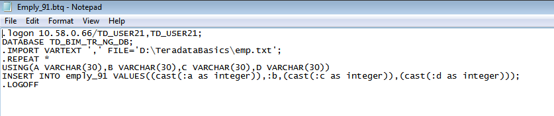

Shift+rightclick

D:\TeradataBasics>bteq<Emply_91.btq

