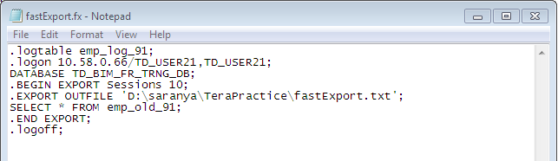

.logtable emp_log_91;

.logon 10.58.0.66/TD_USER21,TD_USER21;

DATABASE TD_BIM_FR_TRNG_DB;

.BEGIN EXPORT Sessions 10;

.EXPORT OUTFILE 'D:\saranya\TeraPractice\fastExport.txt';

SELECT * FROM emp_old_91;

.END EXPORT;

.logoff;

