**Mload**

.LOGTABLE TD_BIM_FR_TRNG_DB.Employe_log16191;

.LOGON 10.58.0.66/TD_USER21,TD_USER21;

.BEGIN MLOAD TABLES emply_1691;

.LAYOUT Employee;

.FIELD in_EmployeeNo * VARCHAR(10);

.FIELD in_FirstName * VARCHAR(30);

.FIELD in_LastName * VARCHAR(30);

.DML LABEL EmpLabel;

INSERT INTO emply_1691 (

EmployeeNo,

FirstName,

LastName

)

VALUES (

:in_EmployeeNo,

:in_FirstName,

:in_Lastname

);

.IMPORT INFILE 'D:\TeradataBasics\emply_91.txt'

FORMAT VARTEXT ','

LAYOUT Employee

APPLY EmpLabel; // apply dml where depno=10

.END MLOAD;

LOGOFF;

D:\TeradataBasics>mload<multiLoad.ml

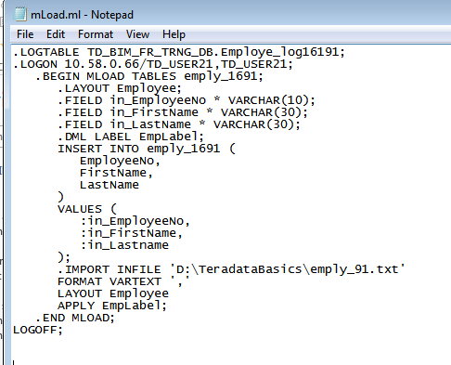

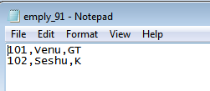

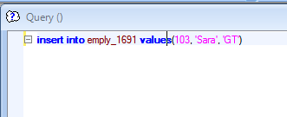

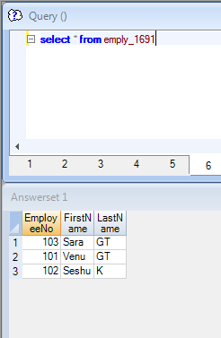

**FastLoad**

.logon 10.58.0.66/TD_USER21,TD_USER21;

DATABASE TD_BIM_FR_TRNG_DB;

BEGIN LOADING sar

ERRORFILES Employee_ET_1691, Employee_UV_1691;

SET RECORD VARTEXT ",";

DEFINE in_ename (varchar(30)),

in_firstname (VARCHAR(30)),

in_lastname (VARCHAR(30))

FILE = 'D:\TeradataBasics\employee_161691.txt';

INSERT INTO sar(

ename,

firstname,

lastname

)

VALUES(

:in_ename,

:in_firstname,

:in_lastname

);

.END LOADING;

.LOGOFF;

D:\TeradataBasics>fastload<fastLoad.fl

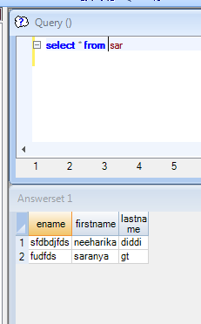

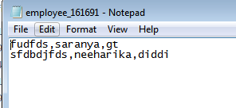

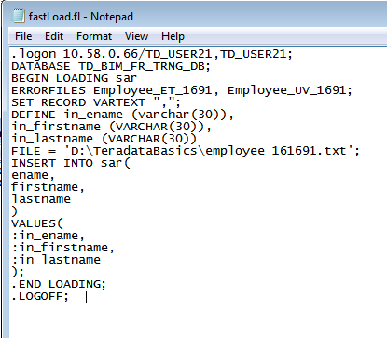

Macro Statement

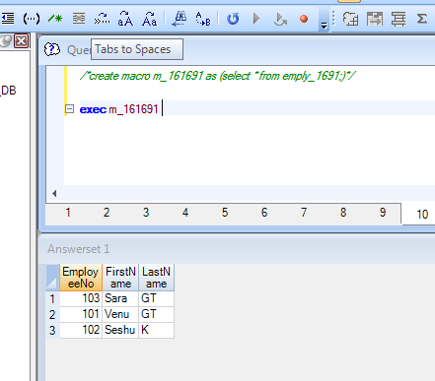

Parameterized macro

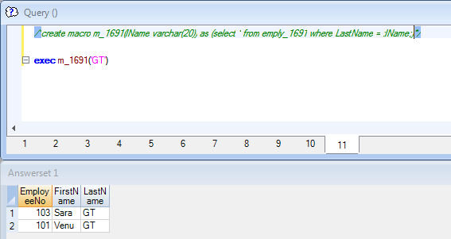

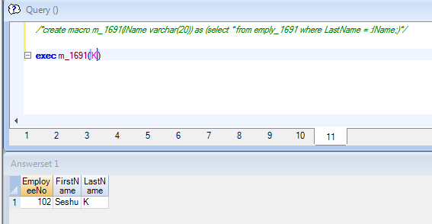

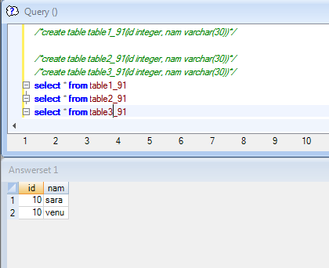

.LOGTABLE TD_BIM_FR_TRNG_DB.Employe_log_116691;

.LOGON 10.58.0.66/TD_USER21,TD_USER21;

.BEGIN MLOAD TABLES table1_91,table2_91,table3_91;

.LAYOUT Employee11111;

.FIELD in_id * VARCHAR(30);

.FIELD in_nam * VARCHAR(30);

.DML LABEL EmpLabel11111;

INSERT INTO table1_91(

id,

nam

)

VALUES (

(cast(:in_id as integer)),

:in_nam

);

.DML LABEL EmpLabel22222;

INSERT INTO table2_91(

id,

nam

)

VALUES (

(cast(:in_id as integer)),

:in_nam

);

.DML LABEL EmpLabel33333;

INSERT INTO table3_91(

id,

nam

)

VALUES (

(cast(:in_id as integer)),

:in_nam

);

.IMPORT INFILE 'D:\TeradataBasics\mLoad3.txt'

FORMAT VARTEXT ','

LAYOUT Employee11111

APPLY EmpLabel11111 where in_id='10'

APPLY EmpLabel22222 where in_id='20'

APPLY EmpLabel33333 where in_id='30';

.END MLOAD;

.LOGOFF;