**TERADATA ASSIGNMENTS**

**LAB 5**

***THE WHERE CLAUSE***

**SELECT** * **FROM** Student_Table**;**

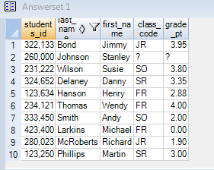

***LIMITS RETURNING ROWS***

**SELECT** FIRST_NAME,LAST_NAME,CLASS_CODE,GRADE_PT

**FROM** STUDENT_TABLE

**WHERE** FIRST_NAME='SUSIE'**;**

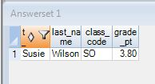

***USING COLUMN ALIAS THROUGHOUT SQL***

**SEL** FIRST_NAME **AS** FNAME

,LAST_NAME LNAME

,CLASS_CODE "CLASS CODE"

,GRADE_PT **AS**"AVG"

,STUDENTS_ID

**FROM** STUDENT_TABLE

**WHERE** FNAME='SUSIE'**;**

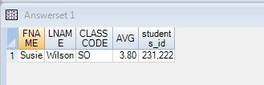

***DOUBLE QUOTED ALIASES ARE RESERVED FOR SPACES***

**SEL** FIRST_NAME **AS** FNAME

,LAST_NAME LNAME

,CLASS_CODE "CLASS CODE"

,GRADE_PT **AS**"AVG"

,STUDENTS_ID

**FROM** STUDENT_TABLE

**WHERE** FNAME='SUSIE'

**ORDER** **BY** "AVG"**;**



***CHARACTER DATA NEEDS SINGLE QUOTES IN THE WHERE CLAUSE***

**SELECT** FIRST_NAME,LAST_NAME,CLASS_CODE,GRADE_PT

**FROM** STUDENT_TABLE

**WHERE** FIRST_NAME='SUSIE'**;**



***CHARACTER DATA NEEDS SINGLE QUOTES BUT NUMBER DON’T***

**SEL** *

**FROM** STUDENT_TABLE

**WHERE** GRADE_PT=3.35**;**

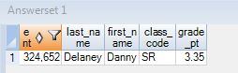

***NULL MEANS UNKNOWN DATA SO EQUAL (=) WON’T WORK***

**SEL** *

**FROM** STUDENT_TABLE

**WHERE** CLASS_CODE=**NULL;**

**SEL** *

**FROM** STUDENT_TABLE

**WHERE** CLASS_CODE **IS** **NULL;**

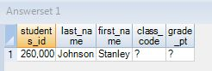

***NULL IS UNKNOWN DATA SO NOT EQUAL WON’T WORK***

**SEL** *

**FROM** STUDENT_TABLE

**WHERE** CLASS_CODE = **NOT** **NULL;**

**SEL** *

**FROM** STUDENT_TABLE

**WHERE** CLASS_CODE **IS** **NOT** **NULL;**

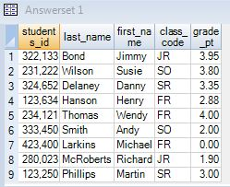

***USING GREATER THAN OR EQUAL TO OPERATOR (>=)***

**SEL** *

**FROM** STUDENT_TABLE

**WHERE** GRADE_PT >=3.0**;**

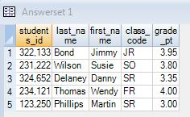

***USING GE AS GREATER THAN OR EQUAL TO (>=)***

**SEL** *

**FROM** STUDENT_TABLE

**WHERE** GRADE_PT GE 3.0**;**



***AND IN THE WHERE***

**SEL** *

**FROM** STUDENT_TABLE

**WHERE** CLASS_CODE = 'FR'

**AND** FIRST_NAME='WENDY'**;**

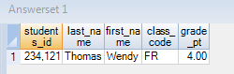

***TROUBLESHOOTING AND***

**SEL** *

**FROM** STUDENT_TABLE

**WHERE** GRADE_PT =3.0 **AND** GRADE_PT=4.0**;**

**NO ROWS RETURNED**

***OR IN THE WHERE***

**SEL** *

**FROM** STUDENT_TABLE

**WHERE** GRADE_PT =3.0 **OR** GRADE_PT=4.0**;**

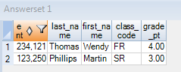

***TROUBLESHOOTING OR***

**SEL** *

**FROM** STUDENT_TABLE

**WHERE** GRADE_PT =3.0 **OR** 4.0**;**

**ERROR OCCURS**

***OR MUST UTILISE SAME COLUMN NAMES***

**SEL** *

**FROM** STUDENT_TABLE

**WHERE** GRADE_PT =3.0 **OR** GRADE_PT=4.0**;**



***TROUBLESHOOTING CHARACTER DATA***

**SEL** *

**FROM** STUDENT_TABLE

**WHERE** GRADE_PT =3.0 **AND** CLASS_CODE=SR**;**

**ERROR OCCURS**

**SEL** *

**FROM** STUDENT_TABLE

**WHERE** GRADE_PT =3.0 **AND** CLASS_CODE='SR'**;**

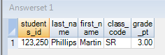

***QUIZ – HOW MANY WILL RETURN?***

**SEL** *

**FROM** STUDENT_TABLE

**WHERE** GRADE_PT =3.0 **OR** GRADE_PT=4.0**;**

**AND** CLASS_CODE ='SR'**;**

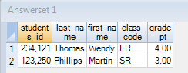

**ANSWER IS 2 ROWS**

***USING PARANTHESIS TO CHANGE THE ORDER OF PRECEDENCE***

**SEL** *

**FROM** STUDENT_TABLE

**WHERE** (GRADE_PT =3.0 **OR** GRADE_PT=4.0)

**AND** CLASS_CODE ='SR'**;**

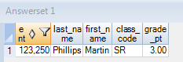

***Using an IN LIST in place of OR***

**SEL** *

**FROM** STUDENT_TABLE

**WHERE** GRADE_PT **IN** (3.0 ,4.0)

**AND** CLASS_CODE ='SR'**;**



***The IN LIST is an excellent technique***

**SEL** *

**FROM** STUDENT_TABLE

**WHERE** GRADE_PT **IN** (2.0,3.0 ,4.0)**;**

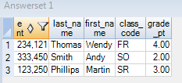

***IN list vs OR brings the same results***

**SEL** *

**FROM** STUDENT_TABLE

**WHERE** GRADE_PT = 2.0

**OR** GRADE_PT = 3.0

**OR** GRADE_PT = 4.0**;**



***Using a NOT IN LIST***

**SEL** *

**FROM** STUDENT_TABLE

**WHERE** GRADE_PT **NOT** **IN** (2.0,3.0 ,4.0)**;**

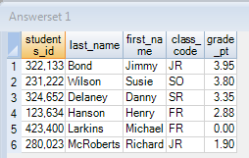

***TECHNIQUE FOR HANDLING NULL IN NOT IN LIST***

**SEL** *

**FROM** STUDENT_TABLE

**WHERE** GRADE_PT **NOT** **IN** (2.0,3.0 ,4.0)

**OR** GRADE_PT **IS** **NULL;**

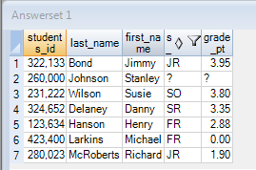

***AN IN LIST WITH KEYWORD ANY***

**SEL** *

**FROM** STUDENT_TABLE

**WHERE** GRADE_PT = ANY (2.0,3.0 ,4.0)**;**

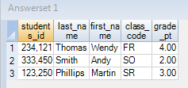

***A NOT IN LIST WITH KEYWORDS NOT=ALL***

**SEL** *

**FROM** STUDENT_TABLE

**WHERE** GRADE_PT **NOT**= **ALL** (2.0,3.0 ,4.0)**;**

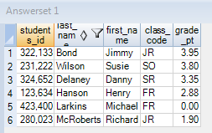

***BETWEEN is inclusive***

**SEL** *

**FROM** STUDENT_TABLE

**WHERE** GRADE_PT between 2.0 **and** 4.0**;**

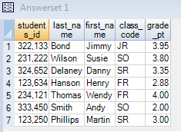

***BETWEEN works for character data***

**SEL** *

**FROM** STUDENT_TABLE

**WHERE** last_name between 'L' **and** 'LZ'**;**

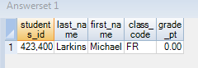

***LIKE USES WILDCARDS PERCENT ‘%’ AND UNDERSCORE ‘_’***

**SEL** *

**FROM** STUDENT_TABLE

**WHERE** last_name LIKE 'SM%'**;**

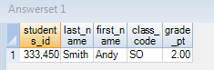

***LIKE COMMAND UNDERSCORE IS WILDCARD FOR ONE CHARACTER***

**SEL** *

**FROM** STUDENT_TABLE

**WHERE** last_name LIKE '_a%'**;**

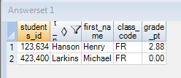

***LIKE ALL means ALL conditions must be met***

**SEL** *

**FROM** STUDENT_TABLE

**WHERE** last_name LIKE **ALL** ('%M%', '%S%')**;**

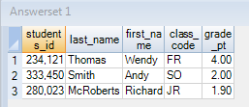

***LIKE ANY means ANY of the conditions must be met***

**SEL** *

**FROM** STUDENT_TABLE

**WHERE** last_name LIKE ANY('%M%', '%S%')**;**

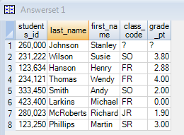

***IN ANSI TRANSACTION MODE CASE MATTERS***

***IN TREADATA TRANSACTION MODE CASE DOES NOT MATTERS***

**SEL** *

**FROM** STUDENT_TABLE

**WHERE** last_name LIKE **ALL**('%S%', '%m%')**;**

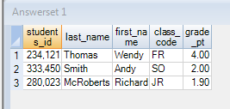

***LIKE COMMAND WORKS DIFFERENTLY ON CHAR Vs VARCHAR***

**SEL** *

**FROM** STUDENT_TABLE

**WHERE** first_name LIKE '%y'**;**

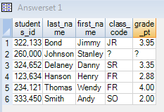

***TROUBLESHOOTING LIKE COMMAND ON CHAR DATA***

**SEL** *

**FROM** STUDENT_TABLE

**WHERE** last_name LIKE '%a'**;**

**NO ROWS RETURNED**

***TRIM COMMAND***

**SEL** last_name

**FROM** STUDENT_TABLE

**WHERE** TRIM (last_name) LIKE '%n'**;**

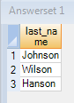

***AN EXAMPLE OF DATA WITH LEFT JUSTIFICATION AND RIGHT JUSTIFICATION***

**SEL** STUDENTS_ID, LAST_NAME

**FROM** STUDENT_TABLE**;**

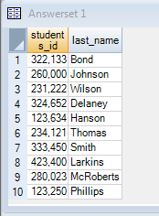

***ESCAPE CHARACTER IN THE LIKE COMMAND CHANGES WILDACRDS***

**SEL** *

**FROM** STUDENT_TABLE

**WHERE** FIRST_NAME LIKE 'S@%' **ESCAPE** '@'**;**

***TO FIND THE WILDCARD***

**SEL** *

**FROM** STUDENT_TABLE

**WHERE** TRIM(LAST_NAME) LIKE 'T@_' **ESCAPE** '@'**;**

**Sample**

**SELECT** * **FROM** STUDENT_COURSE_TABLE

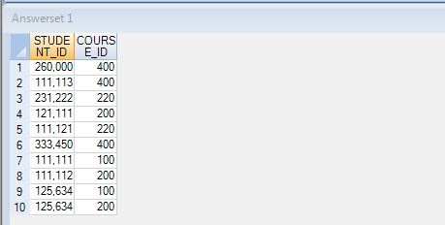

**SELECT** * **FROM** STUDENT_COURSE_TABLE

**SAMPLE** 5**;**

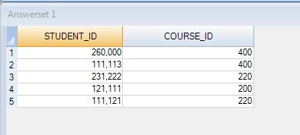

**SELECT** * **FROM** STUDENT_COURSE_TABLE

**SAMPLE** .25 **;**

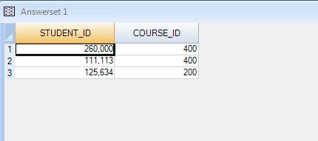

**SELECT** * **FROM** STUDENT_COURSE_TABLE

**SAMPLE** .25, .25

**ORDER** **BY** 1,2 **;**

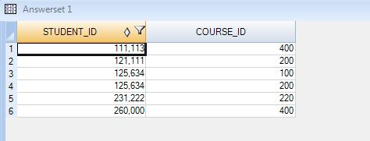

Sample with replacement

**SELECT** student_id, course_id,**SAMPLEID** **FROM** STUDENT_COURSE_TABLE

**SAMPLE** **WITH** **REPLACEMENT** 5,5,5

**ORDER** **BY** 3,1,2**;**

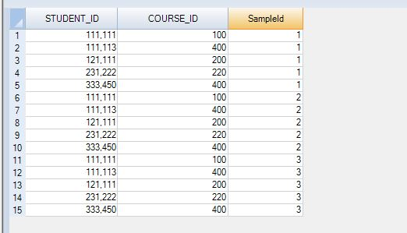

Sample with 10% sampled

**SELECT** student_id, course_id,**SAMPLEID** **FROM** STUDENT_COURSE_TABLE

**SAMPLE** .1,.1,.1,.1

**ORDER** **BY** **SAMPLEID** **;**

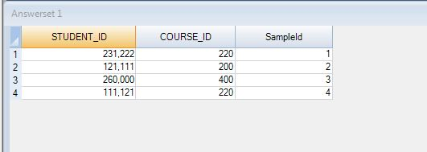

Sample with conditional logic

**SELECT** student_id, course_id,**SAMPLEID** **FROM** STUDENT_COURSE_TABLE

**SAMPLE** **RANDOMIZED** **ALLOCATION**

**WHEN** COURSE_ID>200 **THEN** .1,.1 **ELSE** .2,.2

**END**

**ORDER** **BY** 3**;**

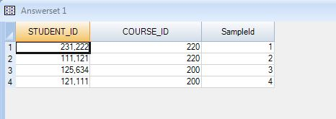

AGGREGATES and SAMPLE USING DERIVED TABLE

**SELECT COUNT(DISTINCT( course_id)) FROM (SEL COURSE_ID FROM STUDENT_COURSE_TABLE**

**SAMPLE 5) DT;**

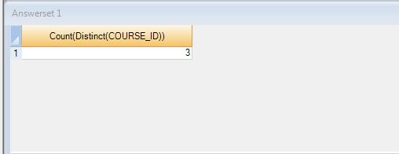

RANDOM NUMBER GENERATOR

**SELECT** RANDOM(1,20)

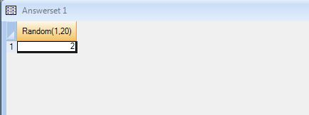

RANDOM TO SELECT PERCENTAGE OF ROWS

**SELECT** * **FROM** SALES_TABLE

**WHERE** RANDOM(1,100)=5**;**

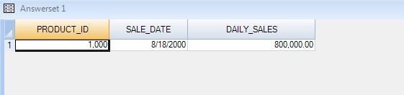

**SELECT** PRODUCT_ID, COUNT(DAILY_SALES) **FROM** SALES_TABLE

**GROUP** **BY** 1**;**

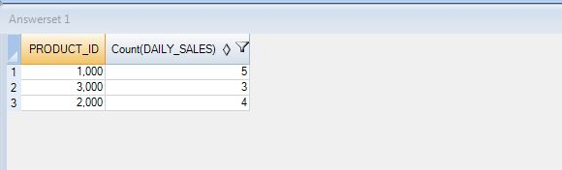

**SET OPERATORS FUNCTIONS**

**SELECT** * **FROM** TABLE_RED**;**

**SELECT** * **FROM** TABLE_BLUE**;**

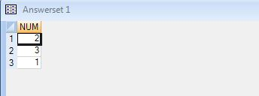

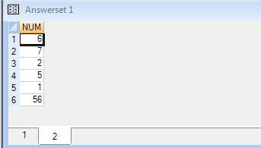

INTERSECT

**SELECT** * **FROM** TABLE_RED**;**

**INTERSECT**

**SELECT** * **FROM** TABLE_BLUE**;**

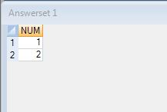

UNION

**SELECT** * **FROM** TABLE_RED

**UNION**

**SELECT** * **FROM** TABLE_BLUE**;**

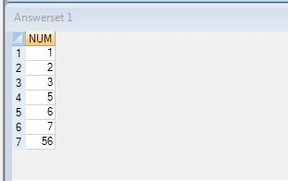

UNION ALL

**SELECT** * **FROM** TABLE_RED

**UNION** **ALL**

**SELECT** * **FROM** TABLE_BLUE**;**

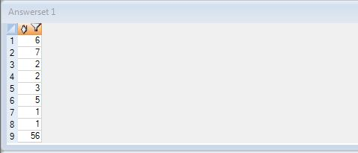

MINUS

**SELECT** * **FROM** TABLE_RED

**MINUS**

**SELECT** * **FROM** TABLE_BLUE**;**

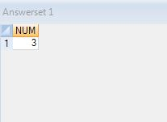

TESTING THE KNOWLEDGE:

1)

**SELECT** * **FROM** TABLE_RED

**EXCEPT**

**SELECT** * **FROM** TABLE_BLUE**;**

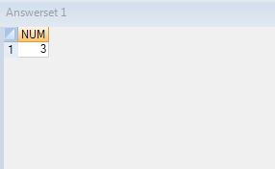

**SELECT** * **FROM** TABLE_RED

**MINUS**

**SELECT** * **FROM** TABLE_BLUE**;**

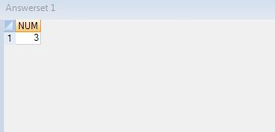

2)20

**SELECT** * **FROM** TABLE_BLUE

**MINUS**

**SELECT** * **FROM** TABLE_RED**;**

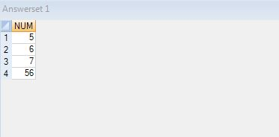

**SELECT** * **FROM** TABLE_BLUE

**EXCEPT**

**SELECT** * **FROM** TABLE_RED**;**

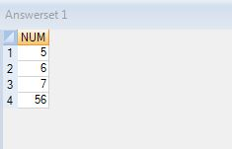

SELECT LIST

**SELECT** DEPT_NO, EMP_NO **FROM** EMPLOYEE_TABLE

**INTERSECT**

**SELECT** DEPT_NO,MGR_NO **FROM** DEP_TABLE**;**

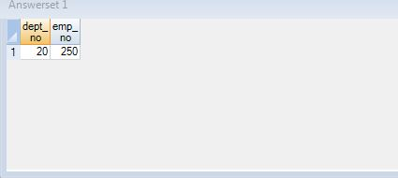

**STATISTICAL AGGREGATE FUNCTIONS:**

**The Stats Table:**

**SELECT** * **FROM** Stats_Table**;**

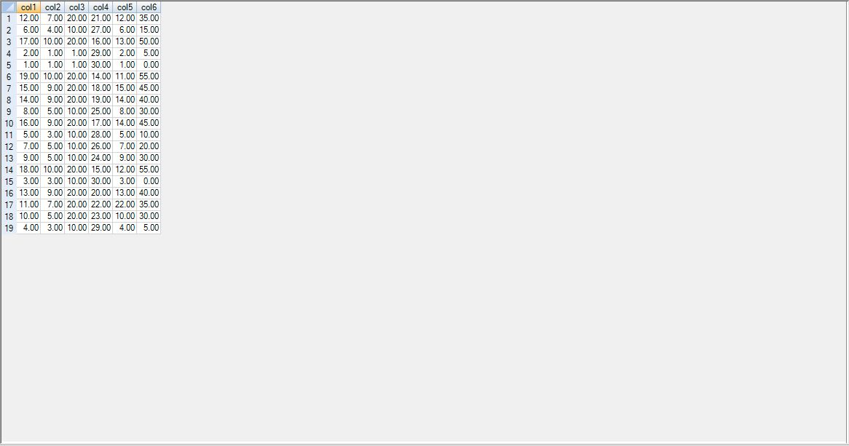

**THE KURTOSIS FUNCTION:**

**SELECT** KURTOSIS(col1) **AS** KofCol1

**FROM** Stats_Table**;**

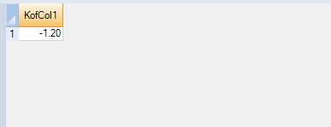

**SELECT** * **FROM** Stats_Table**;**



**SELECT** KURTOSIS(col1) **AS** KofCol1

,KURTOSIS(col2) **AS** KofCol2

,KURTOSIS(col3) **AS** KofCol3

,KURTOSIS(col4) **AS** KofCol4

,KURTOSIS(col5) **AS** KofCol5

,KURTOSIS(col6) **AS** KofCol6

**FROM** Stats_Table**;**

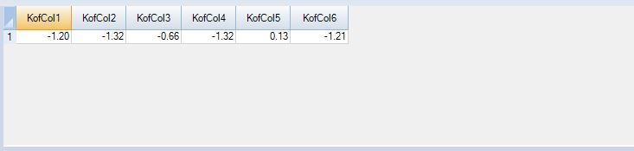

**SKEW FUNCTION:**

**SELECT** SKEW(col1) **AS** SKofCol1

**FROM** Stats_Table**;**

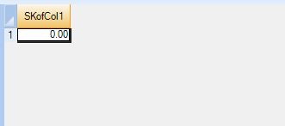

**SELECT** SKEW(col1) **AS** SKofCol1

,SKEW(col2) **AS** SKofCol2

,SKEW(col3) **AS** SKofCol3

,SKEW(col4) **AS** SKofCol4

,SKEW(col5) **AS** SKofCol5

,SKEW(col6) **AS** SKofCol6

**FROM** Stats_Table**;**

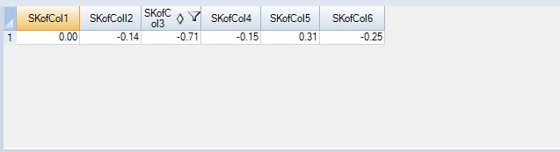

**THE STDDEV_POP FUNCTION:**

**SELECT** STDDEV_POP(col1) **AS** SDPCol1

**FROM** Stats_Table**;**

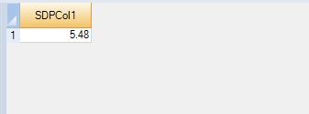

**A STDDEV_POP EXAMPLE:**

**SELECT** STDDEV_POP(col1) **AS** SDPCol1

,STDDEV_POP(col2) **AS** SDPColl2

,STDDEV_POP(col3) **AS** SDPCol3

,STDDEV_POP(col4) **AS** SDPCol4

,STDDEV_POP(col5) **AS** SDPCol5

,STDDEV_POP(col6) **AS** SDPCol6

**FROM** Stats_Table**;**

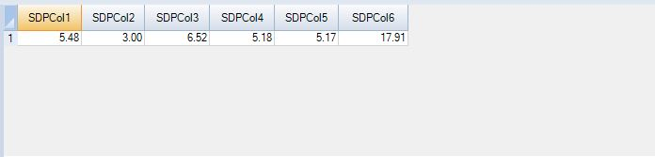

**THE STDDEV_SAMP FUNCTION:**

**SELECT** STDDEV_SAMP(col1) **AS** SDSCol1

**FROM** Stats_Table**;**

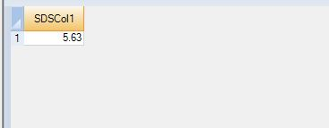

**A STDDEV_SAMP EXAMPLE:**

**SELECT** STDDEV_SAMP(col1) **AS** SDSCol1

,STDDEV_SAMP(col2) **AS** SDSColl2

,STDDEV_SAMP(col3) **AS** SDSCol3

,STDDEV_SAMP(col4) **AS** SDSCol4

,STDDEV_SAMP(col5) **AS** SDSCol5

,STDDEV_SAMP(col6) **AS** SDSCol6

**FROM** Stats_Table**;**

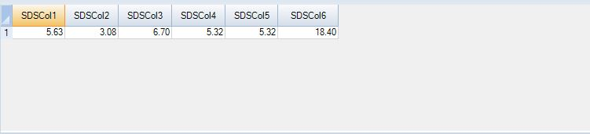

**THE VAR_POP FUNCTION:**

**SELECT** VAR_POP(col1) **AS** VPCol1

**FROM** Stats_Table**;**

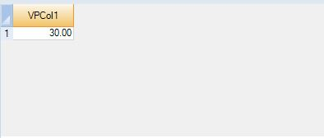

**A VAR_POP EXAMPLE:**

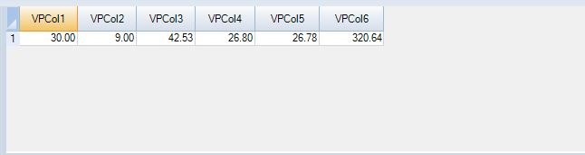

**THE VAR_SAMP FUNCTION:**

**SELECT** VAR_SAMP(col1) **AS** VSCol1

**FROM** Stats_Table**;**

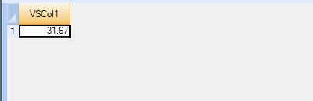

**A VAR_SAMP EXAMPLE:**

**SELECT** VAR_SAMP(col1) **AS** VSCol1

,VAR_SAMP(col2) **AS** VSCol2

,VAR_SAMP(col3) **AS** VSCol3

,VAR_SAMP(col4) **AS** VSCol4

,VAR_SAMP(col5) **AS** VSCol5

,VAR_SAMP(col6) **AS** VSCol6

**FROM** Stats_Table**;**

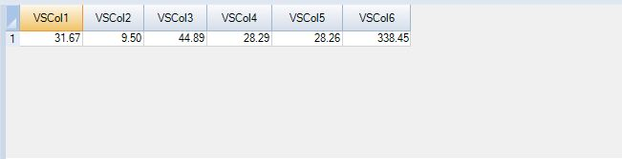

**THE CORR FUNCTION:**

**SELECT** CORR(col1, col2) **AS** CCol1#2

**FROM** Stats_Table**;**

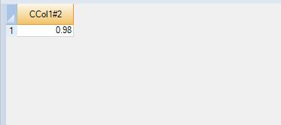

**A CORR EXAMPLE:**

**SELECT** CORR(col1, col2) **AS** CCol1#2

,CORR(col1, col3) **AS** CCol1#3

,CORR(col1, col4) **AS** CCol1#4

,CORR(col1, col5) **AS** CCol1#5

,CORR(col1, col6) **AS** CCol1#6

**FROM** Stats_Table**;**

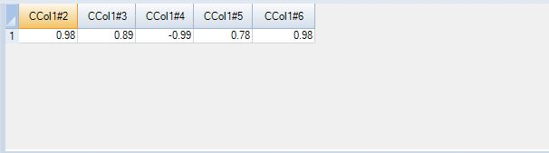

**ANOTHER CORR EXAMPLE:**

**SELECT** CORR(col1, col2) **AS** CCol1#2

,CORR(col1, col3) **AS** CCol1#3

,CORR(col1, col1) **AS** CCol1#1

,CORR(col1, col5) **AS** CCol1#5

,CORR(col1, col6) **AS** CCol1#6

**FROM** Stats_Table**;**

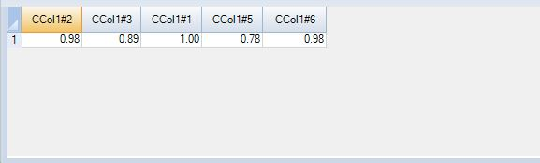

**THE COVAR_POP FUNCTION:**

**SELECT** COVAR_POP(col1, col2) **AS** CCol1#2

**FROM** Stats_Table**;**

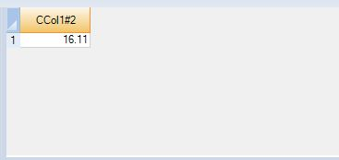

**A COVAR_POP EXAMPLE:**

**SELECT** COVAR_POP(col1, col2) **AS** CPCol1#2

,COVAR_POP(col1, col3) **AS** CPCol1#3

,COVAR_POP(col1, col4) **AS** CPCol1#4

,COVAR_POP(col1, col5) **AS** CPCol1#5

,COVAR_POP(col1, col6) **AS** CPCol1#6

**FROM** Stats_Table**;**

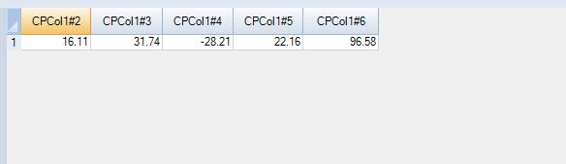

**ANOTHER COVAR_POP EXAMPLE:**

**SELECT** COVAR_POP(col1, col2) **AS** CPCol1#2

,COVAR_POP(col1, col3) **AS** CPCol1#3

,COVAR_POP(col1, col1) **AS** CPCol1#1

,COVAR_POP(col1, col5) **AS** CPCol1#5

,COVAR_POP(col1, col6) **AS** CPCol1#6

**FROM** Stats_Table**;**

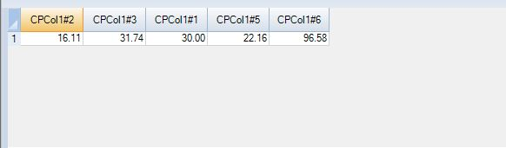

**THE REGR_INTERCEPT FUNCTION:**

**SELECT** REGR_INTERCEPT(col1, col2) **AS** RTofCol1#2

**FROM** Stats_Table**;**

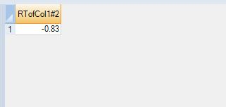

**A REGR_INTERCEPT EXAMPLE:**

**SELECT** REGR_INTERCEPT(col1, col2) **AS** RTofCol1#2

,REGR_INTERCEPT(col1, col3) **AS** RTofCol1#3

,REGR_INTERCEPT(col1, col4) **AS** RTofCol1#4

,REGR_INTERCEPT(col1, col5) **AS** RTofCol1#5

,REGR_INTERCEPT(col1, col6) **AS** RTofCol1#6

**FROM** Stats_Table**;**

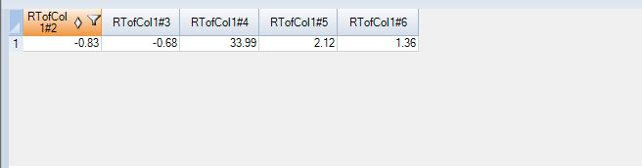

**ANOTHER REGR_INTERCEPT EXAMPLE:**

**SELECT** REGR_INTERCEPT(col1, col2) **AS** RTofCol1#2

,REGR_INTERCEPT(col1, col3) **AS** RTofCol1#3

,REGR_INTERCEPT(col1, col1) **AS** RTofCol1#1

,REGR_INTERCEPT(col1, col5) **AS** RTofCol1#5

,REGR_INTERCEPT(col1, col6) **AS** RTofCol1#6

**FROM** Stats_Table**;**

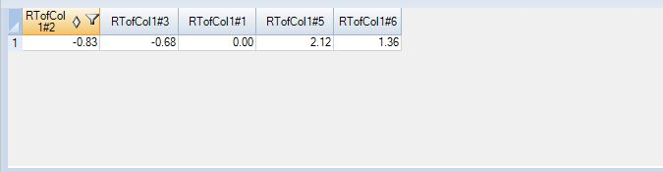

**THE REGR_SLOPE FUNCTION:**

**SELECT** REGR_SLOPE(col1, col2) **AS** RSCol1#2

**FROM** Stats_Table**;**

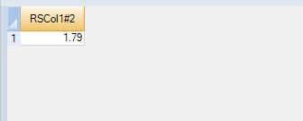

**A REGR_SLOPE EXAMPLE:**

**SELECT** REGR_SLOPE(col1, col2) **AS** RSCol1#2

,REGR_SLOPE(col1, col3) **AS** RSCol1#3

,REGR_SLOPE(col1, col4) **AS** RSCol1#4

,REGR_SLOPE(col1, col5) **AS** RSCol1#5

,REGR_SLOPE(col1, col6) **AS** RSCol1#6

**FROM** Stats_Table**;**

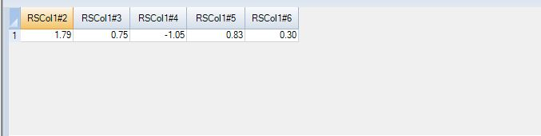

**ANOTHER REGR_SLOPE EXAMPLE:**

**SELECT** REGR_SLOPE(col1, col2) **AS** RSCol1#2

,REGR_SLOPE(col1, col3) **AS** RSCol1#3

,REGR_SLOPE(col1, col1) **AS** RSCol1#1

,REGR_SLOPE(col1, col5) **AS** RSCol1#5

,REGR_SLOPE(col1, col6) **AS** RSCol1#6

**FROM** Stats_Table**;**

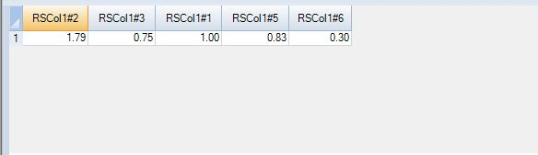

**USING GROUP BY:**

**SELECT** col3

,count(*) **AS** Cnt

,avg(col1) AVG1

,stddev_pop(col1) **AS** SD1

,var_pop(col1) **AS** VP1

,avg(col4) **AS** AVG4

,stddev_pop(col4) **AS** SD4

,var_pop(col4) **AS** VP4

,avg(col6) **AS** AVG6

,stddev_pop(col6) **AS** SD6

,var_pop(col6) **AS** VP6

**FROM** Stats_Table

**GROUP** **BY** 1 **ORDER** **BY** 1**;**

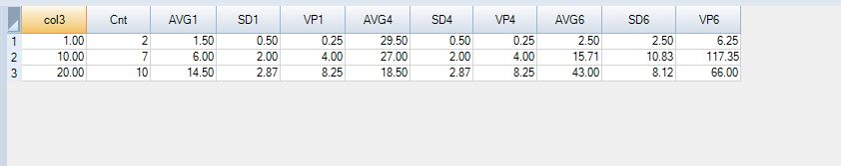

**NO HAVING CLAUSE VS USE OF HAVING CLAUSE:**

**SELECT** col3

,count(*) **AS** Cnt

,avg(col1) AVG1

,stddev_pop(col1) **AS** SD1

,var_pop(col1) **AS** VP1

,avg(col4) **AS** AVG4

,stddev_pop(col4) **AS** SD4

,var_pop(col4) **AS** VP4

,avg(col6) **AS** AVG6

,stddev_pop(col6) **AS** SD6

,var_pop(col6) **AS** VP6

**FROM** Stats_Table

**GROUP** **BY** 1 **ORDER** **BY** 1**;**



**SELECT** col3

,count(*) **AS** Cnt

,avg(col1) AVG1

,stddev_pop(col1) **AS** SD1

,var_pop(col1) **AS** VP1

**FROM** Stats_Table

**GROUP** **BY** 1

**ORDER** **BY** 1

**HAVING** Cnt>2 **AND** VP1<20**;**

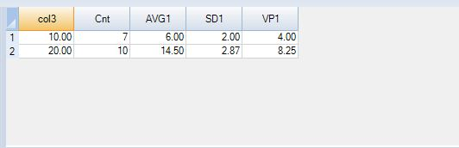

**STORED PROCEDURE FUNCTIONS:**

**STORED PROCEDURE FUNCTIONS:**

**CREATING A STORED PROCEDURE:**

**CREATE** **PROCEDURE** First_Procedure1()

**BEGIN**

**INSERT** **INTO** Customer_Table **DEFAULT** **VALUES;**

**END;**

**HOW TO CALL A STORED PROCEDURE:**

**CREATE** **PROCEDURE** First_Procedure1()

**BEGIN**

**INSERT** **INTO** Customer_Table **DEFAULT** **VALUES;**

**END;**

**CALL** First_Procedure1()**;**

**SELECT** * **FROM** CUSTOMER_TABLE**;**

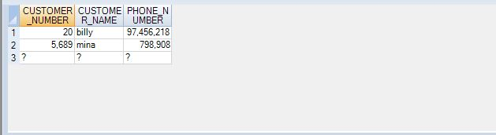

**LABEL ALL BEGIN AND END STATEMENTS EXCEPT FIRST ONES:**

**CREATE** **PROCEDURE** Second_Procedure1()

**BEGIN**

**INSERT** **INTO** Customer_Table **DEFAULT** **VALUES;**

SecondSection:**BEGIN**

**DELETE** **FROM** Customer_Table **WHERE** CUSTOMER_NUMBER **IS** **NULL;**

**END** SecondSection**;**

**END;**

**CALL** Second_Procedure1()**;**

**HOW TO DECLARE A VARIABLE:**

**CREATE** **PROCEDURE** Declare_Procedure2()

**BEGIN**

**DECLARE** var1 INTEGER **DEFAULT** 11111111**;**

**DELETE** **FROM** Customer_Table **WHERE** CUSTOMER_NUMBER=:var1**;**

**END;**

**CALL** Declare_Procedure2()**;**

**HOW TO DECLARE A VARIABLE AND THEN SET THE VARIABLE:**

**CREATE** **PROCEDURE** SetVar_Procedure2()

**BEGIN**

**DECLARE** var1 INTEGER**;**

**SET** var1=31313131**;**

**DELETE** **FROM** Customer_Table **WHERE** CUSTOMER_NUMBER=:var1**;**

**END;**

**CALL** SetVar_Procedure2()**;**

**AN IN VARIABLE IS PASSED TO THE PROCEDURE DURING THE CALL:**

**CREATE** **PROCEDURE** PassInput_Procedure2(**IN** var1 INTEGER)

**BEGIN**

**DELETE** **FROM** Customer_Table **WHERE** CUSTOMER_NUMBER=:var1**;**

**END;**

**CALL** PassInput_Procedure2(31323134)**;**

**THE IN, OUT AND INOUT PARAMETERS :**

**CREATE** **PROCEDURE** Test_Proc2(**IN** var1 BYTEINT,**IN** var2 BYTEINT,**OUT** Msg CHAR(20))

**BEGIN**

**CASE** **WHEN** var1=var2 **THEN** **SET** Msg='They are equal'**;**

**WHEN** var1<var2 **THEN** **SET** Msg='Variable1 less'**;**

**ELSE** **SET** Msg='Variable1 greater'**;**

**END CASE;**

**END;**

**CALL** Test_Proc2(1,2,Msg)

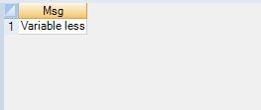

**USING IF INSIDE A STORED PROCEDURE:**

**CREATE** **PROCEDURE** Testif_Proc2(**IN** var1 BYTEINT,**IN** var2 BYTEINT,**OUT** Msg CHAR(20))

**BEGIN**

**IF** var1=var2 **THEN** **SET** Msg='They are equal'**;**

**END IF;**

**IF** var1<var2 **THEN** **SET** Msg='Variable1 less'**;**

**END IF;**

**IF** var1>var2 **THEN** **SET** Msg='Variable1 greater'**;**

**END IF;**

**END;**

**CREATE** **PROCEDURE** Testif1_Proc2(**IN** var1 BYTEINT,**IN** var2 BYTEINT,**OUT** Msg CHAR(20))

**BEGIN**

**IF** var1=var2 **THEN** **SET** Msg='They are equal'**;**

**END IF;**

**IF** var1<var2 **THEN** **SET** Msg='Variable1 less'**;**

**END IF;**

**IF** var1>var2 **THEN** **SET** Msg='Variable1 greater'**;**

**END IF;**

**ELSE** **SET** Msg='variable 1 is greater'**;**

**END IF;**

**END;**

**USING LOOPS IN STORED PROCEDURE:**

CREATE TABLE My_Log_Tbl1(

Cntr Integer

,TheTime Time

)Primary Index(Cntr)**;**

CREATE PROCEDURE Inserter_Five1( )

LOOPER:BEGIN

DECLARE Cntr INTEGER DEFAULT 0**;**

Loopin:LOOP

SET Cntr=Cntr+1**;**

IF Cntr>5 THEN LEAVE Loopin**;**

END IF**;**

INSERT INTO My_Log_Tbl1 VALUES(:Cntr,Time)**;**

ENDLOOP Loopin**;**

END LOOPER**;**

CALL INSERTER_FIVE1()

SELECT * FROM MY_LOG_TB11

ORDER BY 1;

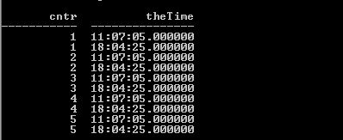

**NAMING THE FIRST BEGIN AND END:**

CREATE TABLE My_Log_Tbl1(

Cntr Integer

,TheTime Time

)Primary Index(Cntr)**;**

CREATE PROCEDURE Inserter_Five1( )

LOOPER:BEGIN

DECLARE Cntr INTEGER DEFAULT 0**;**

Loopin:LOOP

SET Cntr=Cntr+1**;**

IF Cntr>5 THEN LEAVE Loopin**;**

END IF**;**

INSERT INTO My_Log_Tbl1 VALUES(:Cntr,Time)**;**

ENDLOOP Loopin**;**

END LOOPER**;**

CALL INSERTER_FIVE1()

SELECT * FROM MY_LOG_TB11

ORDER BY 1;



**USING KEYWORDS LEAVE VS UNTIL LEAVE REPEAT:**

**PROCEDURE ONE:**

CREATE PROCEDURE Ins_5_1( )

LOOPER:BEGIN

DECLARE Cntr INTEGER DEFAULT 0**;**

Loopin:LOOP

SET Cntr=Cntr+1**;**

IF Cntr>5 THEN LEAVE Loopin**;**

END IF**;**

INSERT INTO My_Log_Tbl1 VALUES(:Cntr,Time)**;**

ENDLOOP Loopin**;**

END LOOPER**;**

**PROCEDURE TWO:**

CREATE PROCEDURE Ins_5A_1( )

LOOPER:BEGIN

DECLARE Cntr INTEGER DEFAULT 0**;**

Loopin:REPEAT

SET Cntr=Cntr+1**;**

IF Cntr>5 THEN LEAVE Loopin**;**

END IF**;**

INSERT INTO My_Log_Tbl1 VALUES(:Cntr,Time);

UNTIL cntr>4;

ENDREPEAT Loopin**;**

END LOOPER**;**

**STORED PROCEDURE FOR BASIC ASSIGNMENT:**

**CREATE** **MULTISET** **TABLE** TD_BIM_FR_TRNG_DB.InsProcXYZ1

(col1 INTEGER,

col2 INTEGER)**Primary** **Index**(col1)**;**

**CREATE** **PROCEDURE** TD_BIM_FR_TRNG_DB.InsProc1()

**BEGIN**

**DECLARE** MyNumber INTEGER **DEFAULT** 0**;**

**SET** MyNumber=1000**;**

MYLOOP:**LOOP**

**SET** MyNumber=MyNumber+1**;**

**IF** MyNumber=2000 **THEN** **LEAVE** MYLOOP**;**

**END IF;**

**INSERT** **INTO** TD_BIM_FR_TRNG_DB.InsProcXYZ1 **VALUES**(:MyNumber,:MyNumber MOD 250)**;**

**END LOOP** MYLOOP**;**

**END;**

**CALL** TD_BIM_FR_TRNG_DB.InsProc1();

**SELECT** **DISTINCT**(col2) **FROM** TD_BIM_FR_TRNG_DB.InsProcXYZ1

**ORDER** **BY** 1**;**

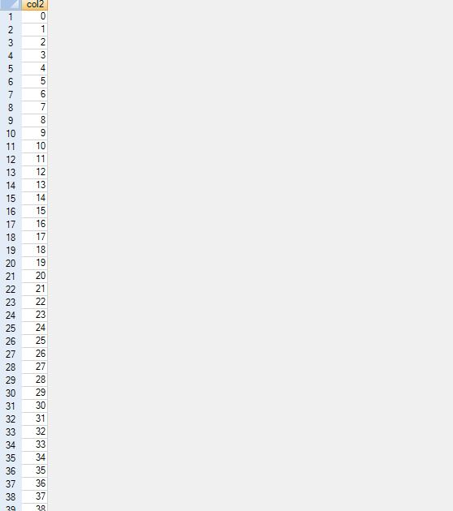

**STORED PROCEDURE FOR ADVANCED ASSIGNMENT:**

**CREATE** **MULTISET** **TABLE** TD_BIM_FR_TRNG_DB.InsProc2_XYZ

(col1 INTEGER,

col2 INTEGER)**Primary** **Index**(col1)**;**

**CREATE** **MULTISET** **TABLE** TD_BIM_FR_TRNG_DB.InsProc3_XYZ

(col1 INTEGER,

col2 INTEGER)**Primary** **Index**(col1)**;**

**CREATE** **PROCEDURE** TD_BIM_FR_TRNG_DB.adv_assg2()

**BEGIN**

**DECLARE** MyNumber INTEGER **DEFAULT** 0**;**

**SET** MyNumber=1000**;**

MYLOOP:**LOOP**

**SET** MyNumber=MyNumber+1**;**

**IF** MyNumber>2000 **THEN** **LEAVE** MYLOOP**;**

**END IF;**

**INSERT** **INTO** TD_BIM_FR_TRNG_DB.InsProc2_XYZ **VALUES**(:MyNumber MOD 500,:MyNumber MOD 100)**;**

**INSERT** **INTO** TD_BIM_FR_TRNG_DB.InsProc_3XYZ **VALUES**(:MyNumber MOD 200,:MyNumber MOD 40)**;**

**END LOOP** MYLOOP**;**

**END;**

**CALL** TD_BIM_FR_TRNG_DB.adv_assg2()**;**

**SELECT** COUNT(**DISTINCT**(col1)),COUNT(**DISTINCT**(col1)) **FROM** TD_BIM_FR_TRNG_DB.InsProc2_XYZ**;**

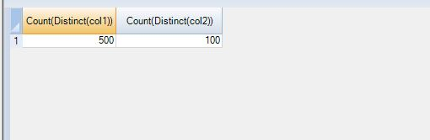

**SELECT** COUNT(**DISTINCT**(col1)),COUNT(**DISTINCT**(col1)) **FROM** TD_BIM_FR_TRNG_DB.InsProc3_XYZ**;**

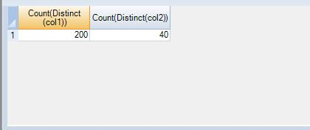

**Sub-query Functions**

**employee_table department_table**

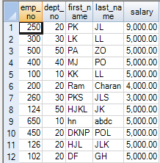 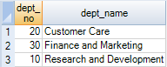

**IN LIST**

**select** * **from** employee_table

**where** dept_no **IN** (10,20)**;**

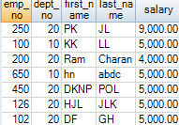

**select** * **from** employee_table

**where** dept_no **IN** (10,10,20,20)**;**

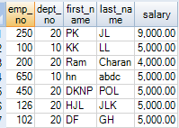

**Working of SUBQUERY**

**select** * **from** employee_table

**where** dept_no **IN** (**select** dept_no

**from** department_table )**;**

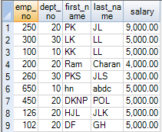

**QUIZ:**

**Using subquery:**

**select** * **from** employee_table

**where** dept_no **IN** (**select** dept_no

**from** department_table )**;**



**Using Join:**

**select** E.*

**from** employee_table **as** E

**Inner** **JOIN**

department_table **as** D

**on** E.dept_no = D.dept_no**;**

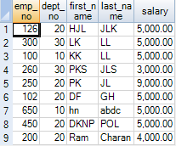

**Quiz:**

**Cutomer_table order_table**

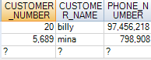 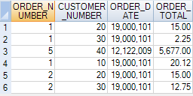

**select** * **from** customer_table

**where** customer_number **IN** (**select** customer_number

**from** order_table )**;**



**select** * **from** customer_table

**where** customer_number **IN** (**select** customer_number

**from** order_table

**where** order_total > 10)**;**



**Quiz: Subquery with an aggregate**

**select** * **from** employee_table

**where** salary > (**select** avg(salary)

**from** employee_table)**;**



**Quiz: Correlated Subquery**

**select** * **from** employee_table **as** EE

**where** salary > (**select** avg(salary)

**from** employee_table **as** eeee

**where** ee.dept_no = eeee.dept_no)**;**



**Correlated subquery example vs a join with a derived table**

**Correlated subquery**

**select** last_name, dept_no,salary

**from** employee_table **as** EE

**where** salary > (**select** avg(salary)

**from** employee_table **as** eeee

**where** ee.dept_no = eeee.dept_no)**;**



**Join with a derived table**

**select** E.*, AVGSAL

**from** employee_table **as** E

**INNER** **JOIN** (**select** dept_no, avg(salary)

**from** employee_table

**group** **by** dept_no)

**as** teratom (depty, avgsal)

**on** dept_no=depty

**and** salary> avgsal**;**



**Quiz:**



**Sales_Table**

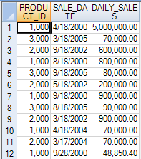

**select** * **from** sales_table **as** tops

**where** daily_sales > (

**select** avg ( daily_sales)

**from** sales_table **as** bots

**where** tops.product_id = bots.product_id)

**order** **by** product_id, sale_date**;**

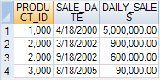

Quiz:



**select** * **from** sales_table **as** tops

**where** daily_sales > (

**select** avg ( daily_sales)

**from** sales_table **as** bots

**where** tops.sale_date = bots.sale_date)

**order** **by** sale_date**;**

Quiz:

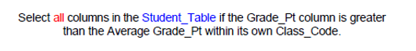

**select** * **from** student_table **as** top5

**where** grade_pt > (

**select** avg ( grade_pt)

**from** student_table **as** bot5

**where** top5.class_code = bot5.class_code)

**order** **by** class_code**;**

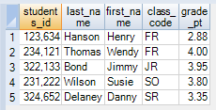

Quiz:

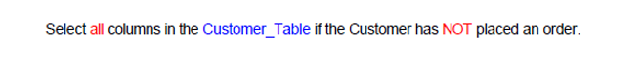

**select** * **from** customer_table

**where** customer_number **NOT** **IN**

(**select** customer_number **from** order_table

**where** customer_number **is** **not** **null**)**;**



**Subquery with two parameters**

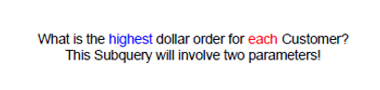

**select** customer_number, order_number, order_total **from** order_table

**where** (customer_number,order_total) **IN**

(**select** customer_number, max(order_total)

**from** order_table

**group** **by** 1)**;**

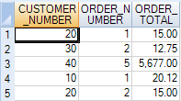

**Triple Subquery**

**Quiz:**

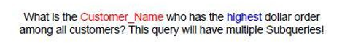

**select** customer_number **from** customer_table

**where** customer_number **IN**

( **select** customer_number

**from** order_table

**where** order_total **IN**

(**select** max(order_total)

**from** order_table) )**;**

**Rows return on a Not In with NULL**

**select** customer_number

**from** customer_table

**where** customer_number **NOT** **IN**

(**select** customer_number

**from** order_table )**;**



**Using ANY instead of IN**

**select** customer_number, customer_name

**from** customer_table

**where** customer_number = ANY

(**select** customer_number

**from** order_table)**;**



**Using correlated exists**

**select** customer_number, customer_name

**from** customer_table **as** TOP1

**where** EXISTS (**select** * **from** order_table **as** BOT1

**where** top1.customer_number=bot1.customer_number)**;**

The **correlated not exists**

**select** customer_number, customer_name

**from** customer_table **as** TOP1

**where NOT** EXISTS (**select** * **from** order_table **as** BOT1

**where** top1.customer_number=bot1.customer_number)**;**

