**LAB 02**

**Distinct Vs Group By Functions**

**Distinct Command**

It eliminates duplicates from returning in answer sheet

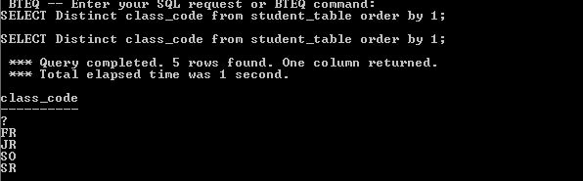

**Distinct vs Group BY**

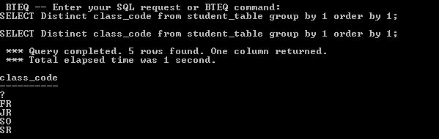

**Group BY vs Distinct**

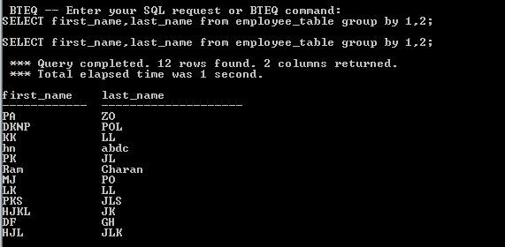

**ORDER BY**

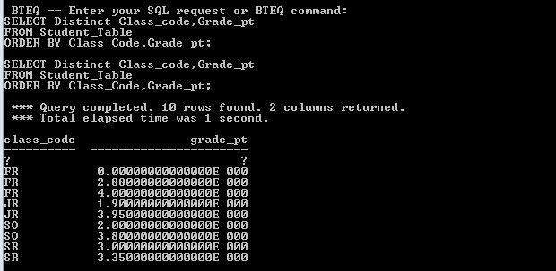

**EXPLAIN**

Unique Primary Index

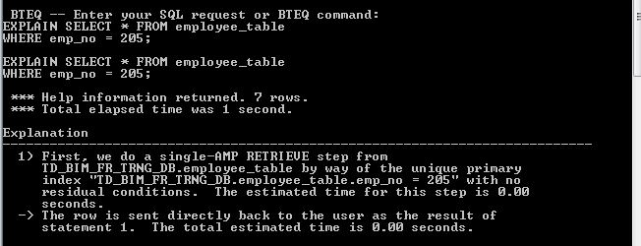

Non-Unique Primary Index

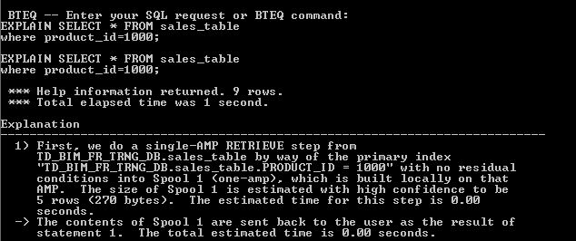

**Unique Secondary Index**



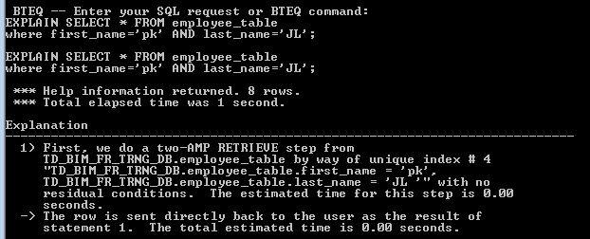

EXPLAIN- Redistributed to ALL-AMP’s

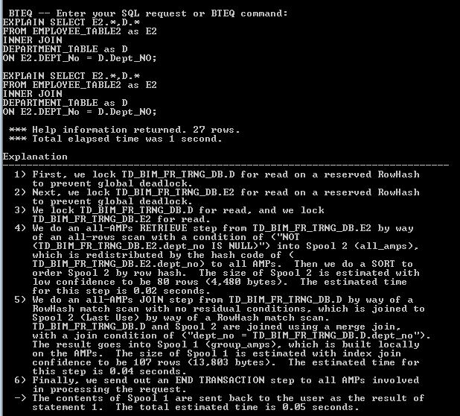

EXPLAIN- ROW HASH MATCH SCAN

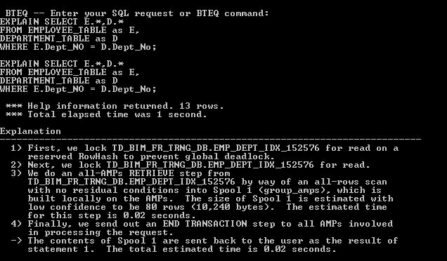

**EXPLAIN – LOW CONFIDENCE**

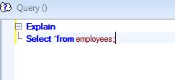

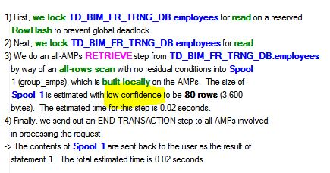

**EXPLAIN – High Confidence**

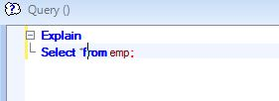

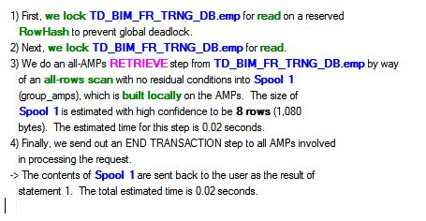

**EXPLAIN – Product Join**

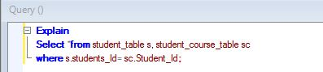

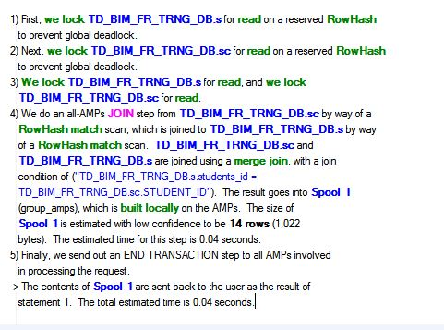

**EXPLAIN- BMSMS**

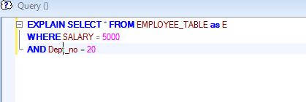

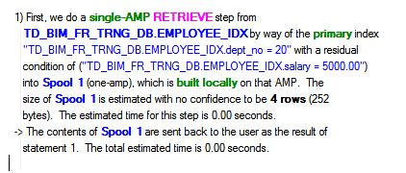

**EXPLAIN – From Single Partitions**

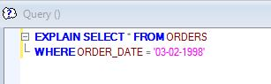

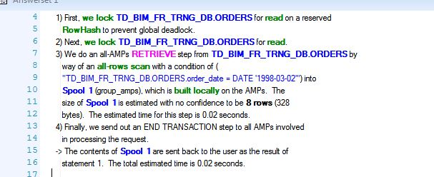

**EXPLAIN – From N Partitions**

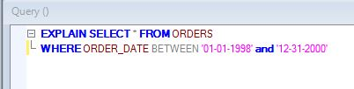

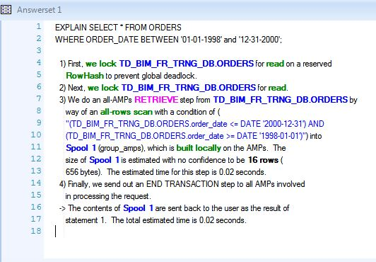

**EXPLAIN – Partitions and Current_Date**

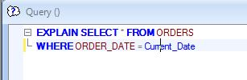

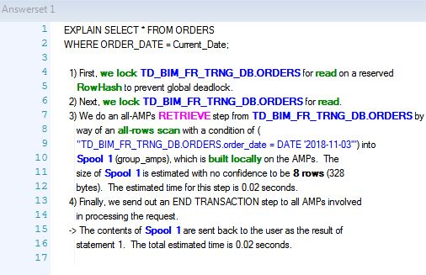

**FORMAT FUNCTIONS**

FORMAT COMMAND

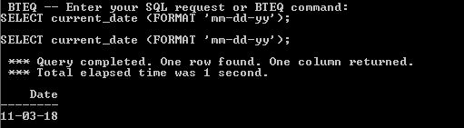

Formatting with MMMM

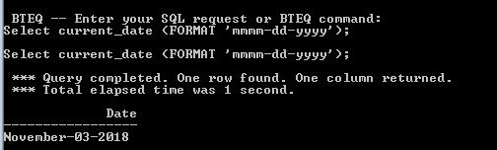

Formatting with MMM

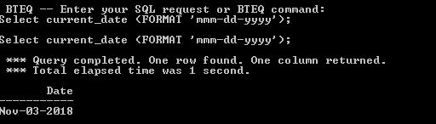

Formatting with EEE for Day of week

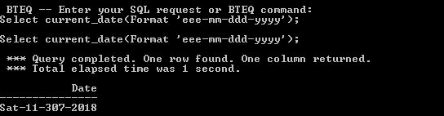

Formatting with EEEE for Day of week

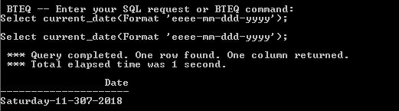

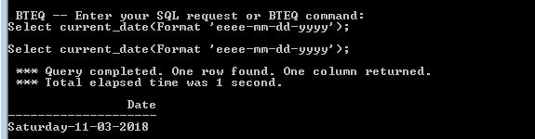

Formatting Spaces with B or b

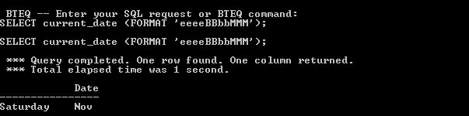

Formatting with 9

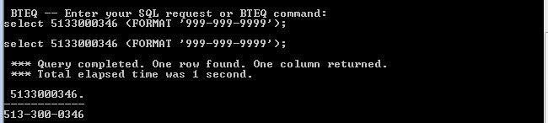

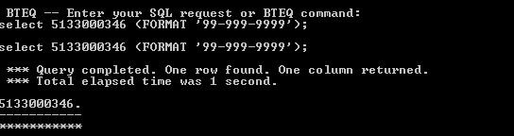

Formatting with X or x

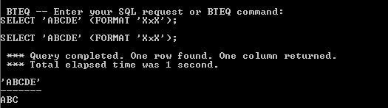

Formatting with Z Visual

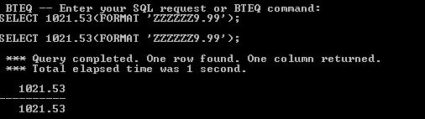

Formatting with 9

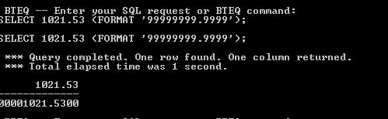

Formatting with $

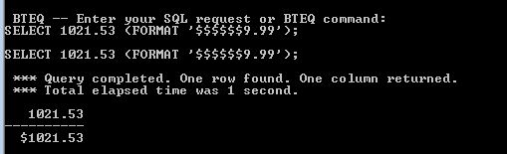

Formatting with $ and Commas

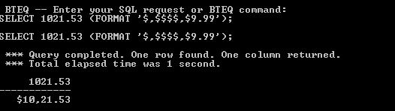

Formatting with $ and Commas and 9

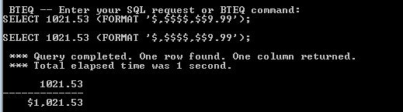

**Formatting with $ and commas and 9 with zero dollars**

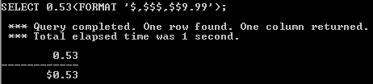

**A Great Formatting Example**

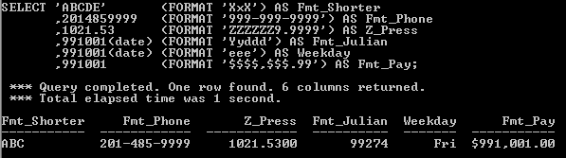

**A great example to perform format operations on day, month and year**

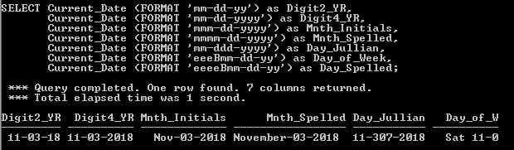

**A trick to get sql assistant to get format data**

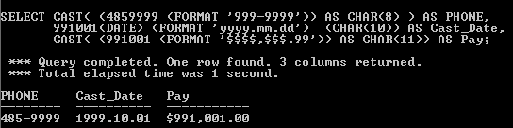

**USING THE CASESPECIFIC(CS) COMMAND IN TERADATA**

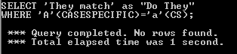

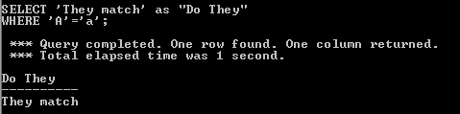

**USING THE NOT CASESPECIFIC COMMAND IN ANSI MODE**

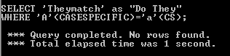

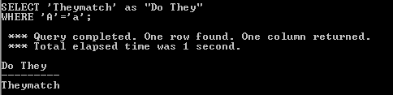

**USING THE LOWER COMMAND**

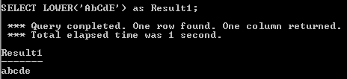

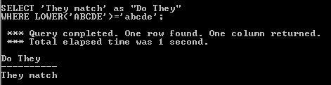

**USING THE UPPER COMMAND**

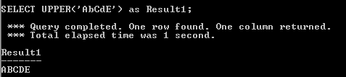

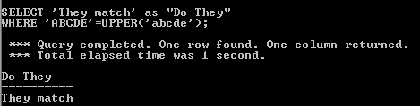

**HELP AND SHOW COMMANDS**

**Determining the release of your terdata system**

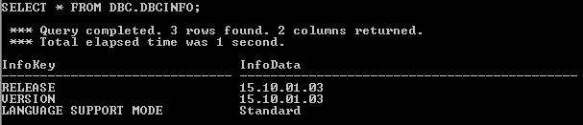

**HELP USER**

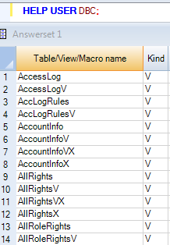

**HELP TABLE**

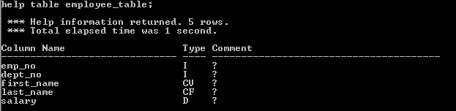

**ADDING COMMENT TO A TABLE**



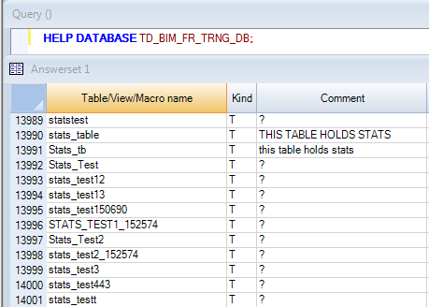

**ADDING COMMENT TO A VIEW**



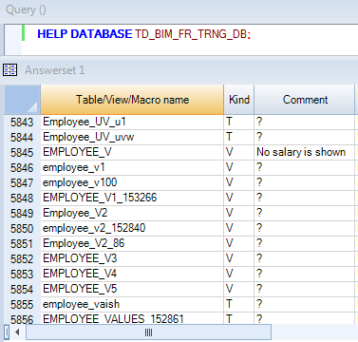

**SELECT SESSION**

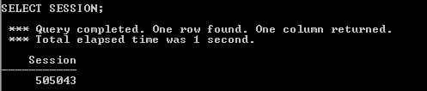

**HELP SESSION**

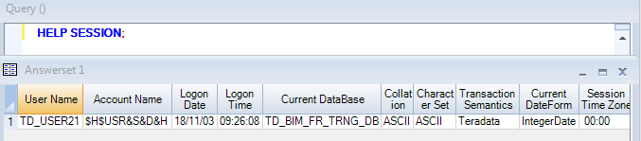

**HELP SQL**

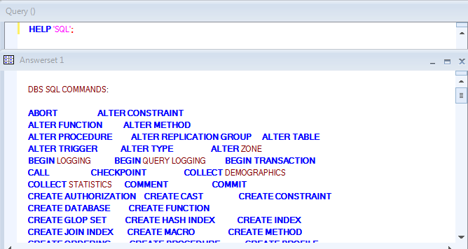

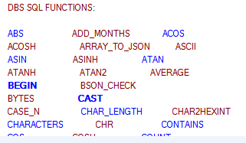

**A HELP SQL EXAMPLE**

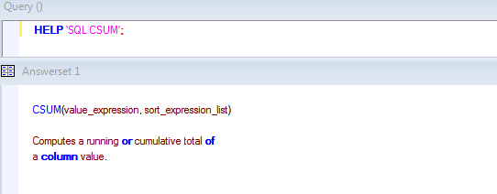

**SHOW TABLE COMMAND FOR TABLE DDL**

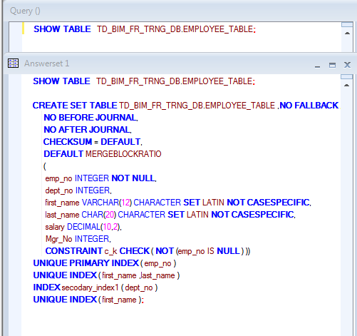

**SHOW VIE COMMAND FOR VIEW CREATE STATEMENT**

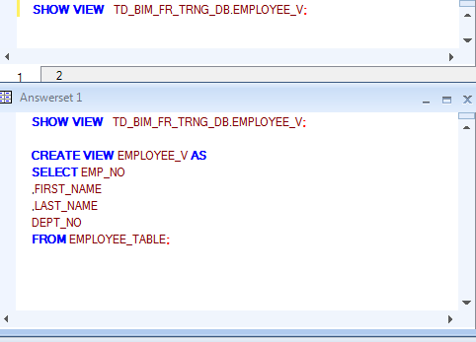

**JOIN FUNCTIONS**

**A TWO TABLE JOIN USING NON_ANSI SYNTAX**

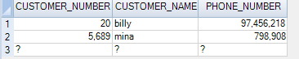

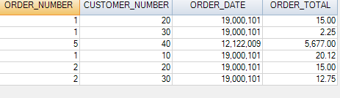

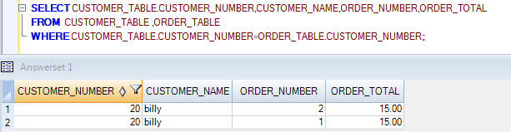

**A TWO TABLE JOIN USING NON_ANSI SYNTAX WITH TABLE ALIAS**

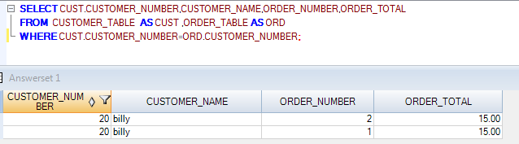

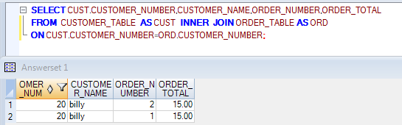

**INNER JOIN**

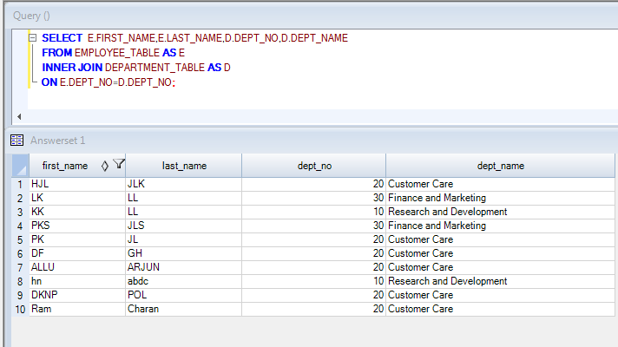

**LEFT OUTER JOIN**

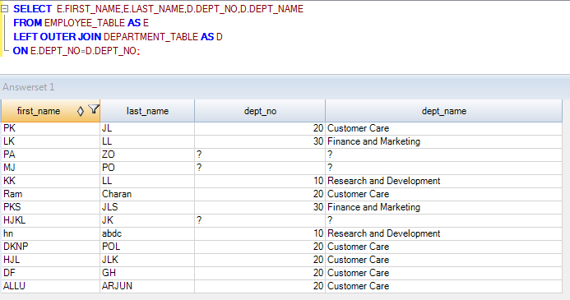

**RIGHT OUTER JOIN**

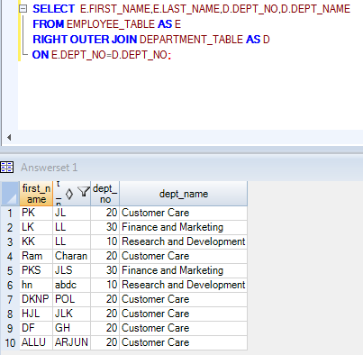

**FULL OUTER JOIN**

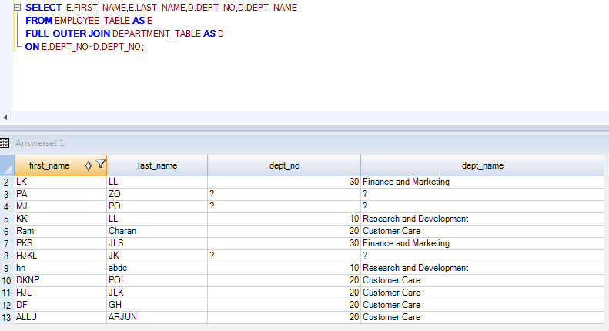

**ANSI INNER JOIN WITH ADDITIONAL AND CLAUSE**

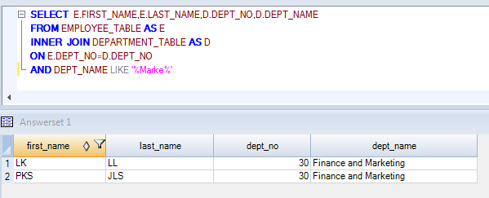

**OUTEER JOIN WITH ADDITIONAL AND CLAUSE**

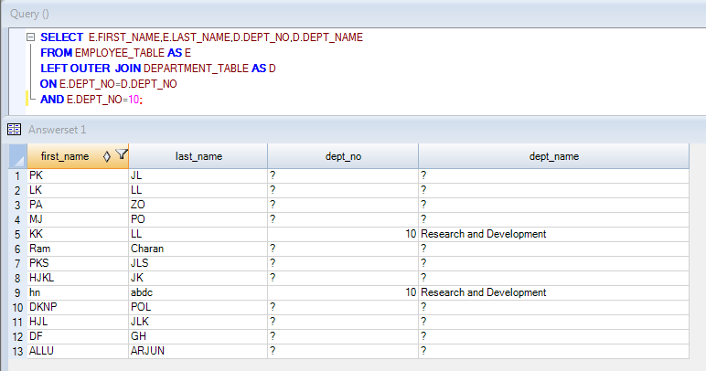

**Formatting with $ and commas and 9 with zero dollars**



**A Great Formatting Example**



**A great example to perform format operations on day, month and year**



**A trick to get sql assistant to get format data**



**USING THE CASESPECIFIC(CS) COMMAND IN TERADATA**





**USING THE NOT CASESPECIFIC COMMAND IN ANSI MODE**





**USING THE LOWER COMMAND**





**USING THE UPPER COMMAND**





**HELP AND SHOW COMMANDS**

**Determining the release of your terdata system**



**HELP USER**



**HELP TABLE**



**ADDING COMMENT TO A TABLE**





**ADDING COMMENT TO A VIEW**





**SELECT SESSION**



**HELP SESSION**



**HELP SQL**





**A HELP SQL EXAMPLE**



**SHOW TABLE COMMAND FOR TABLE DDL**



**SHOW VIE COMMAND FOR VIEW CREATE STATEMENT**



**JOIN FUNCTIONS**

**A TWO TABLE JOIN USING NON_ANSI SYNTAX**







**A TWO TABLE JOIN USING NON_ANSI SYNTAX WITH TABLE ALIAS**





**INNER JOIN**



**LEFT OUTER JOIN**



**RIGHT OUTER JOIN**



**FULL OUTER JOIN**



**ANSI INNER JOIN WITH ADDITIONAL AND CLAUSE**



**OUTEER JOIN WITH ADDITIONAL AND CLAUSE**

