**Math Functions**

**What is the answer to this Math Question?**

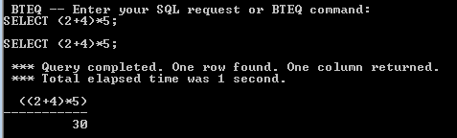

**What is the answer to this Math Question?**

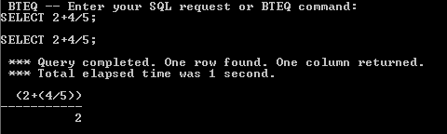

**What is the answer to this Math Question?**

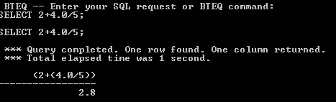

**OLAP Functions**

**Calculate the Cumulative Sum after Sorting the date**

SELECT Product_ID, Sale_Date, Daily_Sales

,CSUM(Daily_Sales, Sale_Date) AS “CSUM”

FROM Sales_Table;

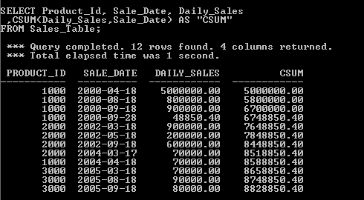

**OLAP Major Sort Key**

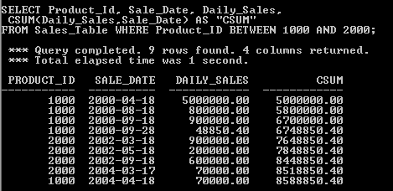

**The OLAP Major Key and Minor Key**

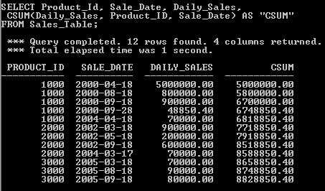

**GROUP BY In TERADATA OLAP Syntax**

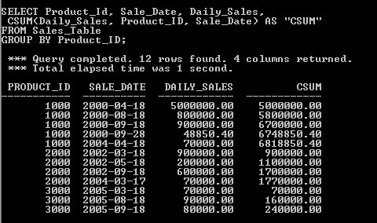

**CSUM the Number 1 to get Sequential Number**

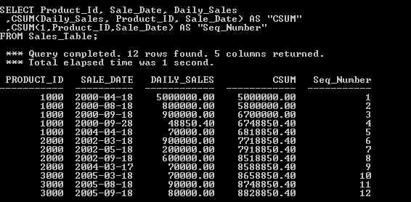

**Using GROUP BY**

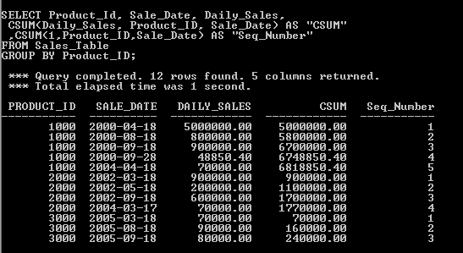

**ANSI CSUM**

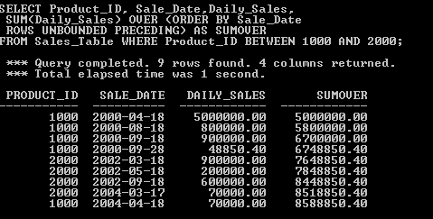

**The ANSI CSUM Major and Minor Sort Keys**

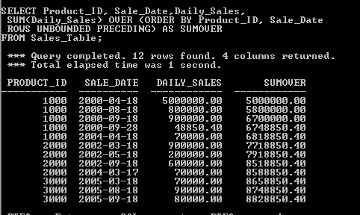

**ANSI CSUM Getting Sequential Number**

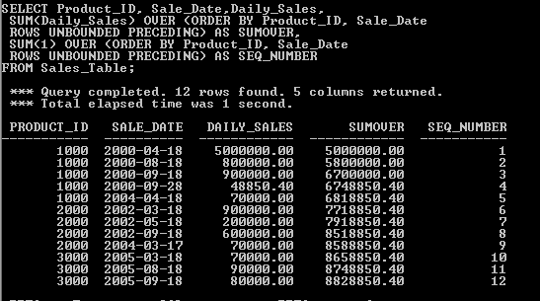

**The ANSI OLAP Reset with PARTITION BY**

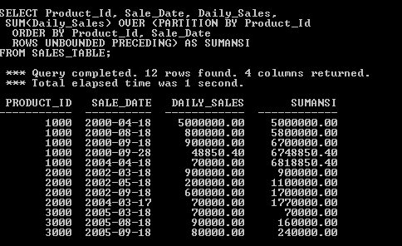

**PARTITION BY Single OLAP function**

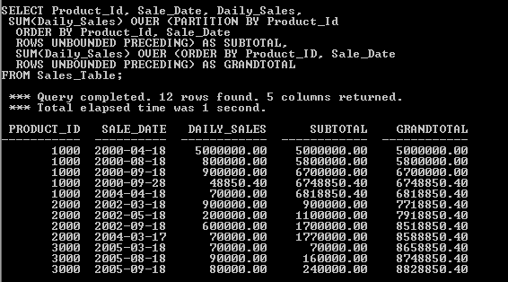

**MSUM**

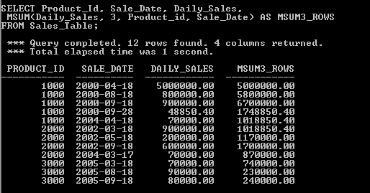

**GROUP BY in MSUM**

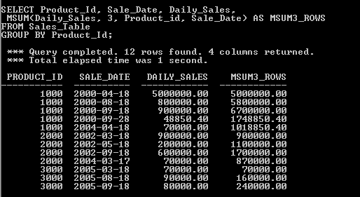

**Both Teradata Moving Sum and ANSI Version**

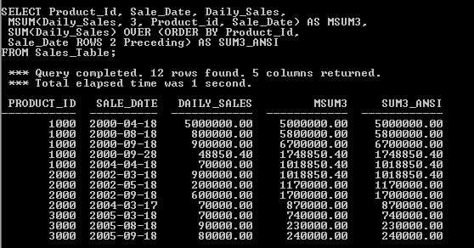

**MSUM for every 3 rows vs Continuous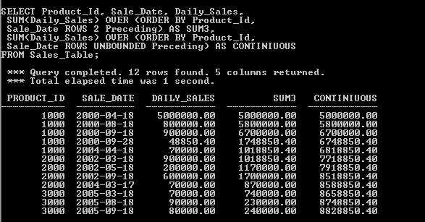Partition By using ANSI**

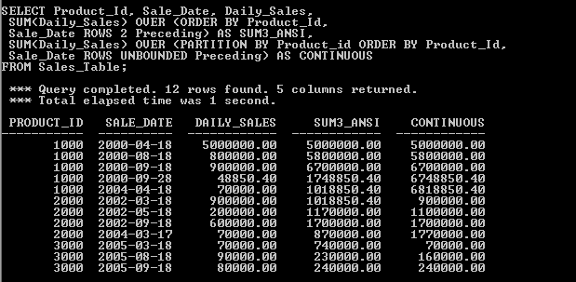

**Moving Average**

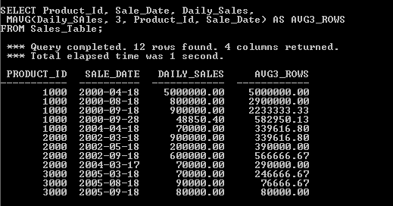

SELECT Product_ID, Sale_Date, Daily_Sales,

MAVG(Daily_Sales, 3, Product_ID, Sale_Date) AS AVG3_Rows

FROM Sales_Table

GROUP BY Product_ID;

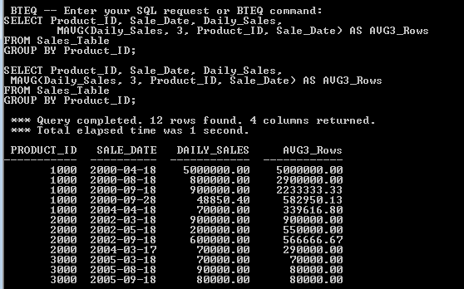

**Both the Teradata Moving Average and ANSI Version**

SELECT Product_ID, Sale_Date, Daily_Sales,

MAVG(Daily_Sales, 3, Product_ID, Sale_Date) AS AVG_3,

AVG(Daily_Sales) OVER (ORDER BY Product_ID,

Sale_Date ROWS 2 Preceding) AS AVG_3_ANSI

FROM Sales_Table;

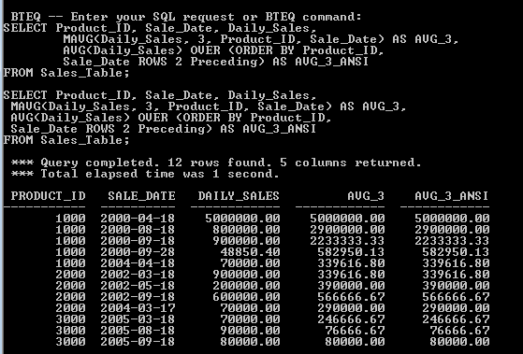

**How is the total calculated?**

SELECT Product_ID, Sale_Date, Daily_Sales,

AVG(Daily_Sales) OVER (ORDER BY Product_ID,

Sale_Date ROWS 2 Preceding) AS AVG_3_ANSI

FROM Sales_Table;

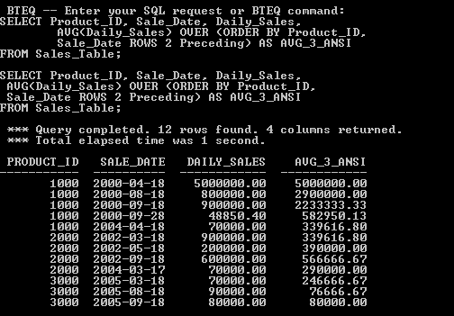

**Moving average every 3 rows Vs. a continuous average**

SELECT Product_ID, Sale_Date, Daily_Sales,

AVG(Daily_Sales) OVER (ORDER BY Product_ID, Sale_Date

ROWS 2 Preceding) AS AVG3,

AVG(Daily_Sales) OVER (ORDER BY Product_ID, Sale_Date

ROWS UNBOUNDED Preceding) AS Continuous

FROM Sales_Table;

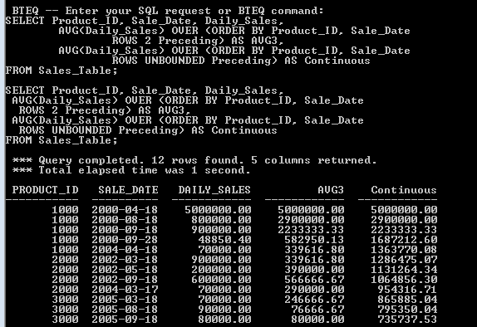

**Partition BY Resets an ANSI OLAP**

SELECT Product_ID, Sale_Date, Daily_Sales,

AVG(Daily_Sales) OVER (ORDER BY Product_ID, Sale_Date

ROWS 2 Preceding) AS AVG3,

AVG(Daily_Sales) OVER (PARTITION BY Product_ID

ORDER BY Product_ID, Sale_Date

ROWS UNBOUNDED Preceding) AS Continuous

FROM Sales_Table;

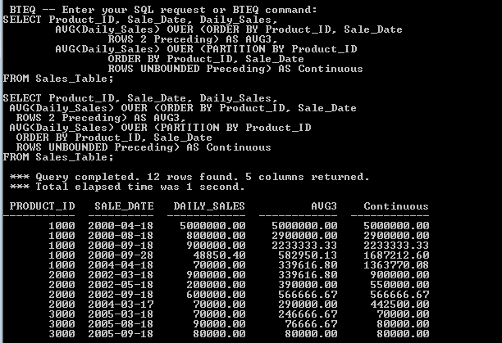

**The Moving Difference(MDIFF)**

SELECT Product_ID, Sale_Date, Daily_Sales,

MDIFF(Daily_Sales, 4, Product_ID, Sale_Date) AS "MDiff"

FROM Sales_Table;

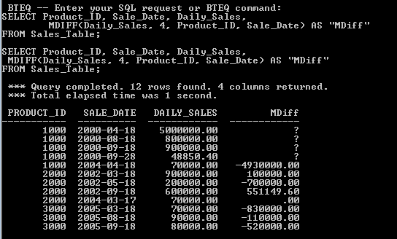

**Trouble Shooting the Moving Difference(MDIFF)**

SELECT Product_ID, Sale_Date, Daily_Sales,

MDIFF(Daily_Sales, 7, Product_ID, Sale_Date) AS Compare2Rows

FROM Sales_Table

GROUP BY Product_ID;

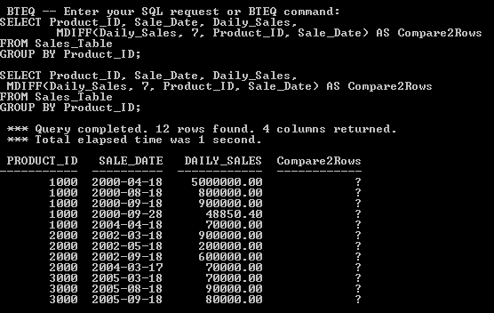

**Using the RESET WHEN option in Teradata(V13)**

SELECT Product_ID, Sale_Date, Daily_Sales,

ROW_NUMBER() OVER (PARTITION BY Product_ID ORDER BY Sale_Date

RESET WHEN Daily_Sales <= SUM(Daily_Sales)

OVER (PARTITION BY Product_ID ORDER BY Sale_Date

ROWS BETWEEN 1 PRECEDING AND 1 PRECEDING )) -1 AS Increases

FROM Sales_Table

WHERE Product_ID BETWEEN 1000 and 2000;

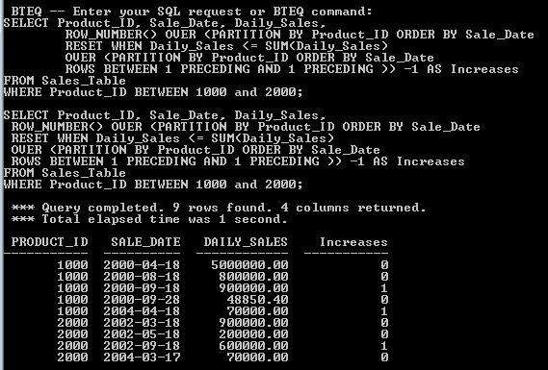

**How Many Months per Product_ID has Revenue Increased?**

**The RANK Command**

SELECT Product_ID, Sale_Date, Daily_Sales,

RANK(Daily_Sales) as "Rank"

FROM Sales_Table WHERE Product_ID IN (1000, 2000);

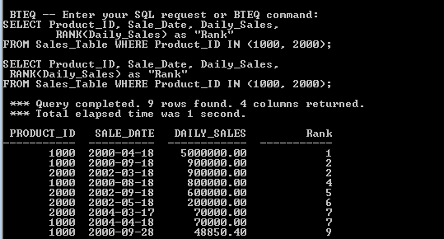

**How to get Rank to Sort in Ascending Order**

SELECT Product_ID, Sale_Date, Daily_Sales,

RANK(Daily_Sales ASC) as "Rank"

FROM Sales_Table WHERE Product_ID IN (1000, 2000);

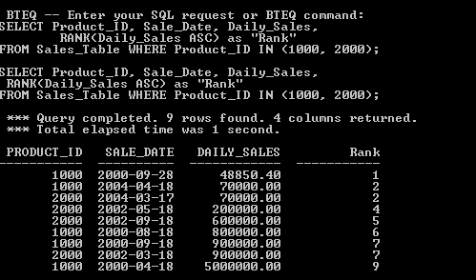

**Method 2**

SELECT Product_ID, Sale_Date, Daily_Sales,

RANK(Daily_Sales ASC) as Rank1,

RANK(-Daily_Sales) as Rank2

FROM Sales_Table WHERE Product_ID IN (1000, 2000);

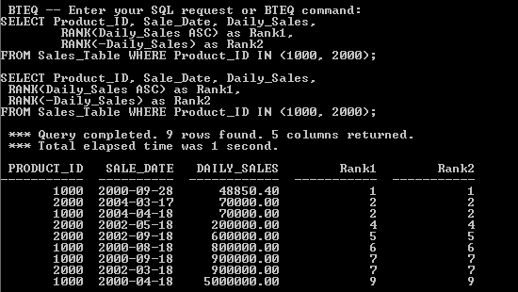

**RANK Using ANSI Syntax Defaults to Ascending order**

SELECT Product_ID, Sale_Date, Daily_Sales,

RANK() OVER( ORDER BY Daily_Sales) as Rank1

FROM Sales_Table WHERE Product_ID IN (1000, 2000);

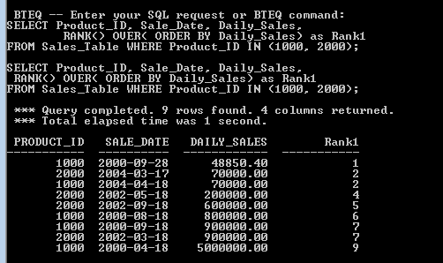

**RANK Using ANSI Syntax Defaults to Sort in Descending Order**

SELECT Product_ID, Sale_Date, Daily_Sales,

RANK() OVER( ORDER BY Daily_Sales DESC) as Rank1

FROM Sales_Table WHERE Product_ID IN (1000, 2000);

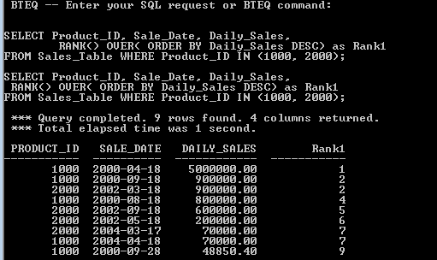

**RANK() OVER AND PARTITION BY**

SELECT Product_ID, Sale_Date, Daily_Sales,

RANK() OVER( PARTITION BY Product_ID ORDER BY Daily_Sales DESC) as Rank1

FROM Sales_Table WHERE Product_ID IN (1000, 2000);

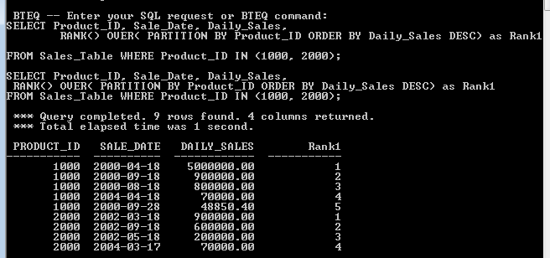

**RANK() OVER AND QUALIFY**

SELECT Product_ID, Sale_Date, Daily_Sales,

RANK() OVER(ORDER BY Daily_Sales DESC) as Rank1

FROM Sales_Table WHERE Product_ID IN (1000, 2000)

QUALIFY Rank1 < 7;

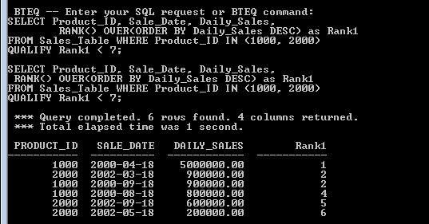

**RANK() OVER AND PARTITION BY WITH A QUALIFY**

SELECT Product_ID, Sale_Date, Daily_Sales,

RANK() OVER(PARTITION BY Product_ID ORDER BY Daily_Sales DESC) as Rank1

FROM Sales_Table WHERE Product_ID IN (1000, 2000)

QUALIFY Rank1 < 4;

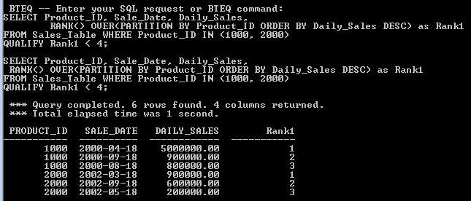

**QUALIFY and WHERE**

SELECT Product_ID, Sale_Date, Daily_Sales,

RANK(Daily_Sales ASC) as Rank1,

RANK(-Daily_Sales) as Rank2

FROM Sales_Table

WHERE Product_ID IN (1000, 2000)

QUALIFY Rank(-Daily_Sales) < 6;

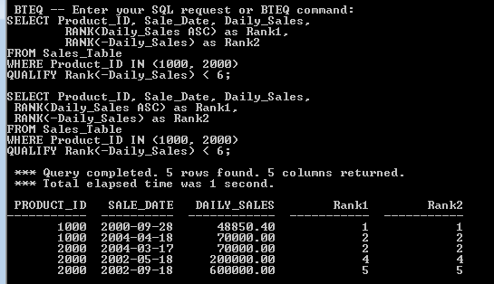

**How to simplify the QUALIFY statement**

SELECT Product_ID, Sale_Date, Daily_Sales,

RANK(Daily_Sales ASC) as Rank1,

RANK(-Daily_Sales) as Rank2

FROM Sales_Table

WHERE Product_ID IN (1000, 2000)

QUALIFY Rank2 < 6;

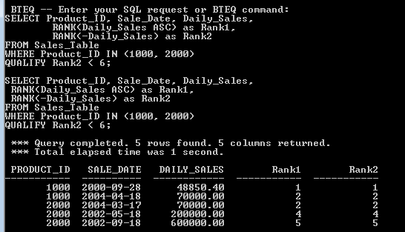

**The QUALIFY statement without TIES**

SELECT Product_ID, Sale_Date, Daily_Sales,

RANK(Daily_Sales) as Rank1

FROM Sales_Table

WHERE Product_ID IN (1000, 2000)

QUALIFY Rank1 < 6;

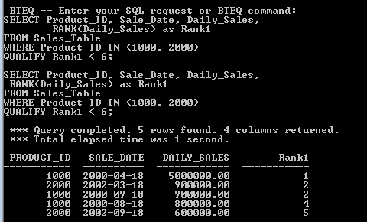

**The QUALIFY statement with TIES**

SELECT Product_ID, Sale_Date, Daily_Sales,

RANK(Daily_Sales ASC) as Rank1

FROM Sales_Table

WHERE Product_ID IN (1000, 2000)

QUALIFY Rank1 < 6;

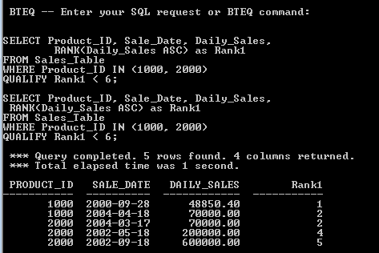

**The QUALIFY statement with TIES Brings Back Extra Rows**

SELECT Product_ID, Sale_Date, Daily_Sales,

RANK(Daily_Sales ASC) as Rank1

FROM Sales_Table

WHERE Product_ID IN (1000, 2000)

QUALIFY Rank1 < 2;

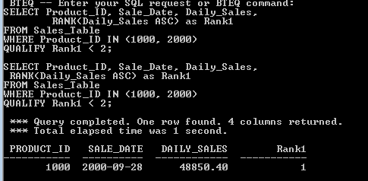

**Mixing sort order by QUALIFY statement**

SELECT Product_ID, Sale_Date, Daily_Sales,

RANK(Daily_Sales) as Rank1

FROM Sales_Table

WHERE Product_ID IN (1000, 2000)

QUALIFY Rank(Daily_Sales ASC) < 6;

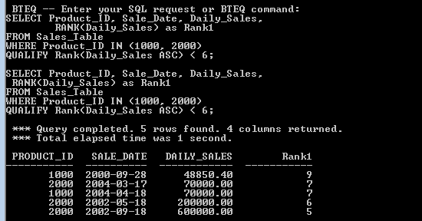

**Rank to RESET**

SELECT Product_ID, Sale_Date, Daily_Sales,

RANK(Daily_Sales) as Rank1

FROM Sales_Table

WHERE Product_ID IN (1000, 2000)

GROUP BY Product_ID

QUALIFY Rank1 < 4;

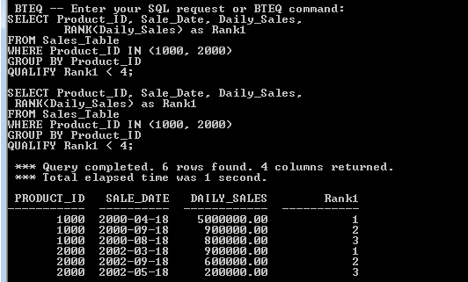

**Name those Sort Orders**

**RANK(Daily_Sales) as NON_ANSI_Rank**

SELECT Product_ID, Sale_Date, Daily_Sales,

RANK(Daily_Sales) as NON_ANSI_Rank1

FROM Sales_Table

WHERE Product_ID IN (1000, 2000)

GROUP BY Product_ID

QUALIFY NON_ANSI_Rank1 < 4;

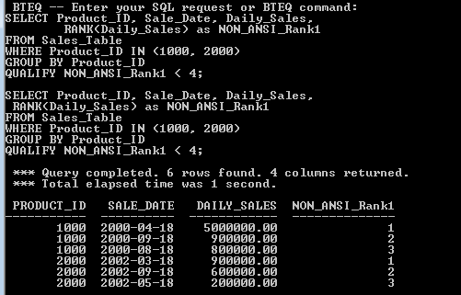

**PERCENT_RANK() OVER**

SELECT Product_ID, Sale_Date, Daily_Sales,

PERCENT_RANK() OVER(PARTITION BY Product_ID

ORDER BY Daily_Sales DESC) as PercentRank1

FROM Sales_Table

WHERE Product_ID IN (1000, 2000);

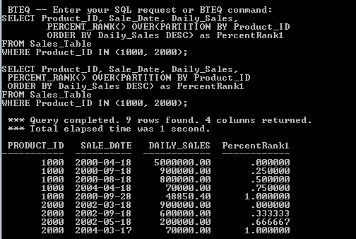

**What causes the Product_ID to reset?**

SELECT Product_ID, Sale_Date, Daily_Sales,

PERCENT_RANK() OVER(PARTITION BY Product_ID ORDER BY Daily_Sales DESC) as PercentRank1

FROM Sales_Table

WHERE Product_ID IN (1000, 2000);

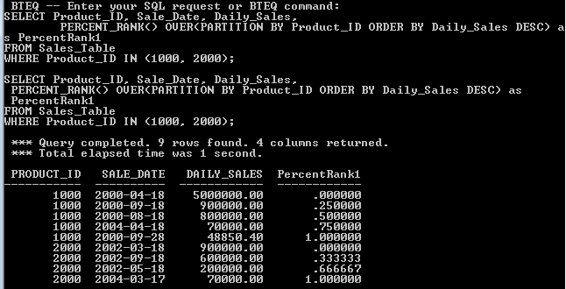

**Substrings and Positioning Functions**

1. THE CHARACTERS COMMAND COUNTS CHARACTER

SELECT FIRST_NAME

,CHARACTERS(FIRST_NAME) AS LNTHS

FROM EMPLOYEE_TABLE

WHERE CHARACTERS(FIRST_NAME) <7

ORDER BY 1;

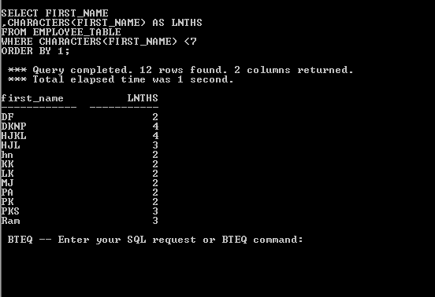

1. THE CHARACTER COMMAND CAN COUNT SPACES TOO

SELECT ` R a m ` AS FIRST_NAME

,CHARACTERS(` R a m `) AS LNTH

FROM EMPLOYEE_TABLE;

1. THE CHARACTER COMMAND AND CHAR(20) DATA

SELECT LAST_NAME

,CHARACTERS(LAST_NAME) AS LNTHS

FROM EMPLOYEE_TABLE

ORDER BY 1;

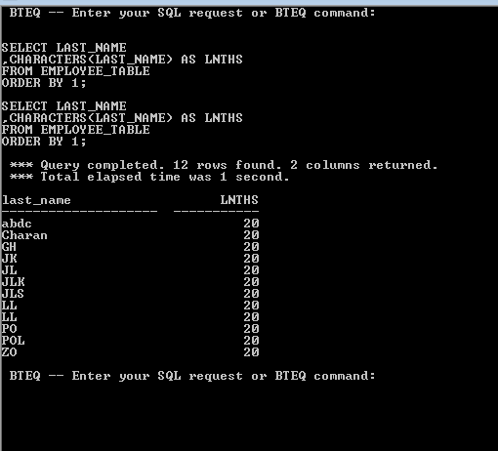

1. TRIM COMMAND

SELECT LAST_NAME

,CHARACTERS(TRIM(LAST_NAME)) AS LNTHS

FROM EMPLOYEE_TABLE

ORDER BY 1;

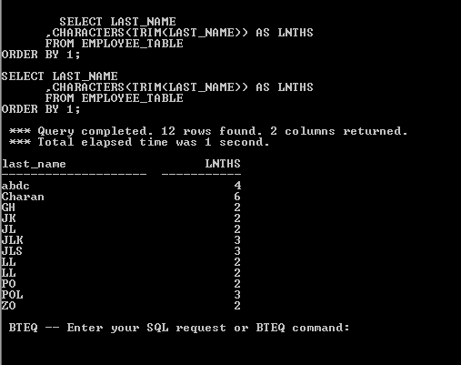

TRIM IS USED FOR TROUBLESHOOTING CHARACTER COMMAND

THE TRIM COMMAND WILL TRIM OFF ALL SPACES BEFORE AND AFTER THE LAST_NAME

1. CHARACTER AND CHARACTER_LENGTH EQUIVALENT

**SELECT** First_Name

,Characters(first_Name) **AS** C_tength

**FROM** Employee_Table**;**

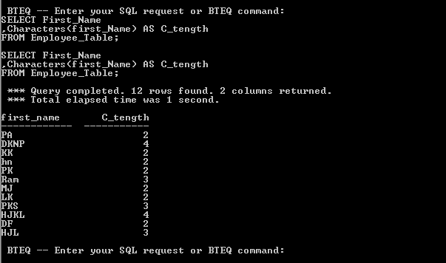

**SELECT** First_Name

,Character_length(first_Name) **AS** C_tength

**FROM** Employee_Table**;**

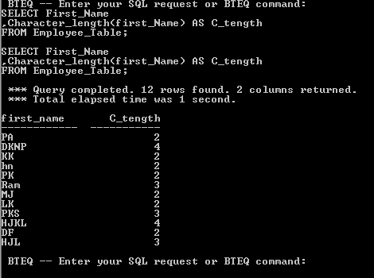

1. OCTET_LENGTH

**SELECT** First_Name

,octet_length(first_Name) **AS** C_tength

**FROM** Employee_Table**;**

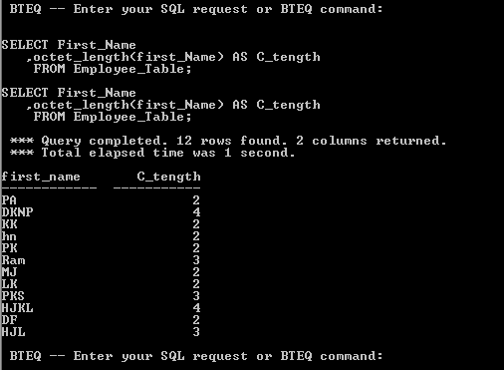

1. The TRIM Command trims both Leading and Trailing Spaces

Select Last_Name

,trim(Last_Name) AS No_Space

FROM Employee_Table;

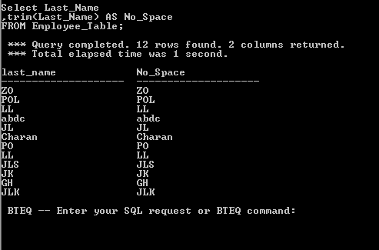

Select Last_Name

,trim(BOTH FROM Last_Name) AS No_Space

FROM Employee_Table;

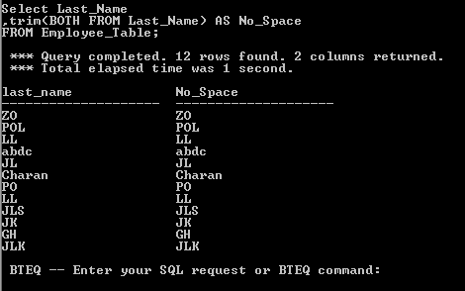

1. **Select** FIRST_NAME

, TRIM(TRAILING 'L' **from** first_name ) **AS** No_L

**FROM** Employee_Table

**ORDER** **BY** 1**;**

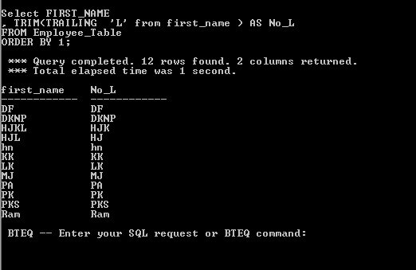

1. TRIM COMBINED WITH CHARACTER COMMAND

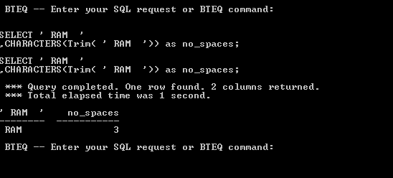

1. TRIM COMBINED WITH TRAIL

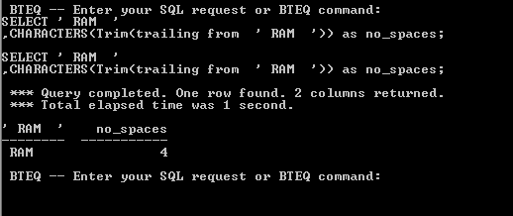

1. TRIMING TRAILING LETTERS

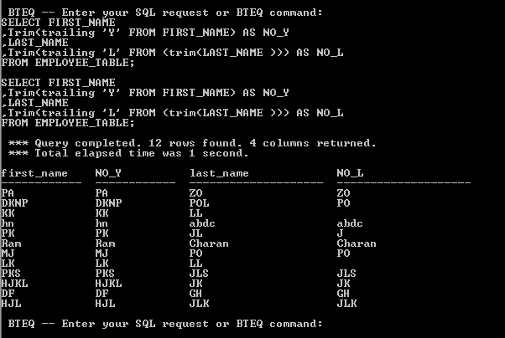

1. HOW TO TRIM TRAILING LETTER AND USE CHARACTER COMMAND

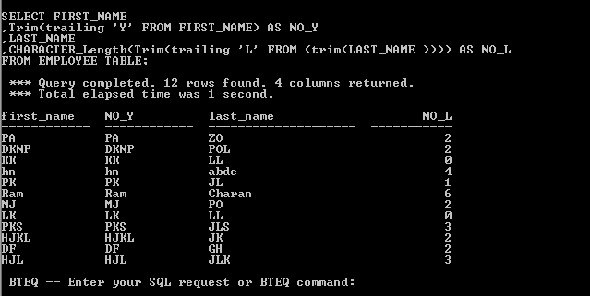

1. THE SUBSTRING COMMAND

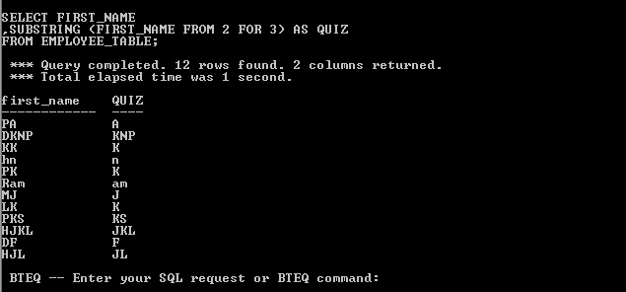

1. SUBSTRING WITH NO END VALUE

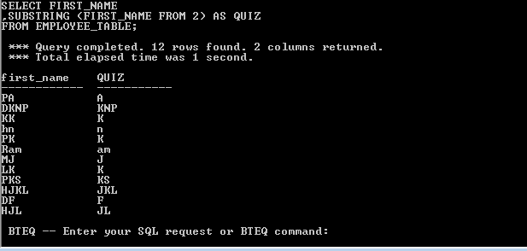

1. USING SUBSTRING TO MOVE BACKWARD

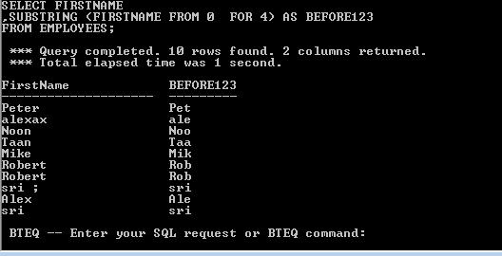

1. SUBSTRING WITH STARTING POSITION AS -1

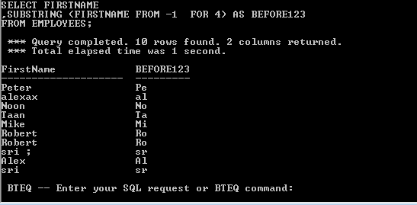

1. SUBSTRING WITH ENDING POSITION FOR 0

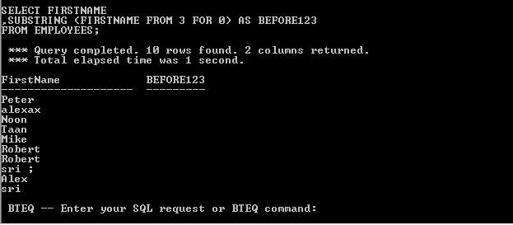

1. SUBSTRING and SUBSTR are equal, but use different syntax

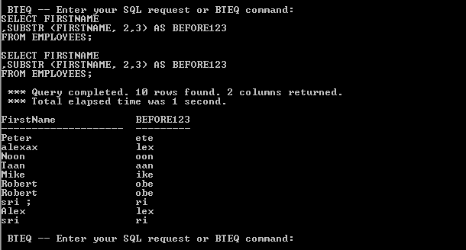

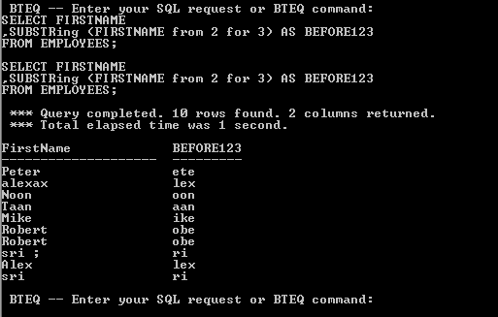

1. THE POSITION COMMAND FINDS A LETTER POSITION

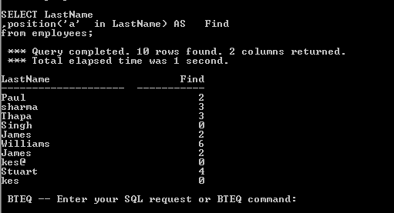

1. THE POSITION COMMAND WITH SUBSTRING

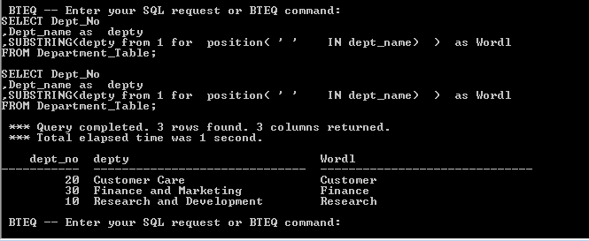

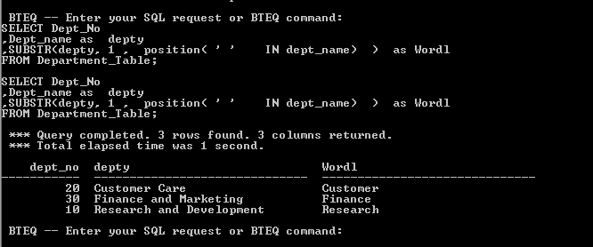

1. USING THE SUBQUERY TO FIND THE SECOND WORD ON

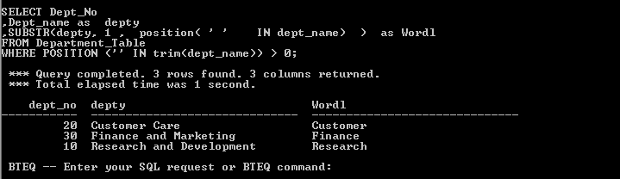

1. WHY TWO ROWS

THEY LOOK FOR TWO SPACES

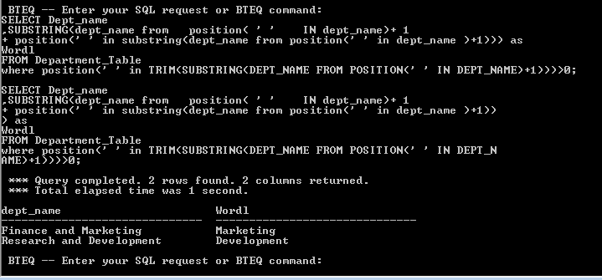

1. CONCATENATION

