1. AJAX is an acronym for **Asynchronous JavaScript and XML**.
2. AJAX is a group of inter-related technologies like JavaScript, DOM, XML, HTML, CSS and XMLHttpRequest.
3. AJAX allows you to send and receive data asynchronously without reloading the web page, so it is fast.
4. AJAX allows you to send only important information to the server not the entire page. So only valuable data from the client side is routed to the server side. It makes your application interactive and faster.
5. Used🡺There are too many web applications running on the web that are using Ajax technology like **Gmail**, **facebook**,**twitter**,**Google map**, **YouTube** etc.

Understanding Synchronous vs. Asynchronous

1. Synchronous🡺 used by classic web application model
2. Asynchronous🡺 used by Ajax web application model

|  |  |
| --- | --- |
| Synchronous | Asynchronous |
| A synchronous request blocks the client until operation completes i.e. browser is not unresponsive. In such case**, javascript engine of the browser is blocked.** | An asynchronous request doesn’t block the client i.e. browser is responsive. At that time, user can perform another operation also. In such case, **javascript engine of the browser is not blocked**. |

1. 
2. Note 🡺 **JAVASCRIPT IS MAILY USED TO DO CLIENT SIDE VALIDATION**

Understanding XMLHttpRequest

1. An object of XMLHttpRequest is used for asynchronous communication between client and server.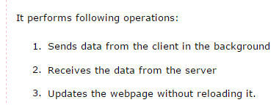
2. The XMLHttpRequest object is the key to AJAX.
3. **It has been available ever since Internet Explorer 5.5 was released in July 2000, but was not fully discovered until AJAX and Web 2.0 in 2005 became popular.**
4. XMLHttpRequest (XHR) is an API that can be used by JavaScript, JScript, VBScript, and other web browser scripting languages to transfer and manipulate XML data to and from a web server using HTTP, establishing an independent connection channel between a webpage's Client-Side and Server-Side
5. XMLHttpRequest can be used to fetch XML data, JSON data or even plain text.

# XMLHttpRequest Methods

1. **abort()🡺**Cancels the current request.
2. 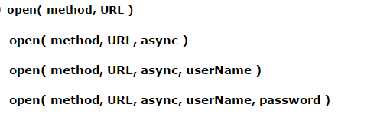

Let’s see each parameter of the parameters of the Overloaded open methods,

1. The method parameter can have a value of "GET", "POST" or any HTTP methods
2. The "async" parameter specifies whether the request should be handled asynchronously or not.
3. **send( content )🡺** Sends the request.

# XMLHttpRequest Properties

1. **onreadystatechange🡺** An event handler for an event that fires at every state change.
2. **readyState🡺** The readyState property defines the current state of the XMLHttpRequest object.

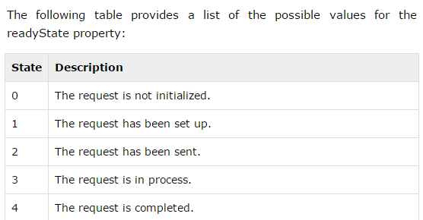

Let’s see each of the properties below,

* **readyState = 0** After you have created the XMLHttpRequest object, but before you have called the open() method.
* **readyState = 1** After you have called the open() method, but before you have called send().
* **readyState = 2** After you have called send().
* **readyState = 3** After the browser has established a communication with the server, but before the server has completed the response.
* **readyState = 4** After the request has been completed, and the response data has been completely received from the server.

1. **responseText🡺** Returns the response as a string.
2. **responseXML🡺** Returns the response as XML.
3. **Status🡺** Returns the status as a number (e.g., 404 for "Not Found" and 200 for "OK").
4. **statusText🡺** Returns the status as a string (e.g., "Not Found" or "OK").

# How AJAX works?

1. AJAX communicates with the server using XMLHttpRequest object.
2. 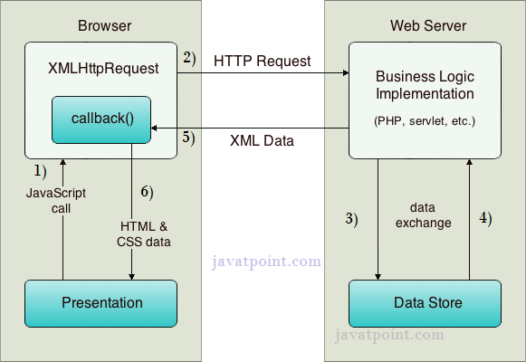
3. 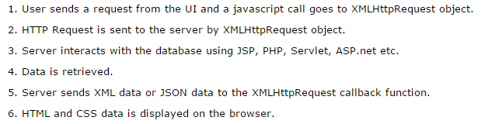

Note:🡺 TO CREATE AJAX EXAMPLE, YOU NEED TO USE ANY SERVER-SIDE LANGUAGE E.G. SERVLET, JSP, PHP, ASP.NET ETC.

# AJAX IN ACTION

1. 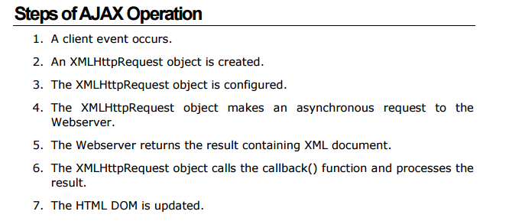
2. 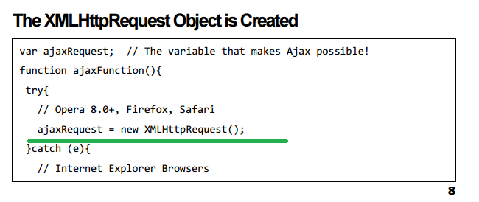

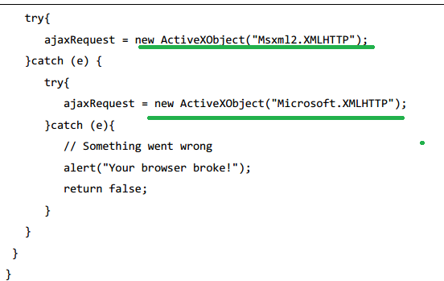

1. The XMLHttpRequest Object is Configured🡺 Here open() and send() methods will be called
2. MS🡺Once the process is completed and readyState property value is =4 indicates that server had sent back the response , so now we can use this response and do what a ever required activities like calling innerHTML property to write this dynamic content on web page

NOTE:🡺 FOR SYNTAX SEE THE TUTORIALS POINT (OR) JAVATPOINT