1. JavaScript is an object-based scripting language that is lightweight and **cross-platform**.
2. JavaScript is **not compiled** but translated. The JavaScript Translator (embedded in browser) is responsible to translate the JavaScript code.
3. Is used to create dynamic web page.
4. JavaScript provides 3 places to put the JavaScript code: within body tag, within head tag and external JavaScript file.
5. The **document.write()** function is used to display dynamic content through JavaScript🡺 MS document is the global object and write() is a fn
6. Syntax to include the JavaScript file into html page.

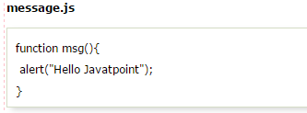

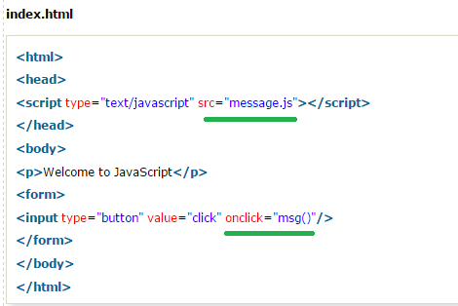

1. JS comment is same like java comment
2. A **JavaScript variable** is simply a name of storage location. There are two types of variables in JavaScript: local variable and global variable.
3. JavaScript variables are case sensitive.
4. A **JavaScript global variable** is declared outside the **function or declared with window object**. It can be accessed from any function.

#### Declaring JavaScript global variable within function

1. 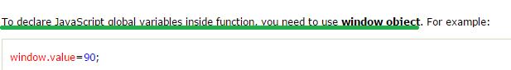
2. 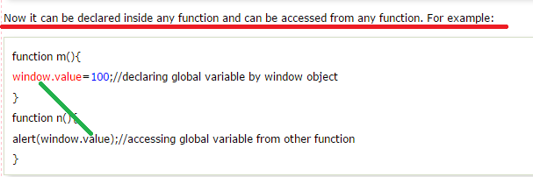
3. 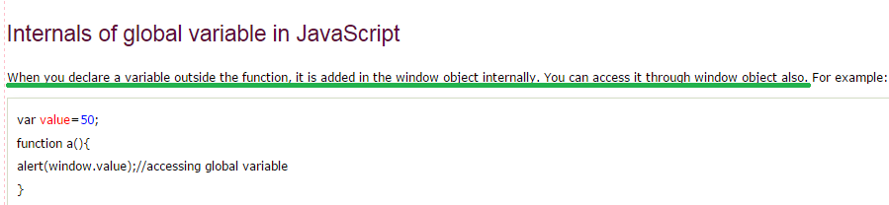

# JavaScript Data Types

1. There are two types of data types in JavaScript🡺**Primitive data type and Non-primitive (reference) data type.**
2. JavaScript is a **dynamic type language**, means you don't need to specify type of the variable because it is dynamically used by JavaScript engine. You need to use only **var** here to specify the data type. It can hold any type of values such as numbers, strings etc.
3. 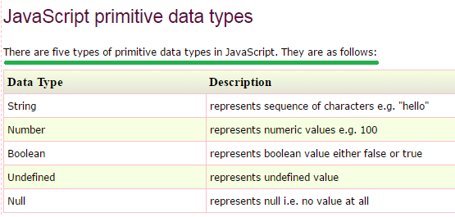
4. 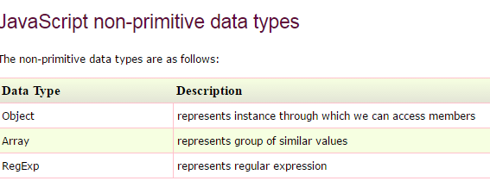
5. JavaScript operators are symbols that are used to perform operations on operands🡺 MS: ALL THE JAVA OPERATORS ARE VALID IN JS🡺LIKE Arithmetic, Comparison, Logical, Bitwise, Assignment
6. 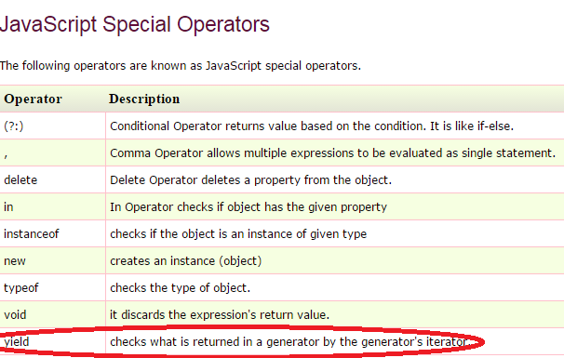
7. There are three forms of if statement in JavaScript.

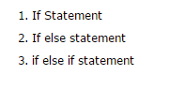

1. Switch🡺 same as java
2. 

# JavaScript Loops

1. 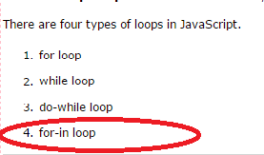

# JavaScript Functions

1. Function is for reusability
2. 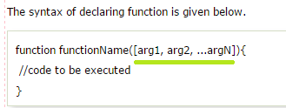
3. MS🡺different way to invoke the JS function,
4. First way:
5. Second way🡺Later from V Tutu
6. 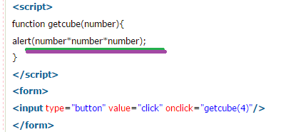
7. We can call function that returns a value and use it in our program🡺Ms JS functions can have Statements after return statement which is not allowed in Java see V Tuto later for more INFORMATION.

# JavaScript Objects

1. A JavaScript object is an entity having state and behavior (properties and method).
2. JavaScript is an object-based language. Everything is an object in JavaScript.
3. JavaScript is template based not class based. Here, we don't create class to get the object.
4. 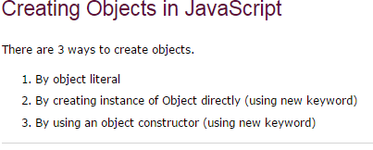
5. 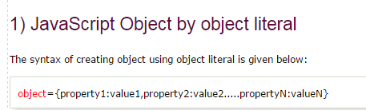
6. Example:
7. 
8. 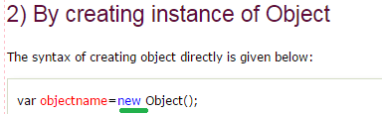

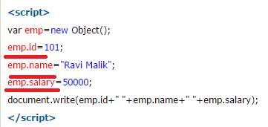

1. 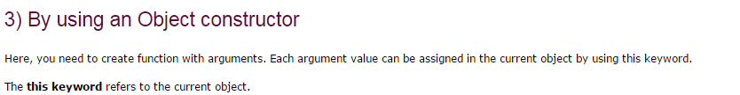

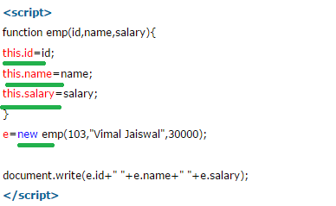

## Defining method in JavaScript Object

1. **We can define method in JavaScript object. But before defining method, we need to add property in the function with same name as method.**
2. 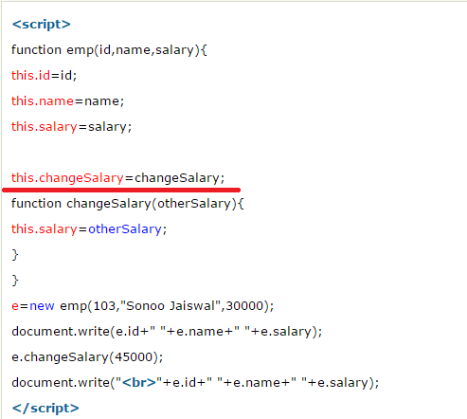

# JavaScript Array

1. 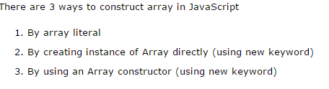
2. 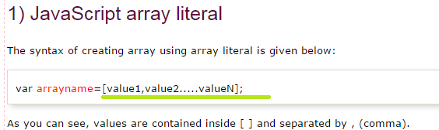
3. The .length property returns the length of an array.
4. 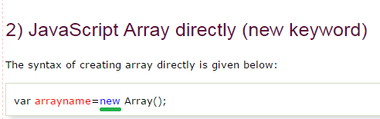
5. 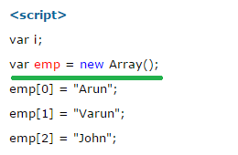
6. 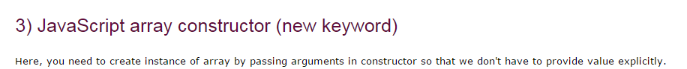
7. 

# JavaScript String

1. The **JavaScript string** is an object that represents a sequence of characters.

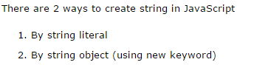

1. By String Literal🡺 var stringname="string value";
2. By string Obj🡺  var stringname=new String("string literal");

## JavaScript String Methods

1. 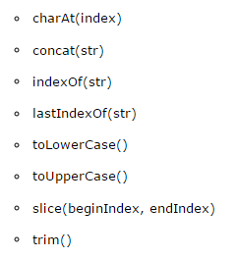
2. The JavaScript String slice(beginIndex, endIndex) method returns the parts of string from given beginIndex to endIndex. In slice() method, beginIndex is inclusive and endIndex is exclusive.

# JavaScript Date Object

1. 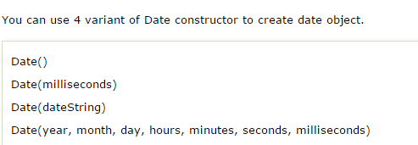
2. 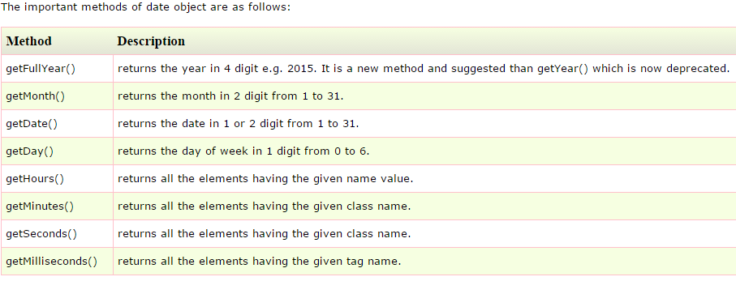

# JavaScript Math Object

1. The **JavaScript math** object provides several constants and methods to perform mathematical operation. **Unlike date object, it doesn't have constructors**.
2. Math Object Functions are:
3. Math.sqrt(n)
4. Math.random(),
5. Math.pow(m, n)
6. Math.floor(n)
7. Math.ceil(n)
8. Math.round(n)
9. Math.abs(n)

# JavaScript Number Object

1. If value can't be converted to number, it returns NaN(Not a Number) that can be checked by isNaN() method.
2. 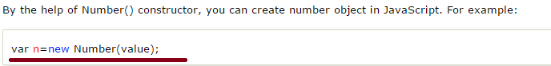

OR

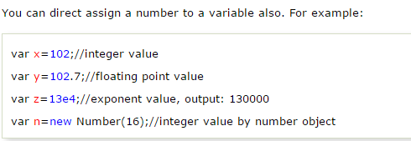

1. 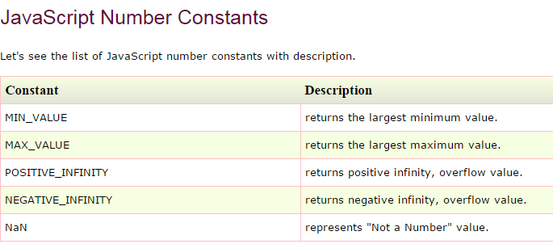
2. 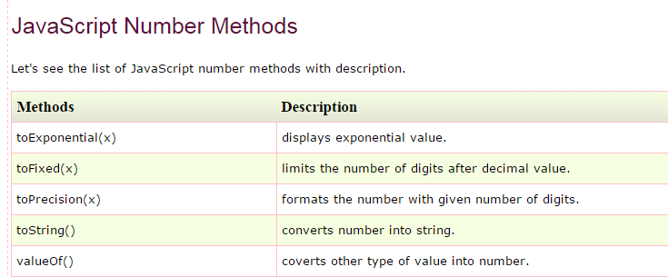

# JavaScript Boolean

1. Syntax:

Boolean b=new Boolean(value);

Or

Var b =false/true;

1. 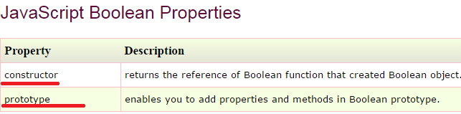
2. 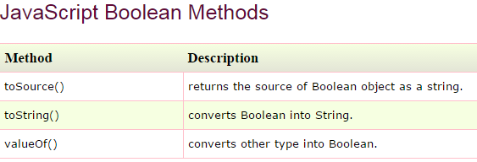

# Browser Object Model

1. The **Browser Object Model** (BOM) is used to interact with the browser
2. 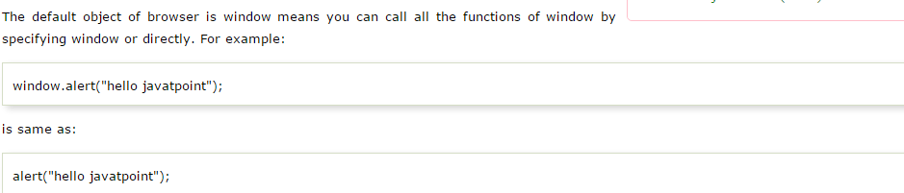
3. 
4. 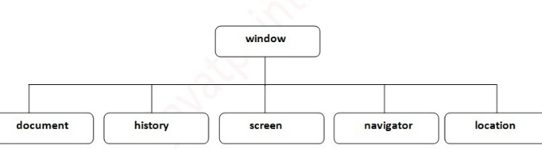

# Window Object

1. The **window object** represents a window in browser. An object of window is created automatically by the browser.
2. **Window is the object of browser, it is not the object of JavaScript.** The JavaScript objects are string, array, date etc.
3. 
4. 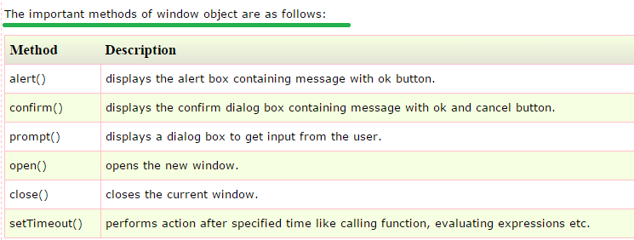
5. Example for Alert:

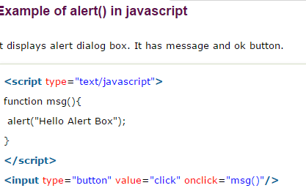

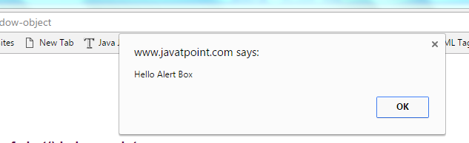

#### Example of confirm() in javascript

1. 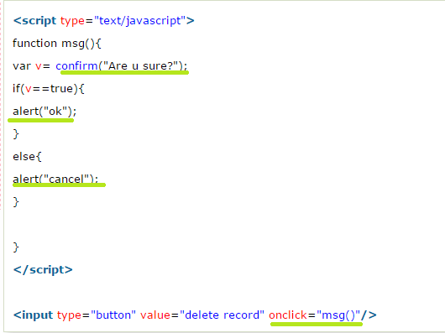
2. 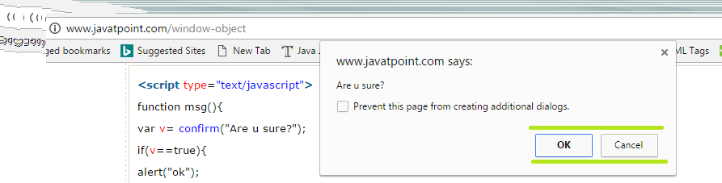

#### Example for prompt()

1. 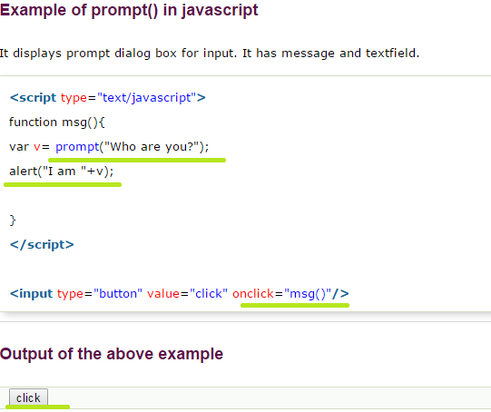

OUTPUT OF THE ABOVE PROGRAM

1. 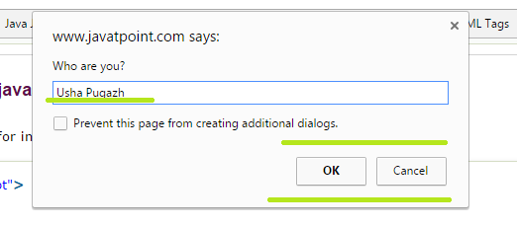
2. 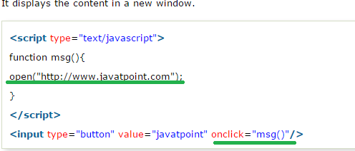

#### Example of setTimeout() in JavaScript

1. 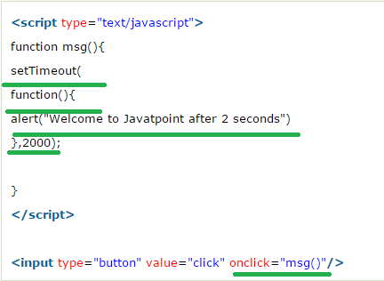

# JavaScript History Object

1. The **JavaScript history object** represents an array of URLs visited by the user. By using this object, you can load previous, forward or any particular page.

# JavaScript Screen Object

1. The **JavaScript screen object** holds information of browser screen. It can be used to display screen width, height, color Depth, pixel Depth etc.

# Document Object Model

1. The **document object** represents the whole html document.
2. When html document is loaded in the browser, it becomes a document object. It is the **root element** that represents the html document. It has properties and methods. By the help of document object, we can add dynamic content to our web page.
3. 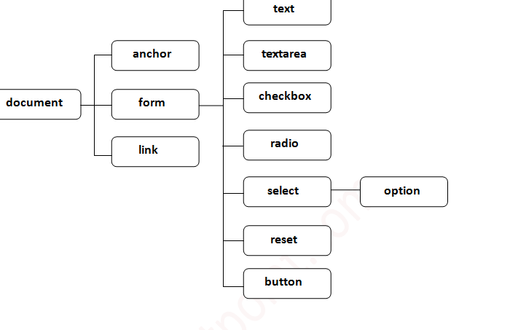
4. 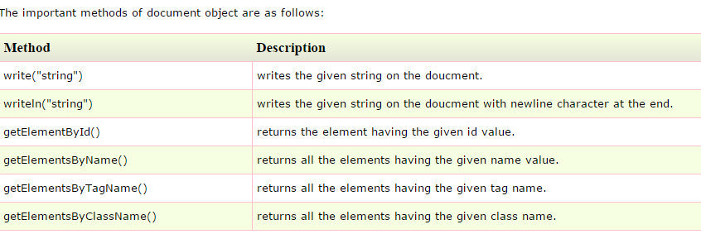

### Accessing field value by document object

1. In this example, we are going to get the value of input text by user. Here, we are using **document.form1.name.value** to get the value of name field.
2. 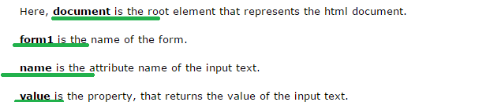
3. Program is shown below
4. 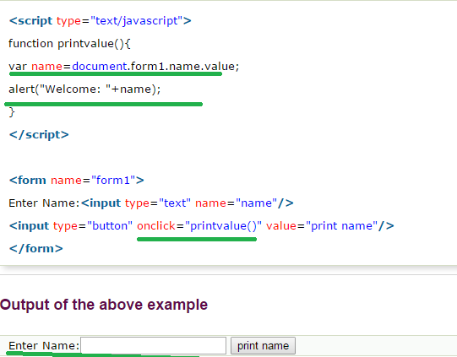

# JavaScript-document.getElementById() method

1. The **document.getElementById()** method returns the element of specified id.
2. In the previous page, we have used **document.form1.name.value** to get the value of the input value. Instead of this, we can use document.getElementById() method to get value of the input text. But we need to define id for the input field.
3. 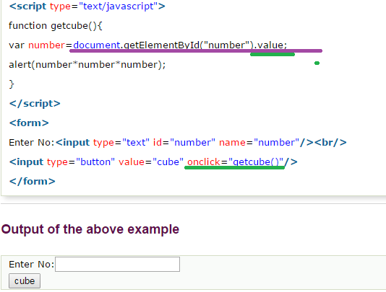

# JavaScript - document.getElementsByName() method

1. The **document.getElementsByName()** method returns all the element of specified name.
2. Example🡺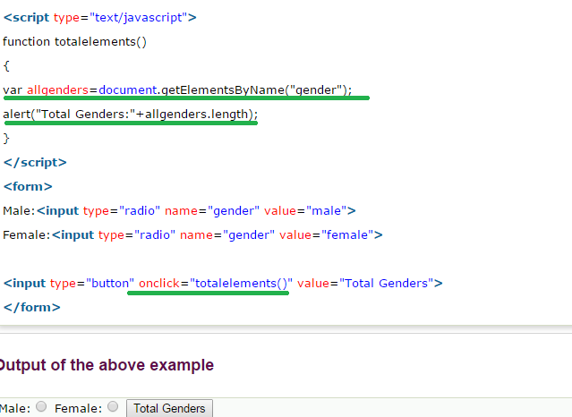

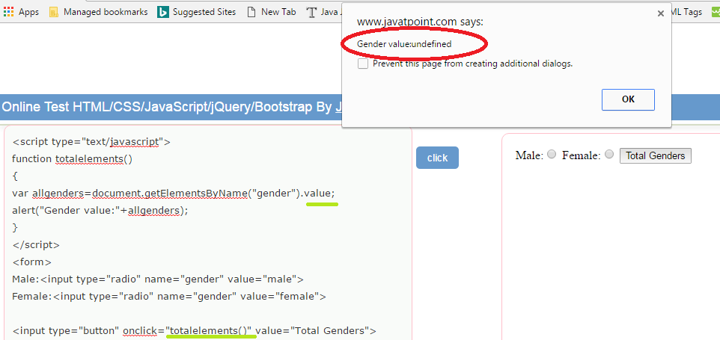

# JavaScript - document.getElementsByTagName() method

1. LATER

# JavaScript - innerHTML

1. The **innerHTML** property can be used to write the dynamic html on the html document.
2. 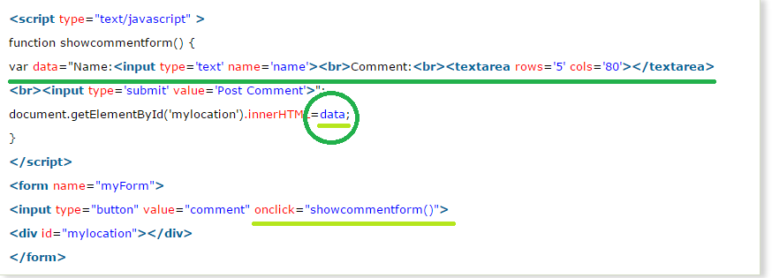
3. how the div element looks after clicking the comment button is shown below,

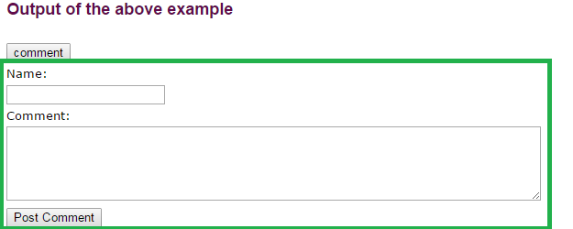

### Show/Hide Comment Form Example using innerHTML

1. in the above example once comment button is clicked div element content gets changed and after that I cannot hide the div content on again clicking on comment tag, in order to get this functionality we use Show/Hide, lets see below in detail.
2. 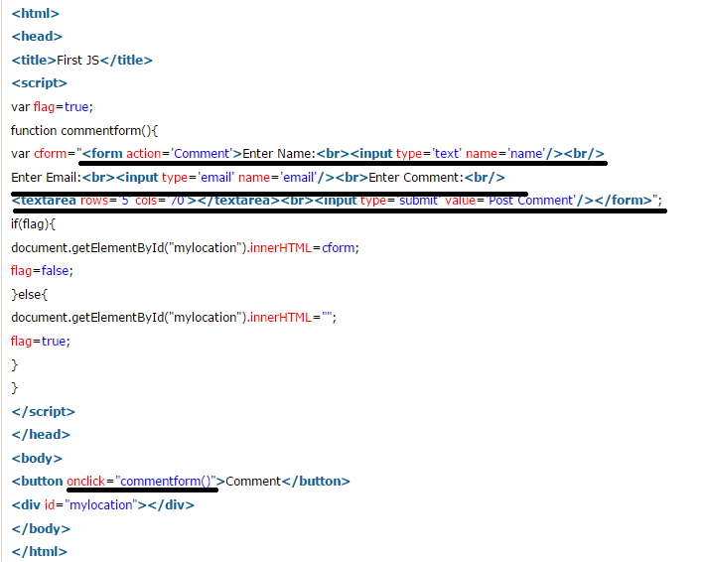

# JavaScript - innerText

1. The **innerText** property can be used to write the dynamic text on the html document. Here, text will not be interpreted as html text but a normal text.
2. 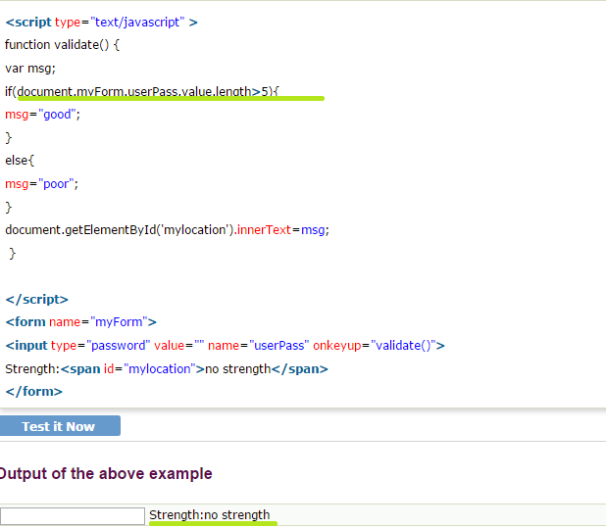
3. Output for the above Program is ,

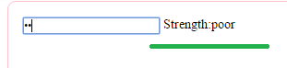

# JavaScript Form Validation/email Validation

1. It is important to validate the form submitted by the user because it can have inappropriate values. So validation is must.
2. The JavaScript provides you the facility the validate the form on the client side so processing will be fast than server-side validation.
3. Through JavaScript, we can validate name, password, email, date, mobile number etc fields.
4. Its simpler only see the Tutorial Point, no special JavaScript methods are used, normal java code is used to validate the name, password, email, mobile Number and etc..
5. To validate the name and password. The name can’t be empty and password can’t be less than 6 characters long

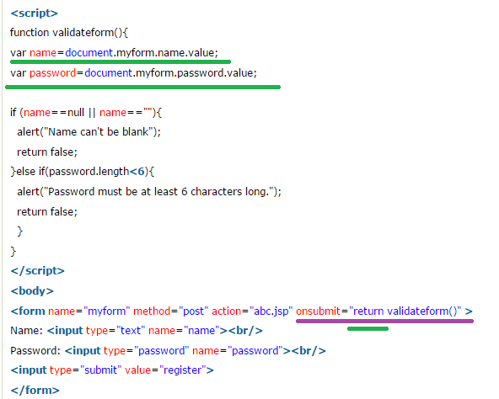

## JavaScript Retype Password Validation🡺

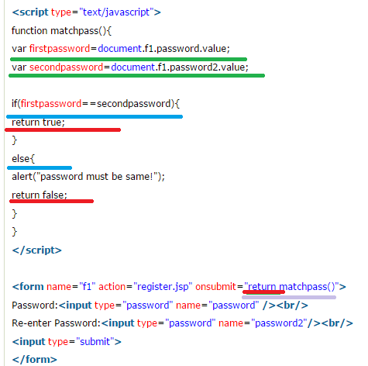

## (c)JavaScript Number Validation🡺 Here, we are using isNaN() function to identify valid number is entered by user or not

## JavaScript email validation🡺 for email validation we follow set of steps like,

