JDBC

1. Methods of DriverManager class

* public static void registerDriver(Driver driver)
* public static void deregisterDriver(Driver driver)🡺 is used to deregister the given driver (drop the driver from the list) with DriverManager.
* public static Connection getConnection(String url)
* public static Connection getConnection(String url, String userName, String password)

# Connection interface🡺 A Connection is the session between java application and database.

# object of Connection can be used to get the object of Statement, PreparedStatement and DatabaseMetaData.

#### By default, connection commits the changes after executing queries.

### Commonly used methods of Connection interface

# **public Statement createStatement()**

# **public void setAutoCommit(boolean status):** is used to set the commit status. By default it is true.

# **public void commit():** saves the changes made since the previous commit/rollback permanent.

# **public void rollback():** Drops all changes made since the previous commit/rollback.

# **public void close():** closes the connection and Releases a JDBC resources immediately.

# The Statement interface provides methods to execute queries with the database. it provides factory method to get the object of ResultSet.

1. The important methods of Statement interface are as follows:

* **public ResultSet executeQuery(String sql)🡺** is used to execute SELECT query. It returns the object of ResultSet.
* **public int executeUpdate(String sql)🡺** is used to execute specified query, it may be create, drop, insert, update, delete etc.
* **public boolean execute(String sql)🡺** is used to execute queries that may return multiple results.
* **public int[] executeBatch()🡺**is used to execute batch of commands.

1. The object of ResultSet maintains a cursor pointing to a row of a table. Initially, cursor points to before the first row.

#### By default, ResultSet object can be moved forward only and it is not updatable.

1. But we can make this object to move forward and backward direction by passing either TYPE_SCROLL_INSENSITIVE or TYPE_SCROLL_SENSITIVE in createStatement(int, int) method as well as we can make this object as updatable by:



1. TYPE_SCROLL_INSENSITIVE🡺
2. TYPE_SCROLL_SENSITIVE
3. Commonly used methods of ResultSet interface:

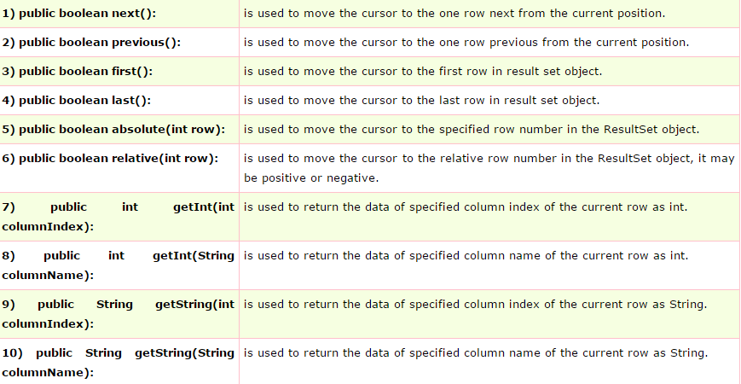

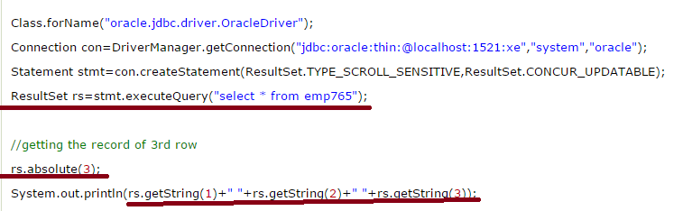

1. **The PreparedStatement interface is a sub interface of Statement.** It is used to execute parameterized query

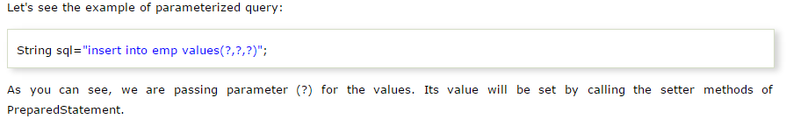

1. **Improves performance**: The performance of the application will be faster if you use PreparedStatement interface because query is compiled only once.
2. The prepareStatement() method of Connection interface is used to return the object of PreparedStatement.

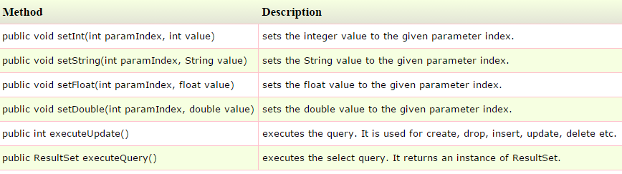

1. Example for PreparedStatement,

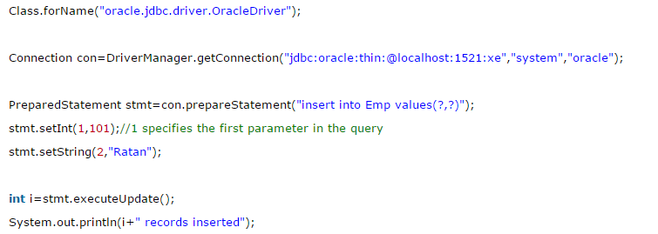

Java ResultSetMetaData Interface

1. The metadata means data about data i.e. we can get further information from the data.
2. **If you have to get metadata of a table like total number of column, column name, column type etc. , ResultSetMetaData interface is useful because it provides methods to get metadata from the ResultSet object.**
3. The **getMetaData()** method of ResultSet interface returns the object of ResultSetMetaData.
4. 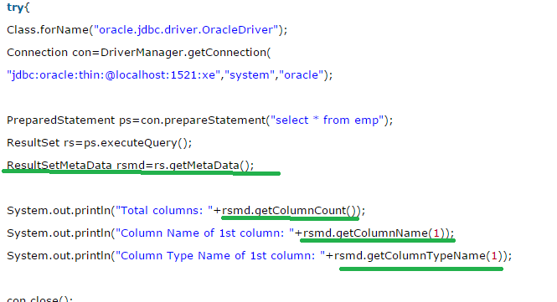
5. 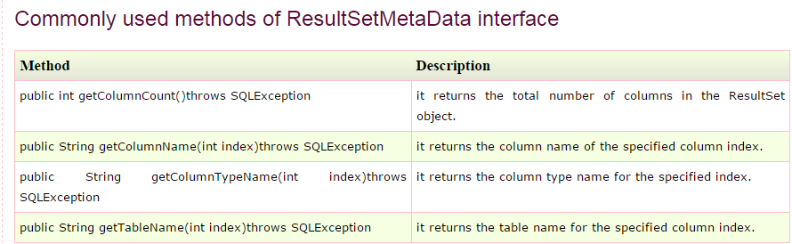

Java DatabaseMetaData interface

1. DatabaseMetaData interface provides methods to get meta data of a database such as database product name, database product version, driver name, name of total number of tables, name of total number of views etc.
2. The **getMetaData()** method of Connection interface returns the object of DatabaseMetaData

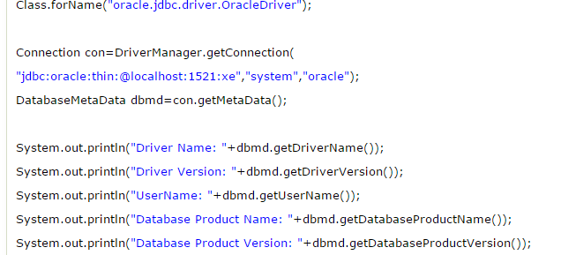

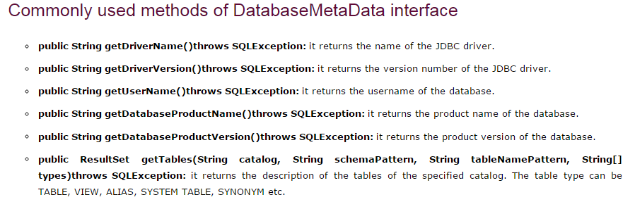

1. 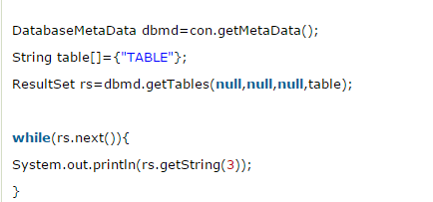

store image in Oracle database**************

1. You can store images in the database in java by the help of **PreparedStatement** interface
2. The **setBinaryStream()** method of PreparedStatement is used to set Binary information into the parameterIndex.
3. 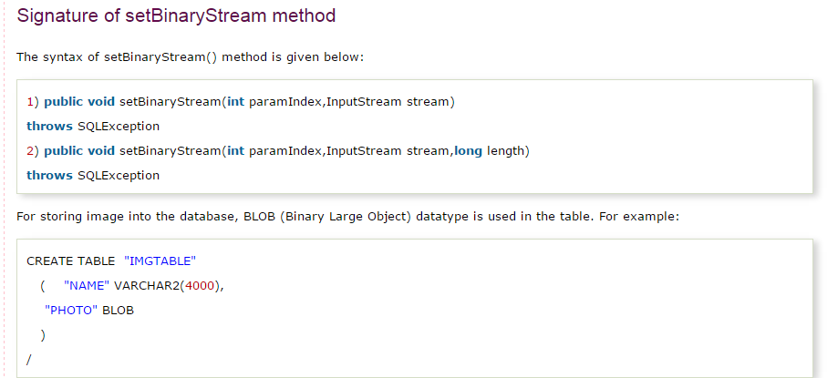
4. 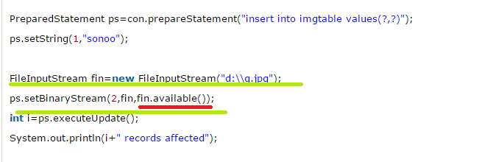

**Note: WHAT IS THE PURPOSE OF fin.available() METHOD HERE.**

Retrieve image from Oracle database

1. By the help of **PreparedStatement** we can retrieve and store the image in the database.
2. The **getBlob()** method of PreparedStatement is used to get Binary information, it returns the instance of Blob.
3. After calling the **getBytes()** method on the blob object, we can get the array of binary information that can be written into the image file.
4. 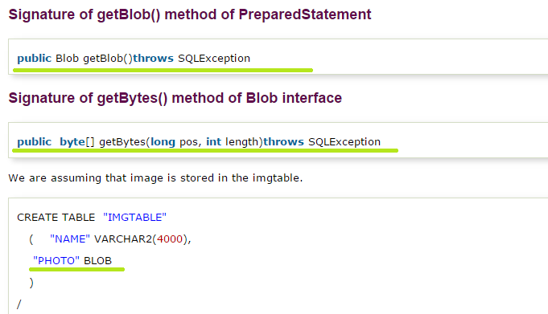
5. 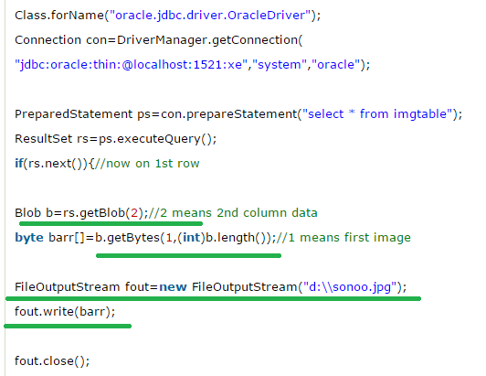

Store file in Oracle database:

1. The setCharacterStream() method of PreparedStatement is used to set character information into the parameterIndex
2. 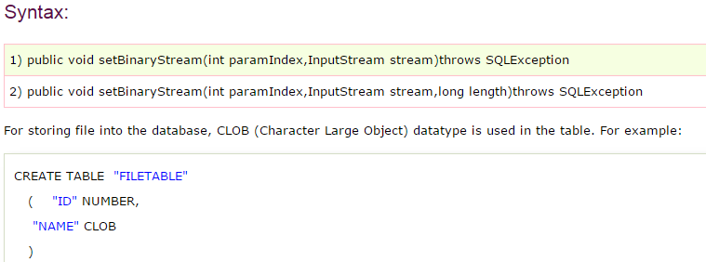
3. 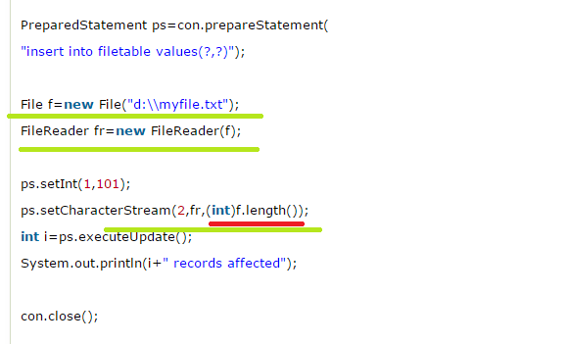

Retrieve file from Oracle database:

1. The getClob() method of ResultSet is used to get file information from the database.
2. 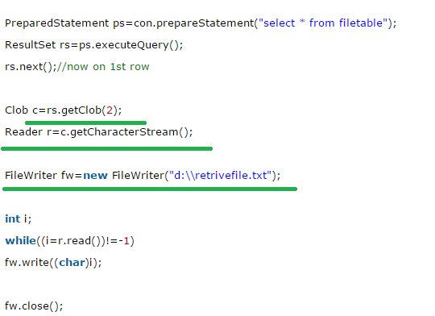

Java CallableStatement Interface

1. CallableStatement interface is used to call the **stored procedures and functions**.
2. **stored procedures and functions that will make the performance better because these are precompiled.**

Transaction management:

1. **Connection interface** provides methods to manage transaction.

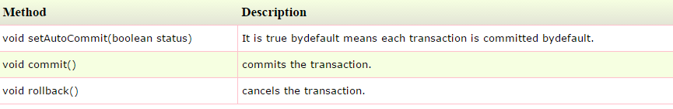

# Collections in Java

1. Collection framework represents a unified architecture for storing and manipulating group of objects.
2. 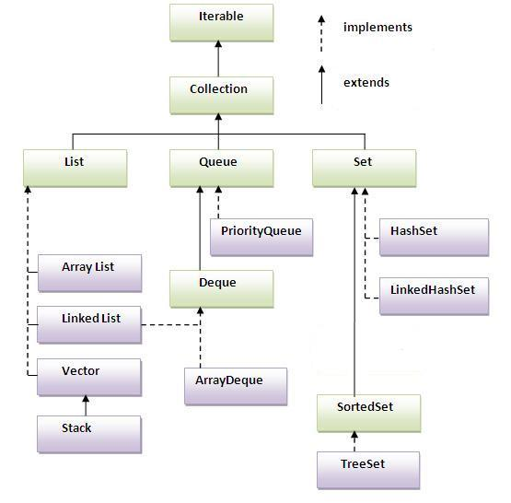
3. 