1. 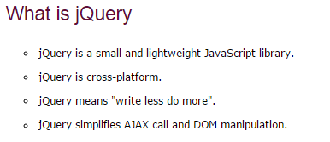
2. jQuery was first released in January 2006 by **John Resig** at BarCamp NYC.
3. Latest version🡺

|  |  |
| --- | --- |
| 2.1 | 24, January, 2014 |

1. **jQuery is developed by Google.**
2. To create the first jQuery example, you need to use JavaScript file for jQuery. You can download the jQuery file from jquery.com or use the absolute URL of jQuery file.
3. Syntax for absolute URL is shown below



Note: In another Script tag we can write our JavaScript/JQuery Code

1. JQuery function example:
2. css() function 🡺Ms , accepts css property and its value as the input

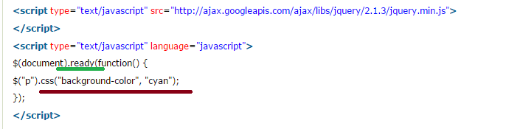

$(document).ready() and $()

1. The code inserted between $(document).ready() is executed only once when page is ready for JavaScript code to execute.
2. In place of $(document).ready(), you can use shorthand notation $() only.,
3. Example🡺

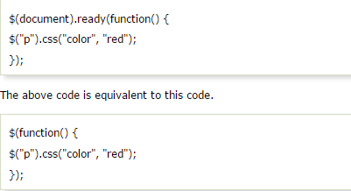

# JQuery Selectors

1. jQuery Selectors are used to select and manipulate HTML elements. They are very important part of jQuery library.
2. **All jQuery selectors start with a dollar sign and parenthesis e.g. $(). It is known as the factory function.**
3. JQuery uses the same CSS Selectors

# JQuery Effects

1. JQuery enables us to add effects on a web page. jQuery effects can be categorized into fading, sliding, hiding/showing and animation effects.
2. 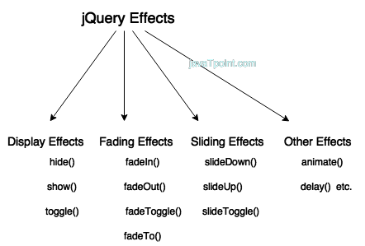
3. A complete list of jQuery effect methods are given below:

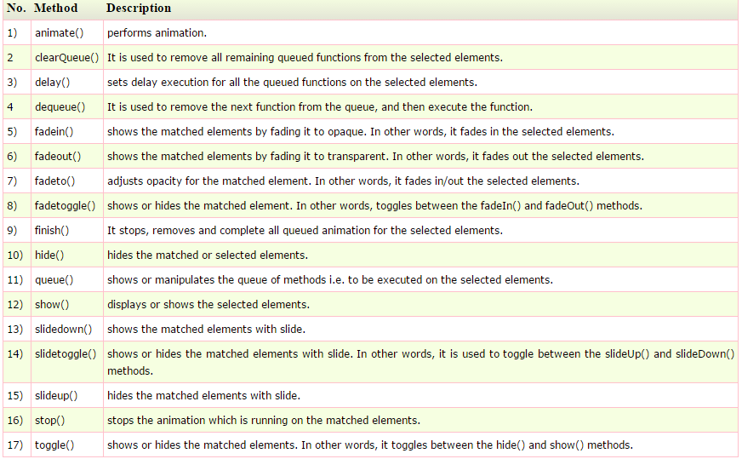

1. Let’s see the above methods one by one

# jQuery hide()

1. The jQuery hide() method is used to hide the **selected** elements.
2. 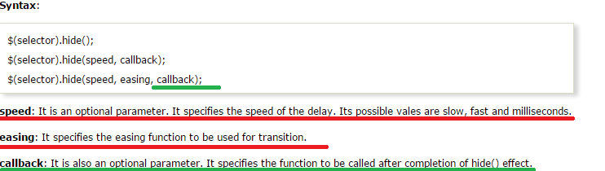
3. 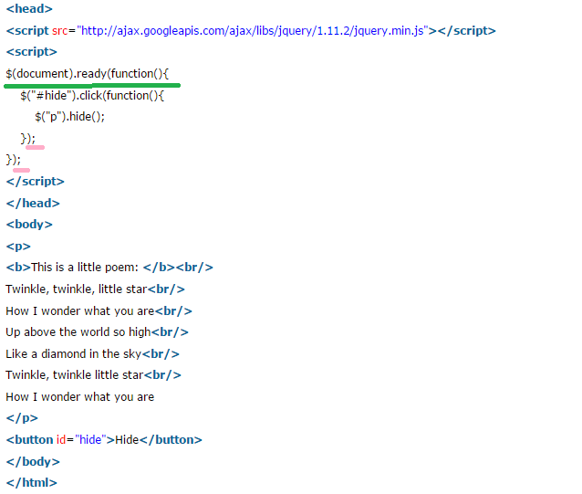

# jQuery show()

1. The jQuery show() method is used to show the **selected** elements.
2. 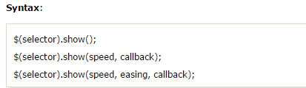
3. Example: in this program we use 2 buttons, on click on one button the content is hidden and on click of another button the content is shown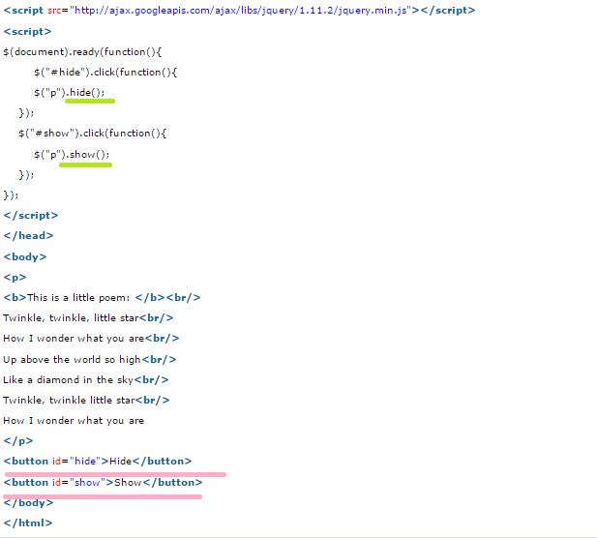

# JQuery toggle()

1. The jQuery toggle() is a special type of method which is used to toggle between the hide() and show() method. It shows the hidden elements and hides the shown element.
2. 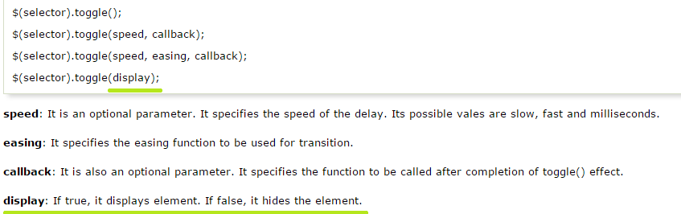
3. Example🡺 by sing single button we can hide or show the content

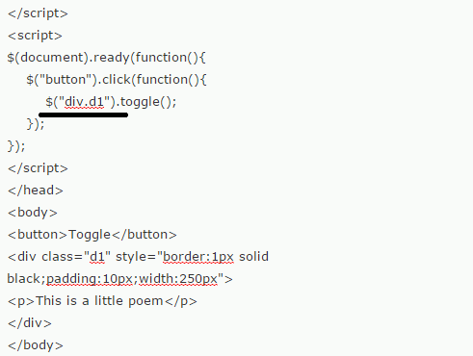

# JQuery fadeIn()

1. jQuery fadeIn() method is used to fade in the element.
2. 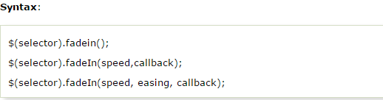

Fade in🡺 An effect in which the image **appears** on screen gradually out of darkness.

1. Example🡺

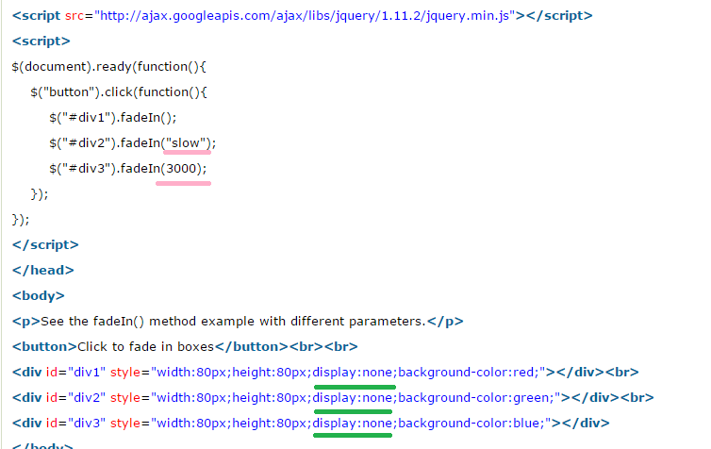

# jQuery fadeOut()

1. Is Opposite of Fade in
2. Functions of fade out is same as that of fade in just replace in by out.

# JQuery fadeToggle()

1. JQuery fadeToggle() method is used to toggle between the fadeIn() and fadeOut() methods. If the elements are faded in, it will make them faded out and if they are faded out it will make them faded in.
2. 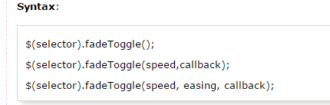

NOTE🡺SLIDEUP, SLIDEDOWN,SLIDETOGGLE, ANIMATE, DELAY, NOT COVERED THIS FUNCTIONS.

1. Query HTML/CSS Functions

# jQuery html():

1. jQuery html() method is used to change the entire content of the selected elements. **It replaces the selected element content with new contents**.
2. The API documentation of the jQuery html function consists of three method signatures. Let’s see one by one below,
3. 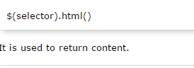

The jQuery html() method is used either for set the content or return the content of the selected elements.

**To return content**: When you use this method to return content, it returns the content of the **first** matched element.

1. 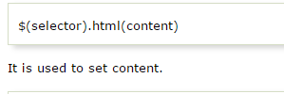

**To set content**: When you use this method to set content, it overwrites the content of the **all** matched elements.

1. 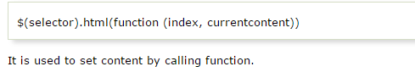
2. 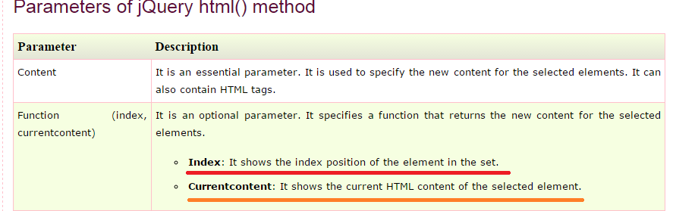
3. Examples:
4. an example to demonstrate jQuery html() method. It is changing the content of all p elements.

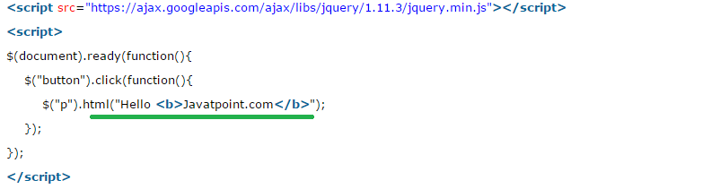]

1. an example of jQuery html() method that returns HTML content. It returns the content of first paragraph only.

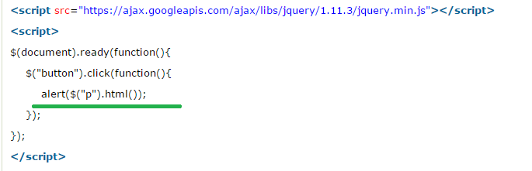

1. **text()** 🡺 method is used to set or return only the text content of the selected elements.

Html output, on calling html()🡺 Click here to change the html to text

Above html’s equivalent text output, on calling text()🡺**Click here to change the <span id="tag">html to text</span>**

1. **jQuery val()🡺**There are two usage of jQuery val() method.
2. It is used to get current value of the first element in the set of matched elements.
3. It is used to set the value of every matched element.

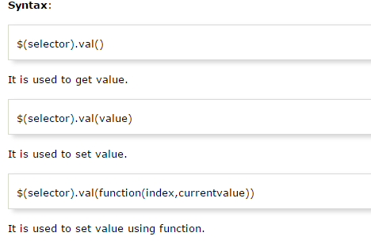

Iii 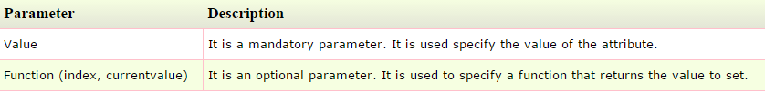

iv 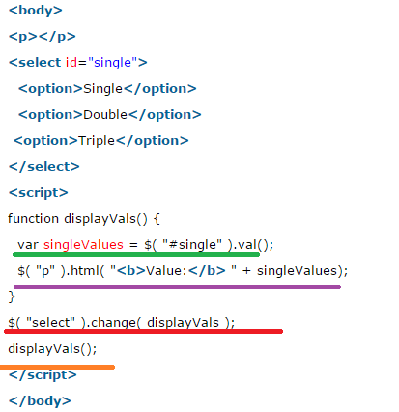

v See There is different scenario when select can have multiple options to be selected

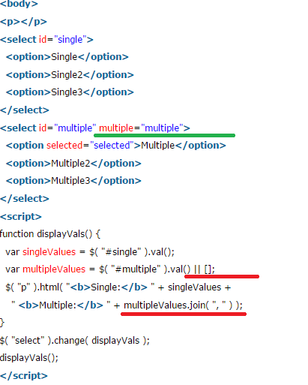

# jQuery css()

1. The jQuery CSS() method is used to **get (return)or set** style properties or values for selected elements. It facilitates you to get one or more style properties.

## Return a CSS property

1. 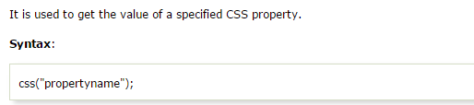
2. 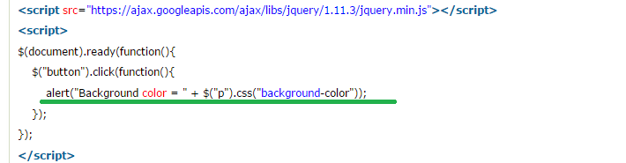

## Set a CSS property

1. 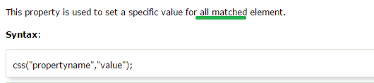
2. 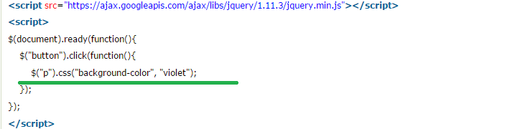

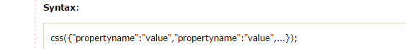

# jQuery before()

1. The jQuery before() method is used to insert the specified content before the selected elements.

#### The before() and insertBefore() both methods are used to perform same task. The main difference between them is in syntax, and the placement of the content and the target.

1. 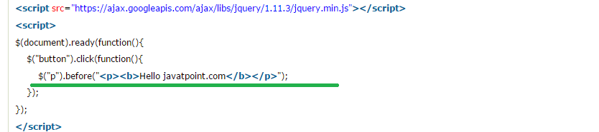

# jQuery after()

1. The jQuery after() method is used to insert specified content after the selected element. **It is just like jQuery append() method**.
2. 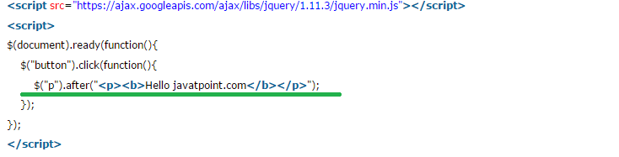

# JQuery insertAfter()

1. The jQuery after() and jQuery insertAfter() both methods are used to perform the same task of inserting additional contents after the selected elements.
2. 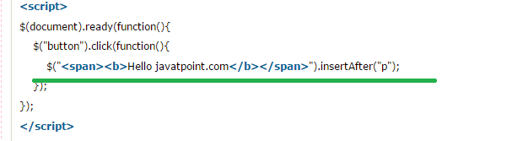

# jQuery append()

1. The jQuery append() method is used to insert specified content as the last child (at the end of) the selected elements in the jQuery collection.
2. 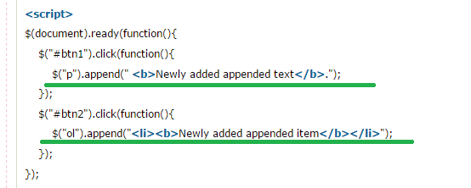

# JQuery appendTo()

1. It is same as jQuery append() method. There is only syntactical difference between append() and appendTo() methods.
2. 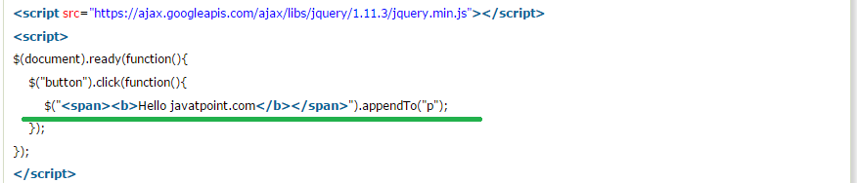

# JQuery prepend()

1. The jQuery prepend() method is used to insert the specified content at the **beginning (as a first child)** of the selected elements.
2. 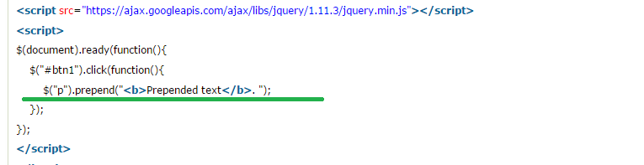

# jQuery clone()

1. The jQuery clone() method is used to make copies of the set of matched elements. It also makes copies of their child nodes, texts and attributes. The clone() method is a convenient way to duplicate elements on a page.
2. 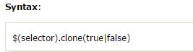
3. 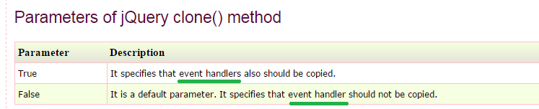
4. 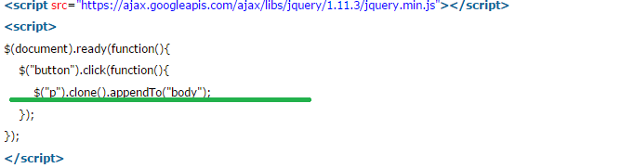

# JQuery remove()

1. The jQuery remove() method is used to remove the selected elements out of the DOM. It removes the selected element itself, as well as everything inside it (including all texts and child nodes). This method also removes the data and the events of the selected elements.

#### If you want to remove elements without removing data and events, you should use the detach() method. If you want to remove only data and events, use the empty() method.

1. 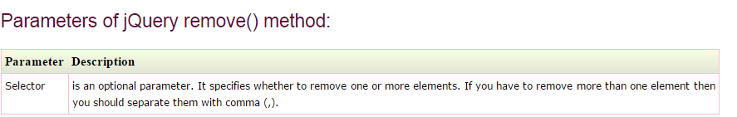
2. 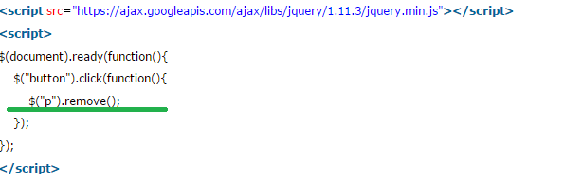

# JQuery empty()

1. 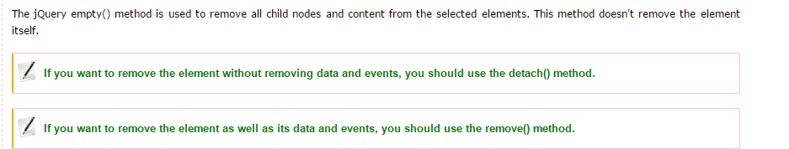
2. 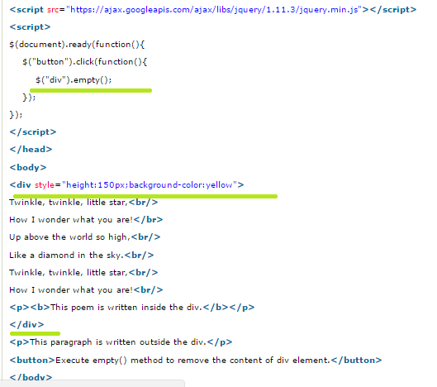

# JQuery detach()

1. The jQuery detach() method is used to remove the selected elements, including all texts and child nodes and keeps only data and events.
2. 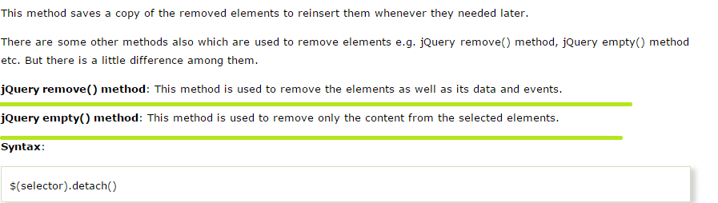

# JQuery attr()

1. The jQuery attr() method is used to set or return attributes and values of the selected elements.
2. 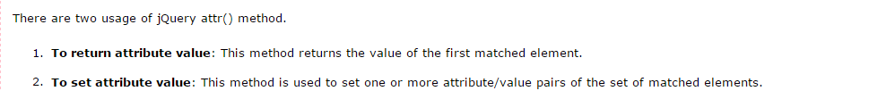

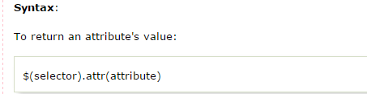

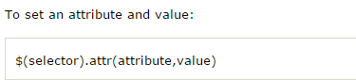

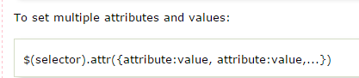

1. 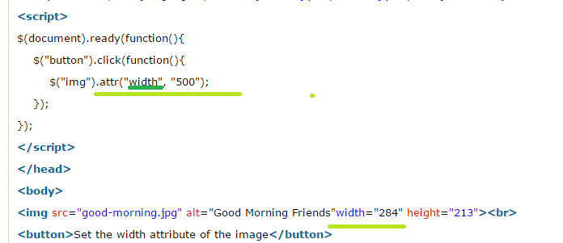

# JQuery prop()

1. 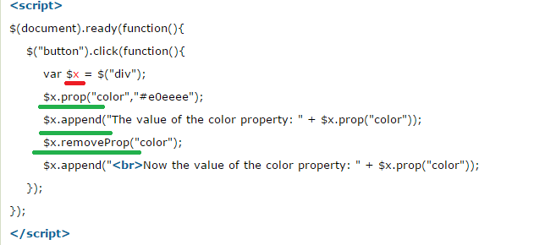

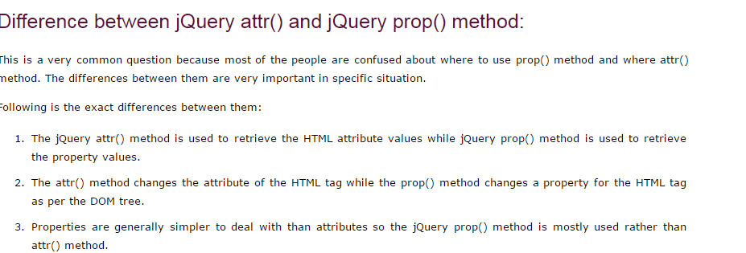

# JQuery position()

1. The jQuery position () method makes you able to retrieve the current position of an element relative to the parent element.

# JQuery addClass()

1. The addclass() method is used to add one or more class name to the selected element. This method is used only to add one or more class names to the class attributes not to remove the existing class attributes.

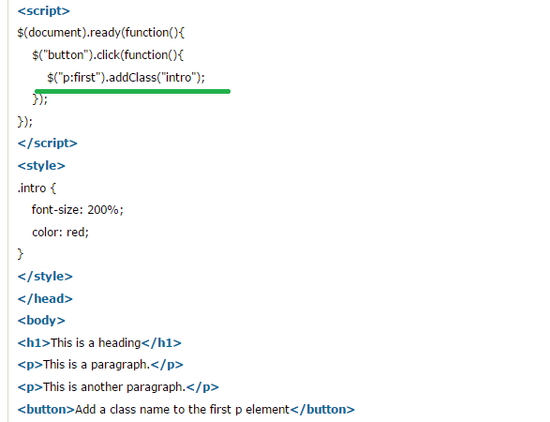

# JQuery hasClass()

1. The jQuery hasClass() method is used to check whether selected elements have specified class name or not. It returns TRUE if the specified class is present in any of the selected elements otherwise it returns FALSE.
2. 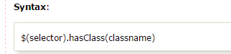
3. 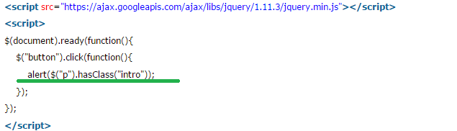

# JQuery toggleClass()

1. The jQuery toggleCLass() method is used to add or remove one or more classes from the selected elements. This method toggles between adding and removing one or more class name. It checks each element for the specified class names. If the class name is already set, it removes and if the class name is missing, it adds. In this way, it creates the toggle effect

# JQuery width(), height()

1. jQuery width() method is used to return or set the width of matched element.
2. 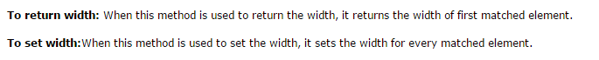
3. Along with this it has other dimensions related methods like

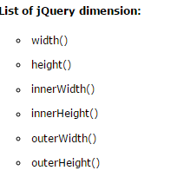

1. 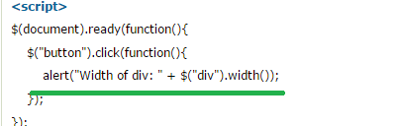
2. **Example for height()**

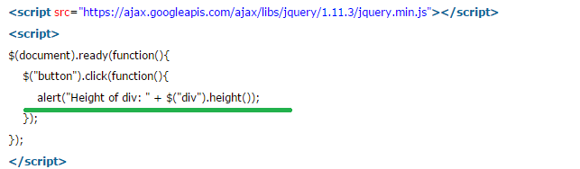

# JQuery wrap()

1. Wrap means🡺cover or enclose
2. JQuery wrap() method is used to wrap specified HTML elements around each selected element.
3. 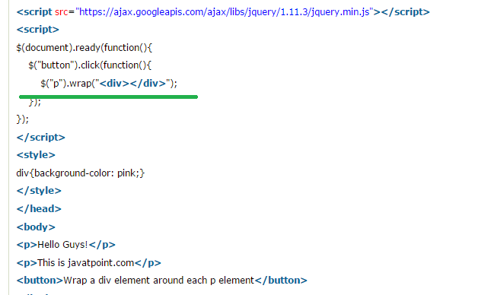
4. Similarly we have **wrapInner(), wrapAll(), unwrap().**

# JQuery Events

1. **Most of the DOM events have an equivalent jQuery method**.
2. 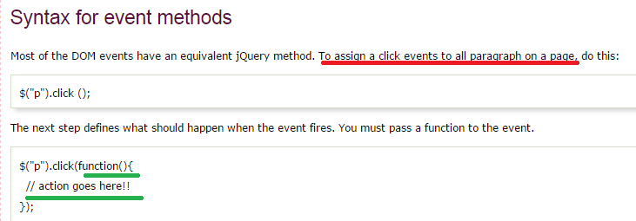

# JQuery event functions:

# JQuery click()

1. When you click on an element, the click event occurs and once the click event occurs it execute the click () method or **attaches a function to run**.
2. 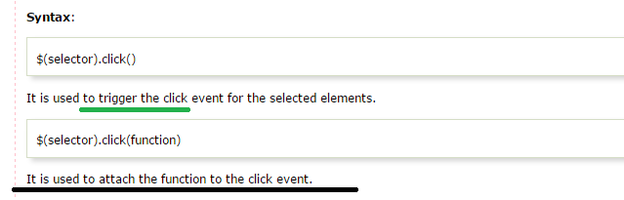

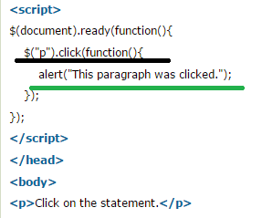

# JQuery bind()

1. It specifies a function to run when the event occurs.
2. 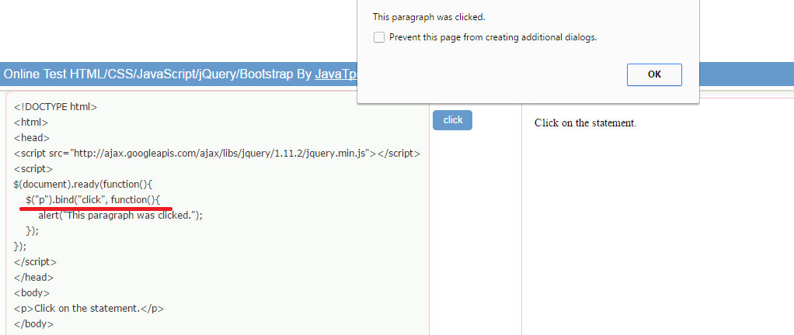
3. 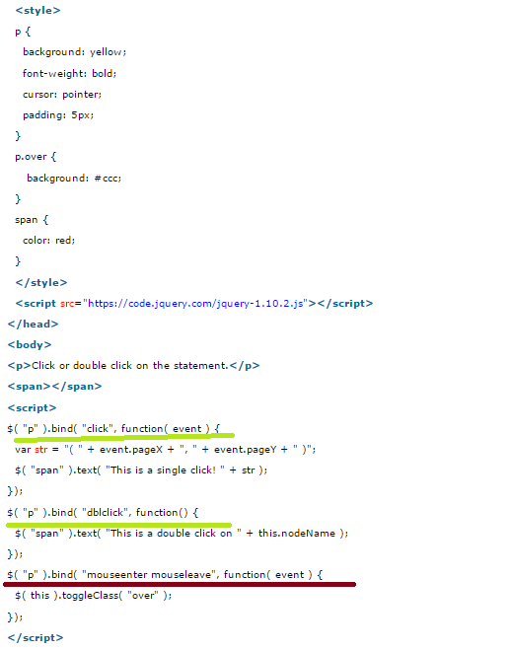

# JQuery blur()

1. **MS🡺See in text box if I take the mouse cursor inside then it gains focus, suppose if I come out of the text field then it is said to be blurred**
2. The jQuery blur event occurs when element loses focus.
3. It makes you **enable to attach a function to the event that will be executed when the element loses focus**. Originally, this event was used only with form elements like <input>. In latest browsers, it has been extended to include all element types.
4. 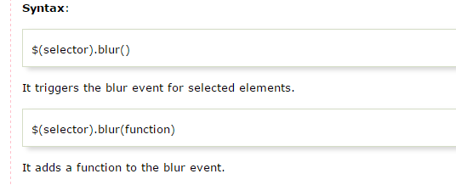
5. 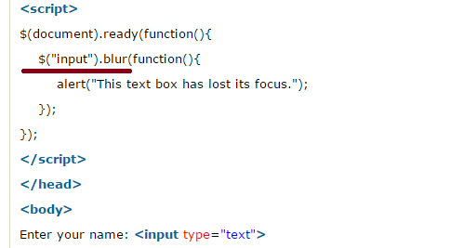

# JQuery focus()

1. The jQuery focus event occurs when an element gains focus. It is generated by a mouse click or by navigating to it.
2. This event is implicitly used to limited sets of elements such as form elements like <input>, <select> etc. and links <a href>.
3. Example🡺 we will use the above example onlu for focus also

# JQuery select()

1. jQuery select event **occurs when a text is marked or selected in text area or a text field**
2. Example:

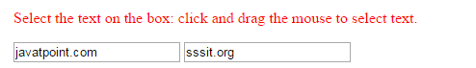

Now on selecting the text in the text box select event will be triggered, see the below screen shot

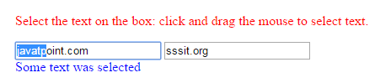

1. Code :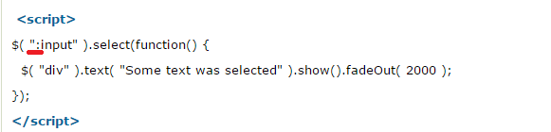

# JQuery change()

1. JQuery change event occurs when the value of an element is changed. It works only on form fields. When the change event occurs, the change () method attaches a function with it to run.
2. This event is limited to <input> elements, <textarea> boxes and <select> elements.
3. 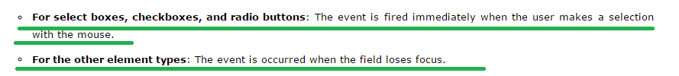
4. 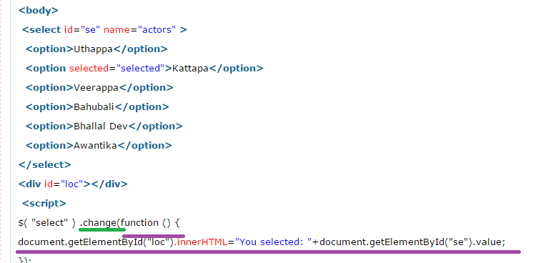

# JQuery submit()

1. JQuery submit event is sent to the element when the user attempts to submit a form.
2. This event is only attached to the <form> element. Forms can be submitted either by clicking on the submit button or by pressing the enter button on the keyboard when that certain form elements have focus. When the submit event occurs, the submit() method attaches a function with it to run.
3. 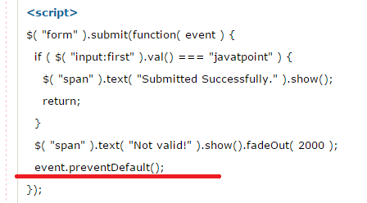

# Window Events:

# JQuery load()

1. It was deprecated in jQuery 1.8 version of jQuery library.
2. The load event occurs when a specific element is loaded.

# JQuery unload()

1. It was deprecated in jQuery 1.8 version of jQuery library.
2. The jQuery unload() method is used to unload a specific element.
3. Example 🡺WE WILL SEE IT LATER