HTML5 Tutorial

1. 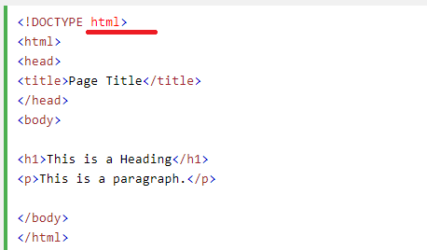
2. The <!DOCTYPE html> declaration defines this document to be HTML5 and It must only appear once, at the top of the page (before any HTML tags)🡺 does this means doctype is for html 5?
3. The <head> element contains meta information about the document
4. 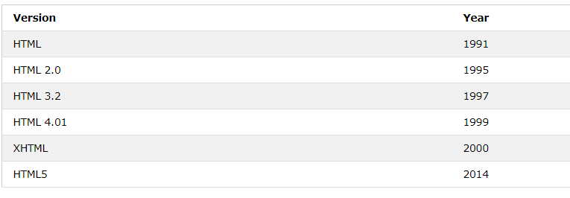
5. HTML headings are defined with the **<h1>** to **<h6>** tags.
6. 
7. HTML elements can be nested (elements can contain elements) 🡺 example 🡺<html><head></head></html>
8. Attributes provide **additional information** about an element. Attributes are always specified in **the start tag**. Attributes usually come in name/value pairs like: **name="value" 🡺**

<html lang="en-US">

1. **title** attribute 🡺 The value of the title attribute will be displayed as a tooltip when you mouse over
2. The <hr> tag defines a thematic break in an HTML page
3. Output without <pre>

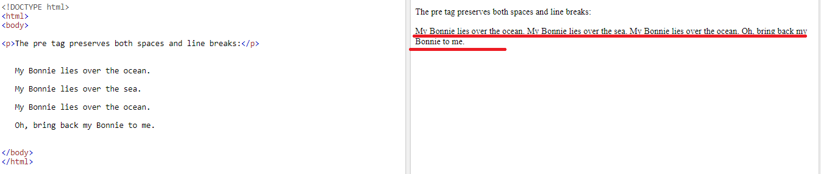

Output with <pre>

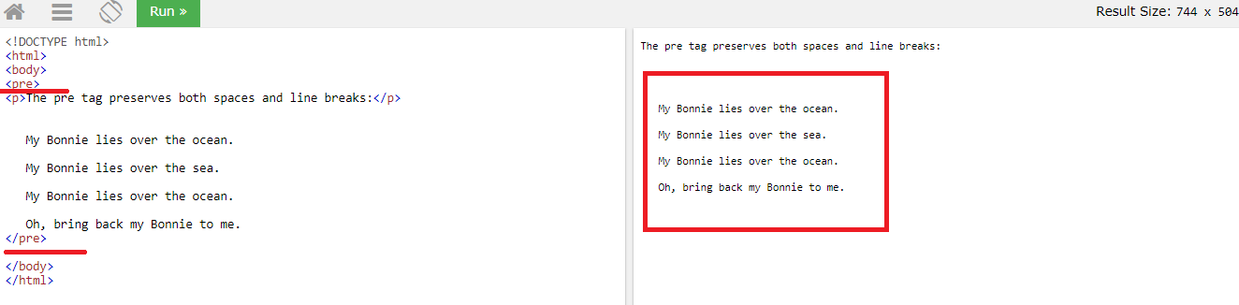

1. 

Few Examples ,

1. style="background-color:powderblue;"
2. Background Color🡺style="background-color:DodgerBlue;"
3. Text-color🡺 style="color:Tomato;"
4. style="color:blue;”
5. border Color🡺style="border:2px solid Tomato;
6. style="font-family:verdana;”
7. style="font-family:courier;”
8. style="font-size:300%;"
9. style="text-align:center;"

Color values 🡺

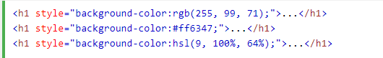

In HTML, a color can be specified using hue, saturation, and lightness (HSL) in the form🡺 **hsl(hue, saturation, lightness)**

1. few of the formatting elements are🡺
2. <b>
3. <strong>
4. I
5. Em
6. Mark
7. Small
8. Del
9. Ins
10. Sub
11. sup

## HTML Quotation and Citation Elements🡺

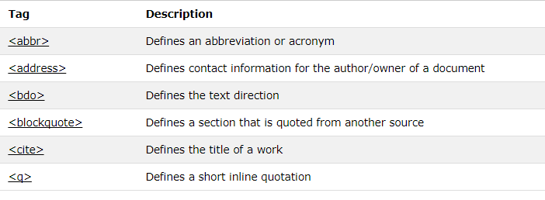

1. Comments🡺 <!-- Write your comments here -->
2. CSS can be added to HTML elements in 3 ways 🡺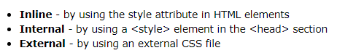
3. Inline example🡺
4. Internal🡺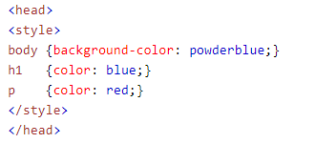
5. External🡺
6. Few of the CSS Styling 🡺

h1 {

color: blue;  
    font-family: verdana;  
    font-size: 300%;

border: 1px solid powderblue;

padding: 30px;

margin: 50px;

1. Link🡺

<a href="https://www.w3schools.com/html/">Visit our HTML tutorial</a>

The **href** attribute specifies the destination address and The **link text** is the visible part

## Below screen shot is an example on Image as a Link

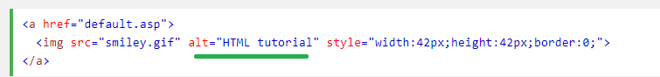

VERY VERY IMPORTANT LOOK AT THE FOLLOWING HREF VALUE

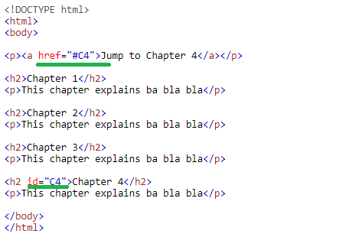

1. Link colors 🡺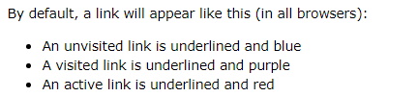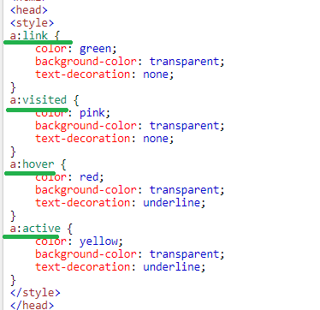

A:link 🡺 indicates

a:visited

a:hover

a:active 🡺 this we can see on continuously clicking the mouse on the

click

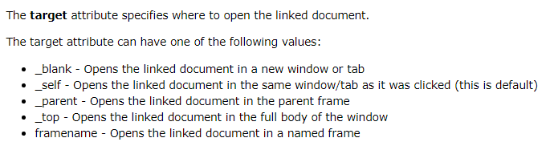

1. Few examples on link’s href value is 🡺
2. <a href="https://www.w3schools.com/html/default.asp uses a full URL to link to a web page
3. <a href="/html/default.asp">HTML tutorial</a>🡺 inks to a page located in the html folder on the current web site
4. <a href="default.asp">HTML tutorial</a>🡺 links to a page located in the same folder as the current page
5. <img src="*url*"> 🡺🡺
6. Animated images will be with .gif extension

## **Image Floating**

1. Use the CSS **float** property to let the image float to the right or to the left of a text🡺

## **Background Image**

1. To add a background image on an HTML element, use the CSS property background-image: 🡺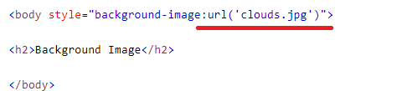

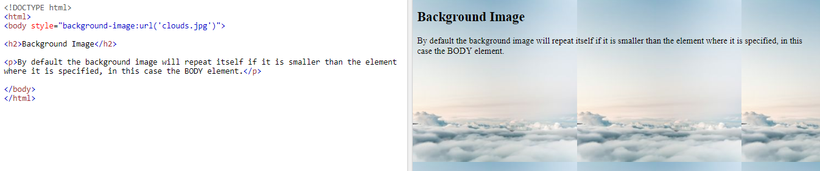

## **HTML Screen Readers**

1. A screen reader is a software program that reads the HTML code, converts the text, and allows the user to "listen" to the content. Screen readers are useful for people who are blind, visually impaired, or learning disabled.

# HTML Tables

1. 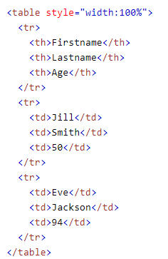
2. Adding a border to a table🡺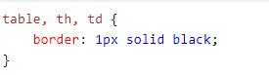
3. Remember to define borders for both the table and the table cells.
4. Cell padding specifies the space between the cell content and its borders
5. Text align 🡺 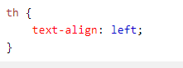
6. Border spacing specifies the space between the cells.

## **HTML Table - Cells that Span Many Columns**

1. 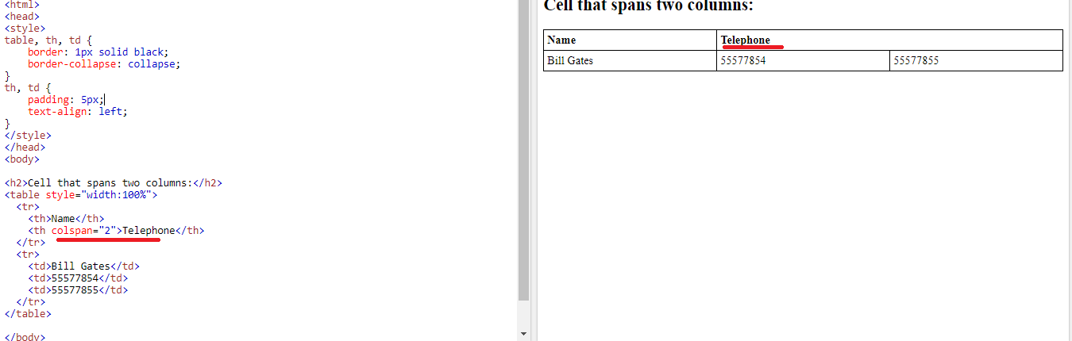

## **HTML Table - Cells that Span Many Rows**

1. To make a cell span more than one row, use the **rowspan** attribute🡺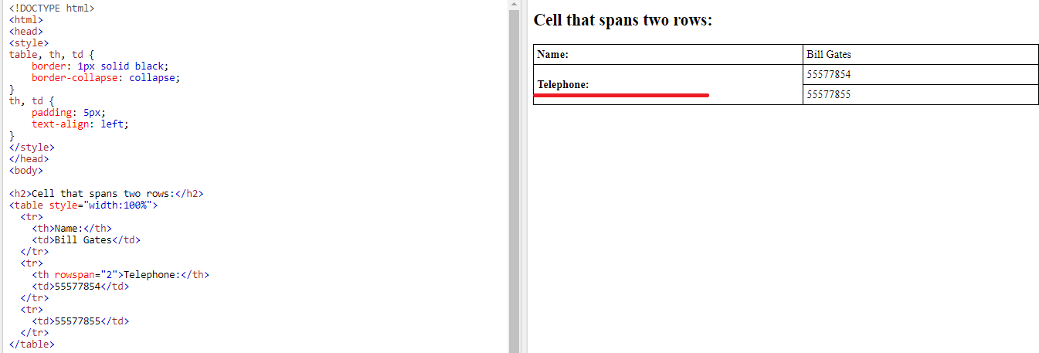
2. Caption 🡺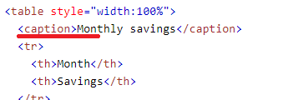
3. 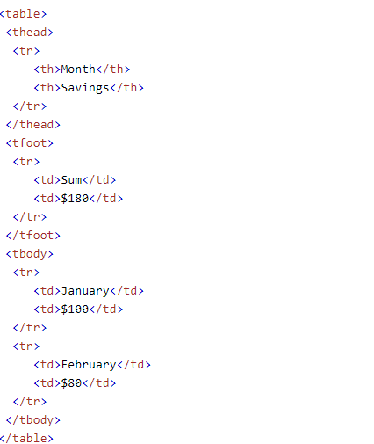 🡺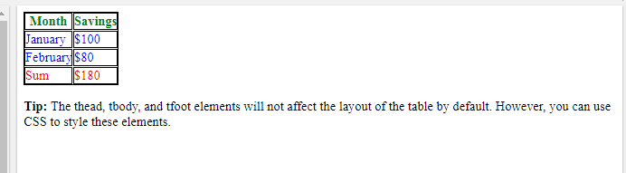

## **Unordered HTML List - Choose List Item Marker**

1. 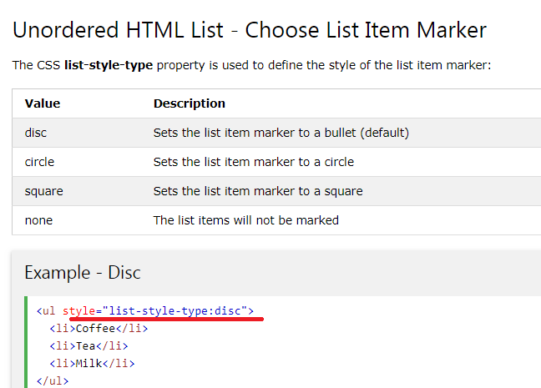
2. In case of Ordered List we have 🡺 Type attribute🡺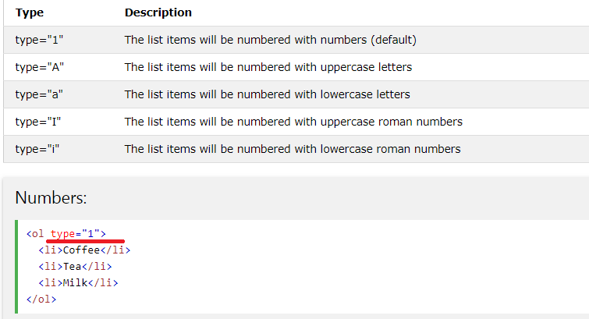

# HTML Block and Inline Elements

1. Every HTML element has a default display value depending on what type of element it is. The default display value for most elements is block or inline.

## **Block-level Elements**

1. A block-level element always starts on a new line and takes up the full width available (stretches out to the left and right as far as it can).
2. List of block elements🡺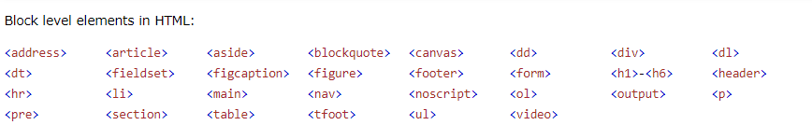

## **Inline Elements**

1. An inline element does not start on a new line and only takes up as much width as necessary
2. List of Inline element🡺 span, iput, all formatting tags and etc...

.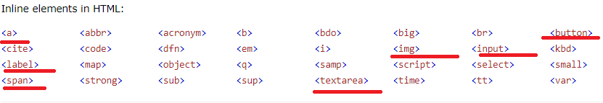

# HTML Iframes

1. An iframe is used to display a web page within a web page.
2. By default, an iframe has a border around it.
3. Syntax and Examples
4. 
5. <iframe src="demo_iframe.htm" style="border:none;"></iframe>
6. <iframe src="demo_iframe.htm" style="border:2px solid grey;"></iframe>

## **Iframe - Target for a Link**

1. An iframe can be used as the target frame for a link.
2. 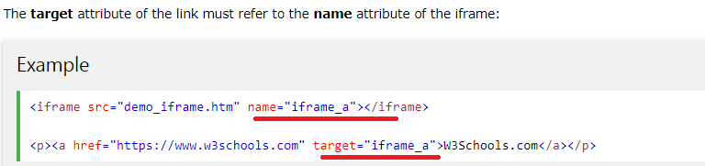
3. The **<script>** tag is used to define a client-side script (JavaScript).
4. Common uses for JavaScript are image manipulation, form validation, and dynamic changes of content
5. Examples,
6. 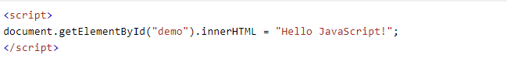
7. 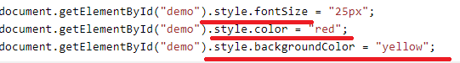
8. 
9. 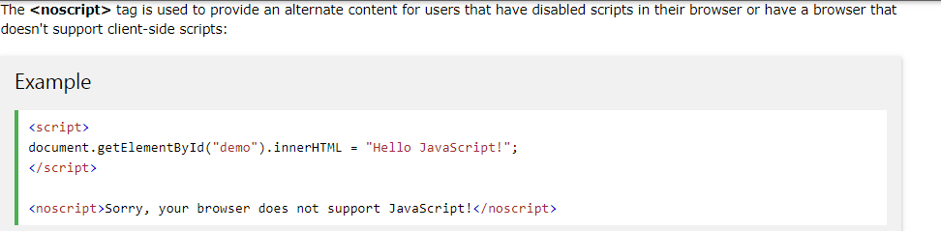

# HTML File Paths

1. 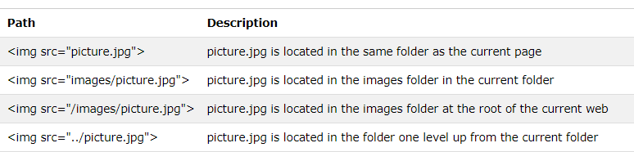

# HTML Layouts

1. Websites often display content in multiple columns (like a magazine or newspaper).
2. 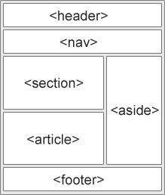
3. 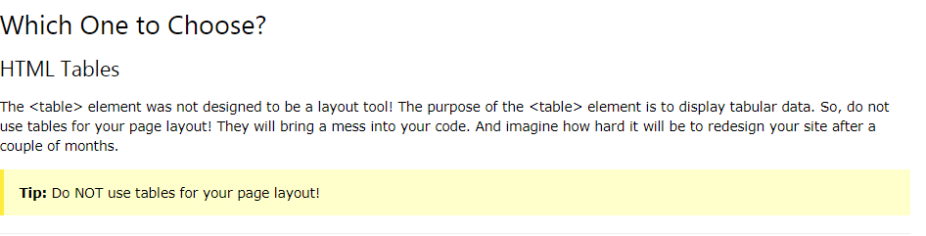\

# HTML Responsive Web Design

1. Responsive Web Design makes your web page look good on all devices (desktops, tablets, and phones).

## **HTML Symbol Entities**

1. Ms🡺 this is like &gt , &lt as in XMl

# HTML and XHTML

1. 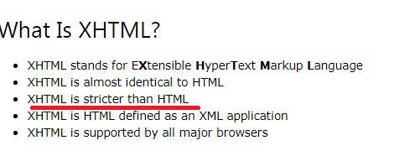
2. Here stricter means 🡺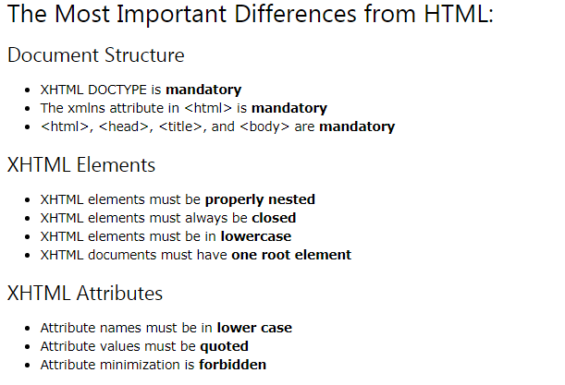

# HTML Forms

1. 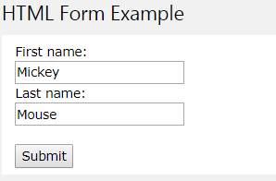
2. The HTML **<form>** element defines a form that is used to collect user input:
3. The **<input>** element is the most important form element. The <input> element can be displayed in several ways, depending on the **type** attribute
4. 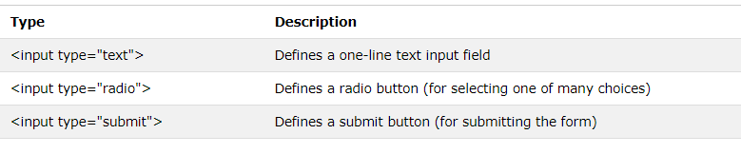
5. 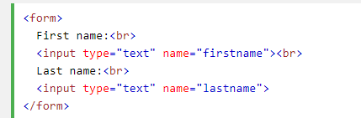
6. 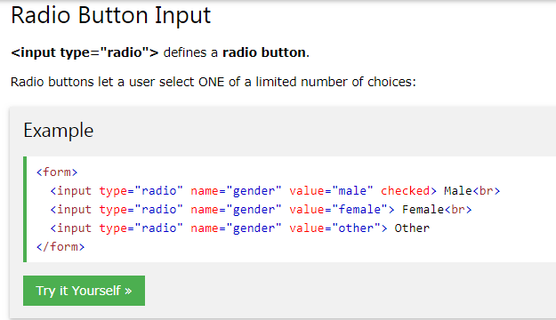
7. <input type="submit" value="Submit">
8. The **action** attribute defines the action to be performed when the form is submitted. Normally, the form data is sent to a web page on the server when the user clicks on the submit button.
9. The **target** attribute specifies if the submitted result will open in a new browser tab, a frame, or in the current window.The default value is "**_self**" which means the form will be submitted in the current window. To make the form result open in a new browser tab, use the value "**_blank**" 🡺

<form action="/action_page.php" **target="_blank"**>

1. The **method** attribute specifies the HTTP method (**GET**or **POST**) to be used when submitting the form data:
2. 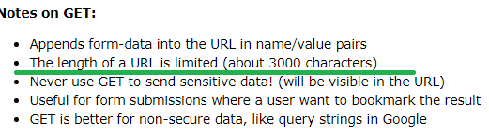
3. Name attribute of the form element

|  |  |
| --- | --- |
| name | Specifies a name used to identify the form |

# HTML Form Elements

1. The <input> element can be displayed in several ways, depending on the **type** attribute🡺 If the **type**attribute is omitted, the input field gets the default type: "text".
2. The **<select>** element defines a **drop-down list🡺** By default, the first item in the drop-down list is selected. To define a pre-selected option, add the **selected** attribute to the option. se the **size** attribute to specify the number of visible values🡺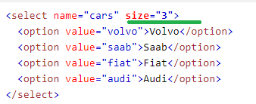

### **Allow Multiple Selections:**

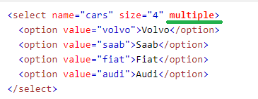

1. The **<textarea>** element defines a multi-line input field (**a text area**)🡺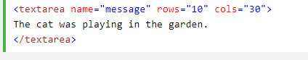
2. The **<button>** element defines a clickable **button**🡺 <button type="button" onclick="alert('Hello World!')">Click Me!</button>
3. The **<datalist>** element specifies a list of pre-defined options for an <input> element. Users will see a drop-down list of the pre-defined options as they input data. The **list** attribute of the <input> element, must refer to the **id** attribute of the <datalist> element🡺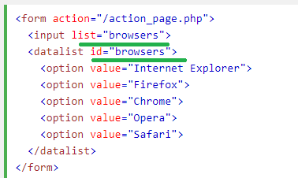

# HTML Input Types

1. 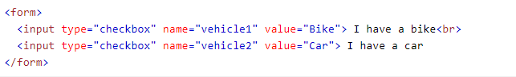
2. 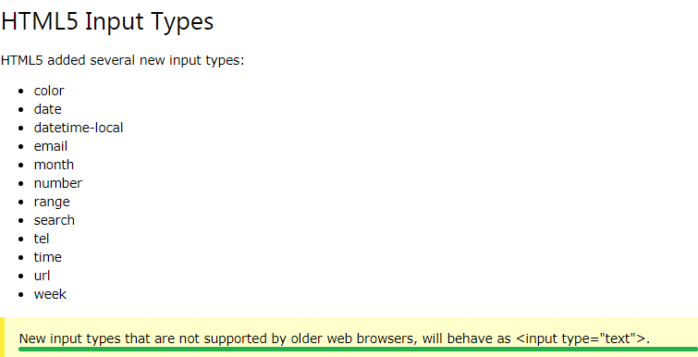

## **Input Restrictions**

1. Here is a list of some common input restrictions (some are new in HTML5):

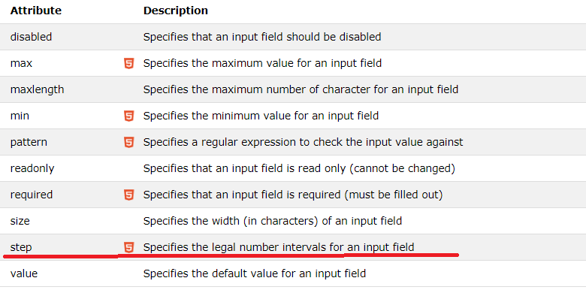

1. Example🡺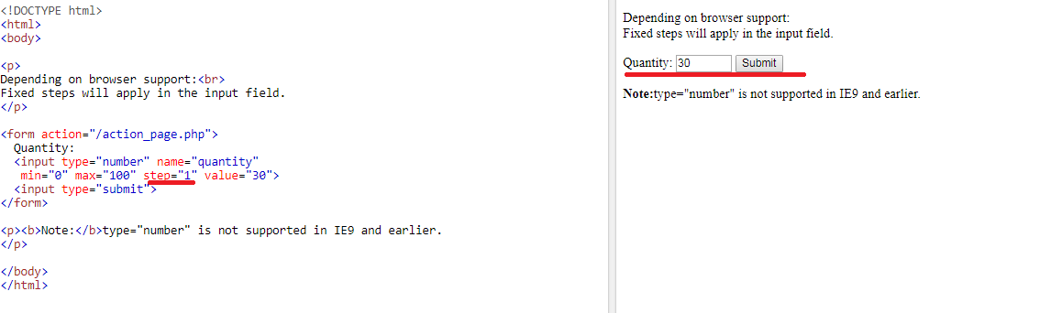

Explanation🡺step =’1’ indicates on clicing Up arrow or down arrow the next vale will be inc or dec in steps of 1

Value=30🡺 ms initial value

1. 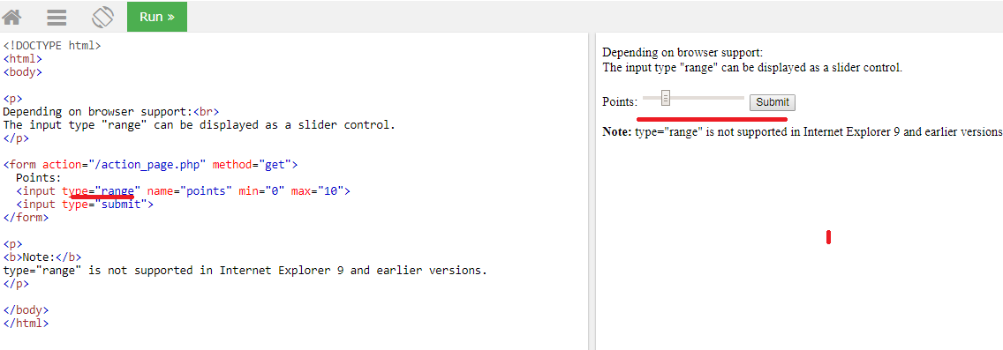
2. Input Search Type example
3. Initially🡺 here no auto suggestion was coming

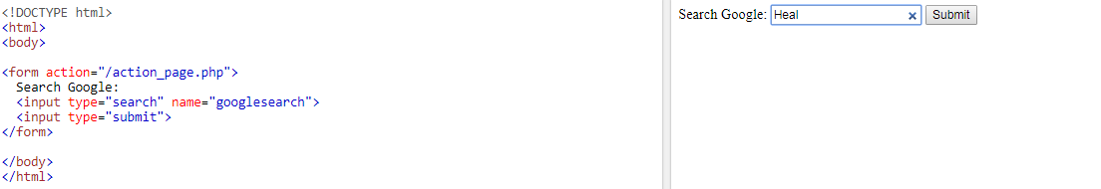

1. Second time search🡺

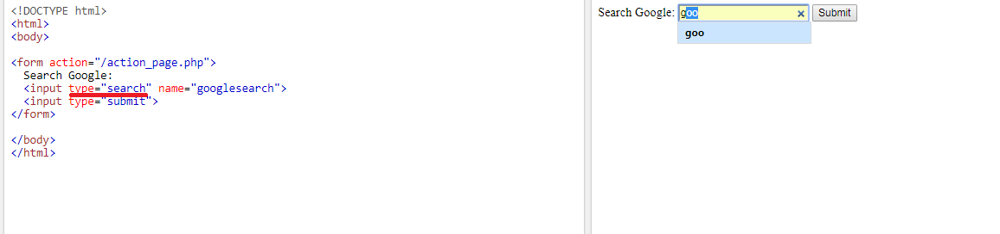

# HTML Input Attributes

1. The **value** attribute specifies the initial value for an input field:
2. he **readonly** attribute specifies that the input field is read only (cannot be changed):
3. The **disabled** attribute specifies that the input field is disabled.A disabled input field is unusable and un-clickable, and its value will not be sent when submitting the form:
4. he **size** attribute specifies the size (in characters) for the input field
5. The **maxlength** attribute specifies the maximum allowed length for the input field

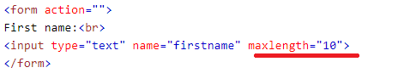

WHAT IS THE DIFFERENCE BETWEEN MAX AND MAXLENGTH

1. 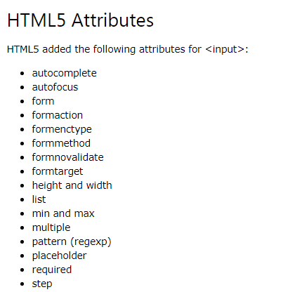



AND ITS Corresponding output🡺



No I just need only value as ‘Yes” or “No” 🡺 to do that I can go for Substr 🡺 substr(actualString _from_which_to_get_the_subString, startPositio, endPosition)

Here start position 🡺 by looking at the output itself we know that start position is 1

End position 🡺 I should get all the characters before the delimit so for this first I can get the position of delimiter by using instr() and that result -1 will give me the position of letter o incase if value is “No”

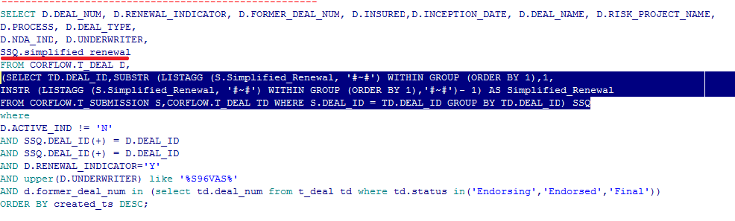s