SIMATS ENGINEERING
CSA0508 - Database Management System

NAME:LOSHITHAP
REG.NO:1965260080

QUESTION 1:
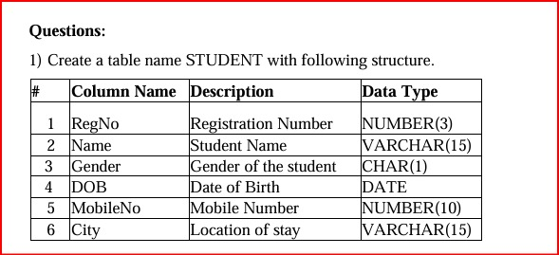

OUTPUT:
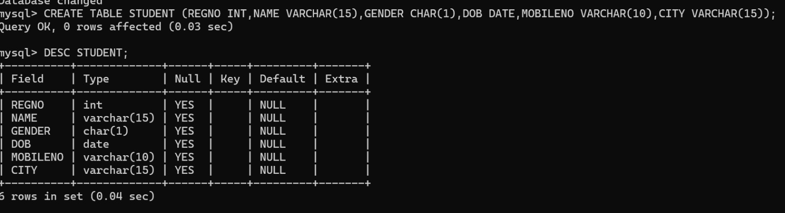
QUESTION 2:

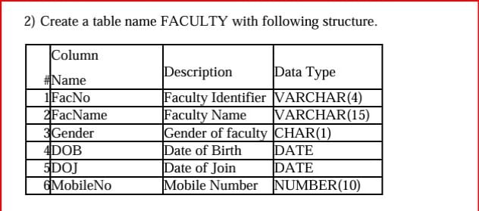

OUTPUT:
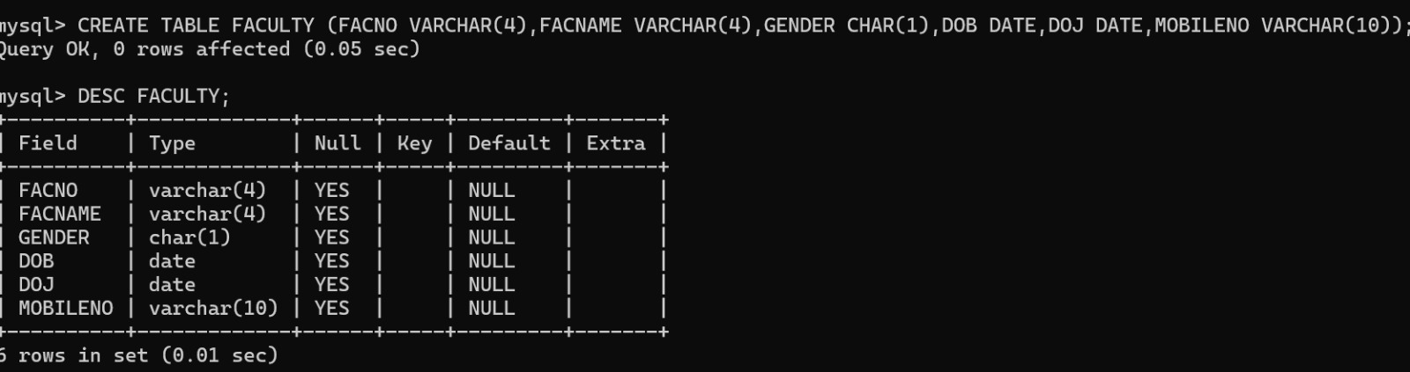
QUESTION 3:

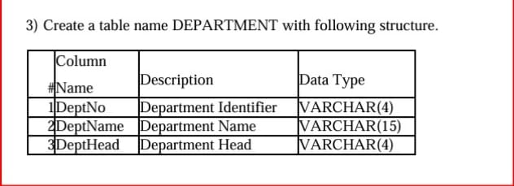

OUTPUT: 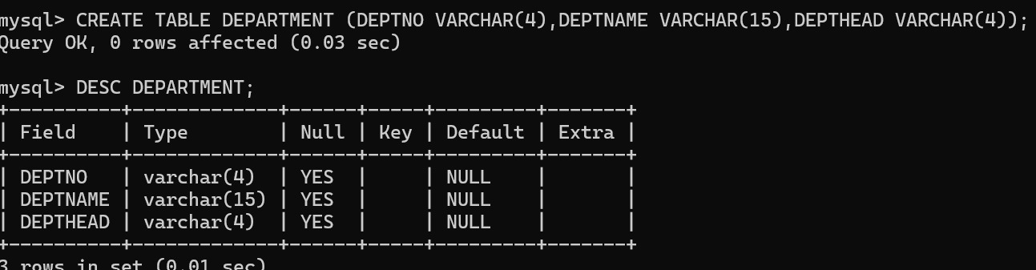
QUESTION 4:

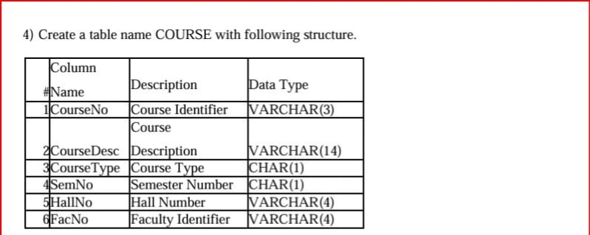

OUTPUT: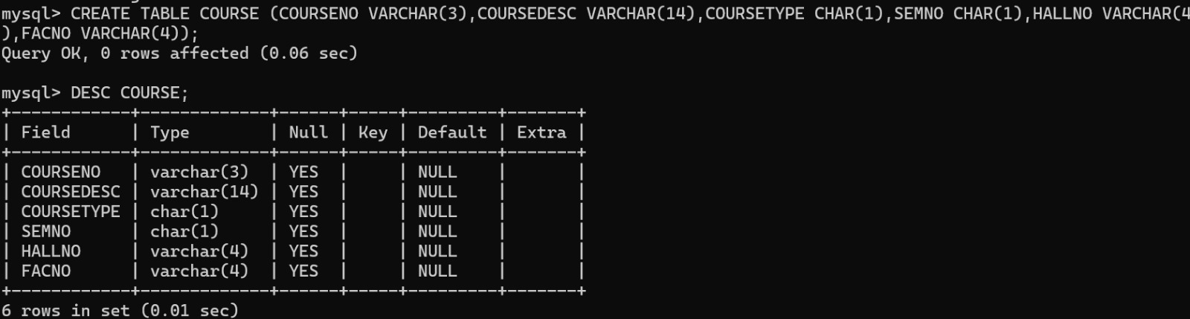
QUESTION 5:
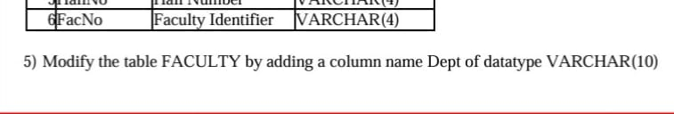
OUTPUT:
