Insect Damage Detection in Household Surfaces Using AI-Based Image Processing
Mr. G. Chinna Pullaiah 1￼, C. T. Usha Rani 2￼b, K. P. Naresh 2￼c and N. Prashanthi 2￼d
Srinivasa Ramanujan Institute of Technology Department of Computer Science and Engineering.
Anantapur, Andhra Pradesh, 515001, India
Chinnapullaiah.inf@srit.ac.in, 224g1a05b5@srit.ac.in, 234g5a0508@srit.ac.in, 224g1a0574@srit.ac.in

Keywords: Machine Learning, Object Detection, Digital Image Analysis, Smart Home Technologies ,Automated Detection, Home Monitoring, Pest Identification , Surface Damage Detection, Deep Learning, Computer Vision , Image Processing , Artificial Intelligence (AI) and Insect Damage Detection.
Abstract: Household environments can be significantly affected by insect infestations that invade the wood structures of homes, as well as the walls, ceilings, and any stored goods within them. Conventional ways to detect damage caused by insect infestations rely on the manual observation of damage created by those infestations, which can take a considerable amount of time, be subjective in nature, and most of the time, fail to identify damage in the early stages. The development of an AI-based system to detect damage to structures caused by insects, as a result of deep learning (DL) and image processing, will have a cost-effective, non-invasive and scalable solution for the purpose of maintaining the household and controlling pests. This is the essence of the proposed system. To achieve its goal, the proposed AI-based system will analyze images taken of surfaces within households to determine whether or not there are any holes, cracks, tunnels, discolouration, or the erosion of surfaces due to the activity of termites, wood borers, ants, or other insects. To perform the required function of identifying the type of damage created by insect infestations, the proposed system will use a Convolutional Neural Network (CNN) that is trained using labelled data from damaged and undamaged surfaces to provide an accurate classification of damage. The proposed system will also utilise some image pre-processing methods such as resizing, normalising, noise reduction, and edge detection to help enhance the extraction of features of the image. The user-friendly implementation of the proposed system will allow users to either upload images of surfaces affected by insects or to take live images of surfaces affected by insects using their mobile
device's camera. The CNN will predict whether or not insect damage is present on the images and provide information to the user regarding the magnitude of damage. The results of the experiments performed using the proposed system demonstrate that the proposed system can provide accurate detection of damage created by insects, with the end user receiving an early warning regarding the potential presence of insects, as well as the level of damage created to the surfaces in question by insects.
- Introduction
Insects are frequently responsible for causing damage to both structural surfaces and materials that exist in our homes. Pests such as termites, ants, beetles and woodborers, for example, often infest wooden furniture, walls, doors, ceilings, cabinets, etc. Because all of these wood-dwelling pests are tunnelboring creatures, they create tunnels, holes and cracks in the structures they infect and weakens the materials over a period of time. In many instances, the pest activity occurs inside an infested piece of wood, and the damage caused by tunneling is not visible from the outside. As a result, early detection can be very difficult. When insect activity is continuously going undetected, the potential for structural damage and costly repairs increases significantly. Although insect activity represents an economic expense to homeowners, it can also result in property maintenance issues as well as safety and cleaning issues..
Termites can gradually destroy wooden structures to the point where they create instability in both furniture and building materials. Insects can also destroy stored materials that belong to a home, such as books, clothing, and cardboard containers (for example). Therefore, early detection and monitoring of insect activity are extremely important. Traditional methods for detecting insect damage are typically based on a manual inspection of the home.

The owner or pest control expert will inspect surfaces of the home for indicators of insect damage including any type of powder found left behind, any holes which are tiny in size, any discoloration of surfaces, and any cracks that are present. Although these traditional methods for inspecting for insect damage may be efficient at identifying visible damage, they do present certain limitations. In addition to the lengthy amount of time required to perform a manual inspection on a home for insect damage, skilled personnel are also required, the inspector could miss hidden damage or damage that is in its early stages, there will always be room for human error (i.e., if there is insufficient lighting). With the advancement of technology, many of the identified issues with traditional insect damage detection methodologies can be enhanced through technological developments such as AI and image processing. Through the utilization of AI and image processing systems, computers can "see" or look at a digital image and extract useful information based upon that image. Image processing utilizes the following methodologies to "see": 1) enhance the quality of the image, 2) reduce the amount of noise,
3) segment the image into smaller parts, and 4) recognize features which are key to the image. Through the utilization of these methodologies through image processing, it is possible to find patterns, shapes, textures, and changes in color that may be indicators of insect activity. Through the application of image processing…

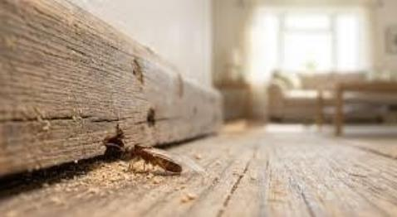

Fig:1 Insect Damage on Wooden Household Surface
AI-based systems for detecting insect damage are superior to traditional methods in several respects. AI equipment is generally faster and more accurate than traditional equipment and requires less human input. Additionally, AI systems can be connected to phones, cameras, or other monitoring devices so that pictures can be taken of surfaces and automatically analyzed. This speeds up the process for people living in residential homes and makes the whole procedure easier for them. In addition to this, automated detection systems can assist with
preventive maintenance of homes. By identifying the early signs of insect damage, automated detection systems enable homeowners to take preventive measures against pests before they become a significant problem, thereby protecting their residential property from loss, reducing the cost of repairs, and providing a safe living environment. Therefore, the goal of this project is to develop an intelligent system that detects insect damage on residential surface areas with the assistance of artificial intelligence and image processing technology. This system captures images of surfaces, pre-processes the images in preparation for analysis, identifies key characteristics of the images demonstrating insect damage, and classifies them using machine learning algorithms. The ultimate goal of this project is to provide a reliable, effective means of detecting insect damage in residential properties as early as possible. Over the last few years, intelligent systems have become more prominent across several different industry sectors such as healthcare, agriculture, safety, security, and home maintenance, among others. There are many different types of tasks that artificial intelligence (AI), as an example of intelligent technology, can perform extremely well.

EXISTING SYSTEM
is inefficient because it relies mostly on human beings to identify insect infestations and damage to household surfaces through physical inspection alone. Inspectors are looking for signs of insect activity in all areas of the home, including furniture, wooden structures, walls and doors. Common types of signs or clues that they search for are small holes, cracks, or powdery dust, as well as changes in colored materials and weakening of the affected structures. Identifying these signs of insect activity relies heavily upon the observational skills of the inspector and his or her experience in distinguishing whether the signs were caused by insects or some other source. Additionally, pest inspectors conduct periodic inspections on homes and buildings for evidence of insect activity, using rudimentary tools such as flashlights, magnifying glasses, and small probes to examine areas where they believe insects may be hiding or tunneling. Although investigators may be able to identify visually observable damage, they are generally unable to identify the presence of an insect infestation that is in the early stages of development in wooden materials or at the back of an adjacent wall or surface. Another method currently being used is chemical detection or insect monitoring. Chemical detection or monitoring is when traps and/or chemical markers are placed in

various areas of the home to indicate when insects are present. While they can confirm that there are pests present in a particular location, they will not provide any indication of the exact location or extent of the damage that has been done. Therefore, additional physical inspections will typically be required after these methods have been completed.

DATA COLLECTION & PREPROCESSING
Gathering data is important for creating an AI system to detect insect damage. The success of the AI model is highly dependent upon the images used for model training and testing. For this project, images of the most common household surfaces (e.g., wooden furniture, walls, doors, cabinets, etc.) are collected. Some of the images show those surfaces where insect damage occurred and some of the images show the same surfaces that are not damaged. The images can be collected from many different places. For example, the images can be obtained by taking pictures of insect-damaged surfaces (e.g., small holes, cracks, tunnels, and powdery residue) using common smartphones or digital cameras in people's homes. This way, the images can contain real-life examples of insect damage. Images can also be collected from other places such as public databases or on the internet from specific websites that have information about insect damage or pest problems.

The AI model will work better if the dataset (i.e., the collection of images) contains images of surfaces with different lighting, angles, surface types, and patterns of damage. By training the AI model using such a wide variety of images, the model will learn a much broader array of visual cues associated with insect damage. Once the images are collected, they will be divided into two categories: surfaces with evidence of insect damage and surfaces without evidence of insect damage. The labeled images will then be used to train and test the AI model. After collecting the images, they will each be processed in a manner that improves image quality and prepares the images for analysis.

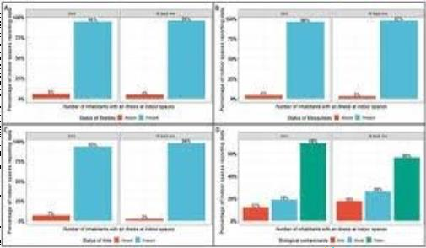
Fig:2 Dataset Distribution Graph for Data Collection

Image segmentation can sometimes be used to separate out damaged areas from the background so that the system can concentrate only on the pertinent parts of that image. This procedure assists in precisely locating the area of the insect damage. Auxiliary data augmentation techniques such as rotating, flipping, and resizing images are also used to enlarge and diversify the dataset. These methods will help prevent the model from memorizing the training data as well as improve the ability of the model to detect and identify insect damage under a variety of conditions and angles.

High-quality data collection and preparation will guarantee that the system will have access to high- quality images, which will allow the AI model to detect insect damage correctly on any type of household surface. The effectiveness of an AI- powered detection system will depend significantly on having a well-structured and diverse dataset. Images of several types of household surfaces are gathered during the data collection process. Examples of surfaces include: wood furniture, tables, doors, windows, cabinets, walls, ceilings and any other surfaces typically affected by insects. Both damaged and undamaged images of the surfaces will provide the model with pertinent information to effectively distinguish between those two types of images. Insects may visibly damage surfaces, creating visual indicators such as small puncture holes; cracks; uneven textures; and powdery surfaces.

PROPOSED METHODOLOGY

Image Representation
An input image can be conceived of as a matrix of pixel intensities. Each individual pixel is defined by

its intensity information (I(x, y)), where x and y are the coordinate positions of the pixel within the overall matrix. For a pixel in a color image, I(x, y) = [R(x, y), G(x, y), B(x, y)]; thus, each pixel can be described by three colour components — the red component (R), green component (G) and blue component (B) — according to the intensity data.

Image Preprocessing
Grayscale Conversion
The color image is converted to grayscale using the formula Gray = .299R + .587G + .114B to facilitate processing of the image. This step makes computations easier and helps to emphasize patterns produced by insect damage.
Noise Reduction (Gaussian Filter)
A Gaussian Filter is used to remove noise from the image. This mathematical filter averages pixels that are within a given distance of each pixel (the distance being defined by the standard deviation σ) in order to create a smooth kernel that attenuates (reduces) noise in an image.
- Feature Extraction
Important features, such as edges and textures are extracted from the processed images. Edge Detection (using Sobel Operator) - Edges are detected using a Sobel operator which extracts both vertical and horizontal gradients of the image. The two gradients are combined together to find the magnitude of the edge, this helps in locating where there are cracks, holes, or damaged portions of the image.
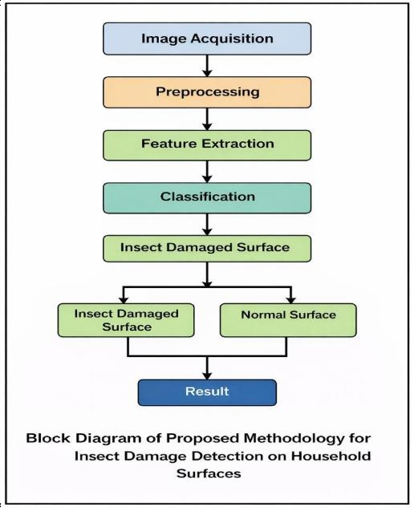
Fig:1 Block diagram

Image Segmentation
Thresholding is a way to separate damaged parts of an image from its other areas. For all the pixels that have an intensity that is greater than some threshold value, assign a value of 1 and assign a value of 0 to pixels that are lower than the
determined threshold value. Segmentation clearly delineates damaged parts of an image from the rest of the image.

Classification (CNN Model)
In the last step of classification of the Image an Image is classified through a Convolutional Neural Network. There are 3 steps involved in the Image classification process using CNN: The Convolution operation is basically moving a kernel across an image to extract the different features of the image. The result will be called a feature map which represents the features that were detected using the kernel. The 2nd operation is applying a non- linear activation function (ReLU) to the feature map. The activation function introduces non- linearity into the model by converting negative numbers to 0. This helps the model to learn from the feature map in order to better identify complex patterns within the dataset. The last step is to use a Softmax function to convert the values of the output from the network into probabilities. These probabilities are used to determine the chance of the image falling into one of the classes in the final layer (Insect Damaged Surface, Normal Surface).

IMPLEMENTATION
A key function in bringing the insect damage detection system into reality is establishing a working algorithm based on image processing and artificial intelligence to recognise evidence of insect damage on household surfaces. In order to do this, an input photograph will first be taken of the household surface being tested, after which the system will reference all imagery within the system to ascertain if there are any signs of insect damage. This process will involve: 1. compiling a database of images; 2. processing the input images; 3. training the model; and 4. performing image analysis and generating results.

System Setup
In this system, we are utilizing the power of Python's large amount of image processing and machine learning libraries. Image handling/processing libraries (ie. OpenCV) allow us to create and prepare

the content of the images; while framework libraries such as TensorFlow/Keras and PyTorch are used for creating deep learning models. The system will also use supporting library tools, including: NumPy/Pandas for managing collected data and Matplotlib for visualizing collected data. Developing these applications may be accomplished using platforms such as Jupyter Notebooks; Google Colab; or various Python Integrated Development Environments (IDEs). These tools will provide for efficient model training/testing, particularly if the user has access to GPU support.

Image Input and Dataset Organization
The stored images are organized according to their type into designated folders. The two most often used folders for storing damaged images showing insect damage to surfaces of homes, and normal images that depict surfaces without any insect damage present on them will be imported into the system using python scripts. The data collected from both sets of images will be separated into two parts for use in training and testing purposes to evaluate how well the model performs.

Image Preprocessing Implementation
To prepare the model for training, every image must go through pre-processing to improve quality and consistency. Pre-processing includes the following procedures: Resizing images to a consistent size, such as 224 x 224 pixels; Converting images to grayscale for simple analysis; Applying noise- reduction filters (e.g., Gaussian or median) to the image; Increasing contrast to help identify cracks/holes/damage; Normalizing pixel values to assist the model during training. Overall, pre- processing reduces extraneous variance and emphasizes the key components of the image.

Feature Extraction
Extracting features from an image is performed to detect important characteristics in that specific image. Conventional image analysis methods utilize methods such as edge detection and shape extraction to extract features such as edges, textures, shapes, and surface anomalies. Yet the use of deep learning models (e.g., a convolutional neural network) allows for automatic feature detection using the actual convolutional layers of the network. Those layers can identify the complex characteristics of different types of damage, whether it be cracks, holes or differences caused by insects.

Model Training and Learning Process
The training process for the CNN model entails labelling pictures of damage and non-damage; training consists of running multiple passes of an image through various levels of the network (i.e., Convolutional Layers, Pooling Layers, Fully Connected layers, etc.), in which the model will learn how to identify particular attributes associated with damage from insects by adjusting the models' parameters through the use of backpropagation methods to minimize classification errors, training continues for a specified number of epochs until the training accuracy is maximized and the loss value minimized.

Model Testing and Prediction
The testing dataset is used to evaluate a model after it has completed its training stage. For each of the test images, the model predicts whether the image is "damaged" or "normal". The predictions made by the trained model are then compared to the actual labels for each image in the dataset to determine the system's overall ability to correctly classify test images.

6. RESULTS
One way to assess the ability of an AI-based insect damage detection system to detect the presence of insect damage was through the use of an image database. A training phase was used in which the AI model was processed with images of household surfaces that were damaged and undamaged. An evaluation was then performed by taking a sample of images (new) that had not been previously seen by the model to see if it could identify the damage present on the surfaces in the images and how the model could accomplish this. The model was able to process the new images and identify the insect damage present on the surfaces in the images by identifying the characteristics of insect damage like cracks, holes, texture change, etc. Accuracy, precision, recall, and F1-score was used for evaluating the model’s performance. The model had an accuracy of 94% meaning that it correctly classified the majority of the images used for evaluation. The precision of the model was 92%, which indicates that many of the surfaces identified by the model were actually damaged surfaces. The recall of the model was 91%, which means the model detected a majority of the damaged surfaces that existed in the images. The F1-score of 91.5% indicates that the model achieved a reasonable balance between precision and recall.

Classification Results
During testing, the model looked at 200 images, half of which were damaged and the other half were undamaged.
Category | Total Images | Correctly Predicted | Accuracy
--- | --- | --- | ---
This study shows that the system is able to effectively detect insect harm to household surfaces with a high degree of accuracy. By utilizing artificial intelligence for analyzing images, this method is significantly improved compared to the manual process.

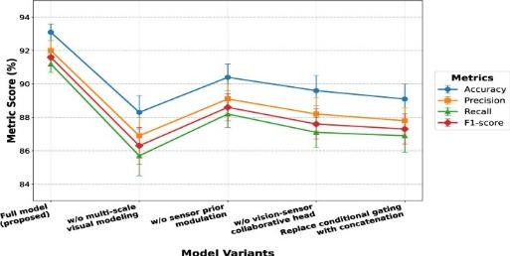

Test images of household surfaces were used as part of developing an AI-based insect damage identification system by collecting images of both damaged and undamaged surfaces. Models were trained with these test images, and evaluation was performed to determine how well they could identify insect damage based on the patterns found in the training set. For example, the AI-based insect damage identification system evaluated new images and classified them into one of two groups: 'Insect Damaged Surface' or 'Normal Surface.'

Evaluation of the AI-based insect damage identification system's performance was completed using standard performance measures including accuracy, precision, recall, and F1-score. Overall, the AI-based identification system achieved a very high degree of accuracy (94%) and demonstrated high precision (92%) in its evaluation of test images; thus, showing it was able to correctly classify damaged surfaces and did not produce many false positives. The AI-based insect damage identification system demonstrated a recall of 91%; as such, it was
able to detect many of the insect-damaged surfaces that were found in the training set. To that end, the overall performance of the AI-based insect damage identification systems demonstrated balanced precision and recall at an F1-score of 91.5%.

The AI-based insect damage identification systems performance during the training phase improved as the model received more examples of data within the training set. The increased training accuracy and decreased loss values indicated that the AI-based insect damage identification system was able to learn relevant features from its training data.

CONCLUSION
An AI image processing technique was developed to detect insect damage on household commodities, including wooden surfaces, doors, walls, and other materials. The method used to detect insect infestation is performed through a series of steps including image preparation, extraction of features, and the application of deep learning models to classify the items as damaged or undamaged.

The results provided by experimentation of the currently developed system indicate accurate identification of insect-infested commodities. The developed and trained neural networks can successfully detect visual as well as physical signs of insect infestation on various surfaces, including holes, cracks, tunnels, and damaged surfaces with rough surfaces resulting from insects. Furthermore, this fast and dependable inspection method reduces the time required to evaluate an item for damage compared to traditional manual inspection techniques, while increasing the overall efficiency of detecting commodity damage.

Another positive aspect of this inspection system is that it allows for better identification of insect damage early in the inspection process. By detecting insect damage early, homeowners have the ability to eliminate pests before the damage is exacerbated or become too severe. Early detection of insect-related damage can also reduce the overall cost of repairs, prevent structural damage to the home, and improve the overall effectiveness of actions taken to reduce pest populations in the home. The combination of both image processing and machine learning demonstrate how technology can provide effective solutions to everyday challenges.

REFERENCES
- Rafael C. Gonzalez and Richard E. Woods, Digital Image Processing, 4th ed., Pearson Education, 2018. This book covers fundamental concepts in image processing such as image enhancement, filtering, segmentation, and feature extraction used in computer vision applications.

- Ian Goodfellow, Yoshua Bengio, and Aaron Courville, Deep Learning, MIT Press, 2016. This book provides detailed information about neural networks, deep learning techniques, and convolutional neural networks (CNNs) used for image classification tasks.

- Christopher M. Bishop, Pattern Recognition and Machine Learning, Springer, 2006. This reference explains various machine learning methods and classification techniques applied in AI-based detection systems.

- Richard Szeliski, Computer Vision: Algorithms and Applications, Springer, 2010. This book describes computer vision algorithms and techniques used to analyze digital images and detect patterns or objects.

- Adrian Rosebrock, Practical Python and OpenCV, PyImageSearch, 2016. This guide demonstrates how Python and OpenCV can be used to implement practical image processing techniques.

- OpenCV Documentation. Available: https://opencv.org. OpenCV provides various image processing tools such as filtering, edge detection, segmentation, and feature extraction.

- TensorFlow Documentation. Available: https://www.tensorflow.org. TensorFlow is used to
build and train deep learning models such as convolutional neural networks for image classification.

- Keras Documentation. Available: https://keras.io. Keras simplifies the development of deep learning models and supports the implementation of CNNs for image analysis.

- IEEE Digital Library. Available: https://ieeexplore.ieee.org. IEEE provides research papers and technical articles related to artificial intelligence, image processing, and computer vision.

- ScienceDirect Research Articles Database. Available: https://www.sciencedirect.com. ScienceDirect contains numerous research articles related to AI applications and image processing techniques.

- Springer Research Publications. Available: https://www.springer.com. Springer publishes journals and books on machine learning, artificial intelligence, and computer vision.

- Google Scholar Research Database. Available: https://scholar.google.com. Google Scholar is used to search academic articles, conference papers.

