Project Report

TEAM ID: LTVIP2026TMIDS87719

INTRODUCTION:
  - Project Overview
The Heart Disease Analysis using SQL and Tableau project focuses on analyzing cardiovascular health data to identify patterns, risk factors, and trends associated with heart disease. The project utilizes MySQL for structured data storage, SQL for data processing, Tableau for interactive dashboard visualization, and Flask for web integration and deployment.
The objective of this project is to transform raw healthcare data into meaningful visual insights. By analyzing patient demographics, lifestyle habits, and medical indicators such as BMI, diabetes, smoking, physical activity, and general health condition, the project enables healthcare professionals and individuals to understand risk patterns effectively.
Through interactive dashboards and story-based visualization, the system simplifies complex medical datasets and supports preventive healthcare decision-making.

IDEATION PHASE
2.1 Problem Statement
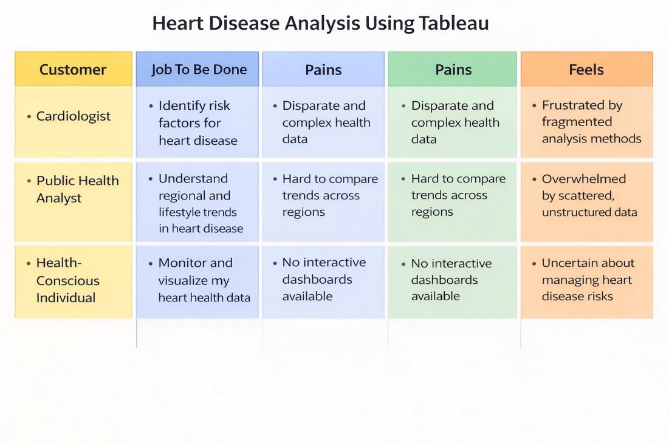
Customer problem statement
Problem Statement (PS) | I am (Customer) | I’m trying to | But | Because | Which makes me feel
PS-1 | a cardiologist | identify high-risk heart disease patients | patient health data is scattered and complex | there is no unified visual dashboard to analyze risk factors | uncertain about early diagnosis decisions
PS-2 | a healthcare policymaker | track heart disease trends across different age groups and regions | I can’t compare demographic and lifestyle patterns easily | dashboards are not interactive or centralized | frustrated and unsure about preventive policy planning
PS-3 | a health data analyst | analyze relationships between diabetes, BMI, smoking, and heart disease | the dataset contains multiple variables and requires manual filtering | there is no automated SQL + visualization system | overwhelmed and time-constrained
PS-4 | an individual concerned about heart health | understand personal risk factors | medical reports are difficult to interpret | data is not visually explained in simple format | confused about health condition

2.2 Empathy Map Canvas

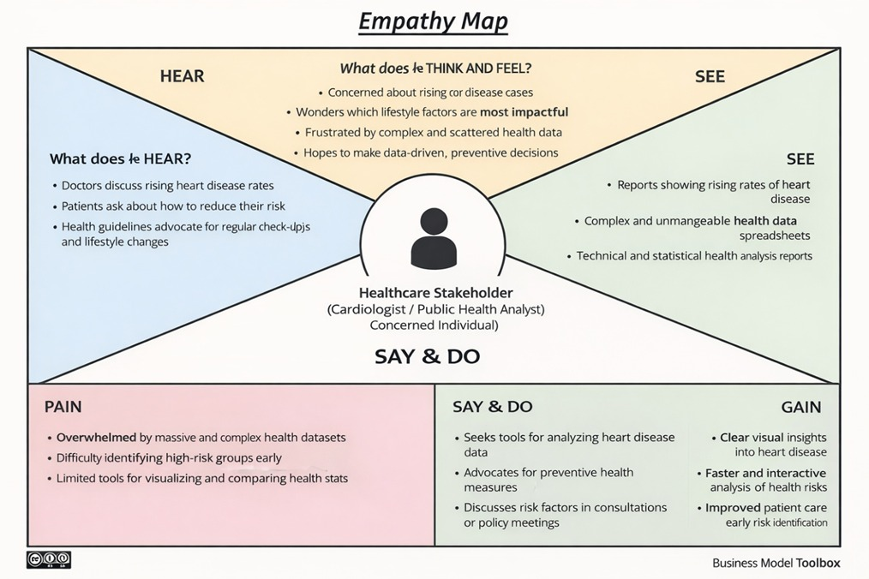

  - Brainstorming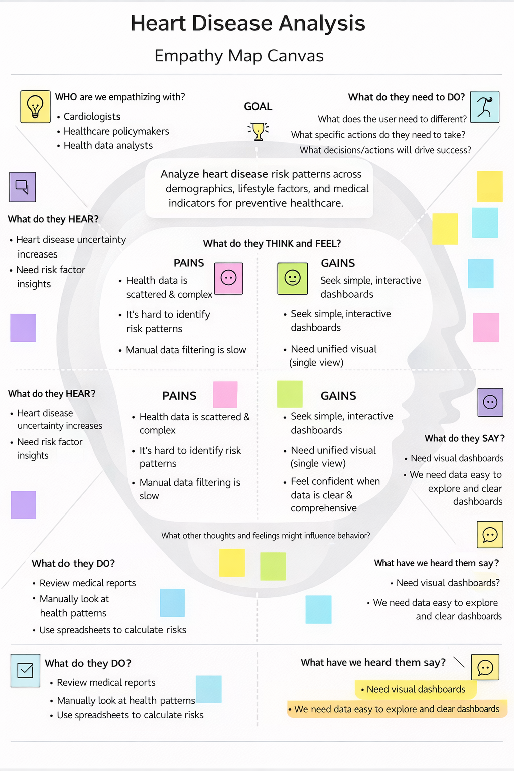
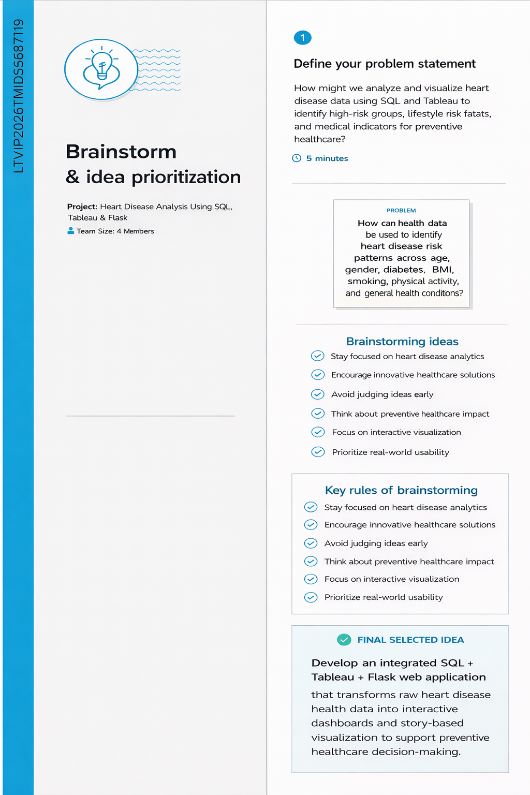

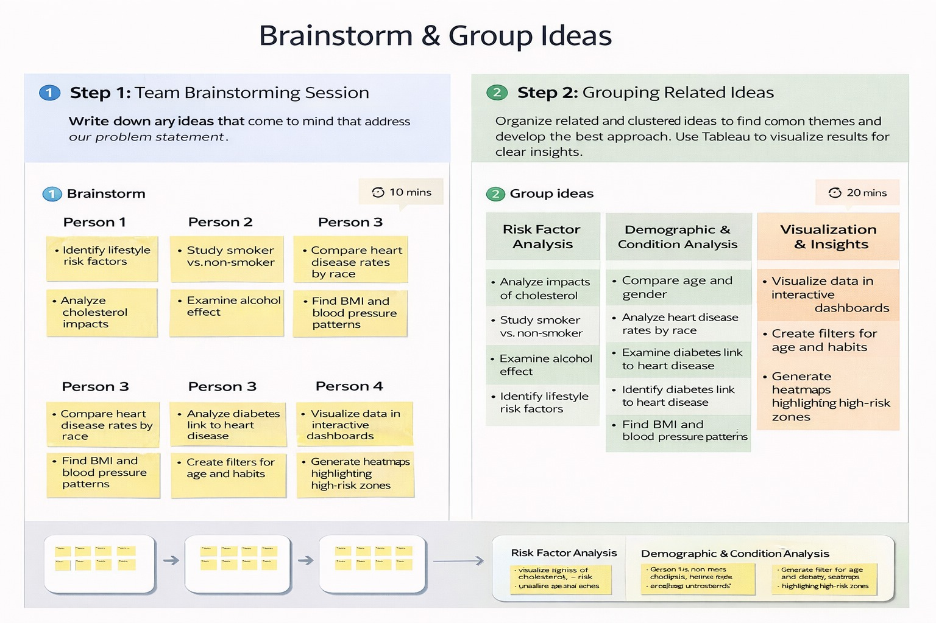

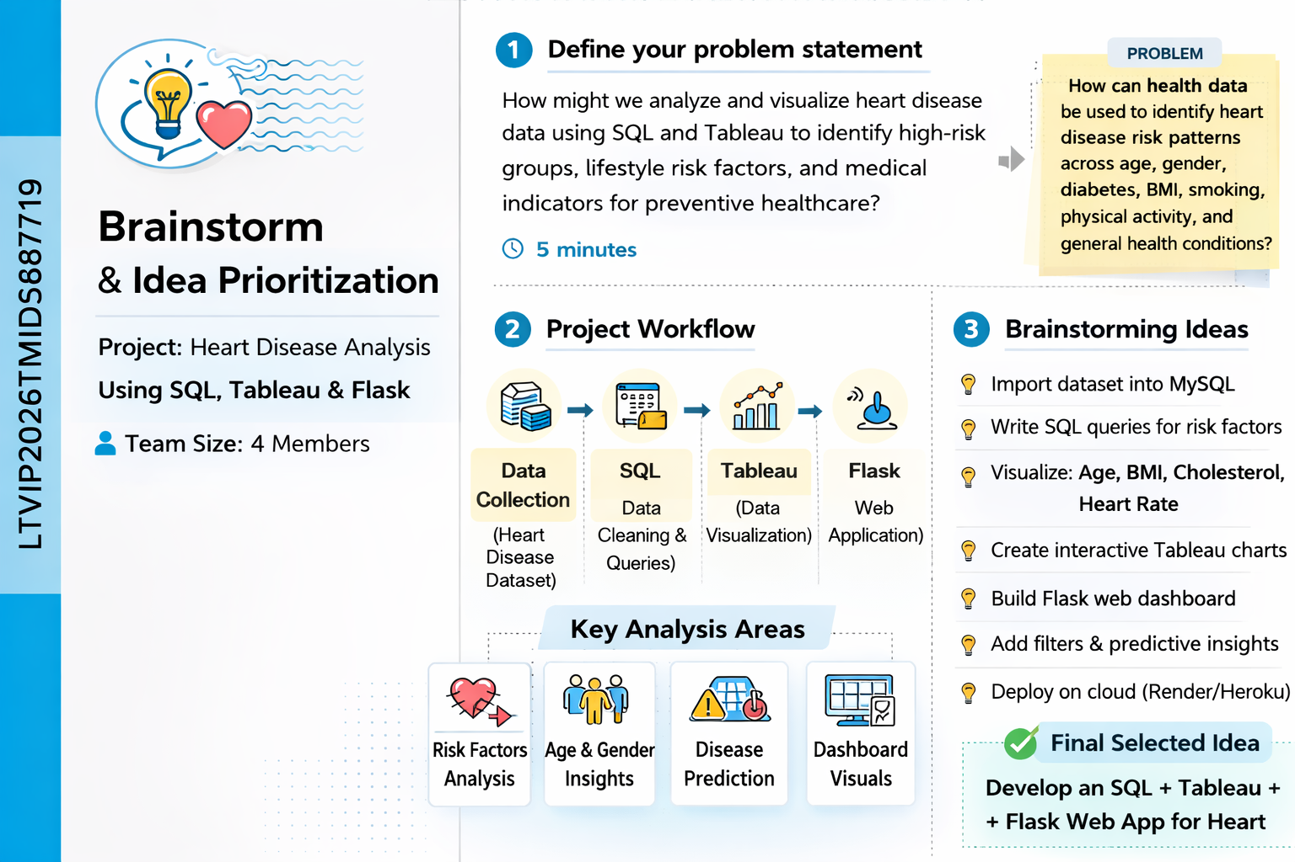
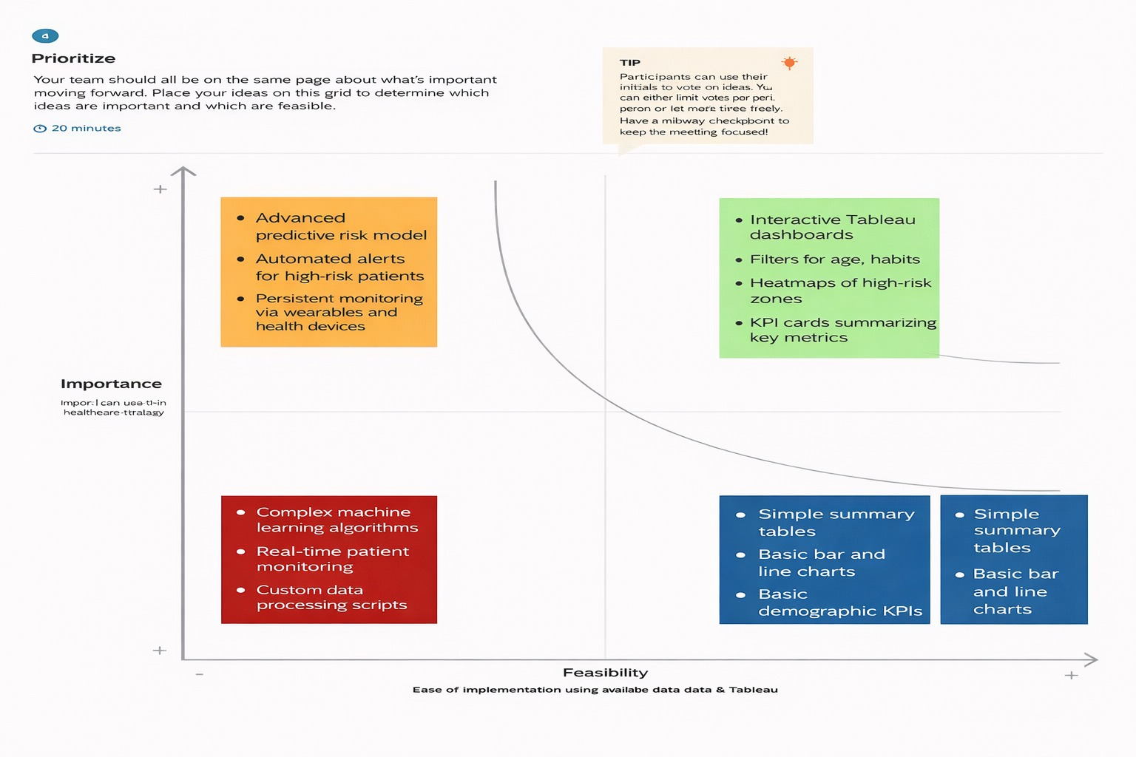

3. REQUIREMENT ANALYSIS
3.1 Customer Journey map – Heart Disease Analysis

Stage | Need | Action | Touchpoint | Pain Point | Opportunity
Discover | Understand heart disease risk patterns | Searches health dataset and reports | Raw dataset, SQL database | Data is complex and difficult to interpret | Unified interactive dashboard
Explore | Analyze risk factors like age, BMI, diabetes, smoking | Filters and compares health indicators | Tableau dashboards | Too many variables to compare manually | Filter-enabled interactive dashboards
Engage | Compare affected vs non-affected groups | Views charts and visual comparisons | Tableau charts & graphs | Static reports lack clarity | Story-based interactive visualization
Decide | Present insights for preventive healthcare | Exports visuals and dashboards | Tableau Story & Flask web app | Difficult to explain medical data clearly | Narrative-driven data storytelling
Act | Take preventive measures or policy decisions | Reviews risk factor insights | Web application (Flask + Render) | Lack of clear actionable insights | Data-driven preventive healthcare support

3.2 Solution Requirement
Functional Requirements:
FR No. | Functional Requirement (Epic) | Sub Requirement (Story / Sub-Task)
FR-1 | User Access to Web Application | Navigate through Home, Dashboard, Story, About, Contact pages
FR-2 | Data Storage | Store heart disease dataset in MySQL database
FR-3 | Data Processing | Perform SQL operations for filtering and structuring data
FR-4 | Data Validation | Ensure dataset is clean and properly formatted before visualization
FR-5 | Data Visualization | Generate interactive Tableau dashboards
FR-6 | Story Creation | Create Tableau Story for structured analytical narrative
3.3 Data Flow Diagram

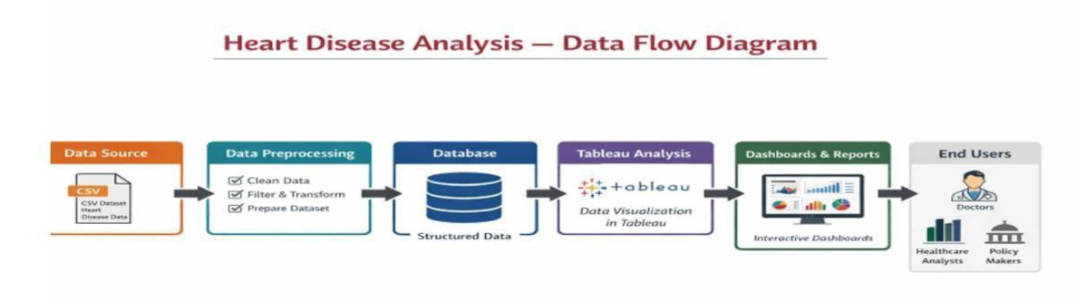
  - Technology Stack
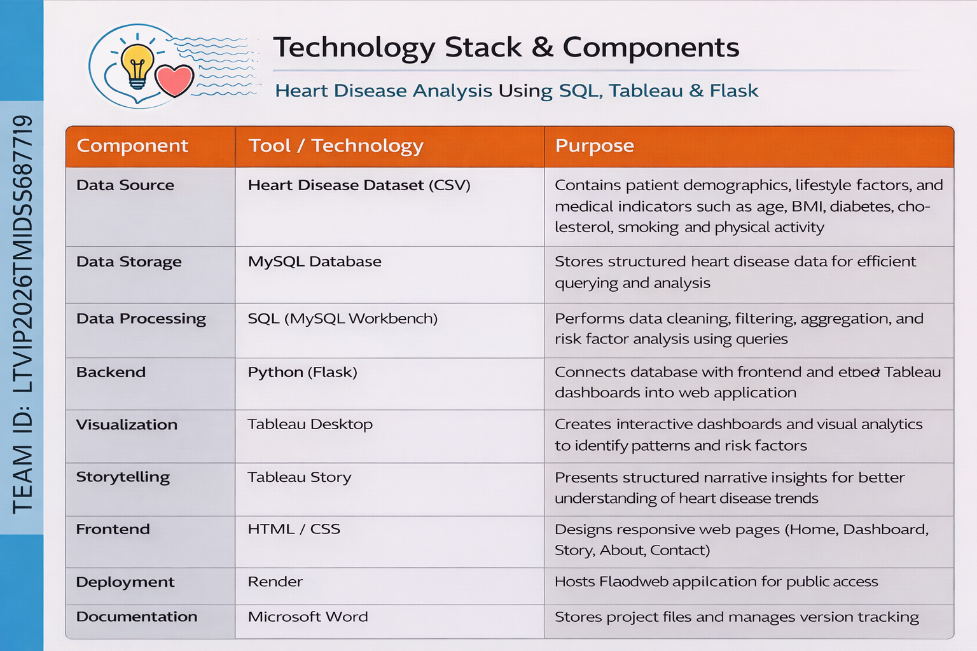
4. PROJECT DESIGN
4.1 Problem Solution Fit
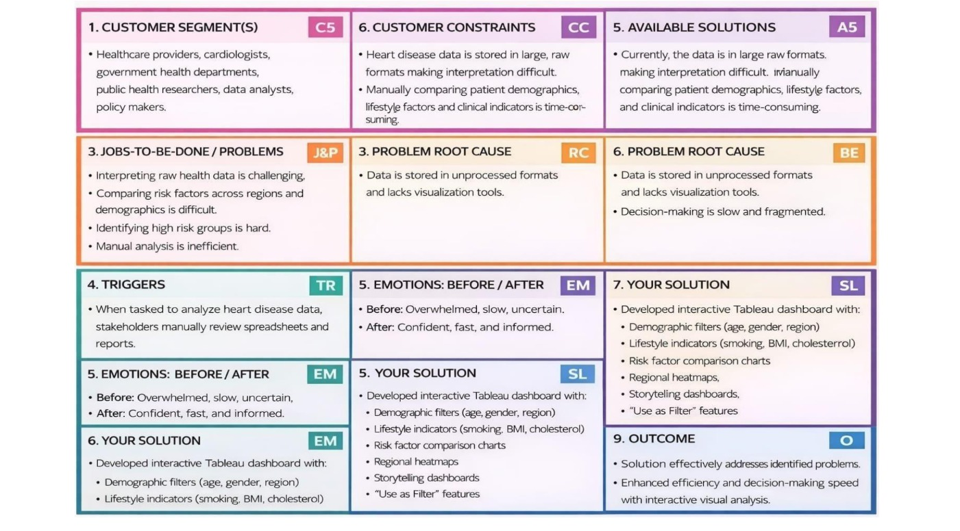
  - Proposed Solution

S.No. | Parameter | Description
 | Problem Statement (Problem to be solved) | Manual analysis of electricity consumption data is time-consuming and does not clearly reveal peak demand, seasonal trends, or regional usage patterns, making efficient energy planning difficult.
 | Idea / Solution description | The solution analyzes electricity consumption data using Python and visualizes insights through interactive Tableau dashboards to identify peak demand, seasonal trends, and regional variations.
 | Novelty / Uniqueness | Integrates automated data processing with interactive Tableau dashboards, allowing users to dynamically explore electricity usage without technical expertise.
 | Social Impact / Customer Satisfaction | Helps energy providers and policymakers optimize electricity usage, reduce wastage, and improve planning, resulting in better service reliability and customer awareness.
 | Business Model (Revenue Model) | Offered as a subscription-based dashboard, licensed analytics tool for energy agencies, or a consulting solution for electricity consumption analysis.
 | Scalability of the Solution | Scalable architecture supports large datasets, cloud storage, and future integration of additional regions, years, or real-time electricity data.

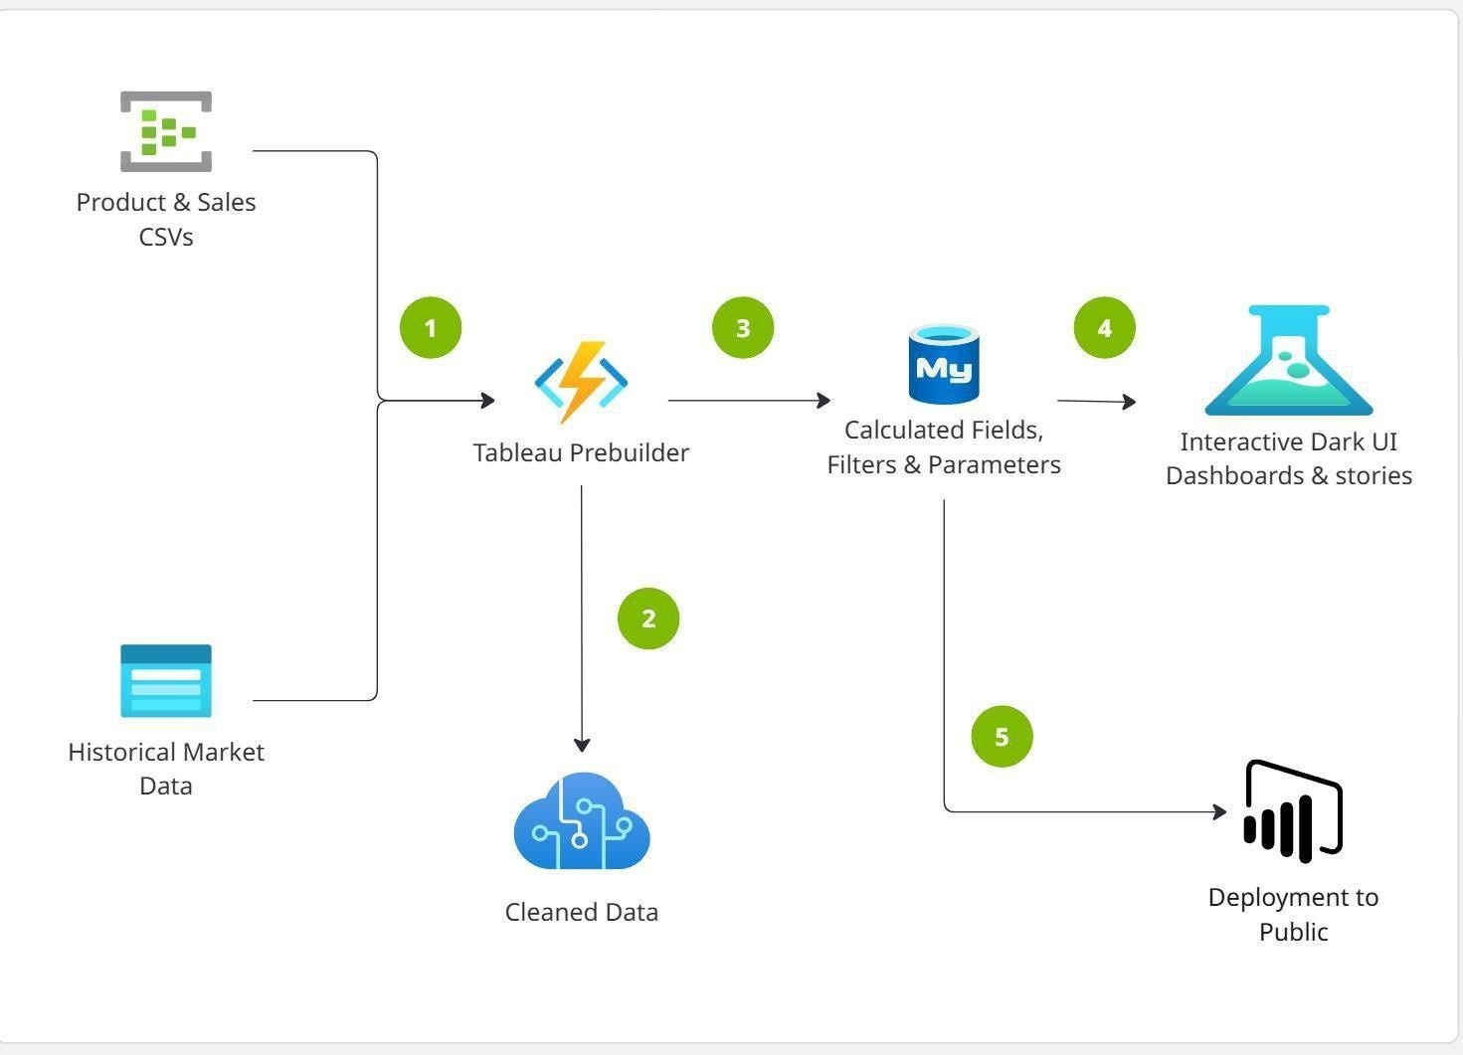
4.3 Solution planning

5. PROJECT PLANNING & SCHEDULING
  - Project Planning

Sprint | Functional Requirement (Epic) | User Story Number | User Story / Task | Story Points | Priority | Team Members
Sprint-1 | Data Collection | USN-1 | As a user, I can import the heart disease dataset (CSV) into the MySQL database. | 2 | High | Member-1
Sprint-1 | Data Pre-processing | USN-2 | As a user, I want the system to clean and structure raw heart disease data using SQL queries. | 2 | High | Member-2
Sprint-1 | Data Storage | USN-3 | As a user, I want the processed heart disease data to be stored securely in MySQL for analysis. | 1 | Medium | Member-3
Sprint-2 | Data Analysis | USN-4 | As a user, I can analyze risk factors such as age, BMI, diabetes, smoking, cholesterol, and physical activity. | 3 | High | Member-1
Sprint-2 | Visualization | USN-5 | As a user, I can view interactive Tableau dashboards showing heart disease trends and comparisons. | 3 | High | Member-2
Sprint-2 | Dashboard Filters | USN-6 | As a user, I can filter dashboards by gender, age group, medical condition, and lifestyle factors. | 2 | Medium | Member-4
Sprint-3 | Story Creation | USN-7 | As a user, I can view a structured Tableau Story that explains heart disease insights step-by-step. | 2 | Medium | Member-3
Sprint-3 | Web Integration | USN-8 | As a user, I can access dashboards and stories through a Flask web application. | 2 | High | Member-2
Sprint-3 | Deployment | USN-9 | As a user, I can access the deployed web application online via Render. | 1 | High | Member-4
Sprint-3 | Performance Testing | USN-10 | As a user, I want dashboards to load efficiently even with larger datasets. | 2 | Medium | Member-3

FUNCTIONAL AND PERFORMANCE TESTING
  - Performance Testing

S.No. | Parameter | Screenshot / Values
1 | Data Rendered | Heart disease dataset successfully loaded into MySQL and connected to Tableau. Dataset includes multiple dimensions such as Age, Gender, Race, BMI, Smoking Status, Diabetes, Physical Activity, and General Health, along with measures like Heart Disease Status and Stroke cases.
2 | Data Preprocessing | Data cleaning performed using SQL: null values handled, categorical values standardized, unnecessary fields removed, and data grouped by age, gender, and medical conditions for effective visualization.
3 | Utilization of Filters | Interactive filters implemented in Tableau dashboards including Gender, Age Group, Diabetes Status, Smoking, Physical Activity, and Race to dynamically explore high-risk groups.
4 | Calculation Fields Used | - Calculated fields created in Tableau such as Risk Category Classification, BMI Groups, Percentage of Heart Disease Cases, and Comparative Ratios between affected and non-affected individuals.
5 | Dashboard Design | Number of Visualizations / Graphs – 8 to 10 including Bar Charts (Gender vs Heart Disease), Line Charts (Age Trends), Pie Charts (Target Distribution), Heat Maps (Risk Factors), KPI Cards (Total Cases), Scatter Plots (BMI vs Age), and Comparative Charts (Diabetes & Stroke Impact).
6 | Story Design | Number of Story Scenes – 5 to 7 including Demographic Overview, Lifestyle Risk Analysis, Medical Condition Impact, Race-wise Comparison, and Final Insights Summary for preventive healthcare decisions.

7.Results
7.1 Output screenshorts
Dashboards

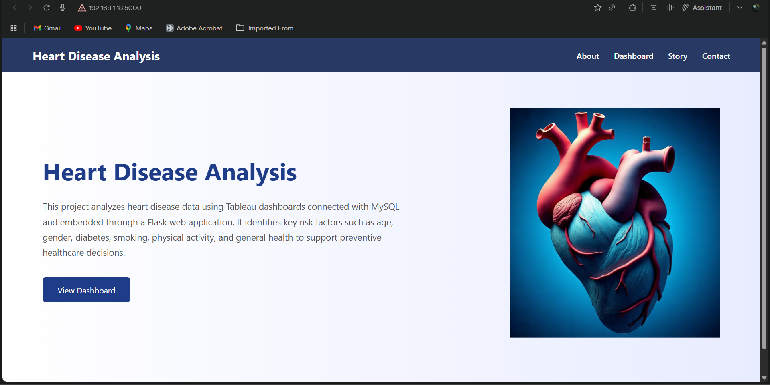

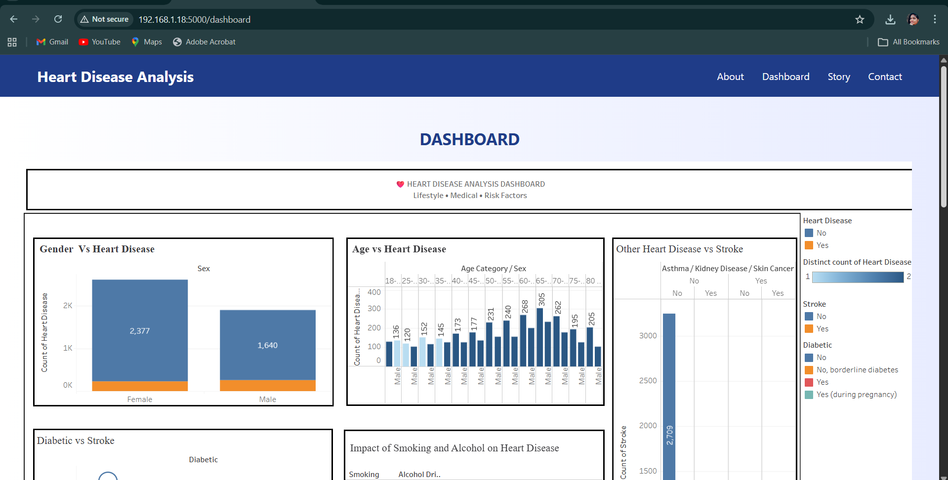
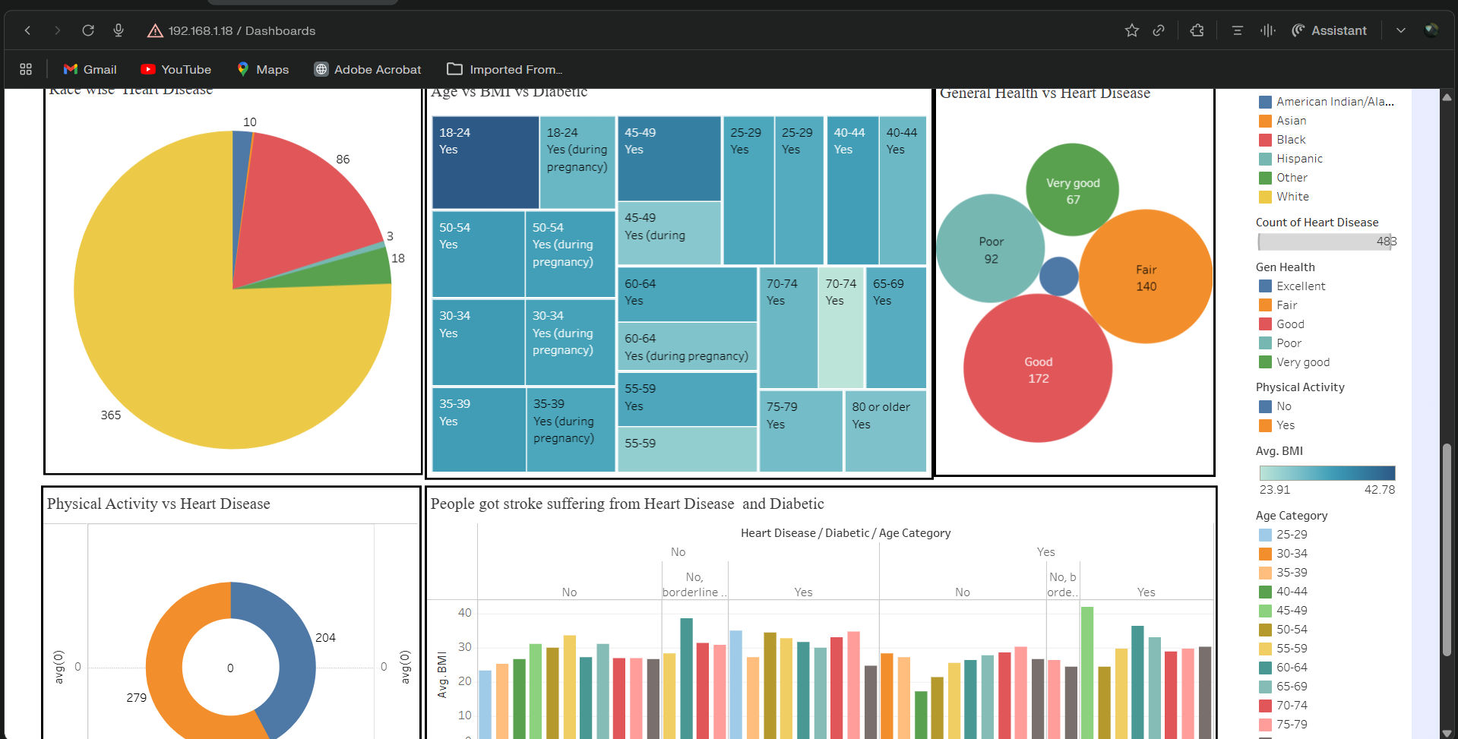

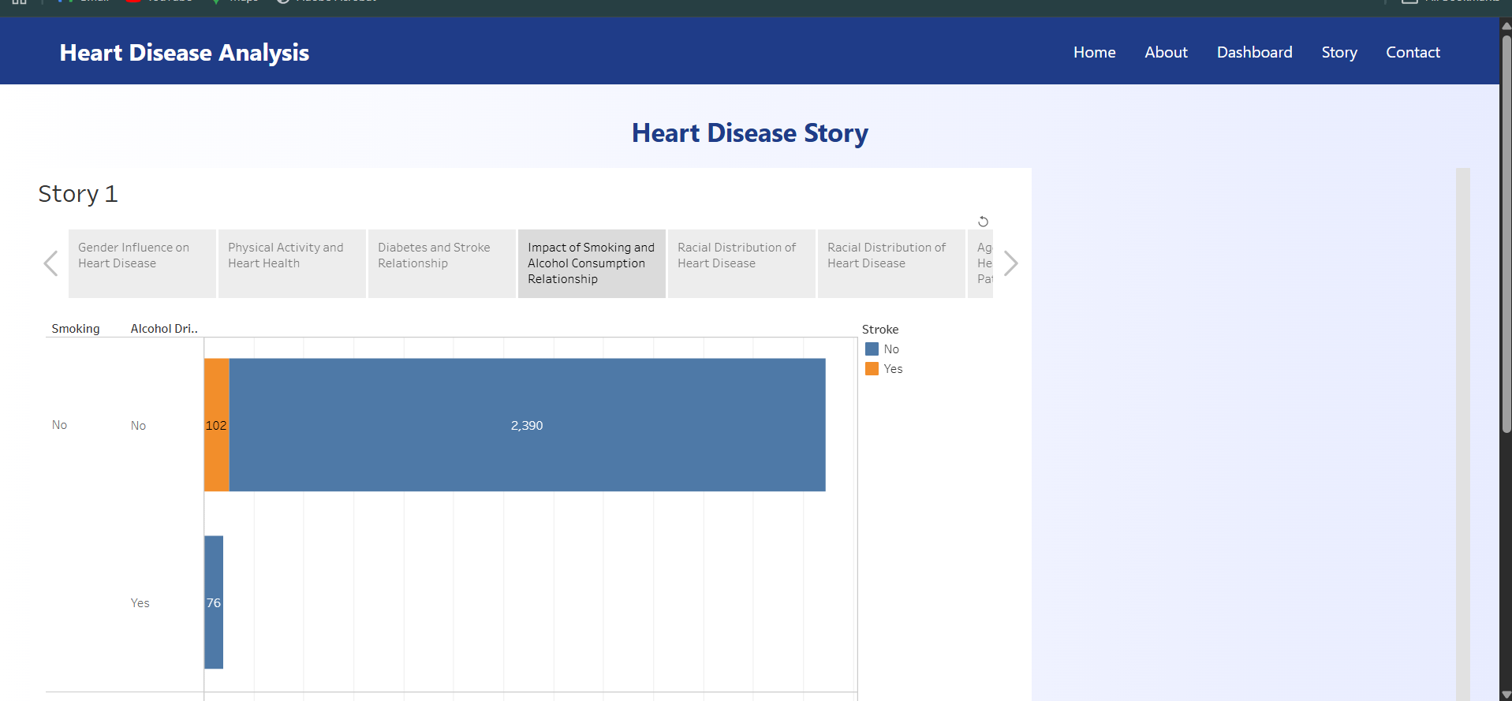
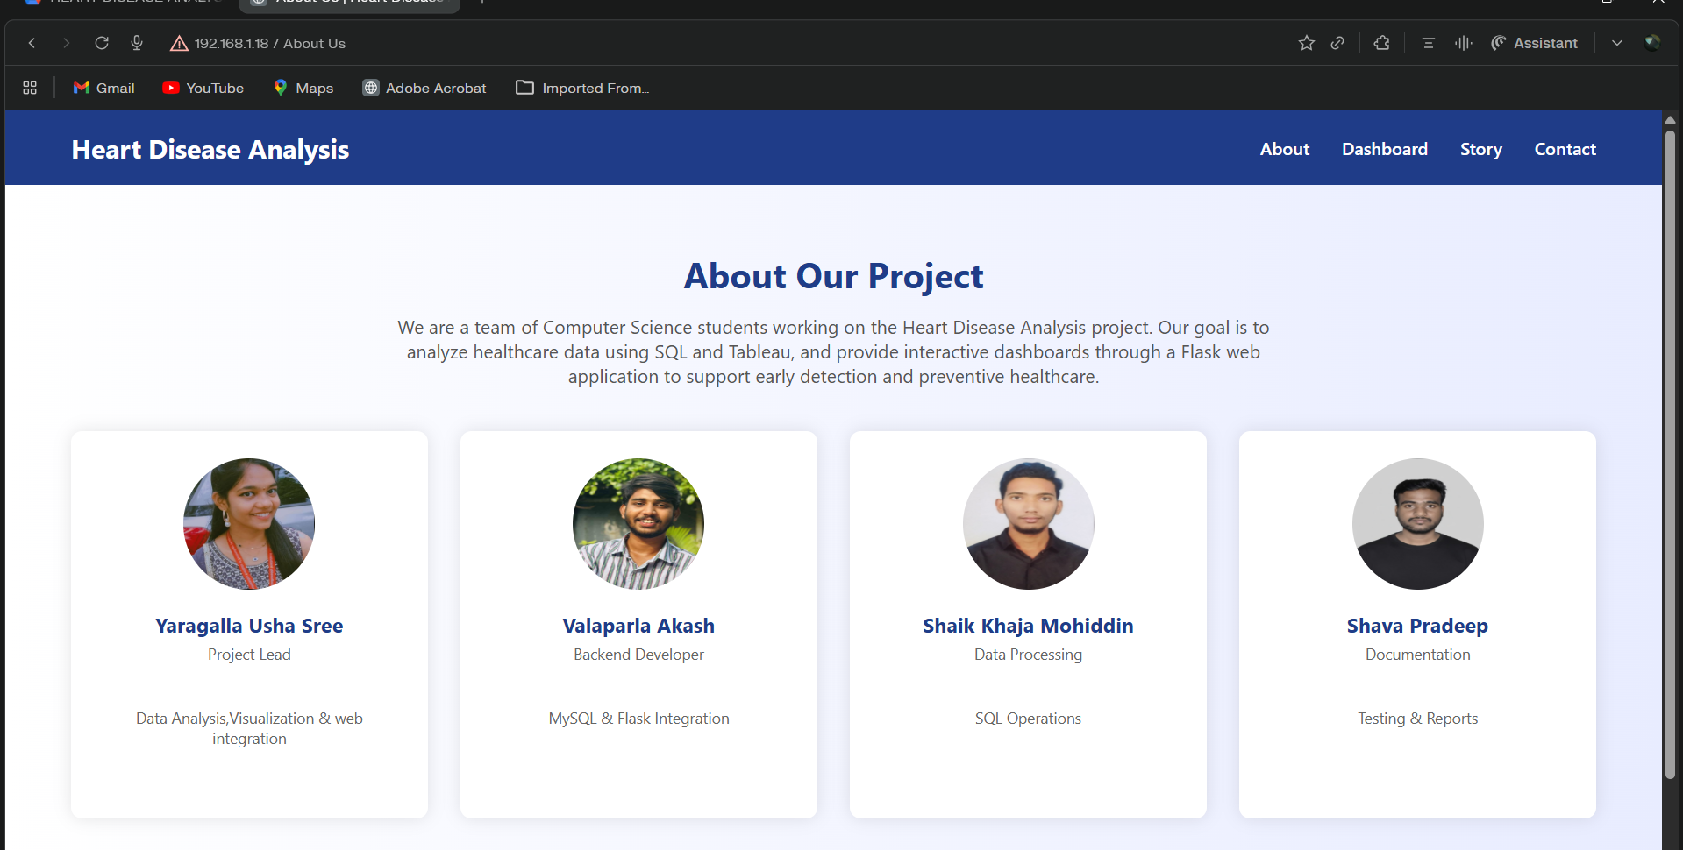

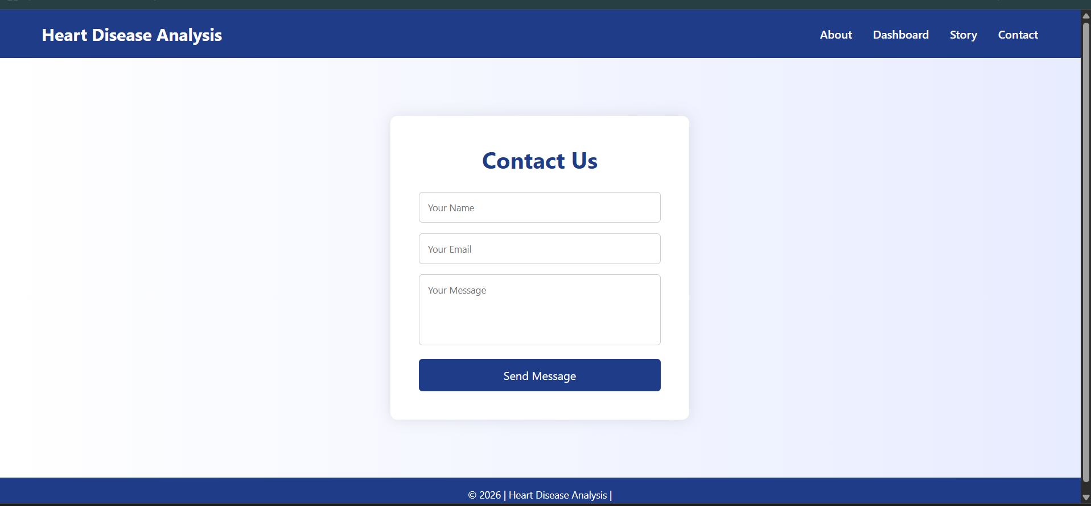

Advantages
1. Interactive Data Visualization
The project uses Tableau to transform complex heart disease datasets into interactive dashboards, making medical data easier to understand and analyze.
2. Improved Healthcare Decision-Making
Supports doctors, healthcare professionals, and policymakers in identifying high-risk groups and planning preventive strategies.
3. Identification of Key Risk Factors
Clearly highlights the impact of age, gender, diabetes, smoking, BMI, physical activity, and general health on heart disease occurrence.
4. Time-Saving Data Processing
SQL-based data cleaning and structured preparation reduce manual analysis effort and improve efficiency.
5. Scalable Architecture
The system can handle large healthcare datasets and can be extended to include additional years, regions, or medical indicators.
6. Enhanced Preventive Awareness
Helps individuals understand their risk factors and encourages lifestyle improvements for heart disease prevention.
7. User-Friendly Dashboard
Filter-enabled Tableau dashboards allow users to explore data dynamically by age group, gender, race, diabetes status, and lifestyle habits.

Conclusion
The Disadvantages:

1. Dependency on Data Quality
Incorrect, incomplete, or biased healthcare data may lead to inaccurate insights.
2. No Real-Time Health Monitoring
The project currently works with historical datasets and does not include live patient monitoring data.
3. Initial Setup Complexity
Integration of MySQL, Tableau, and Flask requires technical expertise.
4. Performance Issues with Extremely Large Datasets
Dashboard performance may slow down without proper optimization.
5. Limited Predictive Analytics
The project mainly focuses on descriptive analytics rather than AI-based disease prediction models.

Conclusion
The Heart Disease Analysis using SQL and Tableau project demonstrates how healthcare data can be transformed into meaningful insights through interactive visualization.
By integrating structured data processing with Tableau dashboards and story features, the system effectively highlights demographic patterns, lifestyle risk factors, and medical correlations related to heart disease.
The project enhances data-driven decision-making for healthcare professionals, policymakers, and individuals by providing clear, visual insights into cardiovascular risk factors.
Overall, the project proves that interactive data visualization plays a crucial role in preventive healthcare, early risk identification, and informed medical planning.

Future Scope
1. Real-Time Health Data Integration
Integrate live patient monitoring systems or wearable device data for real-time risk analysis.
2. AI-Based Heart Disease Prediction
Incorporate Machine Learning models to predict heart disease probability based on patient attributes.
3. Cloud Deployment
Deploy dashboards using Tableau Server, AWS, or Azure for scalable and remote access.
4. Mobile-Friendly Dashboard
Develop responsive dashboards for access on smartphones and tablets.
5. Integration with Electronic Health Records (EHR)
Connect with hospital databases for comprehensive patient analysis.
6. Automated Risk Alert System
Implement automated alerts for high-risk patient identification.
7. Advanced Predictive Analytics
Add predictive modeling, anomaly detection, and personalized health recommendations.

