**ASSIGNMENT**

**FINANCIAL ANALYSIS**

**TITLE: Analysing competitive advantage of competitive companies**

**CONTENTS**

* Introduction
* Background
* Competitive advantage
* Financial performance evaluation
* Comparative analysis
* Assessment of sustainability
* Conclusion

In this task I am analysing the competitive advantage of two real companies operating in two different industries. They are

1. SAUDI ARABIAN OIL GROUP (a petroleum and gas sector company)
2. ELI LILLY (a pharmaceutical sector company)

**INTRODUCTION**

SAUDI ARABIAN OIL GROUP: A petroleum and gas sector company 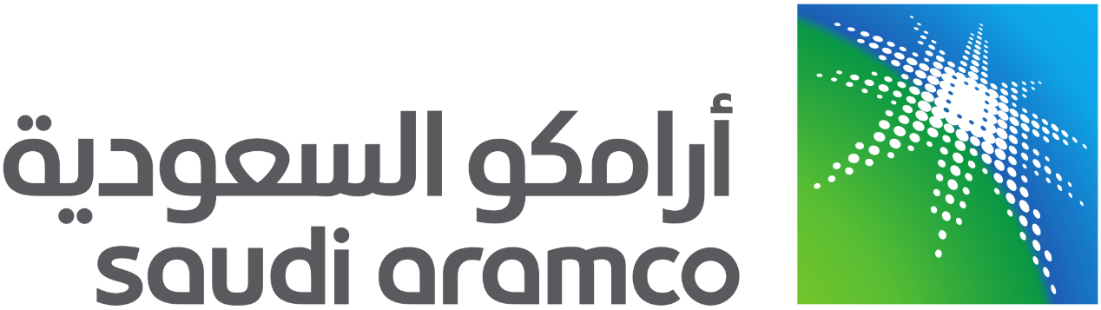

Informally **Saudi Armanco** formerly **Arabian-American Oil Company** is a petroleum and natural gas company that is a national oil company of Saudi Arabia

Saudi Aramco operates the world's largest single hydrocarbon network, the Master Gas System. In 2013, its crude oil production total was 3.4 billion barrels (540 million cubic metres), and it manages over one hundred oil and gas fields in Saudi Arabia, including 288.4 [trillion](https://en.wikipedia.org/wiki/10%5E12) of [natural gas](https://en.wikipedia.org/wiki/Natural_gas) reserves. Along the [Eastern Province](https://en.wikipedia.org/wiki/Eastern_Province,_Saudi_Arabia), Saudi Aramco most notably operates the [Ghawar Field](https://en.wikipedia.org/wiki/Ghawar_Field) (the world's largest [onshore oil field](https://en.wikipedia.org/wiki/Onshore_(hydrocarbons))) and the [Safaniya Field](https://en.wikipedia.org/wiki/Safaniya_Field) (the world's largest [offshore oil field](https://en.wikipedia.org/wiki/Offshore_drilling)).

On 11 December 2019, the company's shares commenced trading on the [Tadawul stock exchange](https://en.wikipedia.org/wiki/Tadawul). The shares rose to 35.2 [Saudi riyals](https://en.wikipedia.org/wiki/Saudi_riyal), giving it a market capitalization of about [US$](https://en.wikipedia.org/wiki/US$)1.88 trillion, and surpassed the US$2 trillion mark on the second day of trading. In the 2023 [Forbes Global 2000](https://en.wikipedia.org/wiki/Forbes_Global_2000), Saudi Aramco was ranked as the second-[largest public company in the world](https://en.wikipedia.org/wiki/List_of_public_corporations_by_market_capitalization)

 As of 2022, it is the second-[largest company in the world by revenue](https://en.wikipedia.org/wiki/List_of_largest_companies_by_revenue) and is headquartered in [Dhahran](https://en.wikipedia.org/wiki/Dhahran). It has repeatedly achieved the [largest annual profits](https://en.wikipedia.org/wiki/List_of_largest_corporate_profits_and_losses) in global [corporate history](https://en.wikipedia.org/wiki/Corporate_history). Saudi Aramco at more than 270 [billion barrels](https://en.wikipedia.org/wiki/Barrel_(unit)#Oil_barrel) (43 billion cubic metres), and largest daily oil production of all oil-producing companies

ELI LILLY: A pharmaceutical sector company 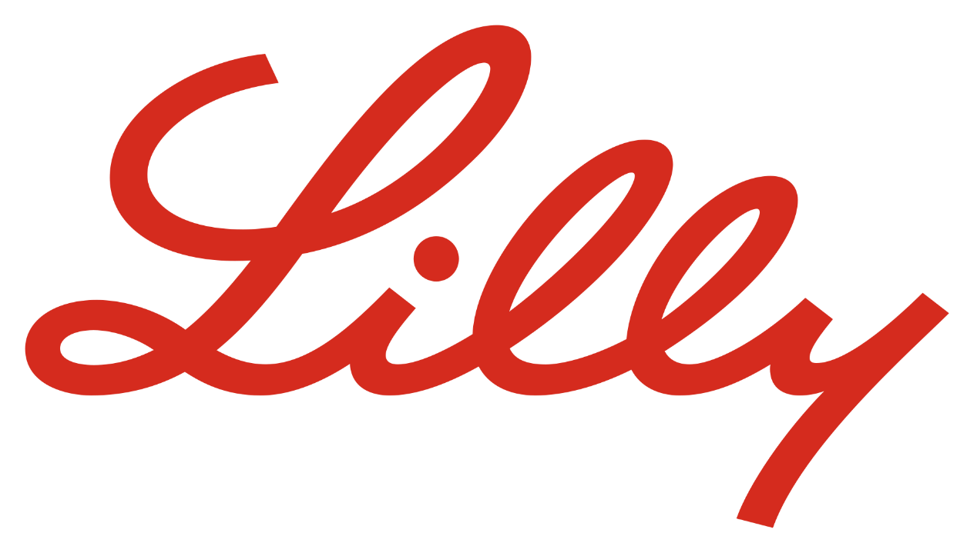

Lilly is a full member of the [Pharmaceutical Research and Manufacturers of America](https://en.wikipedia.org/wiki/Pharmaceutical_Research_and_Manufacturers_of_America) and the [European Federation of Pharmaceutical Industries and Associations](https://en.wikipedia.org/wiki/European_Federation_of_Pharmaceutical_Industries_and_Associations)

**Eli Lilly and Company** is an American [pharmaceutical](https://en.wikipedia.org/wiki/Pharmaceutical) company headquartered in [Indianapolis](https://en.wikipedia.org/wiki/Indianapolis), [Indiana](https://en.wikipedia.org/wiki/Indiana), with offices in 18 countries. Its products are sold in approximately 125 countries. The company was founded in 1876 by, and named after, Colonel [Eli Lilly](https://en.wikipedia.org/wiki/Eli_Lilly), a pharmaceutical [chemist](https://en.wikipedia.org/wiki/Chemist) and a [Union Army](https://en.wikipedia.org/wiki/Union_Army) veteran of the [American Civil War](https://en.wikipedia.org/wiki/American_Civil_War).

It was one of the first [pharmaceutical](https://en.wikipedia.org/wiki/Pharmaceutical) companies to produce human [insulin](https://en.wikipedia.org/wiki/Insulin) using [recombinant DNA](https://en.wikipedia.org/wiki/Recombinant_DNA) including Humulin ([insulin medication](https://en.wikipedia.org/wiki/Insulin_(medication))

As of 1997, it was the largest corporation and the largest charitable benefactor in Indiana, the largest ever in a healthcare case and the largest criminal fine for an individual corporation ever imposed in a U.S. criminal prosecution of any kind at the time.

As of 2019, the company was ranked 123rd on the [Fortune 500](https://en.wikipedia.org/wiki/Fortune_500)

**BACKGROUND**

COMPANY NAME: SAUDI ARABIAN OIL GROUP

Saudi Aramco's origins trace to the oil shortages of [World War I](https://en.wikipedia.org/wiki/World_War_I) and the exclusion of American companies from [Mesopotamia](https://en.wikipedia.org/wiki/Mandatory_Mesopotamia) by the United Kingdom and France under the [San Remo Petroleum Agreement](https://en.wikipedia.org/wiki/San_Remo_conference) of 1920.

Through its subsidiary company, the [Bahrain Petroleum Co.](https://en.wikipedia.org/wiki/Bahrain_Petroleum_Company) (BAPCO), SoCal struck oil in [Bahrain](https://en.wikipedia.org/wiki/Bahrain) on May 30, 1932. This event heightened interest in the oil prospects of the Arabian mainland. On 29 May 1933, the Saudi Arabian government granted a concession to SoCal in preference to a rival bid from the Co.

The concession allowed SoCal to explore for oil in Saudi Arabia. SoCal assigned this concession to a wholly owned [subsidiary](https://en.wikipedia.org/wiki/Subsidiary), California-Arabian Standard Oil (CASOC). In 1936, with the company having had no success at locating oil, the [Texas Company](https://en.wikipedia.org/wiki/Texaco)

COMPANY NAME: ELI LILLY

The company's founder was Colonel [Eli Lilly](https://en.wikipedia.org/wiki/Eli_Lilly), a [pharmaceutical chemist](https://en.wikipedia.org/wiki/Pharmacist) and [Union army](https://en.wikipedia.org/wiki/Union_Army) veteran of the [American Civil War](https://en.wikipedia.org/wiki/American_Civil_War). Lilly served as the company president until his death in 1898.

In 1869, after working for drugstores in Indiana, Lilly became a partner in a [Paris, Illinois](https://en.wikipedia.org/wiki/Paris,_Illinois), drugstore with James W. Binford. In 1873, Lilly left the partnership with Binford and returned to Indianapolis. In 1874, Lilly partnered with John F. Johnston and opened a drug manufacturing operation called Johnston and Lilly, but dissolved the partnership in 1876. Lilly used his share of the assets to open his own pharmaceutical manufacturing business in Indianapolis in May 1876. His new business venture became Eli Lilly and Company.

On 9 January 2023, Eli Lilly and TRexBio announced a collaboration and license agreement for three assets to treat [immune-mediated diseases](https://en.wikipedia.org/wiki/Immune-mediated_disease).[[140]](https://en.wikipedia.org/wiki/Eli_Lilly_and_Company#cite_note-140) TRexBio received an upfront payment of $55 million as part of this deal.

**COMPETITIVE ADVANTAGE**

Now we are comparing the advantages of both the companies

|  |  |  |
| --- | --- | --- |
| COMPANY NAME | SAUDI ARMANCO | ELI LILLY |
| Diversified product portfolio | It has a wide range of products:  Gasoline  Sulphur  Butane  Propane  Crude oil  Natural gasoline  Deisel  Ethane  Jet A-1 | focusing on neuroscience cardiometabolic, cancer  immunology, is a significant strength.  This diversity allows the company to cater to a wide range of medical needs |
| STRONG FINANCIAL PERFORMANCE | For the full year, the company reported sales was SAR 1,856,373 million compared to SAR 2,266,373 million a year ago. Revenue was SAR 1,856,373 million compared to SAR 2,266,373 million a year ago. | as evidenced in its 10-Q filing, underscores its operational efficiency and effective business strategies. This financial stability enables Eli Lilly to invest in research and development, acquisitions, and market expansion, fuelling its growth trajectory |
| LARGE PRODUCTION CAPACITY | It has a large capacity for production and refining its materials. This helps the company to serve a large audience in the market with its products. | It has a wide range of drugs nearly 51 varieties but produced on demand basis |

|  |  |  |
| --- | --- | --- |
| ADVANCEMENT OF TECHNOOGY | Saudi Aramco uses the latest technology in the production and management of its products. This helps it to be efficient in its process and in return get more production. | It has drugs that are already produced and cannot be changes without intense research and development |
| LOW PRICE | The cost per production of a barrel of Aramco is one of the lowest in the market all over the world. Thus, this helps it to enjoy the advantages of a low-cost environment. | The cost of the drugs are better prices when compared with other company drugs  The cost of prices is around 50% less when compared to other company’s research |
| HIGH DEPENDENCY ON ONE PRODUCT | Saudi Aramco is more dependent on the profitability of only one of its products which is crude oil. If this goes on the company may face trouble in the future if any changes occur in the profitability of that product.  They only produce petrochemical produce which are depleting over time and the value and the resources to obtain petroleum is also reducing and raping expansion and urbanisation of the countries | The number of products of Eli Lilly are high so they do not have to depend on the demand of single product. The demand will remain constant in compound as they do not rely on one product |

**ANALYSING FINACIAL INFORMATION**

Analysing of financial performance of SAUDI ARAMCO (The petroleum and gas sector company)

REVENUE GROWTH

Aramco said total revenue fell 17% to $440.88 billion, down from $535.19 billion last year. Free cash flow also fell to $101.2 billion in 2023, compared to $148.5 billion in 2022.

Profit margin

Aramco reported a 25% decline in profit to $121.3 billion in 2023, down from $161.1 billion in 2022, and boosted its mega dividend payout despite “economic headwinds.

Analysis of financial performance of eli lilly(The pharmacetucal sector company)

Revenue growth

Eli Lilly annual/quarterly revenue history and growth rate from 2010 to 2023. Revenue can be defined as the amount of money a company receives from its customers in exchange for the sales of goods or services. Revenue is the top line item on an income statement from which all costs and expenses are subtracted to arrive at net income.

* Eli Lilly revenue for the quarter ending December 31, 2023 was **$9.353B**, a **28.1% increase** year-over-year.
* Eli Lilly revenue for the twelve months ending December 31, 2023 was **$34.124B**, a **19.56% increase** year-over-year.
* Eli Lilly annual revenue for 2023 was **$34.124B**, a **19.56% increase** from 2022.

Profit margin

Current and historical gross margin, operating margin and net profit margin for Eli Lilly (LLY) over the last 10 years. Profit margin can be defined as the percentage of revenue that a company retains as income after the deduction of expenses. Eli Lilly net profit margin as of December 31, 2023 is **15.36%**.

**COMPARARING COMPETITIVE POSITION**

|  |  |  |
| --- | --- | --- |
| COMPANY NAME | SAUDI ARMANCO | ELI LILLY |
| MARKET SHARE | As of March 2024, Saudi Aramco has a market cap of $2.007 Trillion. This makes Saudi Aramco the world's 4th most valuable company by market cap according to our data. | As of March 2024, Eli Lilly has a market cap of $724.65 Billion. This makes Eli Lilly the world's 9th most valuable company by market cap |
| GROWTH PROSPECTS | The gas production growth target was raised to,” more than 60%by 2030 against a 2021 baseline, compared with a previous goal of "more than 50%" | Eli Lilly is forecast to grow earnings and revenue by 27.2%espectively. EPS is expected to grow by 27.1% per annum. |

|  |  |  |
| --- | --- | --- |
| COMPETATIVE THREATS | The global market share of Saudi Aramco can decrease if other countries are successful in the exploration of new products. This will result in a threat to Saudi Aramco.  If the dependability on renewable energy and non-conventional sources of energy increases then the company may face a large drawback as their products are not environment friendly. | Eli Lilly operates in a highly competitive pharmaceutical industry. The company faces competition from both established players and emerging firms, which can exert pricing pressures and challenge its market share.  The company is susceptible to the impact of global macroeconomic conditions, including trade disruptions, currency fluctuations, and economic downturns. These factors can adversely affect Eli Lilly's operations, financial performance, and strategic plans. |
| BARRIER TO ENTRY | The barriers to entry in the oil and gas sector are extremely strong and include high resource ownership, high startup costs, patents and copyrights in association with proprietary technology | Food and Drug Administration (FDA) Approval.  Research and Development (R&D) Costs.  Intellectual Property Challenges. |
| POSITIONING OF COMPANY | Saudi Aramco has surpassed Apple Inc. as in May 2022  It is on top of the charts in terms of value of assets held the company and in terms of revenue too | Eli Lilly is on top of the chart in pharmaceutical companies and it is in the list of fortune 500 companies |

**ASSESSMENT OF SUSTAINABILITY**

Sustainability assessment requires an evaluation of present and future conditions to show that present decisions and actions are not compromising future human and ecological health and well-being.

COMPANY NAME: SAUDI ARABIAN OIL GROUP

 In line with our ambition to achieve net zero Scope 1 and Scope 2 GHG emissions across wholly-owned operated assets by 2050, we strive to provide reliable energy while maintaining leadership as one of the lowest carbon intensity producers of hydrocarbon products. Committed to build one of the world’s largest CCS hubs (capacity target of 11 MMtpa by 2035) Established a $1.5 billion Sustainability Fund to invest in technology to address climate challenges. Target to reduce our emissions by ~52 MMtCO2 e annually from 2035 onwards .Target to lower our upstream carbon intensity by 15% by 2035 .Delivered an upstream methane intensity of 0.05%, well below the OGCI ambition (0.20% by 2025) .59%1,2 of our total R&D spend was on sustainability related R&D, an increase of 7% from 2021 .Participated, and purchased credits, in the first carbon credit auction held in Saudi Arabia through the Regional Voluntary Carbon Market, where 1.4 million carbon credits were sold, of which 650,000 were purchased by Aramco.

We strive to conserve natural resources, apply circular models across our value chain, and to have a legacy of projects that improve both natural habitats and shared resources. We apply technology, innovation, and resources to invest in environmental protection and nature-based solutions, and we embed circular economy principles across our operations. Ambition to deliver net positive biodiversity and ecosystem impacts by setting a target to increase our net positive impact* (NPI) for biodiversity and ecosystem services by 30% by 2025. Recycled* 39.9%1 of our industrial waste (an increase in waste recycled compared to the prior year, despite the 33% rise in industrial waste). Launching refurbishment and recycling programs for material streams and equipment Over 20 initiatives incorporating circular economy principles Continued investments in tail gas treatment facilities. ISO 14001 certification* for 98%1 of applicable facilities in 2022, with a view to

complete coverage in 2023. Pursuing a water neutrality strategy. Planted 11 million mangroves and an additional one million trees during the year. We seek to grow value wherever we operate. With our biggest footprint in Saudi Arabia, we have invested in the Kingdom’s oil and gas ecosystem to enhance the reliability of our supply chain, providing employment and economic opportunities to thousands of Saudi nationals. As our business expands around the world, we seek to apply the same principles and values that made Aramco a success at home. Increased our payments to governments by 52% in 2022, compared to the prior year. Aramco entered into over 90 agreements with an estimated value of $17.3 billion1 to build long-term collaborative relationships with strategic local suppliers. Via our investments, encouraged suppliers to have an aggregate investment of over $600 million1 in capex, which also created over 4,000 jobs in our supply chain in Saudi Arabia. Via iktva, facilitated creation of 31 new local manufacturers. Made a social investment* of $370 million1 on a range of global socio-economic and environmental initiatives

COMPANY NAME: ELI LILLY

[Eli Lilly and Company](https://c212.net/c/link/?t=0&l=en&o=3869205-1&h=1971919359&u=http%3A%2F%2Fwww.lilly.com%2F&a=Eli+Lilly+and+Company) today released its latest [Environmental, Social and Governance (ESG) report](https://c212.net/c/link/?t=0&l=en&o=3869205-1&h=334837985&u=https%3A%2F%2Fesg.lilly.com%2F&a=Environmental%2C+Social+and+Governance+(ESG)+report) showing progress towards the company's ambitious sustainability goals, which are critical to maintaining a strong and resilient company.

Notable sustainability highlights in the report include:

* Reducing greenhouse gas emissions in the company's operations by more than 20% from 2020 to 2022 despite significant business growth over the same timeframe.
* Continuing to improve the [diversity of Lilly's workforce](https://c212.net/c/link/?t=0&l=en&o=3869205-1&h=2452035119&u=https%3A%2F%2Fwww.esg.lilly.com%2Fsocial%2Fdei%3Fsection%3Ddei-data&a=diversity+of+Lilly%27s+workforce) with minority group members now serving in a quarter of all management positions in the U.S. – and women serving in nearly half (49%) of all management positions globally.
* [Improving access to Lilly insulin in the U.S.](https://c212.net/c/link/?t=0&l=en&o=3869205-1&h=2678461892&u=https%3A%2F%2Fesg.lilly.com%2Fsocial%2Fus-access-affordability%3Fsection%3Dus-affordability-solutions&a=Improving+access+to+Lilly+insulin+in+the+U.S.), including capping out-of-pocket costs at $35 or less per month (effective March 2023) and reducing the list price of Lilly's most prescribed insulins by 70% (effective Q4 2023).1
* Nearly doubling the number of patients reached in resource-limited settings from 7.3 million in 2020 to 13 million in 2022 via the [Lilly 30x30 initiative](https://c212.net/c/link/?t=0&l=en&o=3869205-1&h=757613472&u=https%3A%2F%2Fesg.lilly.com%2Fsocial%2Fimproving-global-access-and-health%3Fsection%3Dlilly-30x30&a=Lilly+30x30+initiative).

"Since Lilly was founded nearly 150 years ago, we've aimed to have a positive impact on patients, communities and the environment," said Lilly's Head of ESG, James Greffet. "Sustainability is critical to our resiliency as a business and is integrated into how we fulfil our purpose of creating medicines that make life better for people."

Other [environmental progress](https://c212.net/c/link/?t=0&l=en&o=3869205-1&h=2081931871&u=https%3A%2F%2Fesg.lilly.com%2Fenvironmental%2Fclimate%3Fsection%3D2030-climate-goals-and-progress&a=environmental+progress) includes expanding use of solar energy at the company's global facilities and outperforming the biotech and pharmaceutical company average with an A- score for climate and water submissions [from CDP in 2022](https://c212.net/c/link/?t=0&l=en&o=3869205-1&h=1332358453&u=https%3A%2F%2Fassets.ctfassets.net%2F1o78rkhl3da6%2F2Tbtn1aPtydSL2AGyP4GDC%2F7dc757a52af4e231b414fbee6a48686b%2FLilly_CDP_Climate_Change_Report_2022_Final.pdf&a=from+CDP+in+2022).

Diversity, equity and inclusion (DEI) continue to be a priority for Lilly. For five consecutive years, Lilly has been in the top five of the DiversityInc Top 50 Companies for Diversity list. Additional DEI highlights in 2022 include establishing an annual global DEI conference for employees and exceeding many of its Racial Justice Commitment goals – among them, increasing the company's spending with Black-owned businesses from $143 million in 2020 to $358 million in 2022.

Under Lilly 30x30, Lilly recently announced novel collaborations to improve quality healthcare in low- and middle-income countries, including with [EVA Pharma](https://c212.net/c/link/?t=0&l=en&o=3869205-1&h=185773277&u=https%3A%2F%2Finvestor.lilly.com%2Fnews-releases%2Fnews-release-details%2Flilly-and-eva-pharma-announce-collaboration-enhance-sustainable&a=EVA+Pharma) to increase the supply of affordable, high-quality insulin in Africa; and with [UNICEF](https://c212.net/c/link/?t=0&l=en&o=3869205-1&h=4018041535&u=http%3A%2F%2Flilly.mediaroom.com%2F2022-02-02-UNICEF-and-Lilly-Collaborate-to-Help-Improve-Health-Outcomes-for-10-Million-Children-and-Adolescents&a=UNICEF) to improve the lives of more than 10 million young people living with noncommunicable diseases. These and other efforts help meet [U.N. Sustainable Development Goals](https://c212.net/c/link/?t=0&l=en&o=3869205-1&h=2581575058&u=https%3A%2F%2Fesg.lilly.com%2Ftransparency%2Fsustainable-development-goals&a=U.N.+Sustainable+Development+Goals).

"Lilly has plans to introduce several additional potential medicines in 2023 and our sustainability strategy provides a foundation for us to continue to deliver on our commitment to patients around the globe," continued Greffet.

**CONCLUSION**

SAUDI ARBAIAN OIL GROUP

Saudi Arabia’s heir apparent and future King Mohammed bin Salman has made it abundantly clear that Saudi Aramco will play a central role in the economic transformation of the Kingdom. The Vision 2030 and the National Transformation Plan 2020 are strategic decisions to wean the Kingdom away from oil dependency and ensure that a more sustainable non-oil revenue base supports this transformation. Saudi Aramco’s IPO, first announced during 2016, would assist the transformation, partly reversing the 1980 nationalization of Aramco by selling around 5% of the company to local and international investors. The objectives were clearly set out by Prince Mohammed: the flotation would transform Aramco into a global integrated energy company, increase its corporate governance, and use the proceeds of the IPO to invest in Saudi and international projects to generate non-oil revenue.

ELI LILLY

The main focus that we have derived at to increase Eli Lilly as a company is to reduce the quantity of drugs and focus more on the quality of drugs, we can successfully pass through FDA standards.  We are wasting endless amounts of money on marketing and research of the drugs that are being frozen in Phase 3 the finals phase.  We need to increase our marketing by using more advertisement not only for the product but the company name to show how reliable we are.  The last part we need to focus on is expanding Elanco Animal Health since they continually grow with the lack of competition in the industry.