An Observational Study of iPhone Users

**INFM605: Users and Use Context**

**Instructor : Dr. Chad Doran**

Team-2 : Aditya Aswin Kumar, Animesh Nandan, Pranav Adiraju, Ritika Namilikonda, Srikanth Parvathala, Ushasri Bhogaraju

**1. Introduction**

Smartphones, notably iPhones, have become crucial in daily life, particularly among students who use them for communication and interaction. These tech-savvy youngsters, transitioning to independence, purchase iPhones either with parental support or earnings from part-time jobs. Steve Jobs introduced the iPhone in 2007, and its operating system iOS, has since become a cultural phenomenon. Studies reveal that students use smartphones for up to 9 hours a day. Despite holding a global market share of only 27.6%, the iPhone dominates the US market with 54.74% and an impressive 87% among US youth. The App Store's wide variety of educational, productivity, gaming, and social apps, along with iPhone's exclusive iMessage feature, contribute to its popularity. Businesses and developers target this student market, creating products and services specifically for iPhones.

iMessage is a private messaging service available only on Apple devices that enables users to communicate with other Apple users online by texting, sending images, sending videos, and sending other types of multimedia. Students and other iPhone users favor iMessage because it integrates with other Apple services like iCloud and the Apple ecosystem. Google introduced the RCS (Rich Communication Services) messaging system in recent years, which adds support for high-quality media transfer, tapback replies, read receipts, and texting over Wi-Fi. Apple has been hesitant to implement this protocol since doing so would render iMessage obsolete and take away the motivation for users to keep using iPhones.

Therefore, the UX study question we are focusing on is whether the incentive to utilize iMessage influences people' decisions to buy iPhones. In order to understand the factors that led existing iPhone users to make that choice and the part that iMessage played in that choice, this research may involve conducting surveys or interviews with those individuals. To identify the precise characteristics or functionalities that make iMessage more appealing, the study may compare the usage trends of iMessage among iPhone users to those of users who use other messaging services. Additionally, we are interested to find other factors that played a role in their decision to buy an iPhone if not for iMessage.

**2. Literature Review**

iMessage, with its unique features, has become integral to the iPhone experience and boasts over 1.3 billion users. The Pew Research Center reveals that messaging apps surpass social media platforms in popularity among US teenagers. TechCrunch's study further suggests that messaging apps are among the most used applications, especially by the younger demographic.

Research by Kim and Park (2013) finds brand loyalty significantly influences consumer choices, and it is shaped by factors like product quality, pricing, and brand image. Lee, Kim, and Lee's (2019) study also supports the importance of product design and brand image in consumer behavior.

However, these studies fail to focus on iMessage's role in brand loyalty or iPhone purchase decisions. Better understanding of iMessage's appeal could inform product design and marketing strategies, potentially enhancing user satisfaction and engagement. A gap exists in research exploring iMessage's impact on iPhone buying behavior, necessitating further study.

**3. Purpose of the Study**

Our study intends to delve deep into the intriguing trend of high iPhone usage among students, particularly the role iMessage plays in this loyalty. We are curious about the factors that drive this preference, the value students extract from it, and its influence on their smartphone usage patterns. One crucial question we aim to answer is whether iMessage is a deciding factor that nudges students to opt for an iPhone over other smartphones.

Project requirement

* Our goal is to unearth the reasons fueling the popularity of iPhones among the student demographic.
* We plan to scrutinize the significance of iMessage in bolstering the appeal of iPhones and students’ brand loyalty.
* We aspire to recognize the pros and cons of iMessage compared to other messaging apps, and whether these factors sway students’ smartphone buying decisions.

Our user group analysis

* We aim to understand how students utilize their iPhones and interact with iMessage.
* We endeavor to analyze what students expect from their iPhones, their preferences, and how these needs are satisfied.
* We seek to understand how iPhone usage blends into the broader aspects of students’ lives including their academic, personal and social spheres.

How do they fit into the larger user group?

* We intend to evaluate how the trends and usage patterns of iPhone and iMessage among students align with the broader iPhone user base.
* We aim to distinguish any unique traits or behaviors of student iPhone users that differentiate them from the other user segments.
* We also want to establish whether the attractions that pull students toward the iPhone also resonate with other user groups and how these insights can be utilized to boost the iPhone’s market share overall.

Who will benefit from this study?

* The revelations in this research may prove useful to Apple Inc. as they seek comprehension of the qualities that draw younger demographics to their product, also how these factors can be harnessed for improvement in areas such as manufacturing innovation, promotional campaigns, consumer connections and possibly acquisition of additional users.
* Other smartphone developers can learn from these insights about what drives brand loyalty and use this knowledge to enhance their products and services.
* This study could offer valuable data to researchers exploring technology usage trends among young people, enhancing our understanding of how digital devices shape the behavior and lifestyle of consumers.
* The revelations of this investigation may furnish UX designers with the ability to comprehensively comprehend and properly discern the demands and predilections of young individuals who make use of their smartphones, thereby endowing said artisans with the power necessary for conceptualizing designs that are more logical in nature, captivating in appeal, as well as effortless to navigate.
* Marketing and Advertising agencies can analyze the findings of this study to devise more impactful marketing and advertising strategies which are targeted at young smartphone users.

**4. Data Collection and Analysis Methods**

**Exploration of Data Collection and analysis methods, arriving at a suitable Research Plan:**

I. Desk Research

The fact that authors Travis and Hodgson et al. have dedicated an entire essay to this important secondary research method in their book ‘Thinking Like a UX Researcher’ is evidence of its importance. Desk Research is important for three reasons.

i. To know if we have found something new in our own study.

ii. To have credible information and relevant questions to ask in the interview.

iii. For effective use of time with the participants

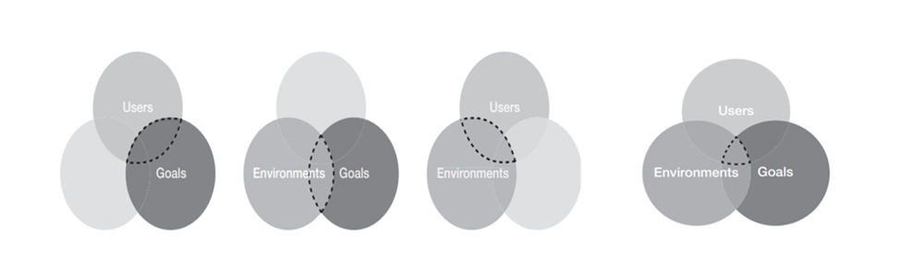  
Figure 1: Venn Diagrams (Travis & Hodgson, page 52 & 53)

These Venn Diagrams from ‘Thinking like a UX Researcher’ identify the focus areas for research that yield insights

Desk Research must be focused on the overlapping areas between either two or all three of Users, Environments, and Goals to yield insightful results. Our Desk Research not only helped us identify our user group behavior and environments, but also in gaining insight into the features of the iPhone and its competitors, to further fine-tune our Survey and interview questions.

II. Identifying our user group

While discussing how to identify User groups for UX Research in Thinking Like a UX Researcher, authors Travis and Hodgson say,

**‘**A common reason that teams don’t do UX research is not that they don’t think users matter but because they simply don’t know where to start. There’s a paralysis of analysis that prevents action.’ (Page 67).

Our User Group: Students comprise the largest user group of iPhone users (87%) in the United States. They are usually more well-informed than the average buyer and are early adopters of new technologies or Apps. Our study is designed to identify the real reason behind such a high rate of acceptance of the iPhone among student users. Is it iOS? Or the famed Apple ecosystem? Or an exclusive app such as iMessage? In this context, we decided that our User Group should consist of fellow students, and students within our family and friends to bring in more perspectives.

III. Recruiting, options and our methods

Once we finalized our user group for study, we researched suitable techniques to reach our user groups from the following options taught in Chapter 6, ‘Observing the User Experience’.

**1.** **Community email mailing lists:** This option was one of the most suitable for us as we ourselves are students at UMD and could request our iSchool administration to allow us to use the listserv to deliver our Surveys to the email of the student community.

**2.** **Online Forums:** This method too was easy to follow and efficient for us.

**3.** **Neighbors, Friends, and Family:** As long as they fit the required criteria for users, authors Goodman and Kuniavsky recommend that we use this resource to our benefit. We could also schedule interviews more easily with them than with other groups of users as they are easily approachable.

**4.** **Ads and other traditional methods:** Since we could easily achieve our goal of recruiting the required number of participants by adopting methods 1 to 3, we did not employ other formal methods.

IV. Our participant screener

A screener is a script that helps in filtering the general population for the criteria specific to our Research. While preparing our screener we paid attention to the key points authors Goodman and Kuniavsky and Travis and Hodgson enumerated in their respective books and could avoid common pitfalls that Researchers fall into.

Some precautions we took in creating the Screener are:

1. We kept it short to 10 basic questions.

2. We asked purposeful questions.

3. We aimed to screen for behaviors, not demographics.

4. We avoided jargon and leading questions.

We prepared our screener using Google Forms so that when participants answer the Survey, the results get automatically updated in a Google Sheet, which the team could analyze easily.

V. Gaining Informed Consent

In their book ‘Thinking Like a UX Researcher’, authors Travis and Hodgson suggest that Researchers look at obtaining informed consent from the participants as more of an ethical initiative than a legal obligation. Therefore, we stated the purpose of our study prominently at the beginning of our Screener and the very first question asked to participants was whether they were willing to participate in our study, and if yes, whether they would share their email so that we can contact them for an interview. Thus, we obtained explicit consent from our participants.

VI. Structuring the Interview

Our study was to analyze the reasons for the widespread phenomenon of preferring the iPhone over other options by a large community of mobile phone users such as students. It is not aimed at improving the design of the iPhone or its Apps.*Therefore, we did not propose to ask our users to use the iPhone or any of its features during the interview.*But we chose to conduct the interviews at places convenient to the participants, for the reason that they will be relaxed in their preferred environments and will be more forthcoming in replying to our questions.

Preparation for the Interview:

**Compiling interview questions:** We consciously compiled non-directed questions, without inducing bias with the language or tone of the question, so as to not influence the participant’s line of thought. We avoided binary questions and left our questions open-ended.

**Building rapport with the user:** At the beginning of the interview, we asked the participants if it was ok to record and make notes during the interview for analysis by the team at a later time. This ensured transparency and trust.

**Transitioning to the main part of the interview:** Our core questions addressing the purpose of our study were open-ended and framed to elicit detailed responses from the participants. All our participants were very forthcoming in sharing their preferences of Apps, and how they use them. They gave detailed views on the Apple ecosystem, iOS, and whether or not they would switch to other mobile phone makers.

**Taking detailed notes and summarizing:** During the course of the interview, we took copious notes and summarized the key takeaways with a few bullet points. We ran the summary by the participant in one or two cases where we thought it was necessary.

**Avoiding Biases:**

In ‘Thinking like a UX Researcher’ authors alert Researchers to ‘Researcher Effects’, biases that contaminate UX research. Some of them are:

1. Biases due to data recording errors

2. Giving undue weight to certain participant responses.

3. Jotting down our interpretation rather than what the participant said.

4. Losing attention during the interview and failing to record what was said.

5. Data entry errors.

**Our solution to avoid biases:** We ensured that all interviews were conducted with a team of two at the minimum. One team member was taking notes and the other was asking questions. At the end of the interview, the summary was double-checked by both team members.

Analyzing our Research:

Research analysis and synthesis are key processes that are useful to draw meaning from UX research data collection. In Research Analysis data is sorted and categorized. Since our data collection method involved both Surveys and Interviews, we employed both quantitative and qualitative methods of analysis.

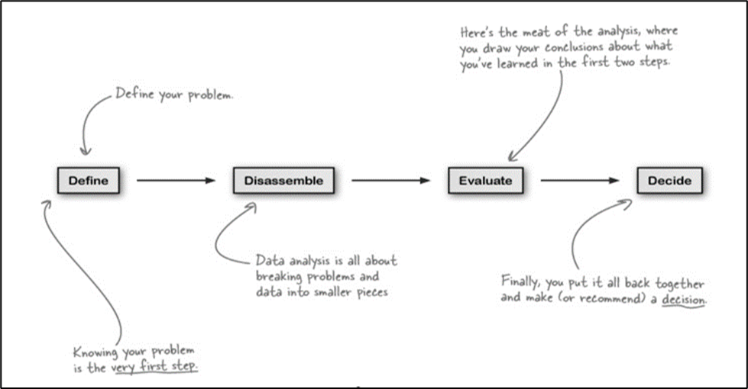  
Figure 2 : Research Analysis Process (userinterviews.com)

**Quantitative Analysis**

**Survey Analysis:** The two common Survey analysis techniques we learned from Chapter -12 ‘Observing the User Experience’ are counting, which involves tabulating basic survey responses to reveal simple trends. Secondly, comparing different responses, we used cross-tabulation to compare the value of one variable with the other.

We used different statistical methods and graphs to analyze and report our findings in the Reports part of this essay.

**Qualitative Analysis:** In their book ‘Observing the User Experience’, authors Goodman and Kuniavsky aptly describe the volume of data produced by research as ‘the wall of data’. Unlike quantitative data, this data is not suitable for Statistical analysis. Since there is no one right way to analyze it, we may apply different techniques with a goal to ‘find and confirm patterns within that data, interpret those patterns, and create analyses that inform action’ (Page 423)

**Coding or labeling the data:** We used digital methods for coding as they were more convenient to access for our team.We categorized the data collected into code groups such as ‘uses more than 2 Apple products’, ‘frequent user of iMessage’ before we began our analysis. Any team member that sourced data, would capture it on the Google Document we created, under the appropriate code. This was the reference point for team discussions.

**Debriefing:** After the interviews were conducted, a summary was written by the team conducting it, as part of a ‘debriefing’ process. This would be shared with other team members during our meetings. The essence was also updated in the Google Document under appropriate codes.

**Transcription:** Our material included audio and video recordings and notes. While transcribing, we paid attention to the meaning of what was being said by the participant rather than the exactness of the words. This helped us group our information into appropriate codes quickly.

**Affinity Clustering:** While processing, we grouped together items that appeared to belong together such as ‘uses more than 2 apple products’, ‘Likes Apple ecosystem more’, and later worked out the patterns and the underlying logic.

**Conclusion:** Thus, after exploring and identifying suitable methods for Data collection and analysis, we formulated the following Research Plan.

**Research Plan**: Planning the stages for Research with all the team members and drawing up an appropriate schedule clarifying the steps involved to reach our goal, was our first step. Our Research plan is inspired by the steps taught in our course reading, chapter 4, ‘Observing the User Experience’.

**Summary:** This Study of the iPhone student user group is being conducted to ascertain the motivation for such widespread use of the iPhone by Student users. This is for the fulfillment of the Project requirement for our Course.

**Research Issues**: We arrived at our research questions after analyzing discussions on blogs and discussions with fellow students that are iPhone users.

1. Why are students loyal to iPhones?

2. Which features of the iPhone are most popular among iPhone student users?

3. Is there a single determinant for the choice of buying an iPhone among student users?

4. Is it because of iOS? The famed Apple ecosystem? Or an app such as iMessage, an exclusive feature for iPhone users?

Research Structure:This research will be conducted in two parallel segments.

**1.** **Analysis of existing User Research:** Identified team members will analyze existing research and prepare a comprehensive summary of previous research findings on this topic, for comparison with the outcomes from our current research.

**2.** **Conduct fresh User Research**: Parallelly, identified team members will identify the target user group.

a. **Recruiting**

i. **Surveys:** Surveys will be sent over email to fellow UMD students. Students in our family and friends circle outside of UMD are also being sent this survey to ensure a variety of responses from students in different student groups are obtained.

ii. **Screening the participants**: Based on the responses from the Surveys, we will identify users that use iPhone, are students and have given their consent to participate in the study. We will then send out requests for interview appointments.

b. **Interviewing** the selected group of Participants

i. **Site visits**: Based on the interview appointments received we will visit the location of the user and conduct the interview.

ii. **Zoom Calls**: Some participants may prefer online interviews. If the participant consents, we will record the interview for subsequent analysis.

iii. **Telephone interviews**: If the participants are only willing to talk over the telephone, we will conduct telephone interviews at their convenience.

**3. Analysis and reporting** of the findings

**4. Recommendations**

Our Research Schedule:We fixed dates for Team meetings and allotted the research tasks to team members. The following schedule indicates the tasks performed on each of these days.

|  |  |  |  |  |  |  |  |
| --- | --- | --- | --- | --- | --- | --- | --- |
| Research dates and preparation weeks are represented in Green, Analysis weeks in Red | | | | | | | |
|  | 27-Mar | 29-Mar | 10-Apr | 14-Apr | 24-Apr | 27-Apr | 29-Apr |
| Exploratory Research |  |  |  |  |  |  |  |
| Email Surveys |  |  |  |  |  |  |  |
| Site Visits |  |  |  |  |  |  |  |
| Zoom Calls |  |  |  |  |  |  |  |

Figure 3: ‘An Observational Study of iPhone Student Users’ Research Schedule

**Budgets**: No Budget allocation was proposed, as the User group to be studied is within the community and accessible to the Researchers without cost.

**5. Findings**

Surveys:

We had surveyed a total of 25 people out of which 64% of the users were iPhone users and the rest i.e. 36% were Android users. The median age group of all the users was 21-25 years.

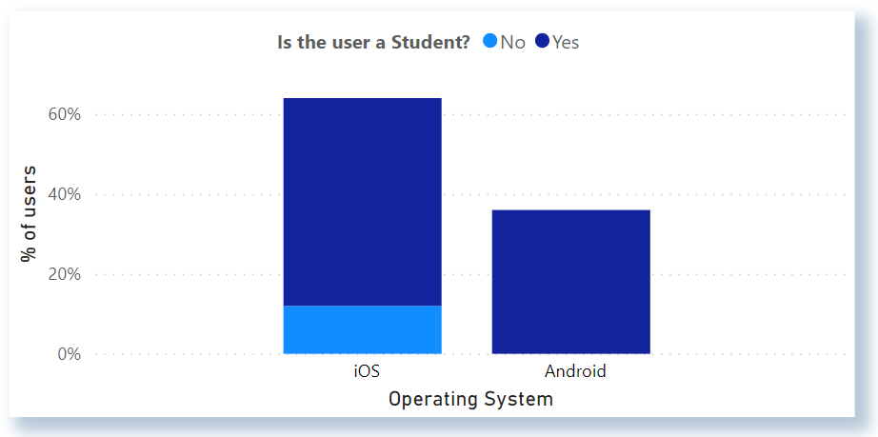  
Figure 4: Percentage of Users using iOS and Android

While we mostly focussed on students, there were also a few participants that were working professionals. They happened to be iOS users, amounting to 12%, as it can be seen in Figure 4.

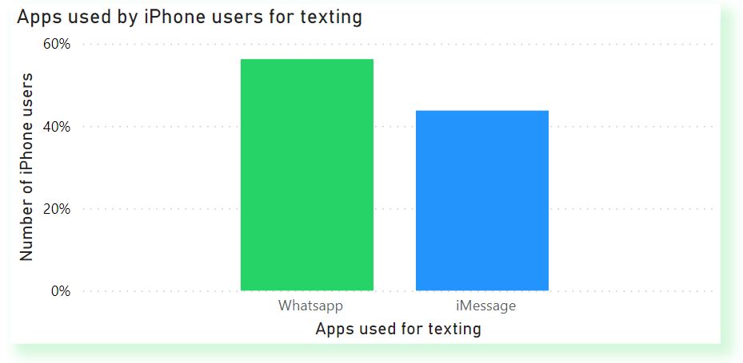  
Figure 5: Apps used by iPhone users for Messaging

It was very interesting to note that, although several users were iPhone users, which was our main focus in this study, they tended to use WhatsApp more than iMessage.

Around 28% iPhone users happen to use WhatsApp over iMessage on a daily basis. This is surprising considering the fact that iMessage is the primary messaging service on iPhones.

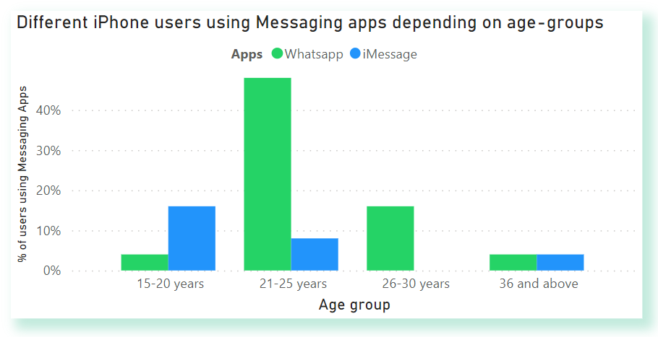  
Figure 6: Age-group wise Usage of Messaging Apps

But upon diving deeper into the iPhone users, namely looking at the different age groups, it can be seen that the age group 21-25, iPhone users who use WhatsApp are 500% higher than iPhone users who use iMessage as their go-to messaging service.

But a riveting observation is looking at the 15-20 year age group. High school students and College Freshman and Sophomore students who use iPhones tend to use iMessage more than WhatsApp. iMessage users are over 300% compared to WhatsApp iPhone users.

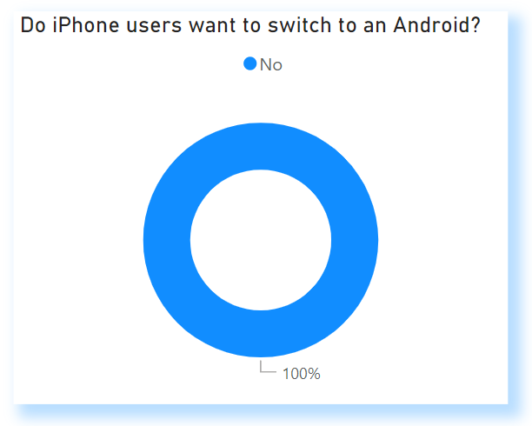  
Figure7: Willingness to Switch from iPhone to Android

Finally, dwelling upon whether the iPhone participants would switch to an Android, we found that 0% of the users, nobody wanted to switch to an Android from an iPhone. This shows that the iPhone users are very loyal to the brand Apple.

User Interviews:

Coming to the user interviews, we managed to interview 11 people who owned a variety of Apple products, ranging from the iPhone to Macbook to the iPad. There were several participants who owned and regularly used four-five products in the Apple ecosystem.

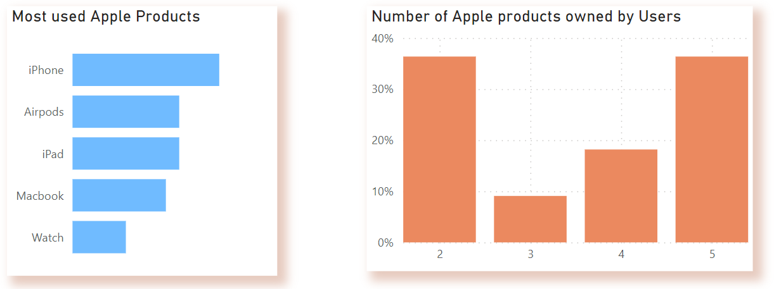  
Figure 8: Most used Products Figure 9: No of Products per User in our Study

The most commonly used Apple product was the iPhone, with Airpods and iPad as the joint second. The most frequently seen combo is the iPhone and Airpods. It seems that this combination is attractive as it works flawlessly due to the ecosystem and the features it has to offer.

The trend seen in the survey continues in the user interviews, where the participants tend to prefer WhatsApp over other messaging apps like iMessage.  
However, even if iMessage is not a primary messaging app for all users, its convenience, integration with other Apple devices, and data privacy make it appealing to some.

Almost all the participants say that the seamless integration of Apple devices is a vital factor in their continued usage of Apple products. The word “ecosystem” was repeatedly brought up during the interviews, underscoring its significance to the users. This tight integration and ecosystem enables features like airdrop and airplay, which are used extensively on a regular basis.

AirDrop feature allows users to instantly share documents, photos, and more with people nearby. AirPlay, on the other hand, allows users to wirelessly stream videos, photos, and music from iPhone to compatible devices like smart TVs or speakers. This feature lets users enjoy their favorite media on a bigger screen or better sound system with just a few taps on your iPhone. Both these features eliminate the need for cables.

Other common themes include the users valuing convenience and integration provided by the Apple ecosystem, which plays a significant role in keeping them loyal to the brand. As identified earlier in the surveys, no user wants to switch to an Android from an iPhone. This shows that Apple's consumers are very loyal towards them. Upon asking the interviewees regarding the same, they emphasized that they are habituated to the operating system, and switching would mean they are presented with another learning curve, which is not the most convenient situation.

The seamless connection between the iPad and the Apple pencil also seems quite popular amongst Apple users. They enjoy the ability to use a pencil to scribble notes on the iPad with an almost pen-to-paper feel.

Coming to whether the brand name Apple, played an important role in their decision to purchase an iPhone, it was interesting to note that a couple of participants, who are originally from India said that owning an iPhone in India is a “status symbol”.

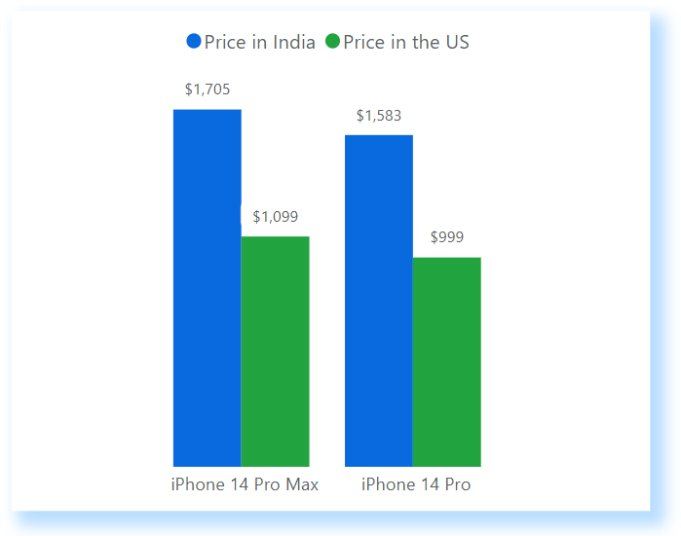  
Figure 10: The Price Factor

Upon digging further, we discovered that the iPhone is significantly more expensive in India compared to the United States. The iPhone costs around 55% more in India than the US. This price hike is the main reason behind the iPhone being considered a status symbol in India.

Another reason behind users preferring to buy an iPhone seems to be the camera. Greater than 75% of the participants said that they wanted a good quality and reliable camera to shoot photos and videos, and their heads automatically turned to the iPhone which, in their opinion, shoots the best photos, as one user describes it “DSLR-esque photos”.

Contrary to our belief, iMessage, one of iPhone's distinctive features, isn't as pivotal as once assumed. Several participants tend to use it on a daily basis, but they do have other alternatives like WhatsApp or Snapchat. Some users pointed out that iMessage's dependency on a carrier's network can prove disadvantageous in areas with weak or nonexistent signals, whereas WhatsApp and Snapchat are functional with just a Wi-Fi connection. Participants also said that they would not recommend an iPhone to others solely for iMessage.

Despite this, there are plenty of reasons why users would endorse the iPhone, such as its superior camera quality, seamless integration with the Apple ecosystem, and user-friendly interface. The proposition of iMessage becoming available on Android devices did not seem to sway the majority of users towards considering a switch from their iPhones. It appears that the allure of the Apple ecosystem and its interconnectedness with other Apple devices hold more sway in their decision to remain brand loyal.

**6. Recommendations**

Based on our research findings, it can be said that users are highly dependent on Apple’s ecosystem and the features it has to offer. However, this creates a sense of anti-competitiveness. This “ecosystem” promotes its users to only use Apple devices and nothing else, thus dominating the userspace.

Apple needs to focus on cross-platform accessibility. Even though the tight integration of Apple devices and its softwares are greatly appreciated by its users, adopting standards such as RCS (Rich Communication Services), which was introduced by Google whose sole goal is to upgrade standard SMS. Apple adopting this technology would make it the de facto standard for messaging no matter the platform or operating system, and make messaging services decentralized and much more secure which promotes privacy.

This “war” between Android and Apple for adopting a standard for messaging is resulting in a win for WhatsApp. As seen in the findings earlier, users are switching to WhatsApp or prefer using WhatsApp over iMessage because of the interoperability and cross-platform features it has to offer. Thus, adopting a standard can also benefit Apple where it can bring users back to iMessage.

**7. Conclusion**

To conclude, it can be said that our observational study provides insights into the reasons behind the loyalty of Apple users to iPhones. It is apparent that the unified Apple ecosystem, which allows seamless integration across all the devices in the Apple lineup, holds a great deal of significance for the consumers. However, it is important to note that certain features like iMessage can benefit from switching standards, making it interoperable and platform independent.

Unquestionably, aesthetics contributes to the success of the iPhone. The device's attraction is aided by its stylish design, which study participants frequently praised. However, it goes beyond just physical attraction. Many iPhone users view the device as a status symbol, a physical manifestation of wealth. Another important unique selling point for the iPhone seems to be the camera and the ease of use. It is easy to learn and does not have any complex structure to it.

Alas, the loyalty of iPhone users is not only a byproduct of clever marketing or brand value, but a consequence of Apple’s continuous commitment to user experience, tightly integrated ecosystem and innovative features.

**References**

Analyzing UX Research: Tips and Best Practices. Retrieved from [www.userinterviews.com/ux-research-field-guide-chapter/research-analysis](http://www.userinterviews.com/ux-research-field-guide-chapter/research-analysis).

Aacap. Screen Time and Children. Retrieved from [www.aacap.org/AACAP/Families_and_Youth/Facts_for_Families/FFF-Guide/Children-And-Watching-TV-054.aspx#:~:text=Children%20and%20adolescents%20spend%20a,spend%20up%20to%209%20hours](http://www.aacap.org/AACAP/Families_and_Youth/Facts_for_Families/FFF-Guide/Children-And-Watching-TV-054.aspx#:~:text=Children%20and%20adolescents%20spend%20a,spend%20up%20to%209%20hours).

Clover, Juli. “iPhone Ownership Among Teens Hits 87%, More Than Double Since 2012.” MacRumors, 11 Oct. 2022, Retrieved from [www.macrumors.com/2022/10/11/teen-survey-iphone-ownership/#:~:text=iPhone%20Ownership%20Among%20Teens%20Hits%2087%25%2C%20More%20Than%20Double%20Since%202012,-Tuesday%20October%2011](http://www.macrumors.com/2022/10/11/teen-survey-iphone-ownership/#:~:text=iPhone%20Ownership%20Among%20Teens%20Hits%2087%25%2C%20More%20Than%20Double%20Since%202012,-Tuesday%20October%2011).

“Global Mobile OS Market Share 2022 | Statista.” Statista, 21 Feb. 2023, Retrieved from www.statista.com/statistics/272698/global-market-share-held-by-mobile-operating-systems-since-2009/#:~:text=Android%20maintained%20its%20position%20as,the%20mobile%20operating%20system%20market.

Goodman, Elizabeth, et al. *Observing the User Experience: A Practitioner’s Guide to User Research*. Elsevier, 2012.

“iPhone Ownership Among Teens Hits 87%, More Than Double Since 2012.” MacRumors, 11 Oct. 2022, Retrieved from www.macrumors.com/2022/10/11/teen-survey-iphone-ownership/#:~:text=iPhone%20Ownership%20Among%20Teens%20Hits%2087%25%2C%20More%20Than%20Double%20Since%202012,-Tuesday%20October%2011.

Kim, A. J., & Park, J. (2013). *The effects of consumer knowledge on message processing of electronic word-of-mouth via online consumer reviews*. Electronic Commerce Research and Applications, 12(5), 406-418.

Lee, H. H., Kim, S. H., & Lee, K. (2019). *The effects of brand experience on brand resonance in the smartphone industry. Journal of Retailing and Consumer Services*, 49, 283-292.

Pew Research Center. (n.d.). Teens, social media & technology 2018. Pew Research Center. Retrieved from <https://www.pewresearch.org/internet/2018/05/31/teens-social-media-technology-2018/>

Statista, 21 Feb. 2023, Retrieved from [www.statista.com/statistics/272698/global-market-share-held-by-mobile-operating-systems-since-2009/#:~:text=Android%20maintained%20its%20position%20as,the%20mobile%20operating%20system%20market](http://www.statista.com/statistics/272698/global-market-share-held-by-mobile-operating-systems-since-2009/#:~:text=Android%20maintained%20its%20position%20as,the%20mobile%20operating%20system%20market).

TechCrunch. (2017). Messaging apps are now bigger than social networks. TechCrunch. Retrieved from https://techcrunch.com/2017/01/25/messaging-apps-are-now-bigger-than-social-networks/

Travis, David, and Philip Hodgson. *Think Like a UX Researcher: How to Observe Users, Influence Design, and Shape Business Strategy*. CRC Press, 2019.

Why RCS? Retrieved from jibe.google.com.