Inventory Management System
Cloud and DevSecOps Capstone Project Report

Project detail | Value
Participant | Ushasri D
Group | 22
Capstone | Foundation AI-Driven Cloud and DevSecOps
Role | Cloud and DevSecOps Engineer
Organization scenario | Acme Retail Ltd.
AWS region | Mumbai ap-south-1
Report date | 21 September 2026

A verified implementation of repeatable infrastructure, secure delivery, managed runtime services, autoscaling, observability, and recoverable data archives.

Document purpose
This report records the final design, implementation, evidence, decisions, and operating model for the Inventory Management System capstone. It distinguishes completed work from conditional controls and future improvements. The central result is a tested AWS solution created through a reviewed GitHub Actions Terraform workflow, delivered with short-lived OIDC credentials, and removable without affecting retained logs, state, or portable database backups in an independent S3 archive.

Contents
- 1 Executive summary
- 2 Business problem and project scope
- 3 AI-assisted development approach
- 4 Application and container delivery
- 5 Final AWS architecture
- 6 Infrastructure as Code
- 7 Continuous integration and delivery
- 8 Security architecture
- 9 Testing and validation evidence
- 10 Autoscaling and performance
- 11 Backup, restore, and persistent archives
- 12 Operations, deployment, and troubleshooting
- 13 Engineering decisions and trade-offs
- 14 Cost management and cleanup
- 15 Limitations and future work
- 16 Deliverables and conclusion

Status definitions
Status | Meaning
Implemented | Present in the repository and validated through local, CI, or AWS evidence.
Conditional | Configured but runs only when a token, variable, or environment is available.
Future | Documented improvement that was not presented as completed work.

1 Executive summary
Acme Retail Ltd. needed a repeatable and secure engineering lifecycle for an existing Spring Boot inventory and e-checkout application. The project replaced manual infrastructure and deployment work with Terraform, container delivery, GitHub Actions, layered security checks, AWS ECS Fargate, private MySQL on Amazon RDS, and persistent S3 archives.
GitHub Copilot and conversational AI assistants helped draft application changes, Terraform, CI/CD workflows, Docker and Kubernetes artifacts, automation scripts, troubleshooting steps, and documentation. Every AI-assisted artifact remained subject to engineering review, security scanning, tests, and runtime verification before acceptance.

Verified project results
Validation | Verified result
Application readiness | HTTP 200 with status UP
ECS autoscaling | One task scaled to two under load and returned to one
Load test | 7,507 requests, 0 failures, 24.76 requests per second
Infrastructure policy | Checkov 185 passed, 0 failed, 29 skipped
Database backup | Dump and upload containers both exited with code 0
Restore test | 8 tables, 4 member records, and 8 product records restored
Log archive | Application and VPC flow logs retained in S3
Infrastructure automation | Reviewed dev plan approved and applied through GitHub Actions with OIDC
Current deployment | ECS rollout completed with 1 desired and 1 running task; ALB readiness HTTP 200

Final outcome
The application deployed successfully, passed readiness checks, handled the bounded load test without failed requests, scaled out and in as designed, produced and restored a portable SQL backup, and retained operational evidence. The current dev platform was recreated through an approved Terraform workflow, deployed through CI/CD, and verified with a completed ECS rollout and ALB readiness HTTP 200.

2 Business problem and project scope

Business problems
- Manual infrastructure provisioning and application deployments
- No reusable Infrastructure as Code baseline
- No standard continuous integration and delivery workflow
- Insufficient security checks for source, images, and infrastructure
- Incomplete operational, recovery, and engineering-decision documentation
- No defined process for reviewing AI-generated engineering artifacts

Project objectives
1. Package and validate the Java 17 Spring Boot application with Maven and Docker.
2. Provision repeatable AWS infrastructure with modular Terraform.
3. Automate build, security checks, image publication, and ECS deployment through GitHub Actions.
4. Protect identities, secrets, network boundaries, data, and retained evidence.
5. Test health, load, autoscaling, backup, restore, logging, and safe teardown.
6. Produce specifications, architecture, ADRs, operating guides, and presentation material required by the capstone.

Scope boundaries
The capstone applied and tested the development environment in AWS. Production Terraform was validated but not applied. The temporary dev ALB used HTTP because no controlled domain was available for ACM public-certificate validation. Kubernetes manifests were retained for local portability and policy scanning, while ECS Fargate served as the AWS runtime.

3 AI-assisted development approach
The project used GitHub Copilot and conversational AI assistants to accelerate initial drafts, investigate failures, and organize evidence. AI did not approve architecture, security exceptions, infrastructure plans, or deployments. The engineer reviewed and validated every accepted change.

Where AI was used
Project area | AI assistance | Engineer validation
Application | Spring Boot structure, API logic, validation, and test suggestions | Maven tests, packaging, readiness checks
Terraform | Module drafts for VPC, ALB, ECS, RDS, IAM, KMS, CloudWatch, autoscaling, and S3 | Formatting, validation, plan review, Checkov, AWS inspection
CI and CD | GitHub Actions workflow generation and troubleshooting | Successful CI runs, controlled CD, ECS stability checks
Docker and Kubernetes | Dockerfile, task-definition, Kubernetes, and Kustomize suggestions | Image build, Trivy, rendered-manifest Checkov
Automation scripts | CloudWatch log archive and Fargate database-backup scripts | Shell syntax checks and successful AWS execution
Security | Interpretation of Gitleaks, Trivy, and Checkov findings | Manual remediation and reviewed exceptions
Documentation | Initial structure for diagrams, ADRs, guides, report, and slides | Comparison with repository and verified evidence

Human-controlled acceptance process
AI-assisted draft > Engineer review > Local validation > Security scanning > AWS verification > Git commit
Maven, Terraform validation, Checkov, Trivy, Gitleaks, GitHub Actions, AWS health checks, load testing, autoscaling evidence, and backup-and-restore tests provided the acceptance evidence. Credentials, secret values, full prompts, and chat histories were excluded from the repository and submission artifacts.

4 Application and container delivery
The existing application uses Java 17, Spring Boot, and Maven. It supports inventory categories, item search, members, purchase orders, receipts, discounts, sales analysis, recommendations, and e-checkout behavior. The modernization preserved application behavior while changing how the service is built, delivered, secured, observed, backed up, and removed.

Build and runtime model
Component | Implementation
Build | Maven compiles, tests, packages, and publishes the JAR as a CI artifact
Container | Docker image built in CI and scanned before delivery
Registry | Amazon ECR stores images tagged with the source commit SHA
Runtime | ECS Fargate runs the Spring Boot container on port 8080
Health | ALB target health uses the Spring Boot readiness endpoint
Configuration | RDS connection settings and managed credentials are supplied at runtime
Portability | Kubernetes and Kustomize manifests remain for local validation and scanning

AI contribution and review
GitHub Copilot and conversational AI assisted with code structure, tests, Docker configuration, ECS task-definition details, and Kubernetes manifests. The project accepted these artifacts only after application tests, image builds, security scans, and runtime readiness checks succeeded.

5 Final AWS architecture
Users reach an internet-facing Application Load Balancer. The ALB forwards approved traffic to ECS Fargate tasks. Tasks connect to private MySQL RDS through security-group rules and retrieve credentials from Secrets Manager. ECR holds immutable images, CloudWatch receives logs and metrics, and the independent S3 archive retains compressed logs and portable SQL backups.
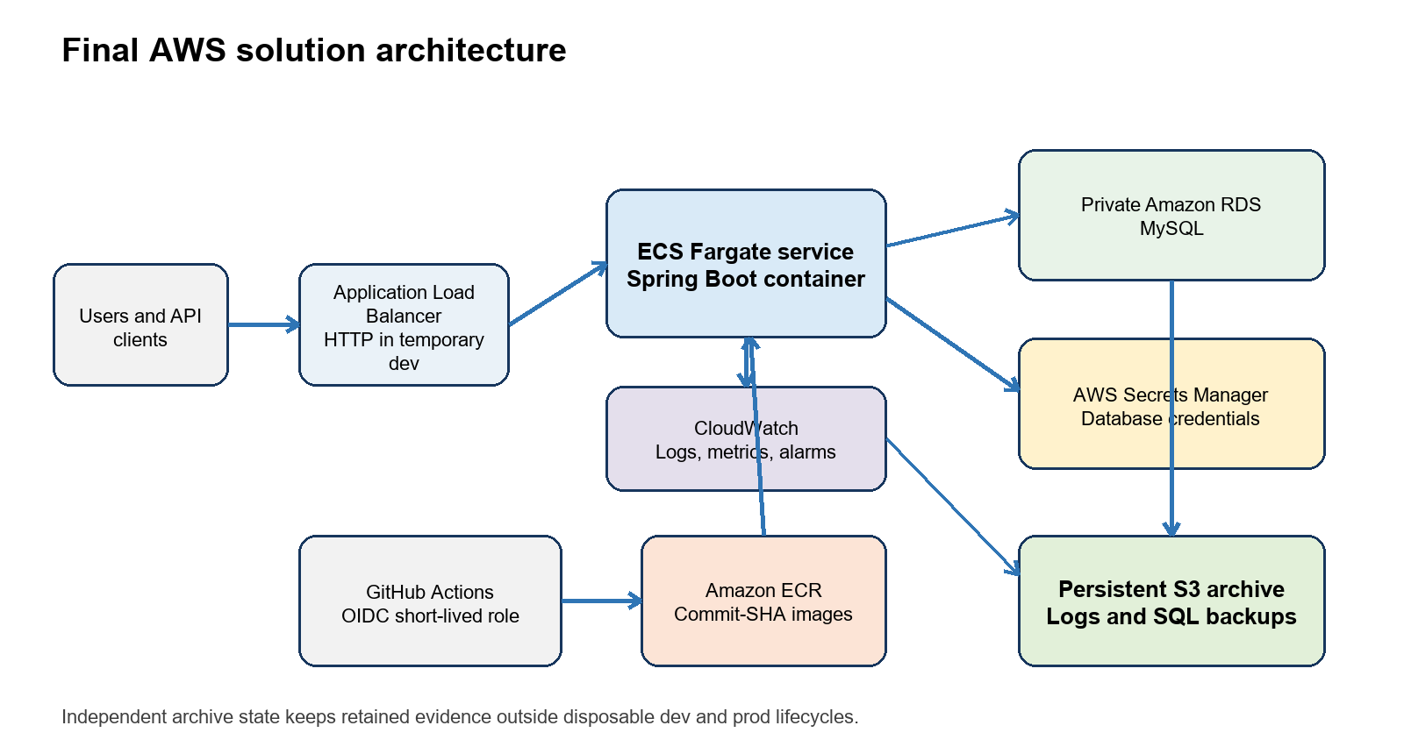
Figure 1 Final AWS solution architecture

Trust boundaries
- The public boundary ends at the ALB; application tasks accept port 8080 only from the ALB security group.
- RDS remains in private subnets and accepts MySQL traffic only from the approved task security context.
- GitHub Actions uses short-lived OIDC credentials instead of stored AWS access keys.
- Secrets Manager holds database credentials, and the archive has independent state and retention controls.

6 Infrastructure as Code
Terraform defines the reusable platform and separates the dev, production, and archive lifecycles. The archive environment is applied first and remains after disposable application environments are destroyed. Terraform owns the platform baseline, CI/CD owns deployed ECS image revisions, and Application Auto Scaling owns desired task count while enabled.

Terraform coverage
Module or environment | Responsibility
Networking | VPC, subnets across two Availability Zones, routing, internet gateway, security groups, and optional flow logs
IAM | ECS execution and task roles, GitHub OIDC role, and least-privilege policies
ECR | Container repository and image-retention controls
ECS | Cluster, service, task definition, ALB, target group, health checks, logs, and autoscaling
RDS | Private MySQL database, subnet group, encryption, and managed master secret
Archive | Private versioned S3 bucket with lifecycle policies and deletion protection
Dev and prod | Environment-specific capacity, networking, retention, and resilience settings

Validation and ownership
AI assisted with early Terraform generation and later refactoring, including separation of persistent archive state. The engineer reviewed saved plans before applying them, validated all environments, and used Checkov as a blocking policy check. Terraform ignores task-definition and desired-count changes that belong to CD and autoscaling, preventing the platform baseline from reverting live ownership.

7 Continuous integration and delivery
GitHub Actions separates validation, reviewed infrastructure change, and application delivery. CI runs for pull requests and pushes to master. The Terraform workflow creates a plan, waits for protected-environment approval, and applies dev automatically on master or dev or prod through manual dispatch. CD starts after successful CI on master and safely skips if the dev ECS service or ECR repository is absent.
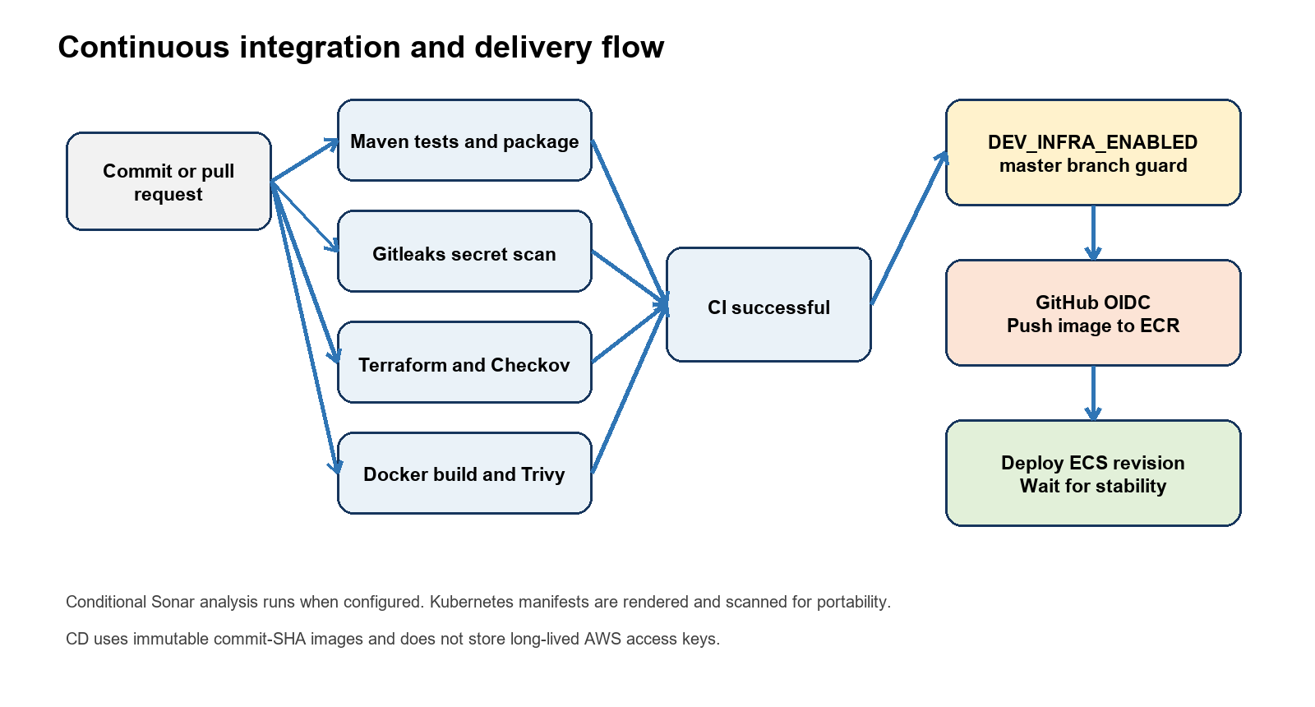
Figure 2 Continuous integration and delivery flow

Pipeline controls
- CI runs Maven tests and packaging, Gitleaks, Terraform validation, Checkov, Docker build, Trivy, and SonarCloud analysis. The latest reviewed change passed the SonarCloud Quality Gate with no new security issues or hotspots.
- For a first deployment, the approved Terraform workflow creates the foundation, pushes the first commit-SHA image, deploys one task, and enables autoscaling. Later CD runs assume an AWS role through OIDC, push a commit-SHA image to ECR, render a new ECS task revision, and wait for service stability.
- GitHub Copilot and conversational AI assisted with workflow generation and troubleshooting; successful workflow execution provided the acceptance evidence.

8 Security architecture
Security controls cover source history, application tests, infrastructure policy, container vulnerabilities, delivery identity, runtime roles, network boundaries, secrets, encryption, and retained storage. The project distinguished blocking controls from conditional analysis and future improvements.

Implemented controls
Layer | Control | Enforcement
Source | Gitleaks full-history secret detection | Blocks CI
Application | Maven tests | Blocks packaging
Code quality | SonarCloud Quality Gate | Enabled for reviewed changes
Container | Trivy fixable high and critical findings | Blocks CI
Infrastructure | Terraform format and validate | Blocks CI
Policy | Checkov for Terraform and rendered Kubernetes | Blocks CI except reviewed skips
Delivery | GitHub OIDC and scoped IAM role | Short-lived credentials
Runtime | Separate execution and task roles | Least privilege
Database | Private RDS and scoped security groups | Network isolation
Storage | Encryption, secure transport, versioning, public-access block | Terraform managed

AI contribution and accountability
AI helped interpret scanner findings and propose remediations, but the engineer decided whether to fix a control, reject a suggestion, or record a narrowly scoped exception. Production work must review every development exception again.

9 Testing and validation evidence
Testing covered local application behavior, infrastructure syntax and policy, container security, live AWS health, performance, scaling, recovery, log retention, and teardown. This evidence was used to validate both human-written and AI-assisted artifacts.
Area | Method | Outcome
Java application | Maven CI | Tests and package jobs succeeded
Docker | CI image build | Image built successfully
Secrets | Gitleaks | Workflow succeeded
Terraform | Format, init, validate | Root and environments valid
Policy | Checkov | 185 passed, 0 failed, 29 skipped
Code quality | SonarCloud Quality Gate | Passed with no new security issues or hotspots
Health | ALB readiness request | HTTP 200 and UP
Load | ApacheBench | 7,507 requests with no failures
Autoscaling | CPU load and AWS activity | One to two tasks, then two to one
Backup | One-off Fargate task | Both containers exited 0
Restore | Temporary MySQL 8.4 | 8 tables, 4 members, 8 products
Log archive | Direct CloudWatch read and S3 upload | Application and VPC objects retained
Infrastructure automation | GitHub Actions plan approval apply | Reviewed dev plan applied with OIDC credentials
Current deployment | ECS and ALB checks | Completed rollout with 1 running task and readiness HTTP 200

Evidence limits
The performance result applies to the temporary development configuration and is not a production capacity claim. Production Terraform is available through the same reviewed workflow but was not applied. Snyk and OWASP ZAP were not implemented.

10 Autoscaling and performance
The ECS target-tracking policy used average CPU utilization with a 60 percent target, a minimum of one task, and a maximum of two tasks. CPU load triggered a successful scale-out to two running tasks. After the low-alarm evaluation period, the service returned to one task.
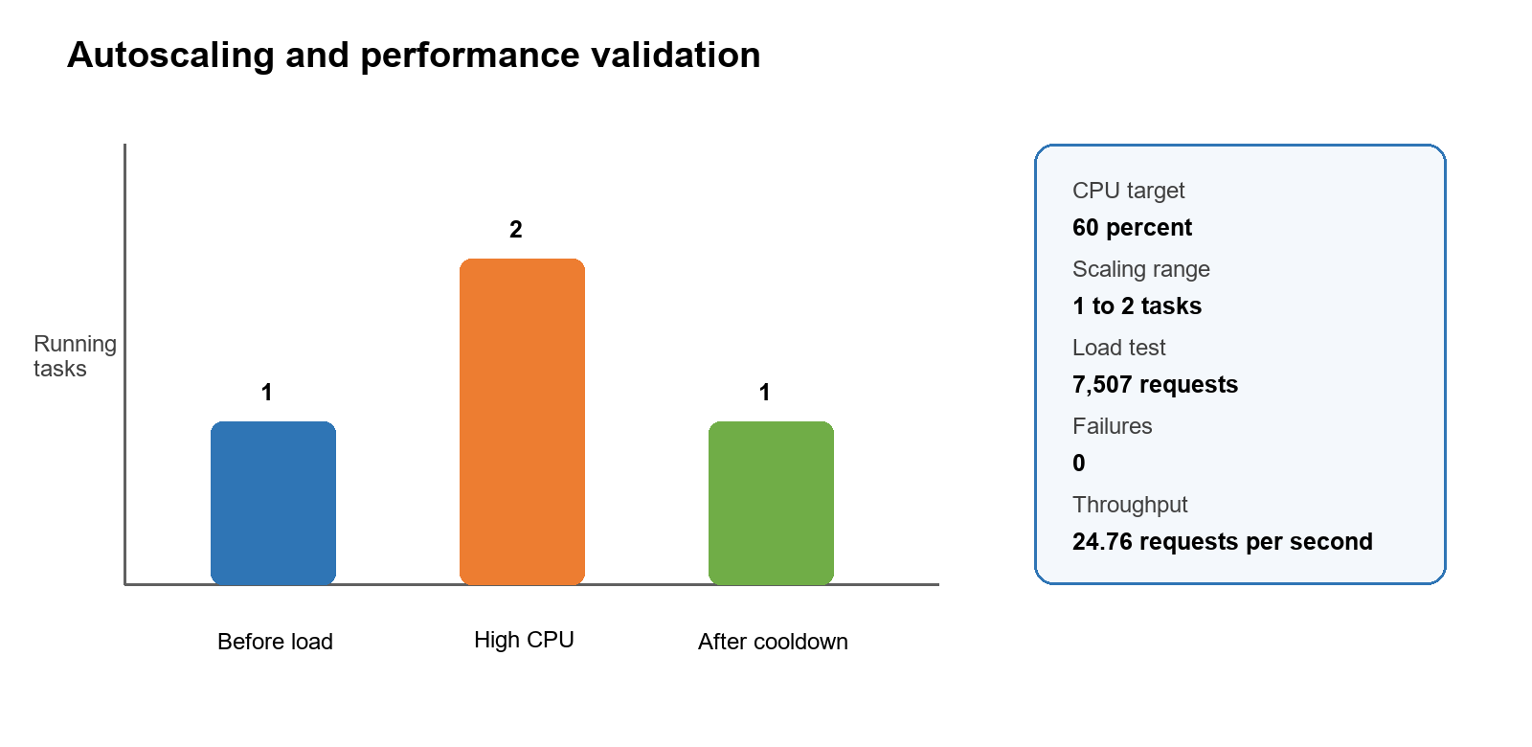
Figure 3 Verified autoscaling and load-test results

Interpretation
The load test completed 7,507 requests with zero failures at an average 24.76 requests per second. The result proves the configured scaling path and a stable bounded test, but it does not establish a production service-level objective or maximum throughput.

11 Backup, restore, and persistent archives
The persistent archive uses a private S3 bucket in an independent Terraform state. EventBridge Scheduler starts the one-off Fargate database-backup task daily at 02:00 UTC by default, while an operator may still run an additional backup on demand. It blocks public access, denies insecure transport, uses AES256 server-side encryption, enables versioning, expires logs after 30 days, expires portable SQL backups after 90 days, and sets force_destroy to false.

Database backup and restore
1. A one-off ECS Fargate task ran mysqldump against private RDS.
2. A dedicated upload container copied the SQL file to the backups/dev prefix.
3. Both containers exited with code 0 and the S3 object had nonzero size, AES256 encryption, and a version ID.
4. The backup was imported into an isolated MySQL 8.4 instance.
5. Verification recovered 8 tables, 4 member records, and 8 product records.

Operational log archive
Archive object | Verified size | Retention
Application logs | 5,005 bytes | 30 days
VPC flow logs | 43,525 bytes | 30 days
Portable SQL backup | 10,234 bytes | 90 days

AI assisted with the backup and log-archive scripts and with diagnosis of an RDS table-lock permission failure. The reviewed dump command used skip-lock-tables, disabled GTID output, and omitted tablespace metadata. RDS automated backups remain the primary recovery mechanism; the S3 SQL file is a portable secondary copy.

12 Operations, deployment, and troubleshooting

Deployment sequence
1. Apply the independent archive environment first.
2. Bootstrap dev with zero desired tasks and autoscaling disabled while ECR is empty.
3. Allow successful CI and controlled CD to publish the first image and deploy one task.
4. Enable autoscaling and apply the reviewed Terraform plan.
5. Verify ECS rollout state, ALB readiness, logs, alarms, and retained evidence.
6. Use a reviewed destroy plan when dev is no longer needed; CD detects missing infrastructure and skips safely.

Routine operations
- Check desired, running, pending, and rollout state for the ECS service.
- Review ALB target health, readiness, CloudWatch logs, scaling activities, and alarm state.
- Review CI security results and dependency findings before approving delivery.
- Verify backup container exit codes, S3 metadata, archive retention, and restore readiness.

Troubleshooting principles
Start at the failing layer and capture sanitized evidence. Do not weaken IAM, expose RDS, disable security gates, or delete retained data to bypass a failure. The project resolved stale Terraform plans by replanning, backup lock failures with RDS-compatible dump options, and CloudWatch export-task KMS errors by reading events directly and uploading compressed JSON to S3.

13 Engineering decisions and trade-offs
Decision | Reason | Trade-off
AWS target platform | Matches the capstone cloud scenario and managed-service requirements | Region-specific design and AWS service dependency
ECS Fargate instead of EKS | Lower cost and administration for one service | Kubernetes is not the production runtime
Amazon ECR | Native IAM and ECS integration | Images remain AWS-specific
GitHub OIDC | Avoids long-lived deployment keys | Requires carefully scoped trust and role policy
Layered security scans | Covers secrets, infrastructure, Kubernetes, and images | Exceptions need ongoing review
Managed secrets | Keeps credentials out of source and workflows | Runtime access depends on IAM and Secrets Manager
Local validation before AWS | Finds errors before cost and deployment risk | Local success cannot replace runtime testing
Independent S3 archive | Preserves logs and backups after dev teardown | Small continuing S3 cost and separate lifecycle

Development and production differences
Development avoided a NAT gateway and used public task IPs with restricted inbound rules to control cost. Production configuration uses private tasks, NAT, stronger RDS resilience, longer retention, a controlled domain, an ACM certificate, HTTPS, and HTTP redirect. Development shortcuts were documented rather than presented as production defaults.

14 Cost management and cleanup

Main cost drivers
- RDS instance and storage
- Application Load Balancer hours and capacity units
- ECS Fargate CPU and memory
- Production NAT gateways
- CloudWatch ingestion and retention
- ECR, S3, Secrets Manager, KMS, and data transfer

Cost controls
ECS Fargate replaced an always-on EKS cluster for the single-service runtime. Dev avoided NAT, ran one task until autoscaling required another, used bounded retention, and can be destroyed after testing and recreated through the reviewed workflow. The archive remained because recovery evidence has a different lifecycle from disposable infrastructure.

Safe cleanup result
The engineer previously archived required logs, created and restored the portable backup, inspected the dev destroy plan, destroyed 50 resources, and confirmed that the dev Terraform state was empty. The environment was later recreated through the approved Terraform workflow; the independent S3 archive remained intact throughout. The S3 archive remained active with retained objects because it uses separate state and force_destroy is false.

15 Limitations and future work
Area | Current status | Recommended next step
HTTPS | Dev used HTTP because no controlled domain was available | Use a domain, ACM certificate, HTTPS listener, and HTTP redirect
Production | Terraform validated but not applied | Run a formal production readiness and cost review before deployment
Sonar | Quality Gate enabled and passing | Continue to review new-code findings
Dynamic testing | OWASP ZAP not implemented | Add an approved temporary-endpoint scan
Dependency tooling | Snyk not implemented | Evaluate overlap and incremental value
Notifications | Teams notifications not implemented | Add sanitized deployment and failure notifications
Backups and logs | Database backup scheduled daily; logs archived on demand | Add scheduled log archival and monitoring
AWS security services | Not enabled for this cost-conscious exercise | Assess CloudTrail, Config, GuardDuty, and Security Hub

AI governance improvement
Future work should retain the same review model: record specifications before implementation, require peer review for AI-assisted changes, keep secrets and raw conversations out of the repository, and preserve automated evidence showing that accepted artifacts meet project controls.

16 Deliverables and conclusion

Submission deliverables
Deliverable | Contents
AI Engineering Specifications | Application, infrastructure, CI/CD, security, testing, and documentation specifications
Implementation alignment | Final outcomes, approved deviations, and validation evidence
Architecture | High-level, AWS, CI/CD, request, and security flows
Engineering decisions | Eight ADRs covering platform, runtime, registry, identity, scanning, secrets, validation, and S3
Operating documentation | Setup, deployment, operations, security, testing, troubleshooting, cost, and backup guides
Presentation | Sixteen-slide editable PowerPoint and submission PDF
Project report | This consolidated DOCX report

Conclusion
The capstone delivered a secure and repeatable engineering lifecycle for the inventory application. Terraform and GitHub Actions create the platform through a reviewed approval gate, validate and deliver immutable images, use AWS-managed runtime services, enforce security gates, scale under load, and preserve state, logs, and a tested portable backup across dev teardown.
AI assistance accelerated drafting and troubleshooting across code, Terraform, pipelines, containers, Kubernetes, scripts, security analysis, and documentation. The final result remained engineer-controlled because each accepted artifact was reviewed against specifications and verified through automated checks and observable AWS behavior.

Repository naming note
The participant guide expects the submission repository name group22-foundation. Confirm the final repository name with the trainer before renaming or transferring the current repository.

