ALL Dashboards will display the following icons and features:

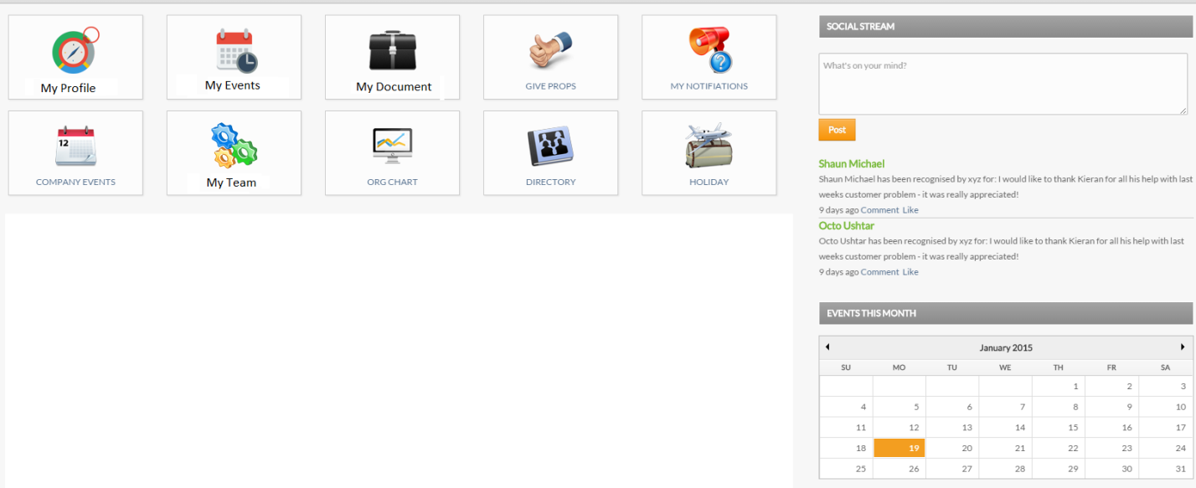

Icons:

My Profile: View Only <http://hrm.devsystem.in/edit-profile.html>

My Events: Users Events: <http://hrm.devsystem.in/edit-profile.html>

My Documents: Users Private Documents: <http://hrm.devsystem.in/publishdoc.html>

Give Props:

My Notifications: Users Notifications

Company Events: Events created by Admin:

My Team: Employees in the same department

Org Chart: <http://hrm.devsystem.in/view.html>

Directory: <http://hrm.devsystem.in/directory.html>

Holidays: Company Holidays setup by Admin <http://hrm.devsystem.in/holidays.html>

Add New Admin setup page to the following navigation: **Spring Admin > SpringTools > Dashboard Setup**

Admin will select which additional pagelets will appear on the user’s dashboards by selecting the pagelet and sub-pagelet (if X = check box is uncheck – the pagelet will be removed from the dashboard)

|  |  |  |  |  |
| --- | --- | --- | --- | --- |
| **Pagelet** | **Sub Pagelet** | **Admin Dashboard** | **Manager Dashboard** | **Employee Dashboard** |
| **Setup Spring Links** |  | X |  |  |
| **Recent Articles** |  | X | X | X |
|  | Document | X | X | X |
|  | News | X | X | X |
|  | Event | X | X | X |
| **Alerts** |  | X | X | X |
|  | Anniversaries | X | X | X |
|  | Birthdates | X | X | X |
|  | New Jobs | X | X | X |
|  | New Hires | X | X | X |
|  | Terminations | X | X | X |
|  | New Promotions | X | X | X |
| **Company Directory Search** |  | X | X | X |
| **Workflow** |  | X | X |  |
|  | Pending Leave Requests | X | X |  |
|  | Pending Timesheets | X | X |  |
|  | Interview Schedules | X | X |  |
|  | Pending Schedule Change Requests | X | X |  |
| **My Direct Reports** |  |  | X |  |
|  | Summary |  | X |  |
|  | Job Details |  | X |  |
|  | Contact |  | X |  |
|  | Appraisals |  | X |  |
|  | Training |  | X |  |
| **Organizational Graphs** |  | X | X |  |
|  | Age Chart | X | X |  |
|  | Gender Chart | X | X |  |
|  | Department Chart | X | X |  |
|  | Job Title Chart | X | X |  |
|  | Location Chart | X | X |  |
|  | Manager Chart | X | X |  |
|  | Job Status Chart | X | X |  |
|  | Organizational Chart | X | X |  |
|  | Employee Distribution by Department | X | X |  |
|  | Employee Distribution by Sub Department | X | X |  |
|  | Headcount | X | X |  |
|  | Vacancy Succession Report | X | X |  |
| **Benefit Graph** | (display on right side of dashboard) | X | X |  |
|  | Leave Taken by Department | X | X |  |
| **Performance Report** | (display on right side of dashboard) | X | X |  |
|  | Appraisal Status |  | X |  |
| Clocked In/Out Graph |  | X | X | X |
| Leave Taken by Department Chart |  | X | X |  |
| Leave Taken by Sub Unit |  | X | X |  |
| My Leave Status Chart |  |  |  | X |
| Trial Period Status Indicator | Display on top left side of dashboard | X |  |  |
| Document Storage Status Indicator | (will need an ability to purchase more space) | X |  |  |
| My Team Schedule | (display current week team work schedule – with timeoff indicators) | X | X |  |
| My Props |  | X | X |  |