## EMPLOYEE MANAGEMENT SYSTEM

**A PROJECT REPORT**

*Submitted by*

**PATEL JENEESH S. (2019095900007045)**

**PATEL VIDHIN D. (2019095900007567)**

**PATEL JEET A. (2019095900007061)**

***In fulfillment of the subject Mini Project***

***of***

**B.Tech. Semester V**

***In***

**INFORMATION TECHNOLOGY**



## Sankalchand Patel College of Engineering, Visnagar Sankalchand Patel University, Visnagar

2021 - 22

CERTIFICATE

**Date: / /**

**This is to certify that the project entitled “EMPLOYEE MANAGEMENT SYSTEM” has been carried out by Patel Jeet A.(2019095900007061), Patel Vidhin D.(2019095900007567), Patel Jeneesh S.(2019095900007045) under my guidance in fulfillment of the subject Mini Project of Bachelor Of Engineering in Information Technology (Semester V) of Sankalchand Patel University, Visnagar during the academic year 2021- 22.**

**Internal Guide**

**Name: Govind Patel , Piyush Suthar**

**Date:**

**Head of Department**

**(DR. Kirit .J. Modi)**

**Table of Contents**

**Acknowledgement………………………………………………………**

**Abstract……………………………………………………………………...**

**1.Introduction……………………………………………………………..**

1.1. Overview of Project………………………………………..

1.2. Project Profile…………………………………………………

**2.Technology..................................................................**

2.1. Software requirement ......................................

2.2. Hardware requirement .....................................

**3.Data Modeling Diagram...............................................**

3.1. ER-Diagram .......................................................

3.2 Data Flow Diagram………………………………………….

3.2.1 DFD level 0 ………………………………………….

3.2.2 DFD level 1 ………………………………………….

**4.Survey of Technology .................................................**

**5.Snapshots…………………………………………………………………**

**6.Refrence and Bibliography ..........................................**

**7. Conclusion……………………………………………………………….**

## Acknowledgement

This project report on “Employee Management System” beats the important of several people with the proper guidance of those persons, this project has been completed.

We extend our sincere and heartful thanks to our esteemed guide “Prof. Govind V. Patel” & “Prof. Piyush S. Suthar” for providing me and my team an opportunity for us to show our hidden talent to you & providing their suggestion for betterment of our program our project would not have been possible without your faith on us.

We would like to extend thanks to our respected Head of the Department, “Dr. Kirit J. Modi” for allowing us to use the facilities available.

PATEL JENEESH

PATEL JEET

PATEL VIDHIN

## Abstract

**Employee Management System** is a distributed application, developed to maintain the details of employees working in any organization. It maintains the information about the personal details of their employees, also the details about the payroll system which enable to generate the pay slip. The application is actually a suite of applications developed using Java.

It is simple to understand and can be used by anyone who is not even familiar with simple employees system. It is user friendly and just asks the user to follow step by step operations by giving him few options. It is fast and can perform many operations of a company.

This software package has been developed using the powerful coding tools of JAVA at Front End and Microsoft Sql Server at Back End. The software is very user friendly. The package contains different modules like Employee details. This version of the software has multi-user approach. For further enhancement or development of the package, user’s feedback will be considered.

***INTRODUCTION***

Employee Management system is an application that enables users to create and store Employee Records. The application also provides facilities of a payroll system which enables user to generate Pay slips too. This application is helpful to department of the organization which maintains data of employees related to an organization .

Java is a platform independent language. Its created applications can be used on a standalone machine as well as on distributed network. More over applications developed in java can be extended to Internet based applications.

Thus java was chosen as background to design this application.

***1.1 OBJECTIVE OF THE PROJECT***

In this world of growing technologies everything has been computerized. With large number of work opportunities the Human workforce has increased. Thus there is a need of a system which can handle the data of such a large number of Employees in an organization. This project simplifies the task of maintain records because of its user friendly nature.

#### *1.2 PROJECT PROFILE*

Project Name : Employee Management System

Submitted To : Sankalchand Patel University , Visnagar

Front End : Java

Back End : My SQL

Documentation Tool : Microsoft Word

Project Guide : Prof. Govind patel, Prof . Piyush Suther

Team Members : Patel Jeet A. (2019095900007061)

Patel Vidhin D. (2019095900007567)

Patel Jeneesh S. (2019095900007045)

#### Chapter-2

**2. TECHNOLOGY**

* 1. **Software Requirements:**

Operating System - Windows XP Professional

Developing Language - JAVA(jdk-5)

DATABASE - Microsoft SQL SERVER 2005

* 1. **Hardware Requirements:**

**Memory Space:**

Minimum - 32 MB

Recommended - - 64 MB

**HDd** - To install the software at least 2 GB and the data storage is depending upon the organizational setup.

**PROCESSOR -** Intel Pentium IV, 1GHZ or above

**ram -** 256MB or above

**KEYBOARD -** Standard 104 Keys(QWERTY)

#### Chapter-3

**ER-DIAGRAM :-**

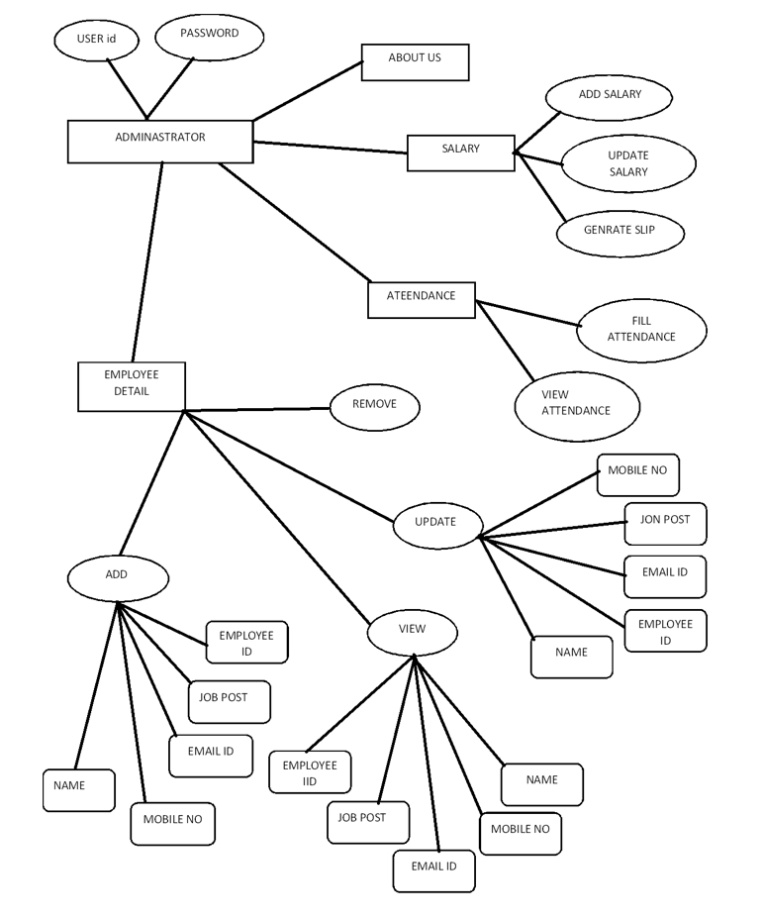

**DATA FLOW DIAGRAM :-**

**DFD Level 0 (Context Level Diagram):-**

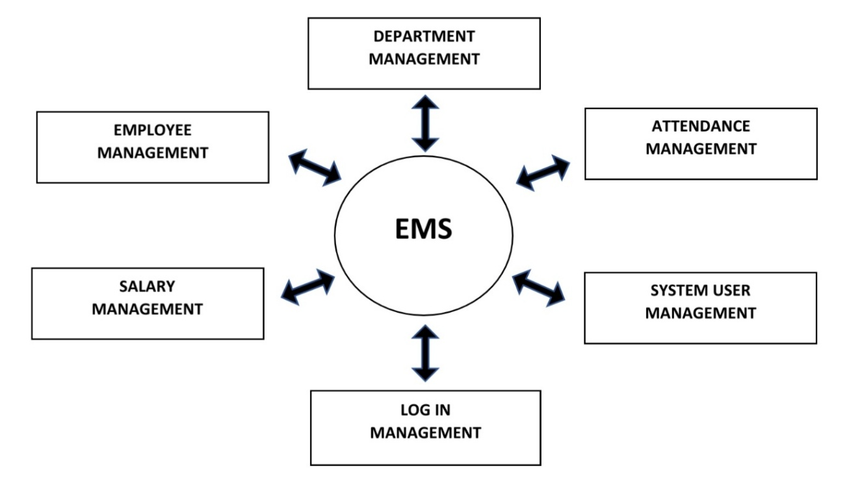

**DFD Level 1 :-**

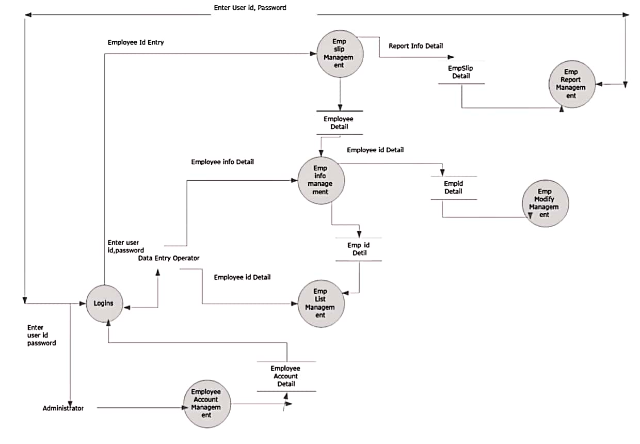

**Chapter-4**

**SURVEY OF TECHNOLOGY :-**

**JAVA:**

**Java** is a general computer programming language developed by Sun Microsystems. Originally called "Oak", by its inventor James Gosling, **Java** was designed with several innovative features. These include a language that is entirely object oriented, and the ability to write an application once and move it to virtually any platform.

**Classes and Objects**

Classes :- In the real world, you'll often find many individual objects all of the same kind. There may be thousands of other bicycles in existence, all of the same make and model. Each bicycle was built from the same set of blueprints and therefore contains the same components. In object-oriented terms, we say that your bicycle is an instance of the class of objects known as bicycles. A class is the blueprint from which individual objects are created.

Objects :- It is a basic unit of Object-Oriented Programming and represents the real life entities. A typical Java program creates many objects, which as you know, interact by invoking methods.

**Inheritance**

Different kinds of objects often have a certain amount in common with each other. Mountain bikes, road bikes, and tandem bikes, for example, all share the characteristics of bicycles (current speed, current pedal cadence, current gear). Yet each also defines additional features that make them different: tandem bicycles have two seats and two sets of handlebars; road bikes have drop handlebars; some mountain bikes have an additional chain ring, giving them a lower gear ratio.

**Interface**

As you've already learned, objects define their interaction with the outside world through the methods that they expose. Methods form the object's interface with the outside world; the buttons on the front of your television set, for example, are the interface between you and the electrical wiring on the other side of its plastic casing. You press the "power" button to turn the television on and off.

**Package**

A package is a namespace that organizes a set of related classes and interfaces. Conceptually you can think of packages as being similar to different folders on your computer. You might keep HTML pages in one folder, images in another, and scripts or applications in yet another. Because software written in the Java programming language can be composed of hundreds or thousands of individual classes, it makes sense to keep things organized by placing related classes and interfaces into packages.

**GUI Swing Widgets**

A Graphical User Interface (GUI) is a visual paradigm which allows a user to communicate with a program in an intuitive way. Its main features are widgets (aka controls) and event driven activities. Clients expect a graphical interface in an application.

**JFrame and JPanel**

JFrameis the most commonly used top-level container. It adds basic functionality such as minimize, maximize, close, title and border to basic frames and windows. Some important JFrame methods are: setBounds(x,y,w,h), setLocation(x,y), setSize(w,h), setResizable(bool), setTitle(str), setVisible(bool), isResizable() and getTitle(). The setDefaultCloseOperation(constant) method controls the action that occurs when the close icon is clicked. Normally the constant used isJFrame.EXIT_ON_CLOSE**.**

JPanelis the most commonly used content pane. An instance of the pane iscreated and then added to a frame. Theadd() method allows widgets (GUI components) to be added to the pane. The way they are added is controlled by the current layout manager.

**Labels, Icons and Buttons**

Labels are non-interactive text objects most commonly used as prompts. They are created using the JLabel() constructor with the required text as the first parameter. Another parameter can be added using a SwingConstant value to set horizontal alignment. Vertical alignment is through the setVerticalAlignment() method. The contents of a label can be changed with the setText() method.

Icons can be easily added to labels or other controls either to brand, dress up, or aid accessibility. Icons are constructed from the ImageIcon class and then added as a parameter to the label (or other) control. An extra parameter can be used to control the position of the text relative to the icon. It must use one of the SwingConstants values.

Buttons are used to start operations. They are created with the JButton() constructor. They can be deactivated with the setEnabled(false) method and tested with the isEnabled() method. One useful button method is setMnemonic(char) which allows a hot key to be associated with the button

**Event Listeners**

GUIs are event-based. That is they respond to buttons, keyboard input or mouse activities. Java uses event listeners to monitor activity on specified objects and react to specific conditions. For a listing of useful event listeners check the appendix. For techniques on organizing many different events in larger projects, view advanced event listeners.

The first step in adding a basic button push event handler to the above example is to import awt.event.* which contains all of the event classes. Next add the phrase implements ActionListener to the class header. Register event listeners for each button widget using the addActionListener(this) method

**Chapter-5**

**SNAPSHOT: -**

There are number of screensorts in terms of responsiveness.

**1-WELCOME**

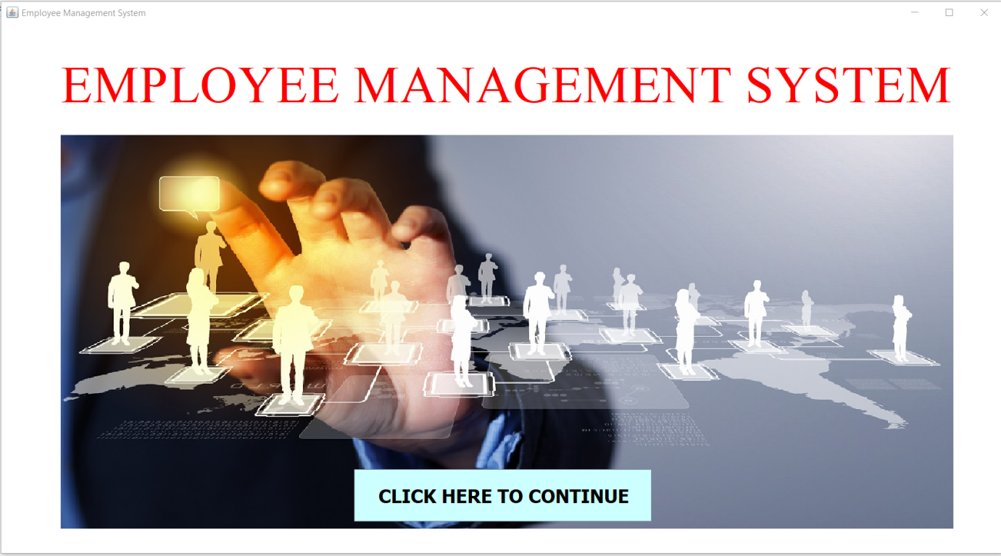

**2-LOGIN**

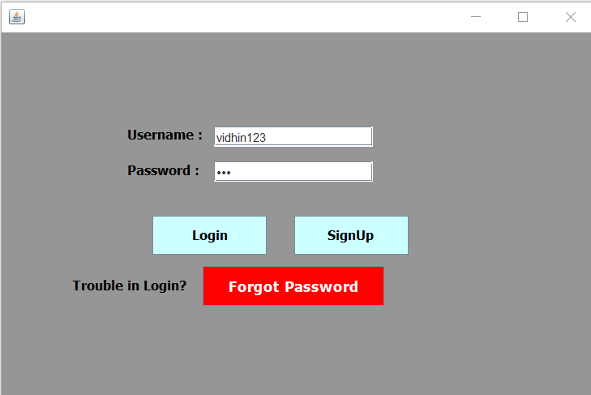

**3-HOME**

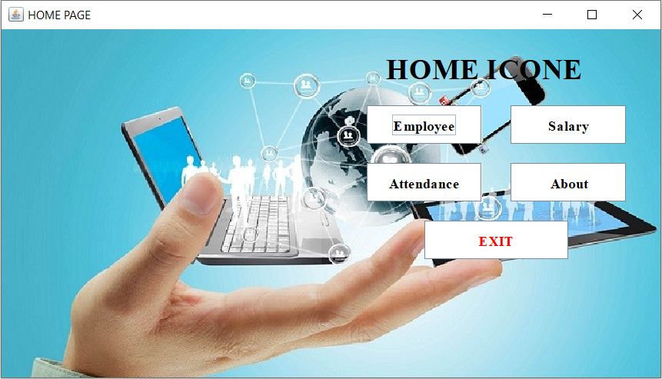

**4-EMPLOYEE**

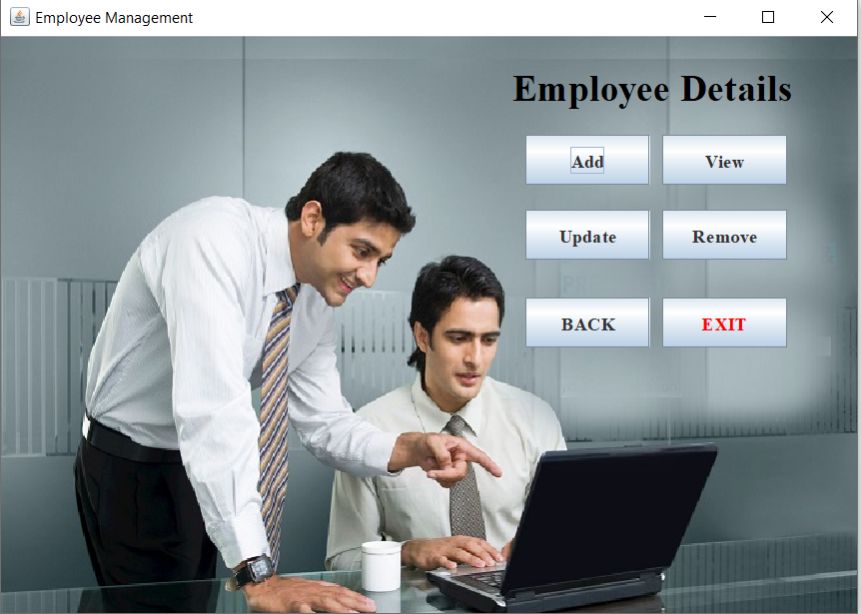

**5-SALARY**

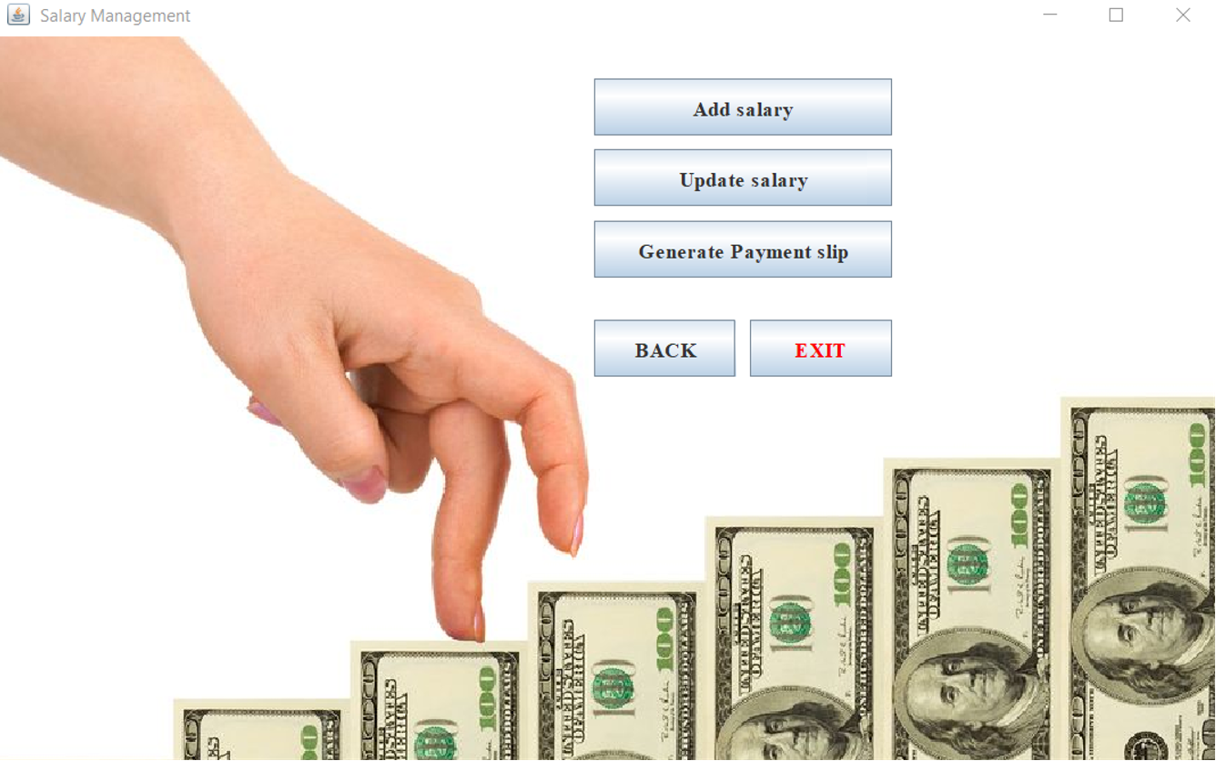

**6-ATTENDANCE**

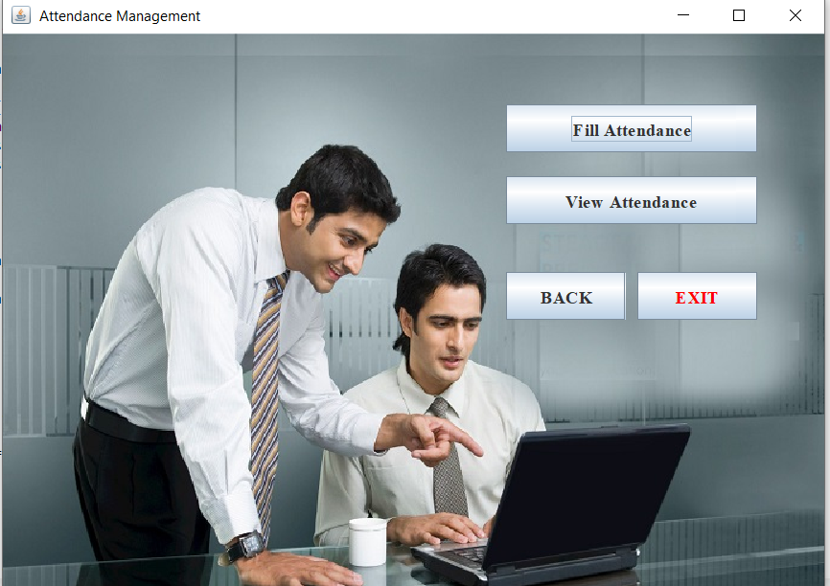

**Chapter-6**

**REFERENCE AND BIBLIOGRAPHY : -**

• Websites referred

CORE JAVA(Vol-I) by SUN MICROSYSTEMS

[WWW.GOOGLE.COM](http://WWW.GOOGLE.COM)

WWW.JAVA.SUN.COM

[WWW.ONLY4GURUS.COM](http://WWW.ONLY4GURUS.COM)

[WWW.SMARTDRAW.COM](http://WWW.SMARTDRAW.COM)

[WWW.YOUTUBE.COM](http://WWW.YOUTUBE.COM)

• Book referred

Java programming – Herbert Schildt

**Chapter-7**

**Conclusion:-**

**Since this project has been designed exclusively as a project, certain complexities that do faced by any real life manual problem like total no. of employee, address redundancy etc. are considered in this project. But enhancement to the project can easily be made without changing the current design and programming structure.**

**This project is use for computerizing employee management work in offices , schools , etc….**

**The software keep record of employee’s provide fund, gratuity and salary and generates the slips of salary too.**

**The software is capable of easy storage of information related to employee through database.**