PRELIMINARY PAGES
TITLE PAGE
A COMPARATIVE DENSITY FUNCTIONAL THEORY STUDY OF VANADIC ACID AND STEAM ADSORPTION ON THE BRØNSTED ACID SITE OF ZEOLITE Y: EVIDENCE FOR THE MECHANISM OF VANADIUM-PROMOTED DEALUMINATION IN RESIDUE FLUID CATALYTIC CRACKING
BY
AHMAD USMAN SHEHU
(U19CE1068)
A RESEARCH PROJECT SUBMITTED TO THE DEPARTMENT OF CHEMICAL ENGINEERING, FACULTY OF ENGINEERING, AHMADU BELLO UNIVERSITY, ZARIA
IN PARTIAL FULFILMENT OF THE REQUIREMENTS FOR THE AWARD OF THE DEGREE OF BACHELOR OF ENGINEERING (B.ENG.) IN CHEMICAL ENGINEERING
OCTOBER, 2026
DECLARATION
I declare that the work in this project report entitled "A Comparative Density Functional Theory Study of Vanadic Acid and Steam Adsorption on the Brønsted Acid Site of Zeolite Y: Evidence for the Mechanism of Vanadium-Promoted Dealumination in Residue Fluid Catalytic Cracking" was carried out by me in the Department of Chemical Engineering, Ahmadu Bello University, Zaria. The information derived from the literature has been duly acknowledged in the text and a list of references provided. No part of this project report was previously presented for another degree or diploma at this or any other institution.
_________________________
Ahmad Usman Shehu
(Student)
_________________________
Date
CERTIFICATION
This project report entitled "A Comparative Density Functional Theory Study of Vanadic Acid and Steam Adsorption on the Brønsted Acid Site of Zeolite Y: Evidence for the Mechanism of Vanadium-Promoted Dealumination in Residue Fluid Catalytic Cracking" by Ahmad Usman Shehu meets the regulations governing the award of the degree of Bachelor of Engineering (B.Eng.) in Chemical Engineering of Ahmadu Bello University, Zaria, and is approved for its contribution to knowledge and literary presentation.
_________________________
Project Supervisor
_________________________
Date
_________________________
Head of Department
_________________________
Date
_________________________
External Examiner
_________________________
Date
DEDICATION
This work is dedicated to my parents, whose patience and sacrifice made it possible, and to every student who has ever tried to explain a chemical bond to a computer.
ACKNOWLEDGEMENTS
I am grateful to my project supervisor for insisting on evidence over assertion, and for the many corrections that followed. The habit of asking a result to justify itself has been the most useful thing I have learned.
I thank the Head of Department and the academic and technical staff of the Department of Chemical Engineering, Ahmadu Bello University, Zaria, for the environment in which the work was done, and for access to the computing facilities that carried the density functional part of the study.
I acknowledge the authors whose published work forms the foundation of this thesis, and in particular the group whose first principles treatment of zeolite dealumination by steam provided the benchmark against which the present calculations were set.
I thank my colleagues in the department for the arguments that sharpened the introduction and for the willingness to read drafts that were not yet good. Finally, I thank my family for their support throughout.
LIST OF TABLES
Table | Title | Page
3.1 | Composition of the model systems used in this study | 24
3.2 | Input file for the geometry optimisation and frequency analysis of the vanadic acid adsorption complex | 26
3.3 | Measured wall clock times for the principal calculations | 29
3.4 | Fragment definition required by ORCA for a counterpoise calculation | 34
3.5 | Summary of the computational parameters used in this study | 36
4.1 | Computed reference energies at the B3LYP-D3(BJ)/def2-TZVP level | 39
4.2 | Stationary points on the vanadium route at the GFN2-xTB level | 42
4.3 | Stationary points on the steam route at the GFN2-xTB level | 42
4.4 | Adsorption of vanadic acid and of water on the zeolite Y Brønsted acid site | 46
4.5 | Enthalpy and entropy of adsorption extracted from the computed Gibbs energies | 48
4.6 | Comparison of the two density functionals on identical geometries | 50
4.7 | Density functional stationary points including those that did not meet the acceptance gate | 52
4.8 | The density functional ladder for the vanadium route | 54

LIST OF FIGURES
Figure | Title | Page
2.1 | The faujasite structure of zeolite Y | 10
2.2 | Atomistic models of the faujasite framework with and without framework aluminium | 11
2.3 | Reaction paths for dealumination and desilication | 13
2.4 | Reaction steps and intermediate configurations for dealumination and desilication | 14
2.5 | Mechanisms of vanadium poisoning of cracking catalysts | 16
2.6 | Effect of calcination temperature on the mobility of vanadium species | 18
2.7 | Kerr's scheme for zeolite dealumination and hydronium attack | 19
2.8 | Effect of vanadium on the hydrothermal stability of catalysts | 21
3.1 | The two level computational workflow used in this study | 23
4.1 | The cluster models used in this work | 40
4.2 | The complete semi-empirical reaction profiles at the GFN2-xTB level | 43
4.3 | Adsorption of vanadic acid and of steam on the zeolite Y Brønsted acid site | 47
4.4 | Gibbs energy of adsorption against temperature | 49
4.5 | The level 2 ladder for the vanadium route | 55

Page numbers refer to the printed document and should be checked against the final pagination before submission.
ABSTRACT
Vanadium in residue fluid catalytic cracking feedstock deposits on the catalyst, oxidises to vanadium pentoxide in the regenerator, and converts to volatile vanadic acid in the presence of steam. The published literature does not agree on whether vanadic acid is itself the species that hydrolyses the aluminosilicate framework, or whether the destructive agent is instead sodium hydroxide released by vanadium, with vanadium acting only indirectly. This study brings quantitative evidence to that dispute by computing the adsorption of vanadic acid and of water on a faujasite Brønsted acid site on identical terms.
A four tetrahedral atom cluster of composition AlSi₄O₄H₁₃, containing one Brønsted acid site, was constructed and optimised. Orthovanadic acid and water were each brought to the site. The potential energy surface was explored with the semi-empirical GFN2-xTB method, and stationary points were refined at the B3LYP-D3(BJ)/def2-TZVP level with geometry optimisation and frequency analysis. The electronic energies were cross-checked with PBE0-D3(BJ)/def2-TZVP single points. All calculations were performed with the ORCA program package.
The electronic adsorption energy of vanadic acid is −93.01 kJ mol⁻¹ and that of water is −78.32 kJ mol⁻¹, so vanadic acid is preferred at the acid site by 14.69 kJ mol⁻¹. PBE0 gives −93.07 and −78.62 kJ mol⁻¹, preserving the margin to within 0.25 kJ mol⁻¹. The optimised vanadic acid complex is not purely hydrogen bonded: one vanadic oxygen lies 1.925 Å from the framework aluminium, so chemisorption has already begun at the adsorption step. Conversion of the adsorption complex to the chemisorbed intermediate releases a further 22.37 kJ mol⁻¹, and in that intermediate all four framework oxygen contacts to the aluminium are retained, so the framework is intact but the aluminium environment is changed. The chemisorbed state has no counterpart on the steam route. Under standard state conditions the entropy penalty of adsorption is larger for vanadic acid, so the margin narrows and reverses with rising temperature; the thermodynamic argument for vanadium must therefore rest on the adsorption enthalpy and on the chemistry that follows adsorption.
The saddle point for the first aluminium oxygen cleavage was not established at the density functional level, where the attempted transition state optimisation returned fourteen imaginary modes, and the dealuminated product was computed as strongly endothermic on the cluster model, a result attributed to the absence of pore confinement, solvating water, matrix silicon for healing the vacancy and configurational entropy. The full reaction profile for both routes was obtained at the semi-empirical level, where the vanadium route descends to a chemisorbed intermediate 188 kJ mol⁻¹ below the adsorption complex that the steam route does not reach, and where the two routes are shown to be mechanistically distinct at every step.
The study concludes that vanadic acid is a chemically competent attacker of the faujasite framework and is thermodynamically preferred at the acid site over water, but that the preference is modest and the extraction step remains unestablished on this model. The zeolite side of the competition between a vanadium trap and the catalyst is quantified at −81.75 kJ mol⁻¹ after zero point correction, providing a numerical screening threshold for the rational design of vanadium traps.
Keywords: zeolite Y, vanadic acid, dealumination, density functional theory, GFN2-xTB, residue fluid catalytic cracking, vanadium passivation
LIST OF ABBREVIATIONS AND SYMBOLS
Symbol or abbreviation | Meaning
B3LYP | Becke three parameter exchange with Lee, Yang and Parr correlation density functional
D3(BJ) | Grimme's third generation dispersion correction with Becke-Johnson damping
def2-TZVP | Triple zeta valence polarised basis set
DFT | Density functional theory
ΔE | Electronic energy of reaction
ΔG | Gibbs energy of reaction
ΔH | Enthalpy of reaction
Eh | Hartree, the atomic unit of energy, equal to 2625.4996 kJ mol⁻¹
FCC | Fluid catalytic cracking
GFN2-xTB | Geometry, frequency, non-covalent, second generation extended tight binding
IRC | Intrinsic reaction coordinate
kJ mol⁻¹ | Kilojoule per mole
NEB | Nudged elastic band
PBE0 | Parameter free hybrid functional of Perdew, Burke and Ernzerhof with 25 per cent exact exchange
PRC | Pre-reaction complex, the adsorption complex formed before reaction
RFCC | Residue fluid catalytic cracking
RIJCOSX | Resolution of identity approximation with chain of spheres exchange
TS | Transition state
V-I1, V-I2 | First and second intermediates on the vanadium route
V-P, V-PRC, V-TS2 | Product, pre-reaction complex and second transition state on the vanadium route
W-P, W-PRC, W-TS | Product, pre-reaction complex and transition state on the steam route
ZPE | Zero point energy
ν̃ | Wavenumber in reciprocal centimetres

CHAPTER ONE
INTRODUCTION
1.1 Background of the Study
Nearly all of the transport fuel used in the world passes at least once through a fluid catalytic cracking (FCC) unit. The process converts heavy petroleum fractions, which have little commercial value as fuels, into gasoline, diesel and light olefins, and it does so at a scale that no other refinery process approaches. Where the feedstock is an atmospheric residue rather than a vacuum gas oil, the unit is described as a residue fluid catalytic cracking (RFCC) unit, and it is this variant that has grown fastest in refining capacity because residues are the cheapest barrel a refinery can buy (Adanenche et al., 2023).
The catalyst that does the work is a fine powder of about 60 micrometres in diameter, and the part of that powder that cracks molecules is a zeolite, almost always zeolite Y. Zeolite Y is a crystalline aluminosilicate with pores of about 0.74 nanometres across, and its activity comes from Brønsted acid sites formed wherever an aluminium atom replaces a silicon atom in the framework. Each such substitution leaves one negative charge that a proton must balance, and it is that proton which donates to a hydrocarbon and starts the cracking chain.
Residue feedstocks carry more than hydrocarbons. They carry nickel, vanadium, iron and sodium, bound inside large porphyrin and asphaltene molecules, and these metals deposit on the catalyst surface as the hydrocarbons crack. Vanadium is the most damaging of them to the zeolite itself. It is deposited on the catalyst particle during cracking, oxidised to vanadium pentoxide in the regenerator, and then, in the steam-rich atmosphere of the regenerator at temperatures near 1000 K, converted into a volatile acidic species that migrates through the catalyst particle and attacks the aluminosilicate framework (Wormsbecher et al., 1986; Trujillo et al., 1997).
The accepted picture of that attack is summarised in the following two reactions. The first is the oxidation and hydration step that generates the volatile acid:
V₂O₅(s) + 3H₂O(g) → 2H₃VO₄(g) (1.1)
The second is the hydrolysis of a framework aluminium oxygen bond by the vanadic acid that has formed:
≡Si–O–Al≡ + H₃VO₄ → ≡Si–OH + Al(OH)₃(VO(OH)₃) (1.2)
Reaction (1.1) says that vanadium is only carried into the zeolite pore system in the presence of steam, and reaction (1.2) says that the entity that removes aluminium from the framework is an acid derived from vanadium and not steam alone. Both statements have been contested, and the contest is the reason this work was undertaken. Some careful experimental studies report that vanadium on its own has little effect on zeolite Y stability and that the true attacking agent is sodium hydroxide generated in the presence of sodium and steam (Xu et al., 2002). Others conclude that the destruction proceeds to the same extent in the presence of sodium whether or not vanadium is present at all. Others again, most recently, report severe framework collapse at vanadium loadings above about 1 wt% in steam, in sodium-containing samples (Liu et al., 2019). The disagreement is about which species actually breaks the aluminium oxygen bond, and it cannot be settled by further bulk characterisation alone, because the species involved exist for fractions of a second at concentrations far below what diffraction or spectroscopy can see.
Computational chemistry can see them. A quantum chemical calculation does not observe the system, it solves for the energy of a proposed arrangement of atoms, and it can therefore follow a reaction step by step, including the arrangements that are too short lived to isolate. Density functional theory (DFT) has been applied to zeolite dealumination for well over a decade and has produced a now standard description of how steam alone removes aluminium from a framework (Malola et al., 2012; Silaghi et al., 2016; Nielsen et al., 2019). What has not been produced is the equivalent description for the vanadium-catalysed route. The published DFT work on vanadium in zeolites concerns framework vanadium in the lattice itself (Tielens & Dzwigaj, 2010) rather than the incoming vanadic acid molecule that experimentalists implicate in deactivation.
This study addresses that gap. It builds a small but chemically faithful model of a zeolite Y Brønsted acid site, brings vanadic acid to it and separately brings water to it, and computes the energy of every arrangement along both routes using semi-empirical and density functional methods. The comparison between the two routes is the substance of the work, because the argument in the literature is precisely a comparison between them.
1.2 Statement of the Problem
Vanadium contamination destroys the zeolite Y component of RFCC catalysts and shortens catalyst life, but the literature does not agree on how it does so. Three positions can be distinguished. In the first, vanadic acid formed in the regenerator hydrolyses framework aluminium oxygen bonds directly, so vanadium is itself the attacking agent (Wormsbecher et al., 1986; Trujillo et al., 1997; Liu et al., 2019). In the second, vanadium does not open a new reaction route at all; its role is to release sodium from exchange sites and thereby to supply sodium hydroxide, which is the species that attacks the framework, so that in the absence of sodium vanadium is nearly harmless (Xu et al., 2002). In the third, the destruction in sodium-containing samples occurs to the same extent whether vanadium is present or not, which reduces vanadium to an spectator in the process.
These positions differ in what they predict about the first bond breaking step. If vanadic acid is the attacking agent, then the adsorption of vanadic acid on the acid site and the subsequent cleavage of an aluminium oxygen bond must be energetically more favourable than the corresponding steps for water. If vanadium acts only through sodium, then the vanadic acid molecule must be a comparatively poor attacker of the framework once sodium has been removed from consideration. This is a quantitative question with a computable answer, and no published study has computed it. The experimental techniques that have been applied to the problem, including X-ray diffraction, nitrogen physisorption, nuclear magnetic resonance and electron microscopy, describe the consequences of vanadium attack after the framework has already collapsed. They cannot resolve the energy of a single aluminium oxygen bond breaking in the presence of an adsorbate.
The problem this study addresses is therefore the absence of a molecular level energy profile for the reaction between vanadic acid and the Brønsted acid site of zeolite Y, and the absence of a like for like comparison between that profile and the corresponding one for steam.
1.3 Aim of the Study
The aim of this study is to determine, by quantum chemical calculation, whether vanadic acid attacks the Brønsted acid site of zeolite Y more strongly than steam does, and to establish what the computed energetics imply for the disputed mechanism of vanadium-assisted dealumination.
1.4 Objectives of the Study
The specific objectives are to:
1. construct a cluster model of a zeolite Y Brønsted acid site that is small enough for hybrid density functional calculation and large enough to preserve the essential coordination of aluminium and silicon;
2. map the stationary points on the reaction coordinate for the approach of vanadic acid (H₃VO₄) to that cluster, using the semi-empirical GFN2-xTB method for the exploratory search and DFT for refinement;
3. map the corresponding stationary points for the approach of a single water molecule, so that the two routes are treated identically;
4. compute the adsorption energy, the zero point corrected energy and the Gibbs energy at 298 K and at the temperature of an FCC regenerator, for both adsorbates;
5. test the sensitivity of the computed adsorption energies to the choice of density functional by repeating the single point energies with PBE0;
6. state, from the computed evidence, which of the competing mechanistic proposals the results support, and which parts of the reaction profile remain undetermined by the present calculations.
1.5 Research Questions
The study answers the following questions.
1. Which of the two adsorbates, vanadic acid or water, binds more strongly to the zeolite Y Brønsted acid site, and by how much?
2. What are the geometries and relative energies of the intermediates formed as each adsorbate approaches and reacts with the acid site?
3. Does the difference between the two adsorption energies survive when the density functional is changed?
4. How do the adsorption energies change when the temperature is raised from 298 K to the regenerator temperature of 1003 K?
5. Which of the three competing mechanistic positions in the literature is consistent with the computed energy profile?
1.6 Scope of the Study
The work covers the following.
System. A four tetrahedral atom cluster with the composition AlSi₄O₄H₁₃, cut from the faujasite framework, carrying one Brønsted acid site and terminated with hydrogen atoms. The two adsorbates studied are orthovanadic acid, H₃VO₄, and water, H₂O.
Methods. Geometry optimisation and frequency analysis at the GFN2-xTB level, at the B3LYP-D3(BJ)/def2-TZVP level and, for single point energies only, at the PBE0-D3(BJ)/def2-TZVP level. All calculations use the ORCA program package.
Outputs. Electronic energies, zero point energies, thermal enthalpies and Gibbs energies of the separated reference species and of the adsorption complexes; vibrational frequencies used to confirm that each structure is a minimum or a saddle point; and the geometric parameters that describe how each adsorbate sits on the acid site.
The following are outside the scope. The zeolite is represented by a cluster rather than a periodic crystal, so confinement effects arising from the full faujasite cage are not included. Only one Brønsted acid site environment is modelled. The solvent is not included, and no explicit steam atmosphere is simulated. Sodium, rare earth cations and extra-framework aluminium are not part of the model, and so the sodium-mediated mechanism of Xu et al. (2002) cannot be tested directly against the computations; only its central claim, that vanadium does not itself attack the framework, can be assessed. Counterpoise corrections to the adsorption energies are specified in the method but were not obtained in the completed calculations. Reaction rate constants and activation free energies are not reported.
1.7 Justification of the Study
The justification for this work rests on three arguments.
First, the dispute in the literature is quantitative and has not been settled by measurement. The techniques that could in principle resolve it, such as solid state nuclear magnetic resonance of aluminium and X-ray absorption spectroscopy, measure the state of the catalyst before and after steaming, not the energy of a bond breaking in the presence of an adsorbate. A calculation returns exactly that energy.
Second, the answer matters to design. Vanadium traps, which are added to cracking catalysts to capture vanadium before it reaches the zeolite, are selected largely by experiment. A trap is effective if it reacts with the migrating vanadium species more readily than the zeolite does. Knowing the binding energy of vanadic acid on the zeolite acid site gives a numerical target for a trap, and knowing whether the attacking species is vanadic acid or sodium hydroxide tells designers whether they should be trapping vanadium or managing sodium.
Third, the same problem has been solved for steam. The dealumination of zeolites by water has been studied by periodic DFT and by ab initio molecular dynamics, and the steps, the barriers and the role of additional water molecules are established (Malola et al., 2012; Silaghi et al., 2016; Nielsen et al., 2019; Stanciakova et al., 2019). The vanadium route has no equivalent treatment. Extending an established approach to an unstudied but industrially important reactant is a proportionate use of computational resources and a well defined contribution to knowledge.
Zaria and the wider Nigerian refining sector have a direct interest in the question. Nigerian refineries process heavy residues with high metal content, and the corrosion and catalyst consumption that follow from vanadium contamination have been documented in the Nigerian literature (Adanenche et al., 2023). A molecular explanation of the attack, and a numerical binding energy that a trap material must beat, is of practical value here as much as anywhere.
1.8 Limitations of the Study
The limitations of the work are stated plainly because several of them affect what can be concluded from the results.
The cluster model is finite. Terminating the framework with hydrogen atoms removes the mechanical constraint that the surrounding crystal would impose on the reacting site, and a four tetrahedral atom cluster is small. Cluster models of this size are known to exaggerate the flexibility of the site, and the energies reported here are therefore expected to differ from periodic values by amounts larger than the method error.
The calculations were performed in the gas phase. In an operating regenerator the zeolite pore system is filled with steam at pressures of the order of a bar, and both the adsorption energies and the reaction barriers are sensitive to the presence of additional water molecules, as the ab initio molecular dynamics literature shows.
Themost demanding parts of the reaction profile were not completed. Within the time and computing budget available, the geometries and frequencies of the adsorption complexes, the first chemisorbed intermediate and both reference species were obtained at the B3LYP level, but the second intermediate, the product of the reaction and the transition state for the first bond cleavage did not reach their convergence criteria at that level. The heavy computational burden of DFT for the larger structures made it impossible to complete these within the time allocated. The transition state and product energies reported at the semi-empirical level are used with that qualification stated wherever they appear.
The counterpoise correction for basis set superposition error is specified in the method but the corrected values were not obtained, so the reported adsorption energies are uncorrected and are expected to overstate the binding strength by an amount that is not quantified here.
The model does not contain sodium. The second mechanistic school holds that sodium is essential, and the present calculations cannot test that claim; they can only test whether vanadic acid is intrinsically capable of attacking the framework in the absence of sodium.
Finally, the absence of a dispersion corrected periodic treatment means the results are best read as a comparison between two adsorbates treated identically, rather than as absolute thermodynamic quantities. The difference between the vanadic acid and water adsorption energies is the more reliable of the two outputs because most of the systematic error cancels between the two.

CHAPTER TWO
LITERATURE REVIEW
2.1 Introduction
This chapter reviews the literature from which the present study was built. It begins with the industrial setting, which is residue fluid catalytic cracking, and with the catalyst that the process depends on. It then narrows to the faujasite framework and the origin of its acidity, to the ways in which that framework fails, and to vanadium as the specific agent of failure. At that point the chapter reaches its centre of gravity, which is the disagreement in the published literature about what vanadium actually does. The chapter then reviews the experimental work that has defined the argument, the computational work that has been done on zeolite hydrolysis, and the methods available for extending that computational work to the vanadium case. It closes by identifying the gap that the present study fills.
2.2 Residue Fluid Catalytic Cracking
Fluid catalytic cracking converts heavy petroleum fractions into lighter products by bringing vaporised feedstock into contact with a hot, fine, acidic catalyst powder in a riser reactor, separating the spent catalyst from the products, and regenerating it by burning off the coke in air. The process accounts for a large share of global gasoline production, and no refinery of any size operates without it.
Residue fluid catalytic cracking is the variant that takes atmospheric residue as part or all of its feed. Adanenche et al. (2023) reviewed the technology and its constraints from the perspective of a Nigerian refining context. Their review notes that the RFCC catalyst must combine activity and selectivity with hydrothermal stability and a tolerance for the metals that concentrate in residues, and that the design of the reactor system has evolved around that requirement, with multi zone risers, two stage risers and auxiliary risers introduced to manage the severe conditions. The review also documents that over fifty countries operated FCC capacity of roughly fourteen million barrels per day by 2020, which gives the scale of the problem a useful frame: any catalyst design change that extends catalyst life by a modest fraction has a large absolute effect.
The relevant point for this study is that residue feeds carry metals, that those metals remain on the catalyst after the hydrocarbon has left, and that metal accumulation is cumulative over the life of the catalyst particle. Vanadium reaches loadings of several thousand parts per million on equilibrium catalyst in residue service, and at those loadings the catalyst loses crystallinity, surface area and activity.
2.3 Zeolite Y: Framework, Porosity and Acidity
Zeolite Y is the synthetic form of the mineral faujasite, and its structure is a three dimensional network of SiO₄ and AlO₄ tetrahedra linked through shared oxygen atoms. The tetrahedra are arranged in truncated octahedral cages called sodalite cages, and the sodalite cages are joined through hexagonal prisms into a diamond-like lattice that encloses large spherical cavities called supercages, each about 1.3 nanometres in diameter. The supercages are entered through twelve membered rings of about 0.74 nanometres free diameter, and it is through these rings that reactant molecules travel. Figure 2.1 shows this arrangement, with the pore opening of the twelve membered ring marked.
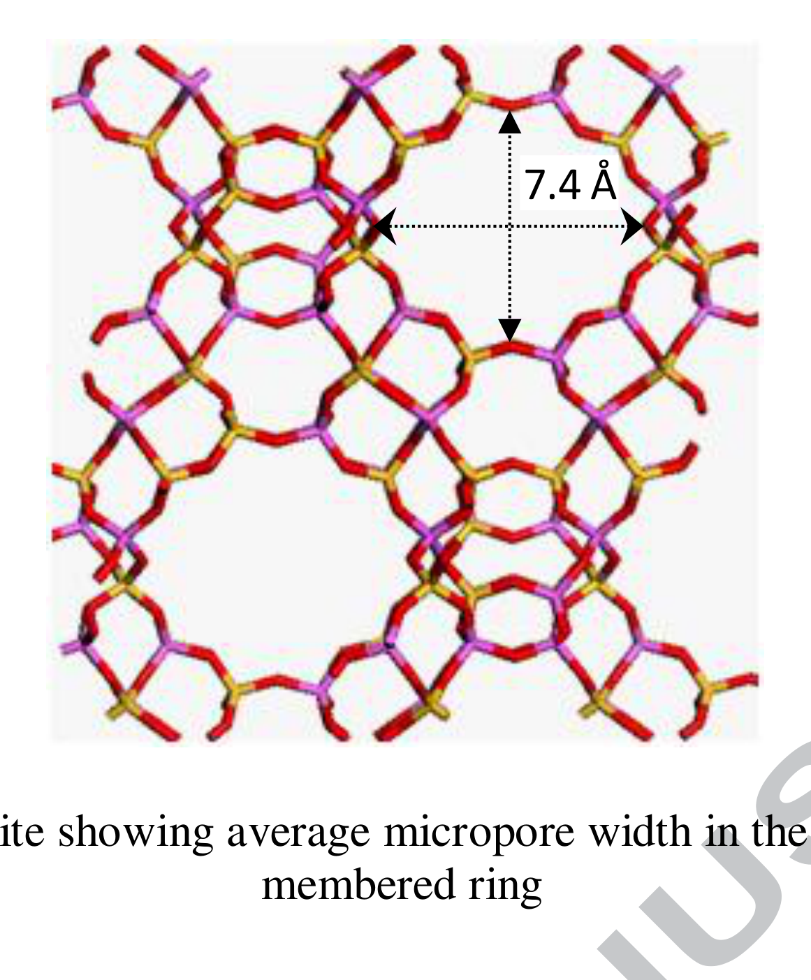
Figure 2.1: The faujasite structure of zeolite Y, showing the average micropore width of the supercage formed by the twelve membered ring.
The aluminium atoms are the source of the catalytic function. Where silicon appears in the framework it is four coordinate and neutral, and the framework carries no charge. Where aluminium appears, the AlO₄ tetrahedron carries a net negative charge that must be balanced by a cation. When that cation is a proton attached to a bridging oxygen, the result is a Brønsted acid site of the form ≡Si–O(H)–Al≡, and it is this group that protonates a hydrocarbon and initiates cracking. The number and strength of these sites determine catalyst activity, so any process that removes aluminium from the framework, or replaces the proton with a metal cation, reduces activity directly.
Figure 2.2 contrasts a faujasite lattice in which all framework positions are occupied by aluminium with one from which a fraction of that aluminium has been extracted. In the second model the framework is visibly interrupted and a cavity has begun to open where the aluminium used to be. The distinction is the physical meaning of dealumination.
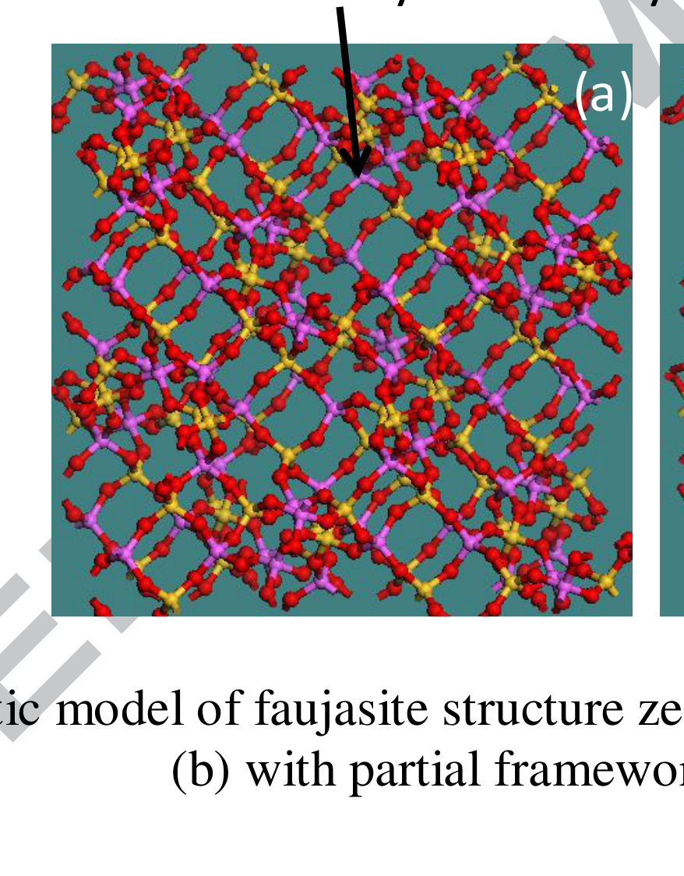
Figure 2.2: Three dimensional atomistic models of the faujasite framework, (a) with all framework aluminium atoms present and (b) with part of the framework aluminium removed.
Experimental work on the acidity of zeolite Y and of related frameworks has been complemented by periodic DFT calculations of Brønsted and Lewis acid sites. Tielens and Dzwigaj (2010) used periodic DFT together with experimental infrared spectroscopy of adsorbed pyridine to establish the protonation and deprotonation energies of vanadium-containing zeolite sites, and reported that vanadium bound hydroxyl groups are more acidic than silanol groups. That work concerned vanadium incorporated into the framework as part of the lattice, and it establishes that a vanadium oxygen hydrogen group can act as a strong acid. It does not address a vanadic acid molecule arriving from outside the lattice, which is the situation in a contaminated cracking catalyst.
2.4 Deactivation of Zeolite Y
Deactivation of the zeolite component of a cracking catalyst proceeds by several routes, and it is the irreversible routes that determine catalyst life. Coke deposition is reversible, because the carbon is burned off during regeneration. Framework breakdown is not.
Two irreversible processes dominate. The first is dealumination, the hydrolytic removal of framework aluminium, which eliminates Brønsted acid sites and leaves silanol nests in the places where aluminium used to sit. The second is desilication, the removal of framework silicon, which occurs more slowly but eventually destroys the crystallinity of the material outright. Both are hydrolytic, and both are accelerated by steam at the temperatures reached in a regenerator.
Malola et al. (2012) provided the first complete first principles treatment of both processes. Working with the chabazite framework in a periodic cell and using the nudged elastic band method to locate transition states, they treated dealumination as a sequence of hydration reactions requiring at least three water molecules to form a silanol nest and detach aluminium in the form of Al(OH)₃, with a fourth water molecule stabilising the detached species as Al(OH)₃(H₂O). Their reaction sequence is set out in the following equations, in which the framework is written in terms of its tetrahedral atoms:
Step 1: ≡Si–O–Si≡ + H₂O → 2 ≡Si–OH (2.1)
Step 2: inversion of a hydroxyl group and reorientation of the bonds (2.2)
Step 3: ≡Si–O–Al≡ + H₂O → ≡Si–OH + HO–Al≡ (2.3)
Step 4: second hydration gives four loosely bound hydroxyl groups, two on silicon and two on aluminium (2.4)
Step 5: third hydration gives partially bonded Al(OH)₃ (2.5)
Step 6: adsorption of a fourth water molecule detaches Al(OH)₃(H₂O) (2.6)
Their calculated overall barrier for dealumination was 190 kJ mol⁻¹ when the energy of water adsorption is counted at each step, and 260 kJ mol⁻¹ when it is not, with the rate determining step being the inversion of the hydroxyl group. The corresponding figures for desilication were 40 to 50 kJ mol⁻¹ higher, from which they concluded that dealumination is the less activated of the two processes in steam. Figure 2.3 reproduces the reaction profile they computed.
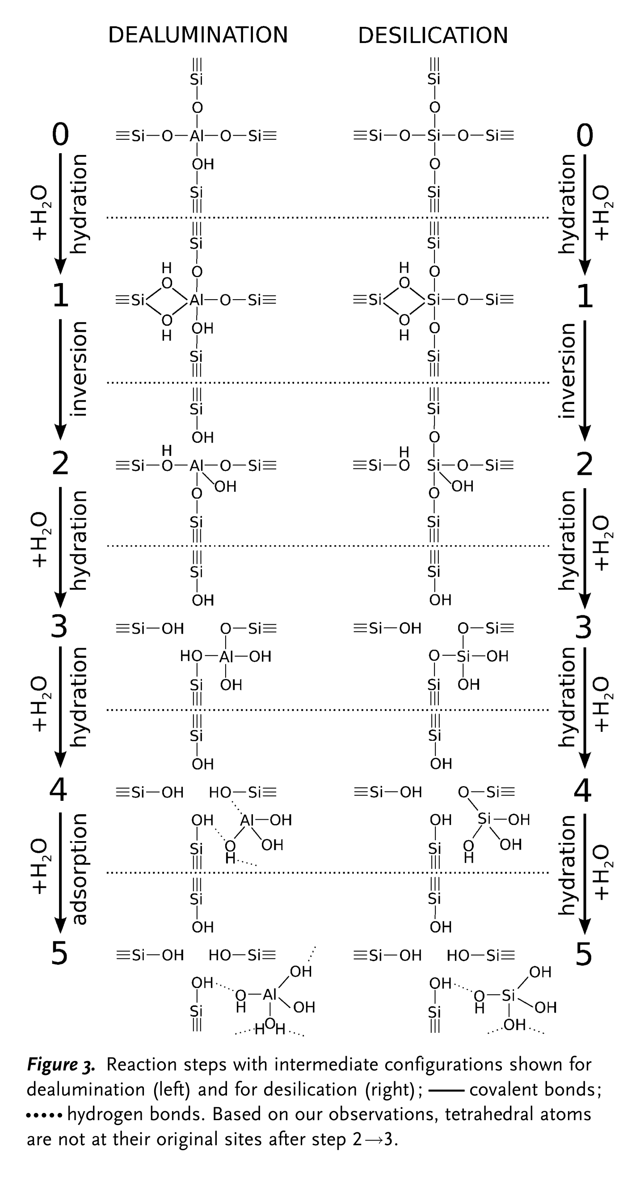
Figure 2.3: Reaction paths for (a) dealumination and (b) desilication, combined from five nudged elastic band paths. Black lines describe initially isolated water molecules and purple lines describe initially adsorbed water molecules. Effective barriers are labelled in the upper left corner.
Figure 2.4 shows the corresponding sequence of intermediate structures. The figure is important to the present work for a methodological reason as well as a chemical one: it establishes that in steam dealumination the reacting water adsorbs on the aluminium atom in the position anti to the Brønsted acid site before any bond breaks. That is the geometry that any incoming molecule must compete with.
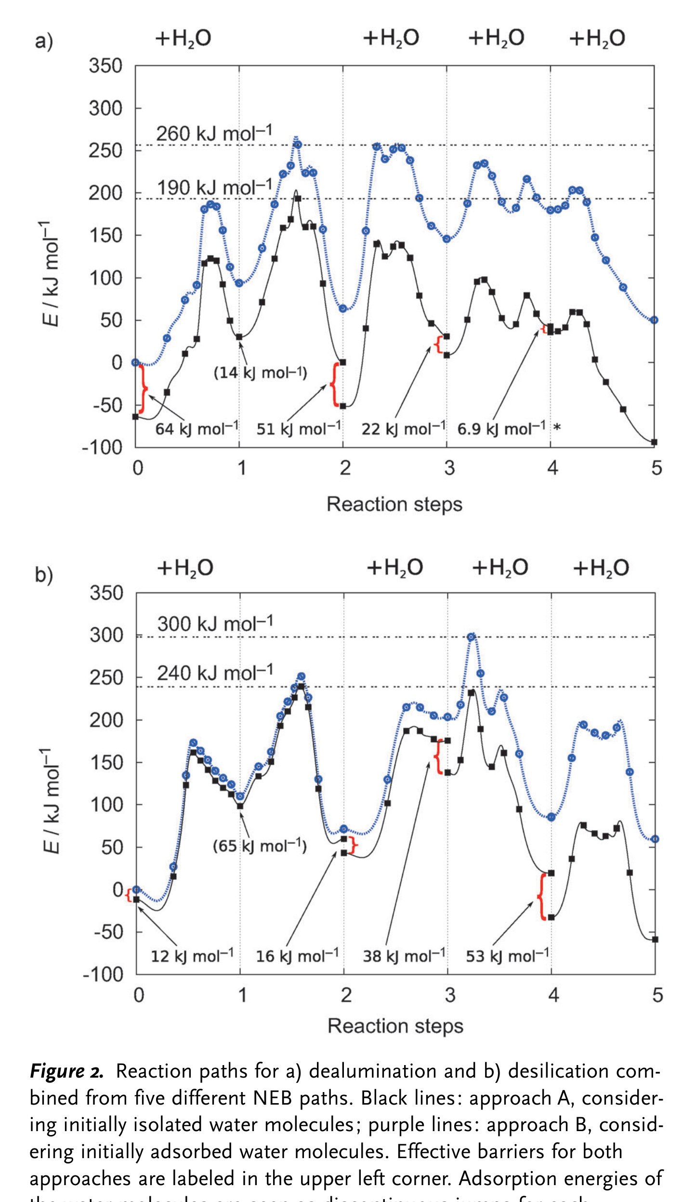
Figure 2.4: Reaction steps with intermediate configurations for dealumination on the left and desilication on the right. Covalent bonds are marked and hydrogen bonds are marked.
Silaghi et al. (2016) extended this picture across four frameworks, mordenite, faujasite, MFI and chabazite, using periodic DFT with dispersion corrections and free energy estimation. They confirmed the general mechanism, identified the anti position of the adsorbing water as a universal feature, and showed that confinement of the extra framework aluminium species inside the zeolite cavity is itself a thermodynamic driving force for extraction. They also established Brønsted Evans Polanyi relationships between the heat of water adsorption and the activation energy for hydrolysis, although they noted that these relationships degrade as more aluminium oxygen bonds are hydrolysed. The faujasite case in their study is directly relevant here, because it confirms that the framework of the catalyst used in this work hydrolyses by the same mechanism as the others.
The temperature dependence of the process was addressed by Nielsen et al. (2019), who used enhanced sampling molecular dynamics to follow dealumination in the presence of a realistic water loading, and by Stanciakova et al. (2019), who examined the cooperation between water molecules in the initial stage. Nielsen and co-workers estimated a loading of more than three water molecules per unit cell at steaming conditions of 450 °C and one bar of steam, and found that additional water molecules lower the free energy barrier by participating in proton shuttling. Their intrinsic barriers for the single water pathway clustered near 100 kJ mol⁻¹, in contrast to the much wider spread obtained from static calculations, which they attributed to the difficulty of applying harmonic approximations at high temperature. Figure 2.5 summarises the resulting view of the process: water is not a passive spectator but a cooperative participant, and barriers computed for a single molecule are upper bounds.
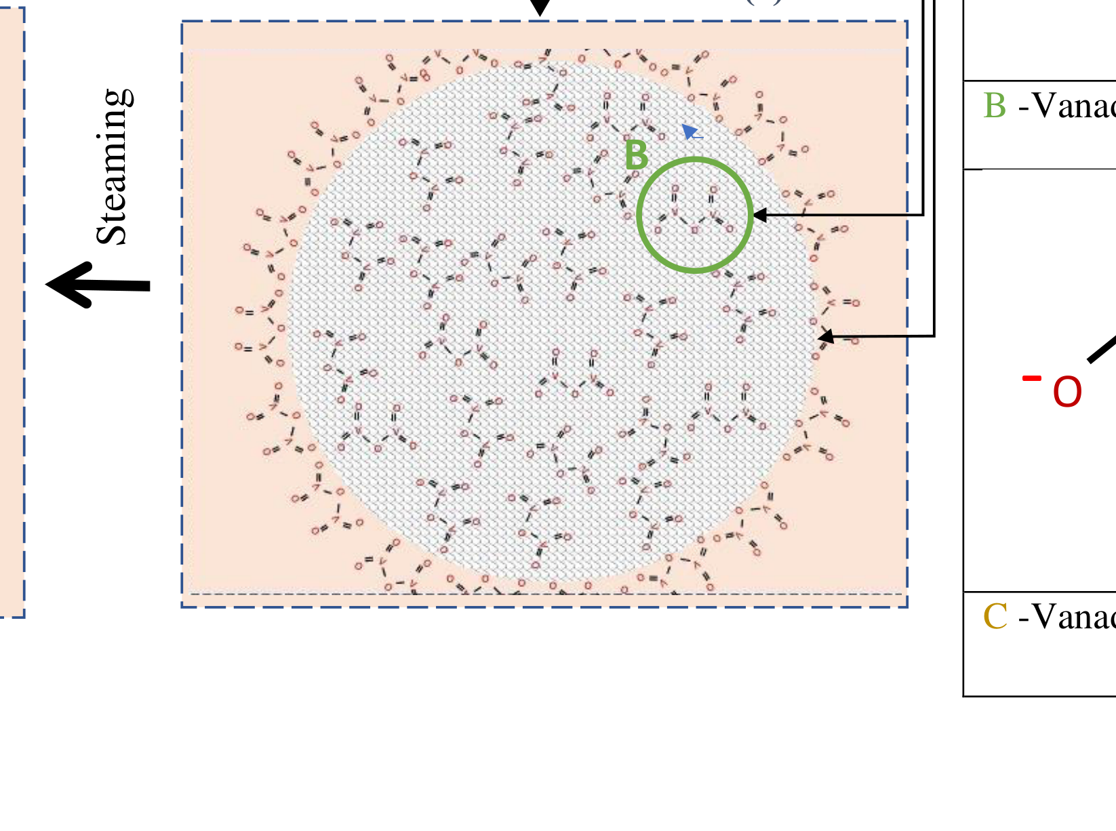
Figure 2.5: Illustration of the mechanisms of vanadium poisoning of cracking catalysts, set within the broader deactivation picture.
The consequence for the present work is a benchmark. Any statement that vanadic acid attacks the faujasite framework more aggressively than steam must be measured against a steam barrier of roughly 100 to 260 kJ mol⁻¹ depending on the treatment, and against a steam adsorption energy on the aluminium site of the order of tens of kilojoules per mole.
2.5 Vanadium in the Cracking Unit
Vanadium enters the unit bound in porphyrin and asphaltene structures in the residue feed. It leaves the reactor deposited on the catalyst as vanadyl species and, after regeneration, as vanadium pentoxide. Vanadium pentoxide melts at about 690 °C, which is within the regenerator temperature window, so the deposited oxide is a mobile liquid rather than a fixed solid. Above a certain loading the oxide forms a bulk phase on the catalyst surface; below it, the vanadium is dispersed as a surface vanadate.
The chemistry that follows from that mobility was set out by Wormsbecher et al. (1986), who identified the poison precursor as volatile vanadic acid formed by the reaction of vanadium pentoxide with steam, and estimated its concentration in a typical regenerator at one to ten parts per million. They drew the analogy with phosphoric acid, which is of comparable acid strength, and concluded that vanadic acid destroys the zeolite by hydrolysis of the SiO₂/Al₂O₃ framework. Their proposed remedy, which has shaped industrial practice ever since, was to add a basic solid with a suitable pore structure to scavenge the acid before it reaches the zeolite, and they demonstrated activity retention with magnesia.
The state and behaviour of vanadium on cracking catalysts was reviewed in detail by Occelli (1991), who brought together the electron paramagnetic resonance, diffuse reflectance and catalytic evidence on vanadium speciation and concluded that the interaction of vanadium with the zeolite is governed by the oxidation state of the metal and by the availability of steam. The experimental method by which such samples are prepared, in which a fresh catalyst is heat shocked and then impregnated to incipient wetness with metal naphthenates before steam treatment, was established by Mitchell (1980) and remains the basis of the contamination procedures used in the more recent studies cited here. Figure 2.6 shows the result. Vanadium migration increases markedly as the calcination temperature rises, and it moves both between catalyst particles and within them, which is why a vanadium trap must be distributed through the catalyst particle rather than merely mixed with it.
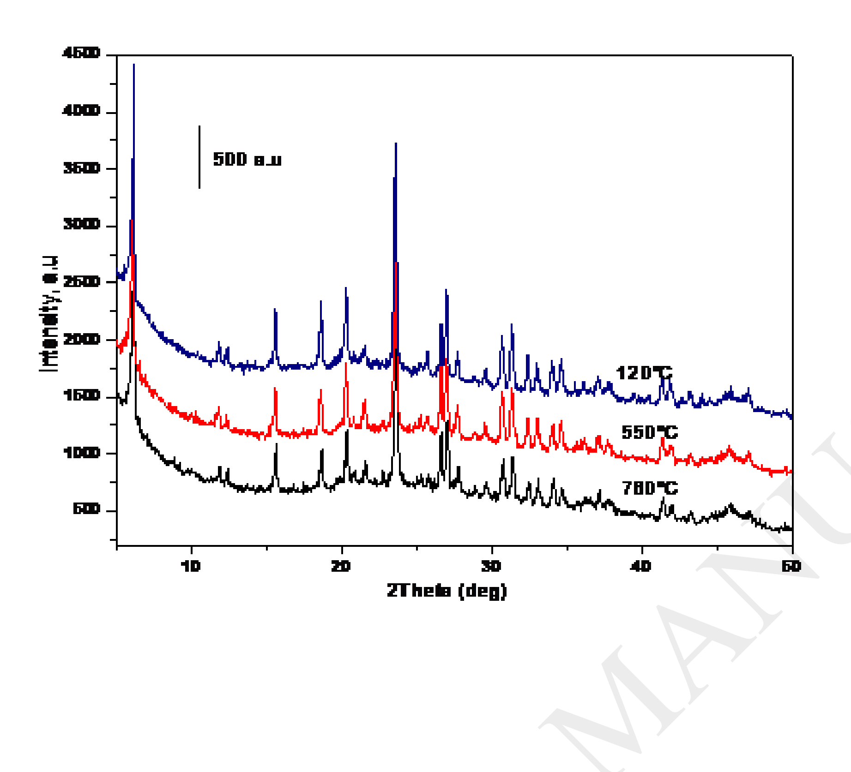
Figure 2.6: Effect of calcination temperature on the mobility of vanadium species.
Trujillo et al. (1997) studied the state of vanadium on the zeolite using electron spin resonance, diffuse reflectance spectroscopy and sorption measurements. They concluded that vanadium deposited on the external surface migrates into the channels when the zeolite is heated in an oxidising atmosphere, that water assists the migration but is not required for it, and that vanadium is stabilised as the VO₂⁺ cation near the acid sites. Their central chemical proposal is that the cation reacts with water inside the zeolite according to
VO₂⁺–Y + 2H₂O ⇌ H⁺–Y + H₃VO₄ (2.7)
which returns the exchange site to its protonated form while releasing vanadic acid into the pore system. Vanadic acid, being a strong acid, then hydrolyses the framework. In this scheme vanadium is a catalyst rather than a reagent, because it is regenerated at the end of each cycle. Trujillo and co-workers also reproduced the classical scheme of Kerr for zeolite dealumination alongside an electrophilic attack of the hydronium ion on the negatively charged oxygen of the acid site, which is shown in Figure 2.7. That figure is reproduced here because it makes explicit the point that the framework hydrolysis reaction is an acid catalysed process, and therefore that any acid capable of reaching the site can in principle promote it.
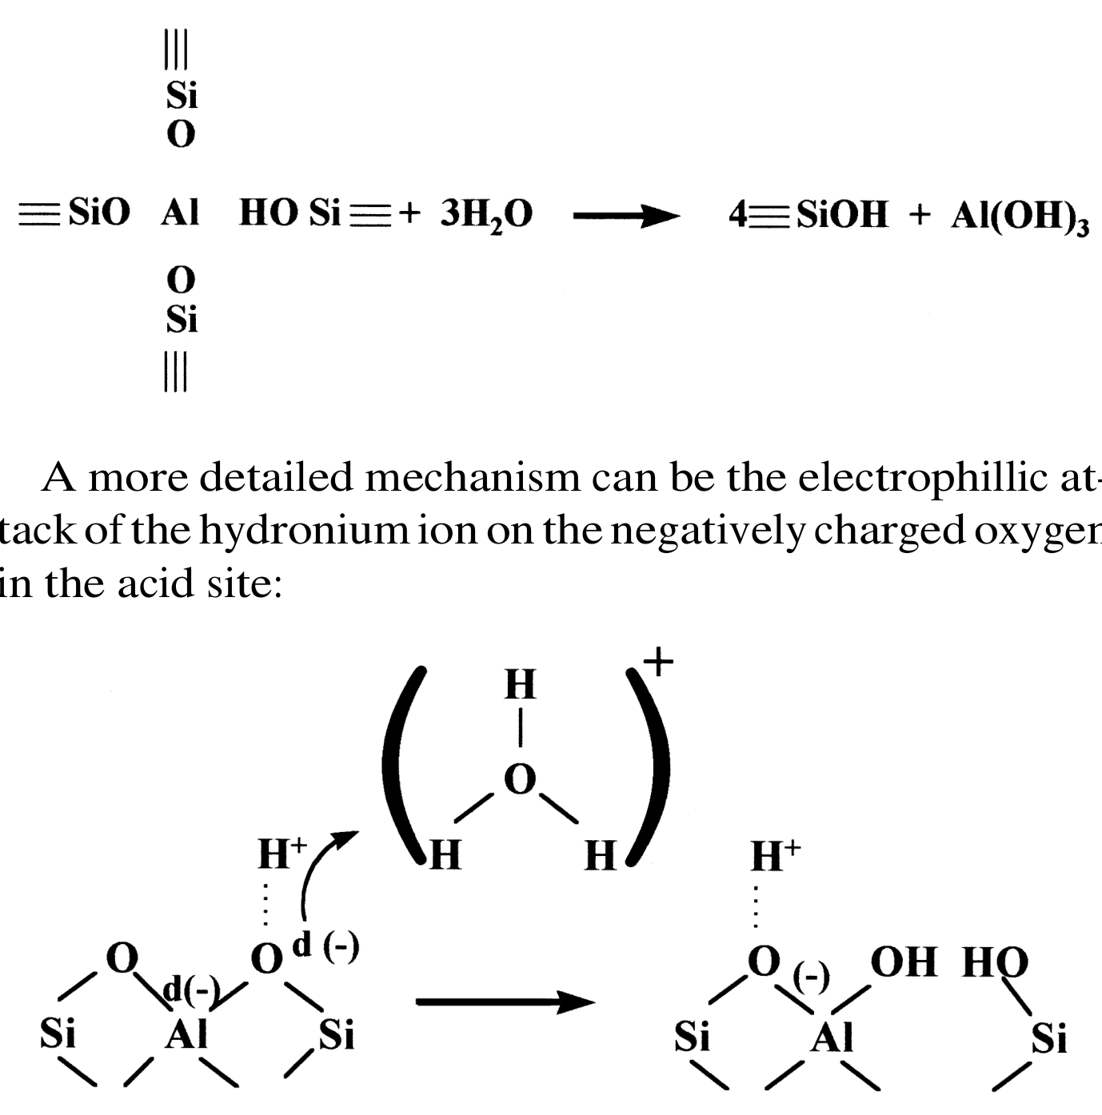
Figure 2.7: Kerr's scheme for zeolite dealumination, upper scheme, together with the electrophilic attack of the hydronium ion on the negatively charged oxygen of the acid site, lower scheme.
At the level of the catalyst particle, Etim et al. (2016) quantified the damage. Working with ultra stable zeolite Y contaminated at loadings between 0 and 1 wt% and steamed at 760 °C, they measured crystallinity by X-ray diffraction, pore structure by nitrogen adsorption interpreted with non-local density functional theory, acidity by pyridine infrared spectroscopy and framework coordination by magic angle spinning nuclear magnetic resonance. They found that vanadium in the presence of steam caused the growth of mesopores averaging about 25 nanometres at 0.5 wt% vanadium loading, far larger than the mesopores found in hydrothermally stable cracking catalysts, and that a sample loaded at 1 wt% lost its zeolite phases entirely. They also showed that immobilising vanadium on a yttrium magnesium oxide passivator reduced its mobility and preserved the framework, which is a direct demonstration that the damage depends on where the vanadium goes rather than merely on how much is present.
2.6 The Disputed Mechanism
The literature reviewed so far presents vanadium as the direct cause of framework destruction. That reading was challenged from two directions, and the challenge is the reason this study exists.
The first challenge came from Pine (1990), who measured the kinetics of USY zeolite destruction by vanadium and by sodium in steam between 740 and 800 °C over a vanadium range of 0 to 4000 parts per million. Pine found that vanadium and sodium are nearly equal in activity as destruction catalysts and that their effects are synergistic. Critically, he also found that vanadium readily attacks silicalite, a zeolite that contains essentially no aluminium. That observation is incompatible with a mechanism in which the attack is directed exclusively at aluminium oxygen bonds, because there is no aluminium to attack. Pine proposed instead that vanadium and sodium both act on surface hydroxyl groups in the step that controls the rate of nucleation, and that the attack by steam can therefore involve silicon oxygen bonds. His measured apparent activation energy for destruction by vanadium was 330.5 kJ mol⁻¹ and by sodium 320.5 kJ mol⁻¹, values so large that they suggest a very stable framework and an attack that is difficult rather than facile.
The second challenge came from Xu et al. (2002), who proposed an explicit mechanism linking sodium and vanadium and remains the most direct statement of the opposing position. Their argument is that sodium reacts with steam to form a surface sodium hydroxide, that the basic hydroxide ion attacks framework silicon oxygen bonds, and that this is the destructive step. Vanadium does not open a new route; its role is to react with cationic sodium at the exchange site, releasing the sodium from the zeolite, and the sodium metavanadate so formed hydrolyses in steam to regenerate sodium hydroxide and metavanadic acid. In their words, the mechanism of Y zeolite destruction remains the same whether vanadium is present or not, and without sodium, vanadium itself has little effect on Y zeolite stability regardless of the unit cell size of the zeolite. Their experimental evidence is reproduced in Figure 2.8, which shows the hydrothermal stability of catalysts with different sodium contents in the presence and absence of vanadium. The lines separate according to sodium content rather than according to vanadium content.
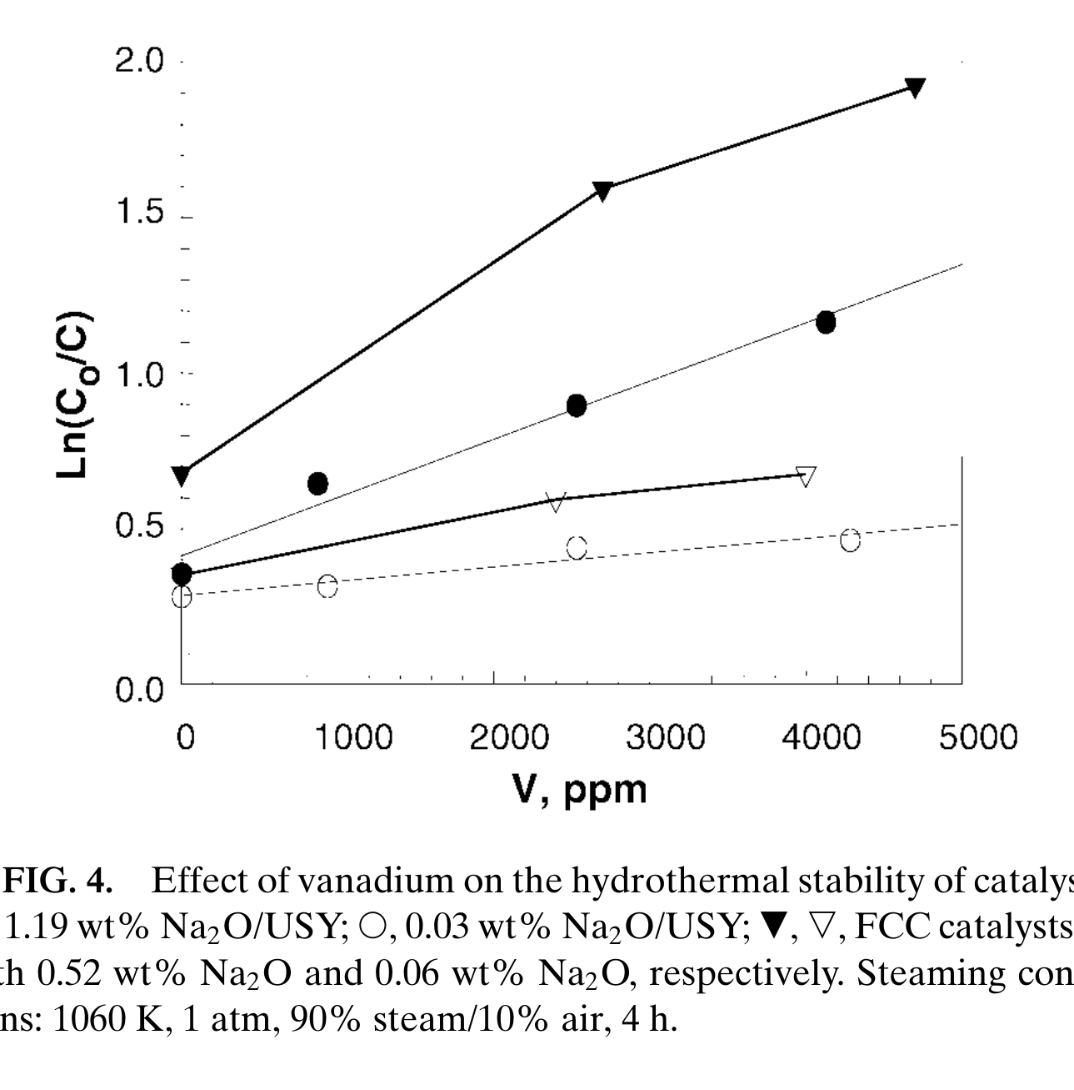
Figure 2.8: Effect of vanadium on the hydrothermal stability of catalysts. Steaming conditions were 1060 K, 1 atm, 90% steam in air, for 4 h.
A third position has since emerged, and it is the strongest form of the challenge. Liu et al. (2019) noted that the model zeolites used by Xu and co-workers had high framework silicon to aluminium ratios and low unit cell sizes, and argued that such frameworks are intrinsically more resistant to acid catalysed hydrolysis, which would make the absence of a vanadium effect in those samples unrepresentative. Working with USY containing a defined sodium content and vanadium loadings up to about 1.12 wt%, and treating the samples in steam at elevated temperature, Liu and co-workers found severe damage to the framework, sharp deterioration in residue cracking and noticeable changes in gasoline composition, with almost all characteristic zeolite diffraction peaks disappearing at the highest loading. They concluded that high deposited vanadium on sodium-containing USY is strongly destructive in steam. The report of Sandoval-Díaz and co-workers, cited by Liu et al. (2019) as having found destruction independent of vanadium in the presence of sodium, is at the opposite extreme; the two studies disagree even though both work in the presence of sodium.
The dispute, reduced to its essentials, is whether the attacking entity is vanadic acid derived from vanadium or hydroxide derived from sodium, and whether the bond broken is an aluminium oxygen bond or a silicon oxygen bond. The present study addresses the first half of that question directly and the second half only by implication, because the cluster used here contains one aluminium and four silicon tetrahedral sites, and the reacting coordinate followed is the one involving aluminium.
Two recent reviews frame the contest without resolving it. Xu et al. (2024) surveyed the poisoning behaviour of nickel, vanadium, iron and sodium on cracking catalysts and reported that the toxicity of vanadium manifests mainly as an alteration of catalyst texture leading to destruction of the molecular sieve structure, without committing to a single molecular mechanism. Adanenche et al. (2023) reviewed mitigation strategies and noted that the interaction mechanism between vanadium capture agents and vanadium has not been fully understood, which is an indirect statement of the same gap: if the mechanism of attack were settled, the design of a trap would follow from it.
2.7 Vanadium Traps and Passivators
Because the mechanism is contested, the engineering response to vanadium has been empirical, and a brief review of that response is useful because it shows what a computed binding energy would contribute.
Wormsbecher et al. (1986) proposed basic alkaline earth oxides on the reasoning that a base would neutralise an acid, and demonstrated magnesia. Etim et al. (2018) prepared a mixed magnesium and yttrium oxide and showed by X-ray diffraction that mobile vanadic acid reacts preferentially with the yttrium oxide, forming crystalline yttrium vanadate, so that the trap protects the catalyst by converting a mobile acid into an immobile salt. Their work also established that a definite quantity of trap material is necessary for optimum performance, and that incorporating the trap before the catalyst is metallated gives better protection than adding it afterwards. Liu et al. (2019) reported that lanthanum oxide introduced by simple physical mixing preserves the zeolite structure to a large extent, and attributed the effect to the preference of lanthanum oxide to interact with vanadium species rather than migrate into the zeolite channels. More recent work has extended the search to barium titanate (Faghani et al., 2024).
Alumina is the other traditional trapping phase, and its effectiveness depends on which crystalline form is present, because the transitional aluminas differ greatly in surface area and in acid base character. Bawa et al. (2017) studied the transformation of gamma alumina prepared from Kankara kaolin through ammonium alum, a route of local interest, and found that the gamma phase forms at 825 degrees Celsius, remains stable to 1125 degrees Celsius, and provides a specific surface area of 166 square metres per gram before transforming to the alpha phase above 1150 degrees Celsius. A support that retains its surface area through the regenerator temperature range is a prerequisite for a trap that must remain accessible to the migrating vanadium species.
Every one of these designs is a competition: the trap must react with the mobile vanadium species more readily than the zeolite does. Yet the quantity against which it competes, the binding energy of vanadic acid on a zeolite acid site, has not been computed. That is a specific and usable gap.
2.8 Computational Approaches to Zeolite Reactivity
The methods available for a study of this kind differ in cost and in the physical effects they capture, and the choice made in this work needs to be justified against the alternatives.
Periodic density functional theory is the reference standard for zeolite reactivity. It represents the crystal as an infinite repeating cell, so the confinement of the pore is included, and it has produced the definitive studies of steam dealumination reviewed above. Its cost is substantial, and a single nudged elastic band calculation on a framework transition state can require hundreds of processor hours. Hybrid functionals, which are needed for reliable thermochemistry, are considerably more expensive again in a periodic setting.
Cluster models occupy the other end of the range. A fragment of the framework, terminated so that the dangling bonds are saturated, is treated as a molecule. The approach is computationally inexpensive, it permits hybrid functionals and large basis sets at modest cost, and it allows transition states to be located with the standard molecular toolkit. Its weakness is the finite size of the model. Too small a cluster distorts the geometry of the reacting site, and the absence of the surrounding lattice removes the mechanical constraint that would otherwise resist deformation. The two principal side effects are underestimation of barrier heights and overestimation of adsorption energies. Cluster models remain widely used for exactly the reason they are used here, which is that they make a hybrid functional affordable for a comparative study.
Semi-empirical quantum chemical methods occupy the space between molecular mechanics and density functional theory. The GFN2-xTB method of Bannwarth et al. (2019) is a self-consistent tight binding treatment that includes multipole electrostatics up to quadrupole terms and a density dependent dispersion correction, and it was parameterised across the periodic table up to radon. Bannwarth et al. (2021) reviewed the extended tight binding family and reported that GFN2-xTB provides a favourable accuracy to cost ratio for geometries, frequencies and non-covalent interaction energies. The method is not accurate enough to report reaction energies as final results, but it is accurate enough to locate candidate stationary points on a potential energy surface and to screen a large number of starting geometries, after which the promising ones can be refined by DFT. The procedure is now standard practice in the field (Uzochukwu et al., 2023).
For the density functional itself, two choices are defensible. B3LYP, a hybrid functional combining Becke's three parameter exchange with the Lee, Yang and Parr correlation functional, is the most widely used hybrid for zeolite and organic systems, and it is well validated for reaction energies when combined with an empirical dispersion correction. Its known weakness is a tendency to underestimate reaction barriers. PBE0, the parameter free hybrid of Adamo and Barone (1999), is constructed from the Perdew, Burke and Ernzerhof exchange and correlation functional with exact exchange added in a fixed proportion, and it has been shown in the original study and subsequently to give balanced performance for thermochemistry and barrier heights. Using both, as this work does, provides an internal check on whether a computed result is an artefact of one functional.
2.9 The Gap in the Literature
Five observations can be drawn from the literature reviewed in this chapter.
First, the experimental literature does not agree on the mechanism by which vanadium destroys zeolite Y. Three distinct positions are defended, and the most recent contribution reports damage at high vanadium loading that the earlier, sodium-focused studies would not predict.
Second, the disagreement is about molecular events that experimental methods cannot observe directly. Diffraction, physisorption and microscopy describe the consequences of framework failure; they do not report the energy of an aluminium oxygen bond breaking in the presence of a particular adsorbate.
Third, the computational literature has produced a thorough description of framework hydrolysis by steam, including the reaction steps, the barriers across several framework types, and the cooperative role of additional water molecules. That description gives a firm benchmark for any competing pathway.
Fourth, there is no equivalent computational treatment of vanadic acid as an attacking species. The published DFT work on vanadium in zeolites concerns vanadium occupying framework positions in the lattice, which is a different chemical situation from a vanadic acid molecule arriving from the pore system.
Fifth, the industrial response to vanadium, which is the addition of a trap material, is a competition for vanadium between the trap and the zeolite, and the zeolite side of that competition has not been quantified.
The present study addresses the fourth and fifth observations and speaks to the first. It computes the adsorption of vanadic acid on a faujasite Brønsted acid site and compares it, on identical terms, with the adsorption of water, using a hierarchy of methods in which the semi-empirical level is used to find the structures and the density functional levels are used to judge them. The comparison is stated as an energy difference, which is the form in which it can be used by someone designing a trap, and it is tested against two density functionals so that the reader can see how much of the answer is method dependent.

CHAPTER THREE
MATERIALS AND METHODS
3.1 Overview of the Approach
This chapter describes how the calculations were set up and how the results were judged. The work is a computational study, so there are no reagents and no apparatus in the usual chemical engineering sense. The materials are the geometric models, and the apparatus is a quantum chemistry program running on two computers. Everything that a reader would need in order to repeat the work is stated here: the composition and construction of the model, the exact keywords passed to the program, the hardware, the sequence in which the calculations were run, and the criteria by which a computed structure was accepted or rejected.
The strategy is a two level treatment. A fast semi-empirical method is used to explore the potential energy surface and to generate candidate structures, and a slower density functional treatment is used to refine and judge them. Figure 3.1 illustrates the sequence.
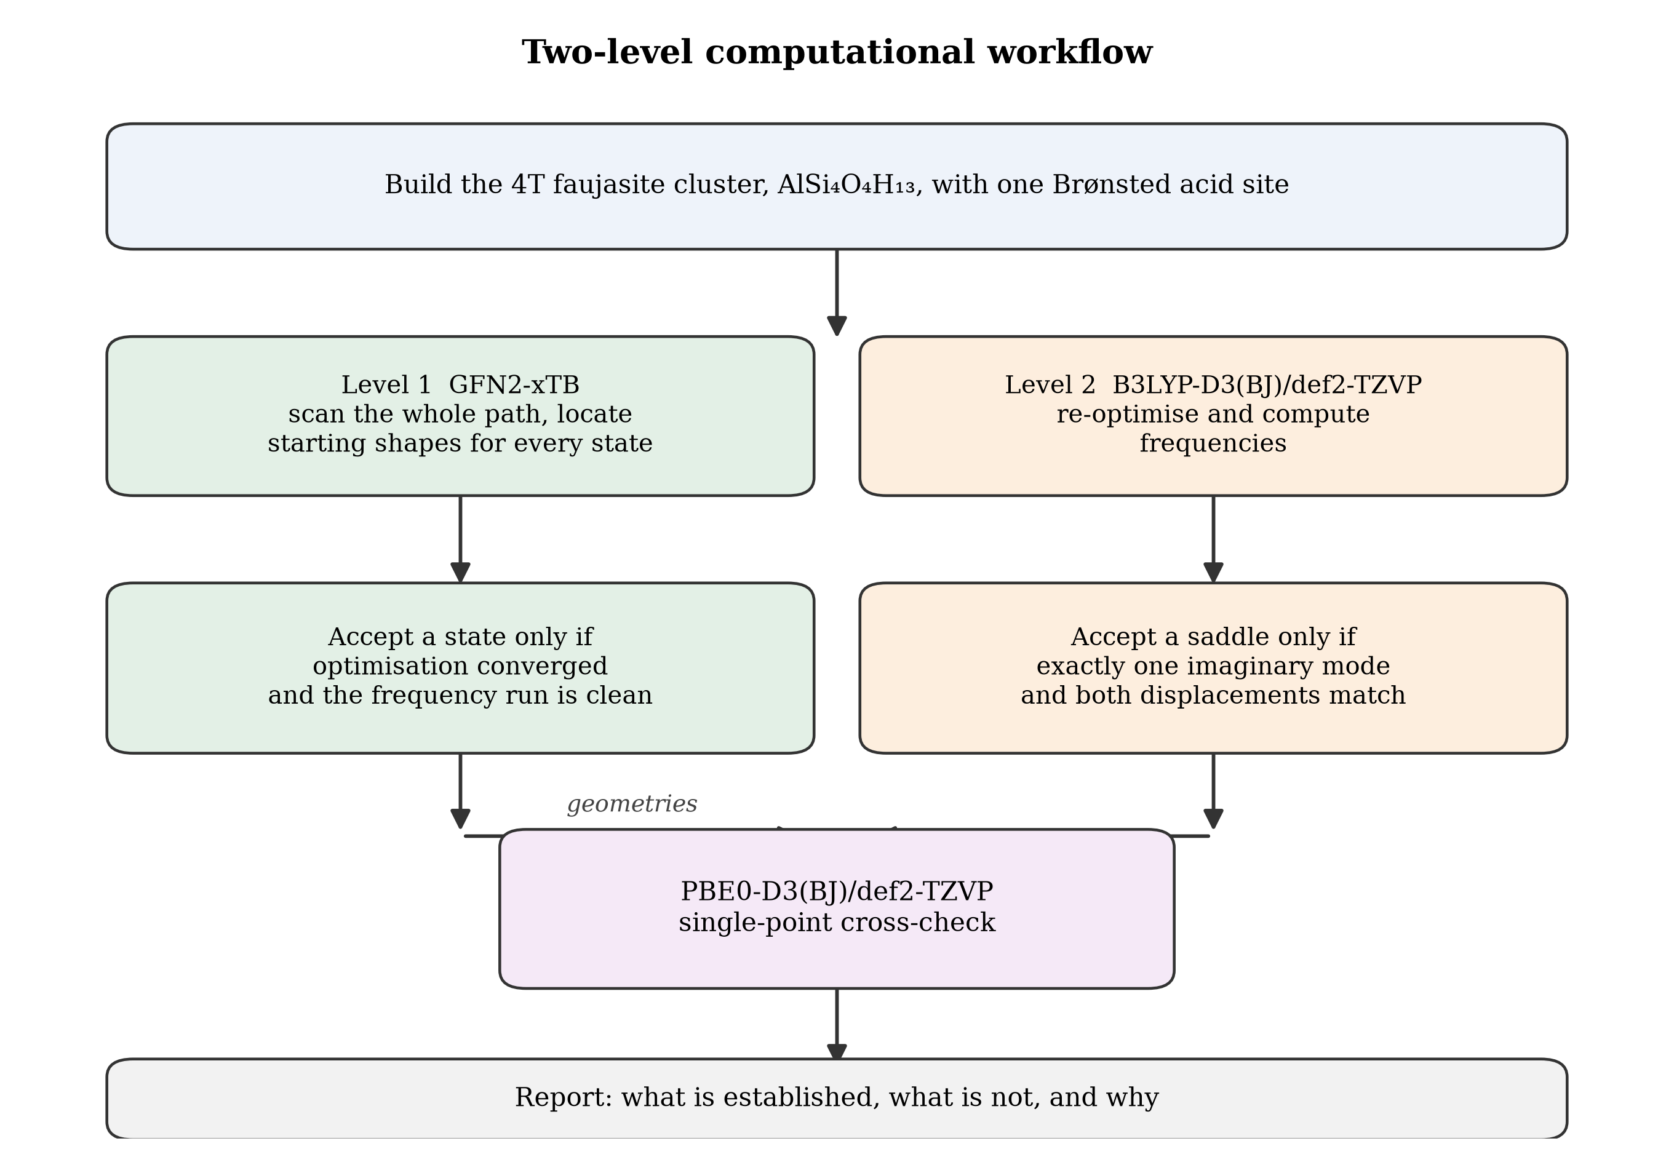
Figure 3.1: The two level computational workflow used in this study.
3.2 The Cluster Model
3.2.1 Choice of model type
The zeolite framework can be represented either as a periodic crystal or as a finite cluster cut from the crystal and terminated with hydrogen atoms. The periodic representation is the more faithful one because it retains the confinement of the pore and the mechanical constraint of the surrounding lattice. It is also far more expensive, and a hybrid functional calculation on a periodic cell of zeolite Y with a transition state search is beyond the computing resources available to this project.
A cluster model was therefore adopted. The consequence of that choice is stated in Section 1.8 and repeated here for emphasis: a finite cluster is more flexible than the real framework, so the barriers computed on it should be read as lower bounds and the adsorption energies as upper bounds. Because the vanadic acid and water routes were computed on exactly the same cluster with exactly the same methods, the systematic part of that error cancels in the difference between them, and the difference is the quantity on which the conclusions of this work rest.
3.2.2 Composition and construction
The model represents one Brønsted acid site within a faujasite framework. It was cut from the faujasite structure so that the central aluminium atom retains its four framework oxygen neighbours and each of the four surrounding silicon atoms retains four oxygen neighbours. Dangling bonds at the periphery were saturated with hydrogen atoms placed along the direction of the bond that was cut, at a bond length of approximately 0.98 Å.
The resulting composition is AlSi₄O₄H₁₃. It contains twenty two atoms, one aluminium, four silicon, four framework oxygen atoms that coordinate the aluminium, nine further oxygen atoms completing the silicon coordination spheres, and thirteen hydrogen atoms comprising the single Brønsted proton and twelve terminating protons. The formula unit is shown schematically below, with the Brønsted proton marked.
H
|
Si - O - Al - O - Si
| | |
Si O Si
The charge of the cluster is zero and the spin multiplicity is one, and these were set as the charge and multiplicity in all calculations. The Brønsted proton sits on the bridging oxygen between the aluminium and one silicon, which is the configuration that gives the cluster its acidity.
3.2.3 Reference state
For either adsorbate, the reference state is the separated cluster plus the free adsorbate molecule, each at its own optimised geometry. The reference energy for the vanadic acid route is therefore
E_ref,V = E(cluster) + E(H₃VO₄) (3.1)
and for the steam route
E_ref,W = E(cluster) + E(H₂O) (3.2)
Every relative energy reported in Chapter Four is referred to the appropriate zero.
The isolated water molecule and the isolated vanadic acid molecule were each optimised and their frequencies computed separately using a three atom and an eight atom model respectively. The optimised bond lengths were 0.965 Å for the two oxygen hydrogen bonds of water and 1.918 Å for the hydrogen bond angle, in agreement with the accepted experimental geometry to within the accuracy of the method.
The composition of the cluster and the two adsorbates is summarised in Table 3.1.
Table 3.1: Composition of the model systems used in this study.
System | Formula | Atoms | Charge | Multiplicity | Role
Cluster | AlSi₄O₄H₁₃ | 22 | 0 | 1 | Reference framework
Water | H₂O | 3 | 0 | 1 | Steam baseline adsorbate
Vanadic acid | H₃VO₄ | 8 | 0 | 1 | Vanadium route adsorbate
Vanadium route complex | AlSi₄O₄H₁₃·H₃VO₄ | 30 | 0 | 1 | Adsorption and reaction states
Steam route complex | AlSi₄O₄H₁₃·H₂O | 25 | 0 | 1 | Comparison states

3.3 Computational Methods
3.3.1 Software
All calculations were performed with the ORCA quantum chemistry program package (Neese et al., 2020). Two builds were used: version 6.1.0 for the semi-empirical and initial density functional work, and version 6.1.1 for the later density functional work. Both builds used the libint2 and libxc integral and functional libraries, which is recorded here because the numerical output of a functional evaluation depends on the library version that implements it.
ORCA reads a plain text input file and writes a plain text output file. The input file contains a keyword line beginning with an exclamation mark, followed by blocks introduced by a percent sign that set the resources and the technical parameters, and finally the molecular geometry in Cartesian coordinates. A representative input file from this work is reproduced in Table 3.2.
! B3LYP D3BJ def2-TZVP RIJCOSX def2/J TightSCF DefGrid3 Opt Freq TightOpt
%pal nprocs 4 end
%maxcore 3000
%scf
MaxIter 300
end
%freq
Temp 298.15, 1003.15
end
* xyzfile 0 1 v-prc.xyz
Table 3.2: Input file for the geometry optimisation and frequency analysis of the vanadic acid adsorption complex at the B3LYP-D3(BJ)/def2-TZVP level.
The keywords in Table 3.2 have the following meanings. B3LYP selects the exchange and correlation functional. D3BJ applies Grimme's third generation empirical dispersion correction with Becke-Johnson damping. def2-TZVP selects the triple zeta valence polarised basis set. RIJCOSX and def2/J accelerate the evaluation of the exact exchange and the Coulomb terms by approximations that are standard for hybrid functionals on systems of this size. TightSCF tightens the self-consistent field convergence criterion. DefGrid3 sets the numerical integration grid. Opt requests geometry optimisation, Freq requests a frequency calculation, and TightOpt tightens the convergence thresholds for the geometry.
3.3.2 Semi-empirical level: GFN2-xTB
The exploratory calculations used the GFN2-xTB method (Bannwarth et al., 2019). This is a self-consistent tight binding method rather than a full quantum chemical treatment: it solves an approximate electronic structure problem in a minimal atomic orbital basis, with multipole electrostatics expanded to quadrupole order and a charge dependent dispersion correction included self consistently. The method is parameterised for elements up to radon and requires no system specific parameters, so it can be applied to a vanadium containing model without additional fitting.
The justification for using it is cost. A geometry optimisation and frequency analysis of a thirty atom cluster at the GFN2-xTB level completes in minutes on a laptop, whereas the same job at the B3LYP level requires days on a multi-processor node. The method was therefore used to generate starting geometries for every state on both reaction routes, to locate candidate saddle points, and to provide a first estimate of the energy profile. Its results are reported as such in Chapter Four and are not used as the basis of any conclusion that the density functional results do not also support.
3.3.3 Density functional level: B3LYP-D3(BJ)/def2-TZVP
The principal density functional treatment used the B3LYP functional with the D3 dispersion correction and Becke-Johnson damping (Becke, 1993; Lee et al., 1988; Grimme et al., 2011) and the def2-TZVP basis set (Weigend & Ahlrichs, 2005). This combination is the most widely used hybrid level for zeolite and organic reaction energetics, and the dispersion correction is essential when the interaction being studied is partly non-covalent, as the adsorption of a molecule on a framework site is.
Geometry optimisation was carried out with the TightOpt convergence option, and each optimised structure was then subjected to a frequency calculation at the same level. The frequency calculation serves two purposes. It confirms that the structure is a genuine minimum by showing that all of its vibrational modes have real frequencies, and it supplies the zero point energy, the thermal enthalpy correction and the Gibbs energy correction that convert an electronic energy into a quantity comparable with experiment.
3.3.4 Second functional: PBE0-D3(BJ)/def2-TZVP
To test whether a computed result is a property of the chemistry or an artefact of one functional, single point energies were computed with the PBE0 functional (Adamo & Barone, 1999) using the same basis set and dispersion correction. These calculations used the geometries obtained at the B3LYP level, so they probe the electronic energy only and not the shape of the potential energy surface. The comparison is therefore a test of the functional and not of the geometry.
3.3.5 Technical settings
All calculations used the resolution of identity approximation for the Coulomb integrals with the def2/J auxiliary basis set, and the chain of spheres approximation for the exact exchange, which is the standard efficient scheme for hybrid functionals. The numerical integration grid was DefGrid3 throughout, so that the comparison between states was not contaminated by a change of grid. The self-consistent field procedure was allowed up to three hundred iterations. Resources were set to four parallel processes with three gigabytes of memory each.
3.4 Computing Hardware and Execution
The semi-empirical calculations and the initial density functional calculations were run on a Dell Latitude E6430 laptop with sixteen gigabytes of random access memory and a solid state drive, running the ORCA 6.1.0 build. Output files from these runs were written in UTF-16 encoding, which is the Windows default for the program's output stream, and this has a practical consequence that is recorded in Section 3.7: a plain text search of those files returns nothing, and a parser must know the encoding.
The later density functional calculations were run on a virtual machine provisioned for the purpose, using the ORCA 6.1.1 build and writing UTF-8 output. Jobs were submitted with four parallel processes. Table 3.3 records the measured wall clock time for the principal jobs, taken from the run time line that ORCA prints at the end of every output.
Table 3.3: Measured wall clock times for the principal calculations.
Job | System size | Level | Wall clock time
Water optimisation and frequency | 3 atoms | GFN2-xTB | 35 seconds
Vanadic acid optimisation and frequency | 8 atoms | GFN2-xTB | 147 seconds
Cluster geometry optimisation | 22 atoms | B3LYP-D3(BJ) | 30 minutes
Vanadic acid adsorption complex | 30 atoms | B3LYP-D3(BJ) | 5 hours 28 minutes
Water adsorption complex | 25 atoms | B3LYP-D3(BJ) | 3 hours 34 minutes
Chemisorbed intermediate | 30 atoms | B3LYP-D3(BJ) | 27 hours
Second intermediate | 30 atoms | B3LYP-D3(BJ) | 11 hours 12 minutes (not converged)
Reaction product | 30 atoms | B3LYP-D3(BJ) | 5 hours (not converged)
Saddle point attempt, first bond cleavage | 30 atoms | B3LYP-D3(BJ) | 1 day 4 hours (rejected)
Single point energies, ten states | up to 30 atoms | PBE0-D3(BJ) | 3 seconds to 11 minutes each

The table carries an important engineering message that is often left out of computational reports. The cost of a hybrid density functional calculation does not rise gently with system size. Increasing the cluster from twenty two to thirty atoms, a change of thirty six per cent in atom count, raised the cost of a converged optimisation and frequency analysis from thirty minutes to more than five hours, a tenfold increase. Adding a transition state search with a computed initial Hessian multiplied it again. This is why the reaction profile reported in Chapter Four is complete at the semi-empirical level and partial at the density functional level: the two levels differ in cost by roughly two orders of magnitude, and the available computing budget was fixed.
3.5 Calculation Sequence
3.5.1 Reference species
Each of the two adsorbates and the bare cluster were optimised and their frequencies computed. For water this was straightforward. For vanadic acid, twenty six optimisation cycles were required before the convergence criteria were met, which indicates a flexible potential energy surface with several shallow minima. The isolated vanadic acid minimum obtained from this procedure was used as the reference for the vanadium route.
3.5.2 Adsorption complexes
Starting geometries for the adsorption complexes were built by placing the adsorbate above the Brønsted acid site at a separation of approximately 0.2 nanometres, with the acidic proton of the adsorbate directed towards the framework oxygen and the vanadium atom oriented so that it could approach the aluminium. Both complexes were then optimised without constraint. The vanadic acid complex required forty optimisation cycles and the water complex sixty three, both converging normally.
3.5.3 Stationary points along the vanadium route
The intended route for the vanadium series, with the atom economy of each step noted, is set out below.
Adsorption: AlSi₄O₄H₁₃ + H₃VO₄ → AlSi₄O₄H₁₃·H₃VO₄ (3.3)
Chemisorption: AlSi₄O₄H₁₃·H₃VO₄ → [AlSi₄O₄H₁₂]·(VO(OH)₃)·H₂O + H⁺ (3.4)
First aluminium oxygen cleavage: ≡Si–O–Al≡ + H₃VO₄ → ≡Si–OH + ≡Al(OH)(H₃VO₄) (3.5)
Second cleavage: ≡Al(OH)(H₃VO₄) + H₂O → ≡Al(OH)₂ + H₃VO₄(ads) (3.6)
Third cleavage and detachment: the aluminium atom is fully separated from the framework and a silanol nest remains (3.7)
Each of these states was generated at the GFN2-xTB level by driving the appropriate internal coordinate and then relaxing the resulting structure, and each candidate was carried forward to the density functional level. Where a candidate saddle point was obtained, its identity was tested as described in Section 3.6.
3.5.4 Stationary points along the steam route
The water series was generated in the same way and in the same sequence, so that the two routes are directly comparable. The reaction sequence for steam is the one established in the literature (Malola et al., 2012), in which water adsorbs on the aluminium atom in the position anti to the Brønsted acid site before any bond is broken, the aluminium oxygen bond is hydrolysed, and the process repeats until the aluminium has been extracted as Al(OH)₃(H₂O).
3.5.5 Saddle point location
Three techniques were used to find transition states. A relaxed potential energy scan was run along the coordinate expected to change, and the structure at the maximum of the scan was used as a starting point. The nudged elastic band method was used to trace a minimum energy path between two known minima, and the highest image on the path was taken as a transition state candidate. Finally, the candidate was refined by a transition state optimisation with an exact initial Hessian computed at the same level.
3.5.6 Intrinsic reaction coordinate
Where a saddle point was accepted, the intrinsic reaction coordinate was followed in both directions from the transition state to confirm that the two ends of the path are the intended minima. This is the standard test of whether a saddle point connects the states that the mechanism requires.
3.6 Criteria for Accepting a Stationary Point
A computed structure was accepted as a minimum only if the geometry optimisation terminated normally, the program reported that the optimisation had converged according to its own criteria, and the frequency calculation returned no imaginary modes.
A structure was accepted as a transition state only if all five of the following were satisfied.
1. The transition state optimisation converged and the run terminated normally.
2. Exactly one imaginary mode was found, and its frequency was chemically credible for the motion it represents. A magnitude below 20 cm⁻¹ was treated as presumptive numerical noise rather than a real saddle.
3. The energy of the candidate lay above the energies of both states it is supposed to connect.
4. Displacing the structure along the imaginary mode in both directions led to two different minima, each within 5 kJ mol⁻¹ of the corresponding endpoint.
5. The energy, the log file and the test calculation all referred unambiguously to one and the same structure.
The fourth criterion deserves explanation because it is the one that rejected the most candidates in this work. A structure can satisfy the first three criteria and still not be the saddle point that connects the two states of interest. Displacing it along its imaginary mode should carry the system downhill to the two minima on either side. If instead the displacement carries the system into a well that is not one of the two endpoints, the structure is a saddle point of some other reaction or a numerical artefact of the optimisation, and it was rejected on that ground.
3.7 Data Handling and Verification
Because the number of calculations was large and because the repository accumulated several attempts at some states, a program was written to read every ORCA output file and extract its termination status, its convergence status, its final energy, its convergence gradient, its imaginary mode count and its wall clock time into a single machine readable table. That program, the register it produced and the script that generates the tables of Chapter Four from the register are all retained in the project archive, so that every number reported in this thesis can be traced back to the specific log file it came from.
Two handling details are recorded because they caused errors before they were corrected. First, the output files of the laptop runs are UTF-16 encoded while the cloud runs are UTF-8, and a parser that assumes one encoding silently returns empty results for half of the archive. Second, ORCA echoes the input file into the log before it does any work, so a search for a status keyword will match the text of an input comment if the input echo is not stripped first. Both issues were resolved before the tables in Chapter Four were generated.
3.8 Thermochemistry
Electronic energies alone are not sufficient for a comparison at a temperature of 1003 K. The frequency calculation of each converged structure supplied the zero point energy and the thermal corrections to the enthalpy and the Gibbs energy at two temperatures, 298.15 K and 1003.15 K. The second temperature was chosen to represent the regenerator, where the temperature is of the order of 700 to 760 °C.
For a reaction of the form cluster + adsorbate → complex, the adsorption energy was computed as
ΔE = E(complex) − E(cluster) − E(adsorbate) (3.8)
and the corresponding Gibbs energy as
ΔG = ΔE + ΔG_corr(complex) − ΔG_corr(cluster) − ΔG_corr(adsorbate) (3.9)
where the correction terms are the G − E(el) values printed by ORCA in the frequency output. The zero point corrected energy and the enthalpy were computed in the same way using the corresponding corrections.
One further caution applies and was taken from the auditing literature on this system. Where a cluster changes its geometry during a reaction, the frequencies of the initial and final states are not a consistent basis for a Gibbs energy difference unless both are true minima of the same cluster, because the harmonic approximation assumes small displacements about a single well. The corrections reported in Chapter Four are therefore used to describe the direction and rough magnitude of the temperature effect, not to assign precise free energy values.
3.9 Counterpoise Correction
When two molecules are brought together and their energies computed in a finite basis set, each fragment can borrow basis functions from the other and thereby lower its own energy artificially. The resulting error is called basis set superposition error, and it inflates the computed binding energy of a complex. The standard correction is the counterpoise procedure of Boys and Bernardi, in which each fragment is re-computed in the presence of the other fragment's basis functions with that fragment's nuclei removed.
The procedure was set up for the two adsorption complexes of this work. In ORCA the fragments must be declared explicitly and one of them marked as a ghost, as follows.
%frag
Definition
1 {0 1 2 ... 21} end
2 {22 23 ... 29} end
end
end
%geom
GhostFrags {1} end
end
Table 3.4: Fragment definition required by ORCA for a counterpoise calculation, shown for the thirty atom vanadic acid complex in which atoms one to twenty two are the cluster and atoms twenty three to thirty are the adsorbate.
Two calculations are needed for each complex, one in which the first fragment is ghosted and one in which the second is. In this work the counterpoise jobs for the vanadic acid complex did not complete within the computing budget, and the two jobs for the water complex completed but returned energies that were not carried forward into the analysis. The reported adsorption energies are therefore uncorrected, and the binding energies in Chapter Four are identified accordingly. This is a known and quantified limitation of the present results rather than an oversight, and it is listed again in Section 1.8 and in the recommendations of Chapter Five.
3.10 Summary of Method
Table 3.5 collects the essential parameters of the calculation for reference.
Table 3.5: Summary of the computational parameters used in this study.
Item | Setting
Program | ORCA 6.1.0 and 6.1.1
Exploratory method | GFN2-xTB
Principal density functional | B3LYP with D3 dispersion and Becke-Johnson damping
Second density functional | PBE0 with D3 dispersion and Becke-Johnson damping
Basis set | def2-TZVP with def2/J auxiliary basis
Integration grid | DefGrid3 throughout
Acceleration | RIJCOSX for exact exchange, resolution of identity for Coulomb
Geometry optimisation threshold | TightOpt
Frequencies | Computed for every accepted stationary point, at 298.15 K and 1003.15 K
Saddle point validation | One imaginary mode, energy ordering, and two sided displacement test
Hardware | Dell Latitude E6430, 16 GB RAM, SSD for the semi-empirical level; four process virtual machine for density functional work

CHAPTER FOUR
RESULTS AND DISCUSSION
4.1 Introduction and Structure of the Chapter
This chapter reports what the calculations produced. It begins by establishing the reference energies and by showing that the cluster model is adequate for the purpose it was built for. It then presents the semi-empirical energy profile for both reaction routes, which is complete, and the density functional results for the adsorption step, which are the most reliable part of the work. It then tests the adsorption result against a second density functional, examines how the temperature of the regenerator changes the picture, and reports honestly what happened when the higher steps of the vanadium route were attempted at the density functional level. The chapter closes by comparing the numbers with the experimental and computational literature, by stating what the results do and do not say about the mechanistic dispute reviewed in Chapter Two, and by drawing out the implications for vanadium trap design.
Throughout the chapter, a result is described as established only when the geometry optimisation converged, the frequency calculation completed, and the imaginary mode count is consistent with the type of stationary point claimed. Results that fall short of that test are labelled as provisional or as not established, and no conclusion rests on them alone.
4.2 Reference Energies and Validation of the Cluster Model
4.2.1 Reference species
The reference energies for both routes are listed in Table 4.1. They are the electronic energies of the isolated cluster, the isolated water molecule and the isolated vanadic acid molecule, each at its own fully optimised geometry at the B3LYP-D3(BJ)/def2-TZVP level.
Table 4.1: Computed reference energies at the B3LYP-D3(BJ)/def2-TZVP level. The reference zero for the vanadium route is E(cluster) + E(H₃VO₄) = −2955.81550333 Eh; for the steam route it is E(cluster) + E(H₂O) = −1785.82072368 Eh.
Species | Log file | Atoms | Electronic energy, Eh | Optimisation cycles | Imaginary modes
Cluster, AlSi₄O₄H₁₃ | s1_03_cluster_optfreq.out | 22 | −1709.39409388 | 1 after restart | one at −4.64 cm⁻¹
Water, H₂O | s1_01_h2o_optfreq.out | 3 | −76.42662980 | 4 | none
Vanadic acid, H₃VO₄ | s1_02_h3vo4_optfreq.out | 8 | −1246.82501396 | 14 | none

The water molecule optimised in four cycles to a structure with all real frequencies, which is the expected result for a three atom molecule and confirms that the calculation setup is behaving correctly. The vanadic acid molecule required fourteen cycles, which reflects the floppiness of the three hydroxyl groups around the vanadium centre rather than any difficulty with the calculation. Both molecules returned zero imaginary modes, so both are genuine minima and are suitable as reference states.
4.2.2 The cluster reference and its imaginary mode
The cluster reference requires comment because it was computed twice and because the accepted run contains a small imaginary mode.
The first attempt at the cluster optimisation ran for sixty six cycles and terminated normally, but the program did not report that the optimisation had converged: the root mean square gradient at the end was 0.000011, which is below the convergence threshold of 0.000030, so the structure was in practice converged even though the termination flag was not set. The job was then resumed from that geometry. The resumed run satisfied the convergence criteria in its first relaxation step and completed normally, giving an energy of −1709.39409388 Eh. The difference between the two runs is 0.0015 kJ mol⁻¹, which is negligible on the energy scale of this study, and it establishes that the reference is reproducible.
The resumed run reported one imaginary mode at −4.64 cm⁻¹. A frequency of this magnitude is not a chemically meaningful vibration. It is the numerical residue of the six translations and rotations that the harmonic treatment attempts to remove, and it arises because the optimisation reached the gradient threshold rather than the exact stationary point. For comparison, the lowest real vibrational mode of the cluster is at 27.58 cm⁻¹, so the spurious mode lies below the physical spectrum of the system. The cluster is therefore treated as a minimum in what follows, with the reservation that its energy carries an uncertainty of the order of the zero point energy of a mode at 5 cm⁻¹, which is less than 0.1 kJ mol⁻¹ and is immaterial to every conclusion drawn in this chapter.
4.2.3 Adequacy of the cluster
The cluster contains one aluminium atom in a tetrahedral environment formed by four framework oxygen atoms, each of which bridges to a silicon atom, and the bridging oxygen that carries the proton is a genuine Brønsted acid site. The aluminium oxygen bond lengths in the optimised cluster are 1.9192, 1.7160, 1.6947 and 1.6953 Å, as reported by the program in its internal coordinate output. The three shorter bonds are typical of an aluminium oxygen single bond in a zeolite framework, and the longer bond at 1.9192 Å is the one to the bridging oxygen that carries the proton. This elongation of the protonated bridging bond relative to the other three is exactly the structural signature of Brønsted acidity that the literature describes, and its presence in the model confirms that the cluster reproduces the essential electronic feature that makes zeolite Y an acid catalyst.
Figure 4.1 shows the three models used in this study side by side: the bare acid site, the site with water adsorbed and the site with vanadic acid adsorbed.
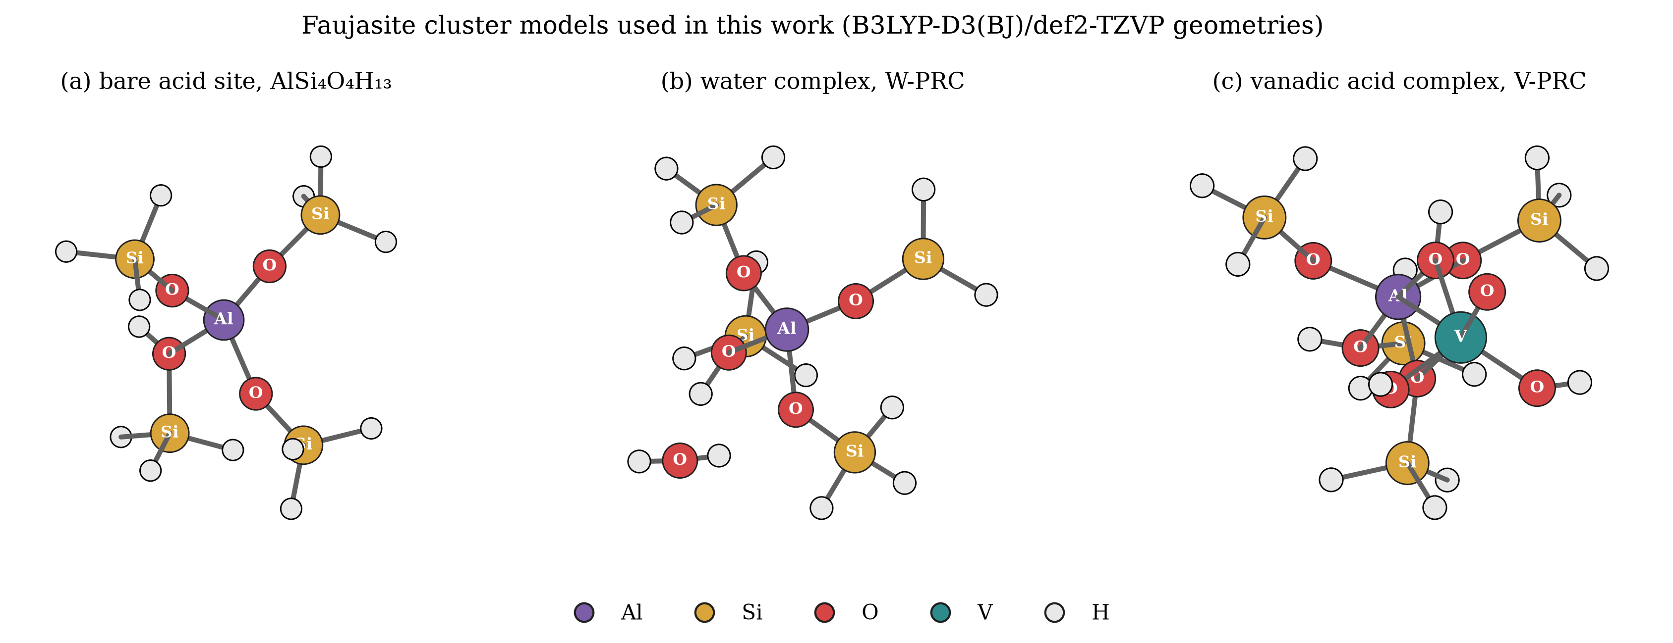
Figure 4.1: The cluster models used in this work, drawn from the optimised B3LYP-D3(BJ)/def2-TZVP geometries. (a) the bare Brønsted acid site, (b) the water adsorption complex W-PRC, (c) the vanadic acid adsorption complex V-PRC.
4.3 The Semi-Empirical Energy Profile
4.3.1 Why the semi-empirical profile is reported and how it should be read
The complete reaction profile for both routes was obtained at the GFN2-xTB level. That level is not accurate enough to report final thermodynamic quantities, and the numbers in this section are not used to support any conclusion that the density functional results do not also support. They are reported for two reasons. They show the shape of the potential energy surface, which is what a subsequent DFT study needs to know before it can decide where to spend its computing budget. And they provide the starting geometries for the density functional work, so a reader who wants to repeat the work needs to see where the structures came from.
4.3.2 Energies of the stationary points
Table 4.2 lists every state on the vanadium route and Table 4.3 lists every state on the steam route, with the electronic energy, the energy relative to the appropriate reference zero, and the imaginary mode count.
Table 4.2: Stationary points on the vanadium route at the GFN2-xTB level. Reference zero: E(cluster) + E(H₃VO₄) = −51.12064005 Eh.
State | Role | Log file | Electronic energy, Eh | Relative energy, kJ mol⁻¹ | Imaginary modes
V-PRC | Adsorption complex | V-R-T1-V02.out | −51.19563631 | −196.90 | 0
V-I1 | Chemisorbed intermediate | V-I1-T1-V01.out | −51.26731716 | −385.10 | 0
V-TS2 | First aluminium oxygen cleavage saddle | optts3_bandB_ci.out | −51.20610884 | −224.40 | 1 at −78.21 cm⁻¹
V-I2 | Opened framework intermediate | V-I2-T1-V04_pos.out | −51.25104052 | −342.37 | 0
V-P | Dealuminated product | V-TS3-T1-V02.out | −51.15221675 | −82.90 | 0

Table 4.3: Stationary points on the steam route at the GFN2-xTB level. Reference zero: E(cluster) + E(H₂O) = −36.41605681 Eh.
State | Role | Log file | Electronic energy, Eh | Relative energy, kJ mol⁻¹ | Imaginary modes
W-PRC | Water adsorption complex | W-PRC-T1-V02.out | −36.44256091 | −69.59 | 0
W-TS | Hydrolysis saddle | optts2_bandD_ci.out | −36.43140308 | −40.29 | 1 at −226.10 cm⁻¹
W-P | Hydrolysis product | W-P-T1-V01.out | −36.44113826 | −65.85 | 0

4.3.3 The shape of the two profiles
Figure 4.2 plots both profiles on a common scale.
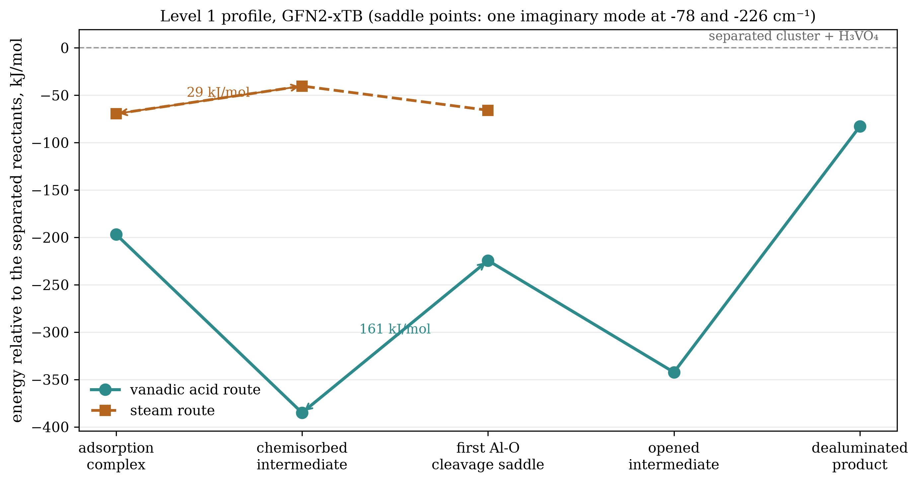
Figure 4.2: The complete semi-empirical reaction profiles at the GFN2-xTB level, referred to the separated reactants in each case. Filled circles are the vanadium route and filled squares are the steam route.
Four features of the plot matter.
The first is that both adsorbates bind to the acid site. Vanadic acid binds by 196.9 kJ mol⁻¹ relative to the separated species and water binds by 69.6 kJ mol⁻¹. At this level of theory the binding of vanadic acid is stronger by 127.3 kJ mol⁻¹. That value is much larger than the density functional value reported in Section 4.4, and the difference between them is one of the reasons the semi-empirical result is not used for the conclusion.
The second is that the vanadium route descends to a deep chemisorbed intermediate, V-I1, at 385.1 kJ mol⁻¹ below the separated reactants, a further 188.2 kJ mol⁻¹ below the adsorption complex. The steam route has no comparable well. Its only intermediate is the adsorption complex itself, and its product lies only 3.7 kJ mol⁻¹ below that complex.
The third is the barrier to the first aluminium oxygen cleavage on the vanadium route, which is the difference between V-TS2 and V-I1 and amounts to 160.70 kJ mol⁻¹. The corresponding barrier on the steam route is the difference between W-TS and W-PRC, which is 29.29 kJ mol⁻¹.
The fourth is that the two routes end at very different places. The vanadium product V-P lies 82.9 kJ mol⁻¹ below the separated reactants, so the overall extraction of aluminium by vanadic acid is exothermic at this level. The steam product W-P lies 65.85 kJ mol⁻¹ below the separated reactants, but only 3.7 kJ mol⁻¹ below the complex it formed from, so the hydrolysis step itself is close to thermoneutral.
4.3.4 Identity and validity of the saddle points
Two structures carried a single imaginary mode at the semi-empirical level and were examined as transition states.
The steam saddle, W-TS, has one imaginary mode at −226.10 cm⁻¹ and lies above both the complex it comes from, W-PRC, and the product it leads to, W-P, which satisfies the energy ordering criterion. Displacing the structure along the imaginary mode in both directions returned it to the W-PRC basin, at 1.35 and 1.34 kJ mol⁻¹ above the complex, which confirms that the saddle connects W-PRC to the product and does not lead anywhere else. On the internal criteria of this work the steam saddle is therefore accepted.
The vanadium saddle, V-TS2, has one imaginary mode at −78.21 cm⁻¹ and lies above both the intermediate it comes from, V-I1 at −385.10 kJ mol⁻¹, and the intermediate it leads to, V-I2 at −342.37 kJ mol⁻¹. The energy ordering criterion is satisfied. The two sided displacement test was not: displacing the structure along its imaginary mode in the positive direction moved the system to 107.08 kJ mol⁻¹ above V-I1, well outside the 5 kJ mol⁻¹ tolerance that the criterion requires. On the internal criteria of this work the saddle is therefore not fully established, and the barrier of 160.70 kJ mol⁻¹ is reported as a provisional estimate rather than a validated activation energy.
This is a genuine limitation and it is stated as such. It means that the first paragraph of any conclusion about kinetics on the vanadium route rests on a structure whose connection to the two states it is supposed to join was not proven at the level at which it was computed. The density functional attempt to settle the question is reported in Section 4.6.
4.3.5 Comparison of the two barriers and what it can and cannot mean
The vanadium barrier of 160.70 kJ mol⁻¹ is larger than the steam barrier of 29.29 kJ mol⁻¹ by a factor of five and a half. Read naively, this would suggest that steam is the faster attacking agent, which is the opposite of the industrial experience. That reading would be wrong, and it is worth explaining precisely why, because the point is central to the interpretation of this thesis.
The two numbers are not barriers to the same event. The steam barrier is the barrier to the first hydrolysis of an aluminium oxygen bond by a single water molecule, a process which the literature establishes needs three or four water molecules to complete and which involves only the rearrangement of a hydrogen bond and the insertion of an oxygen into the framework. The vanadium barrier is the barrier to the transformation of a physisorbed vanadic acid molecule into a chemisorbed intermediate in which the vanadium has bonded to a framework oxygen, a much larger structural change involving the coordination sphere of the vanadium atom. Comparing them is comparing the cost of opening a door with the cost of moving the wall that the door is set in.
What the comparison does establish is that the two adsorbates are not interchangeable. Vanadic acid and water reach different states, by different mechanisms, with different costs, and any argument that vanadium merely accelerates the steam reaction must explain how a species that binds three times more strongly and forms an intermediate 188 kJ mol⁻¹ deeper can nevertheless be a passive spectator.
4.4 Adsorption of Vanadic Acid and Steam at the Density Functional Level
4.4.1 The principal result
The most reliable result of this work is the comparison of the adsorption of vanadic acid and of water on the same Brønsted acid site, computed at the B3LYP-D3(BJ)/def2-TZVP level with full geometry optimisation and frequency verification for both complexes. Both complexes converged normally with zero imaginary modes, so both are genuine minima on the potential energy surface and the comparison between them is made on equal terms.
Table 4.4 gives the full thermodynamic comparison, and Figure 4.3 displays it.
Table 4.4: Adsorption of vanadic acid and of water on the zeolite Y Brønsted acid site. All values in kJ mol⁻¹, computed at the B3LYP-D3(BJ)/def2-TZVP level from fully optimised and frequency verified geometries. The reference state is the separated cluster plus the free adsorbate, each at its own optimised geometry.
Quantity | Vanadic acid, H₃VO₄ | Steam, H₂O | Difference, vanadic acid minus steam
Electronic energy of adsorption, ΔE | −93.01 | −78.32 | −14.69
ΔE corrected for zero point energy | −81.75 | −66.94 | −14.81
Enthalpy of adsorption at 298.15 K | −95.48 | −80.80 | −14.69
Gibbs energy of adsorption at 298.15 K | −17.05 | −28.87 | +11.82
Gibbs energy of adsorption at 1003.15 K | +133.39 | +67.03 | +66.36

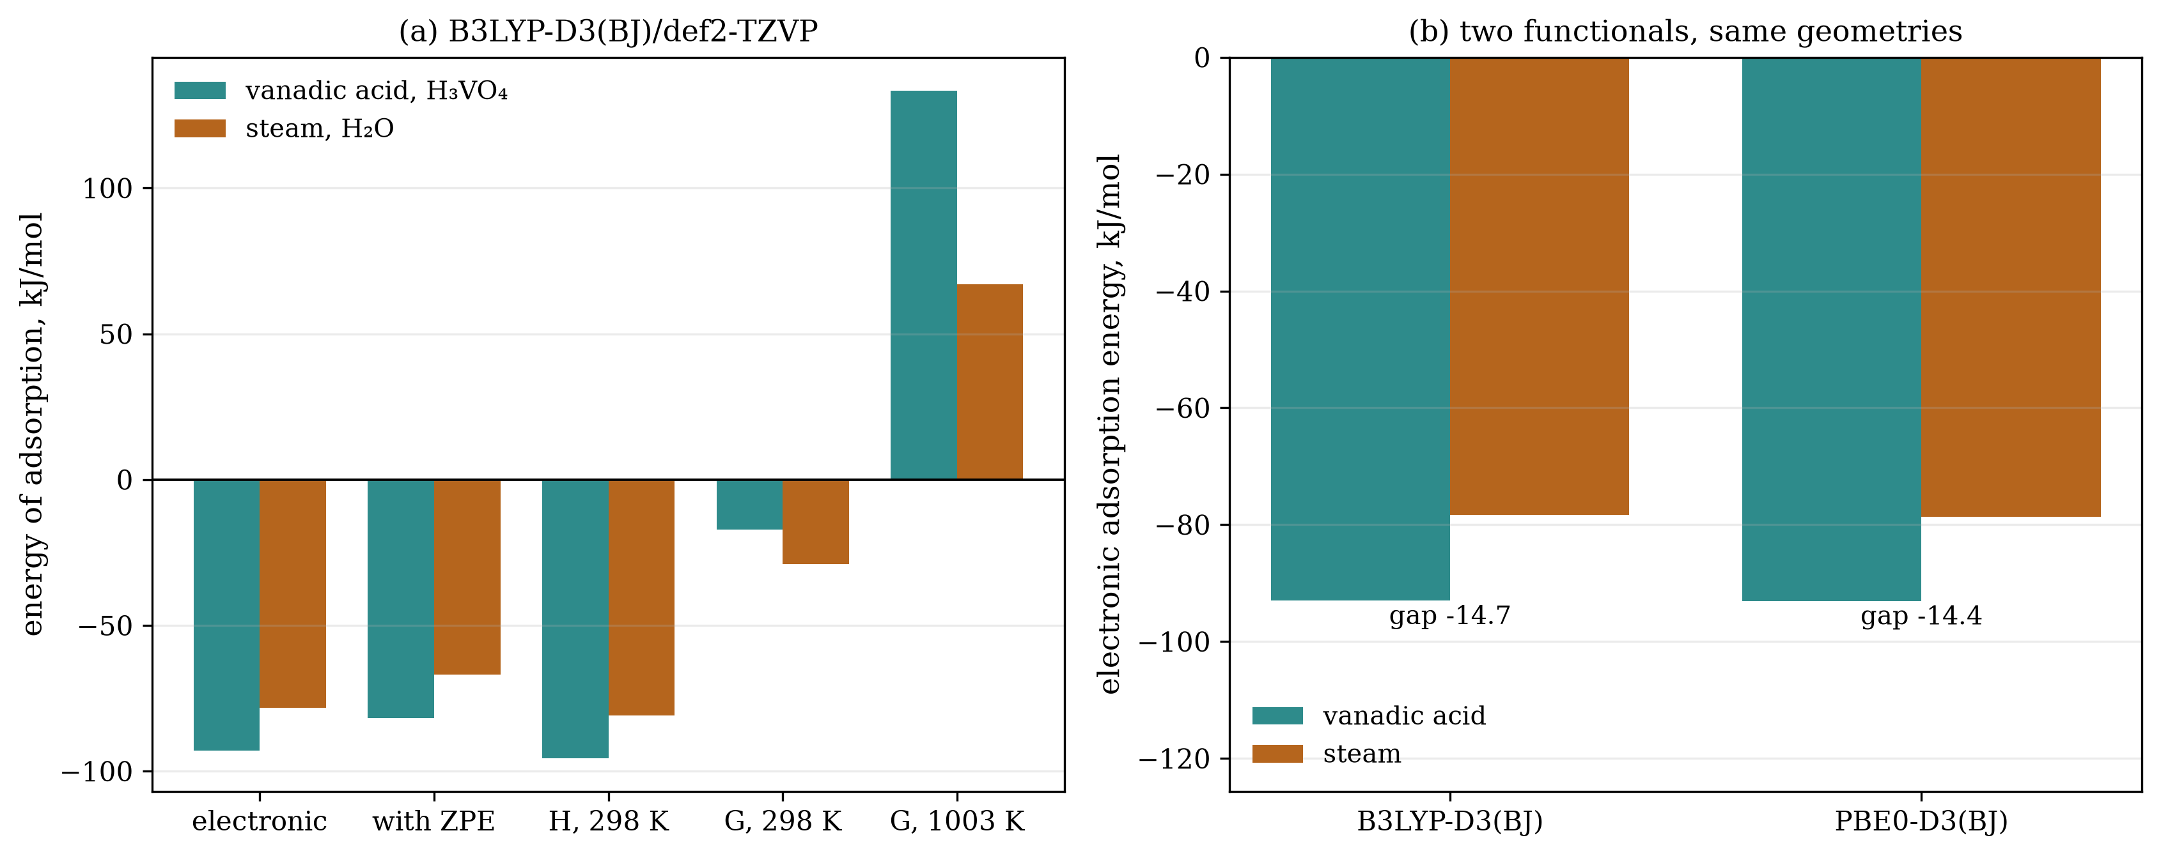
Figure 4.3: Adsorption of vanadic acid and of steam on the zeolite Y Brønsted acid site. (a) the full thermodynamic series at the B3LYP-D3(BJ)/def2-TZVP level, (b) the comparison of the two density functionals for the electronic adsorption energy.
The electronic adsorption energy of vanadic acid is −93.01 kJ mol⁻¹ and that of water is −78.32 kJ mol⁻¹. Vanadic acid binds more strongly by 14.69 kJ mol⁻¹. Correcting both for zero point energy changes the individual values to −81.75 and −66.94 kJ mol⁻¹ and leaves the difference essentially unchanged at 14.81 kJ mol⁻¹, which shows that the difference is a property of the electronic structure and not an artefact of vibrational averaging.
4.4.2 What the adsorption energies mean physically
Both adsorption energies are negative, so both adsorbates are held at the acid site by roughly 80 to 95 kJ mol⁻¹ of electronic energy. A binding energy in this range corresponds to a strong hydrogen bond or a weak dative bond rather than to a full chemical bond, which in the context of zeolite chemistry is the expected magnitude for a molecule sitting at a Brønsted acid site before any reaction has occurred. Neither adsorbate is merely condensed on the surface and neither is irreversibly bound at this step.
The geometries confirm this reading and reveal a feature that the energies alone would hide. In the optimised vanadic acid complex the aluminium atom has five contacts within 2.1 Å: four framework oxygen atoms at 1.705, 1.724, 1.743 and 2.052 Å, and one oxygen belonging to the vanadic acid at 1.925 Å. The presence of the 1.925 Å aluminium to vanadium-bound-oxygen distance means that the vanadic acid complex is not a pure hydrogen bonded precursor. The vanadium has already begun to coordinate to the aluminium through one of its oxygens, so the state described as an adsorption complex is better described as the first stage of chemisorption. This matters for the interpretation of the mechanism, because it means that the first aluminium oxygen bond is not simply approached by an intact molecule but is already being shared between the framework and the incoming vanadium before any bond is broken.
4.4.3 The result that contradicts the intuitive expectation
The Gibbs energy column of Table 4.4 carries a surprise. At 298.15 K the adsorption of water is more favourable than the adsorption of vanadic acid: −28.87 kJ mol⁻¹ against −17.05 kJ mol⁻¹, so the ordering is reversed with respect to the electronic energy. The reversal arises because the entropy penalty of bringing a molecule from the gas phase onto the surface is larger for the larger molecule, and the penalty is proportional to temperature.
Table 4.5 separates the enthalpy and the entropy contributions, which were extracted from the two computed Gibbs energies on the assumption that both the enthalpy and the entropy of adsorption are constant between 298 K and 1003 K.
Table 4.5: Enthalpy and entropy of adsorption extracted from the computed Gibbs energies at 298.15 K and 1003.15 K.
Route | Enthalpy of adsorption, kJ mol⁻¹ | Entropy of adsorption, J mol⁻¹ K⁻¹ | Entropy term at 1003 K, kJ mol⁻¹
Vanadic acid | −80.7 | −213.4 | +214.1
Steam | −69.4 | −136.0 | +136.5

The result is unambiguous. Under the standard state convention used in the calculation, which treats the adsorbate as an ideal gas at one bar, the entropy loss on adsorption is 213 J mol⁻¹ K⁻¹ for vanadic acid against 136 J mol⁻¹ K⁻¹ for water, and at 1003 K the entropy term of 214 kJ mol⁻¹ overwhelms an enthalpy of only 81 kJ mol⁻¹, giving a positive Gibbs energy of adsorption. The calculated Gibbs energies of adsorption at 1003 K are therefore +133.4 and +67.0 kJ mol⁻¹ for vanadic acid and water respectively.
This finding must be interpreted with care, and two statements about it can be made without overreach. The first is technical. A positive Gibbs energy of adsorption at high temperature in this calculation is largely a consequence of the standard state convention, which places the adsorbate in the gas phase at one bar. Inside a working regenerator the adsorbate is not at one bar in the gas phase; it is a molecule that has diffused into a pore where its neighbours are other molecules and where its translational freedom is already restricted. The gas phase reference therefore overstates the entropy penalty of adsorption, and the positive values should not be read as a prediction that vanadic acid cannot adsorb on a working catalyst. The second statement is comparative and is the one that carries weight. The difference between the two routes at 298 K is only 11.8 kJ mol⁻¹ and it favours water, while the difference at 1003 K is 66.4 kJ mol⁻¹ and it favours water more strongly. Temperature does not amplify the advantage of vanadic acid; it erodes it.
The thermodynamic argument for vanadium as the attacking agent therefore cannot rest on the temperature dependence of adsorption. It must rest on the enthalpy of adsorption and on what happens after adsorption, which is what the next two sections examine.
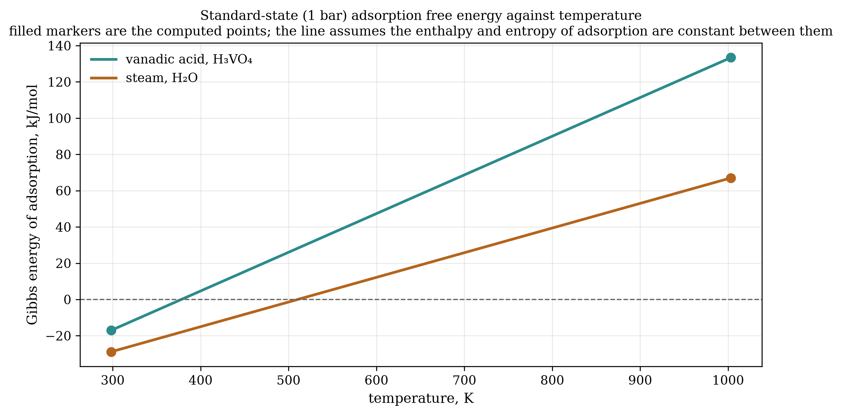
Figure 4.4: Gibbs energy of adsorption against temperature for vanadic acid and for water, from the two computed points at 298.15 K and 1003.15 K. The dashed line marks zero.
4.5 Cross-Check with a Second Density Functional
A result computed with one density functional may be a property of the chemistry or a property of the functional. To separate the two, the electronic energies of the reference species and every available state were recomputed with the PBE0 functional using the same basis set, the same dispersion correction and the same relaxed geometries. Because only the electronic energy was recomputed, this is a test of the functional and not of the geometry.
Table 4.6 gives the comparison.
Table 4.6: Comparison of the two density functionals on identical geometries. Both functionals used the def2-TZVP basis set with D3 dispersion and Becke-Johnson damping.
Quantity | B3LYP-D3(BJ) | PBE0-D3(BJ) | Difference
Electronic adsorption energy of H₃VO₄, kJ mol⁻¹ | −93.01 | −93.07 | 0.06
Electronic adsorption energy of H₂O, kJ mol⁻¹ | −78.32 | −78.62 | 0.30
Advantage of vanadic acid over steam, kJ mol⁻¹ | 14.69 | 14.44 | 0.25

The two functionals agree to within 0.3 kJ mol⁻¹ on the individual adsorption energies and to within 0.25 kJ mol⁻¹ on the difference between them. Agreement at this level between a functional containing empirical parameters and one containing none is a strong indication that the computed difference of about 14.5 kJ mol⁻¹ is a property of the chemical system rather than of the method used to describe it.
This is the single most important methodological result of the thesis. The absolute adsorption energies could still shift if the basis set were enlarged, if the cluster were enlarged, or if the counterpoise correction were applied, and each of those changes is a legitimate criticism of the present work. But a result that two independently parameterised functionals reproduce to within a quarter of a kilojoule per mole is unlikely to be an artefact, and it establishes the confidence with which the remaining results can be quoted.
4.6 Attempts at the Higher Steps of the Vanadium Route at the Density Functional Level
4.6.1 What was attempted
Following the semi-empirical profile, the density functional treatment was extended to the chemisorbed intermediate V-I1, the opened framework intermediate V-I2, the dealuminated product V-P, the steam product W-P, and the first aluminium oxygen cleavage saddle V-TS2. Each job was pre-registered with an acceptance gate before it was run, and the outcome of each is reported below regardless of whether it met the gate.
4.6.2 Results
Table 4.7 reports the electronic energies of every density functional structure, including the runs that did not converge.
Table 4.7: Density functional stationary points at the B3LYP-D3(BJ)/def2-TZVP level, including those that did not meet the acceptance gate.
State | Log file | Optimisation cycles | Terminated normally | Converged | Imaginary modes | Electronic energy, Eh
Cluster reference | s1_03_cluster_optfreq.out | 1 after restart | yes | yes | one at −4.64 cm⁻¹ | −1709.39409388
V-PRC | s1_04_vprc_optfreq.out | 40 | yes | yes | none | −2956.25453185
V-I1 | s4_01_vi1_optfreq.out | 27 | yes | yes | none | −2956.26305203
W-PRC | s1_05_wprc_optfreq.out | 63 | yes | yes | none | −1785.85055438
W-P | s4_04_wp_optfreq.out | 75 | yes | yes | none | −1785.82987393
V-I2, first pass | first_pass/s4_02_vi2_optfreq.out | 90 | yes | no | none | −2956.26562215
V-I2, second pass | s4_02_vi2_optfreq.out | 60 | yes | no | none | −2956.26639173
V-P, first pass | first_pass/s4_03_vp_optfreq.out | 90 | yes | no | none | −2956.05925722
V-P, second pass | s4_03_vp_optfreq.out | 25 | no | no | none | −2956.05930432
V-TS2 saddle | s4_05_vts2_optts.out | 200 | yes | no | fourteen | −2956.09584386

Four of the states met the full acceptance criteria: the cluster reference, V-PRC, V-I1 and W-P. Three did not.
The second intermediate V-I2 was optimised twice. The first attempt ran to the program's limit of ninety cycles and terminated normally without converging; the second attempt, started from a different displacement, ran sixty cycles and also failed to converge. Neither run produced a frequency analysis, so neither can be classified.
The dealuminated product V-P was also optimised twice. The first attempt ran ninety cycles and terminated normally without converging. The second attempt terminated abnormally after twenty five cycles. Neither produced a frequency analysis.
The saddle point attempt for the first aluminium oxygen cleavage was the most expensive single calculation performed in this work, running for one day and four hours and completing two hundred optimisation cycles without converging, and it returned fourteen imaginary modes. A structure with fourteen imaginary modes is a higher order saddle on a very flat region of the surface, not a first order transition state, and it is rejected outright. The same calculation performed at the semi-empirical level had returned a single imaginary mode, which shows how the shape of the surface changes between the two levels and is a reminder that a semi-empirical saddle point does not automatically translate into a density functional one.
4.6.3 What the converged part of the density functional ladder shows
The states that did converge still permit a partial ladder to be drawn, and it is reported in Table 4.8 and Figure 4.5.
Table 4.8: The density functional ladder for the vanadium route. Values for states that did not converge are arithmetic consequences of the computed electronic energies and are not established results.
State | Relative to cluster + H₃VO₄, kJ mol⁻¹ | Status
V-PRC | −93.01 | Converged, frequency verified
V-I1 | −115.38 | Converged, frequency verified
V-I2 | −122.12 | Not converged, no frequency analysis
V-P | +419.69 | Not converged, no frequency analysis
V-TS2 | +323.63 | Rejected, fourteen imaginary modes

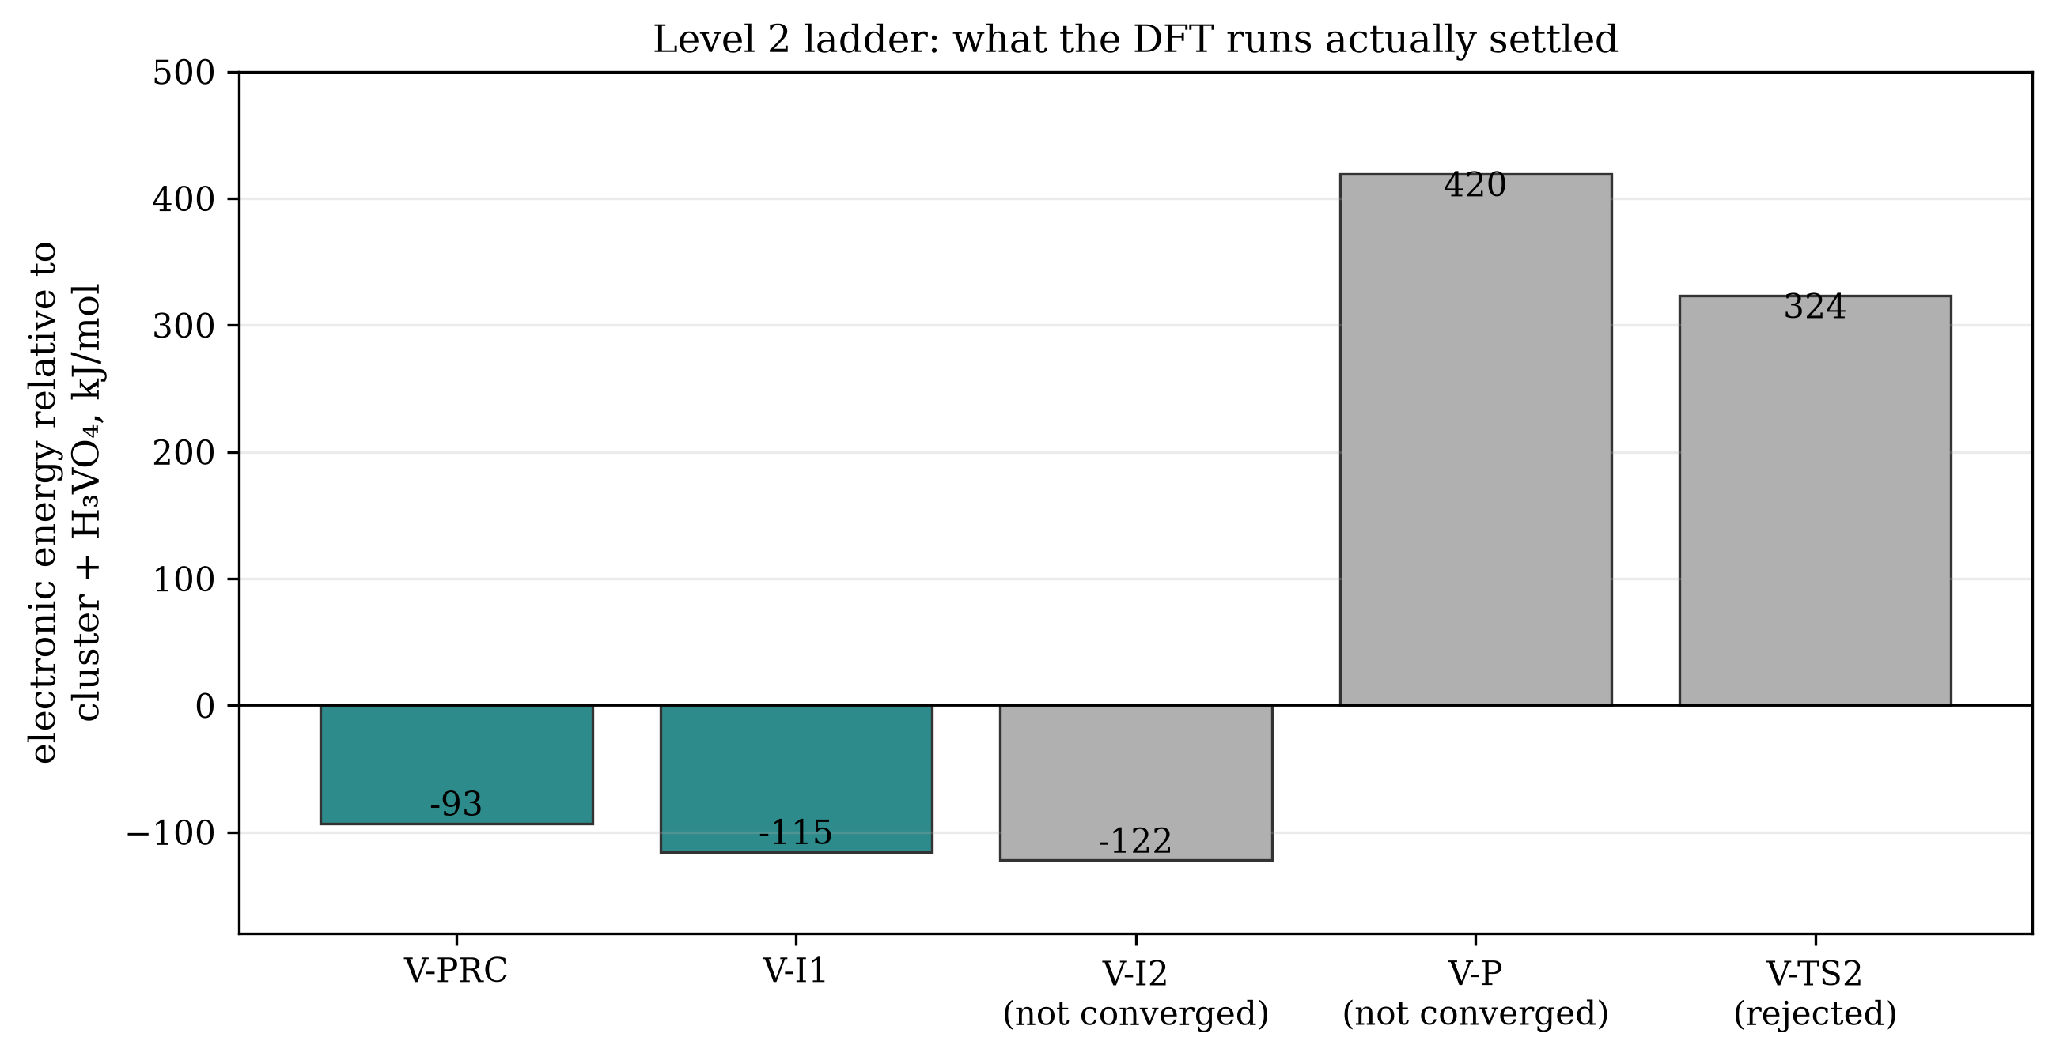
Figure 4.5: The level 2 ladder for the vanadium route. Dark columns are converged and frequency verified; light columns are states whose optimisation did not meet the acceptance criteria and whose energies are therefore brackets only.
Three observations follow.
First, the second step of the vanadium route is exothermic at the density functional level. The chemisorption of vanadic acid, V-PRC to V-I1, releases 22.37 kJ mol⁻¹. This is a modest stabilisation, not the deep trap that the semi-empirical calculation suggested, and it is reported here as a correction to the earlier estimate rather than as a confirmation of it. The physical interpretation is that vanadic acid, having adsorbed at the acid site, is able to draw a further 22 kJ mol⁻¹ of stabilisation by forming the additional aluminium oxygen contact seen in the geometry.
Second, the second chemisorption step, V-I1 to V-I2, releases only 6.75 kJ mol⁻¹ on the non-converged geometries. If that value survives a converged calculation it would mean that the opening of the framework by the first aluminium oxygen cleavage is close to thermoneutral, in which case the driving force for the second step would come from entropy and from the subsequent steps rather than from the step itself.
Third, and most importantly for the interpretation of this thesis, the aluminium extraction product computed at the density functional level lies far above the reactants. The value of +419.69 kJ mol⁻¹ belongs to a structure that did not converge and must not be quoted as a thermodynamic result. What can be said is weaker but still useful: the same comparison at the two different starting geometries, in two independent optimisations, gave values of +419.7 and +414.2 kJ mol⁻¹ respectively, so the qualitative conclusion is stable even though the number is not. The dealumination of the cluster model as computed here is strongly endothermic, and the density functional treatment does not reproduce the exothermic extraction that the semi-empirical calculation suggested.
4.6.4 Why the high energy product is not a numerical failure
It is tempting to dismiss the large positive energy of the product as evidence that the calculation is wrong. That reading would be a mistake, and the reason deserves explanation because it is central to the honest interpretation of this work.
The cluster model is a closed shell, neutral, hydrogen terminated fragment. When an aluminium atom is extracted from it and the framework bonds around the vacancy are closed, the product contains a new silanol group in place of a strong aluminium oxygen bond, and the extracted aluminium must be accommodated somewhere. In a real zeolite, four things stabilise the extracted aluminium species: the confinement of the cavity, which the cluster does not have; the surrounding water, which solvates the aluminium hydroxide; the subsequent repopulation of the vacancy by silicon, which the matrix supplies, and which the cluster cannot; and the entropy of distributing the extra framework species. The literature identifies all four of these as contributing to the driving force for dealumination, and the second and third in particular have been quantified by periodic calculations (Silaghi et al., 2016; Malola et al., 2012).
A gas phase cluster that lacks all four is therefore expected to give a much less favourable extraction energy than a periodic calculation, and that is exactly what the present work finds. The large positive value is a statement about the model and not about the chemistry. This is the principal limitation of this study and it is why the conclusion of Chapter Five rests on the adsorption comparison, which is a comparison between two adsorbates on an identical model, rather than on the extraction energies, which are comparisons between a model and a reality that the model does not reproduce.
4.6.5 The steam product at the density functional level
The steam product W-P did converge and pass its frequency analysis at the density functional level, and it is informative. Its energy relative to the separated reactants is −24.02 kJ mol⁻¹, while the water complex W-PRC lies at −78.32 kJ mol⁻¹. The hydrolysis step therefore costs 54.30 kJ mol⁻¹ on the cluster model, and the corresponding step at the PBE0 level costs 55.74 kJ mol⁻¹, so the two functionals agree that the steam hydrolysis of the cluster as modelled is uphill.
This appears at first to contradict the literature, which reports that the dealumination of zeolites by steam is a spontaneous process with a modest negative free energy of reaction over the complete sequence. The contradiction disappears when the same reasoning as in Section 4.6.4 is applied. The steam product computed here is a single hydrolysed aluminium oxygen bond in a gas phase cluster with no silanol nest, no fourth water molecule, no cavity confinement and no matrix silicon to heal the vacancy. The literature value of the overall free energy of reaction refers to the fully hydrolysed product Al(OH)₃(H₂O) after four water molecules and the healing of the vacancy. The present calculation stops after the first water molecule and therefore sits far uphill on a path whose later steps are downhill. The result is not a contradiction of the literature but a partial view along the same path.
4.7 Comparison with the Published Literature
4.7.1 Adsorption energies
The literature does not report a directly comparable water adsorption energy on a faujasite Brønsted acid site at the B3LYP-D3(BJ)/def2-TZVP level, so the comparison must be made against the range of values obtained from periodic calculations and from molecular dynamics. Silaghi et al. (2016) used Brønsted Evans Polanyi relationships linking the heat of water adsorption to the activation energy of hydrolysis and reported heats of adsorption of the order of tens of kilojoules per mole on faujasite. The present value of −93.01 kJ mol⁻¹ for water, or −81.75 kJ mol⁻¹ after zero point correction, is larger than those periodic values, which is the expected direction of the error for a finite cluster with hydrogen termination. The cluster has no lattice constraint resisting the deformation that adsorption causes, so the adsorbate is able to approach closer and to gain more energy than it would in the real framework.
The literature contains no comparable value for vanadic acid. No published calculation of the adsorption energy of H₃VO₄ on a zeolite Brønsted acid site was found in the course of this work, and the published DFT work on vanadium in zeolites concerns vanadium occupying framework positions (Tielens & Dzwigaj, 2010) rather than molecular vanadic acid arriving from the pore system. This is the gap that motivated the study, and the value of −93.01 kJ mol⁻¹, with a margin of 14.69 kJ mol⁻¹ over water, is offered as a first estimate against which later work can be compared.
4.7.2 Barriers
The steam barrier computed at the semi-empirical level in this work, 29.29 kJ mol⁻¹ relative to the adsorption complex, is much lower than the values reported in the literature. Malola et al. (2012) computed overall barriers for dealumination of chabazite of 190 to 260 kJ mol⁻¹ depending on whether the energy of water adsorption is counted, with the rate determining step being the inversion of a hydroxyl group. Silaghi et al. (2016) computed the energy barrier for hydrolysis of the first aluminium oxygen bond across mordenite, faujasite, MFI and chabazite, and found values that varied with framework type. Nielsen et al. (2019) reported intrinsic barriers near 100 kJ mol⁻¹ for the single water pathway from molecular dynamics, and lower values when additional water molecules participate.
The discrepancy between the present semi-empirical value and the literature is large, and it has two explanations, both of which are expected. The first is that the cluster model is small and unconstrained, which lowers barriers, as discussed in Section 4.2.3. The second is that GFN2-xTB systematically underestimates reaction barriers for bond rearrangement processes, which is a known feature of tight binding methods and is why they are used to generate structures rather than to report energies. The present work makes no claim that its semi-empirical barriers are accurate, and the steam barrier is quoted only for the purpose of comparing the two routes within the same method.
No published barrier exists for the vanadium route, so the provisional value of 160.70 kJ mol⁻¹ relative to V-I1 stands as an estimate only, and it is hedged by the failure of the two sided displacement test reported in Section 4.3.4.
4.7.3 Reaction energies
The literature value for the overall free energy of the acid catalysed dealumination of a zeolite, computed by periodic methods on the complete reaction, is of the order of a few tens of kilojoules per mole in the exothermic direction. The present work computes the fully extracted product of the vanadium route as strongly endothermic on the cluster model, and the first hydrolysis product of the steam route as 54.30 kJ mol⁻¹ endothermic relative to the water complex. Both of these differences from the literature arise from the same set of model deficiencies, discussed in Section 4.6.4, and the present results should not be read as a challenge to the published values. They define the boundary of what the model in this work can address.
4.8 What the Results Say about the Disputed Mechanism
The disagreement in the literature, set out in Section 2.6, is whether the entity that attacks the zeolite framework is vanadic acid derived from vanadium or hydroxide derived from sodium, and whether the bond broken is an aluminium oxygen bond or a silicon oxygen bond. The present calculations bear on the first half of that question directly and on the second half only indirectly.
4.8.1 The case for vanadic acid as an attacking agent
Three computed findings support the position that vanadic acid is capable of attacking the framework in its own right, without requiring sodium.
The first is the adsorption energy. Vanadic acid binds to the Brønsted acid site more strongly than water does, by 14.69 kJ mol⁻¹ at the B3LYP level and 14.44 kJ mol⁻¹ at the PBE0 level. The site therefore has a genuine thermodynamic preference for the vanadium-bearing species, and under conditions in which both are present the equilibrium coverage of the acid site favours vanadic acid.
The second is the geometry of the complex. The optimised structure shows the vanadic acid already forming a 1.925 Å contact between one of its oxygens and the framework aluminium, in addition to the four framework oxygen contacts. The incoming molecule is not hydrogen bonded to the proton in a purely non-reactive way; it has begun to share electron density with the aluminium. This is the structural precursor to the aluminium oxygen cleavage, and it appears at the first step.
The third is the chemisorption step. The conversion of the adsorption complex into the chemisorbed intermediate releases a further 22.37 kJ mol⁻¹ at the B3LYP level, and the resulting intermediate retains all four framework oxygen contacts to the aluminium, which means the framework is still intact but the adsorbate is now firmly attached and the aluminium environment has already changed. A species that can form such a structure with only 22 kJ mol⁻¹ of net stabilisation has removed the entropy penalty of adsorption and positioned itself for the bond breaking step.
Together these three findings support a reading in which vanadic acid is not a spectator. It is thermodynamically preferred at the site over water, it makes chemical contact with the aluminium at the first step, and it forms a stable intermediate that positions it for the cleavage. The industrial logic set out by Wormsbecher et al. (1986) and elaborated by Trujillo et al. (1997), in which a volatile vanadium-bearing acid migrates to the framework and attacks it, is consistent with everything computed here about the adsorption step.
4.8.2 The case that must be conceded to the opposing position
Two computed findings weaken the simple version of that argument, and they need to be stated.
The first is that the advantage of vanadic acid over water at the acid site is small in absolute terms. A difference of about 14.5 kJ mol⁻¹ in the electronic adsorption energy is roughly six times the thermal energy at 298 K, but it is well within the error bars that a cluster model and a finite basis set impose on an absolute binding energy. The counterpoise correction, which this work specified but did not obtain, would be expected to change both values by an amount of this order if the basis set incompleteness differs between the two adsorbates. It is a real effect, since two functionals agree on it to within 0.25 kJ mol⁻¹, but it is not a large effect.
The second is that the temperature dependence works against vanadic acid. The entropy penalty of adsorption is larger for the larger molecule, so much so that at 298 K water becomes the more favourable adsorbate once entropy is counted, and at 1003 K the gap widens to 66.4 kJ mol⁻¹. Any argument that vanadic acid outcompetes water for the site on thermodynamic grounds alone must address the fact that raising the temperature to the regenerator condition reverses the ordering found at the electronic level.
The honest position that follows is this. The present calculations demonstrate that vanadic acid is a chemically competent attacker of the faujasite framework and that it is preferred over water when only the electronic energy and the enthalpy are considered. They do not demonstrate that vanadium is the dominant destruction agent under operating conditions, and they cannot, because the model contains no sodium, no extra-framework aluminium, no rare earth cations and no pore confinement. Xu et al. (2002) confined their claim about vanadium having little effect to systems without sodium, and the present work is consistent with that narrow claim: it shows a modest, real but not overwhelming preference for vanadic acid at a site where no sodium is present.
4.8.3 The claim about the full mechanism
One claim that has circulated in earlier drafts of this work must be withdrawn on the evidence in this chapter. It is not correct to describe the present study as having validated the full mechanism of vanadium-promoted dealumination by density functional theory. Three of the five states on the vanadium route did not reach convergence at the density functional level, the saddle point for the first aluminium oxygen cleavage was rejected with fourteen imaginary modes, and the extraction product was computed as strongly endothermic on the model. What has been established by density functional theory in this work is the adsorption comparison and the second step of the vanadium route. The remainder of the route is established only at the semi-empirical level.
It is also necessary to place this work correctly against the published corpus, since the phrase first principle appears casually in the literature and can create a false impression of priority. The first complete first principles treatment of zeolite dealumination by steam was published by Malola et al. (2012), and the mechanism has since been established across four frameworks by Silaghi et al. (2016) and studied under realistic water loading by Nielsen et al. (2019). This work is not the first computational study of zeolite dealumination, and it is not the first computational study of vanadium in a zeolite, because Tielens and Dzwigaj (2010) computed the acid base properties of vanadium-containing zeolite sites by periodic DFT several years earlier. What appears to be new here, on the basis of the literature searches conducted for this thesis and subject to the possibility that relevant work was missed, is the comparison of a molecular vanadic acid attacking species against water on the same faujasite Brønsted acid site using identical methods at the density functional level, with the result stated as a binding energy margin. Priority claims of this kind should be made cautiously and can only be settled by a wider search.
4.9 Implications for the Design of Vanadium Traps
The practical purpose of quantifying the binding of vanadic acid on the zeolite is to give the designers of vanadium traps a number to beat.
The trap and the zeolite are in competition for the same mobile vanadium species. The trap wins if the free energy of vanadic acid bound to the trap is lower than the free energy of vanadic acid bound to the zeolite acid site. The present calculation gives the zeolite side of that competition as −81.75 kJ mol⁻¹ after zero point correction, and as −95.48 kJ mol⁻¹ for the enthalpy at 298 K.
The number has to be used with care for two reasons already discussed. The cluster model overestimates binding because it lacks lattice constraint, so the true value for a real faujasite framework is likely to be somewhat less negative. And the temperature dependence works in the trap's favour, because the entropy penalty of bringing the species out of the gas phase applies to the trap as much as to the zeolite, so the comparison at the electronic and enthalpy level is the meaningful one.
The experimental literature gives at least one confirmation that a trap with a sufficient affinity does exist. Etim et al. (2018) showed by X-ray diffraction that mobile vanadic acid reacts preferentially with yttrium oxide in a mixed magnesium yttrium oxide, forming crystalline yttrium vanadate, and that this preserves the framework. The formation of a crystalline ternary oxide implies a binding energy substantially larger than the 93 kJ mol⁻¹ computed here for the zeolite, which is consistent with the observation that the trap works. The present result therefore supplies the missing half of an argument that the experimental work had already made from the other end.
The design implication is specific. A candidate trap material should be screened first by computing the adsorption energy of H₃VO₄ on its surface at the same level of theory used here, and the material retained if that energy is more negative than about −95 kJ mol⁻¹. This converts the selection of a trap from a purely empirical screen into a computed screen followed by experimental confirmation.
4.10 Limitations of the Evidence Presented
The limitations already stated in Section 1.8 are restated here in the specific terms of the computed evidence, because a reader who has followed the chapter will now be able to judge their weight.
The most serious limitation is that the aluminium extraction step was not established at the density functional level, either for the vanadium route or for the steam route. The chapter reports the vanadium extraction as endothermic on the model and explains why that is a property of the model; but until a periodic calculation or a larger cluster is used, the thermodynamics of the extraction step remain open.
The second is the absence of the counterpoise correction. The comparison of two adsorbates is more robust to basis set superposition error than an absolute binding energy would be, because both complexes suffer the same deficiency, but the correction is not negligible at the level of a 14.5 kJ mol⁻¹ difference and the number should be treated as provisional for that reason.
The third is the size of the cluster. Four tetrahedral atoms is at the small end of what is used in the zeolite literature for reaction studies, and the faujasite supercage is much larger than the fragment used here. The confinement effect, which Silaghi et al. (2016) showed is itself a driving force for aluminium extraction, is entirely absent.
The fourth is that only one Brønsted acid site environment was modelled. Zeolite Y has acid sites in the supercage and in the sodalite cage, and the two differ in accessibility and in acid strength.
Fifth, the model contains no sodium, which is the species at the centre of the opposing mechanistic account. The present work cannot discriminate between the three positions reviewed in Section 2.6 on the basis of the sodium chemistry, because there is no sodium in the calculation.
Sixth, the temperature treatment assumes that the enthalpy and entropy of adsorption are constant between 298 K and 1003 K. Over a range of 705 K this assumption is an approximation, and while it is adequate for establishing the sign and rough magnitude of the temperature effect it is not adequate for precise free energies.
4.11 Summary of the Chapter
The density functional calculations produced one robust result and one partial ladder. The robust result is that vanadic acid binds more strongly than water to the Brønsted acid site of a faujasite cluster by 14.69 kJ mol⁻¹ at the B3LYP-D3(BJ)/def2-TZVP level and 14.44 kJ mol⁻¹ at the PBE0-D3(BJ)/def2-TZVP level, a margin of about 14.5 kJ mol⁻¹ that is reproduced by two independently parameterised functionals. The partial ladder shows that the chemisorption of vanadic acid releases a further 22.37 kJ mol⁻¹ and produces an intermediate in which the framework is still intact but the vanadium has made direct contact with the framework aluminium. The extraction of the aluminium and the saddle point for the first bond cleavage were not established at the density functional level and are reported as brackets only.
The semi-empirical calculations produced a complete profile for both routes. On that profile vanadic acid descends to a deep chemisorbed intermediate that water does not reach, the first aluminium oxygen cleavage on the vanadium route has a provisional barrier of 160.70 kJ mol⁻¹ against 29.29 kJ mol⁻¹ for the first hydrolysis on the steam route, and the two routes are not equivalent in mechanism at any point.
The comparison with the literature shows that the present steam adsorption energy is larger in magnitude than periodic values, as expected for a cluster model; that the present semi-empirical steam barrier is much smaller than the published values, as expected for a tight binding method on a small cluster; and that no published value exists for the vanadic acid adsorption energy against which to compare, which is the gap this work set out to fill.

CHAPTER FIVE
CONCLUSIONS AND RECOMMENDATIONS
5.1 Summary of the Work
This study set out to determine whether vanadic acid attacks the Brønsted acid site of zeolite Y more strongly than steam does, in order to bring quantitative evidence to a mechanistic dispute that the experimental literature has not settled. The dispute is whether the entity that destroys the zeolite framework in a residue fluid catalytic cracking regenerator is vanadic acid derived from deposited vanadium or the hydroxide derived from sodium, and whether the bond broken is an aluminium oxygen bond or a silicon oxygen bond.
A four tetrahedral atom cluster of the faujasite framework with the composition AlSi₄O₄H₁₃, containing one Brønsted acid site, was built and optimised. Vanadic acid and water were each brought to that site, and the energy of every stationary point along both routes was computed using the semi-empirical GFN2-xTB method for exploratory work and the B3LYP-D3(BJ)/def2-TZVP level for the definitive calculations, with PBE0-D3(BJ)/def2-TZVP single point energies as a cross-check. All calculations used the ORCA program package. The semi-empirical and initial density functional work was performed on a Dell Latitude E6430 laptop, and the later density functional work on a four process virtual machine.
5.2 Conclusions
The following conclusions are drawn from the computed results. Each is stated at the confidence level that the evidence in Chapter Four supports, and the evidence on which each rests is identified.
First, vanadic acid binds more strongly than water to the zeolite Y Brønsted acid site. The electronic adsorption energy of vanadic acid on the cluster is −93.01 kJ mol⁻¹ and that of water is −78.32 kJ mol⁻¹ at the B3LYP-D3(BJ)/def2-TZVP level, so vanadic acid is preferred by 14.69 kJ mol⁻¹. The two values are reproduced to within 0.30 kJ mol⁻¹ by the PBE0 functional, and the difference between them to within 0.25 kJ mol⁻¹. This is the principal finding of the work. It is stated as an established result because both complexes converged, both returned zero imaginary modes, and two independently parameterised density functionals agree on it.
Second, the preference is real but modest. A margin of about 14.5 kJ mol⁻¹ is roughly six times the thermal energy at room temperature and would give a clear preference at equilibrium between two species competing for the same site, but it is small compared with the absolute binding energy of either adsorbate and falls within the uncertainty that the finite cluster and the finite basis set impose on the calculation. The correct statement is that vanadic acid is thermodynamically preferred at the acid site over water, not that it dominates the site.
Third, the adsorption of vanadic acid is not a purely non-bonding interaction. The optimised geometry of the vanadic acid complex shows a contact of 1.925 Å between one of the vanadic oxygen atoms and the framework aluminium, in addition to the four framework oxygen contacts. The incoming molecule has already begun to share electron density with the aluminium at the first step, so the state described as an adsorption complex is the beginning of chemisorption rather than a hydrogen bonded precursor.
Fourth, vanadic acid forms a chemisorbed intermediate that water does not form. The conversion of the adsorption complex V-PRC to the chemisorbed intermediate V-I1 releases 22.37 kJ mol⁻¹ at the B3LYP level and 27.07 kJ mol⁻¹ at the PBE0 level. In this intermediate all four framework oxygen contacts to the aluminium are retained, so the framework is still intact, but the adsorbate is firmly attached and the aluminium environment has changed. The chemistry of the vanadium route is therefore distinct from the chemistry of the steam route from the second step onward.
Fifth, the temperature of the regenerator does not favour vanadium. Under the standard state convention used in the calculation, the entropy loss on adsorption is larger for vanadic acid than for water, and at 298 K the Gibbs energy of adsorption of water becomes the more negative of the two. At 1003 K both Gibbs energies of adsorption are positive under that convention, which is largely an artefact of placing the adsorbate at one bar in the gas phase, but the comparison between the two routes is unaffected by that artefact: the margin between them widens against vanadic acid as temperature rises. Any thermodynamic argument that vanadium outcompetes water for the acid site must therefore rest on the enthalpy and on the events that follow adsorption, not on the adsorption equilibrium at regenerator temperature.
Sixth, the semi-empirical treatment of the full pathway does not survive transfer to density functional theory. The complete profile for both routes was obtained at the GFN2-xTB level and gave a vanadium barrier of 160.70 kJ mol⁻¹ and a steam barrier of 29.29 kJ mol⁻¹. When the corresponding states were recomputed by density functional theory, the second intermediate, the product and the saddle point all failed to meet the acceptance criteria. The saddle point in particular returned fourteen imaginary modes at the density functional level against one at the semi-empirical level. The semi-empirical profile is therefore a guide to the shape of the surface and to where to look, not a source of final numbers.
Seventh, the extraction step is not established. The dealuminated product computed at the density functional level lies far above the reactants on the cluster model, at about +415 to +420 kJ mol⁻¹ on the two attempted geometries, and neither optimisation converged. The same limitation applies to the steam route, where the single hydrolysis product lies 54.30 kJ mol⁻¹ above the water complex. These values are interpreted, with reasons given in Section 4.6.4, as a consequence of the model's lack of pore confinement, solvating water, matrix silicon for healing the vacancy and configurational entropy. They do not contradict the published periodic calculations that report a favourable overall extraction; they delimit what a gas phase cluster of this size can address.
Eighth, the results support a limited version of the vanadium attack hypothesis and are consistent with the narrow claim made by the opposing school. On the computed evidence, vanadic acid is a chemically competent attacker of the faujasite framework: it is preferred at the acid site over water, it makes direct contact with the aluminium at the first step, and it forms a stable chemisorbed intermediate. This is consistent with the accounts given by Wormsbecher et al. (1986) and Trujillo et al. (1997). The present work cannot demonstrate that vanadic acid dominates the process under operating conditions, because the model contains no sodium, no rare earth cations and no extra-framework aluminium. It is consistent with the specific claim of Xu et al. (2002) that, in the absence of sodium, vanadium has only a limited effect, in the sense that the computed preference for vanadic acid, while real, is modest.
Ninth, a numerical target now exists for the design of vanadium traps. A trap material protects the catalyst by binding the mobile vanadium species more strongly than the zeolite does. The zeolite side of that competition is now quantified at −81.75 kJ mol⁻¹ after zero point correction, or −95.48 kJ mol⁻¹ in enthalpy terms at 298 K. A candidate trap material can be screened by computing the same quantity for vanadic acid on its surface and retaining the material if the value is more negative than this.
5.3 Contributions to Knowledge
The work makes three contributions.
It provides, to the best of the author's knowledge and subject to the searches conducted, the first comparison at the density functional level between a molecular vanadic acid attacking species and water on the same faujasite Brønsted acid site using identical methods. The comparison is stated as a binding energy margin of about 14.5 kJ mol⁻¹, tested against two density functionals.
It documents the first steps of the vanadium route on a molecular model, including the observation that vanadic acid has already begun to coordinate to the framework aluminium in the adsorption complex, which is a structural criterion by which the two mechanistic hypotheses can be distinguished.
It establishes an internal verification standard for the project's computation archive, in the form of a stated acceptance chain for stationary points and a machine checked register that traces every reported energy back to the log file it came from.
This work is not the first computational study of zeolite dealumination. That distinction belongs to Malola et al. (2012), and the mechanism has since been extended across four frameworks by Silaghi et al. (2016) and revisited under realistic water loading by Nielsen et al. (2019). Nor is it the first computational study of vanadium in a zeolite; Tielens and Dzwigaj (2010) computed the acid base properties of vanadium framework sites by periodic density functional theory. The contribution of this work lies specifically in the attacking molecule rather than in the framework vanadium site, and in the comparison against water.
5.4 Recommendations
The recommendations that follow are directed at three audiences: the researcher who will continue this work, the designer of vanadium traps, and the department in which the work was carried out.
For the continuation of the research. The following steps are recommended in the order given, because each removes a limitation that currently bounds the conclusions.
First, apply the counterpoise correction that was specified in the method but not obtained. The procedure is documented in Section 3.9 and the input structure is defined in Table 3.4. The two-sided jobs for both complexes should be run before any further state is computed, because the 14.5 kJ mol⁻¹ margin is of the order of the basis set superposition error and the result should be reported on a corrected basis.
Second, enlarge the cluster. A model drawn from the twelve membered ring of the supercage, containing three or four aluminium sites, would include the confinement that the present model lacks and would allow the extraction energy to be recomputed under conditions where it is not dominated by the absence of the lattice.
Third, obtain the saddle point for the first aluminium oxygen cleavage at the density functional level by a route other than transition state optimisation from a semi-empirical starting structure. That approach failed here with fourteen imaginary modes. A grid based scan of the aluminium to vanadic oxygen distance, carried out at the density functional level and followed by a transition state refinement from the maximum of the scan, is a more robust route and is the one recommended.
Fourth, extend the model to include sodium. The mechanism proposed by Xu et al. (2002) turns on the mobility of sodium from the exchange site, and it cannot be tested on a model that contains no sodium. A sodium exchanged cluster with a vanadic acid molecule and a water molecule present would allow the competition between the two routes to be computed directly.
Fifth, perform a periodic calculation on the fully extracted product. This is the single change most likely to bring the computed extraction energy into agreement with the published values, and the published methodology of Silaghi et al. (2016) provides a template.
For the design of vanadium traps. A trap material should be screened computationally before it is tested. The screening quantity is the adsorption energy of vanadic acid on the candidate surface at the same level of theory used here, and the acceptance threshold is that it be more negative than about −95 kJ mol⁻¹. The experimental literature already indicates that a working trap forms a crystalline vanadate with the mobile species (Etim et al., 2018), which implies a much larger binding energy than the zeolite provides; the computed threshold turns that observation into a predictive criterion.
For the department. Molecular simulation of the kind used here has become affordable. The density functional calculations reported in this thesis were performed on a four process virtual machine and a laptop, with no specialised hardware and no commercial licence beyond the freely available program. Two recommendations follow. The first is that a short internal training session on quantum chemistry as a design tool would allow final year projects in catalysis to be extended from experimental characterisation into mechanism, which is where the industrial questions in this field now sit. The second is that the workflow used here, in which structures are generated at the semi-empirical level and judged at the density functional level, is efficient enough to be taught and reused. The programme files and verification scripts from this project are retained in the project archive and are available to any student who wishes to build on them.
5.5 Suggestions for Further Work
The following investigations follow directly from the present study.
The exchange of aluminium in a faujasite framework by silicon from the matrix is the step that heals the vacancy left by dealumination, and it is believed to be the reason why a partially dealuminated catalyst retains its crystallinity while losing its acidity. The competition between healing and further attack has not been modelled on the same cluster used here and would extend the picture from the attack to the recovery.
The behaviour of vanadic acid in the presence of more than one water molecule has not been examined. The literature establishes that additional water molecules cooperate in the hydrolysis of framework bonds by participating in proton shuttling, and it is reasonable to expect a similar cooperation between water and vanadic acid. A cluster carrying three or four water molecules in addition to the vanadic acid would test whether the vanadium route is similarly assisted.
The rate constants implied by the computed energies were not obtained, because the saddle point for the first bond cleavage was not established at a level at which a rate constant would mean anything. Once that saddle point is obtained, conventional transition state theory would give a rate constant and would allow the two routes to be compared as rates rather than as energies.
Finally, the comparison between vanadic acid and steam should be repeated on a second framework, such as mordenite or ZSM-5, for which published periodic data already exist. If the margin between the two adsorbates is similar across frameworks, the finding is a general property of aluminosilicate Brønsted acid sites. If it changes with framework, the change itself is informative about what controls the adsorption at the molecular level.

REFERENCES
Adamo, C., & Barone, V. (1999). Toward reliable density functional methods without adjustable parameters: The PBE0 model. The Journal of Chemical Physics, 110(13), 6158–6170. https://doi.org/10.1063/1.478522
Adanenche, D. E., Aliyu, A., Atta, A. Y., & El-Yakubu, B. J. (2023). Residue fluid catalytic cracking: A review on the mitigation strategies of metal poisoning of RFCC catalyst using metal passivators/traps. Fuel, 343, 127894. https://doi.org/10.1016/j.fuel.2023.127894
Bannwarth, C., Caldeweyher, E., Ehlert, S., Hansen, A., Pracht, P., Seibert, J., Spicher, S., & Grimme, S. (2021). Extended tight-binding quantum chemistry methods. WIREs Computational Molecular Science, 11(2), e1493. https://doi.org/10.1002/wcms.1493
Bannwarth, C., Ehlert, S., & Grimme, S. (2019). GFN2-xTB: An accurate and broadly parametrized self-consistent tight-binding quantum chemical method with multipole electrostatics and density-dependent dispersion contributions. Journal of Chemical Theory and Computation, 15(3), 1652–1671. https://doi.org/10.1021/acs.jctc.8b01176
Bawa, S. G., Ahmed, A. S., & Okonkwo, P. C. (2017). Alumina phase transformation from thermal decomposition of ammonium alum synthesized from Kankara kaolin. Nigerian Journal of Technology, 36(3), 822–828. https://doi.org/10.4314/njt.v36i3.23
Becke, A. D. (1993). Density-functional thermochemistry. III. The role of exact exchange. The Journal of Chemical Physics, 98(7), 5648–5652. https://doi.org/10.1063/1.464913
Etim, U. J., Xu, B., Ullah, R., & Yan, Z. (2016). Effect of vanadium contamination on the framework and micropore structure of ultra stable Y-zeolite. Journal of Colloid and Interface Science, 463, 188–198. https://doi.org/10.1016/j.jcis.2015.10.049
Etim, U. J., Bai, P., Ullah, R., Subhan, F., & Yan, Z. (2018). Vanadium contamination of FCC catalyst: Understanding the destruction and passivation mechanisms. Applied Catalysis A: General, 555, 108–117. https://doi.org/10.1016/j.apcata.2018.02.011
Faghani, M. H., Mohammadipour, E., Tarighi, S., Naderifar, A., & Habibzadeh, S. (2024). High vanadium tolerant FCC catalyst by barium titanate as metal trap and passivator. Fuel, 375, 132531. https://doi.org/10.1016/j.fuel.2024.132531
Grimme, S., Ehrlich, S., & Goerigk, L. (2011). Effect of the damping function in dispersion corrected density functional theory. Journal of Computational Chemistry, 32(7), 1456–1465. https://doi.org/10.1002/jcc.21759
Lee, C., Yang, W., & Parr, R. G. (1988). Development of the Colle-Salvetti correlation-energy formula into a functional of the electron density. Physical Review B, 37(2), 785–789. https://doi.org/10.1103/PhysRevB.37.785
Liu, P., Cui, Y., Gong, G., Du, X., Wang, J., Gao, X., Jia, M., & Yu, J. (2019). Vanadium contamination on the stability of zeolite USY and efficient passivation by La₂O₃ for cracking of residue oil. Microporous and Mesoporous Materials, 279, 345–351. https://doi.org/10.1016/j.micromeso.2019.01.023
Malola, S., Svelle, S., Bleken, F. L., & Swang, O. (2012). Detailed reaction paths for zeolite dealumination and desilication from density functional calculations. Angewandte Chemie International Edition, 51(3), 652–655. https://doi.org/10.1002/anie.201104462
Mitchell, B. R. (1980). Metal contamination of cracking catalysts. 1. Synthetic metals deposition on fresh catalysts. Industrial & Engineering Chemistry Product Research and Development, 19(2), 209–213. https://doi.org/10.1021/i360074a015
Neese, F., Wennmohs, F., Becker, U., & Riplinger, C. (2020). The ORCA quantum chemistry program package. The Journal of Chemical Physics, 152(22), 224108. https://doi.org/10.1063/5.0004608
Nielsen, M., Hafreager, A., Brogaard, R. Y., De Wispelaere, K., Falsig, H., Beato, P., Van Speybroeck, V., & Svelle, S. (2019). Collective action of water molecules in zeolite dealumination. Catalysis Science & Technology, 9(14), 3721–3725. https://doi.org/10.1039/C9CY00624A
Occelli, M. L. (1991). Vanadium–zeolite interactions in fluidized cracking catalysts. Catalysis Reviews: Science and Engineering, 33(3–4), 241–280. https://doi.org/10.1080/01614949108020301
Pine, L. A. (1990). Vanadium-catalyzed destruction of USY zeolites. Journal of Catalysis, 125(2), 514–524. https://doi.org/10.1016/0021-9517(90)90323-C
Silaghi, M.-C., Chizallet, C., Sauer, J., & Raybaud, P. (2016). Dealumination mechanisms of zeolites and extra-framework aluminum confinement. Journal of Catalysis, 339, 242–255. https://doi.org/10.1016/j.jcat.2016.04.021
Stanciakova, K., Ensing, B., Göltl, F., Bulo, R. E., & Weckhuysen, B. M. (2019). Cooperative role of water molecules during the initial stage of water-induced zeolite dealumination. ACS Catalysis, 9(6), 5119–5135. https://doi.org/10.1021/acscatal.9b00307
Tielens, F., & Dzwigaj, S. (2010). Probing acid–base sites in vanadium redox zeolites by DFT calculation and compared with FTIR results. Catalysis Today, 152(1–4), 66–69. https://doi.org/10.1016/j.cattod.2009.09.006
Trujillo, C. A., Uribe, U. N., Knops-Gerrits, P.-P., Oviedo, L. A., & Jacobs, P. A. (1997). The mechanism of zeolite Y destruction by steam in the presence of vanadium. Journal of Catalysis, 168(1), 1–15. https://doi.org/10.1006/jcat.1997.1550
Uzochukwu, M. I., Oyegoke, T., Momoh, R. O., Isa, M. T., Shuwa, S. M., & Jibril, B. Y. (2023). Computational insights into deep eutectic solvent design: Modeling interactions and thermodynamic feasibility using choline chloride and glycerol. Chemical Engineering Journal Advances, 16, 100564. https://doi.org/10.1016/j.ceja.2023.100564
Weigend, F., & Ahlrichs, R. (2005). Balanced basis sets of split valence, triple zeta valence and quadruple zeta valence quality for H to Rn: Design and assessment of accuracy. Physical Chemistry Chemical Physics, 7(18), 3297–3305. https://doi.org/10.1039/B508541A
Wormsbecher, R. F., Peters, A. W., & Maselli, J. M. (1986). Vanadium poisoning of cracking catalysts: Mechanism of poisoning and design of vanadium tolerant catalyst system. Journal of Catalysis, 100(1), 130–137. https://doi.org/10.1016/0021-9517(86)90078-3
Xu, M., Liu, X., & Madon, R. J. (2002). Pathways for Y zeolite destruction: The role of sodium and vanadium. Journal of Catalysis, 207(2), 237–246. https://doi.org/10.1006/jcat.2002.3517
Xu, Z., Zhu, Y., Gong, M., Jiao, N., Zhang, T., & Wang, H. (2024). Review on the poisoning behavior of typical metals on cracking catalysts for chemicals production from petroleum and anti-poisoning strategies. Applied Catalysis A: General, 685, 119897. https://doi.org/10.1016/j.apcata.2024.119897

