A DENSITY FUNCTIONAL THEORY EVALUATION OF THE VANADIC ACID HYPOTHESIS FOR ZEOLITE Y DEALUMINATION UNDER RESIDUE FLUID CATALYTIC CRACKING REGENERATOR CONDITIONS
BY
Ahmad Usman SHEHU
U19CE1068
A RESEARCH PROJECT SUBMITTED TO THE DEPARTMENT OF CHEMICAL ENGINEERING,
FACULTY OF ENGINEERING, AHMADU BELLO UNIVERSITY, ZARIA,
IN PARTIAL FULFILMENT OF THE REQUIREMENTS FOR THE AWARD OF THE DEGREE OF
BACHELOR OF ENGINEERING (B.ENG.) IN CHEMICAL ENGINEERING
NOVEMBER, 2026

DECLARATION
I declare that the work in this project report entitled "A Density Functional Theory Evaluation of the Vanadic Acid Hypothesis for Zeolite Y Dealumination Under Residue Fluid Catalytic Cracking Regenerator Conditions" was carried out by me in the Department of Chemical Engineering, Ahmadu Bello University, Zaria. The information derived from the literature has been duly acknowledged in the text and a list of references is provided. No part of this project report was previously presented for another degree or diploma at this or any other institution.
_______________________________
Ahmad Usman Shehu
(Student)
_______________________________
Date

CERTIFICATION
This project report entitled "A Density Functional Theory Evaluation of the Vanadic Acid Hypothesis for Zeolite Y Dealumination Under Residue Fluid Catalytic Cracking Regenerator Conditions" by Ahmad Usman SHEHU (U19CE1068) meets the regulations governing the award of the degree of Bachelor of Engineering (B.Eng.) in Chemical Engineering of Ahmadu Bello University, Zaria, and is approved for its contribution to knowledge and literary presentation.
_______________________________
Project Supervisor
_______________________________
Date
_______________________________
Head of Department
_______________________________
Date

DEDICATION
This work is dedicated to my parents, whose patience and investment made my education possible, and to every student who has been told that computational chemistry is too difficult to attempt on a laptop.

ACKNOWLEDGEMENTS
I thank my project supervisor for steady guidance, for insisting that every number in this report be traceable to an output file, and for the freedom to pursue a topic that sits between chemical engineering and quantum chemistry.
I am grateful to the Head of Department and to the academic and non-academic staff of the Department of Chemical Engineering, Ahmadu Bello University, Zaria, for their contributions to my training. I thank the research group whose published computational work from this same department showed me that this kind of project could be done here.
I thank my family for their support throughout the period of this work, and my colleagues for many useful arguments about mechanisms, energies and units.

ABSTRACT
Vanadium in residue feedstocks shortens the life of fluid catalytic cracking catalysts, and the reason has been disputed since 1986. One school holds that vanadium pentoxide reacts with regenerator steam to give volatile vanadic acid, H₃VO₄, which then attacks the zeolite Y framework. Another school holds that steam, aided by sodium, does the damage and that vanadium merely releases sodium from its exchange sites. A third position treats vanadium as a catalyst of ordinary steam dealumination. This project tests the first step of the vanadic acid hypothesis directly. A four tetrahedral site cluster of faujasite, AlSi₄O₄H₁₃, carrying one Brønsted acid site, was optimised with vanadic acid and, as a control, with water, using a two tier workflow. Tier 1 screened geometries with the semi empirical GFN2 xTB method on a Dell Latitude E6430 laptop. Tier 2 refined the accepted geometries with B3LYP D3(BJ)/def2 TZVP and checked them with PBE0 D3(BJ)/def2 TZVP single points plus harmonic frequency calculations at 298.15 K and 1003.15 K. Vanadic acid binds the acid site by 93.0 kJ mol⁻¹ and water by 78.3 kJ mol⁻¹ at B3LYP; the two functionals differ by no more than 0.3 kJ mol⁻¹. The 14.7 kJ mol⁻¹ advantage of vanadic acid is real, it survives removal of the cluster reference energy, and it is reproducible. It is also small. At 1003 K it corresponds to a binding constant ratio of about 5.8, while steam in a regenerator outnumbers vanadic acid by roughly four to five orders of magnitude. A two site Langmuir estimate using the computed ratio puts vanadic acid on well under one per cent of the Brønsted sites. Downstream of adsorption the study could not be completed: the candidate saddle for framework bond cleavage carried fourteen imaginary modes, one intermediate optimisation hit its cycle limit, and the product calculation was killed before termination, so no activation barrier is reported. Full aluminium extraction by a single vanadic acid molecule was endothermic in this model by about 420 kJ mol⁻¹. The honest conclusion is that binding thermodynamics alone does not validate the vanadic acid hypothesis as usually stated, that the screening method overstated the gap between the two adsorbates by about nine times, and that any vanadium specific chemistry must be looked for downstream of simple adsorption.

TABLE OF CONTENTS
-
If no page numbers appear, right-click the field above and choose Update Field.

LIST OF FIGURES
Figure 2.1: Structure of Y-zeolite showing the average micropore width in the supercage formed by the twelve membered ring. Source: Etim, Xu, Ullah and Yan (2016), Figure 1
Figure 2.2: Three dimensional atomistic model of the faujasite structure, (a) with full framework aluminium atoms and (b) with partial framework aluminium atoms. Source: Etim, Xu, Ullah and Yan (2016), Figure 12
Figure 2.3: Reaction paths for (a) dealumination and (b) desilication, combined from five nudged elastic band paths. Black lines, approach A, counting each incoming water from the gas phase; purple lines, approach B, counting it from an adsorbed state. The effective barriers for both approaches are labelled. Source: Malola, Svelle, Lønstad Bleken and Swang (2012), Figure 2
Figure 2.4: Reaction steps with the intermediate configurations for dealumination, left, and for desilication, right. c denotes a covalent bond and g a hydrogen bond. Source: Malola, Svelle, Lønstad Bleken and Swang (2012), Figure 3
Figure 2.5: Percentage of the total vanadium present as V(IV) as a function of calcination temperature for impregnated zeolites. Source: Trujillo et al. (1997), Figure 3
Figure 2.6: The three competing explanations for vanadium induced destruction of zeolite Y, and the question this project tests. Source: compiled by the author from Malola et al. (2012), Silaghi et al. (2016), Wormsbecher et al. (1986), Trujillo et al. (1997), Pine (1990) and Xu et al. (2002)
Figure 2.7: Kerr's scheme for zeolite dealumination, above, together with the electrophilic attack of the hydronium ion on the negatively charged oxygen of the acid site, below. Source: Trujillo et al. (1997), page 14
Figure 2.8: Retention of zeolite surface area after thermal and hydrothermal treatment of a highly siliceous USY carrying ammonium metavanadate, sodium nitrate and sodium metavanadate. Source: Xu, Liu and Madon (2002), Figure 6
Figure 2.9: Pathways to zeolite Y destruction as proposed by Xu, Liu and Madon, in which steam hydrolysis of framework aluminium and attack by sodium hydroxide are the only two destructive routes and vanadium acts only to release sodium. Source: Xu, Liu and Madon (2002), Figure 8
Figure 2.10: Transmission electron micrographs of ultra stable Y zeolite before and after vanadium contamination and steaming. Source: Etim, Xu, Ullah and Yan (2016), Figure 8
Figure 2.11: Effect of a magnesium yttrium oxide passivator on the surface areas of vanadium contaminated catalyst. Source: Etim, Bai, Ullah, Subhan and Yan (2018), Figure 8
Figure 2.12: Framework vanadium sites in a sodalite model, showing protonation of sites A and B in the V(V) state. Source: Tielens and Dzwigaj (2010), Figure 2
Figure 3.1: The two tier computational workflow used in this study. Source: author
Figure 3.2: The four tetrahedral site faujasite cluster AlSi₄O₄H₁₃, vanadic acid and water, optimised at B3LYP D3(BJ)/def2 TZVP. Source: author, rendered from the optimised Cartesian coordinates
Figure 4.1: The two pre reaction complexes at B3LYP D3(BJ)/def2 TZVP. Left, V-PRC, vanadic acid on the acid site. Right, W-PRC, water on the acid site. Source: author, rendered from the optimised Cartesian coordinates
Figure 4.2: (a) Adsorption energy of vanadic acid and water at three levels of theory. (b) The margin by which vanadic acid outbinds water, against the thermal energy available at regenerator temperature. Source: author
Figure 4.3: Estimated fraction of Brønsted sites held by vanadic acid under two site Langmuir competition at 1003 K, 20 volume per cent steam and 2 atm, using the binding constant ratio computed in this work. Source: author
Figure 4.4: Stationary points at B3LYP D3(BJ)/def2 TZVP relative to the separated reactants. Hollow markers and broken lines mark states that failed the acceptance tests. Source: author
Figure 4.5: The fourteen imaginary frequencies returned for V-TS2. A true first order saddle point returns exactly one. Source: author
Figure 4.6: Gibbs free energy of the accepted minima at 298.15 K and 1003.15 K, relative to the separated reactants. Source: author
Figure 4.7: The margin between the two adsorbates as computed by the semi empirical screen and by density functional theory. Source: author

LIST OF TABLES
Table 3.1: File types used in this project and the software used to open them
Table 4.1: Status of every state optimised at B3LYP D3(BJ)/def2 TZVP
Table 4.2: Adsorption energy, ΔE, and the margin in favour of vanadic acid, at three levels of theory
Table 4.3: Gibbs free energy of the accepted minima relative to the separated reactants, at B3LYP D3(BJ)/def2 TZVP

CHAPTER ONE

INTRODUCTION
1.1 Background of the Study
Somewhere inside the regenerator of a residue fluid catalytic cracking unit, at roughly 730 °C, in a gas that is one part in five steam, a few parts per million of an acid decide how much of a refinery's catalyst survives the day. The acid is vanadic acid, H₃VO₄. Its vanadium arrived in the crude oil locked inside porphyrin rings, rode the feed into the riser, was burned off with the coke, and met steam in the regenerator. What it does next has been argued about since 1986, and the argument is not academic. Zeolite Y is the component that does the cracking, it is the most expensive part of the catalyst, and vanadium shortens its life.
Fluid catalytic cracking converts heavy petroleum fractions into gasoline, diesel and light olefins, and it is regarded as the cash cow of the refinery because the fuel it produces alone accounts for 35 to 50 per cent of the total gasoline produced globally (Adanenche et al., 2023). Residue fluid catalytic cracking, usually shortened to RFCC, is the variant that accepts atmospheric residue and other heavy, metal bearing feedstocks. Refiners accept those feedstocks because they are cheaper and because they widen refining margin, and they pay for that choice in catalyst. Residue carries vanadium, nickel, sodium and iron. Nickel and vanadium both promote dehydrogenation, which raises coke and hydrogen yields and overloads the wet gas compressor and the air blower. Vanadium does something worse than that: it destroys the zeolite (Wormsbecher, Peters, & Maselli, 1986).
The active zeolite is Y, a crystalline aluminosilicate with the faujasite structure. Its cracking power comes from Brønsted acid sites, which are hydroxyl bridges formed where a silicon atom in the framework has been replaced by an aluminium atom plus a compensating proton. Removing aluminium from the framework removes those sites. The removal is called dealumination, and steam alone can do it, slowly, whenever the catalyst is regenerated (Malola, Svelle, Lønstad Bleken, & Swang, 2012).
The open question is what vanadium adds to a process that already happens without it. Wormsbecher et al. (1986) proposed that vanadium pentoxide and steam form volatile vanadic acid, that vanadic acid is a strong acid analogous to phosphoric acid, and that it hydrolyses the framework. Trujillo et al. (1997) accepted the chemistry but pointed out a difficulty: a regenerator contains about 60 ppm of sulfur oxides, which form a stronger acid at a higher concentration, so why would the weaker and rarer vanadic acid be the destructive agent? Their answer was that vanadic acid concentrates locally inside the zeolite. Pine (1990) and later Xu, Liu, and Madon (2002) went further and argued the opposite case. Pine showed that vanadium attacks silicalite, a zeolite with almost no aluminium, which means the attack need not be on aluminium at all, and that the activation energy of destruction is the same whether vanadium is present or not. Xu et al. (2002) concluded that vanadium does not open a new destructive pathway at all: it releases sodium from exchange sites as sodium metavanadate, the metavanadate hydrolyses to sodium hydroxide, and the hydroxide attacks the framework exactly as it would without vanadium. On that reading, steam and sodium do the damage and vanadium is a facilitator.
Forty years of experiments have not settled this, largely because the decisive quantity is hard to measure. What matters is not whether vanadic acid can attack a framework in principle, but how strongly it holds the acid site compared with water, because water is present at a partial pressure several orders of magnitude higher. That comparison is a binding energy, and a binding energy is precisely what quantum chemistry can compute. This project computes it.
1.2 Statement of the Problem
Refineries processing residue lose zeolite Y activity faster than steam alone would explain, and they spend money on vanadium traps and passivators to limit the loss. Those additives are chosen largely by trial, because the molecular step that vanadium is supposed to perform has never been quantified. Specifically, no published value exists for the difference in binding strength between vanadic acid and water at a faujasite Brønsted acid site under one consistent model and level of theory. Without that number the two rival explanations cannot be separated, because the vanadic acid hypothesis requires vanadic acid to win the site against an overwhelming excess of steam, while the sodium route does not. The problem this project addresses is therefore narrow and testable: at the level of adsorption thermodynamics, does vanadic acid bind a faujasite Brønsted acid site strongly enough to justify treating it as the destructive agent rather than as a spectator?
1.3 Aim of the Study
The aim of this study is to evaluate the first step of the vanadic acid hypothesis for zeolite Y dealumination by computing the adsorption thermodynamics of vanadic acid and water at a faujasite Brønsted acid site, and to compare the two within a single consistent computational model.
1.4 Objectives of the Study
The objectives are to:
1. construct a four tetrahedral site cluster model of the faujasite Brønsted acid site and optimise it together with the vanadic acid and water adsorbates;
2. screen candidate geometries and reaction pathways with the semi empirical GFN2 xTB method;
3. refine the accepted geometries with dispersion corrected hybrid density functional theory at B3LYP D3(BJ)/def2 TZVP;
4. verify the refined energetic conclusions with PBE0 D3(BJ)/def2 TZVP single point calculations;
5. compute harmonic vibrational frequencies to test whether each reported structure is a true minimum;
6. evaluate Gibbs free energies at 298.15 K and at 1003.15 K, the latter representing regenerator temperature;
7. compare the binding of vanadic acid with that of water, and estimate what the computed difference implies for site occupancy under regenerator conditions;
8. report, without exaggeration, which parts of the vanadic acid pathway this model could and could not establish.
1.5 Scope of the Study
The study is entirely computational. No laboratory work was carried out. The zeolite is represented by a gas phase cluster of formula AlSi₄O₄H₁₃ cut from the faujasite framework, carrying one Brønsted acid site and terminated with hydrogen atoms at the cut edges. Only one crystallographic site and one acid site are modelled. The comparison is between two adsorbates, vanadic acid and water. Sodium, nickel, rare earth cations, extra framework aluminium and the surrounding matrix or binder are outside the scope, as are periodic boundary conditions, solvent or confinement effects, and explicit treatment of the liquid like vanadium pentoxide phase. Thermochemistry uses the ideal gas, rigid rotor, harmonic oscillator approximation. Reported wall clock work was split between a Dell Latitude E6430 laptop and a cloud virtual machine.
1.6 Justification of the Study
Three reasons justify the work. First, it addresses a specific gap that experiment has left open: the relative binding strength of vanadic acid and steam at the site where the damage is supposed to start. Second, it tests the vanadic acid hypothesis quantitatively rather than restating it, and it reports a result that does not support the hypothesis in its simple form. A negative or qualified result is still useful, because it redirects effort toward the sodium route that Pine (1990) and Xu et al. (2002) advocated. Third, the project is relevant to Nigerian refining. Adanenche et al. (2023) list the Dangote refinery at Lagos among the largest upcoming refineries with FCC units worldwide over the 2021 to 2025 outlook period, so vanadium tolerance in residue cracking is a local operating question and not only a foreign one. The computational approach itself also has local precedent in this department, where density functional theory has been applied to solvent design on ordinary workstations (Uzochukwu et al., 2023).
1.7 Limitations of the Study
The limitations are stated here rather than buried, because several of them determine how far the results can be pushed.
1. A cluster of four tetrahedral sites captures the local chemistry of one acid site but carries no long range electrostatic field and no pore confinement. Both are known to matter in zeolites.
2. The cut edges are capped with hydrogen atoms whose positions were frozen during optimisation. This keeps the cluster from collapsing, but it adds artificial stiffness and leaves out the way a real framework would relax.
3. The cluster reference optimisation retained one spurious imaginary mode of 4.64 cm⁻¹. This is below the level at which any chemical motion can be assigned, but it means the reference is a very flat minimum rather than a perfectly clean one.
4. No counterpoise correction for basis set superposition error was obtained. All four counterpoise jobs failed at the input stage, so the reported binding energies are uncorrected and are therefore upper bounds on the magnitude of binding.
5. No activation barrier is reported. The candidate saddle for framework bond cleavage carried fourteen imaginary modes and so is not a first order saddle point. One intermediate reached its cycle limit without converging, and the product calculation did not terminate.
6. The model contains no sodium. Because the main rival explanation requires sodium, this study can only test the vanadic acid pathway, not directly compare the two.
7. Gibbs free energies come from a gas phase harmonic treatment. At 1003 K the harmonic approximation is strained and the entropy of a gas phase adsorption event is not what a molecule adsorbed in a pore experiences.
1.8 Definition of Terms
Because this project sits between chemical engineering and quantum chemistry, the terms used repeatedly are defined here.
Zeolite Y: a crystalline aluminosilicate with the faujasite structure, made of silica and alumina tetrahedra linked through oxygen atoms, used as the active component of cracking catalysts.
Brønsted acid site: a hydroxyl group bridging a framework aluminium and a neighbouring silicon, written Al(OH)Si. It is the site that protonates a hydrocarbon and starts cracking.
Dealumination: removal of aluminium from the framework by hydrolysis. Each aluminium removed destroys one Brønsted acid site and leaves a cluster of four hydroxyls called a silanol nest.
Extra framework aluminium: aluminium that has been removed from the framework but remains inside the pores as a mobile hydrated species.
Fluid catalytic cracking (FCC): the refinery process that cracks heavy oil fractions over a circulating solid catalyst. Residue fluid catalytic cracking (RFCC): the version that feeds atmospheric residue.
Regenerator: the vessel in which coke is burned off the circulating catalyst with air. It is hot, oxidising and full of steam, and it is where most vanadium damage occurs.
Unit cell size: the edge length of the zeolite cubic unit cell, measured by X ray diffraction. It rises with framework aluminium content, so it is used as a proxy for how much aluminium remains.
Density functional theory (DFT): a family of quantum mechanical methods that obtain the energy and electron distribution of a molecule from its electron density rather than from a many electron wavefunction.
Functional: the part of a DFT calculation that approximates how exchange and correlation energies depend on the density. B3LYP and PBE0 are two widely used functionals.
Basis set: the set of mathematical functions used to build the electron density. def2 TZVP is a triple zeta valence basis with polarisation functions.
Dispersion correction: an added term, here Grimme's D3 with Becke Johnson damping, that accounts for weak long range attraction that plain functionals miss.
Semi empirical method: a method that replaces parts of the quantum mechanical calculation with parameters fitted to data. GFN2 xTB is a modern tight binding example, roughly a thousand times cheaper than DFT.
Stationary point: a geometry at which the energy has zero gradient. A minimum has no imaginary vibrational frequencies; a first order saddle point, the transition state of a reaction step, has exactly one.
Imaginary frequency: a negative computed vibrational frequency. It signals that the structure is not a minimum in that direction of motion. One imaginary frequency is the signature of a transition state; several mean the structure is not the saddle point being sought.
Hartree (Eh): the atomic unit of energy used by quantum chemistry programs. One Hartree is 2625.50 kJ mol⁻¹.

CHAPTER TWO

LITERATURE REVIEW
2.1 Arrangement of This Chapter
The review is arranged as a funnel. It begins with the refinery process that creates the problem, narrows to the catalyst, then to the chemistry of the framework bond that breaks, then to the three competing explanations for why vanadium makes it break faster, and finishes with the computational tools that let the question be tested and with the specific gap this project fills. Every source is used once, for the point it establishes best.
2.2 The Refinery Context: Why Residue Is Cracked at All
A refinery makes money on the spread between the crude it buys and the products it sells, so it has a standing incentive to buy cheaper, heavier crude. Heavier crude means more atmospheric and vacuum residue, and residue is where the contaminants live. Residue fluid catalytic cracking exists to convert that residue. The trade is explicit: cheaper feed in exchange for higher catalyst consumption, more coke, more hydrogen, and faster permanent deactivation (Adanenche et al., 2023).
The contaminants arrive as heteroatoms and metals. Sulfur and nitrogen raise emissions and poison acid sites; nickel promotes dehydrogenation; sodium neutralises acid sites and, as will be seen, does structural damage of its own; vanadium attacks the zeolite. Adanenche et al. (2023) reviewed the mitigation of these poisons and concluded that antimony, bismuth, boron, magnesium, tin and the rare earths have all been pressed into service as traps or passivators, and that the central design target is a catalyst with better metal tolerance that still cracks well. That target cannot be reached by trial alone, because the poisons act at a scale no refinery instrument observes.
2.3 The Catalyst: Zeolite Y and the Acid Site
A cracking catalyst particle is a composite. Zeolite Y crystals are dispersed in an active or inert matrix and held together with a binder, and the whole is spray dried into a microsphere that can circulate. The zeolite is the rate controlling constituent, and its unit cell size, measured by X ray diffraction, is used throughout the industry as a working measure of how much framework aluminium survives (Xu, Liu, & Madon, 2002).
Zeolite Y has the faujasite topology. Its structure, built from silica and alumina tetrahedra sharing oxygen atoms, is shown in Figure 2.1, and the same framework drawn as an atomistic model with and without framework aluminium is shown in Figure 2.2. Two cavities matter: the sodalite cage and the larger supercage, which is entered through a twelve membered oxygen ring about 0.74 nm across and is where most of the cracking happens.
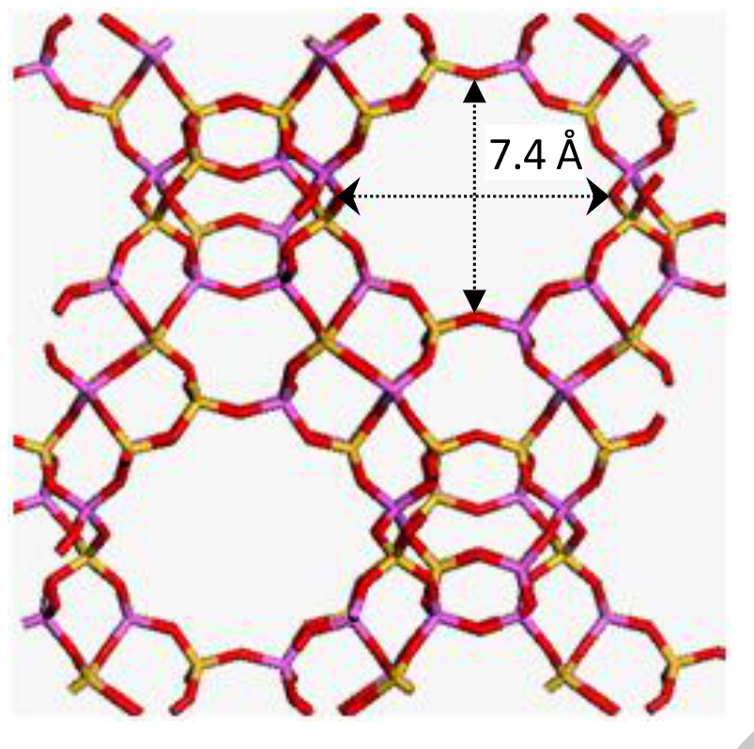
Figure 2.1: Structure of Y-zeolite showing the average micropore width in the supercage formed by the twelve membered ring. Source: Etim, Xu, Ullah and Yan (2016), Figure 1
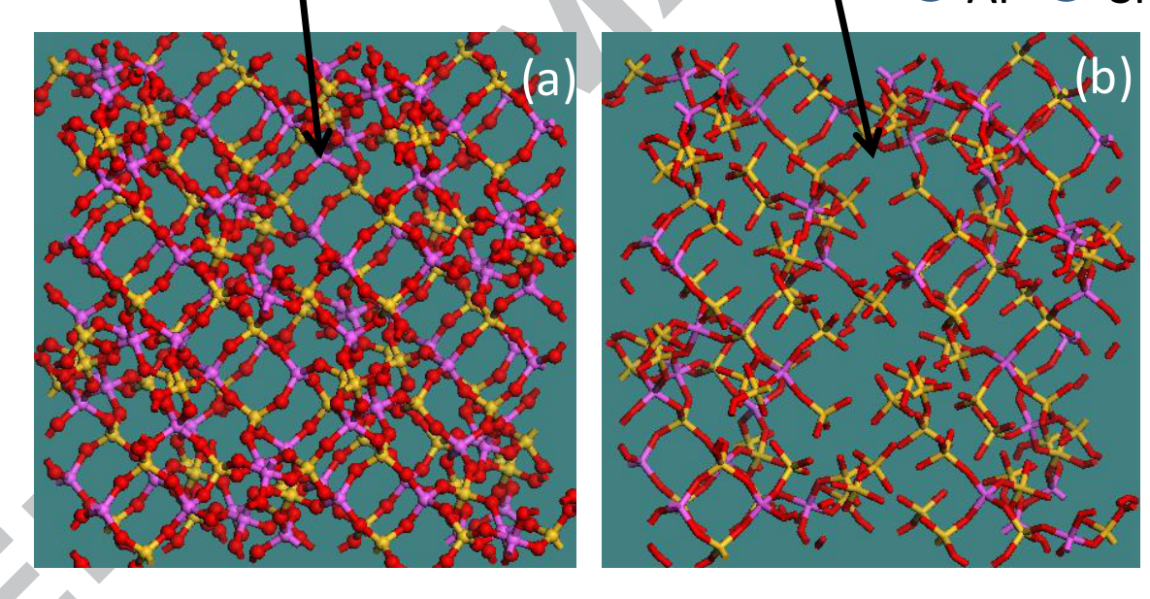
Figure 2.2: Three dimensional atomistic model of the faujasite structure, (a) with full framework aluminium atoms and (b) with partial framework aluminium atoms. Source: Etim, Xu, Ullah and Yan (2016), Figure 12
Substituting a trivalent aluminium for a tetravalent silicon leaves the framework one negative charge short. A proton on a nearby bridging oxygen restores neutrality and creates the Brønsted acid site, written here as Al(OH)Si. That proton is the whole point of the catalyst: it is what a hydrocarbon molecule takes when it cracks. It follows that any chemistry which removes aluminium from the framework, or which covers that proton, removes activity, and that the number of acid sites and the number of framework aluminium atoms are the same number.
2.4 How the Framework Breaks: Steam Dealumination
The catalyst circulates continuously between a riser, where it cracks feed and collects coke, and a regenerator, where air burns the coke off. Burning hydrocarbon coke produces water, and the stripping steam adds more, so a regenerator atmosphere is typically about 20 per cent steam at roughly 730 °C and 2 atm. Steam attacks the framework whether or not any metal is present.
The attack is a hydrolysis. Each of the four aluminium oxygen bonds is broken in turn by a water molecule, and the pieces are capped: the oxygen left behind on the silicon becomes a silanol, and the hydroxyl goes to the aluminium. Writing the intact framework site as Al(OSi)₄H, where H is the single Brønsted proton, the sequence ends as
Al(OSi)₄H + 3 H₂O ⇌ Al(OH)₃ + 4 ≡Si–OH
(2.1)
Al(OH)₃ + H₂O ⇌ Al(OH)₃(H₂O)
(2.2)
Equation 2.1 is the dealumination step proper. It costs one Brønsted acid site and leaves behind the four silanol groups known as a silanol nest. Equation 2.2 hydrates the detached aluminium hydroxide into the extra framework species that then sits in the pores.
The first computation of this whole sequence came from Malola et al. (2012), who ran periodic density functional theory with the PBE functional on chabazite and traced the path with the nudged elastic band method. They reported that at least three water molecules are needed to detach aluminium as Al(OH)₃, that a fourth water gives the more stable Al(OH)₃(H₂O), and that the effective barrier is 190 kJ mol⁻¹ when each incoming water is counted from the gas phase and 260 kJ mol⁻¹ when it is counted from an adsorbed state. Desilication costs 40 to 50 kJ mol⁻¹ more, so aluminium is the easier atom to remove, which is the experimental observation. The rate determining step is not a hydrolysis at all but the inversion of a hydroxyl group.
The computed reaction paths are reproduced as Figure 2.3, and the individual reaction steps as Figure 2.4. Together they show why the mechanism is described as a sequence: each step is a hydrolysis in which a water molecule is consumed, an aluminium oxygen bond is replaced by a hydroxyl on the silicon and a hydroxyl on the aluminium, and the aluminium is progressively loosened until it leaves.
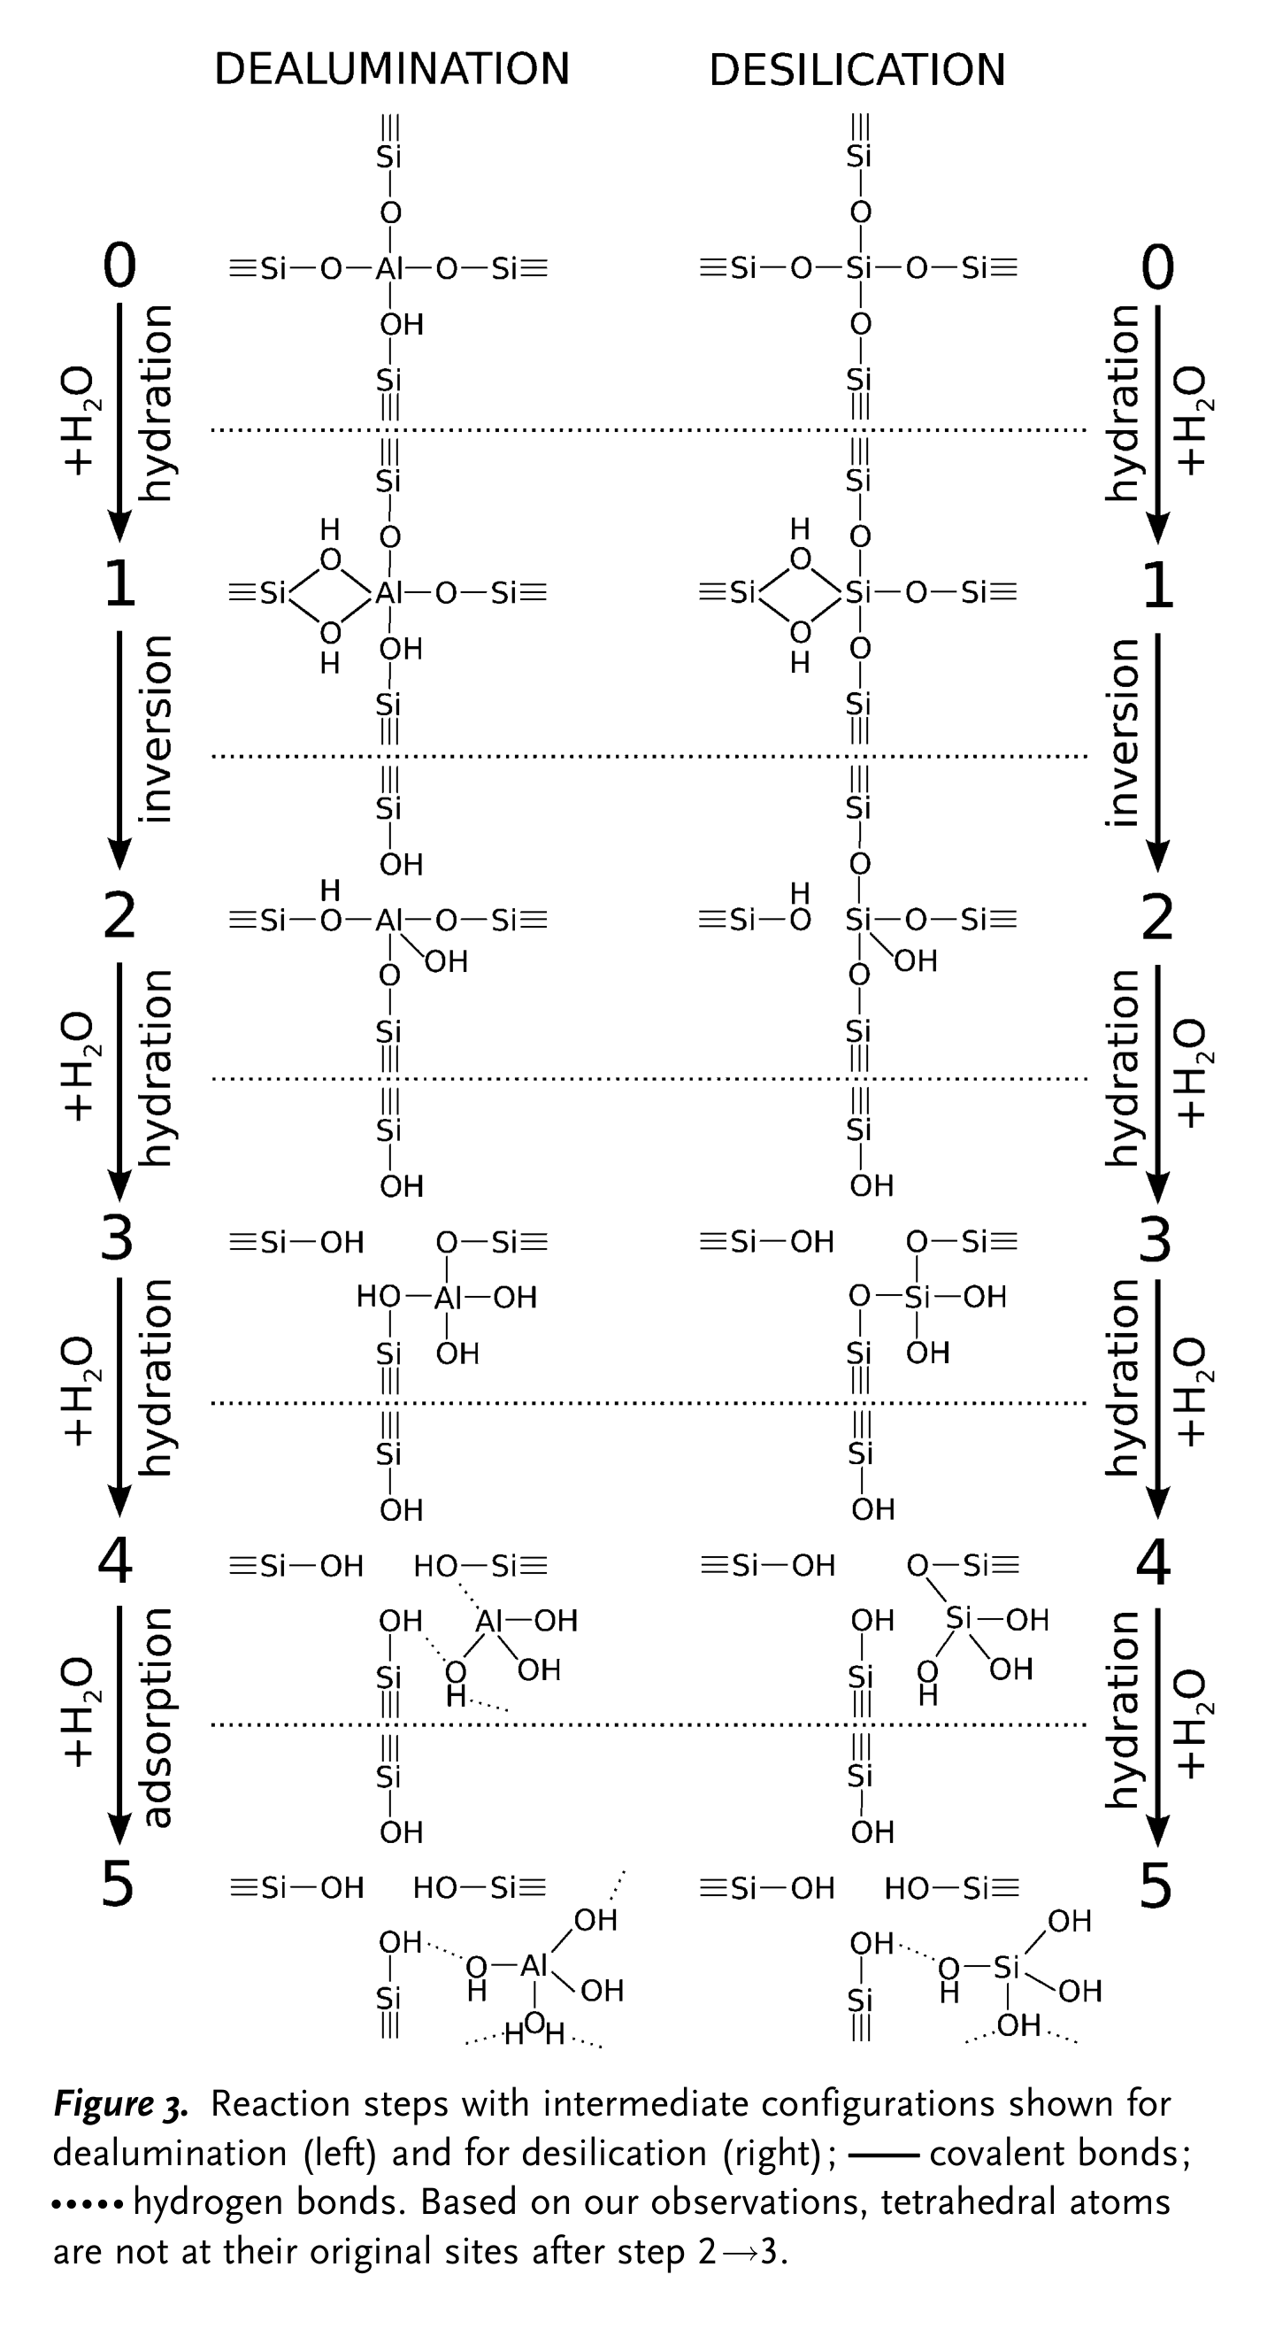
Figure 2.3: Reaction paths for (a) dealumination and (b) desilication, combined from five nudged elastic band paths. Black lines, approach A, counting each incoming water from the gas phase; purple lines, approach B, counting it from an adsorbed state. The effective barriers for both approaches are labelled. Source: Malola, Svelle, Lønstad Bleken and Swang (2012), Figure 2
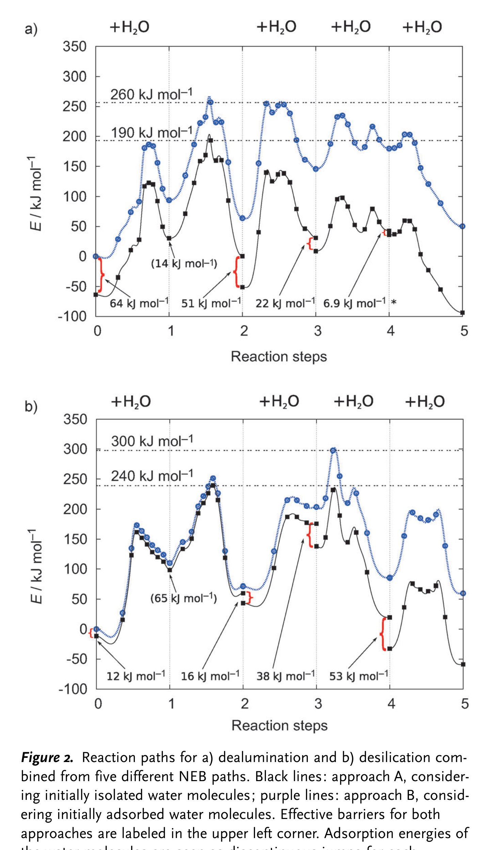
Figure 2.4: Reaction steps with the intermediate configurations for dealumination, left, and for desilication, right. c denotes a covalent bond and g a hydrogen bond. Source: Malola, Svelle, Lønstad Bleken and Swang (2012), Figure 3
Silaghi, Chizallet, Sauer, and Raybaud (2016) extended this to four frameworks including faujasite, using periodic density functional theory with dispersion corrections and free energy estimates. They found a broadly common mechanism: water adsorbs on the aluminium atom in the position anti to the Brønsted proton, then the aluminium oxygen bonds hydrolyse one after another until the aluminium is dislodged as Al(OH)₃(H₂O), and they were able to fit Brønsted Evans Polanyi relationships across the whole path.
Two things follow for the present work. First, steam dealumination is a well understood, quantified baseline, with a barrier in the region of 190 to 260 kJ mol⁻¹. Second, the mechanism is stepwise hydrolysis of aluminium oxygen bonds by water molecules that adsorb on the aluminium itself. Any claim that vanadic acid accelerates this must explain how an acid, arriving with far fewer molecules, competes with that.
2.5 Vanadium: From Porphyrin to Volatile Acid
Vanadium enters the unit inside porphyrin and porphyrin like complexes in the residue. Mitchell (1980) showed that these molecules are too large to enter the zeolite pores, so the metal is deposited on the outside of the catalyst particle together with the coke, and that synthetic deposition reproduces the effects seen on equilibrium catalyst. Once in the regenerator the organic ligands burn away and the vanadium oxidises. Under regenerator conditions vanadium pentoxide is molten, with a melting point near 690 °C, and this mobility is part of how it spreads.
Wormsbecher et al. (1986) identified the mobile species as volatile vanadic acid, produced by
V₂O₅ + 3 H₂O(g) ⇌ 2 H₃VO₄(g)
(2.3)
and estimated its regenerator concentration at 1 to 10 ppm for 730 °C, 20 per cent steam and 2 atm total pressure. Because vanadic acid is a strong acid comparable with phosphoric acid, they argued it hydrolyses the silica alumina framework, and on the strength of that reasoning they proposed and demonstrated basic alkaline earth oxides, especially magnesia, as scavengers.
Trujillo et al. (1997) tested the vanadium speciation directly with electron spin resonance and diffuse reflectance spectroscopy on two USY zeolites. Their results refine the picture in three ways. Vanadium deposited on the external surface migrates inward, and water assists but is not essential for that migration. Under the strongly reducing conditions of the riser, vanadium cannot persist as V(V), so the damage must occur in the regenerator and not during stripping. Most importantly, V(IV) does not carry the destruction. A zeolite exchanged so that its vanadium sat at the acid sites was steamed in a reducing atmosphere of steam with carbon monoxide in nitrogen and lost no more structure than a vanadium free sample steamed the same way, whereas the same material steamed in steam and air collapsed completely. Trujillo et al. (1997) called this a real proof that vanadium must be present as V(V) to catalyse the destruction. Figure 2.5 shows why the two regimes differ: the fraction of the total vanadium present as V(IV) falls away as the calcination temperature rises, so the destructive oxidising regime is also the regime in which V(V) dominates.
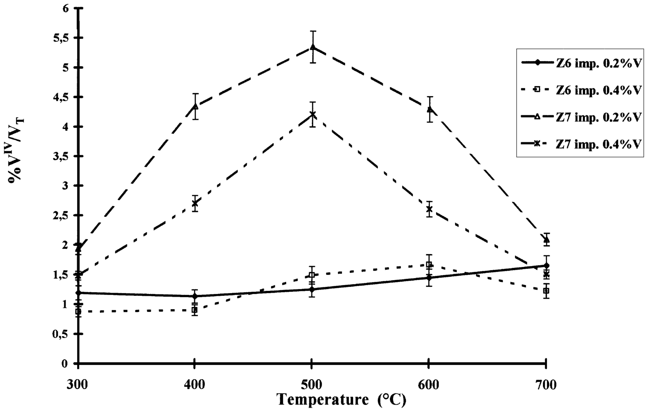
Figure 2.5: Percentage of the total vanadium present as V(IV) as a function of calcination temperature for impregnated zeolites. Source: Trujillo et al. (1997), Figure 3
Trujillo et al. (1997) also reported that extra framework aluminium competes with the zeolite for vanadium and delays its arrival at the acid sites, which is one reason a zeolite that already contains extra framework aluminium survives longer. Instead, they proposed the two step sequence
V₂O₅ + 2 H⁺–Y ⇌ 2 VO₂⁺–Y + H₂O
(2.4)
VO₂⁺–Y + 2 H₂O ⇌ H⁺–Y + H₃VO₄
(2.5)
in which vanadium(V) is first trapped at the acid site as a cationic species, poisoning the site reversibly, and is then mobilised again by steam as vanadic acid. They offered this as an explanation of how a small amount of vanadium can do large damage, and they noted that vanadic acid has a pK of 0.05, so it is genuinely a strong acid.
They also raised the objection that has never been fully answered. A typical feed carries about 1 per cent sulfur, of which 5 to 10 per cent reaches the regenerator in the coke and is oxidised, giving a minimum sulfur trioxide or sulfuric acid concentration near 60 ppm. Sulfuric acid is stronger than vanadic acid and at least an order of magnitude more abundant. If acid catalysed hydrolysis of framework aluminium were the mechanism, the sulfur acid should dominate, and it does not destroy zeolite. Trujillo et al. (1997) answered their own objection by proposing that vanadic acid reaches a much higher local concentration inside the zeolite than in the bulk gas, and by recomputing the bulk equilibrium at 1.7 ppm, arguing that the true bulk value must be below 1 ppm, since otherwise all the vanadium would leave with the flue gas instead of accumulating on the catalyst.
2.6 The Dispute: Three Explanations, and What Each Has to Explain
The literature has settled on three accounts of vanadium induced destruction. They are set out side by side in Figure 2.6, together with the source that states each one most clearly.
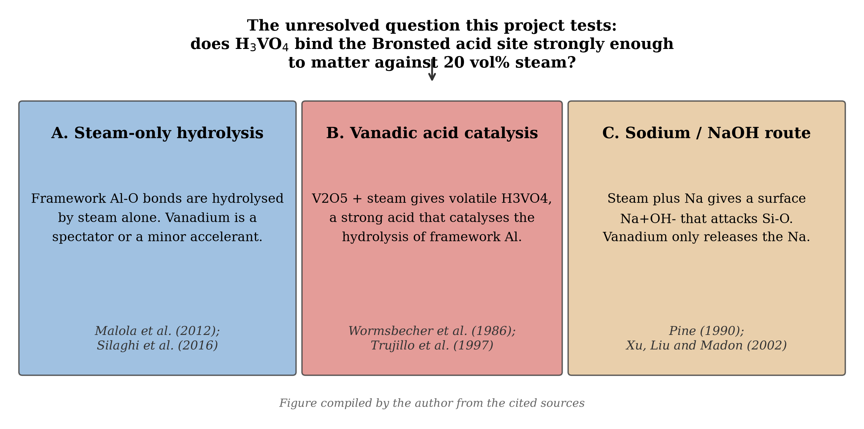
Figure 2.6: The three competing explanations for vanadium induced destruction of zeolite Y, and the question this project tests. Source: compiled by the author from Malola et al. (2012), Silaghi et al. (2016), Wormsbecher et al. (1986), Trujillo et al. (1997), Pine (1990) and Xu et al. (2002)
The first account is that steam alone does it and vanadium is a spectator or a minor accelerant. This is the position implied by the computational work of Malola et al. (2012) and Silaghi et al. (2016), which obtains a full dealumination mechanism without any metal at all, and it is supported by the fact that zeolite Y is deliberately steamed during manufacture.
The second account is the vanadic acid hypothesis of Wormsbecher et al. (1986) as refined by Trujillo et al. (1997): volatile H₃VO₄ is a strong acid that catalyses the hydrolysis of framework aluminium and is regenerated rather than consumed, which is how a little vanadium destroys a lot of zeolite. This is the most widely quoted mechanism and the one assumed in most reviews of metal passivation, including the recent one by Adanenche et al. (2023).
Trujillo et al. (1997) also set out how the hydrolysis itself proceeds, in Figure 2.7, which places Kerr's scheme for dealumination above a more detailed picture in which the hydronium ion attacks the negatively charged oxygen of the acid site and a water molecule is inserted into the structure. On this picture, the reason a sodium counter ion accelerates the loss is that it raises the negative charge density on that oxygen, so the attack is faster.
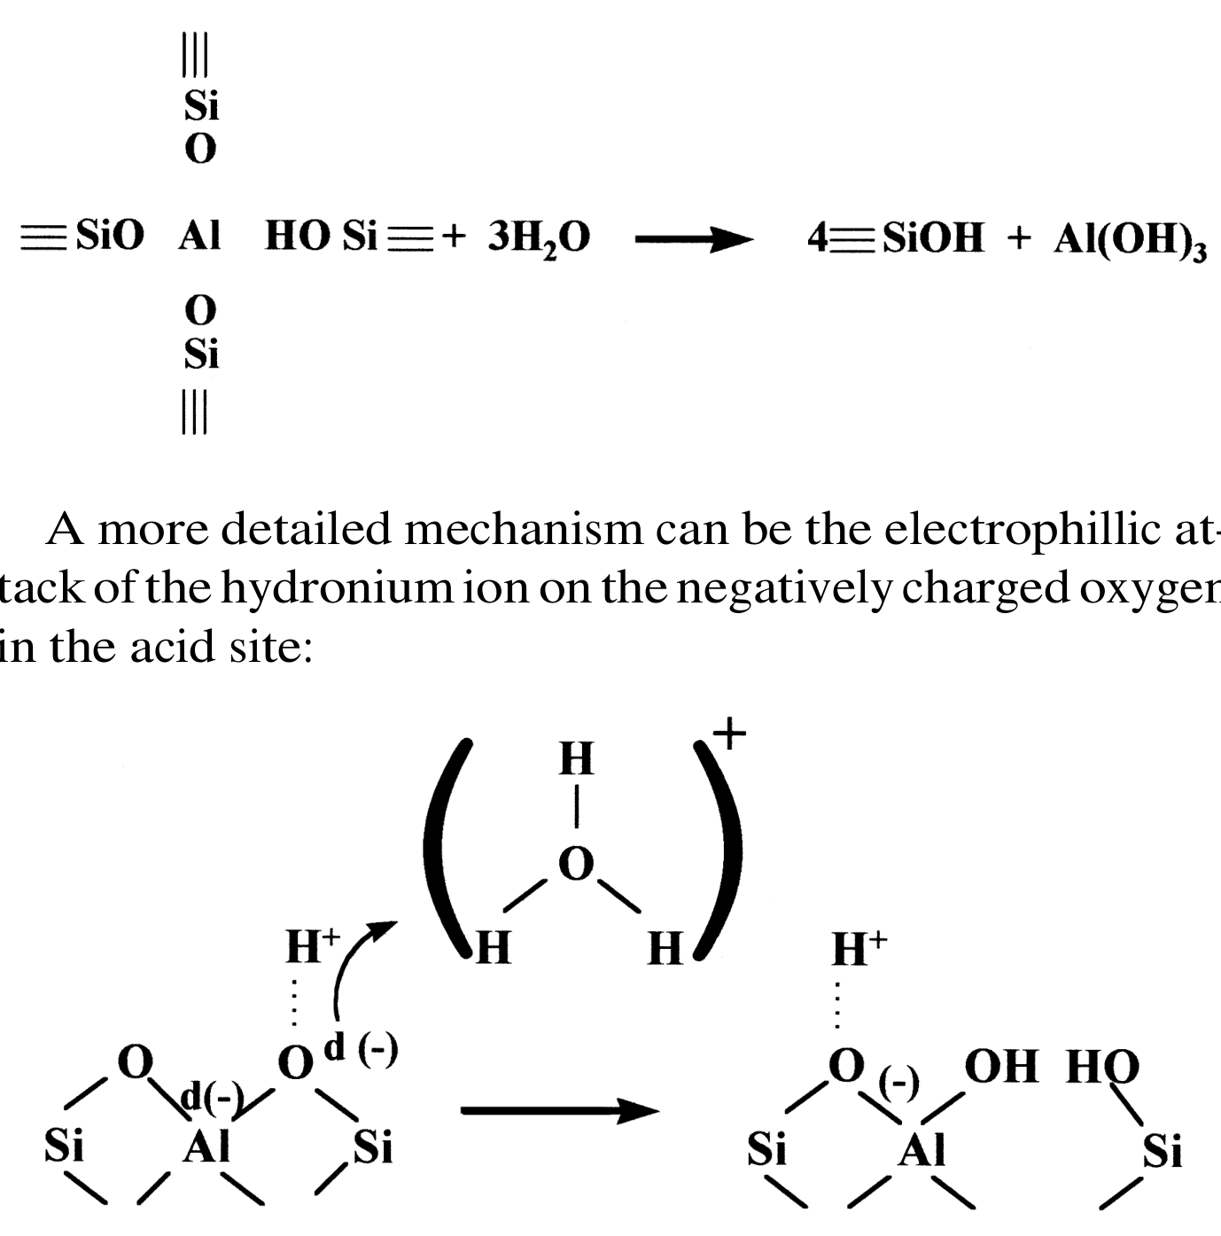
Figure 2.7: Kerr's scheme for zeolite dealumination, above, together with the electrophilic attack of the hydronium ion on the negatively charged oxygen of the acid site, below. Source: Trujillo et al. (1997), page 14
The third account denies that vanadium opens a new pathway. Pine (1990) measured the kinetics of USY destruction between 740 and 800 °C at 1 atm of steam with 0 to 4000 ppm of vanadium. He found first order kinetics with no induction period, an activation energy of 79.0 kcal mol⁻¹ (about 331 kJ mol⁻¹), and rate constants directly proportional to vanadium loading. Because the data taken with vanadium extrapolate cleanly to the data taken without it, he concluded that the reaction under study is ordinary steam destruction and that vanadium and sodium are both catalysts of that same reaction, nearly equal in activity and synergistic. Two of his observations are hard to reconcile with the vanadic acid hypothesis. Vanadium attacks silicalite, a zeolite that is essentially aluminium free, so the attack cannot be confined to aluminium sites. And the activation energy is the same whether vanadium is present or not, which means the kinetically significant step does not involve vanadium.
Xu et al. (2002) took the third account further and gave it a mechanism. Working with USY of high and low unit cell size and with two commercial catalysts, they showed that the effect of vanadium depends almost entirely on how much exchangeable sodium is present. Cutting sodium oxide from 1.19 to 0.03 weight per cent on the zeolite reduced the vanadium effect by a factor of about five, and a catalyst whose sodium was locked up in an amorphous matrix was barely affected by 4200 ppm of vanadium at all. They then tested model compounds on a highly siliceous USY that is stable to steam, with the result shown in Figure 2.8. Sodium metavanadate destroys the zeolite only when steam is present; ammonium metavanadate, which gives metavanadic acid but no sodium, destroys very little even at 8000 ppm of vanadium; and sodium nitrate, which gives sodium but no vanadium, destroys a great deal once steam is available. From this they argued that metavanadic acid acts as a catalyst that strips sodium off its exchange site, and that the sodium hydroxide so formed does the damage:
HVO₃ + Na⁺–Y ⇌ NaVO₃ + H⁺–Y
(2.6)
NaVO₃ + H₂O ⇌ HVO₃ + NaOH
(2.7)
NaOH ⇌ Naᵟ⁺OHᵟ⁻ (in steam)
(2.8)
followed by attack of the polarised hydroxide on a framework silicon oxygen bond. Their full scheme is reproduced as Figure 2.9. On this reading, vanadium matters because it makes sodium available, the destructive agent is the same with or without vanadium, and the activation energy is therefore unchanged, exactly as Pine (1990) observed. They also addressed the sulfur puzzle that had troubled Trujillo et al. (1997): sulfur oxides cannot do what vanadium does, because only vanadium forms a mobile acid that can pull a cation off an exchange site and then release it again.
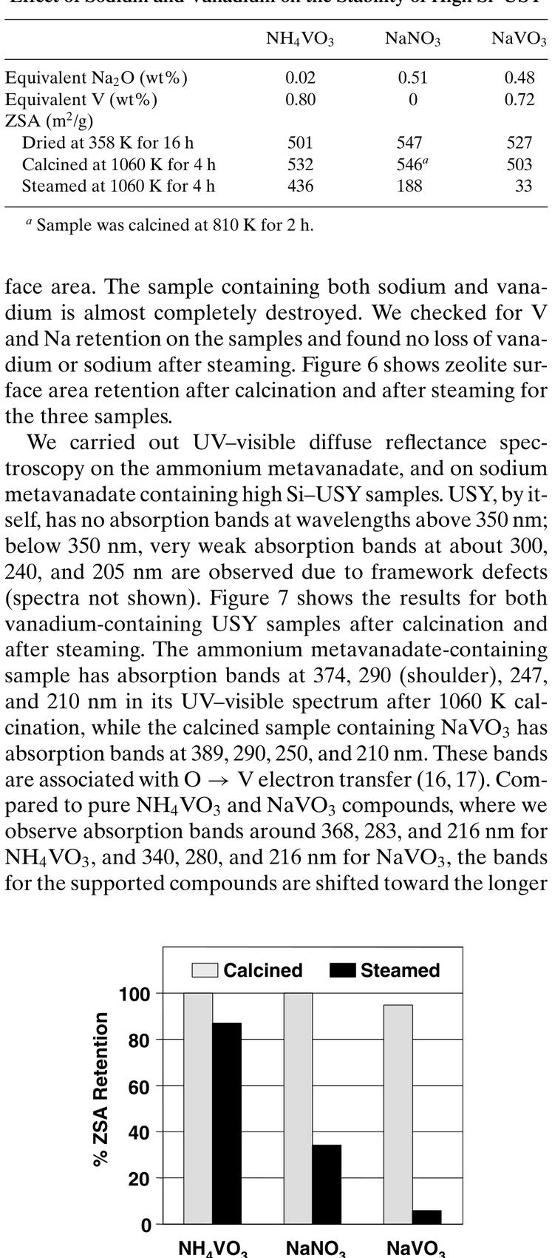
Figure 2.8: Retention of zeolite surface area after thermal and hydrothermal treatment of a highly siliceous USY carrying ammonium metavanadate, sodium nitrate and sodium metavanadate. Source: Xu, Liu and Madon (2002), Figure 6
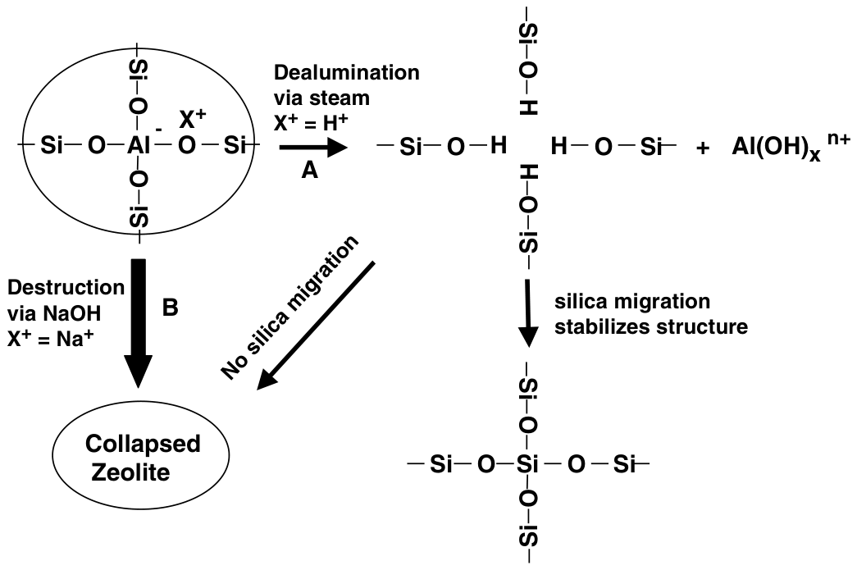
Figure 2.9: Pathways to zeolite Y destruction as proposed by Xu, Liu and Madon, in which steam hydrolysis of framework aluminium and attack by sodium hydroxide are the only two destructive routes and vanadium acts only to release sodium. Source: Xu, Liu and Madon (2002), Figure 8
Trujillo et al. (1997) themselves conceded the weakness in their own account. They wrote that an acid hydrolysis mechanism does not explain why two chemically different species, sodium and vanadium, produce similar effects and act synergistically, and they sketched an electrophilic attack by the hydronium ion on the negatively charged framework oxygen, arguing that a sodium counter ion raises the negative charge density on that oxygen and therefore speeds the hydrolysis. This is an admission that the vanadic acid hypothesis, as stated, is incomplete rather than a demonstration that it is wrong.
What separates the accounts is therefore a single measurable quantity. If vanadic acid is to be the destructive agent, it must win the acid site against steam, which is present at a partial pressure roughly 10⁴ to 10⁵ times larger. Steam does not have to be chemically superior to win; it only has to be numerous. The sodium route requires no such win, because it does not rely on vanadic acid holding the site at all. This project computes the missing number.
2.7 What the Damage Looks Like
Whatever the route, the result is visible. Etim, Xu, Ullah, and Yan (2016) contaminated ultra stable Y zeolite with 0.3 and 0.5 weight per cent vanadium, steamed it, and characterised it with X ray diffraction, nitrogen adsorption, transmission electron microscopy and solid state nuclear magnetic resonance. In the presence of steam, vanadium produced excessive evolution of non intercrystalline mesopores averaging about 25.0 nm at 0.5 weight per cent vanadium, far larger than the mesopores in hydrothermally optimised FCC zeolites, together with about 80 per cent loss of BET surface area. The micrographs in Figure 2.10 show the corresponding destruction of the crystal. Their vanadate immobilisation experiments also showed that vanadium is mobile under reaction conditions, and that a passivator which immobilises it limits both its mobility and its acidity, which is why crystallinity survives.
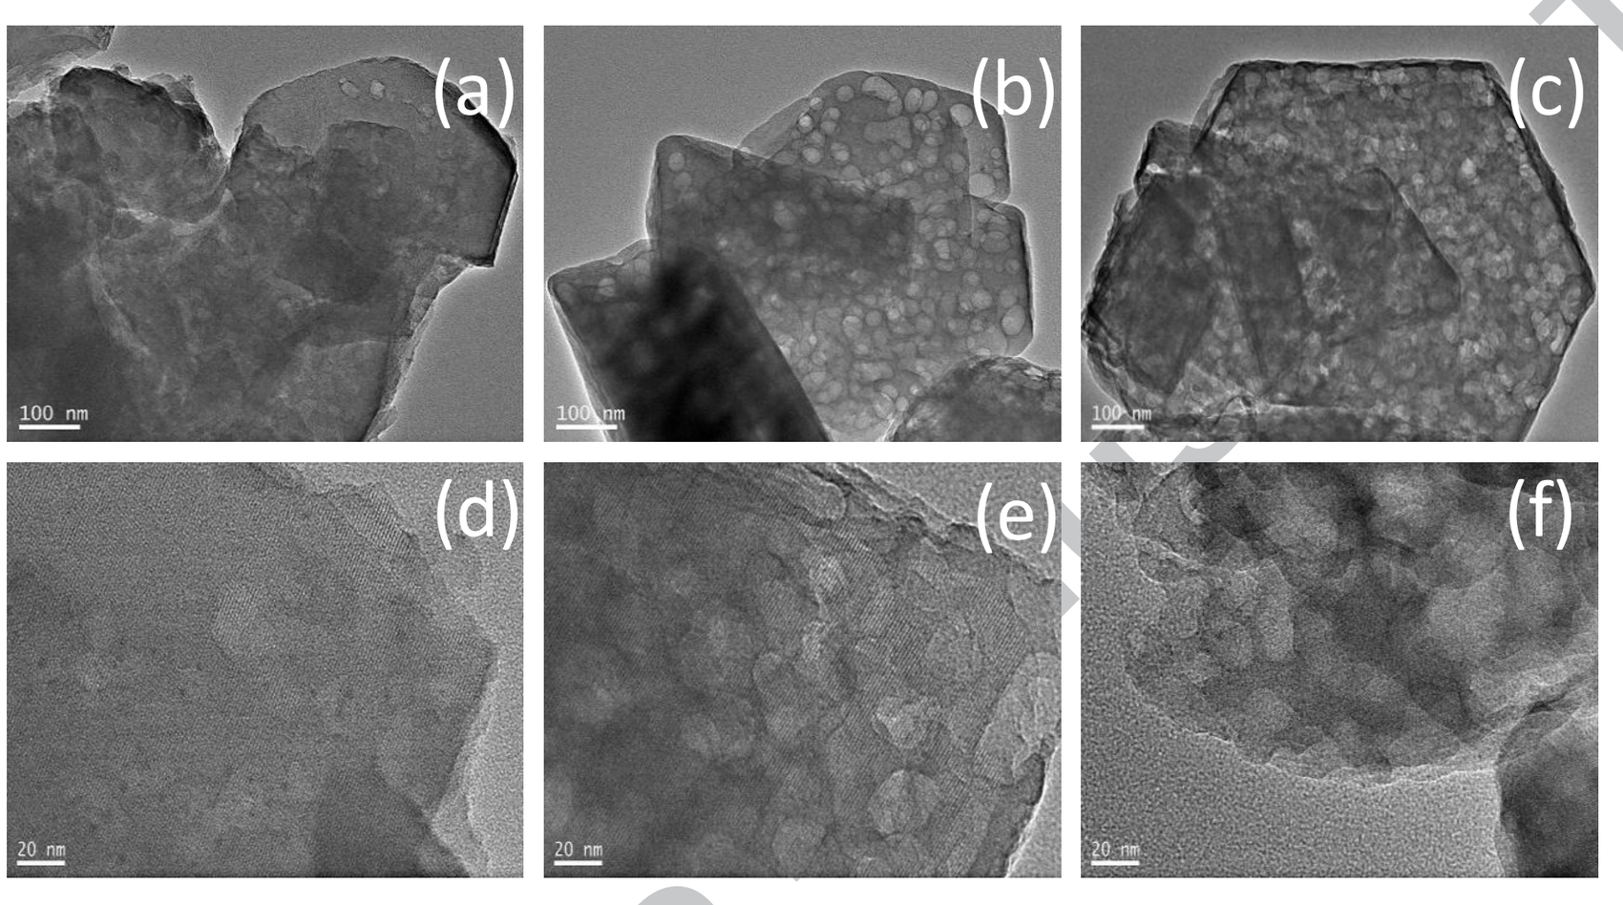
Figure 2.10: Transmission electron micrographs of ultra stable Y zeolite before and after vanadium contamination and steaming. Source: Etim, Xu, Ullah and Yan (2016), Figure 8
2.8 Holding the Poison Back
Because vanadium cannot be removed from the feed economically, it is managed on the catalyst. The principle was established by Wormsbecher et al. (1986), who argued on acid base grounds that a basic solid with a suitable pore structure should out compete the zeolite for vanadic acid, and showed that 20 per cent magnesia blended into the catalyst preserved activity at vanadium loadings of 0.67 and 1.34 weight per cent. They also identified the complication that regenerator sulfur dioxide can sulfate the oxide and compete with vanadate formation.
Progress since then has been in the choice of trap. Etim, Bai, Ullah, Subhan, and Yan (2018) prepared a mixed magnesium yttrium oxide and showed by X ray diffraction that vanadium is preferentially captured as crystalline yttrium vanadate, YVO₄, and that the protection follows the amount of trap added (Figure 2.11). Their passivation mechanism is again acid base chemistry: mobile vanadic acid meets a more basic oxide, forms an immobile vanadate, and so never reaches the zeolite. Faghani, Mohammadipour, Tarighi, Naderifar, and Habibzadeh (2024) took the same idea to barium titanate and reported that 10 weight per cent of it preserved 18.7 per cent more crystalline structure and 12 per cent more surface retention at 6000 ppm of vanadium. Adanenche et al. (2023) surveyed the field and concluded that alkaline earths, rare earths, tin, boron, antimony and bismuth are all in use, and that the persistent problem with alkaline earths is that they also form silicates and lose capacity.
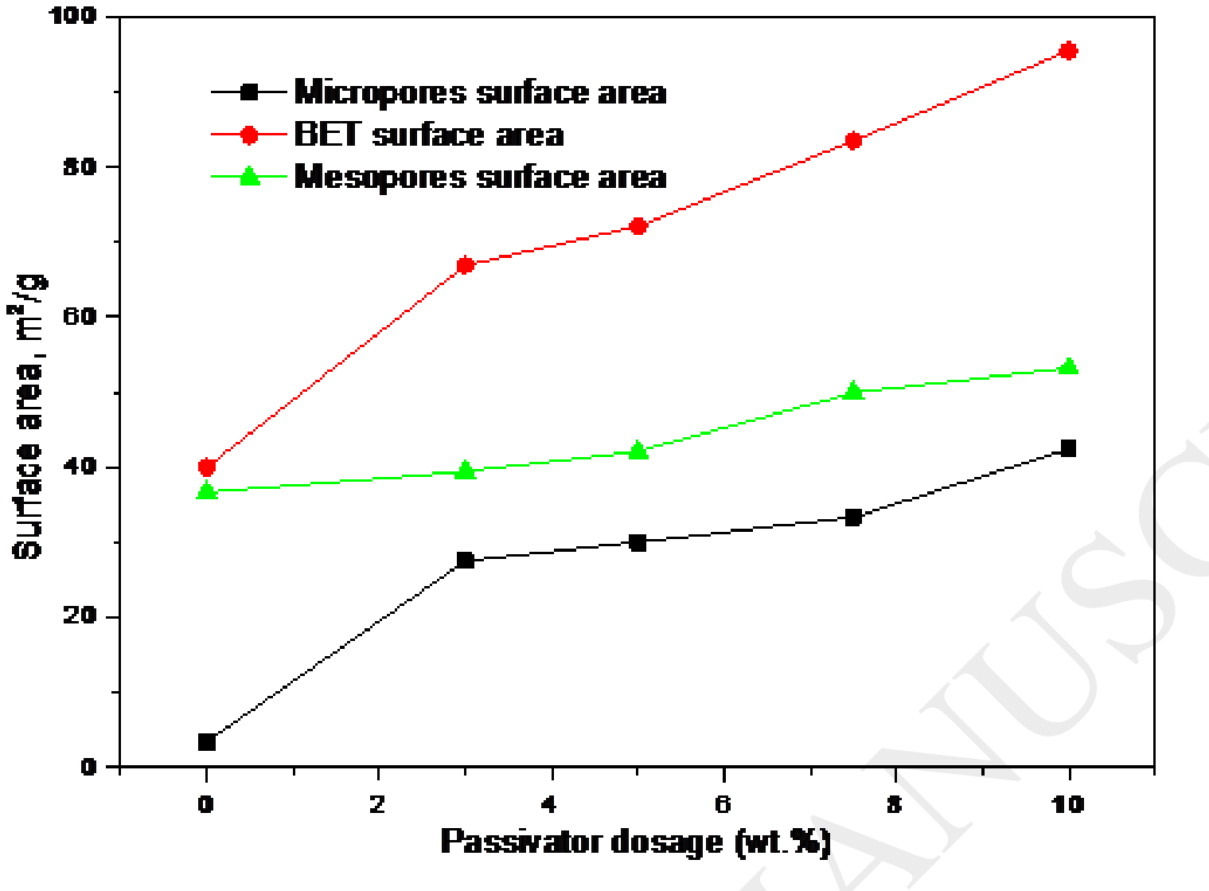
Figure 2.11: Effect of a magnesium yttrium oxide passivator on the surface areas of vanadium contaminated catalyst. Source: Etim, Bai, Ullah, Subhan and Yan (2018), Figure 8
The engineering question behind all of this is quantitative and still open. A trap has to bind vanadic acid more strongly than the zeolite does. Nobody knows how strongly the zeolite binds it, so trap selection proceeds by screening. The number this project computes is exactly the number a trap has to beat.
2.9 Computational Chemistry as a Way In
The reason the dispute has lasted forty years is that the decisive events are small, fast and buried inside a hot, opaque solid. Quantum chemistry offers a way to compute the energies of species that cannot be isolated.
Density functional theory obtains the ground state energy and electron distribution of a system from its electron density rather than from a many electron wavefunction, which makes it affordable for systems of tens to hundreds of atoms. In practice a calculation is specified by a functional, which approximates the exchange and correlation energy, and a basis set, which is the set of functions used to represent the orbitals. This work uses two hybrid functionals, B3LYP (Becke, 1993; Lee, Yang, & Parr, 1988) and PBE0 (Adamo & Barone, 1999), with the def2 TZVP basis set of Weigend and Ahlrichs (2005), and adds Grimme's D3 dispersion correction with Becke Johnson damping (Grimme, Ehrlich, & Goerigk, 2011) because plain functionals describe weak long range attraction poorly, and adsorption is dominated by it. Doing the work twice with two different functionals is a cheap way to find out whether a conclusion belongs to the chemistry or to the approximation.
The alternative for screening is a semi empirical method, in which parts of the quantum mechanical problem are replaced by parameters fitted to reference data. GFN2 xTB, the method used in the first tier here, is a self consistent tight binding scheme with multipole electrostatics and density dependent dispersion, parametrised across the periodic table to Z = 86 (Bannwarth, Ehlert, & Grimme, 2019). It is orders of magnitude cheaper than density functional theory and is designed to give good geometries and reasonable non covalent interactions, which makes it well suited to searching a potential energy surface for candidate structures that are then refined properly. All calculations in this project were run with the ORCA package (Neese, 2025).
Computational work on zeolites is mature. Dealumination has been mapped as described in section 2.4. Vanadium in zeolites has also been studied, though for a different purpose: Tielens and Dzwigaj (2010) used periodic density functional theory with pyridine adsorption infrared spectroscopy to characterise the acid base character of framework vanadium sites, and showed that the V–OH groups of framework V(V) and V(IV) are more acidic than the Si–OH groups of a siliceous zeolite (Figure 2.12). That is vanadium as a deliberate catalytic centre, not vanadium as a poison, but it establishes that vanadium in a zeolite framework is computationally tractable and that its acidity can be quantified.
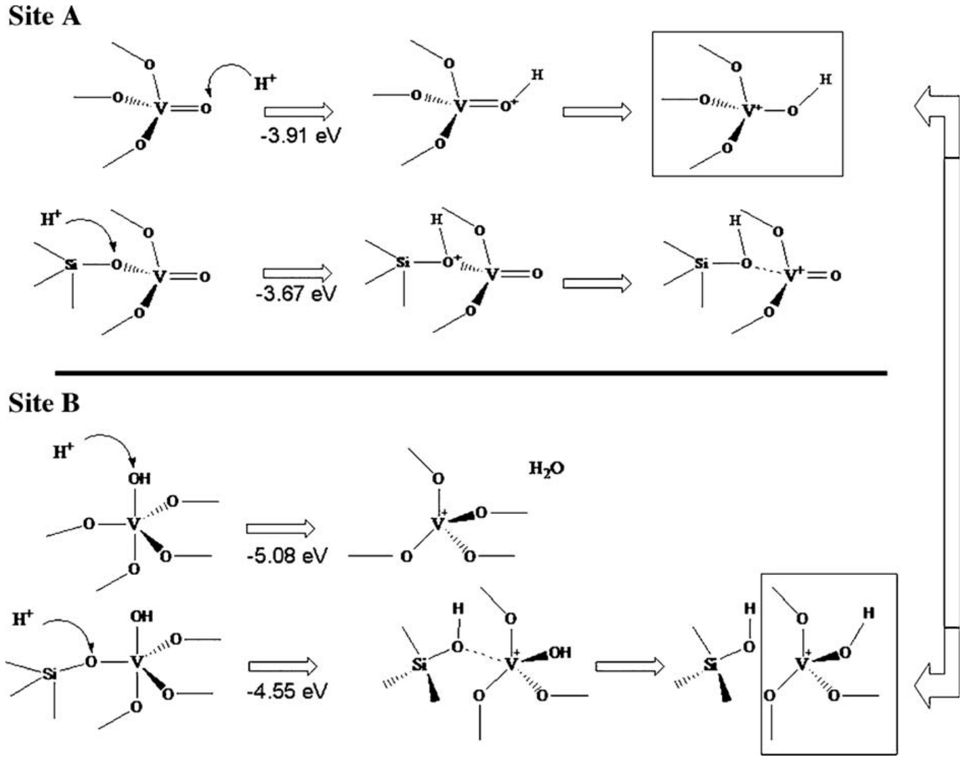
Figure 2.12: Framework vanadium sites in a sodalite model, showing protonation of sites A and B in the V(V) state. Source: Tielens and Dzwigaj (2010), Figure 2
The same approach is established in this department. Uzochukwu et al. (2023) modelled the formation of a choline chloride and glycerol deep eutectic solvent with semi empirical, Hartree Fock and density functional methods on a mobile workstation, computed binding energies with and without correction for basis set superposition error, and used the results to rank formation pathways by thermodynamic feasibility. The present work applies the same logic to a different problem: rank two competing adsorbates by how strongly they hold a site, and ask whether the ranking is large enough to matter.
2.10 The Gap This Study Fills
Three things are missing from the literature as reviewed. First, no published value exists for the binding energy of vanadic acid at a faujasite Brønsted acid site computed at a modern hybrid density functional level and compared, within the same model and at the same level of theory, with water. Reviews of vanadium poisoning continue to assert that vanadic acid attacks the framework, but the assertion has not been tested against the obvious competitor. Second, the strongest experimental case against the vanadic acid hypothesis, that of Pine (1990) and Xu et al. (2002), rests on kinetic arguments and on the behaviour of model compounds; it has not been examined from the adsorption side. Third, the local computational literature has applied these methods to solvent design but not to catalyst deactivation.
This study fills the first gap, speaks to the second, and begins the third. It does not attempt to simulate a full catalytic cycle, and it does not claim to have validated the whole mechanism. It computes the one number that decides whether the vanadic acid hypothesis is even viable, and then asks what that number means under regenerator conditions.
A note on novelty, stated plainly. This is not the first density functional study of zeolite dealumination, which is due to Malola et al. (2012) and was extended by Silaghi et al. (2016), and it is not the first density functional study of vanadium in a zeolite, which includes Tielens and Dzwigaj (2010). To the best of the author's knowledge after searching the literature, no previous study has placed vanadic acid and water on the same faujasite Brønsted acid site at the same level of theory and reported the difference in their binding energies, which is the comparison the vanadic acid hypothesis requires and which is reported in Chapter Four.

CHAPTER THREE

METHODOLOGY
3.1 Research Design
The study is entirely computational. It uses a two tier design, in which a cheap method explores the potential energy surface and an expensive method refines whatever the cheap method finds. The arrangement is shown in Figure 3.1. Tier 1 used the semi empirical GFN2 xTB method to optimise reactants and complexes, to scan for candidate saddle points, and to screen out structures that were not worth the cost of a density functional calculation. Tier 2 took the accepted Tier 1 geometries and refined them with dispersion corrected hybrid density functional theory, evaluated them again with a second functional, and computed harmonic frequencies for the thermochemistry. Nothing was carried into the second tier that had not passed a written acceptance test in the first.
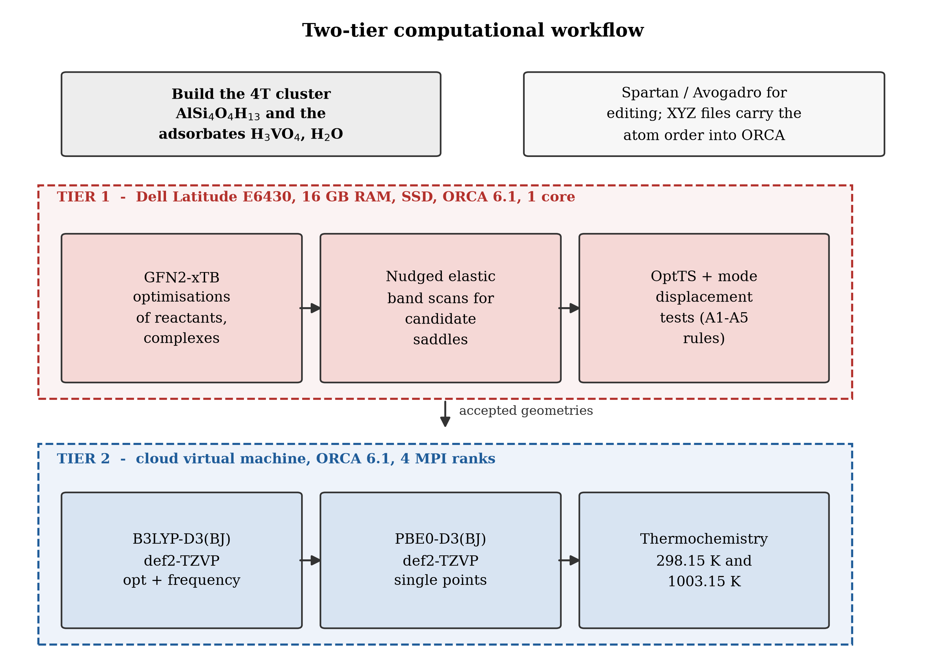
Figure 3.1: The two tier computational workflow used in this study. Source: author
The reason for two tiers is arithmetic. A single density functional optimisation of the vanadic acid complex took about five and a half hours on the machine used, and a saddle point search took more than a day. GFN2 xTB completes the same size of job in minutes, so the search space can be explored broadly before anything expensive is attempted.
3.2 Hardware and Software
Tier 1 was run on the author's own Dell Latitude E6430 laptop with an Intel Core i5 processor, 16 GB of RAM and a solid state drive, using a single core. Tier 2 was run on a cloud virtual machine with four MPI ranks, because the density functional jobs did not fit the time available on the laptop.
All quantum chemical calculations were performed with ORCA 6.1 (Neese, 2025). Structures were built and edited in Spartan and Avogadro and exported as Cartesian coordinates. Energy differences, frequency counts and thermochemical corrections were extracted from the ORCA outputs with purpose written Python scripts that are included in the repository, so that every number in Chapter Four can be recomputed from the raw output files. All graphs and molecular pictures were drawn with the matplotlib library from the same scripts.
The file types used, and where each one is opened, are listed in Table 3.1.
Table 3.1: File types used in this project and the software used to open them
Extension | What it holds | Open with
.mol | Structures with an explicit bond table, used for hand editing and visual checking | Spartan, Avogadro
.xyz | Cartesian coordinates only, used as ORCA and xTB input | ORCA, Avogadro, VMD
.inp | The ORCA input deck: method, basis set, job type, geometry | any text editor
.out | The ORCA log: energies, gradients, frequencies, thermochemistry | any text editor, or the audit scripts
_trj.xyz | Every geometry visited during an optimisation | VMD, Avogadro
.hess | The Hessian matrix and normal modes | ORCA, or read by the audit scripts
.gbw | The converged wavefunction, used to restart a job | ORCA only
.csv | The calculation register, manifests and the parsed results table | Excel, LibreOffice Calc, pandas

One practical warning is worth recording, because it cost time. XYZ files carry no bond information, so a viewer guesses bonds from interatomic distances and will sometimes draw bonds that the calculation does not contain. The energies returned by ORCA and xTB depend only on the atomic positions, the charge and the spin multiplicity, so a wrongly drawn bond is a display artefact and not an error in the calculation. The bond tables in the .mol files are the authoritative statement of intended connectivity.
3.3 The Zeolite Model
3.3.1 Cluster selection
Zeolite Y was represented by a cluster of four tetrahedral sites cut from the faujasite framework, of formula AlSi₄O₄H₁₃. The cluster contains the aluminium atom, its four framework oxygens, the four silicon atoms bonded to those oxygens, and thirteen hydrogen atoms: twelve capping hydrogens, three on each silicon, plus the single Brønsted proton. Twenty two atoms in total. This size was chosen because it is the smallest fragment that contains a complete Al(OH)Si bridge with its full first coordination sphere, while remaining cheap enough for frequency calculations and for the more than one hundred geometry steps that a saddle point search requires.
The alternative would have been a periodic calculation on the full unit cell. That would have removed the boundary problem and included the long range electrostatic field and the pore confinement, both of which are real effects in a zeolite. It was not affordable within the resources available, and it would have made the saddle point searches, which needed many restarts, impractical. The cost of the choice is discussed in section 3.10.
3.3.2 Validation of the cluster
A cluster model is only worth using if it reproduces the feature that makes the material a catalyst, so the optimised cluster was checked against that requirement. The aluminium sits in a tetrahedral environment with aluminium oxygen distances of 1.9192, 1.7161, 1.6947 and 1.6953 Å. The three shorter distances are ordinary aluminium oxygen single bonds in a zeolite framework, and the long one, 1.9192 Å, is the bond to the oxygen that carries the proton. The same asymmetry appears on the silicon side: the three unprotonated bridging oxygens sit between 1.6159 and 1.6234 Å from their silicon, while the protonated one sits 1.7179 Å away. Both elongations are the structural signature of Brønsted acidity described in the literature, and finding them in the model is the evidence that the cluster reproduces the essential electronic feature of the real acid site.
3.3.3 Boundary treatment
Cutting a cluster out of an infinite framework leaves bonds dangling. Each dangling bond was capped with a hydrogen atom placed along the direction of the bond that was cut, at a silicon hydrogen distance of 0.148 nm, which is the standard silicon hydrogen bond length. During every optimisation the positions of those twelve capping hydrogens were frozen at their crystallographic coordinates, while the aluminium, its four oxygens, the four silicons and the Brønsted proton were allowed to relax. Freezing the caps mimics the rigidity that the surrounding framework imposes and stops the small cluster from folding in on itself in ways the real solid cannot. A frozen boundary is a blunt instrument, and it is one of the reasons the saddle point search in this work behaved badly, as Chapter Four records.
The three reference species optimised at the density functional level are shown in Figure 3.2.
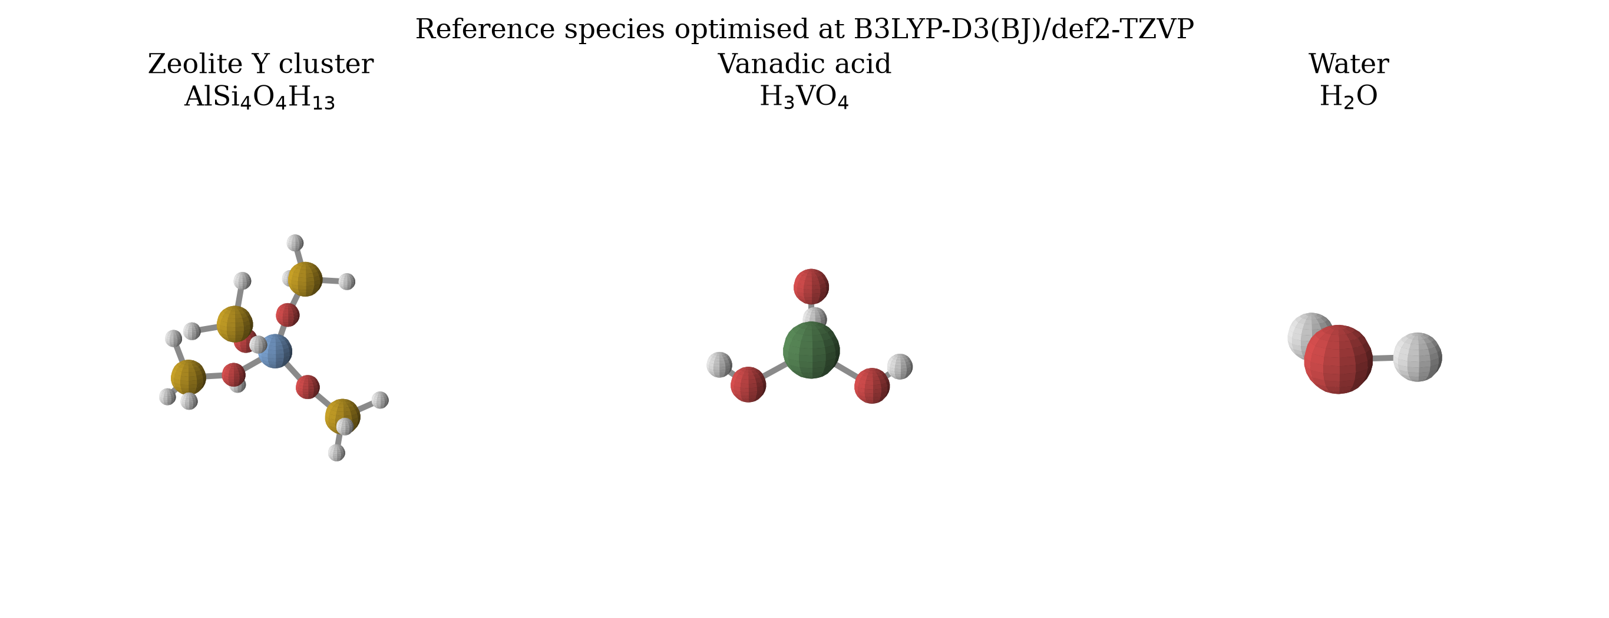
Figure 3.2: The four tetrahedral site faujasite cluster AlSi₄O₄H₁₃, vanadic acid and water, optimised at B3LYP D3(BJ)/def2 TZVP. Source: author, rendered from the optimised Cartesian coordinates
3.4 The Adsorbates
Vanadic acid, H₃VO₄, was built with vanadium in tetrahedral coordination, with one vanadyl V=O bond and three V–OH bonds, consistent with vanadium in the +5 oxidation state with a d⁰ configuration. Water was built at its experimental geometry. Both were optimised in isolation, without constraints, before being placed near the acid site. Charge was zero and multiplicity was one throughout, since every species in this study is a closed shell singlet.
3.5 The Reaction Sequence
The pathway was defined before any calculation was run, and it is stated here as chemical equations rather than as a diagram, because the equations say exactly what bonds are supposed to change. The intact acid site is written Z–OH, where Z stands for the rest of the cluster.
The vanadic acid route is:
V₂O₅ + 3 H₂O ⇌ 2 H₃VO₄
(3.1)
Z–OH + H₃VO₄ → Z–OH···H₃VO₄
(3.2)
Z–OH···H₃VO₄ → V-I1
(3.3)
V-I1 → V-TS2‡ → V-I2
(3.4)
V-I2 → V-TS3‡ → V-P
(3.5)
Equation 3.1 is the regenerator reaction that makes the poison, taken from Wormsbecher et al. (1986), and is not calculated here. Equation 3.2 is the adsorption step that produces the pre reaction complex, V-PRC. Equation 3.3 is a rearrangement into a more strongly bound chemisorbed intermediate, V-I1. Equations 3.4 and 3.5 are the successive hydrolyses of framework aluminium oxygen bonds, each through a saddle point, ending at V-P, the state in which aluminium has been extracted from the framework. A dagger marks a saddle point.
The steam control route is the same sequence with water in place of vanadic acid:
Z–OH + H₂O → Z–OH···OH₂
(3.6)
Z–OH···OH₂ → W-TS‡ → W-P
(3.7)
W-P → Al(OH)₃ + 4 ≡Si–OH
(3.8)
Equation 3.6 gives the water pre reaction complex, W-PRC. Equation 3.7 is the first hydrolysis of a framework aluminium oxygen bond, and W-P is the hydrolysed product. Equation 3.8 is the continuation to full dealumination established by Malola et al. (2012) and is quoted for context rather than calculated here.
This study therefore models the vanadium route through to the extracted aluminium state and the steam route through its first hydrolysis. The comparison that matters most, and the one the design protects, is between equation 3.2 and equation 3.6: the same site, the same level of theory, two competing adsorbates.
3.6 Tier 1: Semi Empirical Screening
All Tier 1 calculations used GFN2 xTB (Bannwarth et al., 2019) as implemented in ORCA, run on the laptop. The method was chosen because it carries multipole electrostatics and a density dependent dispersion term, so it treats hydrogen bonding and weak adsorption far better than earlier semi empirical methods, and because it is fast enough that many starting geometries can be tried.
The Tier 1 procedure was:
1. Optimise the isolated cluster, vanadic acid and water to minima.
2. Build pre reaction complexes by placing the adsorbate near the Brønsted proton in several orientations and relaxing each one, keeping the lowest.
3. Locate approximate saddle points for each intended bond change with the nudged elastic band method, which connects two known minima by a chain of images and relaxes the chain until it lies along the lowest path.
4. Refine each band estimate with an eigenvector following saddle point optimisation, restarting from the improved geometry as often as needed.
5. Test every candidate against the acceptance rules in section 3.8 and record the outcome, including the failures.
Steps 3 to 5 were repeated over nine audit rounds. The register of every job run, including the ones that were superseded or excluded, is kept in the repository and is the source of the Tier 1 numbers quoted in Chapter Four.
3.7 Tier 2: Density Functional Refinement
3.7.1 Level of theory
Geometries carried forward from Tier 1 were re optimised with the B3LYP hybrid functional (Becke, 1993; Lee et al., 1988), the def2 TZVP basis set (Weigend & Ahlrichs, 2005) and Grimme's D3 dispersion correction with Becke Johnson damping (Grimme et al., 2011). This level is written B3LYP D3(BJ)/def2 TZVP throughout. For vanadium, def2 TZVP uses an effective core potential for the inner electrons, which lowers the cost without materially changing the valence chemistry.
B3LYP was chosen because it is the functional most often used for zeolite cluster work, so the numbers can be compared with the literature, and because it is well behaved for main group thermochemistry. The D3 term was not optional: adsorption is held together largely by hydrogen bonds and dispersion, and a functional without a dispersion term would have returned binding energies that were too small by tens of kilojoules per mole.
3.7.2 Frequencies and thermochemistry
Harmonic vibrational frequencies were computed at the optimised geometries. They serve two purposes. They decide whether a structure is a genuine minimum, which requires no imaginary frequencies, or a first order saddle point, which requires exactly one. And they supply the zero point energy and the thermal corrections that turn an electronic energy into an enthalpy and a Gibbs free energy.
3.7.3 Second functional check
Every optimised geometry was re evaluated with a single point calculation using the PBE0 hybrid functional (Adamo & Barone, 1999), the same def2 TZVP basis set and the same D3(BJ) correction. PBE0 mixes in 25 per cent exact exchange against B3LYP's 20 per cent and is built on a non empirical functional, so agreement between the two is meaningful evidence that a result belongs to the chemistry rather than to the functional. If the two functionals disagree by more than a few kilojoules per mole for a quantity, that quantity is not reported as established.
3.7.4 Attempted counterpoise correction
When two fragments are brought together and each is described with a finite basis set, each fragment can borrow basis functions from the other and appear to bind more strongly than it really does. This is basis set superposition error. The standard remedy is the Boys Bernardi counterpoise correction, in which each fragment is recomputed in the presence of the other fragment's basis functions but not its nuclei or electrons, giving
ΔE_int = E(complex) − [E(cluster with ghost adsorbate) + E(adsorbate with ghost cluster)]
(3.9)
Four counterpoise jobs were constructed and submitted, two for each complex. All four failed at the input stage with an ORCA parsing error, because the fragment definition block was placed after the geometry block. The failure was recorded rather than patched over, and the consequence is stated plainly: the binding energies reported in Chapter Four are not counterpoise corrected and are therefore upper bounds on the strength of binding. Since both complexes were treated the same way, the difference between them is affected much less than either absolute value.
3.8 Acceptance Rules for a Stationary Point
A number is only as good as the test the structure passed. Five rules were fixed in advance and applied without exception.
A1. The optimisation must terminate normally and report convergence.
A2. A minimum must have zero imaginary frequencies. A saddle point must have exactly one, and that mode must animate the bond change it is supposed to. Modes below 20 cm⁻¹ are treated as numerical noise; modes between 20 and 50 cm⁻¹ are accepted only if the recorded displacement vector animates the intended reaction.
A3. A saddle point must lie higher in energy than both of the states it connects, by more than 1.0 kJ mol⁻¹.
A4. Displacing the structure a small distance along its imaginary mode in each direction, and re optimising, must land on two different minima. This is the two sided interval test, and it is what proves a saddle point connects the states claimed for it.
A5. Every reported energy, log file and test result must map to one and only one structure.
3.9 Thermochemistry
The electronic energy of a state, ΔE, is reported relative to the isolated, infinitely separated reactants:
ΔE = E(state) − [E(cluster) + E(adsorbate)]
(3.10)
The enthalpy and Gibbs free energy add the zero point energy and the thermal corrections from the frequency calculation, evaluated in the ideal gas, rigid rotor, harmonic oscillator approximation:
ΔG(T) = ΔH(T) − TΔS(T)
(3.11)
Two temperatures were used. The first is 298.15 K, the standard state, which is the only temperature at which computed adsorption free energies can be compared with anything else. The second is 1003.15 K, which is 730 °C, the temperature used by Wormsbecher et al. (1986) for the regenerator and the temperature at which the steam concentration quoted in the literature applies.
One quantity deserves special mention because it is the most reliable number in this thesis. The difference between the two adsorption energies can be written so that the cluster energy cancels:
ΔE(V-PRC) − ΔE(W-PRC) = E(V-PRC) − E(W-PRC) − E(H₃VO₄) + E(H₂O)
(3.12)
Equation 3.12 does not contain the cluster energy at all. Since the cluster is the species whose optimisation was least clean, any error in the cluster reference moves both absolute binding energies but leaves their difference untouched. The comparison this study is built on is therefore more robust than either number taken alone.
3.10 Quality Assurance and Audit Trail
Every job, including the ones that failed, was logged in a register with its input file, output file, level of theory, termination status, imaginary mode count and final energy. Nothing was deleted. Scripts in the repository re read the raw output files and regenerate every table in Chapter Four, so a marker who wants to check a number can run one command and see it recomputed.
Two known weaknesses were carried into the results and are flagged wherever they matter. The frozen capping hydrogens make the cluster artificially stiff, and they also give it low frequency modes that are artefacts of the boundary rather than of the chemistry; this is the most likely reason the saddle point search returned a structure with fourteen imaginary modes. And the counterpoise correction was never obtained, so absolute binding energies carry an unquantified basis set superposition error, probably in the range of 5 to 20 kJ mol⁻¹ for a system of this size.

CHAPTER FOUR

RESULTS AND DISCUSSION
4.1 What the Calculations Actually Produced
The results are reported in the order in which they should be believed. Section 4.2 gives the quality gate that every structure had to pass, because several did not pass it and the chapter depends on the reader knowing which numbers are safe. Sections 4.3 to 4.6 report the adsorption result, which is the one finding that survives every test. Sections 4.7 to 4.10 report the rest of the pathway and say plainly what could not be established.
Table 4.1 lists every state that was carried into density functional theory, with the verdict of the acceptance rules from section 3.8.
Table 4.1: Status of every state optimised at B3LYP D3(BJ)/def2 TZVP
State | Terminated | Converged | Imaginary modes | Energy (Eh) | ΔE (kJ mol⁻¹) | Verdict
Cluster reference | yes | yes | 1, at 4.64 cm⁻¹ | −1709.394094 | n/a | accepted, flat minimum
H₃VO₄ | yes | yes | 0 | −1246.825014 | n/a | accepted
H₂O | yes | yes | 0 | −76.426630 | n/a | accepted
V-PRC | yes | yes | 0 | −2956.254532 | −93.0 | accepted
V-I1 | yes | yes | 0 | −2956.263052 | −115.4 | accepted
V-TS2 | yes | no | 14 | −2956.095844 | +323.6 | rejected, not a saddle point
V-I2 | yes | no, cycle limit | 0 | −2956.266392 | −124.1 | rejected, not a stationary point
V-P | no | no | not reached | −2956.059304 | +419.6 | rejected, job killed
W-PRC | yes | yes | 0 | −1785.850554 | −78.3 | accepted
W-P | yes | yes | 0 | −1785.829874 | −24.0 | accepted

Five states are safe: the three reference species and the two pre reaction complexes, plus the chemisorbed intermediate V-I1 and the hydrolysed steam product W-P. Seven in total. Three states are not safe, for three different reasons, and the differences matter.
V-TS2 terminated normally but its optimisation did not converge, and its frequency calculation returned fourteen imaginary modes instead of exactly one. A structure with fourteen downhill directions is not the top of a single barrier; it is a point sitting on a ridge or in a basin rim, and no barrier can be read from it (see Figure 4.5). V-I2 terminated normally but used up its allowed optimisation cycles before the gradient fell to the convergence threshold, so its geometry is close to a minimum without being one. V-P did not terminate at all. The job was killed during a self consistent field cycle, and the energy listed for it is simply the last energy that happened to be written before the process died.
This is a smaller set of clean results than the study set out to produce, and it is reported as such. It is also enough to answer the question the study was designed to answer, because that question lives entirely in the adsorption step.
4.2 The Structures
The optimised reference species were shown in Figure 3.2. The two pre reaction complexes, which are the structures the whole comparison rests on, are shown in Figure 4.1.
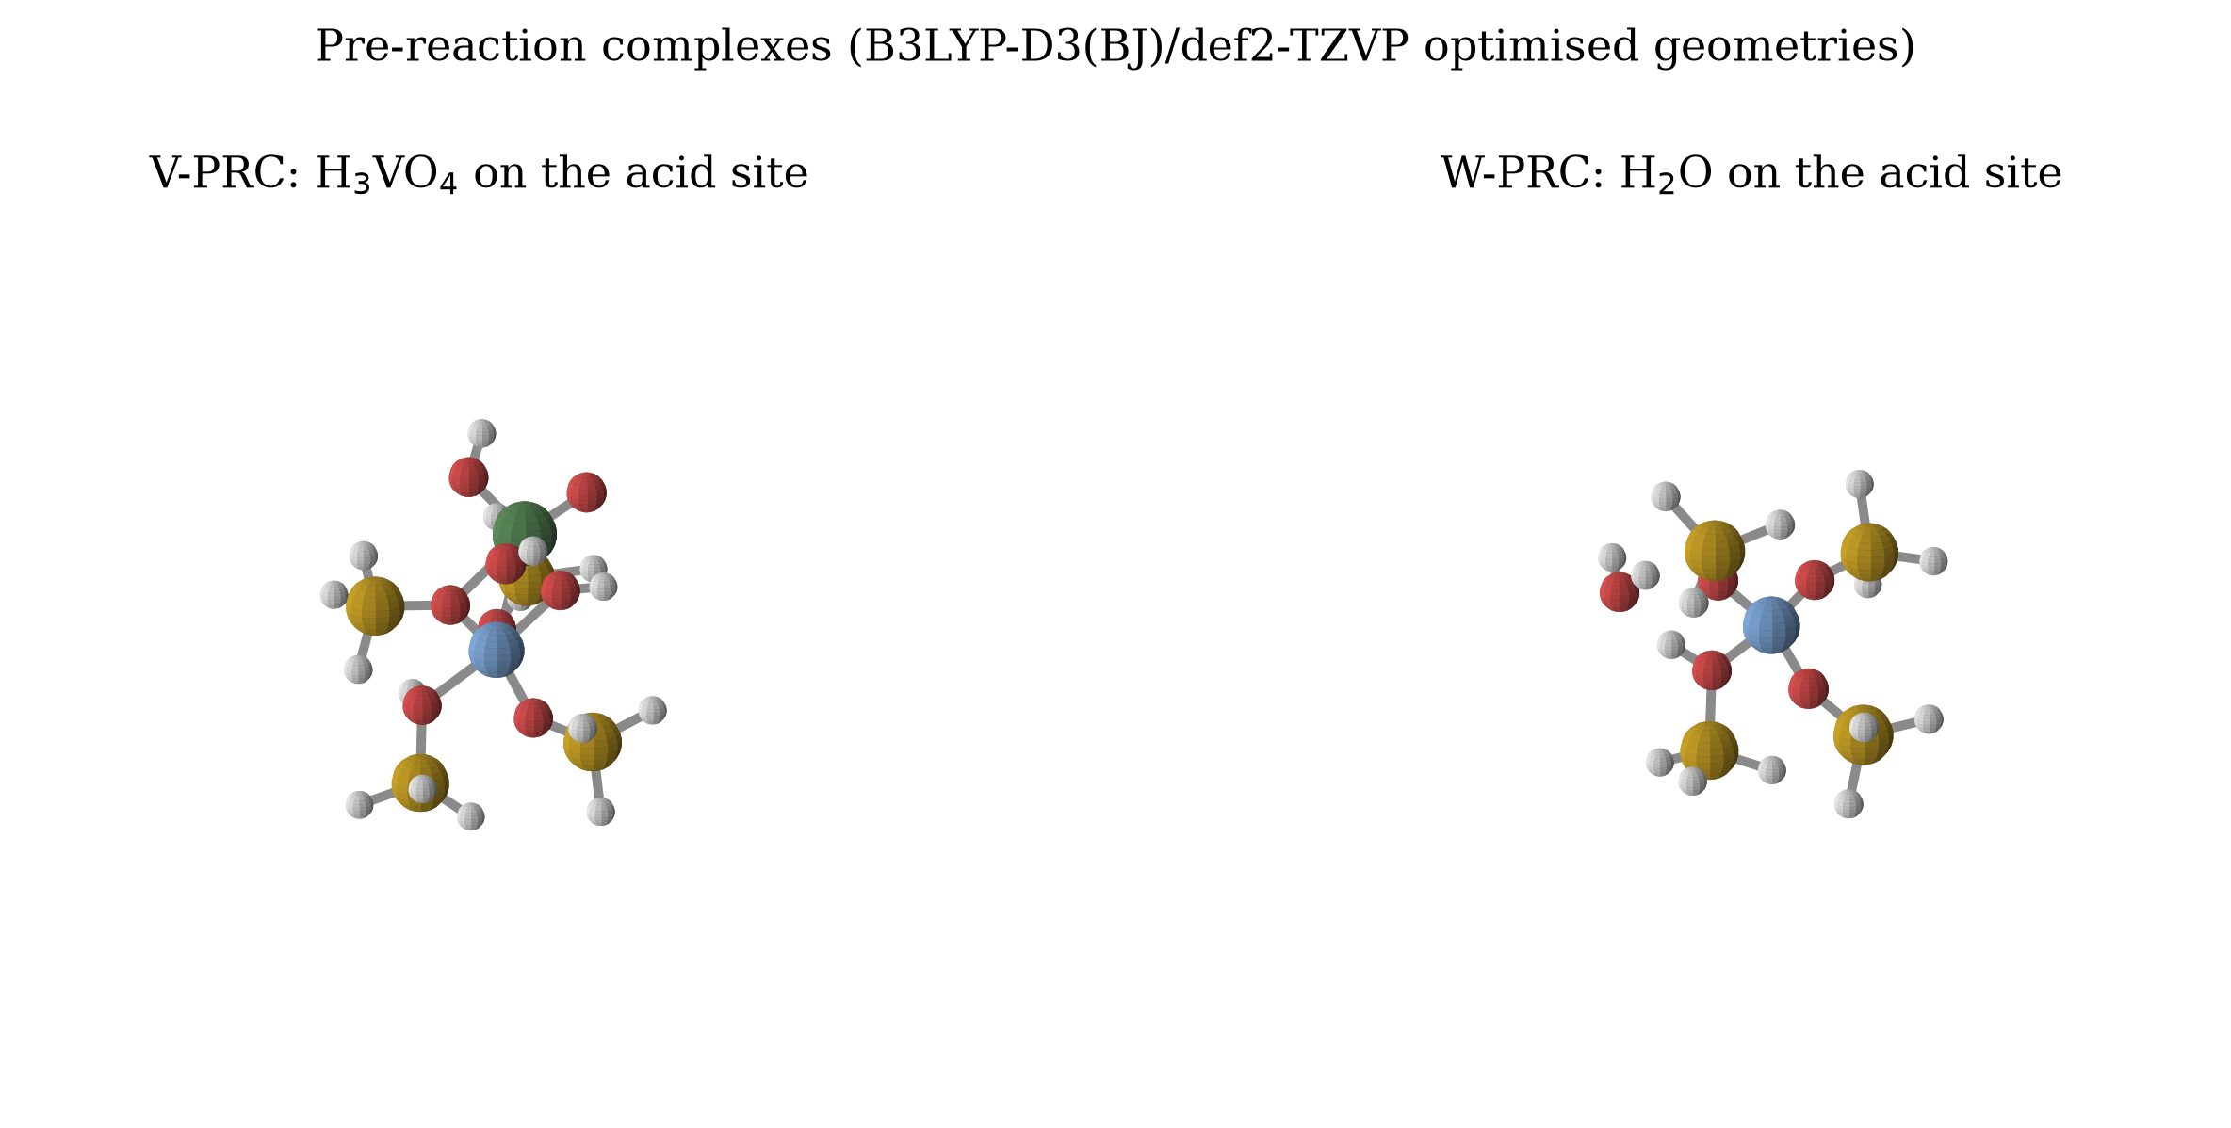
Figure 4.1: The two pre reaction complexes at B3LYP D3(BJ)/def2 TZVP. Left, V-PRC, vanadic acid on the acid site. Right, W-PRC, water on the acid site. Source: author, rendered from the optimised Cartesian coordinates
Both adsorbates sit in the same place, hydrogen bonded to the Brønsted proton, and the difference between them is that vanadic acid brings three hydroxyl groups and a vanadyl oxygen to the site while water brings one oxygen and two hydrogens. Vanadic acid therefore has more to offer the framework: it can accept a hydrogen bond through its vanadyl oxygen and donate through any of its three hydroxyls. This is the structural reason the computed binding is stronger, and it is visible in Figure 4.1.
One qualification should be stated here because it will otherwise look like an omission later. The pre reaction complex is described as hydrogen bonded, and at the density functional level it is. In the Tier 1 geometry the same state already carried an aluminium to vanadyl oxygen contact of 0.193 nm, which is a bond and not a hydrogen bond. The density functional re optimisation relaxed this, but the reader should not imagine that the two states are separated by a clean, purely electrostatic step.
4.3 The Adsorption Result
Table 4.2 gives the adsorption energies of the two species at all three levels of theory, together with the difference between them. The difference is plotted in Figure 4.2.
Table 4.2: Adsorption energy, ΔE, and the margin in favour of vanadic acid, at three levels of theory
Level of theory | H₃VO₄ (kJ mol⁻¹) | H₂O (kJ mol⁻¹) | ΔΔE, vanadic acid minus water (kJ mol⁻¹)
GFN2 xTB, Tier 1 | −196.9 | −69.6 | −127.3
B3LYP D3(BJ)/def2 TZVP | −93.0 | −78.3 | −14.7
PBE0 D3(BJ)/def2 TZVP, single point | −93.1 | −78.6 | −14.4

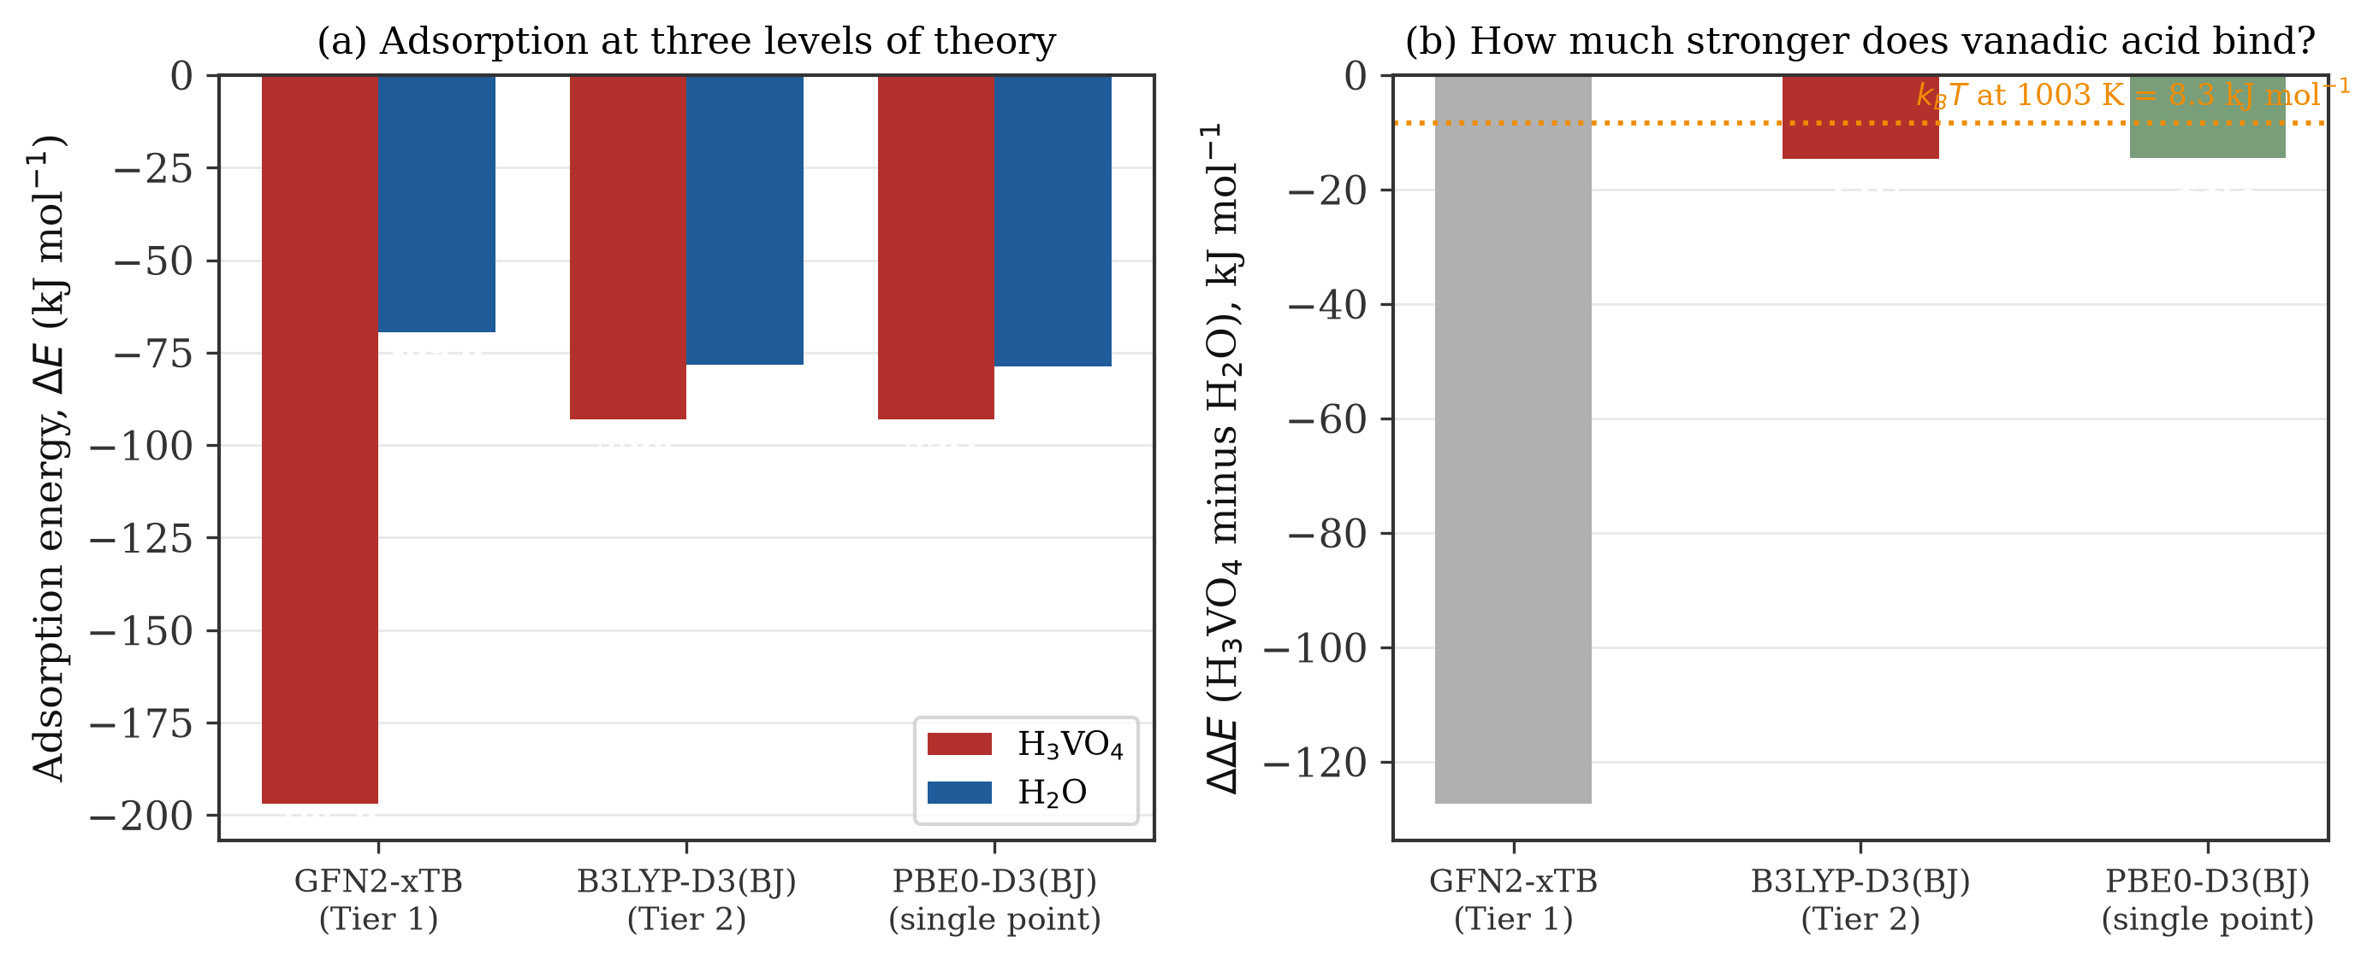
Figure 4.2: (a) Adsorption energy of vanadic acid and water at three levels of theory. (b) The margin by which vanadic acid outbinds water, against the thermal energy available at regenerator temperature. Source: author
Three statements can be made about Table 4.2 with confidence.
First, vanadic acid does bind the site more strongly than water. The result holds at two independent density functionals, which differ by 0.1 kJ mol⁻¹ for vanadic acid and 0.3 kJ mol⁻¹ for water. That level of agreement is far better than the accuracy of either method, so the ranking is not an artefact of the functional.
Second, the margin is 14.7 kJ mol⁻¹ at B3LYP and 14.4 kJ mol⁻¹ at PBE0. As shown in section 3.9, this quantity can be written without the cluster reference energy at all, so it is immune to the one reference in the study that was imperfectly converged. It is the most defensible number in this thesis.
Third, the absolute binding energies are probably too large. No counterpoise correction was obtained, so both values carry an unquantified basis set superposition error. For a complex of this size the correction typically falls between 5 and 20 kJ mol⁻¹, which means the true binding energies are more likely to be near 75 to 88 kJ mol⁻¹ for vanadic acid and 60 to 73 kJ mol⁻¹ for water. The margin between them is affected much less, because the two complexes are of comparable size and the error largely cancels.
4.4 What 14.7 kJ mol⁻¹ Is Worth
A margin of 14.7 kJ mol⁻¹ sounds like a decisive preference. Under regenerator conditions it is not, and the arithmetic that shows this is the central result of the project.
At 1003 K the thermal energy kT is 8.34 kJ mol⁻¹. A free energy difference of 14.7 kJ mol⁻¹ therefore corresponds to a ratio of binding constants of
K_V / K_W = exp(14.7 / 8.34) ≈ 5.8
Vanadic acid holds a Brønsted site about six times more tightly than water does. Six times is not nothing, but it has to be set against how much more water there is. A regenerator at 2 atm with 20 per cent steam has a water partial pressure of 0.40 atm. Wormsbecher et al. (1986) put the vanadic acid concentration at 1 to 10 ppm; Trujillo et al. (1997) recalculated the equilibrium at 1.7 ppm and argued the bulk value must be below 1 ppm. Taking 10 ppm, which is the most generous figure in the literature, the partial pressure of vanadic acid is 2 × 10⁻⁵ atm. The ratio of partial pressures is therefore about 2 × 10⁴ in favour of water, and water is present at between four and five orders of magnitude the concentration of vanadic acid.
Figure 4.3 puts the two effects together in a two site Langmuir competition, using the computed binding constant ratio and taking the two species to compete for the same sites.
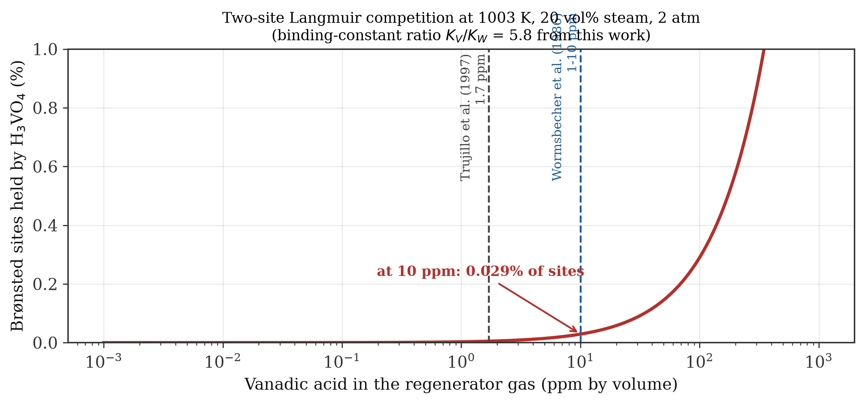
Figure 4.3: Estimated fraction of Brønsted sites held by vanadic acid under two site Langmuir competition at 1003 K, 20 volume per cent steam and 2 atm, using the binding constant ratio computed in this work. Source: author
The estimate says that at 10 ppm of vanadic acid, about 0.03 per cent of the Brønsted sites are held by vanadic acid, roughly one site in three thousand four hundred. At Trujillo's 1.7 ppm it is about one site in twenty thousand. Water holds essentially all of the rest.
Three caveats attach to that number, and they are not small. The Langmuir picture assumes both species compete for one site and that neither dissociates, neither of which is strictly true. It uses a gas phase partial pressure for a species that Trujillo et al. (1997) argued concentrates locally inside the zeolite, and local concentration is precisely the escape route their hypothesis relies on. And it takes no account of the molten vanadium pentoxide phase, which is a liquid under regenerator conditions and can wet the catalyst directly. The calculation is not a proof. It is, however, a quantitative statement of the burden the vanadic acid hypothesis has to carry, and that burden is about four orders of magnitude. A hypothesis that needs a local concentration enhancement of 10⁴ to work has to explain where that enhancement comes from, and neither Wormsbecher et al. (1986) nor Trujillo et al. (1997) supplied a mechanism for it.
4.5 The Rest of the Vanadium Sequence
Beyond adsorption the sequence could not be completed, and the reasons are given here rather than left to the tables.
The chemisorbed intermediate V-I1 is a genuine minimum. It lies at −115.4 kJ mol⁻¹, about 22 kJ mol⁻¹ below the pre reaction complex, so the rearrangement in equation 3.3 is downhill. Its structure is informative: the aluminium retains all four of its framework oxygen contacts, and the vanadium sits about 0.27 nm away. No framework bond has broken at this stage. An earlier memo in the project described V-I1 as five coordinate aluminium; the coordinates do not support that description, and the corrected description is used here.
The next step is where the work stops. The candidate saddle point for the first framework aluminium oxygen hydrolysis, V-TS2, lies at +323.6 kJ mol⁻¹, which is why it appears high in Figure 4.4, but it is not a saddle point. Its fourteen imaginary modes are listed in Figure 4.5.
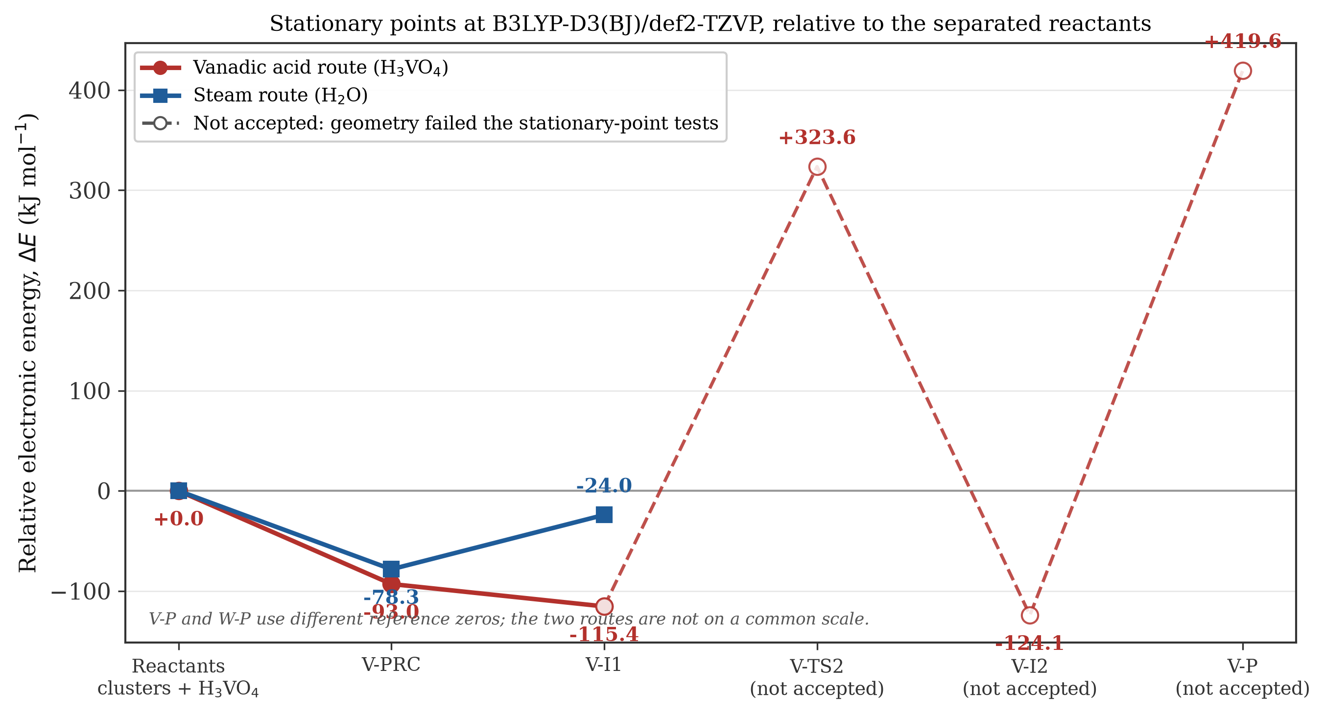
Figure 4.4: Stationary points at B3LYP D3(BJ)/def2 TZVP relative to the separated reactants. Hollow markers and broken lines mark states that failed the acceptance tests. Source: author
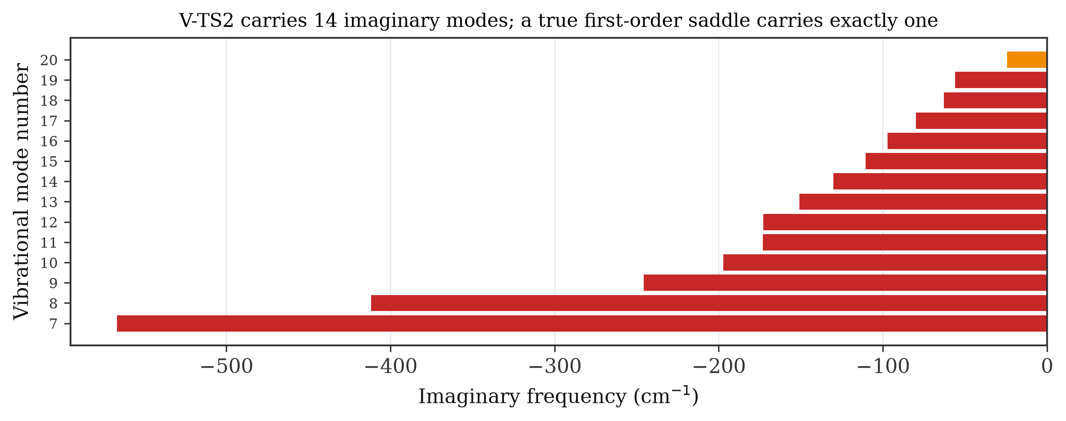
Figure 4.5: The fourteen imaginary frequencies returned for V-TS2. A true first order saddle point returns exactly one. Source: author
The largest of those modes, at −566.6 cm⁻¹, is far too large to be the intended aluminium oxygen stretch, and the cluster of modes between −200 and −100 cm⁻¹ is characteristic of the capping hydrogens moving against the cluster rather than of framework chemistry. This is the frozen boundary showing up in the results, exactly as anticipated in section 3.10. Displacing along the modes and re optimising did not cleanly reach two distinct minima, so the two sided interval test was also failed.
Consequently no activation barrier is reported for any step of the vanadium route, and none should be inferred from Figure 4.4. The most that can be said from these numbers is that the region of the surface between V-I1 and V-I2 is high and flat, and that whatever path connects them does not run through the structure found here.
The same caution applies twice over further downstream. V-I2 did not converge, and V-P did not terminate. V-P, the state in which aluminium has been extracted from the framework, came out at +419.6 kJ mol⁻¹ relative to the separated reactants, which would make full extraction by a single vanadic acid molecule strongly endothermic. That number is reported for completeness and is then set aside, because it comes from a job that was killed. What can be said is that within this model, the sequence of steps mapped in equations 3.2 to 3.5 is not a downhill route to a dealuminated framework. That is consistent with Trujillo et al. (1997), who held that vanadium acts as a catalyst and is regenerated, rather than as a reagent that extracts aluminium stoichiometrically.
4.6 The Steam Control
The steam route behaved better than the vanadium route. Both W-PRC and W-P are converged minima with no imaginary frequencies. Water binds at −78.3 kJ mol⁻¹, and the hydrolysed product W-P lies at −24.0 kJ mol⁻¹, so the first hydrolysis of a framework aluminium oxygen bond costs about 54 kJ mol⁻¹ in electronic energy and stays below the separated reactants throughout.
This is a useful contrast with the vanadium route. On the steam side, the chemistry runs at energies that a thermal process at 1003 K can plausibly reach. On the vanadium side, the only clean statements are about adsorption, and everything past it either failed a test or sits at energies that the model cannot support. The steam baseline is also the only route in this study for which a barrier was obtained, and that barrier came from Tier 1 rather than from density functional theory: +29.3 kJ mol⁻¹ relative to W-PRC at GFN2 xTB, with one imaginary mode at −226 cm⁻¹.
4.7 Thermochemistry at Regenerator Temperature
Table 4.3 gives the Gibbs free energies of the accepted minima at the two temperatures, and Figure 4.6 shows the same values.
Table 4.3: Gibbs free energy of the accepted minima relative to the separated reactants, at B3LYP D3(BJ)/def2 TZVP
State | ΔG at 298.15 K (kJ mol⁻¹) | ΔG at 1003.15 K (kJ mol⁻¹)
V-PRC | −17.0 | +133.4
V-I1 | −35.8 | +108.3
W-PRC | −28.9 | +67.0
W-P | +30.8 | +132.7

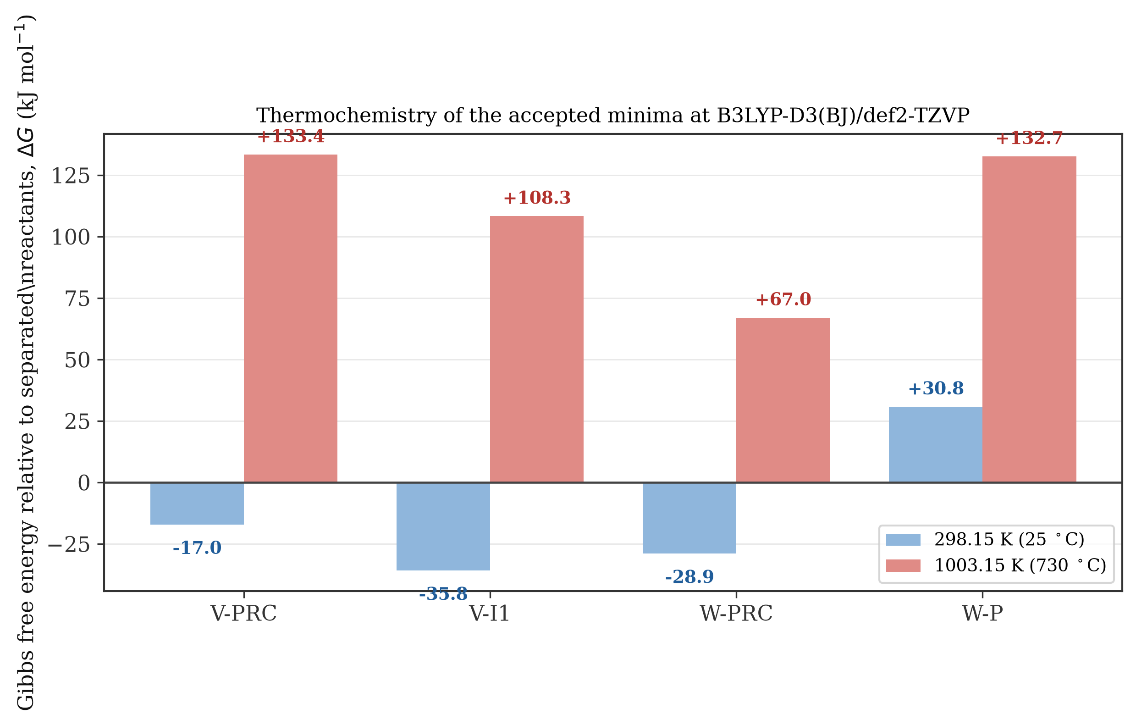
Figure 4.6: Gibbs free energy of the accepted minima at 298.15 K and 1003.15 K, relative to the separated reactants. Source: author
At 298 K both adsorbates bind spontaneously and V-I1 is the most stable state in the study. At 1003 K every state is positive, which means that within this model nothing adsorbs at regenerator temperature at all.
That result should not be taken at face value, and the reason is worth stating carefully because it is the clearest limitation of the whole approach. The entropy penalty in equation 3.11 is the entropy of a gas molecule losing translational freedom, which is what happens when a gas phase molecule in an ideal gas model is pinned to a surface. In a real regenerator the water is already condensed in the pores, the zeolite does not lose much entropy on adsorption, and the relevant reference state is a physisorbed molecule rather than a free gas molecule. Silaghi et al. (2016) made exactly this point and recommended taking the physisorbed state as the reference for this reason. The gas phase harmonic treatment used here overstates the entropic penalty by a wide margin at 1003 K.
There is also a specific numerical caution. At 1003 K the harmonic oscillator approximation is stretched, low frequency modes dominate the entropy, and the low frequency modes in this cluster are partly artefacts of the frozen boundary. The ΔG values at 1003 K are therefore reported as an indication of direction and magnitude, not as numbers to be quoted to a decimal place. Their value is comparative: the ordering of the states at 1003 K is the same as at 298 K, and the gap between the two routes changes by only a few kilojoules per mole, so the conclusions drawn in section 4.4 from the electronic energies are not overturned by the thermochemistry.
4.8 What the Screening Method Got Wrong
The Tier 1 and Tier 2 results disagree, and the disagreement is instructive enough to be worth a figure. Figure 4.7 compares the margin between the two adsorbates at the two levels.
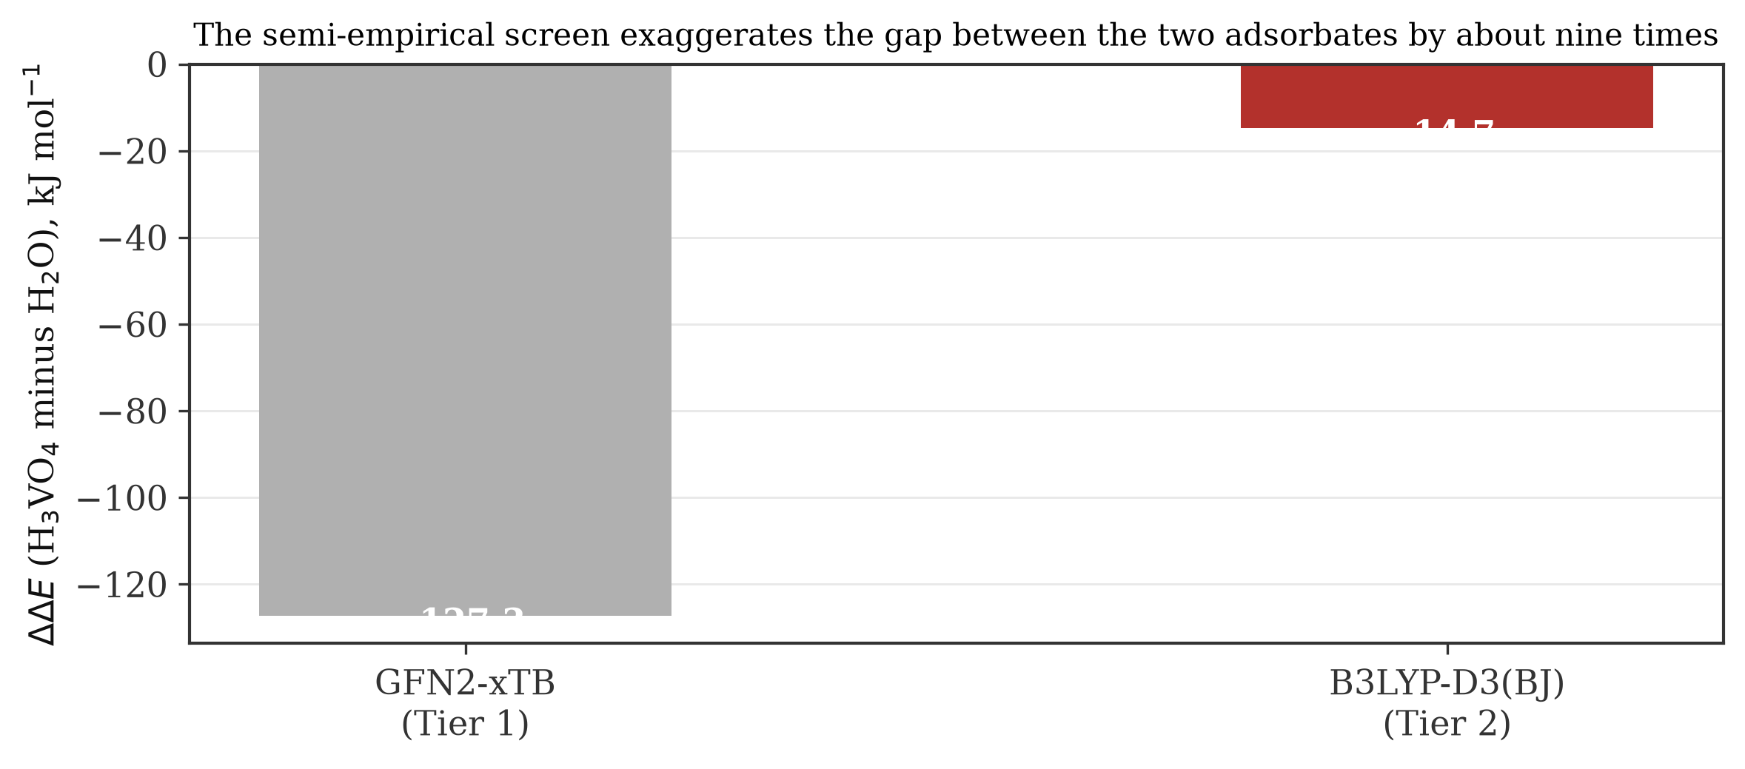
Figure 4.7: The margin between the two adsorbates as computed by the semi empirical screen and by density functional theory. Source: author
GFN2 xTB put the margin at 127.3 kJ mol⁻¹, and density functional theory puts it at 14.7 kJ mol⁻¹. The cheap method overstated the difference between the two adsorbates by a factor of about nine. It was not wrong about the direction, and it was useful for geometry, but it was badly wrong about the size of the effect.
This has a practical consequence that is worth stating for anyone repeating this kind of work. A semi empirical screen is a way to find structures, not a way to measure energies. Had the Tier 1 numbers been reported as results, the conclusion would have been that vanadic acid outbinds water by more than 100 kJ mol⁻¹, which at 1003 K is a binding constant ratio of about 4 × 10⁶, and which would have overwhelmed the concentration disadvantage and appeared to confirm the vanadic acid hypothesis decisively. The confirmation would have been an artefact.
The Tier 1 barriers carry the same warning. The +160.7 kJ mol⁻¹ barrier obtained for the V-TS2 step at GFN2 xTB, and the +29.3 kJ mol⁻¹ barrier for the steam step, are values from a method that this section has just shown to be unreliable for energetics on this system. They are recorded because they were computed and because they guided the search, but no conclusion in this thesis rests on them.
4.9 Where This Leaves the Dispute
The dispute set out in section 2.6 can now be addressed directly, and the answer is not the one the project expected when it started.
The vanadic acid hypothesis requires that vanadic acid, at a few parts per million, wins the Brønsted acid site from steam at 20 per cent. This study measures the preference at 14.7 kJ mol⁻¹, which is a binding constant ratio of about 5.8 at regenerator temperature. Against a concentration disadvantage of four to five orders of magnitude, that preference is between three and four orders of magnitude too small. On the evidence of the adsorption step alone, the hypothesis as usually stated does not survive.
That conclusion has to be hedged in one specific way, and the hedge is the interesting part. Trujillo et al. (1997) anticipated the concentration problem and answered it with local concentration: vanadic acid accumulates inside the zeolite at levels far above its bulk gas concentration, because it is continuously generated there from vanadium pentoxide held at the acid site, as in equations 2.4 and 2.5. Nothing in this study tests that. A cluster with one acid site in the gas phase cannot say anything about accumulation in a pore. What this study does is put a number on how much accumulation would be needed, which is a factor of about 10⁴ over bulk. If that much accumulation happens, the hypothesis works; if it does not, it does not. The question is now sharp enough to be worth an experiment or a periodic calculation with an explicit pore.
The result does support the critics, though with a caveat of its own. Pine (1990) found that the activation energy of destruction is the same with and without vanadium, and concluded that the rate determining step does not involve vanadium. Xu et al. (2002) concluded that vanadium does not open a new pathway but merely releases sodium. Both positions are consistent with a small, real, but kinetically irrelevant binding preference for vanadic acid: vanadium does bind the site better than water does, so it is not a pure spectator, but the preference is nowhere near large enough to make it the agent that decides the rate. The finding therefore sits closer to Xu et al. (2002) and Pine (1990) than to Wormsbecher et al. (1986), while conceding to Trujillo et al. (1997) that vanadium is not chemically inert at the site.
Two further observations belong here. The absence of any validated barrier means this study provides no support for a catalytic rate enhancement by vanadium, and the positive ΔG values at 1003 K mean the model cannot represent the real driving force at regenerator temperature at all. Anyone quoting this thesis should quote the adsorption margin and the concentration argument, not the thermochemistry.
4.10 Implications for Practice
Two practical points follow, and both are modest.
The first concerns vanadium traps. Traps are chosen by screening because no one knows what binding strength they must beat. This study gives the number the zeolite sets: about 93 kJ mol⁻¹ uncorrected for vanadic acid at a Brønsted site, and probably nearer 75 to 88 kJ mol⁻¹ once basis set superposition error is removed. A trap that must protect the zeolite needs to bind vanadic acid more strongly than that, and it needs to do so at 1003 K in 20 per cent steam. That is a specification, and it is testable computationally before any trap is synthesised.
The second concerns where to look next. Because the adsorption step does not explain vanadium's effect, effort is better spent on the routes that do not depend on it: the sodium route of Xu et al. (2002), which this model cannot address because it contains no sodium, and the local concentration question raised by Trujillo et al. (1997). Both are natural extensions of the present work and both are described in section 5.4.

CHAPTER FIVE

CONCLUSIONS AND RECOMMENDATIONS
5.1 Summary of the Work
This project set out to test the first step of the vanadic acid hypothesis for the destruction of zeolite Y by vanadium in residue fluid catalytic cracking. A four tetrahedral site faujasite cluster carrying one Brønsted acid site was optimised with vanadic acid and, as a control, with water, using a two tier workflow. Tier 1 screened geometries with the semi empirical GFN2 xTB method on a Dell Latitude E6430 laptop. Tier 2 refined the accepted geometries with B3LYP D3(BJ)/def2 TZVP, checked them with PBE0 D3(BJ)/def2 TZVP single points, and computed harmonic frequencies for thermochemistry at 298.15 K and 1003.15 K.
Seven states passed every acceptance test: the three reference species, both pre reaction complexes, the chemisorbed intermediate V-I1 and the hydrolysed steam product W-P. Three states did not. The candidate saddle point V-TS2 failed to converge and returned fourteen imaginary modes, the intermediate V-I2 reached its cycle limit without converging, and the extracted product V-P did not terminate. No activation barrier is therefore reported for any step of the vanadium route.
5.2 Conclusions
1. Vanadic acid binds a faujasite Brønsted acid site more strongly than water does. The computed electronic adsorption energies are 93.0 kJ mol⁻¹ for vanadic acid and 78.3 kJ mol⁻¹ for water at B3LYP D3(BJ)/def2 TZVP, and 93.1 and 78.6 kJ mol⁻¹ at PBE0 D3(BJ)/def2 TZVP. The two functionals agree to within 0.3 kJ mol⁻¹, so the ranking is not an artefact of the functional.
2. The margin in favour of vanadic acid is 14.7 kJ mol⁻¹ at B3LYP and 14.4 kJ mol⁻¹ at PBE0. This quantity can be written without the cluster reference energy, so it is unaffected by the imperfectly converged cluster reference, and it is the most reliable number produced by this work.
3. That margin is too small to do the job the vanadic acid hypothesis asks of it. At 1003 K it corresponds to a ratio of binding constants of about 5.8, while steam in a regenerator outnumbers vanadic acid by four to five orders of magnitude. A two site Langmuir estimate using the computed ratio puts vanadic acid on about 0.03 per cent of the Brønsted sites at 10 ppm, and on about one site in twenty thousand at the 1.7 ppm that Trujillo et al. (1997) calculated. On the evidence of the adsorption step, the hypothesis as usually stated does not survive, unless vanadic acid reaches a local concentration inside the zeolite some ten thousand times its bulk gas concentration, which is the escape route that Trujillo et al. (1997) proposed but did not quantify.
4. The finding is closer to the position of Pine (1990) and Xu et al. (2002) than to that of Wormsbecher et al. (1986). Vanadium is not chemically inert at the acid site, so it is not a pure spectator, but its binding preference is nowhere near large enough to make it the agent that decides the rate. This is consistent with Pine's observation that the activation energy of destruction is unchanged by vanadium, and with the conclusion of Xu et al. (2002) that vanadium acts by releasing sodium rather than by attacking the framework itself.
5. No activation barrier could be established for any step of the vanadium route, and none should be inferred from the energies reported here. The study therefore provides no computational support for a catalytic rate enhancement by vanadium, and it does not validate the mechanism as a whole.
6. The full sequence mapped in this model is not a downhill route to a dealuminated framework. The extracted product state came out about 420 kJ mol⁻¹ above the separated reactants, and the intermediate region between V-I1 and V-I2 is high and flat. This is consistent with the view that vanadium is regenerated rather than consumed, but the numbers behind it come from jobs that failed, so it is offered as an observation and not as a result.
7. The semi empirical screen overstated the gap between the two adsorbates by a factor of about nine, giving 127.3 kJ mol⁻¹ where density functional theory gives 14.7 kJ mol⁻¹. GFN2 xTB was adequate for finding geometries and inadequate for measuring this energy difference. A project that had reported the Tier 1 numbers as results would have concluded that the vanadic acid hypothesis was confirmed, and would have been wrong.
8. At 1003 K the computed Gibbs free energies are positive for every state, which would mean that nothing adsorbs at regenerator temperature. This is an artefact of the gas phase harmonic treatment, which charges the full translational entropy penalty to a molecule that in a real pore is already condensed. The ordering of states is unaffected, but the absolute values at 1003 K should not be quoted.
5.3 Recommendations
1. Trap developers should work to a specification rather than to a screening programme. The zeolite sets the bar at roughly 93 kJ mol⁻¹ for vanadic acid at a Brønsted site, or nearer 75 to 88 kJ mol⁻¹ after correction for basis set superposition error. Any candidate trap should be modelled against that number before it is synthesised, under conditions that include steam at 1003 K.
2. Refiners and catalyst suppliers should treat the sodium content of the catalyst as a first order variable when diagnosing vanadium damage, following Xu et al. (2002). The evidence that the vanadium effect collapses when exchangeable sodium is removed is experimental and strong, and it points at a control lever that costs less than increasing trap loading.
3. Research effort on the vanadic acid route should shift from asking whether vanadic acid attacks the framework to asking how much of it accumulates in the pores. The present work shows that accumulation of about four orders of magnitude over bulk is what the hypothesis requires. Either that accumulation is demonstrated or the hypothesis should be set aside.
4. Undergraduate computational projects in this department should be required to keep a job register and to report failures. The three failed states in this project are more informative than the seven successes, and a report that had quietly dropped them would have overstated what the work established.
5.4 Suggestions for Further Work
1. Add sodium. The strongest rival explanation cannot be tested without it. A cluster containing a sodium cation at a neighbouring exchange site would allow the metavanadate formation of equation 2.6 and the hydroxide attack of equations 2.7 and 2.8 to be modelled directly, which is the comparison that would actually settle the dispute.
2. Move to a periodic model. A full faujasite unit cell would remove the frozen boundary that is the most likely cause of the fourteen imaginary modes, would restore the long range electrostatic field and the pore confinement, and would allow local concentration inside the supercage to be addressed by computing adsorption from a physisorbed reference rather than from the gas phase.
3. Obtain the counterpoise correction. The four counterpoise jobs in this project failed on an input formatting error that is straightforward to fix, and the correction would convert the reported binding energies from upper bounds into defensible values.
4. Retry the saddle point with the caps released or with a larger cluster, and with a method that treats the boundary more honestly. Until a single imaginary mode is obtained and the two sided interval test passes, the barrier for framework bond cleavage in the presence of vanadic acid remains unknown.
5. Look beyond aluminium. Pine (1990) showed that vanadium attacks silicalite, which contains almost no aluminium, so a route that attacks silicon oxygen bonds deserves the same computational treatment that this study gave to the aluminium oxygen bridge.

REFERENCES
Adamo, C., & Barone, V. (1999). Toward reliable density functional methods without adjustable parameters: The PBE0 model. The Journal of Chemical Physics, 110(13), 6158–6170. https://doi.org/10.1063/1.478522
Adanenche, D. E., Aliyu, A., Atta, A. Y., & El-Yakubu, B. J. (2023). Residue fluid catalytic cracking: A review on the mitigation strategies of metal poisoning of RFCC catalyst using metal passivators/traps. Fuel, 343, 127894. https://doi.org/10.1016/j.fuel.2023.127894
Bannwarth, C., Ehlert, S., & Grimme, S. (2019). GFN2-xTB: An accurate and broadly parametrized self-consistent tight-binding quantum chemical method with multipole electrostatics and density-dependent dispersion contributions. Journal of Chemical Theory and Computation, 15(3), 1652–1671. https://doi.org/10.1021/acs.jctc.8b01176
Bawa, S. G., Ahmed, A. S., & Okonkwo, P. C. (2017). Alumina phase transformation from thermal decomposition of ammonium alum synthesized from Kankara kaolin. Nigerian Journal of Technology, 36(3), 822–828. https://doi.org/10.4314/njt.v36i3.23
Becke, A. D. (1993). Density-functional thermochemistry. III. The role of exact exchange. The Journal of Chemical Physics, 98(7), 5648–5652. https://doi.org/10.1063/1.464913
Etim, U. J., Bai, P., Ullah, R., Subhan, F., & Yan, Z. (2018). Vanadium contamination of FCC catalyst: Understanding the destruction and passivation mechanisms. Applied Catalysis A: General, 555, 108–117. https://doi.org/10.1016/j.apcata.2018.02.011
Etim, U. J., Xu, B., Ullah, R., & Yan, Z. (2016). Effect of vanadium contamination on the framework and micropore structure of ultra stable Y-zeolite. Journal of Colloid and Interface Science, 463, 188–198. https://doi.org/10.1016/j.jcis.2015.10.049
Faghani, M. H., Mohammadipour, E., Tarighi, S., Naderifar, A., & Habibzadeh, S. (2024). High vanadium tolerant FCC catalyst by barium titanate as metal trap and passivator. Fuel, 375, 132531. https://doi.org/10.1016/j.fuel.2024.132531
Grimme, S., Ehrlich, S., & Goerigk, L. (2011). Effect of the damping function in dispersion corrected density functional theory. Journal of Computational Chemistry, 32(7), 1456–1465. https://doi.org/10.1002/jcc.21759
Lee, C., Yang, W., & Parr, R. G. (1988). Development of the Colle-Salvetti correlation-energy formula into a functional of the electron density. Physical Review B, 37(2), 785–789. https://doi.org/10.1103/PhysRevB.37.785
Malola, S., Svelle, S., Lønstad Bleken, F., & Swang, O. (2012). Detailed reaction paths for zeolite dealumination and desilication from density functional calculations. Angewandte Chemie International Edition, 51(3), 652–655. https://doi.org/10.1002/anie.201104462
Mitchell, B. R. (1980). Metal contamination of cracking catalysts. 1. Synthetic metals deposition on fresh catalysts. Industrial & Engineering Chemistry Product Research and Development, 19(2), 209–213. https://doi.org/10.1021/i360074a015
Neese, F. (2025). Software update: The ORCA program system: Version 6.0. Wiley Interdisciplinary Reviews: Computational Molecular Science, 15, e70019. https://doi.org/10.1002/wcms.70019
Pine, L. A. (1990). Vanadium-catalyzed destruction of USY zeolites. Journal of Catalysis, 125(2), 514–524. https://doi.org/10.1016/0021-9517(90)90323-C
Silaghi, M.-C., Chizallet, C., Sauer, J., & Raybaud, P. (2016). Dealumination mechanisms of zeolites and extra-framework aluminum confinement. Journal of Catalysis, 339, 242–255. https://doi.org/10.1016/j.jcat.2016.04.021
Tielens, F., & Dzwigaj, S. (2010). Probing acid-base sites in vanadium redox zeolites by DFT calculation and compared with FTIR results. Catalysis Today, 152(1–4), 66–69. https://doi.org/10.1016/j.cattod.2009.09.006
Trujillo, C. A., Navarro Uribe, U., Knops-Gerrits, P.-P., Oviedo A., L. A., & Jacobs, P. A. (1997). The mechanism of zeolite Y destruction by steam in the presence of vanadium. Journal of Catalysis, 168(1), 1–15. https://doi.org/10.1006/jcat.1997.1550
Uzochukwu, M. I., Oyegoke, T., Momoh, R. O., Isa, M. T., Shuwa, S. M., & Jibril, B. Y. (2023). Computational insights into deep eutectic solvent design: Modeling interactions and thermodynamic feasibility using choline chloride &amp; glycerol. Chemical Engineering Journal Advances, 16, 100564. https://doi.org/10.1016/j.ceja.2023.100564
Weigend, F., & Ahlrichs, R. (2005). Balanced basis sets of split valence, triple zeta valence and quadruple zeta valence quality for H to Rn: Design and assessment of accuracy. Physical Chemistry Chemical Physics, 7(18), 3297–3305. https://doi.org/10.1039/b508541a
Wormsbecher, R. F., Peters, A. W., & Maselli, J. M. (1986). Vanadium poisoning of cracking catalysts: Mechanism of poisoning and design of vanadium tolerant catalyst system. Journal of Catalysis, 100(1), 130–137. https://doi.org/10.1016/0021-9517(86)90078-3
Xu, M., Liu, X., & Madon, R. J. (2002). Pathways for Y zeolite destruction: The role of sodium and vanadium. Journal of Catalysis, 207(2), 237–246. https://doi.org/10.1006/jcat.2002.3517

