Q1 Create Database

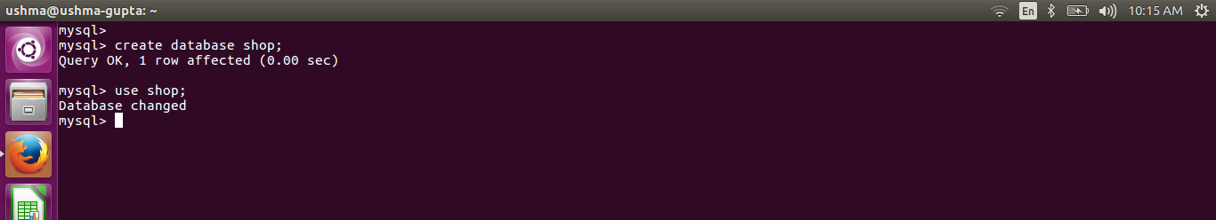

Q2. Design Schema

Q3. Create tables

Table Customer :
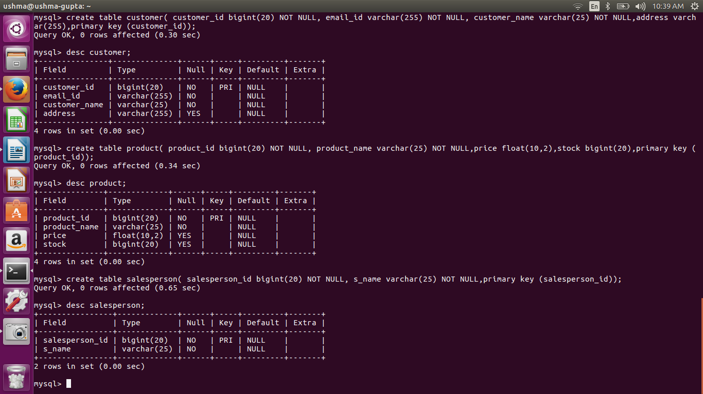

Table Salesperson :

Table Orders :

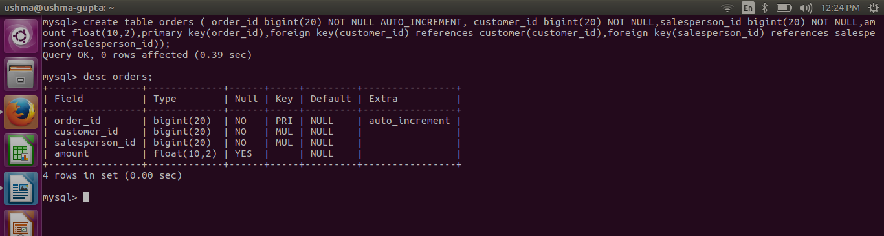

Q4 Insert Sample Data

Table customer :

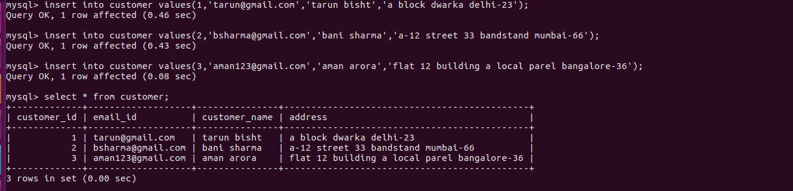

table salesperson;

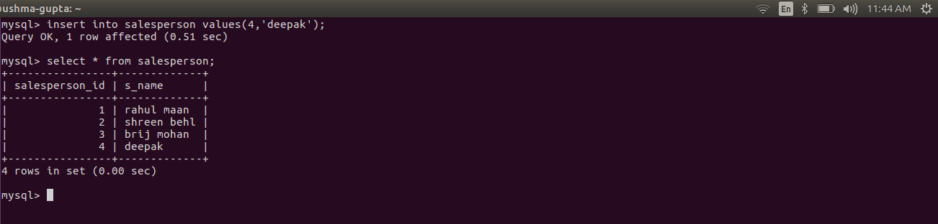

table orders :

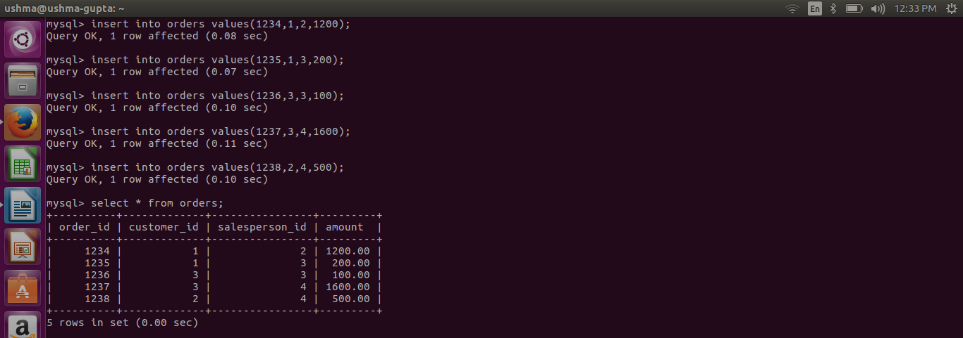

Q5 Find the salespersons having multiple orders.

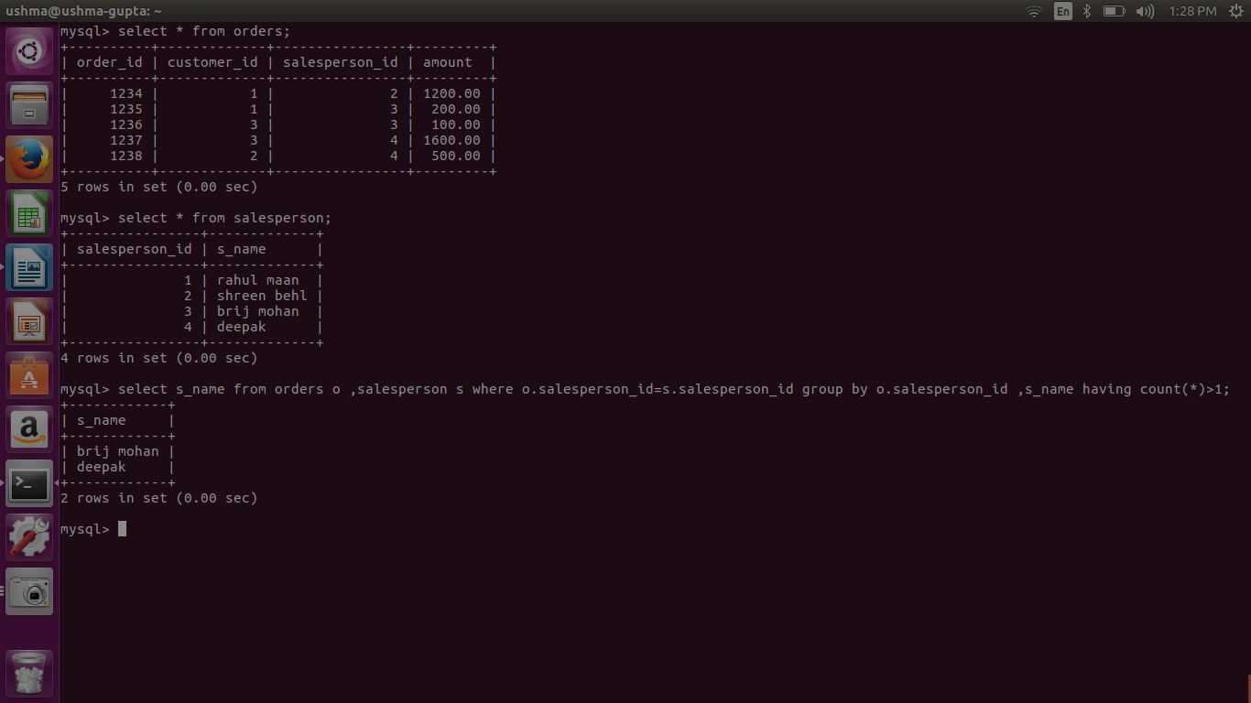

Q6. Find the all sales person details along with order details

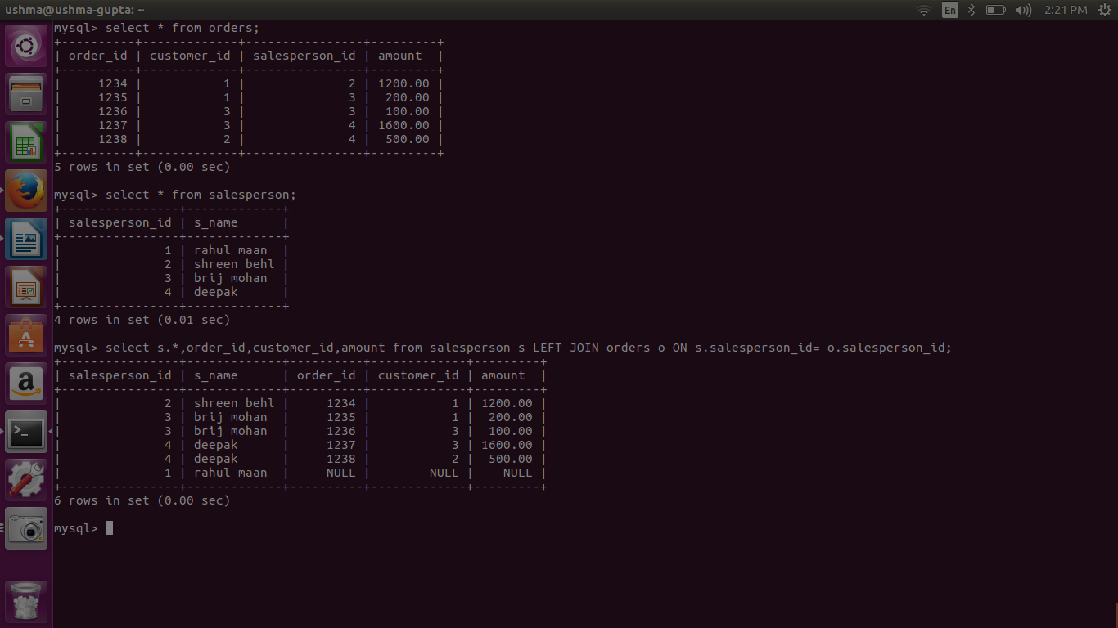

q.7 Create index

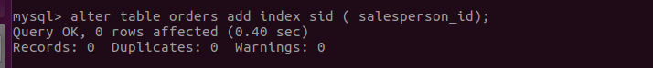

Q.8 How to show index on a table

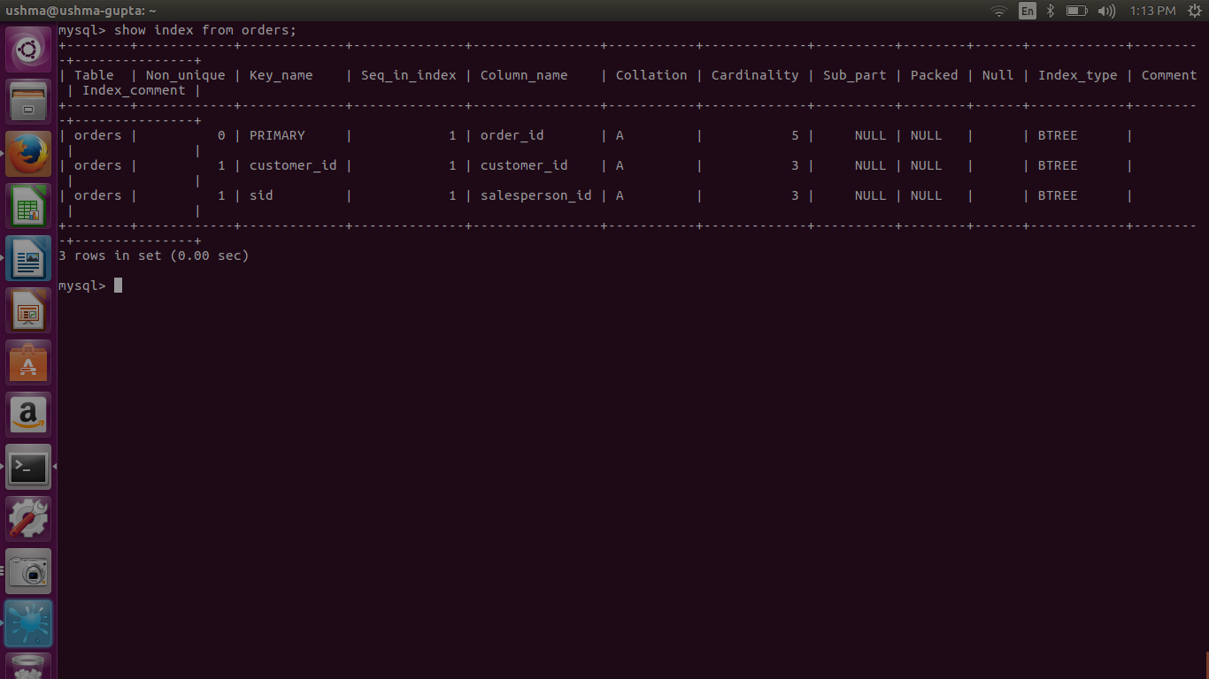

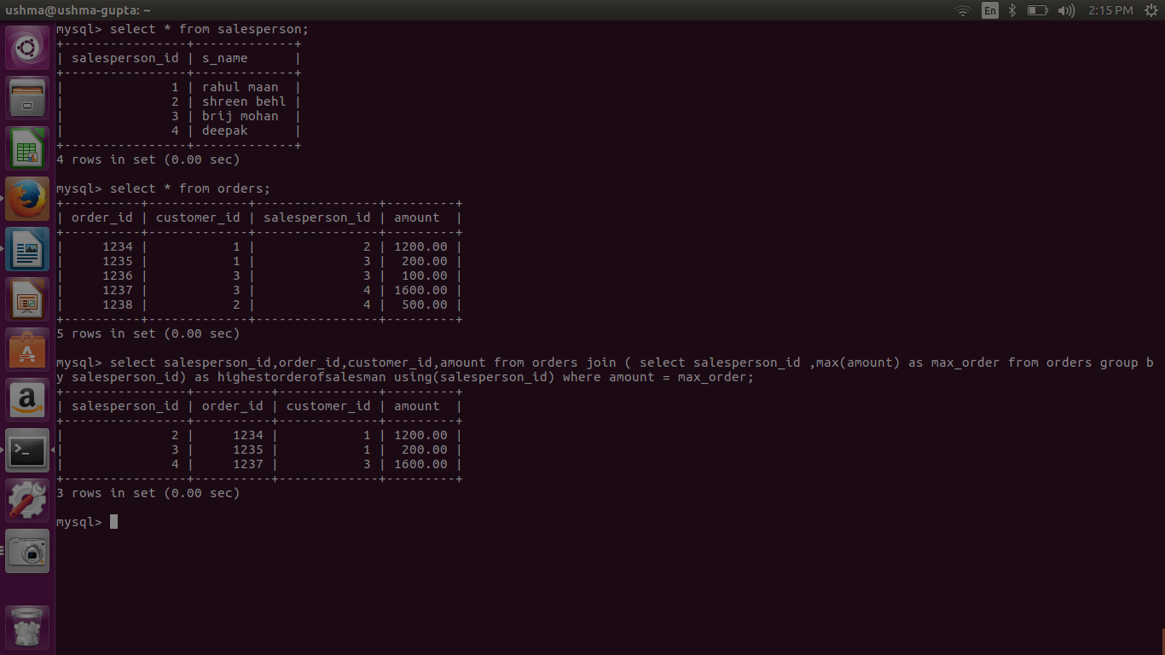
Find the largest order amount for each salesperson and the associated order number, along with the customer to whom that order belongs to

