Q1. Create a directory "exercise" inside your home directory and create nested(dir1/dir2/dir3) directory structure inside "excercise" with single command.
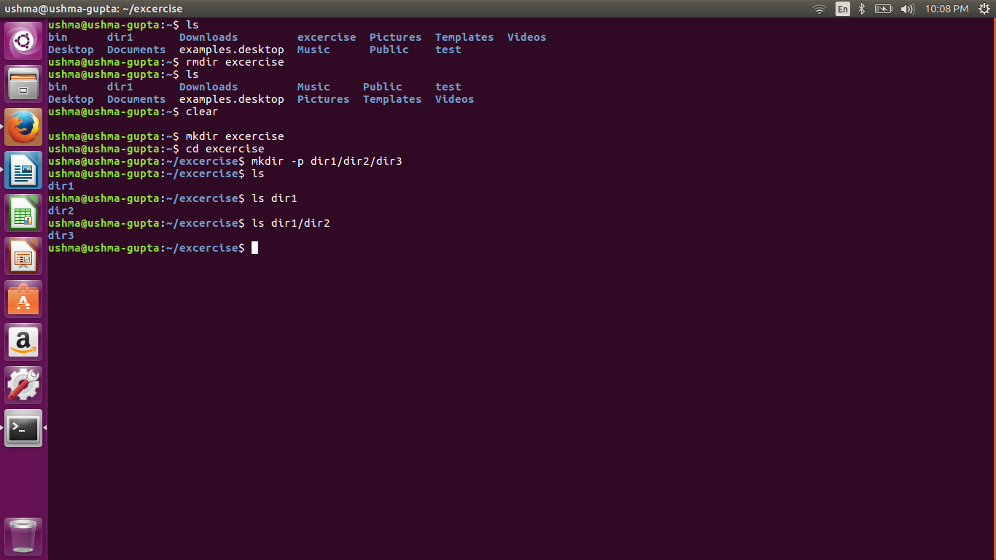

Q2. Create two empty files inside dir: emptyFile1,emptyFile2 in single command and Remove the dir2 direcroty
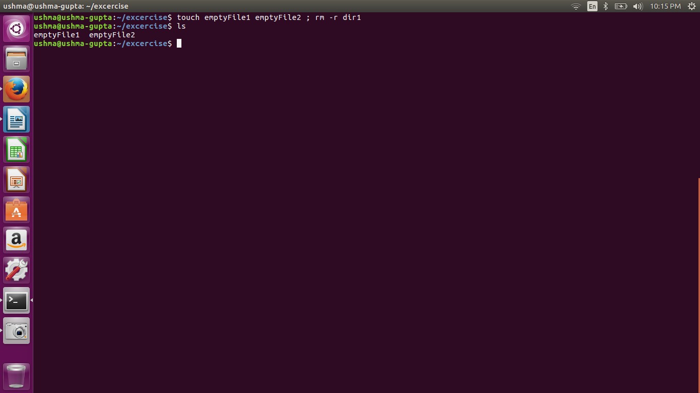

Q3. Create one file file.txt containing text "hello world" and save it.

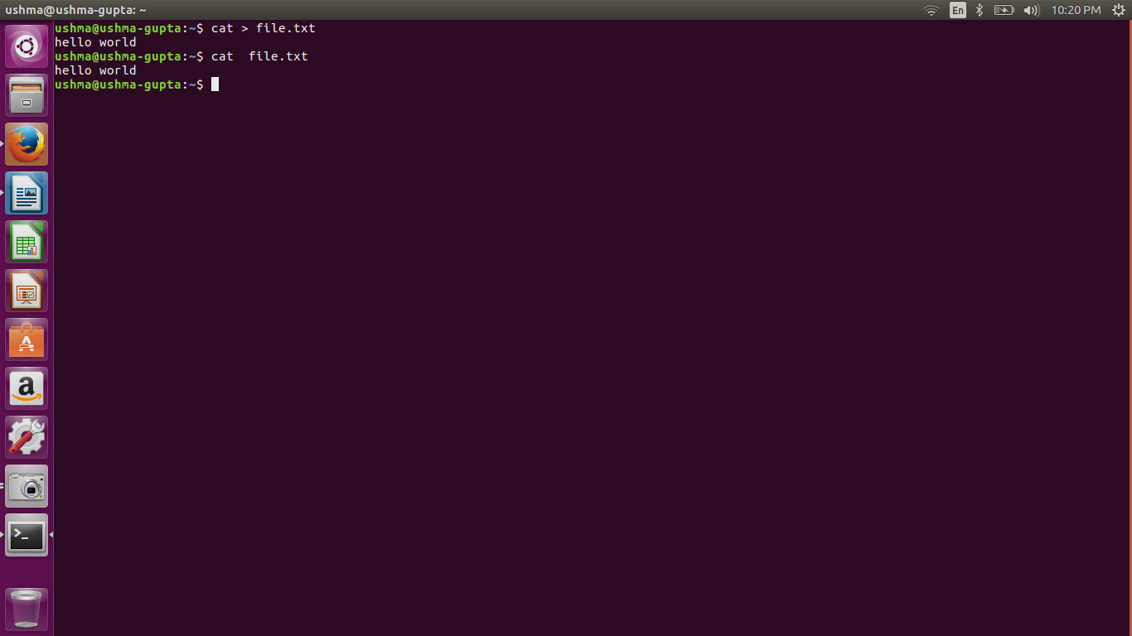

Q4. Find a "passwd" file using find command inside /etc. copy this files as passwd_copy and then rename this file as passwd_backup.

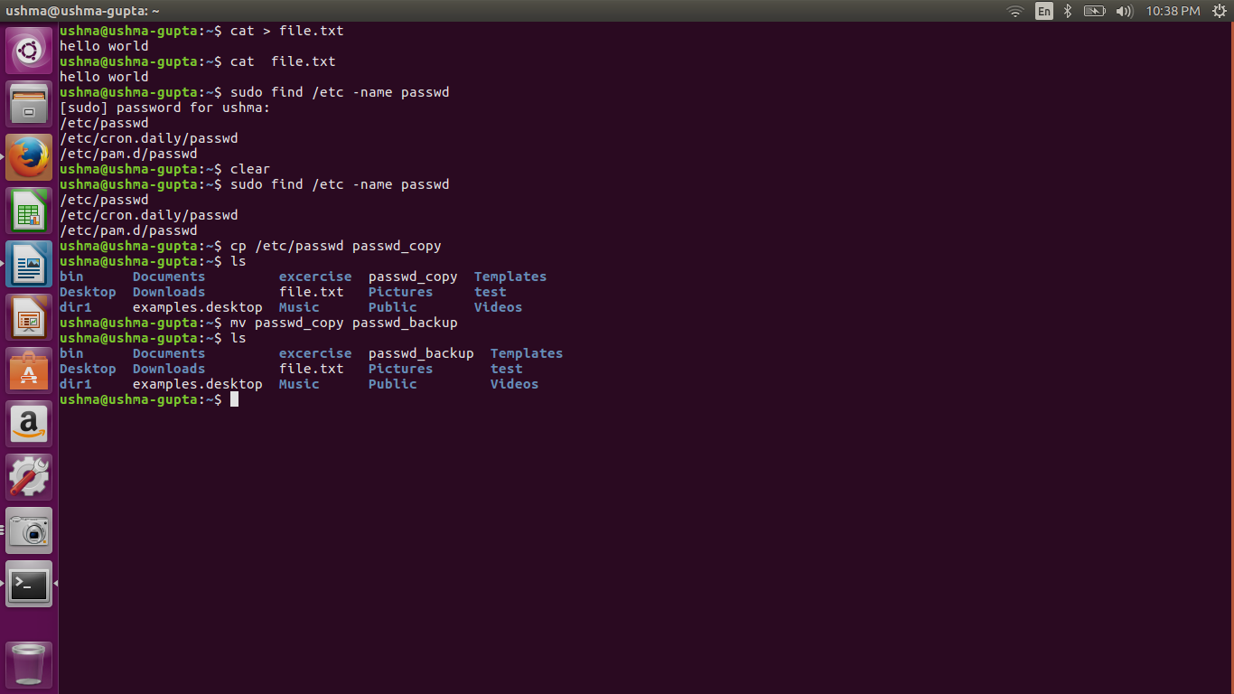

Q5. Try reading passwd_backup file in multiple tools: less,more,cat,strings etc and find the difference in their usage.

ushma@ushma-gupta:~/exercise$ less passwd_backup
We can navigate the page up/down using the less command and not possible in more command.We can search a string in less command. (use /keywordto search)
ushma@ushma-gupta:~/exercise$ more passwd_backup
It is use to view a file one page at a time, press spacebar to go to the next page and cannot be use for navigation and shows the result according to the page size .
Eg: more -5 passwd_backup // It will show 5 lines at a time and the percentage describing how many lines are displayed

ushma@ushma-gupta:~/exercise$ cat passwd_backup
It can be used to join multiple files together and print the result on screen (it will not show page by page)
Eg: cat >> passwd1 // It will be use for appending in existing file
Eg: cat > passwd1 // It will create a new file

ushma@ushma-gupta:~/exercise$ strings passwd_backup
Using strings command, we will be able to view all the printable strings from the binary file.By default strings command will be looking for sequences of at least 4 printable characters that are terminated by a NULL character.

Q6.Find out the number of line in password_backup containing "/bin/false".

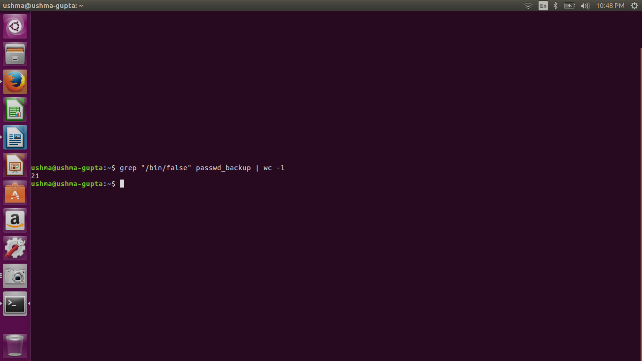

Q7.Redirect the output of the above commands into file "output".

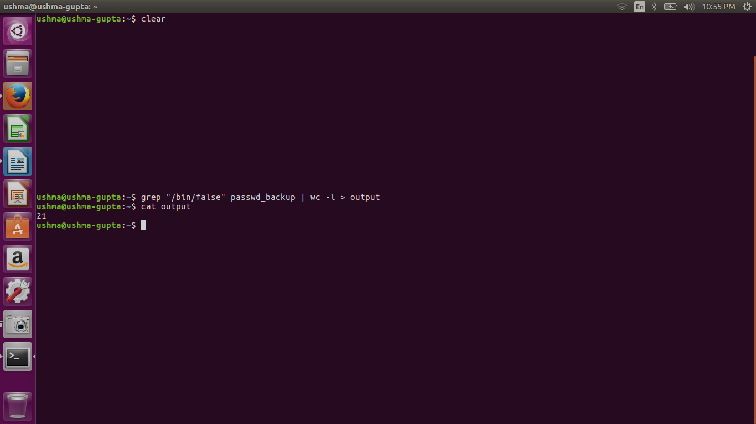

Q8.Create a "test" user,create its password and find out its uid and gid.

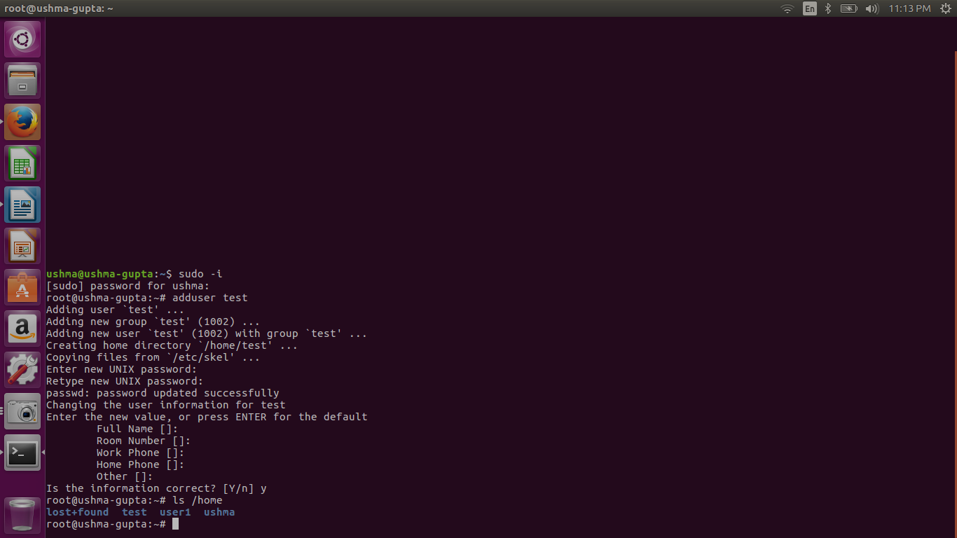

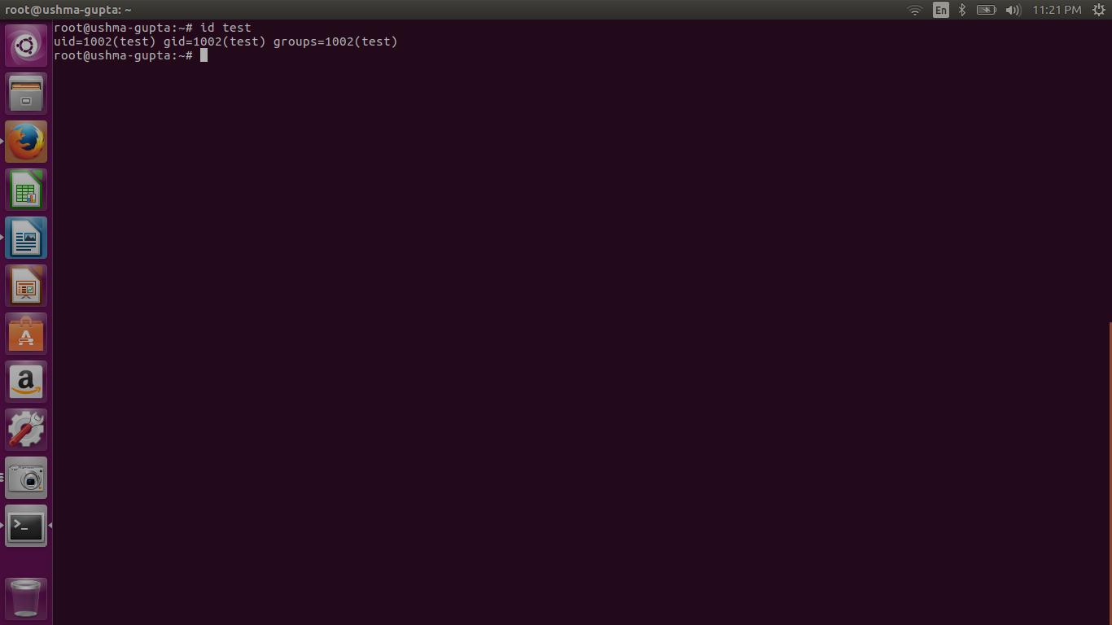

Q9.Login as test user and edit the "output" file created above. Since the permission wont allow you to save the changes.

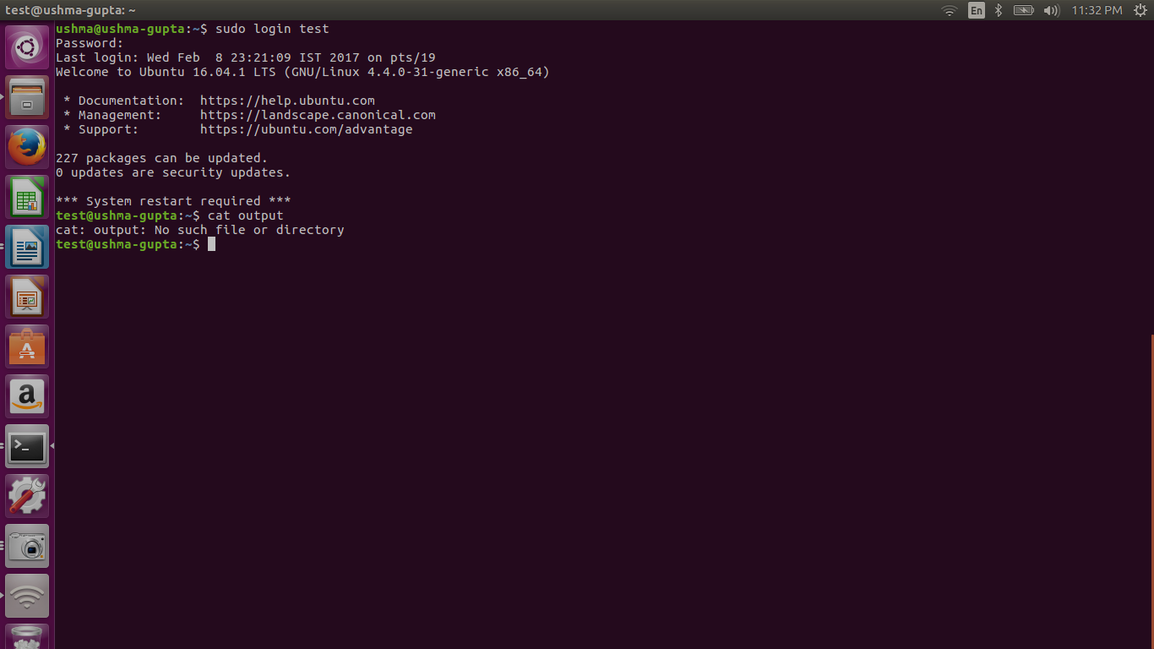

Q10. Configure such that test user can edit it.
- Add group owner of the "output" file as the secondary group of testuser and check/change the "output" file permission if it is editable by group. Once done revert the changes.
- Make the file editable to the world so that test user can access it. Revert the changes after verification
- Change the ownership to edit the file. Try all the options and recommend best of them.
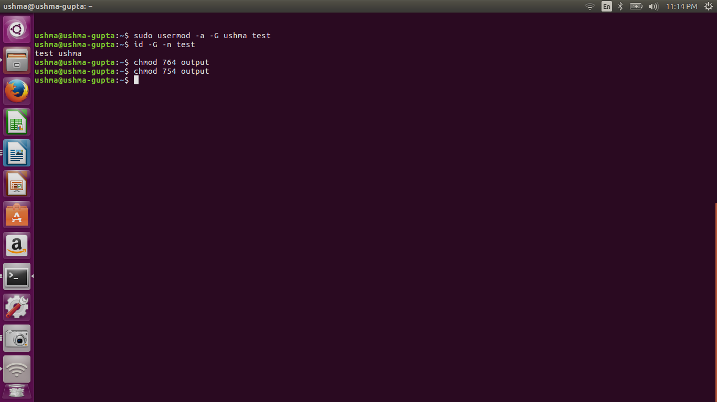

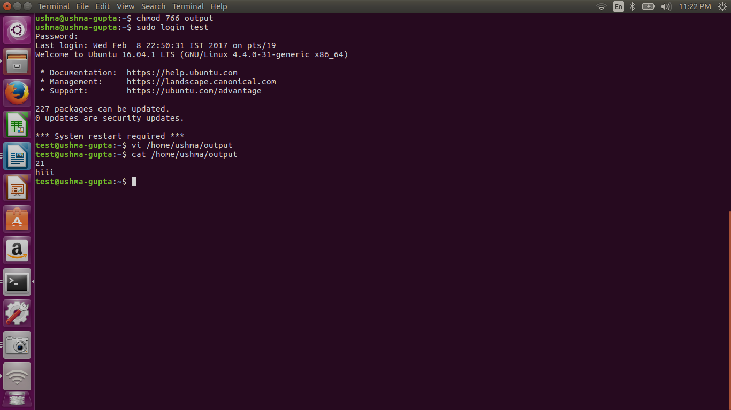

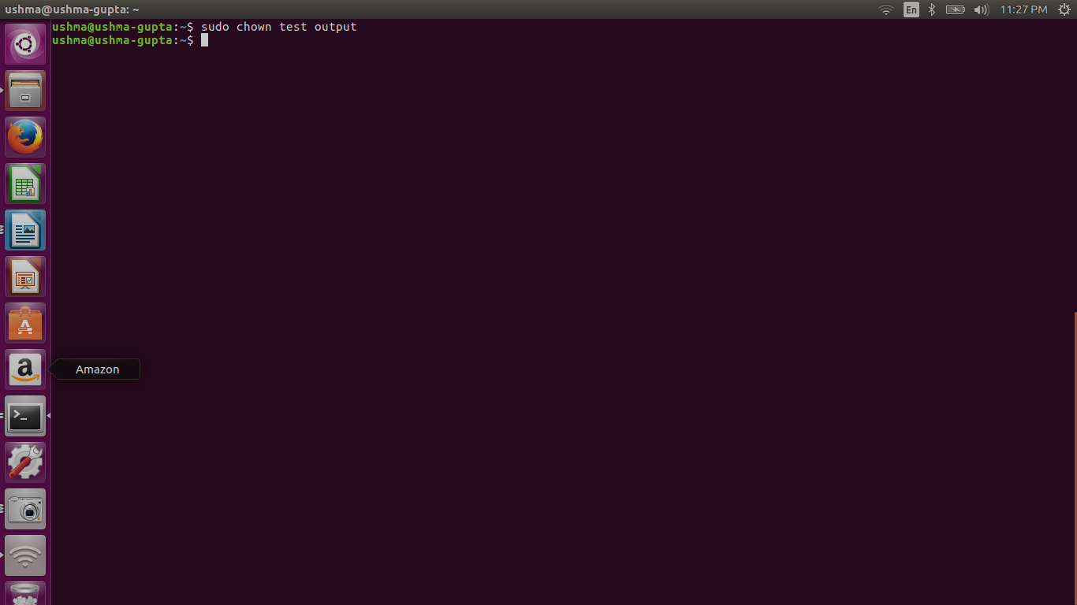

Q.12 Edit ~/.bashrc file such that when you change to "test" user it should clear the screen and print "Welcome".

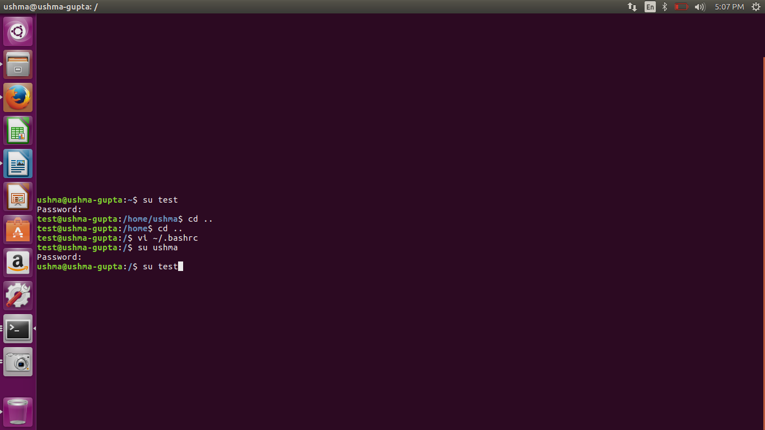

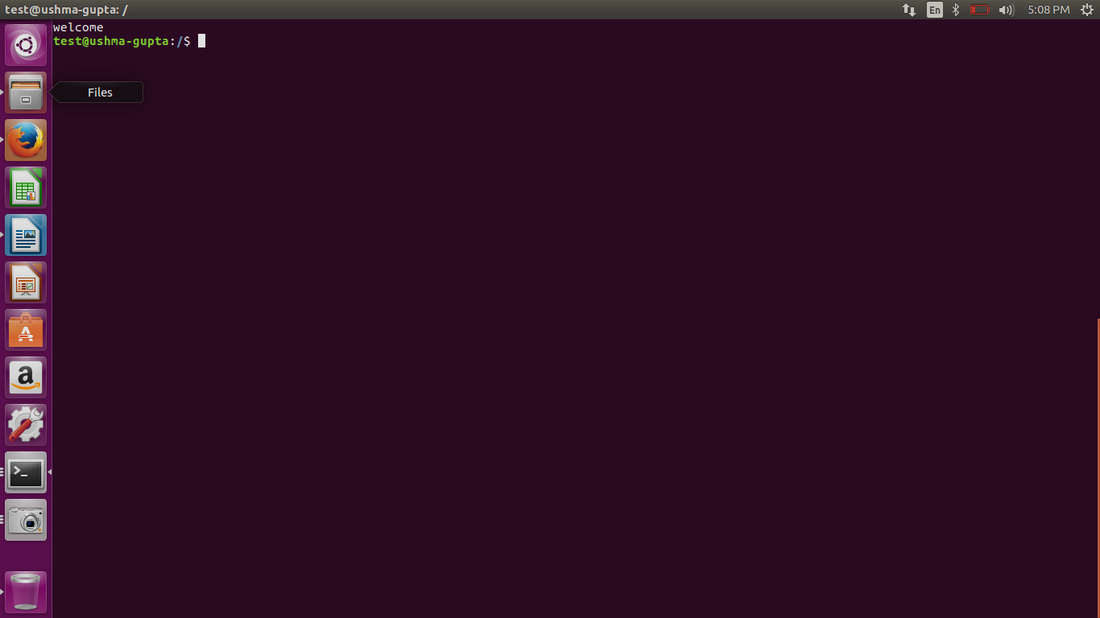

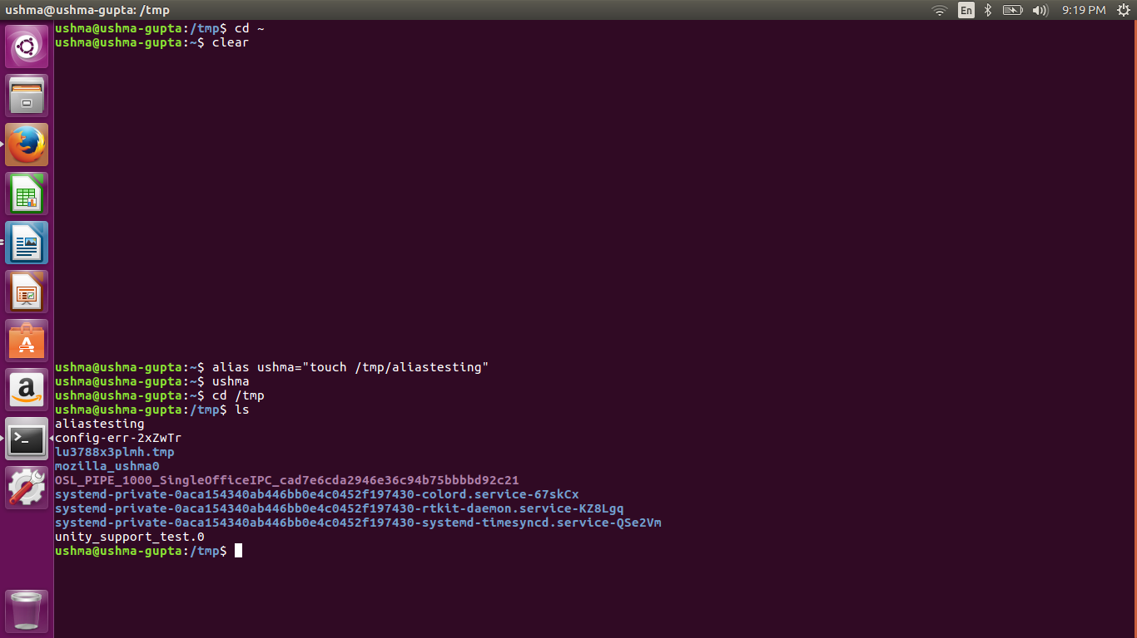
Q.11 Create alias with your name so that it creates a file as "/tmp/aliastesting".

Q.13 Install zip package.

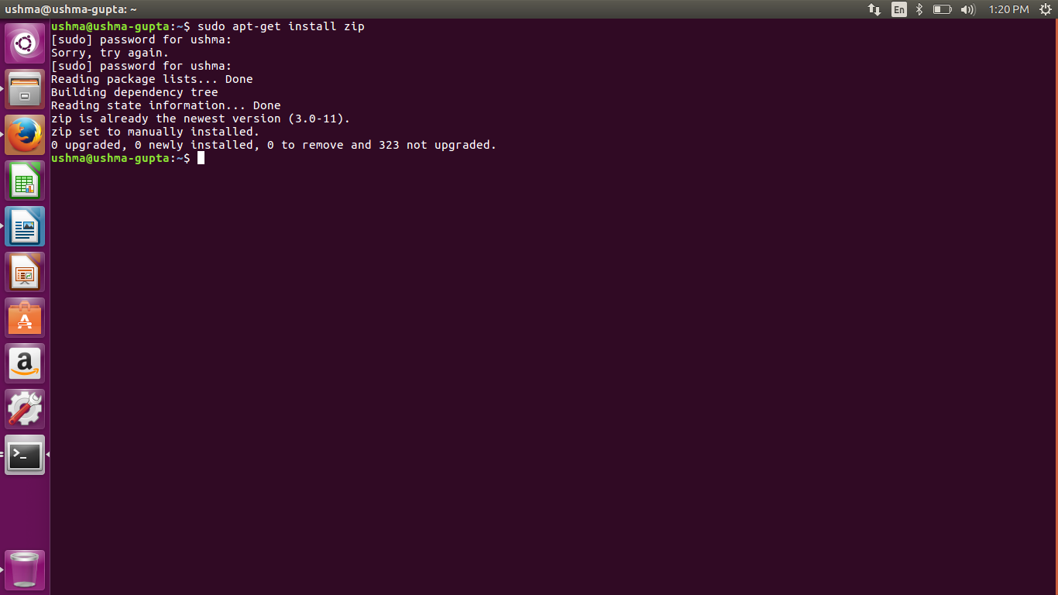

Q.14 Compress "output" and "password_backup" files into a tar ball. List the files present inside the tar created.

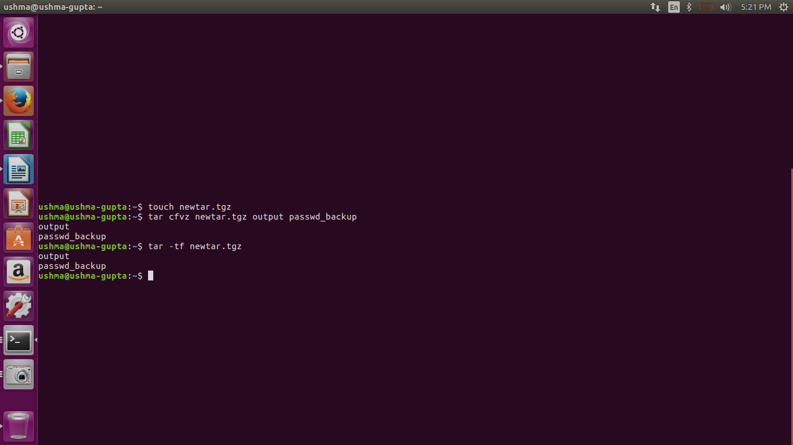

Q.15 scp this file to test user

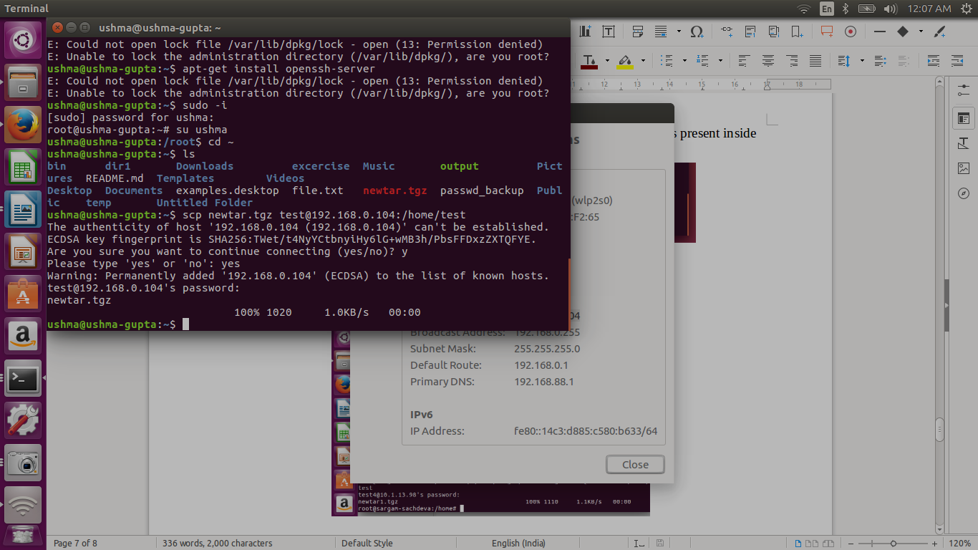

Q 17 Download any image from web and move to desktop

