**Introduction**

The tool I explored is DBschema. DbSchema is a universal database designer for out-of-the-box schema management and documentation, sharing the schema in the team, and deploying on different databases. Visual tools can help developers, database administrators, and decision-makers to query, explore and manage the data.

**DBschema as a tool for database models**

A layout is a database diagram with associated data and query tools. Think of it like a board on which you can make your own representation of the database schema. Inside the layout, you can edit tables and foreign keys by just double-clicking on them. Add tables, foreign keys, groups, callouts, and access data tools like Relational Data Explorer or SQL Editor. You can create as many layouts as you need, each focused on a specific part of the schema. A table can be present in multiple layouts.

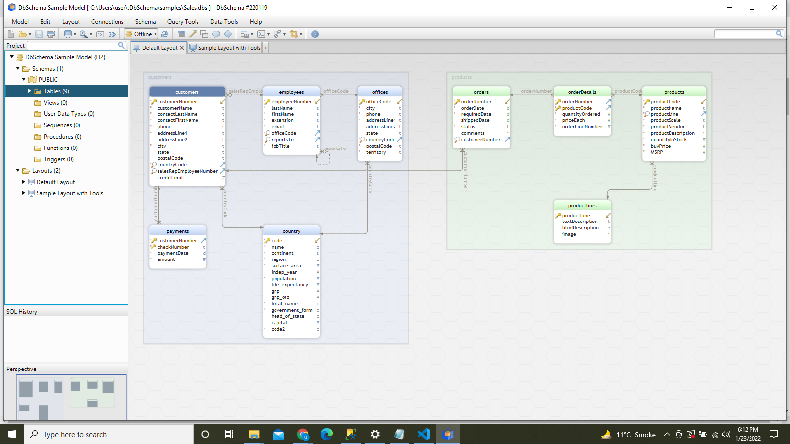

Figure 1: DBschema Layout (using sample data)

## 1. Table

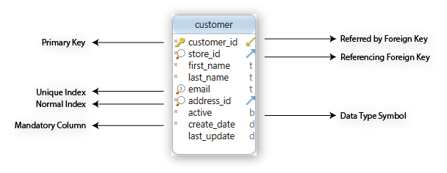

## 2. Foreign Keys

Foreign keys can also have different visual representations based on their cardinality and ordinality. These are consequences of the nature of columns and indexes.

* Cardinality represents the maximum number of times an entry from a table can relate to entries from another table.
* Ordinality represents the minimum number of times an entry from a table can relate to entries from another table.

Based on the referencing column, there are 4 states in which a foreign key can be. We will try to understand them better by looking at some examples:

## 3. Design Schema Online or Offline

## Using DbSchema you can design the schema while connected to a database (online) or without database connection (offline).

In the online mode, all table and column changes will be applied in the database. The executed statements are visible on the left, in the SQL History pane.

In the offline mode, changes will be applied only to the DbSchema model which will be saved to file. You need to connect to the database and choose one of the Schema options (Refresh/Compare with the database).