**DBMS LAB 10**

**Query Execution Plans**



**Submitted to**

Ms. Darakhshan Abdul Ghaffar

**Submitted by**

Ushna Ijaz (2019-CE-39)

**Department of Computer Engineering**

University of Engineering and Technology, Lahore

Date of Submission:

Apr 10, 2022

**Query Execution Plans:   
  
General Description:**

The thickness of the arrow correlates to the number of rows flowing between the steps. Besides the flow of information and arrow symbolism you'll also notice that each step/process has an associated cost. This is a percentage of cost for the step compared to the total cost of all steps in the query plan. Each statement will have an associated query plan, and this metric displays the cost for each statement when compared to the total for all statements run in the batch. The arrows denote not just the direction of data travel, but also (comparatively) amount of data rows being transferred from step-to-step in the execution process

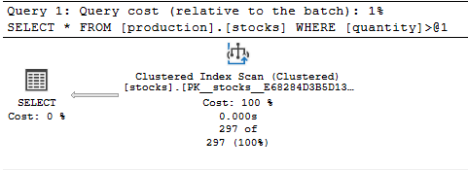

**Description:**

We have executed the query and there are 2 tabs available. If you check the difference it will show you the time taken for the scan. There are 2 parts in which we can divide our execution plan.

* Clustered Index Scan (Clustered)
* Select Operation

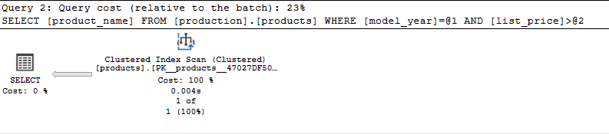

**Description:**

This query is quite similar to the first one. Under each operator we notice the percentage cost of that operator relative to all other costs in the plan. These relative costs can sometimes help highlight where the major pain points in your execution plan are occurring. Here the cost is 100%.

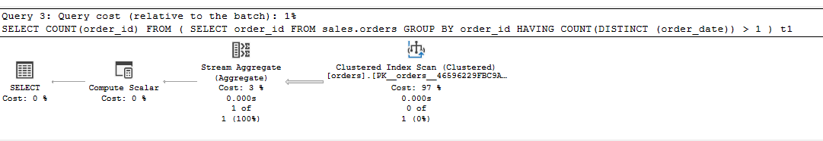

**Description:**

Estimated I/O Cost: 0.0075694

Estimated Operator Cost: 0.0095029 (97%)

Number of Rows read: 1615

Predicate: CASE WHEN [BikeStores].[sales].[orders].[order_date] IS NULL THEN (0) ELSE (1) END>(1)

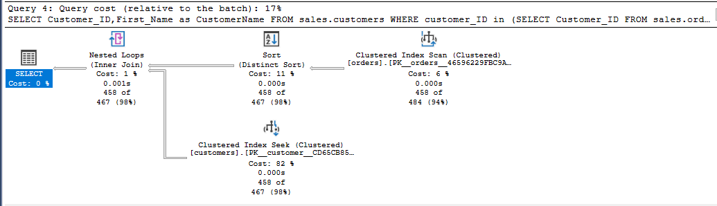

**Description:**

Estimated number of rows per execution: 467.202

Memory grant: 1024 KB

Set options: ANSI_NULLS: True, ANSI_PADDING: True, ANSI_WARNINGS: True, ARITHABORT: True, CONCAT_NULL_YIELDS_NULL: True, NUMERIC_ROUNDABORT: False, QUOTED_IDENTIFIER: True

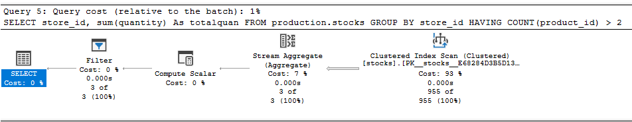

**Description:**

Estimated Operator cost: 0.0072955 (93%)

No of rows read: 955

Object: [BikeStores].[production].[stocks].[PK__stocks__E68284D3B5D1359D]

Output List: [BikeStores].[production].[stocks].store_id, [BikeStores].[production].[stocks].quantity

Estimated I/O cost: 0.006088

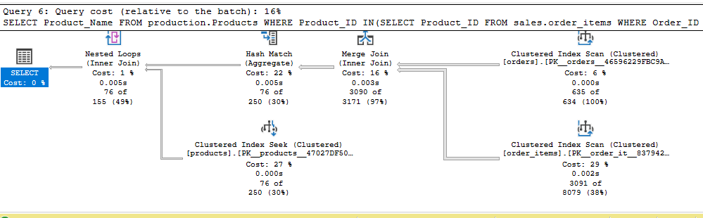

**Description:**

Estimated number of rows per execution: 155.209

Compile time: 56

Set Options: ANSI_NULLS: True, ANSI_PADDING: True, ANSI_WARNINGS: True, ARITHABORT: True, CONCAT_NULL_YIELDS_NULL: True, NUMERIC_ROUNDABORT: False, QUOTED_IDENTIFIER: True

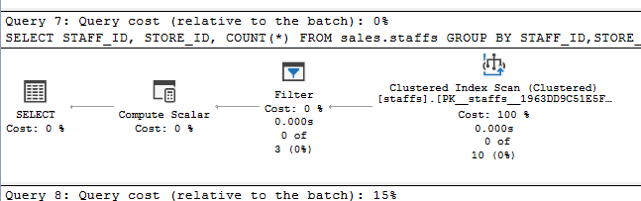

**Description:**

Compile Memory: 336

Set Options: ANSI_NULLS: True, ANSI_PADDING: True, ANSI_WARNINGS: True, ARITHABORT: True, CONCAT_NULL_YIELDS_NULL: True, NUMERIC_ROUNDABORT: False, QUOTED_IDENTIFIER: True

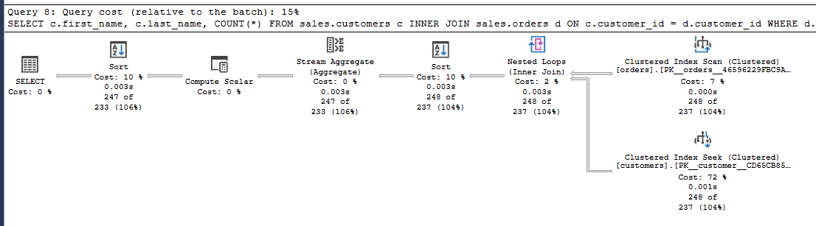

**Description:**

Output List: [BikeStores].[sales].[customers].first_name, [BikeStores].[sales].[customers].last_name

Estimated no. of rows per execution: 237.142

Operator Cost: 0.0028971 (2%)

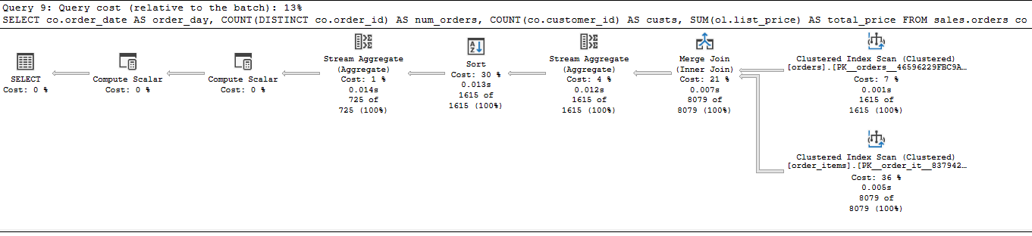

**Description:**

Set options: ANSI_NULLS: True, ANSI_PADDING: True, ANSI_WARNINGS: True, ARITHABORT: True, CONCAT_NULL_YIELDS_NULL: True, NUMERIC_ROUNDABORT: False, QUOTED_IDENTIFIER: True

Output List: [BikeStores].[sales].[orders].order_date, Expr1004, globalagg1006, Expr1012

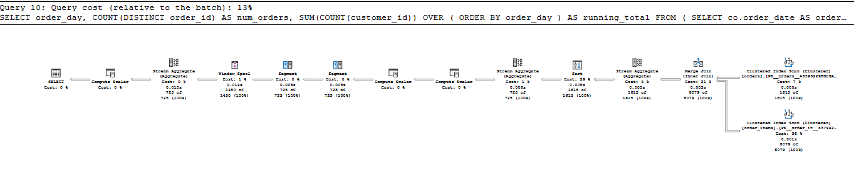

**Description:**

Object: [BikeStores].[sales].[orders].[PK__orders__46596229FBC9ABD9] [co]

Estimated no. of rows to be read: 1615

Logical Operation: Clustered Index Scan