RUSSIA
Since February 2022, Russia’s invasion of Ukraine and the sanctions that followed have changed the conditions under which Russian-linked wealth can enter, remain in or leave Switzerland. The available evidence points to a restriction, and in part a reversal, of Russian wealth inflows rather than a new wave of Russian wealth moving to Ticino.

1. Sanctions and legal developments relevant to wealthy Russian clients

1.1 Swiss sanctions and frozen assets
Switzerland adopted the EU sanctions against Russia within days of the invasion. According to the State Secretariat for Economic Affairs (SECO), by March 2025 Switzerland had adopted 15 of the 16 EU sanctions packages, with 1,859 individuals and 541 companies listed. SECO also reported 14 frozen properties in six cantons, along with vehicles, aircraft and works of art.
The amounts frozen move over time, partly because of market valuation and precautionary freezes that may later be lifted. SECO has stressed that the frozen amount is only a fraction of Russian-origin assets held in Switzerland and should not be read as a measure of the sanctions’ effectiveness.
Date | Frozen financial assets of sanctioned persons | Russian central bank assets reported | Source
November 2022 | CHF 7.5 billion | n/a | SECO, via Bloomberg
End of 2023 | CHF 5.8 billion (valuation losses) | n/a | SECO, via DPA
March 2025 | CHF 7.4 billion | CHF 7.45 billion | SECO, via SDA
1 June 2026 | CHF 8.5 billion | CHF 6.8 billion | SECO spokesperson to TASS (secondary report)

1.2 Deposit restrictions and bank practice
Switzerland banned banks from accepting new deposits from Russian clients above a total of CHF 100,000 and required existing deposits above that level to be reported to SECO. By late 2022, 123 Russian citizens or entities had reported 7,548 business relationships worth CHF 46.1 billion. The Swiss Bankers Association (SBA) estimated that Russian clients held roughly CHF 150 billions of bankable assets at Swiss banks in March 2022. It describes this as a market estimate and notes that much of it is not subject to the deposit restrictions or reporting.
Banks also adopted their own policies. UBS and Credit Suisse closed their Moscow branches in 2022, Vontobel reportedly stopped serving clients with a Russian connection, and Julius Baer stated that it has not onboarded new clients with Russian residence since the invasion. These private decisions, as much as formal sanctions, shape what a new Russian-linked client can realistically do in a Swiss private bank.

1.3 Rules on the Russian side
Russia reintroduced strict currency controls in early 2022, including restrictions on transfers abroad and on transactions with nationals of countries that had announced sanctions. A person is a Russian tax resident after 183 days in the country in a 12-month period; non-residents pay personal income tax on Russian-source income at 30% without deductions, while residents are taxed on worldwide income. Practitioner sources report that most of Russia’s double-taxation treaties have been suspended or denounced since 2022, and that Russia has no separate exit tax: departure itself is not a taxable event. A law-firm note also reports that Switzerland suspended automatic exchange of financial account information with Russia in September 2022.

2. Has the war changed the flow of wealth to Switzerland and Ticino?

2.1 Russian millionaires leaving Russia
Henley & Partners, using data from New World Wealth, estimated in June 2022 that about 15,000 Russian millionaires would leave Russia that year, compared with roughly 5,500 in 2019. Its later reports revised the 2022 net outflow to 8,500 and estimated 2,800 for 2023, with about 1,000 projected for 2024. The same source projected that around 42% of Ukraine’s millionaires would leave in 2022, although it noted that the war made tracking difficult.
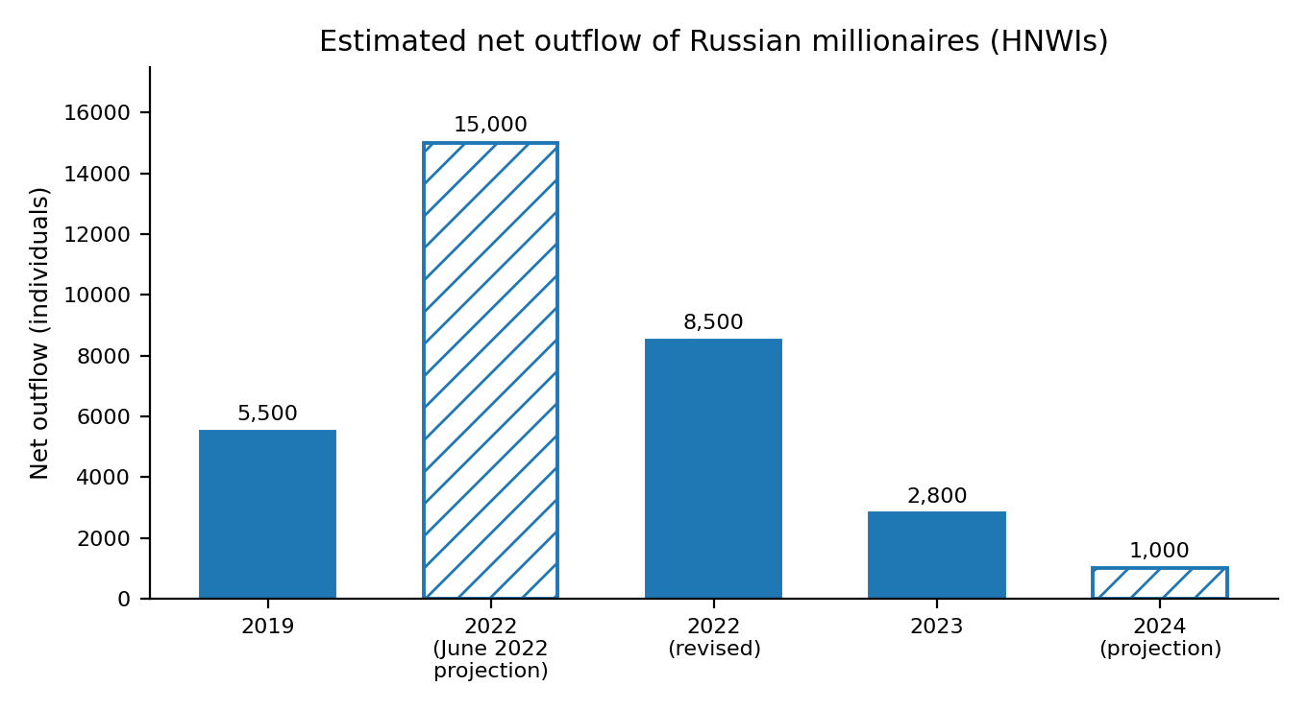

2.2 Russian wealth already held in Switzerland
The evidence suggests that Russian-linked assets in Swiss banks became more constrained after the invasion. A university paper using Bank for International Settlements data found a marked decline in Russian loans and deposits in Switzerland after February 2022, which moved with the decline in Russian household deposits. UBS reported about USD 22 billions of invested assets for Russian clients potentially affected by sanctions in April 2022 and said that some Russian clients had withdrawn assets. This points to a segment that is restricted and under scrutiny rather than expanding.

2.3 Safe haven flows from other regions
Some banks linked geopolitical uncertainty to inflows from other regions. Julius Baer said that each crisis strengthens the search for Switzerland’s safe-haven qualities, and Swiss banking press reported interest from Eastern European and Baltic clients in 2022. In the second half of 2022 Julius Baer recorded net new money of CHF 10 billion, with particularly strong inflows from Germany, the UK, Ireland, the Iberian Peninsula and Qatar.
The aggregate picture is less favourable. A KPMG study found that 73 Swiss banks (excluding UBS and Credit Suisse) received CHF 45 billions of net new money in 2022, against CHF 131 billion in 2021, and attributed the weakness to disruptions in the Swiss banking landscape and geopolitical uncertainty. Credit Suisse clients withdrew CHF 110 billion in the last quarter of 2022 and a further CHF 60 billion in the first quarter of 2023. Boston Consulting Group estimated that Swiss banks managed USD 2.4 trillion of assets belonging to wealthy foreigners in 2022.

2.4 What is known about Ticino
Residence permits
RSI reported in March 2022 that about 172 residence permits had been issued to Russian citizens over roughly a decade for tax reasons or higher interests, the category associated with expenditure-based taxation. Ticino was the second canton for permits of this type across all nationalities, with 130, behind Geneva with 148; the federal data do not show how many of the Ticino permits went to Russians, and issuance in Ticino has declined in recent years. An earlier parliamentary question cited a federal table showing 389 exceptional residence permits nationwide in 2008–2013, including 179 for Russian citizens.
Commodity trading
Lugano is Switzerland’s third commodity-trading hub, with about one hundred firms according to the sector association quoted by RSI in March 2022. Trading companies not on sanctions lists were not directly hit, but several banks restricted their exposure to Russia and Ukraine on their own initiative.
Enforcement cases
Ticino has seen sanctions enforcement on real estate and public controversy over a Russian-owned steel trading company based in Manno. These cases show that Russian-linked wealth is present in the canton, but not how much of it arrived after 2022.
Evidence gaps
No official series identifies Russian-origin wealth or Russian nationals moving to Ticino since 2022.

3. Why Ticino has appealed to Russian-linked clients, and what has changed
Tax and residence
Cantonal residence permits granted for fiscal interest, often linked to expenditure-based taxation, have been used by wealthy foreigners including Russians. Eligibility is conditional and canton-specific, and political and media scrutiny of these permits increased after 2022.
Geographic connectivity and the commodity-trading cluster
Lugano’s position near Milan and its trading cluster have attracted commercial groups from the steel and metals sectors, which run their networks from the canton. After 2022 this exposure became a source of reputational and compliance risk.
Wealth-management and professional ecosystem
Private banks, fiduciaries, lawyers and advisers can support a relocation. For Russian-linked clients, however, onboarding is now limited by sanctions screening, deposit caps and bank policies, so the ecosystem’s role is more about compliance than acquisition.
Lifestyle and real estate
Lake-view villas have been a feature of the canton’s appeal for wealthy foreigners. Frozen properties show that some of this real estate is now subject to sanctions.
Reputation and political scrutiny
A new factor since 2022 is the risk of being associated with sanctioned wealth. This may reduce the appeal for some clients and institutions, while strengthening the position of banks and advisers with strong compliance.

4. Illustrative cases
Andrei Klishas — Russian senator, villa in Ticino
Andrei Klishas, a Russian senator and former president of Nornickel, owned a large lake-view villa in Brione sopra Minusio, near Locarno, bought in 2008. He was added to the SECO sanctions list in 2014 and, according to swissinfo, the canton blocked the villa so that it can no longer be sold. The case shows sanctions enforcement on Ticino real estate, but it does not show new wealth arriving after 2022, since the property was bought well before.
Severstal Export GmbH — Manno
In May 2022 a committee against the war in Ukraine staged a protest in front of Severstal Export in Manno, the company associated with Alexey Mordashov, raising questions on the measures taken by the canton. Replying to a parliamentary question, the Council of State confirmed that the company was not on the SECO list of sanctioned firms. This is a reported controversy, and it does not establish wrongdoing by the company.

Sources
SECO figures on frozen assets, March 2025 (SDA), bluewin: https://www.bluewin.ch/en/news/switzerland-freezes-russian-assets-worth-15-billion-li.2633158
SECO spokesperson, assets frozen as of 1 June 2026 (Izvestia, interview with TASS): https://iz.ru/en/node/2149609
Frozen assets decline in 2023 (DPA via Vreme): https://vreme.com/en/razno/u-svajcarskoj-je-zamrznuta-ruska-imovina-u-vrednosti-od-oko-sest-milijardi-evra/
Bloomberg, “Swiss Say Its $8 Billion of Frozen Russian Assets Is ‘Only a Fraction’ of Total” (1 December 2022), via BNN Bloomberg: https://www.bnnbloomberg.ca/swiss-say-its-8-billion-of-frozen-russian-assets-is-only-a-fraction-of-total-1.1853480
Swiss Bankers Association, Russian clients’ assets and sanctions: https://swissbanking.ch/en/topics/regulation-and-compliance/sanctions
finews.ch, Banque Cramer closes Moscow office (UBS and Credit Suisse closures, Vontobel policy): https://www.finews.ch/news/english-news/60983-cramer-office-moskau-closing
Wealth Briefing Asia, Julius Baer results 2022 (net new money, no new Russian-resident clients): https://wealthbriefingasia.com/article.php?id=196908
finews.ch, “Die neuen Fluchtgelder im Swiss Banking” (2022): https://www.finews.ch/news/finanzplatz/50635-swiss-banking-ukraine-polen-baltikum-geld-vermoegen-finanzplatz
swissinfo, “Switzerland’s global wealth crown up for grabs” (KPMG, BCG, Credit Suisse outflows): https://www.swissinfo.ch/eng/switzerland-s-global-wealth-crown-up-for-grabs/48676922
swissinfo, “Switzerland clings on as world’s top offshore wealth centre” (BCG): https://www.swissinfo.ch/eng/switzerland-clings-on-as-world-s-top-offshore-wealth-centre/48621870
Reuters report on UBS exposure to Russian clients (April 2022), via VitVet: https://vitvet.com/en/about_us/news/dollars_of_russians_in_switzerland_fall_under_sanctions/
Bopst, Connor, “Russian Wealth and The Invasion of Ukraine: Evidence from the Bank for International Settlements,” University of Maryland (student paper): https://drum.lib.umd.edu/items/a4404f48-1dbc-4b60-afde-9b7b92749927/full
Henley & Partners, Private Wealth Migration Report 2023, “Politics and War Continue to Shape the Private Wealth Migration Landscape”: https://www.henleyglobal.com/publications/henley-private-wealth-migration-report-2023/global-insights/politics-and-war-continue-shape-private-wealth-migration-landscape
Spear’s, report on Henley Private Wealth Migration Report 2024 (18 June 2024): https://spearswms.com/?p=136295
Fortune, “15,000 millionaires are expected to leave Russia this year” (14 June 2022): https://fortune.com/2022/06/14/15000-millionaires-are-expected-to-leave-russia-this-year-where-the-rich-are-going
CNN via KVIA, “Russia is ‘hemorrhaging’ millionaires” (14 June 2022): https://kvia.com/news/2022/06/14/russia-is-hemorrhaging-millionaires/
Henley & Partners, Private Wealth Migration Report 2026: https://www.henleyglobal.com/publications/henley-private-wealth-migration-report-2026
RSI, “Ecco chi sono gli oligarchi russi” (1 March 2022): https://www.rsi.ch/info/svizzera/Ecco-chi-sono-gli-oligarchi-russi--1786462.html
L’Espresso, “Petrolio, acciaio e finanza: così la Svizzera è diventata la cassaforte degli oligarchi russi” (28 March 2022): https://lespresso.it/c/inchieste/2022/3/28/petrolio-acciaio-e-finanza-cosi-la-svizzera-e-diventata-la-cassaforte-degli-oligarchi-russi/22442
Interrogazione al Consiglio di Stato ticinese su permessi di residenza derogatori (2008–2013): https://www4.ti.ch/fileadmin/POTERI/GC/allegati/interrogazioni/word/196.14.doc
RSI, “Le materie prime e la piazza di Lugano” (1 March 2022): https://www.rsi.ch/info/ticino-grigioni-e-insubria/Le-materie-prime-e-la-piazza-di-Lugano--1786506.html
swissinfo, “Russian oligarch’s holiday home blocked in Switzerland”: https://www.swissinfo.ch/eng/foreign-affairs/russian-oligarch-s-holiday-home-blocked-in-switzerland/47584946
laRegione, “Sanzioni non per tutti, sit-in contro oligarca russo a Manno” (10 May 2022): https://www.laregione.ch/cantone/luganese/1582332/servizi
Skadden, “Russia Restricts Transactions With Nationals of Sanctioning Countries and Further Limits Transfers of Funds Abroad” (March 2022): https://skadden.com/insights/publications/2022/03/russia-restricts-transactions-with-sanctioning
VitVet, “Tax Residency in Russia” (law-firm note): https://vitvet.com/en/eng_articles/tax_residency_in_russia/
Private.law wiki, “Russia: Relocation, Accounts, and Capital” (practitioner note, exit tax and treaties): https://wiki.private.law/en/russia-hub
Van Rhijn Legal, “Russian Currency Residency” (CRS suspension reported; to be verified): https://www.vanrhijnlegal.com/?p=15361

