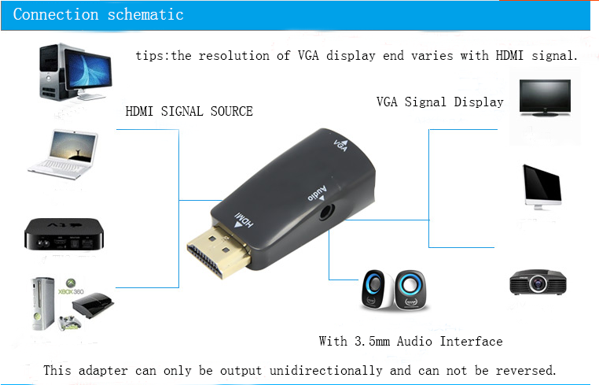

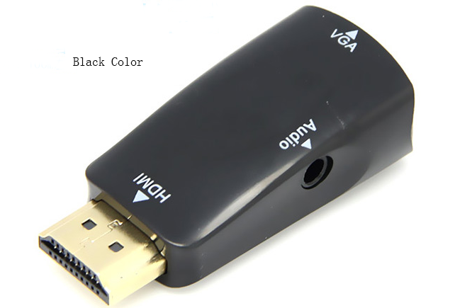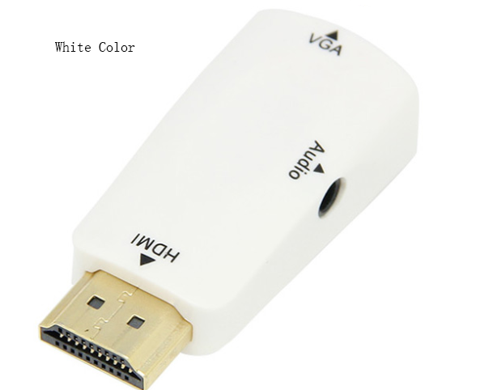

Features:
Compliant with HDMI 1.3 standard.
Convert the video signal from digital to analog.
Upgrade Version, integrated with Audio output.
Powered by HDMI, no external power adapter required.
Plug and Play, no software is needed.
Easy to use: install in seconds, no need of setting.
Conversion: it can convert complete HDMI into VGA video.
Compatible for PC / Laptop / DVD / for PS3 / for Xbox360 / for Sky HD / for Apple TV and other HD device to be connected with VGA monitor / projector or other display.
Specification:
HDMI video input format: 480i/576i/480p/576p/720p/1080i/1080p
VGA video output format: 480i/576i/480p/576p/720p/1080i/1080p
Product size: approx. 50*23*15mm/1.96*0.9*0.59\'\'
Net weight: approx. 20g
Please note:
It is manual measurement, there may be 1-3mm error. And item color displayed in photos may be showing slightly different on your computer monitor since monitors are not calibrated same.hope understanding.

