FAQ
how to use this LCD screen on your Raspbian system
make sure that you can be normal to enter the desktop of your raspbian system, run the command

sudoraspi-config

Determine whether to choose：
Enable Boot to Desktop/Scratch -> Desktop Log in as user ‘pi’ at the graphical desktop

download the LCD Driver, Unpack it,copy it to your system,then run the following commands:

tarxvf LCD-show.tar.gz

cd LCD-show/

#3.2inch RPi LCD (B) run

sudo ./LCD32-show

#3.5inch RPi LCD (A)run

sudo ./LCD35-show

#4inch RPi LCD (A)run

sudo ./LCD4-show

#5inch HDMI LCDrun

sudo ./LCD5-show
Wait for a few minutes, the system automatically restart, can be normal use the LCD
If you want to switch to HDMI display, need to run thiscommand:

sudo ./LCD-hdmi

If you update this system image but can not be use normally
you must follow this method to update your system ,otherwise your system can not run normally:

sudo apt-mark hold raspberrypi-bootloader

sudo apt-get update

sudo apt-get upgrade

How to rotate the screen direction (3.5 inch RPiLCD(A))
Run the following command：

sudonano /etc/modules
- Rotate 90 °：
width=320 height=480改为： width=480 height=320

-1,0x36,0x28,-1 set to：-1,0x36,0x48,-1
- Rotate 180 °：
-1,0x36,0x28,-1 set to：-1,0x36,0xe8,-1
- Rotate 270 °：
width=320 height=480 set to： width=480 height=320

-1,0x36,0x28,-1 set to：-1,0x36,0x88,-1
press Ctrl + X, choose Y ,save and exist
To run the following command：
sudonano /etc/X11/xorg.conf.d/99-calibration.conf

Display as shown in the figure below (touch parameters will be subject to the actual value)
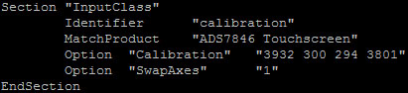
- Rotate 90 °, the config are as follows：
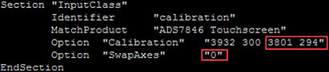
- Rotate 180 °, the config are as follows：
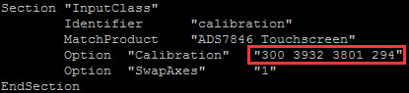
- Rotate 270°, the config are as follows：
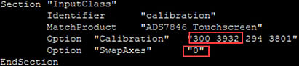
What is the 3.5inch RPi LCD normal working current ?
The normal working current is about 115 mA.

