- What is a steering gear:
In the robotic electromechanical control system, the steering gear control effect is an important factor affecting performance. The steering gear can be used as the basic output actuator in the micro-electromechanical system and model airplane. Its simple control and output make the single-chip microcomputer system very easy to interface with it. The steering gear is a position (angle) servo driver, which is suitable for those control systems that require constant angle changes and can be maintained. At present, it has been widely used in high-end remote control toys, such as airplane models, including airplane models, submarine models, and remote control robots. The steering gear is a common name, but it is actually a servo motor. To 2. Its working principle is: The control signal enters the signal modulation chip from the receiver channel to obtain the DC bias voltage. There is a reference circuit inside it, which generates a reference signal with a period of 20ms and a width of 1.5ms, and compares the obtained DC bias voltage with the voltage of the potentiometer to obtain a voltage difference output. Finally, the positive and negative of the voltage difference is output to the motor drive chip to determine the positive and negative rotation of the motor. When the motor speed is constant, the potentiometer is driven to rotate through the cascade reduction gear, so that the voltage difference is 0, and the motor stops rotating. Of course, we don't need to understand its specific working principle, it is enough to know its control principle. Just like when we use a transistor, we only need to know that it can be used as a switching tube or amplifying tube. As for the specific flow of electrons in the tube, there is no need to think about it. 3. Control of the steering gear: The control of the steering gear generally requires a time base pulse of about 20ms, and the high level part of the pulse is generally the angle control pulse part in the range of 0.5ms~2.5ms. Taking the 180 degree angle servo as an example, the corresponding control relationship is as follows: 0.5ms--------------0 degrees; 1.0ms------45 degrees; 1.5ms------------90 degrees; 2.0ms-----------135 degrees; 2.5ms-----------180 degrees; Please look at the image description:

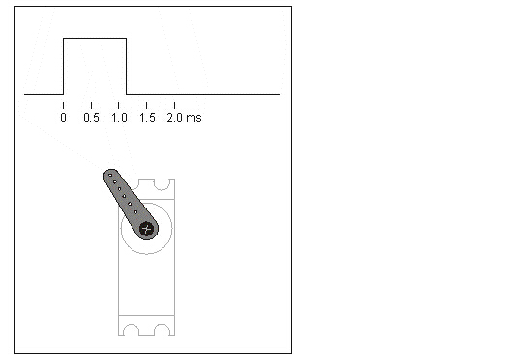
This is only a reference value. For specific parameters, please refer to the technical parameters of the steering gear.
The working voltage of small servos is generally 4.8V or 6V, and the speed is not very fast, usually 0.22/60 degrees or 0.18/60 degrees, so if you change the width of the angle control pulse too fast, the servo may not be able to respond. . If you need a faster response, you need a higher speed.
It is not so easy to control the steering gear accurately. Many steering gears have 1024 position levels. Then, if the effective angle range of the steering gear is 180 degrees, the control angle accuracy can reach 180/1024 degrees about 0.18. In terms of time, the required pulse width control accuracy is 2000/1024us and about 2us. If you take a steering gear, you can't even control the accuracy of 1 degree, and you can see the steering gear shaking. In this case, as long as the voltage of the servo does not jitter, the jitter is your control pulse. And why does this pulse jitter? Of course it depends on the pulse generator you choose. Some predecessors like to use 555 to adjust the driving pulse of the servo. If you only control a few point position servos, it seems that you can do this. You can use a few more switches to pull some resistors out to adjust the duty cycle. Is this easy? Ah, debugging should be very troublesome and the operation is not necessarily reliable. In fact, it is mainly because of his time that the single-chip microcomputer was not popular, so how could it happen!
There are also many schemes of using traditional single-chip microcomputer to control the steering gear. Most of them use timers and interrupts to complete the control. This way of controlling one steering gear is quite effective, but as the number of steering gears increases, it may be controlled. It is not so convenient and can achieve a pulse width control accuracy of about 2 microseconds. I heard that AVR also has a test board for controlling 32 servos, but Tektronix may not know whether the accuracy can reach 2 microseconds. In fact, the test is very simple, you only need to connect its control signal to the oscilloscope, and then let the steering gear control signal output by the test board increase in a width of 2 microseconds.
Why can FPPA easily control the accuracy of the pulse width at 2 microseconds or even less than 2 microseconds. The main reason is that creative instructions such as delay memory have worked. The delay time of this instruction is the value of the immediate value in the data unit plus 1 instruction cycle (data 0 is out, please refer to the precautions for using the delay instruction for details) because it is an 8-bit data storage unit, so the data in memory is ( 0～255), remember that as mentioned earlier, the angle level of the servo is generally 1024, so only one storage space to store the delay parameters does not seem to be enough, so we can use 2 memory units to store the rudder The angle servo parameters of the machine are changed. So in this way, we can adopt this software structure: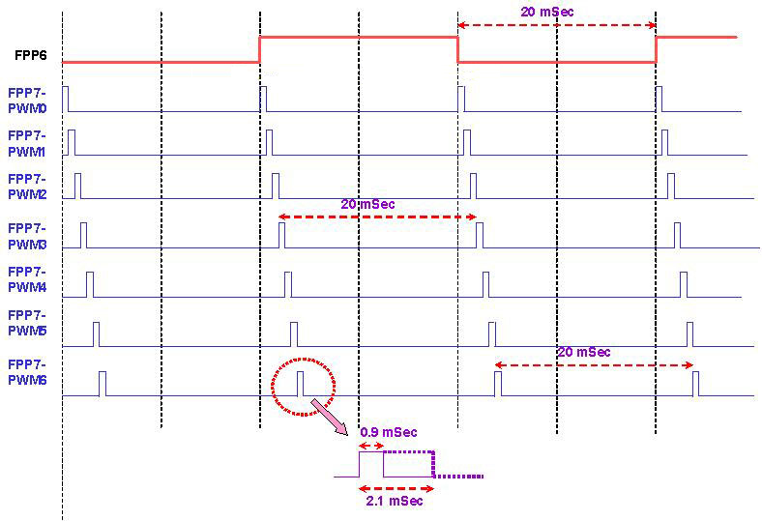
Application occasions of steering gear drive:
1. A high-end remote control simulation car must at least include left-turn and right-turn functions. High-precision angle control will inevitably give you the most realistic driving experience.
2. Multi-degree-of-freedom robot design, why the robots designed by the Japanese can be sold for tens of thousands of RMB?
It is still a quality problem that some of the domestically designed two or three thousand yuan can not be sold.
3. Multi-channel servo model aircraft control, electric remote control aircraft, oil-powered remote control aircraft, nautical models, etc.

