**Report about the developed QGIS Plug-in “Inundation Calculator”**

- by Ute Susanne Kaden, 2021

The following instructions can also be watched in a video (english, with subtitles):

<https://www.youtube.com/watch?v=OH0GrOaJ0NY>

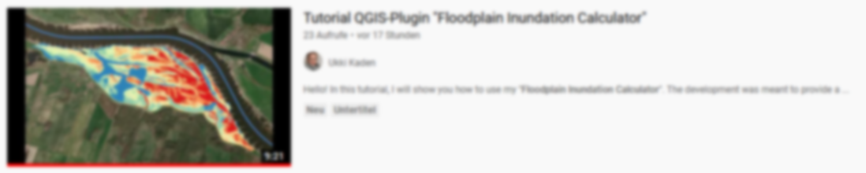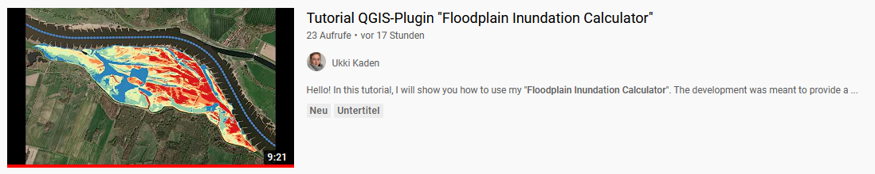

**Aim**

The frequency and duration of inundations in floodplains is of great interest as it affects habitat provision and biodiversity as well as various biogeochemical soil processes maintaining water quality. The development of the Inundation Calculator is intended to enable a simple approximation of yearly average flooding durations in floodplains by using river water levels and the floodplain topography. We are often confronted with the problem that no spatially and/or temporally high-resolution remote sensing data or open source 3D flooding model are available. So we need to find easy solutions which can be applied by everyone, although these remain rough approximations and users must be aware of application limitations.

**Approach**

Floodplain inundation is reflected by overland inundation from the river channel to the floodplain when bank full conditions are exceeded. Additionally, due the rise and fall of the water table of the alluvial aquifer which is coherent with that of the river channel, flooding from below ground through the filling of the alluvial aquifer can inundate the floodplain. Based on this and due to lack of area-wide groundwater monitoring, raster cells with an elevation below the current river water level are assumed to be inundated in the modeling process.

First, the Plugin makes use of a dictionary to create a histogram of all waterlevels (1cm resolution). Afterwards the frequency of inundation for each waterlevel is determined by accumulating histograms. Through counting from top to bottom, it is assumed that if height step x is inundated, all height steps below x are inundated too. This is then compared to the heights of the digital elevation model, so that for each height the sum of flooding days is stored in a matrix. Afterwards this matrix is divided by the number of considered years to get the gridded average inundation days per year. Finally, the information is transferred to the original xy-dimension of the digital elevation model.

**Preparing of Input Data**

1. Study Area (SA)

Please create a shape file / polygon for the area for which you would like to have the inundation information.

Very helpful for delineating the shoreline are the "Contour" tools of QGIS.

For Germany, another option is using the floodplain sections, assessed through the status report on German floodplains. You can download these as shapefiles using the web feature service (WFS)[1], provided by the Federal Agency for Nature Conservation (BfN). Please follow the instructions for using the service[2] and chose the polygon concerned.

For best possible reliability of the results, it's necessary to place your study area under consideration of the following aspects:

- Distant areas that are not connected may be calculated incorrectly 🡪 SA must be located in the active floodplain (e.g. not behind the dike)

- The level data used should ideally be taken from a gauge that is directly on site 🡪 SA must be close as possible to the gauging station (see also point 3)

- Bias are less likely if SA is not characterized by structures such as elevations, channels, dips, etc. 🡪 SA must be as topographically homogeneous as possible, otherwise the inundation effect is caused by assumed coherent raising of the alluvial aquifer

1. Digital Elevation Model (DEM)

The resolution of areal information of calculated inundation durations, is defined by the input data. That's why the DEM used should have a resolution as high as possible.

For Elbe and Rhein there is a download option[3],[4] for the active floodplain with 0.01 m resolution.

To use the plugin, the DEM must be in GeoTIFF format and in 64bit format.

If your raster data is not in tiff format, export it as a GeoTIFF. If your raster data is not in 64bit format please transform it with the help of QGIS Tool "Translate (Convert Format)".

If the extend of your DEM exceeds the size of your SA, use QGIS Tool "Clip Raster by Mask Layer" for resizing and save it again as GeoTIFF.

1. Water Level Data (WLD)

Since changes in the cross-section surfaces cannot be considered, the gauge used should be close as possible to SA, to ensure that the water levels used are at proper elevation.

The plugin needs a daily water level information (one value per day) in the same unit as the digital elevation model (DEM, probably meters above sea level) for (at least one) full year(s).

There is a download option[5] for the latest water level data (raw data) of many Germany rivers. There is also a gauge overview including the provision of master data[6]. Required longer time periods may be provided upon request from the Federal Waterways and Shipping Administration (WSV)[7] or the German Federal Institute of Hydrology[8] . You can also check the metadata catalog MetaVer[9] to see who is responsible for the data (what data is available? Who manages the data and provides information?).

Please provide the daily water levels in one column of a CSV file and delete leap days (February, 29th), so that the column length is a multiple of 365.

Please check that the data set is complete. Delete incomplete years or fill small gaps by interpolation.

If the gauging station is not directly located next to study are (SA), at least one real-time water level difference measurement between gauge and SA must be taken as an approximation. The difference (x) can be used as a factor for compensating (see sketch below). This way, the water level fluctuations of the most adjacent gauge are linearly transferred to the DEM of the SA.

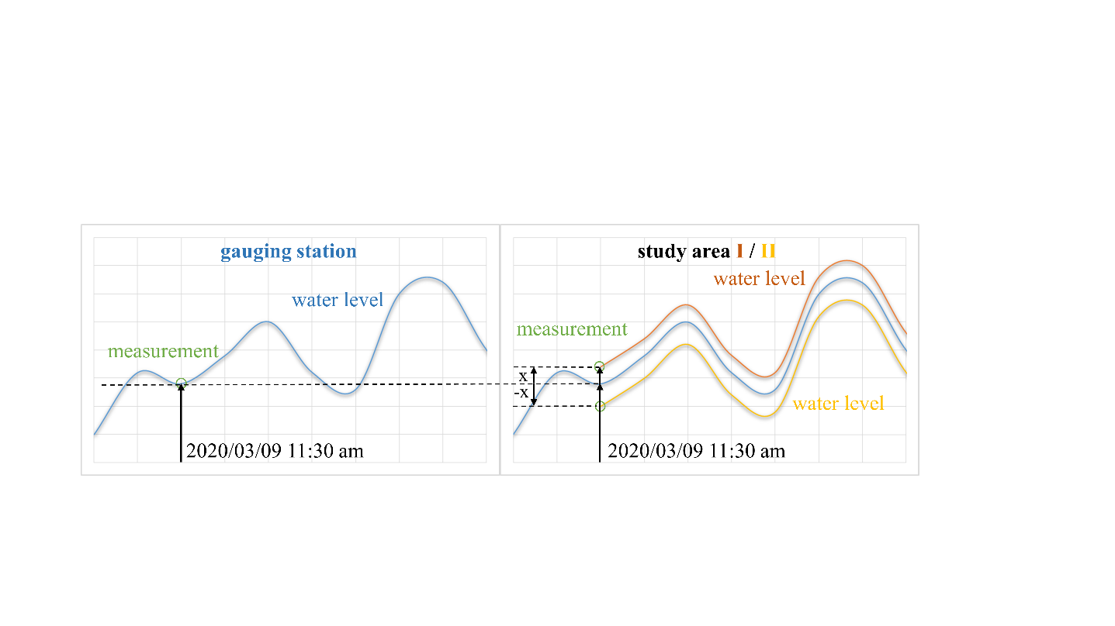

**Instructions for Use**

1. Open a new QGIS Project by *> project > new /* > *Ctrl+N*
2. Add the digital elevation model (DEM) by *> layer > add layer > add raster layer* / > *Ctrl+R*
   1. format: GeoTIFF, 64 bit format (see point 2 of preparing input data for any necessary adjustments)
   2. shape: shaped like study area (see point 3 of preparing input data for any necessary adjustments)
   3. unit: probably mNN or other but equal to WLD
3. Add the daily Water Level Data (WLD) by *> layer > add layer* > *add delimited text layer* / > *Ctrl+Shift+T*
   1. format: CSV
   2. shape: one value per day, full years, 1 column, column length = x*365
   3. unit: probably mNN or other but equal to DEM
4. If necessary: calculate the correction factor x (in cm, see point 3 of preparing input data)
5. Open the Inundation Calculator User Interface: (*Plugins > Floodplain Inundation Calculator > calculate floodplain inundation durations*)
   1. select the DEM in the upper dropdown menu
   2. select the WLD in the dropdown menu below
   3. type in correction factor x, if necessary
   4. select output file by specifying a path (> *...*), and typing in *xxx.tif* (result)
   5. check box “Add result to project”
   6. run (*> OK*)

**Properties Adjustments of Result**

The result (xxx.tif) appears as black to white gradient colored layer, containing values in the range of 0 to 365, or narrower range.

For nice visualization I recommend plotting average inundation days per year in quantiles. By this, the entire area is divided into equally sized classes. The thresholds between the classes are shown in the legend. A comparison of these between different study areas offers a simple basis for analysis.

For an example you can use the following steps:

> *right-hand click on* result layer (xxx.tif) *> Properties > Symbology*

> Render type: *Singleband pseudocolor*

> Interpolation: *discrete*

> Mode: *quantile*

> Classes: *3 (or what you prefer)*

*> Classify*

> you can change the coloring by using a different Color ramp or select colors of different classes individually by clicking on the color-patch

*> Ok*

There are countless visualization methods, try yourself!

**Data Collection, Interpretation, and Limitations**

The resulting map is to be interpreted as approximation of yearly average inundation durations in the floodplain in days per year. By activating the result-layer (xxx.tif) and using *> Identify Features / Strg+Shift+I* you can get the value (average inundation duration in days per year) for each raster cell.

If you want to get this information at specific points (e.g. sampling points in your study area), provide a point-shapefile (*coord.shp*) and use the following steps:

*> Processing > Toolbox / > Ctrl+Alt+T*

*> Raster Analysis > Sample raster values*

> Input layer: *coord*

> Raster layer: xxx.tif

> Output column prefix: *INUNDATION DAYS*

*> Run*

*> right-hand click on appeared* Temporary layer‘Sampled’ *> Open attribute table >* last column

The approximation of yearly average inundation durations in the floodplain (days per year) depends on the length of the time series of the water level data used. By comparing short to long time series, flooding probability trends can be identified.

Due to the simplified approach used, it’s necessary to point out again the limitations of application of this Plugin. The calculation assumes all raster cells with an elevation below the current river water level, to be inundated. This does not apply, for example, to sinks or if there is an elevation (e.g. dike) between the river and the point under consideration. In this case, it’s assumed that inundation is caused by upwelling groundwater, an approximation that can be made in floodplains as fluctuation of the river water are directly connected to the rise and fall of groundwater. However, there is usually a height difference (see losing and gaining streams), a reaction with time delay, and the water differs significantly biochemically from the river water.

Floodplains are complex systems, so their models always remain approximations. They are nevertheless very valuable, as long as limitations are taken into account when interpreting them.

**Outlook**

Further, the input of time stamps could be implemented. This would allow other resolutions (several water levels per day etc.) and shorten the previous data preparation. One could also think about other input formats of the DEM's to avoid a previous conversion.

The biggest further improvement, but also very complex, would be the input of several or all available gauges at a river. Thereupon an interpolation of the water level values of the gauging stations would have to be done. Thus, it would be possible to make statements about the water level at any given river kilometer.

Such products are currently being developed by the German Federal Institute of Hydrology. This so-called "River Hydrology Web Service (FLYS)" can already be tested in a demo version[10].

1. https://geodienste.bfn.de/ogc/wfs/Flussauen_DE_2021
2. https://www.bfn.de/fileadmin/BfN/daten_fakten/Dokumente/Anleitung_zum_Einbinden_von_ogc_Diensten_bf.pdf
3. https://doi.pangaea.de/10.1594/PANGAEA.919293 (active floodplain of Elbe 0.01 m resolution)
4. https://doi.pangaea.de/10.1594/PANGAEA.919308 (active floodplain of Rhine 0.01 m resolution)
5. https://www.pegelonline.wsv.de/webservices/files/Wasserstand+Rohdaten
6. https://www.pegelonline.wsv.de/gast/pegeltabelle
7. https://www.gdws.wsv.bund.de/DE/service-navi/kontakt/kontakt_node.html
8. https://www.bafg.de/EN/06_Info_Service/01_WaterLevels/waterlevels.html?nn=186140
9. https://metaver.de/portal/
10. https://www.bafg.de/DE/05_Wissen/01_InfoSys/flys/flys.html