Mailbox

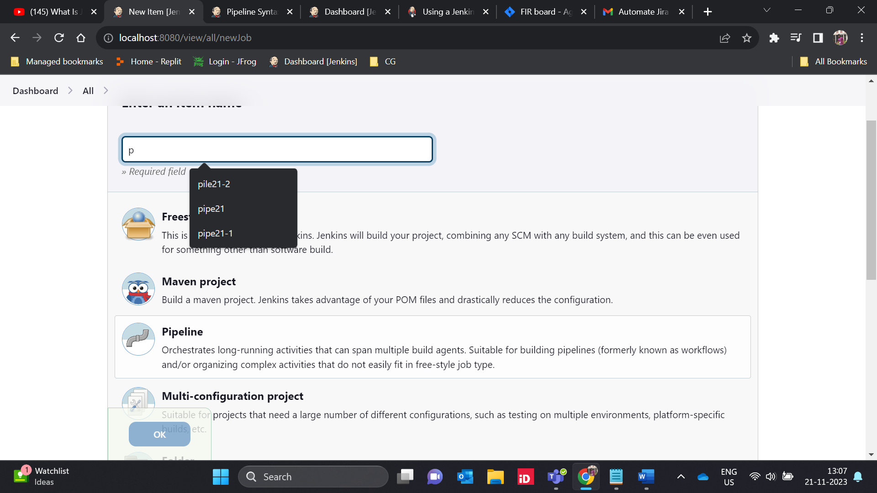

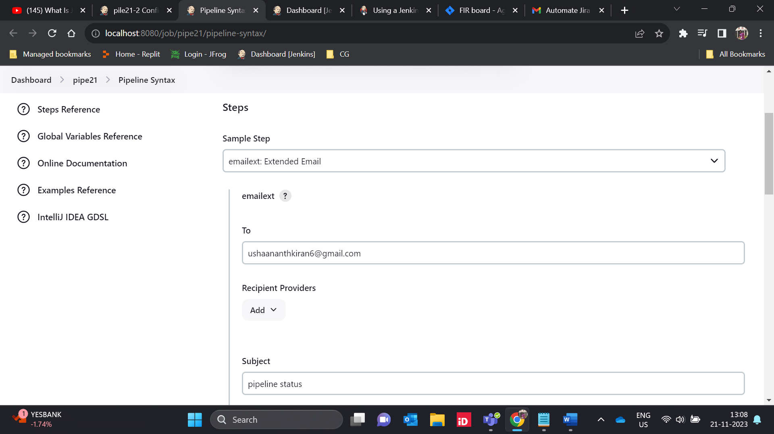

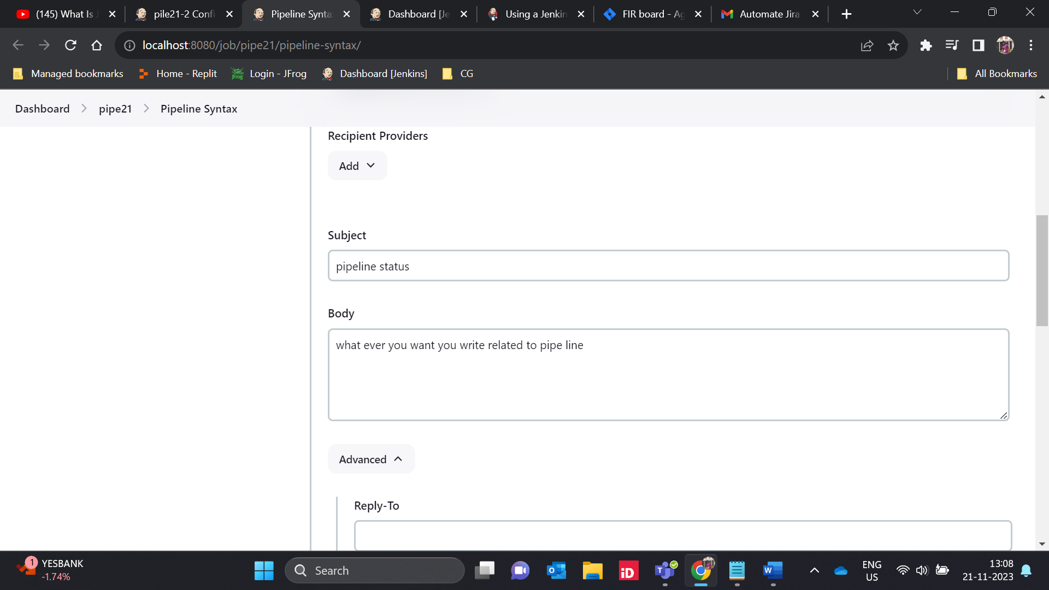

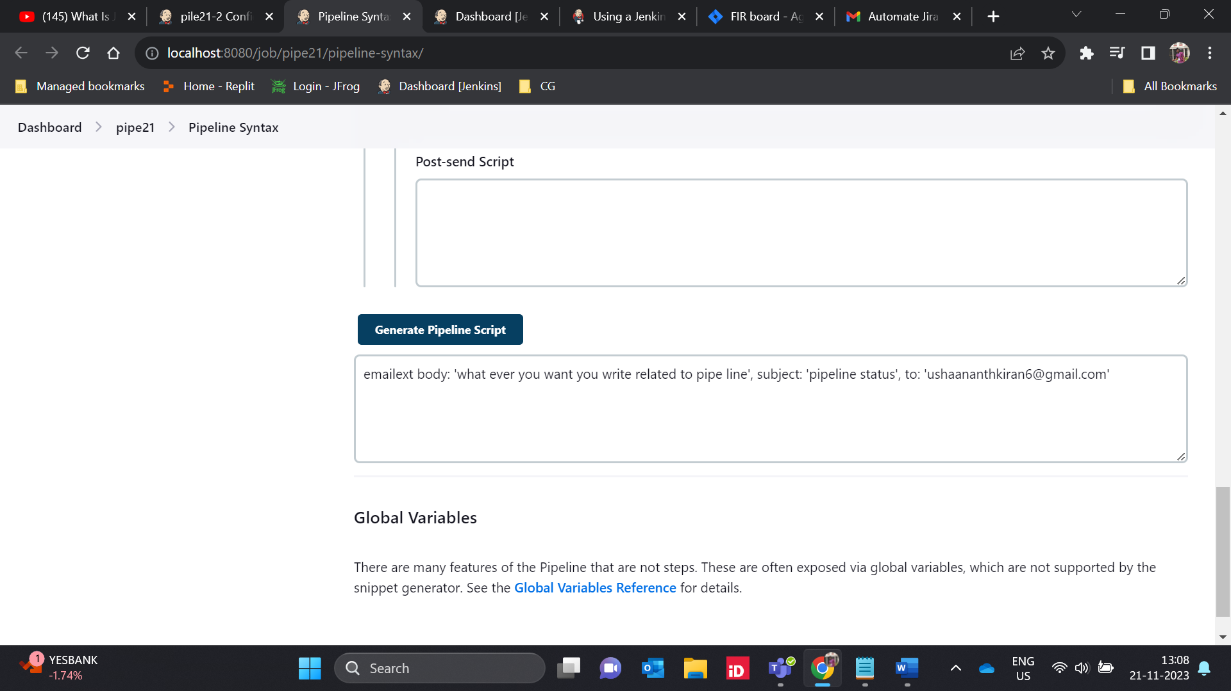

pipeline

{

agent any

stages

{

stage("BUILD")

{

steps

{

echo "BUILD APP"

}

}

stage("TEST")

{

steps

{

echo "TEST APP"

}

}

stage("DEPLOY")

{

steps

{

echo "DEPLOY APP"

}

}

}

post

{

always

{

emailext body: 'what ever you want you write related to pipe line', subject: 'pipeline status', to: 'ushaananthkiran6@gmail.com'

}

}

}

