Mailbox
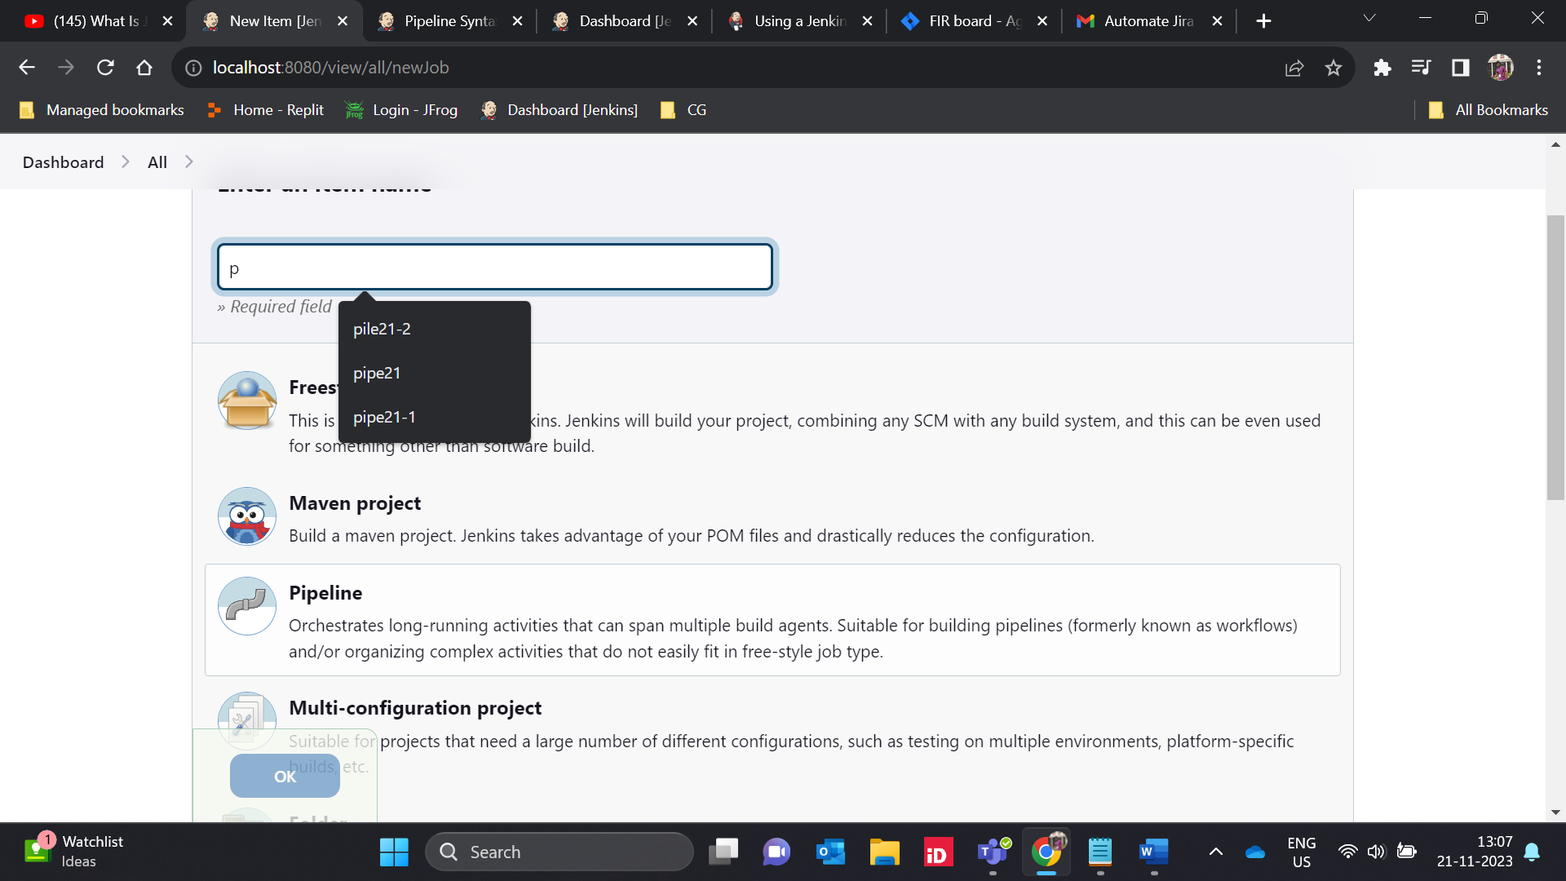
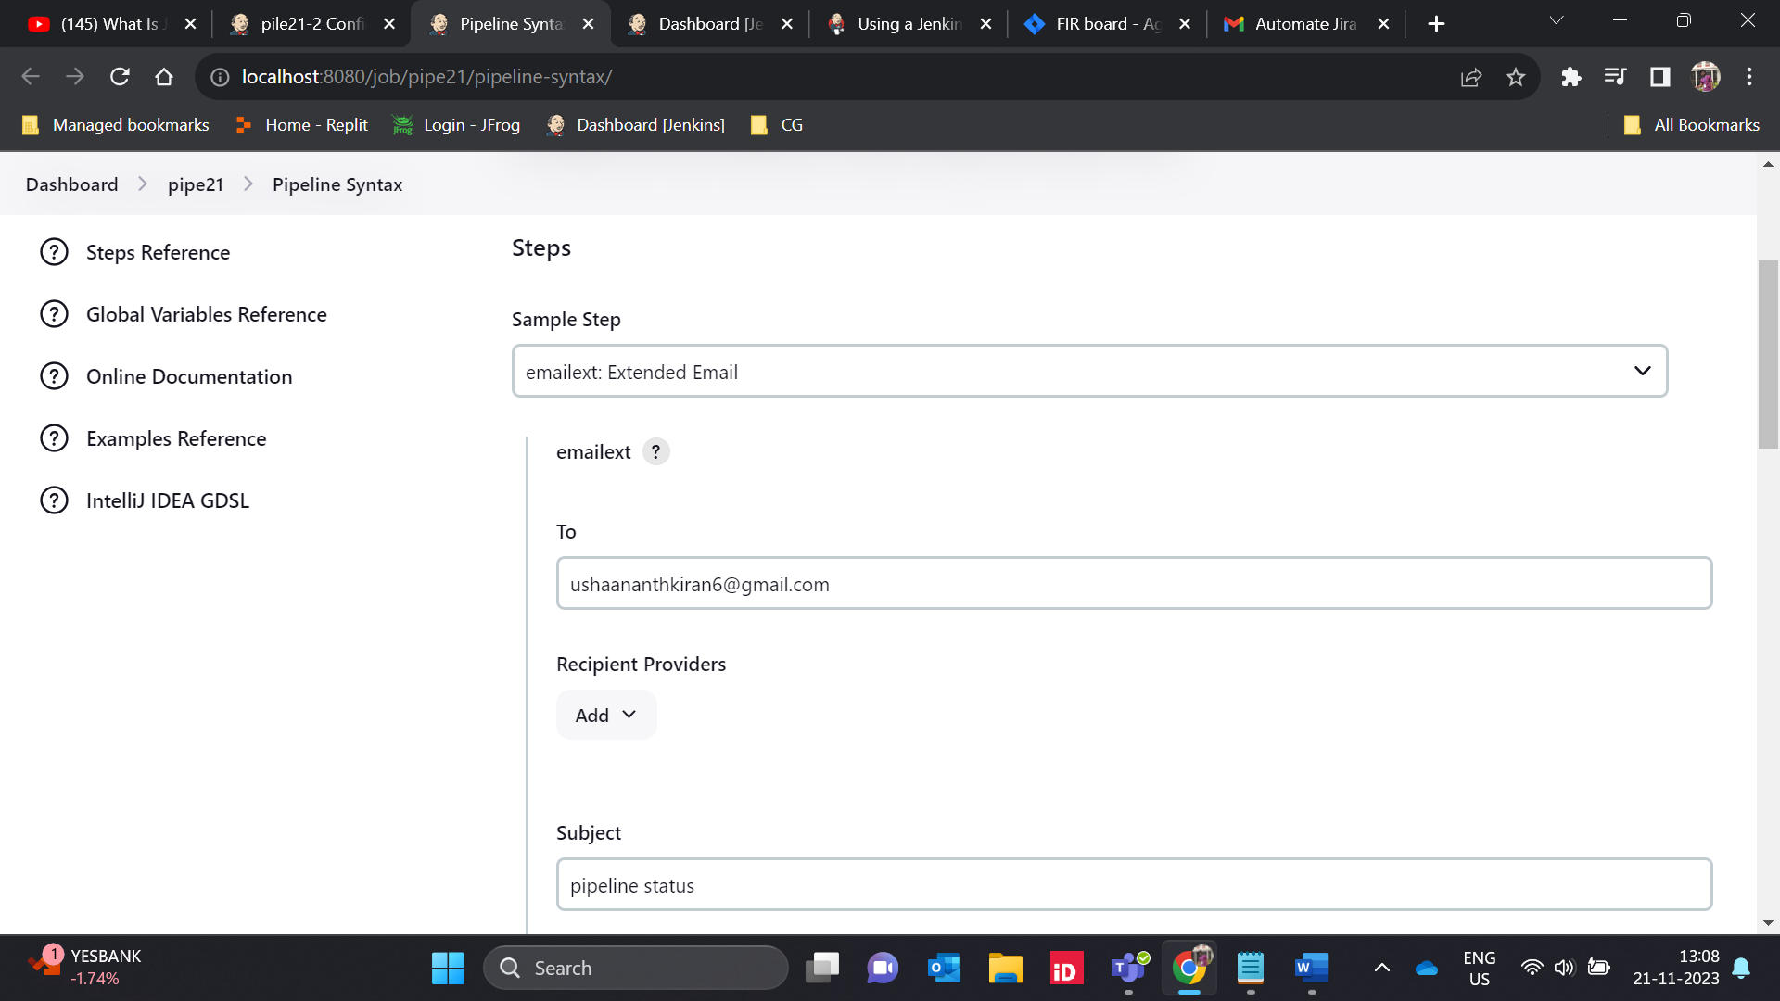
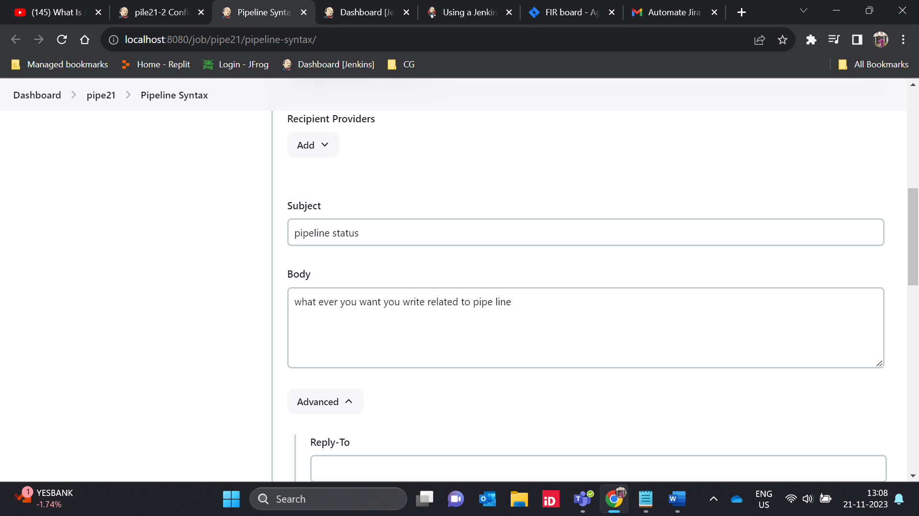
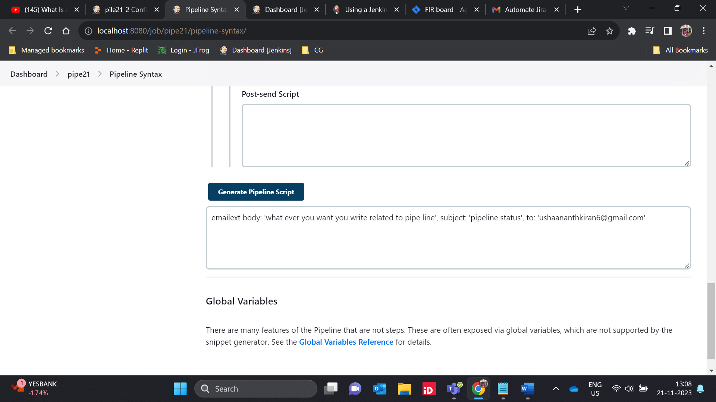
pipeline
{
agent any

stages
{
stage("BUILD")
{
steps
{
echo "BUILD APP"
}
}

stage("TEST")
{
steps
{
echo "TEST APP"
}
}

stage("DEPLOY")
{
steps
{
echo "DEPLOY APP"
}
}
}

post
{

always
{
emailext body: 'what ever you want you write related to pipe line', subject: 'pipeline status', to: 'ushaananthkiran6@gmail.com'
}

}
}
