SWE 574 Software Development as a Team, Spring 2013
Instructor: Dr. Suzan Üsküdarlı

TA: Twitter Analyzer
Requirements Specifications Document

20.10.2013
Revision 2.0

By: Group 2

Revision History

Revision | Date | Explanation
1.0 | 19.10.2013 | - Initial Requirements
2.0 | 20.10.2013 | - Requirement Details updated.  - Mockups added.  - Twitter API added.

Table of Contents

Revision History 2
Table of Contents 3
1. Introduction 4
2. Assumptions 4
2. Requirements 4
2.1. Requirement 1. Authentication 5
2.2. Requirement 2. Parts of Application 5
2.3. Requirement 3. Query Input and Processing 6
2.4. Requirement 4. Report Preparation 7
2.5. Requirement 5. Settings 8
3. Twitter Public APIs 8
4. Testing 8

1. Introduction

This is the Requirements Specification Document (RSD) for the project to develop Twitter Analyzer Application, to carry out mainly the followings:

- An authentication will be made to log in to the application

- Application will be consist of three parts:
  - Query
  - Reports
  - Settings

- Query process will be made by step by step pages:

- Report will be prepared in less than 24 hours.

- User account settings will be shown on settings page. User will be able to update notification settings and user account information using settings page.

2. Assumptions

- The system will run on at least the following computer platforms:
  - Windows
  - Linux

- There is going to be a multi-user web application.

- There is going to be an Android mobile application.

- The system shall be implemented in the following programming languages:
  - Server side in Java
  - Android in Java
  - Web in HTML/Javascript

- Database system is going to be MySQL.

- Servlet Container is going to be Tomcat 7.

- There is going to be an Android mobile application.

2. Requirements

Requirements for this application are listed in this section.

2.1. Requirement 1. Authentication

An authentication will be made to log in to the application. A simple login page will be developed in order to authenticate the user.

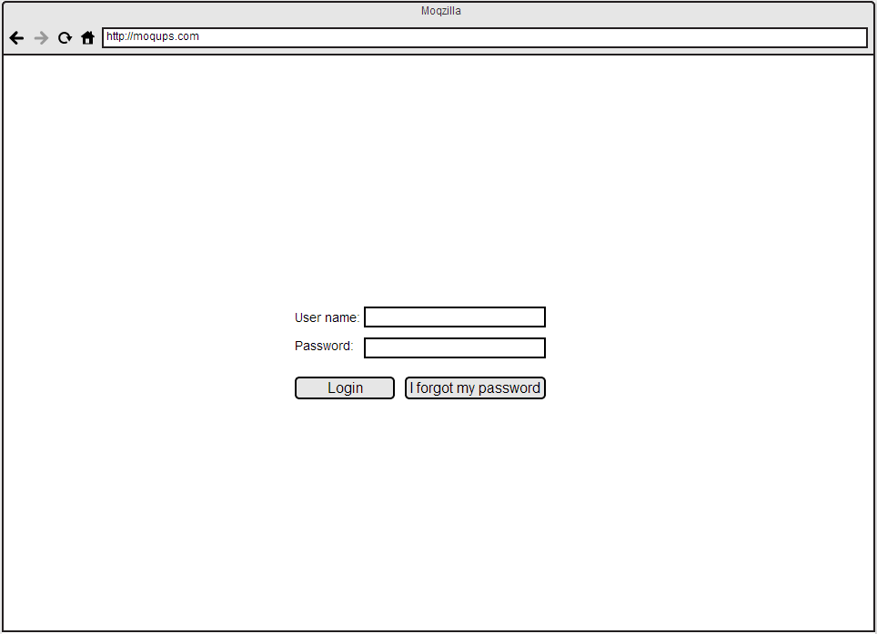
Mock-up 1: Login Page

2.2. Requirement 2. Parts of Application

Application will be consist of three parts:
  - Query
  - Reports
  - Settings

Query is the user input given as a string consists of several keywords. According to these keywords, this query will be processed and new keywords may be added or query may be changed according to previous experience of system and admins.

Reports will give the user:
  - Brief information about sentiment and user opinions
  - Detailed information from brief information via user actions.
  - Charts shall also be included in reports wisely.

Settings give user ability to customize the system as in their opinions and information.

2.3. Requirement 3. Query Input and Processing

Query process will be made by step by step pages:
  - Query will be written into the text box in the first page.

  - In the second page, similar searches or same search with corrected words will be listed and user will be able to select one of those items.

  - There will be time filter on the last page and user will submit his/her query to application.

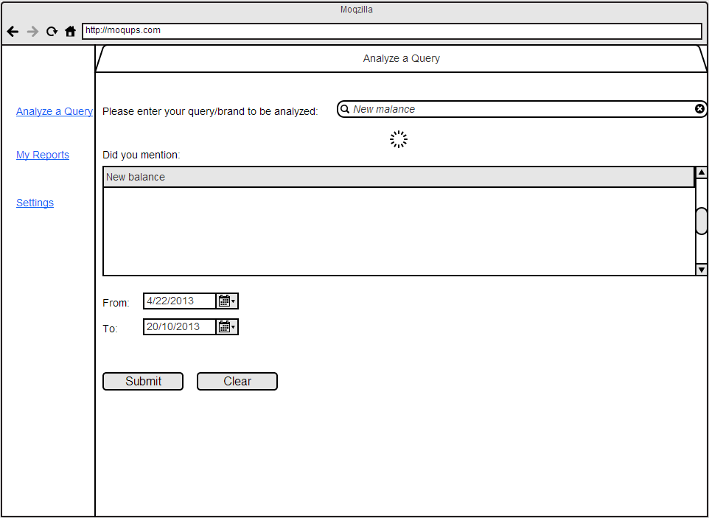
Mock-up 2: Query Page

2.4. Requirement 4. Report Preparation

Report will be prepared in less than 24 hours.
  - User will be notified after the report is ready via e-mail or phone notifications.

  - Ready reports will be listed in reports page sorted by time. User will be able to select one of the reports and go into the detail.

  - A report will consist of several charts like pie chart (positive and negative ideas about the brand) and a chart that shows which words are mostly used with the query.

  - User will be able to go into the detail of a chart by clicking on it.

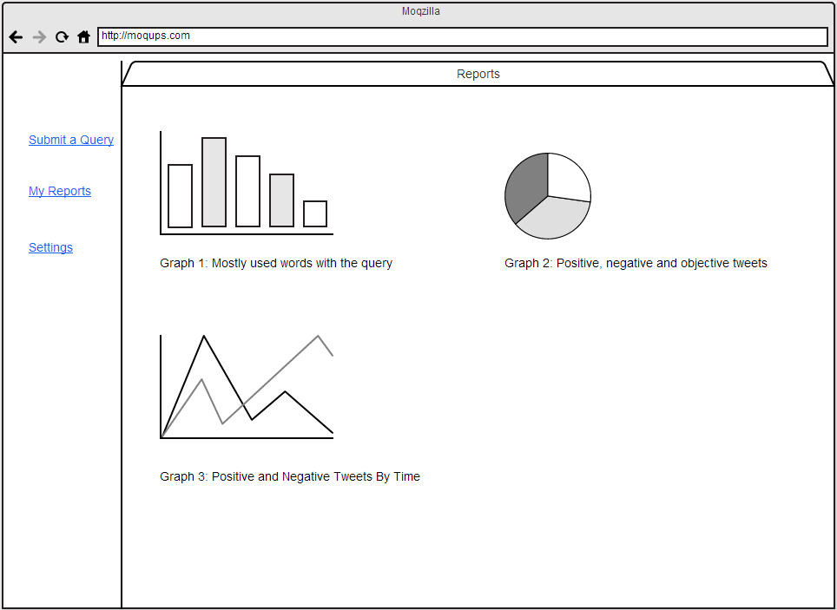
Mock-up 3: Reporting Page

2.5. Requirement 5. Settings

  - User account settings will be shown on settings page.
  - User will be able to update notification settings and user account information using settings page.
  - User may want add useful information for the use of query processing.

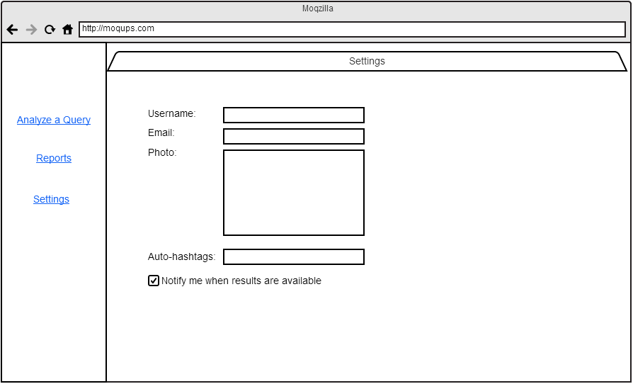
Mock-up 4: Settings Page

3. Twitter Public APIs

Twitter REST API v1.1 will be used during the implementation.

Method will be used to query tweets is ‘Search (GET search/tweets)’ function.

This function returns the collection of relevant tweets by specified query. Parameters could be used;
q: query string
until: tweets which are before the parameter date will be returned

There are some other parameters like geocode, locale, lang, etc. However, these two parameters will be enough.

4. Testing

- Testing of system shall be carried out for recent events in order to avoid false results.
- System shall be tested by ones who are not the developers of the system.
- Testing design shall be completed before implementation starts.

