TRAVELLING RESERVATION SYSTEM

Database Project

**“Traveling Reservation System.”**

**Project Description:**

**The project aims to develop a traveling reservation system that allows users to book various travel services, such as flights, hotels, and car rentals, in a convenient and user-friendly manner. The system will provide a seamless experience for users, enabling them to easily search, compare, and reserve travel options based on their preferences and requirements.**

**Assumptions:**

**1-The system assumes that the necessary APIs and data sources for retrieving information about flights, hotels, and car rentals are available and accessible.**

**2-It assumes that the users have access to the internet and a device to interact with the system.**

**3-The system assumes that users will provide accurate information while making reservations.**

**Flow and Procedure:**

* **User Registration**
* **Search for Travel Options**
* **Display Search Results**
* **Select and Reserve**
* **Confirmation and Payment**
* **Booking Confirmation**
* **Manage Reservations**
* **Complete Car Rental Support**
* **Customer Support**

**By following the above procedure the customer select or book the hotel, air ticket and a hotel for travelling from one point to another.**

**Entities:**

* Customer
* Reservations
* Hotel
* Hotel Location
* Flight
* Airport
* Car Rental
* Car
* Payment
* Packages
* Reviews

ERD DIAGRAM:

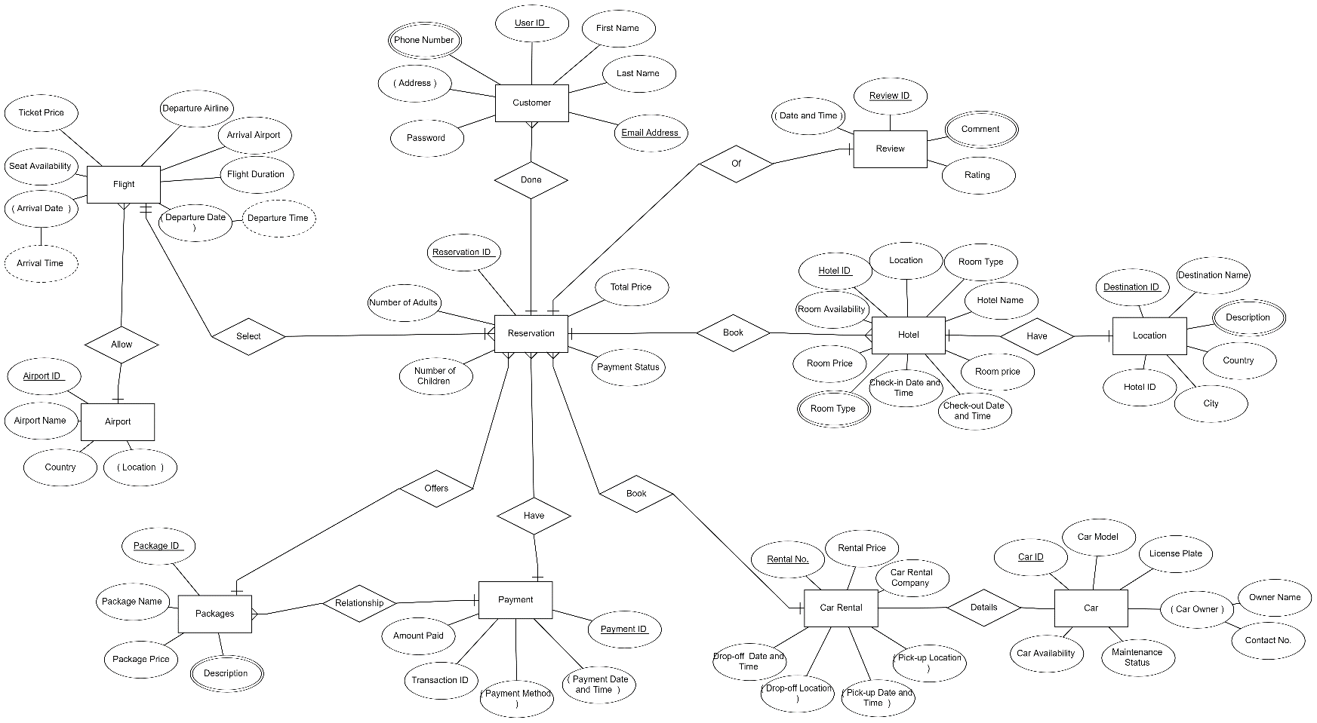

RELATIONAL SCHEMA:

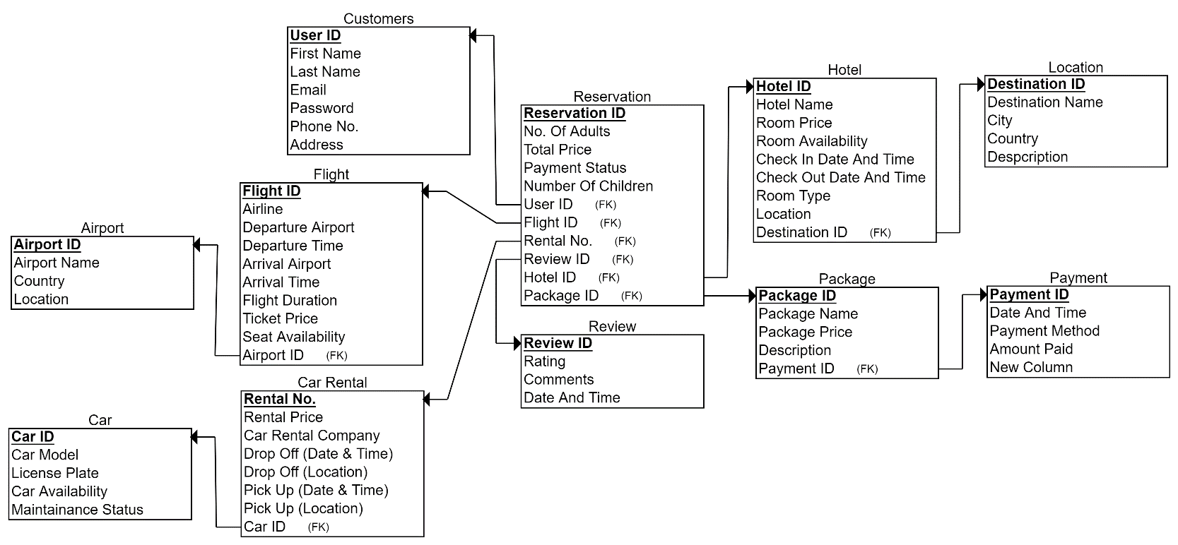

TABLES:

CREATE DATABASE TravelSystem;

use TravelSystem;

-- Customers Table

CREATE TABLE Customers (

User_ID INT PRIMARY KEY AUTO_INCREMENT,

First_Name VARCHAR(50) NOT NULL,

Last_Name VARCHAR(50) NOT NULL,

Email VARCHAR(100) NOT NULL UNIQUE,

Password VARCHAR(100) NOT NULL,

Phone_No VARCHAR(15),

Address TEXT

);

-- Airport Table

CREATE TABLE Airport (

Airport_ID INT PRIMARY KEY AUTO_INCREMENT,

Airport_Name VARCHAR(100) NOT NULL,

Country VARCHAR(50) NOT NULL,

Location VARCHAR(100) NOT NULL

);

-- Car Table

CREATE TABLE Car (

Car_ID INT PRIMARY KEY AUTO_INCREMENT,

Car_Model VARCHAR(50) NOT NULL,

License_Plate VARCHAR(20) NOT NULL UNIQUE,

Car_Availability BOOLEAN NOT NULL,

Maintenance_Status BOOLEAN NOT NULL

);

-- Car Rental Table

CREATE TABLE Car_Rental (

Rental_No INT PRIMARY KEY AUTO_INCREMENT,

Rental_Price DECIMAL(10, 2) NOT NULL,

Car_Rental_Company VARCHAR(50) NOT NULL,

Drop_Off_Date_Time DATETIME NOT NULL,

Drop_Off_Location VARCHAR(100) NOT NULL,

Pick_Up_Date_Time DATETIME NOT NULL,

Pick_Up_Location VARCHAR(100) NOT NULL,

Car_ID INT NOT NULL,

FOREIGN KEY (Car_ID) REFERENCES Car(Car_ID)

);

-- Flight Table

CREATE TABLE Flight (

Flight_ID INT PRIMARY KEY AUTO_INCREMENT,

Airline VARCHAR(50) NOT NULL,

Departure_Airport VARCHAR(50) NOT NULL,

Departure_Time TIME NOT NULL,

Arrival_Airport VARCHAR(50) NOT NULL,

Arrival_Time TIME NOT NULL,

Flight_Duration INT NOT NULL,

Ticket_Price DECIMAL(10, 2) NOT NULL,

Seat_Availability INT NOT NULL,

Airport_ID INT NOT NULL,

FOREIGN KEY (Airport_ID) REFERENCES Airport(Airport_ID)

);

-- Review Table

CREATE TABLE Review (

Review_ID INT PRIMARY KEY AUTO_INCREMENT,

Rating INT NOT NULL,

Comments TEXT,

Date_And_Time DATETIME NOT NULL

);

-- Package Table

CREATE TABLE Package (

Package_ID INT PRIMARY KEY AUTO_INCREMENT,

Package_Name VARCHAR(100) NOT NULL,

Package_Price DECIMAL(10, 2) NOT NULL,

Description TEXT

);

-- Payment Table

CREATE TABLE Payment (

Payment_ID INT PRIMARY KEY AUTO_INCREMENT,

Date_And_Time DATETIME NOT NULL,

Payment_Method VARCHAR(50) NOT NULL,

Amount_Paid DECIMAL(10, 2) NOT NULL

);

-- Location Table

CREATE TABLE Location (

Destination_ID INT PRIMARY KEY AUTO_INCREMENT,

Destination_Name VARCHAR(100) NOT NULL,

City VARCHAR(50) NOT NULL,

Country VARCHAR(50) NOT NULL,

Description TEXT

);

-- Reservation Table

CREATE TABLE Reservation (

Reservation_ID INT PRIMARY KEY AUTO_INCREMENT,

No_Of_Adults INT NOT NULL,

Total_Price DECIMAL(10, 2) NOT NULL,

Payment_Status BOOLEAN NOT NULL,

Number_Of_Children INT NOT NULL,

User_ID INT NOT NULL,

Flight_ID INT,

Rental_No INT,

Review_ID INT,

Hotel_ID INT,

Package_ID INT,

FOREIGN KEY (User_ID) REFERENCES Customers(User_ID),

FOREIGN KEY (Flight_ID) REFERENCES Flight(Flight_ID),

FOREIGN KEY (Rental_No) REFERENCES Car_Rental(Rental_No),

FOREIGN KEY (Hotel_ID) REFERENCES Hotel(Hotel_ID),

FOREIGN KEY (Package_ID) REFERENCES Package(Package_ID)

);

-- Hotel Table

CREATE TABLE Hotel (

Hotel_ID INT PRIMARY KEY AUTO_INCREMENT,

Hotel_Name VARCHAR(100) NOT NULL,

Room_Price DECIMAL(10, 2) NOT NULL,

Room_Availability INT NOT NULL,

Check_In_Date_And_Time DATETIME NOT NULL,

Check_Out_Date_And_Time DATETIME NOT NULL,

Room_Type VARCHAR(50) NOT NULL,

Location VARCHAR(100) NOT NULL,

Destination_ID INT,

FOREIGN KEY (Destination_ID) REFERENCES Location(Destination_ID)

);