KLARO
Autonomous UI-Vision QA & Self-Healing Accessibility Agent
Audit. Repair. Verify.
Capstone Reference Dossier
Course compilation • Kaggle capstone requirements • Project analysis & recommendations
Prepared for: OZzie | Track: Agents for Good | June 2026

Contents
Part 1 — Course Compilation (from the Gemini conversation)
Part 2 — Kaggle Capstone Project (official requirements)
Part 3 — The Klaro Project (blueprint & implementation)
Part 4 — Analysis: does Klaro meet the requirements?
Part 5 — Recommendations & action plan
(Headings use Word styles, so you can also insert a live Table of Contents via References → Table of Contents.)

Part 1 — Course Compilation (from the Gemini conversation)
This part compiles the substance of the shared Gemini conversation “Google Vibe Coding Course Compilation” (created 21 June 2026), which catalogues the 5-Day AI Agents: Intensive Vibe Coding Course topics, grouped by unit, and then derives a capstone blueprint. Topic titles are reproduced verbatim; descriptions are condensed.
Reference Domain: Agentic Software Engineering, Containerized Architectures, and Automated Deployment Pipelines.

Unit 1 — Core Command Interfaces and Containerized Prototyping
Topic 1.1: Getting Started with Google Antigravity
Google Antigravity is an agentic development platform and central command center for launching, monitoring, and orchestrating AI agents. It lets autonomous agents plan, write code, automate tasks, browse the web, and build production-ready applications.
Topic 1.2: Deploy from AI Studio to Cloud Run
Taking a prototype built in Google AI Studio and deploying it as a live, scalable service on Cloud Run.

Unit 2 — Terminal Interfaces and Remote Knowledge Retrievals
Topic 2.1: Hands-on with Antigravity CLI
Driving agent creation, scaffolding, and lifecycle operations from the terminal via the Antigravity / Agents CLI.
Topic 2.2: Developer Knowledge MCP for Antigravity
Using a Model Context Protocol (MCP) server to give agents remote knowledge retrieval — connecting tools and external context through a standard protocol.

Unit 3 — Context-Optimized Skills and Modular Lifecycle Engines
Topic 3.1: Getting Started with Google Antigravity Skills
Authoring reusable, context-optimized “skills” that package instructions/capabilities an agent can load on demand (e.g., the accessibility-auditor skill).
Topic 3.2: Agents CLI and ADK 2.0 Lifecycle
The Agent Development Kit (ADK) 2.0 lifecycle — graph-based workflows of nodes and edges, evaluation loops, and the build → test → deploy motion managed through the Agents CLI.
Key tools/concepts surfaced across the course: Google Antigravity, Agents CLI, ADK 2.0 graph workflows, MCP servers, agent skills, Gemini models, Cloud Run / Vertex Agent Runtime deployment.

Part 2 — Kaggle Capstone Project (official requirements)
Source: AI Agents: Intensive Vibe Coding Capstone Project (Kaggle community hackathon, Sponsor: Google).
Goal: build an AI agent that solves a real-world problem, helps people, or improves everyday living, applying concepts from the 5-Day course.

Tracks (one of four)
- Agents for Good: solutions that help humanity — agriculture, public health, education, art and literature. (Klaro’s track.)
- Agents for Business: agents that solve enterprise problems with cost or revenue at stake.
- Concierge Agents: personal agents that simplify individual/family/social tasks while keeping data safe.
- Freestyle: anything that doesn’t fit a bucket but shows best-practice agent development.

Submission requirements
- Kaggle Writeup: project report with title, subtitle, and detailed analysis; must select a track; ≤ 2,500 words.
- Media Gallery: a cover image is required; attach images/video.
- Video: ≤ 5 minutes, published to YouTube, attached to the gallery.
- Public Project Link: a working demo URL, or a public code repository (e.g., GitHub) with detailed setup instructions; must not require login/paywall.

Required course concepts (demonstrate at least 3)
Key concept | Where to demonstrate
Agent / multi-agent system (ADK) | Code
MCP Server | Code
Antigravity | Video
Security features | Code or Video
Deployability | Video
Agent skills (e.g., Agents CLI) | Code or Video

Evaluation rubric (100 points)
Category / criterion | Points | What it assesses
Pitch — Core concept & value | 10 | Central idea, track relevance, innovation; agents central & meaningful
Pitch — YouTube video | 10 | Clear, concise messaging: problem, why agents, architecture, demo, build
Pitch — Writeup | 10 | How well the writeup articulates problem, solution, architecture, journey
Implementation — Technical | 50 | Architecture & code quality, meaningful use of agents, clever tool use, comments
Implementation — Documentation | 20 | README: problem, solution, architecture, setup, diagrams

Logistics & rules
- Deadline: July 6, 2026, 11:59 PM PT (≈ July 7, 11:59 AM GMT+5).
- Team size: up to 5; **one (1) submission per team** — no leaderboard iteration.
- Winner license: CC-BY 4.0 for the submitted source.
- Hard rule: do NOT include any API keys or passwords in the code.
- Prizes: 12 pieces of Kaggle swag, distributed across the four tracks; badge/certificate on completion.
- Eligibility: registered Kaggle account, 18+, standard sanctions exclusions.

Part 3 — The Klaro Project (blueprint & implementation)
Target track: Agents for Good (Digital Inclusion / WCAG).

Problem (the “why”)
When developers ship UI changes, the most harmful accessibility bugs throw no console error — missing alt text, unlabeled form fields, invalid ARIA roles, low colour contrast, and keyboard focus traps that block screen-reader users. They slip past manual QA and violate WCAG 2.2 AA, locking out people with disabilities.

Solution (what it builds)
An unattended, event-driven agentic pipeline that triggers on a developer commit:
- Live browser control: the agent launches a real headless browser (BrowserMCP / Playwright) and renders the page.
- Visual & DOM auditing: it checks the rendered page against WCAG 2.2 AA — alt text, form labels, ARIA roles, colour contrast, responsive layout.
- Human-in-the-loop gate: on a critical violation it pauses and presents broken-vs-healed comparisons and snapshots to a reviewer on the Klaro dashboard for approval.

Architecture diagram
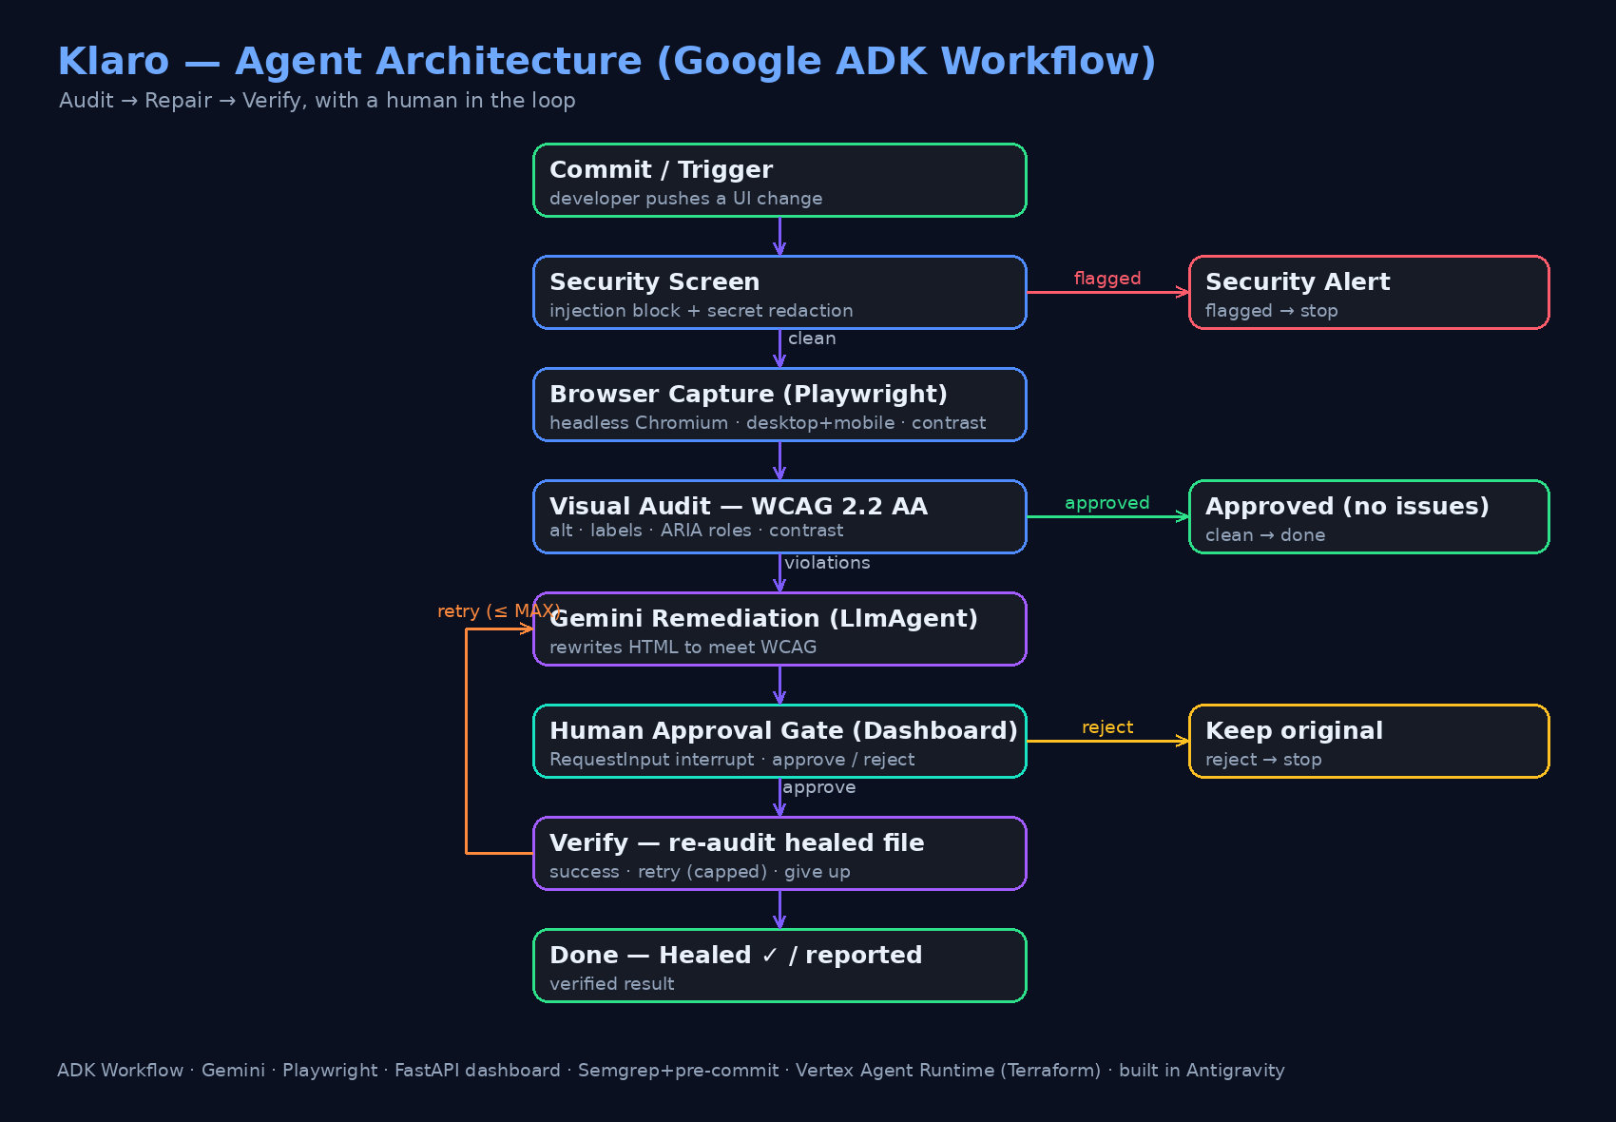
Figure 1 — Klaro’s ADK Workflow graph.

The “wow” factor — self-healing
When a visual/accessibility test fails, the agent autonomously: (1) updates the markup in the workspace; (2) re-runs the audit on the healed file; (3) is guarded by Semgrep + git pre-commit security checks so no credential leak is introduced; and (4) iterates (bounded by a retry cap) until the page passes, then reports a verified, clean result.

Course-concept alignment (as built)
Course concept | How Klaro demonstrates it | Evidence
Agent / ADK | ADK Workflow state-graph + Gemini LlmAgent remediator | Code
Human-in-the-loop | RequestInput interrupt + /resume; Vertex/in-memory sessions, no DB | Code
Security features | Injection screen, PII redaction, Semgrep + pre-commit, no secrets | Code
Agent skills / CLI | agents-cli scaffold + accessibility-auditor skill | Code
Deployability | Terraform + Vertex Agent Runtime + OpenTelemetry tracing | Video/Code
Antigravity | Entire agent vibe-coded in Google Antigravity | Video
Browser/MCP tool use | Headless-browser perception tool feeding the audit | Code
Klaro demonstrates 5–7 concepts — well beyond the required minimum of 3.

Part 4 — Analysis: does Klaro meet the requirements?
Overall verdict: strong fit. The build is the project’s strength; the communication assets (video, writeup, cover image) are the main outstanding work.

Strengths
- Problem & value (Pitch 10): accessibility affects ~1B people; the agent is central and the impact is concrete — ideal for Agents for Good.
- Technical implementation (Impl 50): a genuine ADK Workflow graph, real browser-vision tool use, an honest self-heal-and-verify loop with a retry cap, HITL gating, unit tests + a graph-validity test, and pre-commit CI.
- Meaningful agent use: perceive → decide → act → verify with a human checkpoint — not a single LLM call.
- Security posture: prompt-injection screening, PII redaction, Semgrep, and a clean secrets pre-flight (only intentional test fixtures match).
- Polish: a branded, interactive Klaro dashboard makes for a compelling demo video.

Gaps / risks to close
- No video yet (Pitch 10): highest-leverage missing asset; must be ≤ 5 min on YouTube.
- No writeup attached yet (Pitch 10): drafted (≤ 2,500 words) but needs final links.
- Public code link: repo is local; must be pushed to public GitHub with setup instructions.
- Cover image required: needed for the Media Gallery.
- Documentation (Impl 20): README is solid; add an architecture diagram + screenshots to maximise.
- Optional: wrap the browser layer as a formal MCP server to tick the one remaining concept (not required — already exceed 3).
- Process risk: only ONE submission per team — finalise carefully before submitting.

Estimated scorecard (indicative)
Criterion (max) | Current readiness
Core concept & value (10) | Strong — ready
Video (10) | Not started — script ready
Writeup (10) | Drafted — needs links
Technical implementation (50) | Strong — ready
Documentation (20) | Good — add diagram + screenshots

Part 5 — Recommendations & action plan

Do these, in order
- Create a public GitHub repo; confirm .env stays ignored; push the code (pre-commit runs tests + Semgrep).
- Add the architecture diagram + 3–4 dashboard screenshots to the repo and writeup.
- Record the ≤ 5-min demo video (use the prepared script): problem → why agents → architecture → live demo (audit → heal → approve → verify → next batch) → the build; upload to YouTube.
- Finalise the Kaggle Writeup (≤ 2,500 words), select Agents for Good, paste the GitHub + YouTube links, attach the cover image.
- Double-check: no API keys/passwords anywhere in the public repo.
- Submit once — the single allowed submission — before July 6, 11:59 PM PT.

Nice-to-have if time permits
- Wrap the browser/audit layer as an MCP server to explicitly demonstrate the MCP concept.
- Expand checks to focus-trap and keyboard-navigation rules.
- Run Klaro against real pull-request diffs in CI as a live, deployed showcase.

Assets already prepared in this project
- docs/SUBMISSION_WRITEUP.md — Kaggle writeup draft (Agents for Good, ≤ 2,500 words).
- docs/VIDEO_SCRIPT.md — timed ≤ 5-min video script + shot list.
- LICENSE — CC-BY 4.0 (winner license).
- Working Klaro dashboard + ADK workflow + tests + pre-commit CI.

