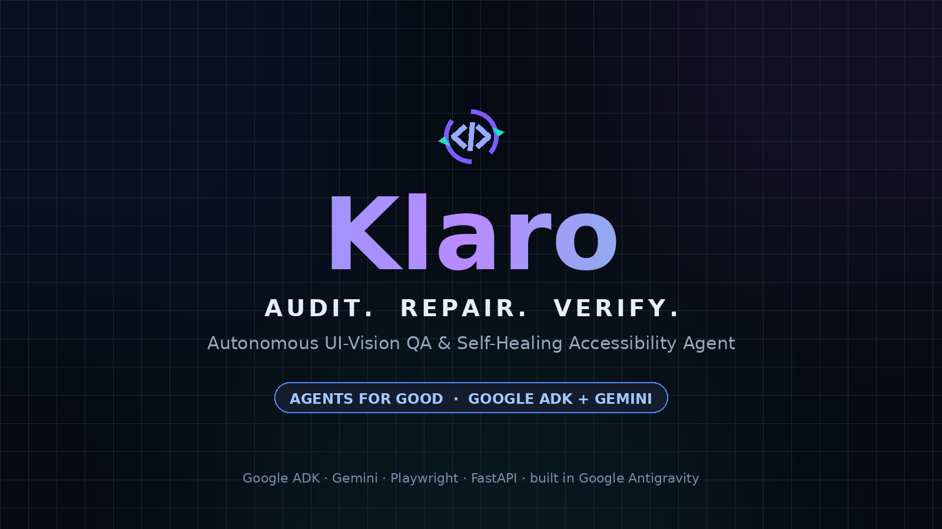
Project overview & technical README
Kaggle AI Agents Capstone — Agents for Good — June 2026

Klaro
Autonomous UI-Vision QA & Self-Healing Accessibility Agent
Klaro opens your page in a real browser, finds the accessibility bugs that never throw an error, fixes them with Gemini, waits for a human to approve, and then re-checks its own work.
Built for the Kaggle “AI Agents: Intensive Vibe Coding” capstone, Agents for Good track. Stack: Google ADK 2.0, Gemini, Playwright, a FastAPI dashboard, vibe-coded in Antigravity.

Contents
The problem
What it does
Course concepts used
Run it
Configuration
Tests
Project layout
A note on scope
Deploy
License
Links

The problem
A lot of accessibility bugs are invisible to the people shipping them: a missing alt, an input with no label, an invalid ARIA role, grey text on a slightly different grey. None of them throw an error, so the build passes and the page goes live broken for anyone using a screen reader or a keyboard. Manual QA catches it, but it’s slow and it’s the first thing cut under deadline. So the bugs pile up, and the bolt-on “accessibility widgets” people buy don’t fix the actual code.

What it does
Klaro runs the loop a human reviewer would, automatically: look at the rendered page, decide what’s wrong, fix it, and verify the fix, with a person approving before anything ships.
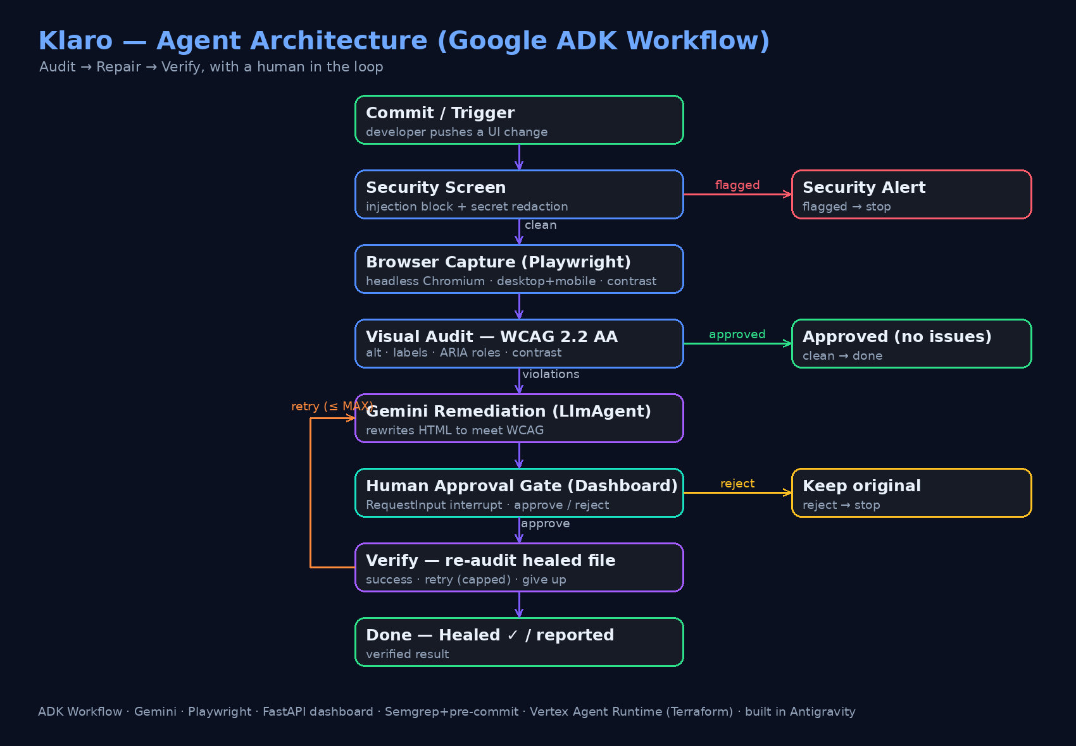
Figure 1 — Klaro’s ADK workflow.
How the graph runs, node by node:
- Security screen checks for prompt-injection and scrubs leaked secrets before anything runs.
- Browser capture loads the page in headless Chromium, takes desktop and mobile shots, and measures contrast in the live DOM (with the correct large-text threshold).
- Visual audit checks the DOM for missing alt, unlabeled inputs, and invalid ARIA roles, then routes “approved” or “violations.”
- Gemini remediation rewrites the HTML to fix the issues without changing the layout.
- Human approval gate pauses and shows you the violations, both screenshots, and a before/after diff, then waits for approve or reject.
- Verify writes the fix, re-audits the healed file, and retries (capped) or gives up.

Course concepts used
Concept | Where | How
Agent / ADK | Code | Workflow graph of @nodes plus a Gemini LlmAgent
Human-in-the-loop | Code | RequestInput interrupt and /resume; Vertex/in-memory sessions, no DB
Security | Code | Injection screen, secret redaction, Semgrep, pre-commit
Agent skills / CLI | Code | agents-cli scaffold and an accessibility-auditor skill
Deployability | Code/Video | Terraform, Vertex Agent Runtime, OpenTelemetry
Antigravity | Video | Built in Google Antigravity
Browser tool use | Code | Headless browser is the agent’s eyes

Run it
agents-cli install
uv run playwright install --with-deps chromium # required for the audit
uv run python -m app.ambient_service # serves http://127.0.0.1:8080
Open http://127.0.0.1:8080/, click Run audit, review the issues and the proposed fix, and Approve. Klaro applies the change, re-audits, and reports clean. Use Next 5 to work through the 20 seeded demo cases.
The heal step calls Gemini, so it needs Google Cloud auth: gcloud auth application-default login. The audit and screenshots work without it.

Configuration
Variable | Purpose | Default
GOOGLE_CLOUD_PROJECT | GCP project for Vertex AI | auto-detected
GOOGLE_CLOUD_LOCATION | Vertex location (use global to avoid model 404s) | global
MAX_HEAL_ATTEMPTS | retries before the agent gives up | 3
LOGS_BUCKET_NAME | GCS bucket for telemetry | off
Copy .env.template to .env and add your own values. Don’t commit .env; it’s gitignored.

Tests
uv run pytest tests/unit # security/audit logic and a graph-validity check
uv run pre-commit run --all-files # unit tests plus a Semgrep secret scan
tests/unit/test_workflow_graph.py imports root_agent, so an invalid graph fails the test. A pre-commit hook runs the unit suite and Semgrep on every commit.

Project layout
app/
agent.py # the ADK workflow graph
ambient_service.py # FastAPI: /trigger, /resume, /next-batch, serves the dashboard
agent_runtime_app.py # Vertex Agent Runtime entrypoint, telemetry, feedback
dashboard/index.html # the review UI
case_library.py # 20 seeded violations, served 5 at a time
mock_app/ # demo target and generated snapshots
tests/ # unit, integration, eval
deployment/terraform/ # infra
docs/ # writeup, video script, architecture diagram, dossier

A note on scope
Automated tools, this one included, catch roughly a third to a half of WCAG issues. The rest needs human judgment, which is why the approval gate is there. For production I’d put a mature engine like axe-core behind Klaro and keep Klaro as the fix-and-verify layer.

Deploy
gcloud config set project <your-project-id>
agents-cli deploy

License
CC-BY 4.0 (the capstone winner license). See LICENSE.

Links
- Video: <ADD YOUTUBE URL>
- Repo: <ADD PUBLIC REPO URL>

