# Muslim Diversity Study: A quantitative study protocol

M. Usman Afzali1,2, Jamila S. Badis1, Parus Khoso3, Farah Shawkat1, Fatima A. Junaid4, Ayca Arkilic5, Mazharuddin Syed Ahmed6, Hussain Raissi7, Hala Burhoum1, Tuba Azeem8, Iman Husain1, Zarqa Shaheen Ali9, Zahra Haidary1, Mashal Khan10, Nasratullah Hamid11, Gul e Aqsa12, Zahra Emamzadeh13, Rizwan Sulehry14, Somia Tasneem1, Aamina Ali15, Adepate Mustapha-Koiki16, Afrah Ali Nadukkudi Puthenpura15, Sandila Tanveer17, Aarif Rasheed18, Kumar Yogeeswaran1, Chris G. Sibley19, and Joseph A. Bulbulia20,21

1School of Psychology, Speech and Hearing, University of Canterbury

2Religion Programme, University of Otago

3College of Education, University of Canterbury

4School of Management, Massey University

5School of History, Philosophy, Political Science and International Relations, Victoria University of Wellington

6Engineering and Architectural Studies, Ara Institute of Canterbury

7The National Centre for Peace and Conflict Studies, University of Otago

8School of ABC, Victoria University of Wellington

9ICL Business School, New Zealand Skills and Education College

10Department of Psychology, Massey University

11School of Psychological Medicine, Universit of Otago

12School of Health Sciences, University of Canterbury

13TBA, Ministry of Education

14School of Management, Victoria University of Wellington

15TBA, TBA

16Department of Politics and International Relations, University of Auckland

17Department of Psychological Medicine, University of Otago Christchurch

18Just Community

19School of Psychology, University of Auckland

20School of Psychology, Victoria University of Wellington

21Department of Linguistic and Cultural Evolution, Max Planck Institute for Evolutionary Anthropology

# Author Note

M. Usman Afzali  http://orcid.org/0000-0001-5119-9388

Jamila S. Badis  http://orcid.org/0009-0005-2866-5033

Parus Khoso  http://orcid.org/0000-0001-6384-038X

Farah Shawkat  http://orcid.org/0000-0000-0000-0001

Fatima A. Junaid  http://orcid.org/0000-0002-6656-8120

Ayca Arkilic  http://orcid.org/0000-0002-1775-3311

Mazharuddin Syed Ahmed  http://orcid.org/0000-0000-0000-0001

Hussain Raissi  http://orcid.org/0009-0000-7985-1622

Hala Burhoum  http://orcid.org/0000-0000-0000-0001

Tuba Azeem  http://orcid.org/0000-0000-0000-0001

Iman Husain  http://orcid.org/0000-0003-4032-4387

Zarqa Shaheen Ali  http://orcid.org/0000-0002-7145-5788

Zahra Haidary  http://orcid.org/0009-0000-5259-622X

Mashal Khan  http://orcid.org/0000-0000-0000-0000

Nasratullah Hamid  http://orcid.org/0009-0002-0120-7428

Gul e Aqsa  http://orcid.org/0009-0003-0928-8039

Zahra Emamzadeh  http://orcid.org/0009-0000-0000-0001

Rizwan Sulehry  http://orcid.org/0000-0002-1209-0635

Somia Tasneem  http://orcid.org/0000-0001-5471-6934

Aamina Ali  http://orcid.org/0000-0000-0000-0001

Adepate Mustapha-Koiki  http://orcid.org/0000-0003-4731-1781

Afrah Ali Nadukkudi Puthenpura  http://orcid.org/0000-0000-0000-0001

Sandila Tanveer  http://orcid.org/0000-0002-0648-5382

Aarif Rasheed  http://orcid.org/0000-0000-0000-0001

Kumar Yogeeswaran  http://orcid.org/0000-0002-1978-5077

Chris G. Sibley  http://orcid.org/0000-0002-4064-8800

Joseph A. Bulbulia  http://orcid.org/0000-0002-5861-2056

This hypotheses and data analysis plan for this study are preregistred at OSF <https://doi.org/10.17605/OSF.IO/B39XT>. The data described in this study are part of the Muslim Diversity Study, that is conducted under the [New Zealand Attitudes and Values Study](https://osf.io/75snb/). The authors have no conflict of interest to disclose. The Muslim Diversity Study - officially known as “A National Longitudinal Study of Muslim Diversity and Flourishing” is supported by a grant from the Templeton Religion Trust (TRT-2022-30579). The funders had no role in preparing the manuscript or the decision to publish it. The authors are grateful to W. Joel Schneider for the [Quarto template](https://github.com/wjschne/apaquarto).

Author roles were classified using the Contributor Role Taxonomy (CRediT; https://credit.niso.org/) as follows: *M. Usman Afzali***:** conceptualisation, data curation, formal analysis, funding acquistion, investigation, methodology, project administration, reources, supervision, visualisation, writing – original draft, and writing - review & editing. *Jamila S. Badis***:** data curation, project administration, writing – original draft, and writing - review & editing. *Parus Khoso***:** data curation, formal analysis, writing - original draft (pilot community consultation), and writing - review & editing. *Farah Shawkat***:** data curation, writing - original draft (method), and writing - review & editing. *Fatima A. Junaid***:** writing - original draft (introduction) and writing - review & editing. *Ayca Arkilic***:** writing - original draft (introduction) and writing - review & editing. *Mazharuddin Syed Ahmed***:** data curation and writing - review & editing. *Hussain Raissi***:** data curation, writing - original draft (method), and writing - review & editing. *Hala Burhoum***:** data curation, writing - original draft (method), and writing - review & editing. *Tuba Azeem***:** data curation, writing - original draft (method), and writing - review & editing. *Iman Husain***:** data curation, writing - original draft (method), and writing - review & editing. *Zarqa Shaheen Ali***:** data curation, writing - original draft (method), and writing - review & editing. *Zahra Haidary***:** data curation, writing - original draft (method), and writing - review & editing. *Mashal Khan***:** data curation, writing - original draft (method), and writing - review & editing. *Nasratullah Hamid***:** data curation, writing - original draft (method), and writing - review & editing. *Gul e Aqsa***:** data curation and writing - review & editing. *Zahra Emamzadeh***:** writing - original draft (strengths and limitations) and writing - review & editing. *Rizwan Sulehry***:** data curation, writing - original draft (strengths and limitations), and writing - review & editing. *Somia Tasneem***:** writing - original draft (strengths and limitations) and writing - review & editing. *Aamina Ali***:** writing - original draft (applications and implications) and writing - review & editing. *Adepate Mustapha-Koiki***:** writing - original draft (applications and implications) and writing - review & editing. *Afrah Ali Nadukkudi Puthenpura***:** writing - original draft (conclusion) and writing - review & editing. *Sandila Tanveer***:** writing - original draft (conclusion) and writing - review & editing. *Aarif Rasheed***:** conceptualisation, data curation, funding acquistion, reources, and writing - review & editing. *Kumar Yogeeswaran***:** conceptualisation, funding acquistion, methodology, writing – original draft, and writing - review & editing. *Chris G. Sibley***:** conceptualisation, data curation, funding acquistion, methodology, project administration, reources, supervision, writing – original draft, writing - review & editing, and development and management of the New Zealand Attitudes and Values Study panel data collection from 2009 to the present. *Joseph A. Bulbulia***:** conceptualisation, funding acquistion, methodology, project administration, reources, supervision, writing – original draft, and writing - review & editing

Correspondence concerning this article should be addressed to M. Usman Afzali, School of Psychology, Speech and Hearing, University of Canterbury, Email: usman.afzali@otago.ac.nz

# Abstract

The New Zealand Attitudes and Values Study is a longitudinal study of social values and attitudes of New Zealanders that started in 2009. Since its inception, it has collected data from > 70,000 adults. In addition to examining numerous social, political, and health aspects of New Zealanders’ lives, this research has particularly examined negative attitudes towards minority groups, such as discrimination and prejudice have been examined. In 2019, the Muslim community was the target of the worst terrorist attack in New Zealand’s modern history. Following this devastating event, we aimed to extract data from the New Zealand Attitudes and Values Study to understand Islamophobia and its implications for the Muslim community. In addition, we deem necessary to investigate the overall wellbeing and flourishing of Muslims in New Zealand, and whether values, identity, religiosity, and meaning-making affect Muslims’ self-perception and health outcomes. However, we were limited by the sample size of Muslims within the New Zealand Attitudes and Values Study to make such inferences. Therefore, the current project, titled the Muslim Diversity Study, was designed to recruit more Muslim participants within the New Zealand Attitudes and Values Study over a three-year quantitative longitudinal study. This protocol describes the context that motivated this research, our pilot Muslim community consultation, the decisions made and modified based on consultation (e.g., whether or not to translate the questionnaire, which groups to target, etc.), data collection methods, research team, quantitative measures, and timeline. It also provides our initial findings and observations, mainly based on the first year of the research and addresses the perceived enablers and challengers of data collection from a culturally distinct religious community in New Zealand. This protocol will serve as a reference text for researchers conducting work not only on Islam and the Muslim community in New Zealand but also on other ethnic and religious communities and minorities in the country. It will also allow researchers to apply the methods and findings to other contexts and regions across the world and provide comparative insights and analyses.

*Keywords*: Muslim, Islam, religion, diversity, discrimination, flourishing, wellbeing, meaning-making, identity, New Zealand, MDS, NZAVS

# Muslim Diversity Study: A quantitative study protocol

On 15 March 2019, a devastating far-right extremist attack on two mosques took place in Christchurch, killing 51 Muslims and injuring 40 (*Royal Commission of Inquiry into the Terrorist Attack on Christchurch Masjidain on 15 March 2019*, 2020). Although this attack shocked the world (*World Leaders Condemn New Zealand Mosque Attacks*, 2019) and was unprecedented in New Zealand (*Jacinda Ardern on the Christchurch Shooting*, 2019), it was not as surprising to the Muslim community (A. Rahman, 2019) due to Muslims’ widespread experience of Islamophobia and prejudice in the country (Sibley et al., 2020). Islamophobia has been reportedly increased overseas following these attacks (*Islamophobia After Christchurch Terror Attacks Quadrupled - Australian Report*, 2022), however, the evidence in New Zealand seems to be mixed. While news articles have reported increased hate towards Muslims (Frykberg, 2023), our findings are indicative of improved attitudes towards Muslims (Bulbulia et al., 2023; Shanaah et al., 2021) following attacks. Addressing this discrepancy is beyond the scope of current article, however, it is worth noting that most of our research in this area, primarily from the New Zealand Attitudes and Values Study (NZAVS) (*New Zealand Attitudes and Values Study*, 2024) lens, has so far shed light on such attitudes from a non-Muslim perspective. In other words, we have reported on how Muslims are perceived by non-Muslim members of New Zealand society, rather than how Muslims perceive themselves. While the published NZAVS reports are an absolute necessity, the self-experience of Muslims themselves as the direct victims of this heinous crime is equally, if not more, important.

The current article elaborates on the protocol of a pioneering three-year longitudinal study titled the Muslim Diversity Study poised to achieve this very goal – examining Muslims’ self-perception in New Zealand from a variety of angles, as well as, the predictors of resilience, flourishing, and wellbeing within Muslims. The study started in 2023 and is planned to conclude in 2026. The goal is to achieve as many as 650 Muslim respondents.

## Introduction

The Muslim community has been expanding in New Zealand. Based on the 2018 census, New Zealand had more than 60,000 Muslims; which has grown to > 75,000 according to the 2023 Census (*Stats NZ*, 2024). Studies also show that the number of converts to Islam has increased after the 2019 terror attack (Arkilic, 2020). The Muslim community is uniquely positioned in New Zealand: as a growing religious minority, it is a historically stigmatized group that were the direct victims of the 2019 terrorist attack (*Royal Commission of Inquiry into the Terrorist Attack on Christchurch Masjidain on 15 March 2019*, 2020; Sibley et al., 2020).

Muslim Diversity Study (MDS) — officially known as *A national longitudinal study of Muslim diversity and flourishing* embraces a community-oriented approach by collaborating with the Muslim community in order to make decisions about the execution of data collection and for identifying key questions of interest for the community at large. It is important that such processes and decisions are recorded in the form of a study protocol so that our findings are shared with the broader public and future researchers in New Zealand and across the globe can benefit from our outputs.

This protocol addresses MDS’ pilot community consultation, the decisions made and modified based on consultation, community engagement, data collection, team, measures, and proposed data analysis plan. To set the rationale for MDS, it is important to have a brief look at attitudes towards Muslims in New Zealand.

## The need for Muslim Diversity Study

Muslims have generally faced prejudicial attitudes in New Zealand (Greaves et al., 2020; Sibley et al., 2020; Yogeeswaran et al., 2019). Until the Christchurch terror attack, news stories on Islam and Muslims in New Zealand media were mostly an extension of ‘the negative othering rhetoric’, and the national media tended to link Muslim converts to jihadis (Drury, 2016). Unsurprisingly, such rhetoric has been found to foster anti-Muslim prejudice (Shaver et al., 2017).

In the aftermath of Christchurch shootings, the Government introduced unprecedented counter-terrorism measures such as the prohibition of the sale of all military-style semi-automatic and assault rifles and creating the Royal Commission of Inquiry into these attacks (*Royal Commission of Inquiry into the Terrorist Attack on Christchurch Masjidain on 15 March 2019*, 2020). The Royal Commission of Inquiry presented an 800-page report emphasizing New Zealand’s inclusive and welcoming identity, among other measures (Arkilic, 2021). In addition, New Zealand press embraced a more inclusive and positive narrative with respect to Islam and Muslims (Kabir, 2024; K. A. Rahman, 2020).

Although, there have been sporadic reports of increased hate crimes after the attacks (Wilson & Shastri, 2020), the average sentiments have improved. The New Zealand Attitudes and Values Study (NZAVS), in a series of articles, reported the positive shift in these attitudes toward Muslims post Christchurch attacks (Bulbulia et al., 2023; Shanaah et al., 2021), and the psychological response of New Zealand public to shootings (Byrne et al., 2022).

The Christchurch shootings prompted many New Zealand research groups and institutions to further study Muslims and with Muslims, that so far have been a culturally-distinct, under-researched, minority group. These studies included trauma-focused response (Sulaiman-Hill et al., 2021; Sulaiman-Hill et al., 2024), inclusion, Islamophobia, and wellbeing (Junaid et al., 2024), perceived discrimination among Muslim immigrant youth (Raissi, 2024), the political implications of government decisions (Arkilic, 2021) among others. Given that, at NZAVS, we have explored perception of Muslims and the mechanisms of attitudinal changes towards Muslims following 15 March 2019 attacks (Bulbulia et al., 2023; Hawi et al., 2019; Shaver et al., 2017; Sibley et al., 2020), it was timely and necessary that we expanded our reach further.

The NZAVS is a planned 20-year-long longitudinal national probability annual panel study of social attitudes, personality, ideology and health outcomes that began in 2009 and is currently in its 15th year. It has so far collected data from more than 70,000 New Zealand residents using the electoral roll (*New Zealand Attitudes and Values Study*, 2024). The NZAVS has been instrumental in exploring key issues related to minorities, including but not limited to discrimination, intergroup relations, identity, distress, security, and the dynamics and mechanisms behind them.

The NZAVS has been uniquely positioned due to its prestigious reputation (> 150 peer-reviewed publications), longiutinal panel design, large sample size, and a large multi-disciplinary research team (Sibley, 2024). More importantly, NZAVS has a nationally representative sample with data from different identity and religious group (Sibley, 2024), thereby, allowing us to compare data from different identity groups. However, the Muslim sample in NZAVS has been < 100, that did not allow us to make meaningful inferences regarding Mulsim lives and issues in comparison with other religious groups. Hence, there was an immediate need to collect more data from Muslims in New Zealand.

In addition, much of the NZAVS work to date with the Muslim community has focused on conveying information about how Muslims are perceived by the non-Muslim members of New Zealand society. After receiving strong positive signals from the Muslim community to scientifically explore diversity, discrimination, self-perception, resilience, meaning-making, and flourishing; this three-year longitudinal study was conceived in 2022 to address this scholarly and community knowledge gap. Therefore, MDS is effectively a booster to NZAVS, and uses the NZAVS questionnaires to collect data from the members of Muslim community in New Zealand.

We aim to explore the diversity of Muslims in New Zealand, assess Muslims’ perceived discrimination in comparison with other religious groups, unearth predictors of flourishing and meaning-making, and measure the effect of service-attendance and religious-identification on these constructs.

MDS started with pilot community consultation as detailed below in this protocol.

## Pilot community consultation

Before applying for the research grant, we deemed necessary to gauge Muslim community’s interest in the project, as well as the feasibility of the project for the Muslim community. This pilot consultation took place between February and November, 2022 where the principal investigator reached out to 29 Muslims (20 representing community, religious or cultural organisations and 9 individuals) in different cities from different academic and cultural backgrounds, age groups, and genders including community leaders, religious scholars, and activists. The conversations focused around four objectives: 1) To assess the feasibility of the project for Muslims, 2) To assess interest of Muslims in the project, 3) To get feedback on the survey items, and 4) To inquire if translation may be needed. First, all 29 respondents believed that the study was feasible and timely for Muslims, and that Muslims will be interested to participate. In addition, the highest participation should be anticipated from youth, second generation migrants, educated, and women. Second, not only did they believe that the study and our planned measures were important, they have also promised to support us in every possible way.

Challenges identified: 1) The participation from Christchurch might not be up to the expectations as after Christchurch shooting people were surveyed a lot and not provided with the findings. 2) It might not be easy for people to understand the questionnaires due to unfamiliarity of the community with research. 3) The participation from elderly community and Muslim converts might be low, so we need to find avenues to address them. 4) Community members might be suspicious and consider the study to have ulterior or personal motives.

Recommendations: 1) The participants must be informed about the study motivation and be transparent and clearly communicate, benefits to the community, and that it will increase Muslims’ visibility and raise their voice in research. Especially the long-term benefits for the community and their children should be made clear. 2) We should reach out to the community via trusted community, ethnic, religious organisations, and mosques. 3) For youth engagement, we should go via youth organisations such as Muslim Student Associations (MSAs) at universities. It was suggested that a family focused strategy should be used as starting with men would be more effective. 4) Findings should be shared back with the community in future due to the diversity it will present. 5) Many said that the questionnaire needs to be translated into seven ethnic languages. However, they also indicated that a majority of potential participants could comprehend the English version easily. 6) To be able to share with the community and keep them up-to-date, it was also recommended to have a unique identity and website. Therefore, instead of calling it a booster to NZAVS, the project was named Muslim Diversity Study.

This whole process led to develop a comprehensive guideline that addresses feasibility, advice on engagement with the community, the possible challenges, and avenues to enhance participation. The participants of this consultation form the Advisory Group of MDS and are being consulted regulary as needed.

## Translation

Our consultation with the community indicated that the translation may only be needed for a small number of New Zealand Muslims, and that a majority will be able to use the English version. As a result of consultation with a group (Sulaiman-Hill and colleagues) who have been conducting research within the Muslim community, instead of using the common translation back-translation procedure, we were thinking of using a more effective way of translating, back-translating, and comparing notes to ensure conceptual equivalence (Sulaiman-Hill et al., 2021). This method was inspired by the recent developments and recommendations based on the needs in countries that home an increasing number of refugees (Barger et al., 2010; Ozolins et al., 2020). Following this, the translation was planned to be checked by experts as recommend by Fenn et al. (2020) and piloted within the Advisory Group to ensure reliability and conceptual equivalence.

However, one important aspect of MDS is comparing Muslim scores on NZAVS with members from other religious groups. With a translated questionnaire, we still faced the risk of inability to capture the attitudes and behaviours as accurately as the English version. Therefore, we would not know if differences between the scores of Muslims and other groups would be due to religious affiliation or a biased translation. We raised this problem with the Advisory Group, and it was recommended not to translate the questionnaire and to furnish the English version to all potential Muslim participants. This gave us a methodological safety-net since we could be more confident that the meaning of concepts is not distorted because of translation.

## Consultation on survey items

In consultation with 21 members of the Advisory Group, we identified six items of the NZAVS questionnaire that could be onf a sensitive nature and may pose challenges for individuals unfamiliar with research. A clear majority (81% – averaging the acceptance rate for all 6 items) thought that no items needed to be removed. Given that the that the NZAVS items were developed with considering Christianity as the largest religious group at the conception of study, we decided not to change the items for MDS to allow us comparison between scores of different religious groups. In addition, the MDS cover letter states: “As the survey is designed for the general New Zealand population, there may be questions that do not necessarily apply to you. Please feel free to skip any questions that you do not wish to answer”.

## Hypotheses

*Hypothesis 1:* Muslims with the strongest ties to their community as measured by service attendance and prayer are buffered most from anti-Muslim prejudice.

*Hypothesis 2:* Muslims experience greater challenges to employment and health than matched members of other religious groups.

*Hypothesis 3:* Subjective well-being, the meaning of life, and psychological distress are similar among Muslims and matched members of religious groups from the buffering of religious community-making.

# Method

## Participants

NZAVS participants details will be available online after the completion of Wave 15 <https://osf.io/75snb/>. MDS attempts to increase the sample size of Muslims in NZAVS by *n* = 650 (> 1% of New Zealand Muslim population), corresponding with the NZAVS sampling rate from the overall New Zealand population. Based on the 2018 Census, New Zealand had 60,261 Muslims in 2022 (*Stats NZ*, 2024) — about 1.3% of New Zealand population. As shown in Table 1, we selected six cities (Auckland, Christchurch, Hamilton, Wellington, Palmerston North, and Dunedin) that had at least 1,000 Muslims, for data collection. Inclusion criteria consist of self identification as Muslim, being 18 year of age or older, and currently residing in New Zealand. In sum a total of xxx Muslim participants completed the questionnaire and joined the NZAVS.

## Materials

NZAVS questionnaire consists of many psychological measures (see Sibley, 2024). In this protocol, we are highlighting measures that are pertinent to the readily planned papers aimed to publish from MDS.

For Likert type scales, the minimum and maximum levels are noted along with description, for instance, 1 = Not Important, 7 = Very Important would mean that a score ranges between 1 and 7, with 1 being the minimum and 7 being the maximum score; whereas (R) indicates the reverse-scored items. Notwithstanding, we might choose to explore further measures which will then be elaborated on in the individual articles.

### Service attendance and religiosity

1. Do you identify with a religion and/or spiritual group? (Yes/No). If yes, what religion or spiritual group? (String entry).
2. How many times did you attend a church or place of worship in the last month? (String entry).
3. How many times did you pray in the last week? (String entry).
4. How many times did you read religious scripture in the last week? (String entry).
5. How important is your religion to how you see yourself? (1 = Not Important, 7 = Very Important).
6. I identify as a spiritual person. (1 = Strongly Disagree, 7 = Strongly Agree).
7. Do you believe in God? (Yes/No).
8. Do you believe in any form of spirit or life force? (Yes/No).

### Prejudice

1. I feel that I am often discriminated against because of my religious/spiritual beliefs. (1 = Strongly Disagree, 7 = Strongly Agree).
2. People from my ethnic group are discriminated against in New Zealand. (1 = Strongly Disagree, 7 = Strongly Agree).
3. I feel that I am often discriminated against because of my age. (1 = Strongly Disagree, 7 = Strongly Agree).
4. I feel that I am often discriminated against because of my ethnicity. (1 = Very Innacurate, 7 = Very Accurate).
5. I feel that I am often discriminated against because of my gender. (1 = Very Innacurate, 7 = Very Accurate).
6. Intergroup Warmth Ratings: Participants are asked to rate their feelings of warmth toward different groups using the “Feeling Thermometer Scale” for each group from least to most warmth on a 7-point scale where 1 = Least Warm and 7 = Most Warm (see Figure 1 for reference). Groups include: NZ Europeans, Māori, Asians in general, Pacific Islanders, Elderly people, People with a disability, Refugees, Overweight people, Immigrants in general, Chinese, Indians, Muslims, LGBTQ+ people, People with mental illness.

### Felt belonging

1. I know that people in my life accept and value me. (1 = Very Innacurate, 7 = Very Accurate).
2. I feel like an outsider. (1 = Very Innacurate, 7 = Very Accurate).
3. I know that people in around me share my attitudes and beliefs. (1 = Very Innacurate, 7 = Very Accurate).

### Support

1. There are people I can depend on to help me if I really need it. (1 = Strongly Disagree, 7 = Strongly Agree).
2. There is no one I can turn to for guidance in times of stress (R). (1 = Strongly Disagree, 7 = Strongly Agree).
3. I know there are people I can turn to when I need help. (1 = Strongly Disagree, 7 = Strongly Agree).

### Employment

1. What is your highest level of qualification? (String entry).
2. Are you currently employed (This includes self-employed of casual work)? (Yes/No). This leads to a four-point nominal response: employed full-time, employed part-time, unemployed, and not in the labour force.
3. In that job, what is your current occupation? (String entry).
4. What is the main activity of the business or employer that you work for? (String entry).
5. How long have you worked at your current organization? (String entry: years/months).
6. How satisfied are you with your current job? (1 = Not Satisfied, 7 = Very Satisfied).
7. How secure do you feel in your current job? (1 = Not Secure, 7 = Very Secure).
8. How valued do you feel by your current organization? (1 = Not valued, 7 = Very Valued).

### Health

1. In general, would you say your health is… (1 = Poor, 7 = Excellent).
2. I seem to get sick a little easier than other people. (1 = Strongly Disagree, 7 = Strongly Agree).
3. I expect my health to get worse. (1 = Strongly Disagree, 7 = Strongly Agree).
4. Do you have a health condition or disability that limits you, and that has lasted for 6+ months? (Yes/No). If yes, please state: (String entry).
5. How often do you have a drink containing alcohol? This is measured using a 6 point nominal scale (a. Never - I don’t drink, b. Monthly or less, c. Up to 4 times a month, d. Up to 3 times a week, e. 4 or more times a week, f. Don’t know).
6. Have you ever regularly smoked tobacco cigarettes? (Yes/No).
7. Have you ever regularly used e-cigarettes? (Yes/No).
8. Do you currently smoke tobacco cigarettes? (Yes/No).
9. Do you currently vape or use e-cigarettes? (Yes/No).
10. Access to and satisfaction with GP: Do you have a regular family doctor/GP? (Yes/No). (If yes) How satisfied are you with the service and care you receive from your family doctor/GP? (1 = Not Satisfied, 7 = Very Satisfied). Do you think your doctor/GP shares a similar cultural background to you? (1 = Definitely No, 7 = Definitely Yes). Does your doctor/GP respect your cultural background when you are discussing health issues with them? (1= Definitely No, 7 = Definitely Yes).
11. Please estimate how many hours you spent during each of the following things last week (String entry). Options provided: Working in paid employment, housework/cooking, looking after children, volunteer/charitable work, exercising/physical activity, watching TV/Netflix/movies, travelling/commuting, watching/reading news, using the internet (in total), using social media (e.g., Facebook), playing video games/computer games.
12. BMI: Calculated by using a person’s weight (Kg) divided by square root of height (m) that is asked separately, using “What is your height? (String entry (meters))”, and “What is your weight? (String entry (Kgs))”.
13. During the past month, on average, how many hours of actual sleep did you get per night? (String entry).
14. Do you have a health condition or disability that limits you, and that has lasted for 6+ months? (Yes/No). If yes, please state: (String entry).
15. Chronic diseases diagnosis: See Figure 2.

### Subjective wellbeing/psychological distress

Measured using the Kessler-6 items (items 1-6 in Figure 3) rated on a 5-point scale (0 = None of the time, 4 = All of the time) (Kessler et al., 2010).

### Meaning of life

Items are: “My life has a clear sense of purpose” (1 = Strongly Disagree, 7 = Strongly Agree) and “I have a good sense of what makes my life meaningful” (1 = Strongly Disagree, 7 = Strongly Agree).

### Life satisfaction and national wellbeing

Items from Figure 4 measured on 11-item measure (0 = Completely Dissatisfied, 10 = Completely Satisfied). In addition, “I am satisfied with my life (1= Strongly Disagree, 7 = Strongly Agree)” and “In most ways my life is close to ideal (1 = Strongly Disagree, 7 = Strongly Agree)” are used.

### Self esteem

Items are, “On the whole I am satisfied with myself”(1 = Very Inaccurate, 7 = Very Accurate), “I take a positive attitude toward myself” (1 = Very Inaccurate, 7 = Very Accurate) and “I am inclined to feel that I am a failure” (R) (1 = Very Inaccurate, 7 = Very Accurate).

### Gratitude

Items are, “I have much in my life to be thankful for” (1 = Strongly Disagree, 7 = Strongly Agree), “When I look at the world, I don’t see much to be grateful for” (1 = Strongly Disagree, 7 = Strongly Agree) and “I am grateful to a wide variety of people” (1 = Strongly Disagree, 7 = Strongly Agree).

### Community making

I feel a sense of community with others in my local neighbourhood (1 = Strongly Disagree, 7 = Strongly Agree).

### Intergroup anxiety

I feel anxious about interacting with people from other races (1 = Strongly Disagree, 7 = Strongly Agree).

### Rumination

During the last 30 days, how often did you have negative thoughts that repeated over and over? (0 = None of the time, 4 = All of the time).

### Forgivingness versus Vengeful Rumination

Items are, “Sometimes I can’t sleep because of thinking about past wrongs I have suffered.” (1 = Strongly Disagree, 7 = Strongly Agree), “I can usually forgive and forget when someone does me wrong. (R)” (1 = Strongly Disagree, 7 = Strongly Agree), and “I find myself regularly thinking about past times that I have been wronged.” (1 = Strongly Disagree, 7 = Strongly Agree).

### Matching with other religious groups

Similar to Bulbulia et al. (2023), we will use the following variables to identify matching members in different religions groups.

1. Age: “What is your age?” (String entry), and “When is your date of birth?” (String entry).
2. Education: Measured by an 11-point ordinal scale (0 = No Qualification, 11 = Doctoral Degree, based on the New Zealand Qualification Framework (*The New Zealand Qualifications Framework*, 2016)) from responses to the qualification-related question.
3. Employment: A binary variable is created (0 = Unemployed, 1 = Employed) based on the responses to employment item “Are you currently employed?”.
4. Ethnicity: The items displayed in Figure 5 are categorised following the New Zealand Census Groups: European, Māori, Pacific Peoples, Asian, MELAA (Middle Eastern, Latin American/African), and Other.
5. Gender: Responses to the string entry item “What is your gender?” will be used to create a binary variable (Male = 1, Not male = 0).
6. Area-unit deprivation: Measured based on 2018 New Zealand Deprivation Index (Atkinson et al., 2019) that assigns a decile-rank index (1 = Least Deprived, 10 = Most Deprived) using participants’ immediate neighbourhood’s aggregate census information. This index is calculated using component factor analysis of nine variables in weighted order as follows: proportion of adults who received a means-tested benefit, household income, proportion not owning own home, proportion of single-parent families, the proportion of unemployed, proportion lacking qualifications, proportion household crowding, proportion no telephone access, and proportion no car access. Hence, this index reflects nationwide mean deprivation level for small neighbourhood-type units (i.e., small community areas consisting about 80-90 people).
7. Socioeconomic status (Occupational prestige): A census-derived occupation-based measure NZSEI (New Zealand Socioeconomic Index) is used to estimate one’s socioeconomic status. It uses an open-ended question regarding one’s occupation, which is subsequently classified in accordance with the Australian and New Zealand Standard Classification of Occupations (ANZSCO) Level 3. In the case of missing values, the measures is imputed using a combination of age and education. The measure is assigned scores between 10 = Low and High = 90.
8. Parent: Measured by assigning a binary variable (1 = Those with children, 0 = The rest) to the item: “How many children have you given birth to, fathered, or adopted?”. (String entry).
9. Partner: Responses to “What is you relationship status?” are assigned a binary variable (1 = Has a partner, 0 = Doesn’t have a partner).
10. Religious identification: Responses to “Do you identify with a religion and/or spiritual group?” are coded a binary variable (1 = Yes, 0 = No).
11. Political orientation: Responses to “Please rate how politically left-wing versus right-wing you see yourself as being” are assigned a 7-point scale (1 = Extremely left-wing, 7 = Extremely right-wing).
12. Residence: Urban or rural residence (a two-item nominal variable) is identified based on the physical addresses provided.
13. Region of habituation: Whether participants are living in an urban or rural area, based on the addresses provided, is coded; 1 = Urban, 0 = Rural.
14. Race-based rejection anxiety: “People from other races would be likely to reject me on the basis of my race”. (1 = Strogly Disagree, 7 = Strongly Agree).
15. Big Six personality traits: Six personality traits, agreeableness, conscientiousness, extraversion, openness, honesty-humility, and neuroticism, are measured using a 7-point (1 = Very Inaccurate, 7 = Very Accurate) Mini-IPIP6 scale (Sibley et al., 2011).

## Ethics

The NZAVS was approved by the University of Auckland Human Participants Ethics Committee on 26 May 2021 until 26 May 2027 (Reference: UAHPEC22576). All participants granted informed written consent and the University of Auckland Human Participants Ethics Committee approved all procedures.

## Design

MDS is a three-year-long booster for NZAVS. NZAVS is a planned 20-year-long longitudinal panel study of adult New Zealanders, currently in its 15th year (Wave 15) that correponds with Wave 1 (the firs year) of MDS (15 Oct 2023 to 14 Oct 2024). Wave 2 and Wave 3 of MDS will correspond with NZAVS Wave 16 (15 Oct 2024 to 14 Oct 2025) and Wave 17 (15 Oct 2025 to 14 Oct 2026), respectively. NZAVS uses quantitative measures. The following dependent variables will be considered to test the proposed MDS hypotheses.

1. Perceived religious discrimination
2. Perceived ethnic discrimination
3. Employment status
4. Job satisfaction
5. Job security
6. Feeling valued by organisation
7. Self-rated health
8. Perceived health decline
9. Chronic diseases and disabilities
10. Kessler-6 psychological distress scale
11. Meaning of life
12. Life satisfaction
13. Sense of belonging
14. Perceived support
15. Warmth toward various groups
16. Vengeful rumination
17. Forgiveness

## Data Analysis

### Hypothesis 1

* Correlation between religiosity and prejudice
* Regression: Service attendance, prayer frequency, religious importance, and spiritual identification (IVs) and perceived discrimination (DV)
* Moderation: Testing whether or not community involvement moderates the relationship between religiosity and perceived discrimination.
* Mediation: Whether or not the sense of belonging mediates relationship between religiosity and perceived discrimination.

### Hypothesis 2

* Using propensity score matching to match Muslims with participants from other religious groups based on variables used in previous publications, such as Bulbulia et al. (2023). These are: age, education, employment, ethnicity, gender, deprivation index, socioeconomic status, being a parent, having a partner, religious identification, political orientation, urban vs. rural residence, region, race-based anxiety, and Big Six personality measures.
* Regression: Employment status (binary) predicted from religious affiliation, job satisfaction, and job security.
* Regression: Self-rated health and disability predicted from religious affiliation, health behaviours, and chronic diseases.
* Chi square: Religious affiliation vs employment status and disability status.

### Hypothesis 3

* Matching participants similar to Hypothesis 2.
* ANOVA: Comparing average scores of subjective wellbeing as well as psychological distress between Muslims and members of other religions.
* Regression: Community support and religious community-making buffering against distress and enhancing wellbeing
* Structural equation modelling: Modelling mediation of community-making on the relationship between religious affiliation and wellbeing outcomes.
* Moderation: To find out whether the strength of community support and belonging moderate the effects of religious group membership on wellbeing and distress.

## Preregistration

The hypotheses, measures, and proposed data analysis are preregistered on OSF (<https://doi.org/10.17605/OSF.IO/B39XT>). The study was preregistered before any attempted data analyses.

## Procedure

### Research Assistant Recruitment and Training

The 30 research assistants, as indicated in Table 1, were recruited before the MDS Wave 1. The position was advertised by University of Canterbury and shared via social media, emails, and community organisations. The eligibility criteria included the least of tertiary level education in New Zealand, familiarity with research in humanities, interest in working with community, and experiences of working with a Muslim community organisation. Thirty research assistants were recruited after initial screening and interviews from a total of 95 applicants.

Before the commencement of study, a series of comprehensive Zoom trainings took place to familiarise research assistants with NZAVS, the MDS background, and survey questionnaires. In addition, research assistants learned about ethnical guidelines, confidentiality principles, and interacting with a culturally diverse participants pool.

### Data Collection

Research assistants used the snowball approach for data collection. They started reaching out to their close circles, and kept expanding their reach. The sample was non-representative, and participants had the choice of filling in the online questionnaire using Qualtrics, or a paper questionnaire and returning it to the NZAVS headquarters in Auckland University using a pre-paid postal envelope.

After the initial stage of reaching out to the close circle, the research assistants started reaching out to community organisations. A runsheet was provided, and different documents and promotional materials such as individual messages, community messages, flyers, and posters were at the research assistants disposal based on their needs. We have also developed a clear vision statement and ethics statement that were part of our MDS introductory letter. In addition, an additinal cover letter was sent to all Muslim participants alongside the information sheet. It was aimed to clearly convey the purposes of booster to the community. Please see appendices A-H for these materials. Finally, 10 promotional shirts were designed that the research assistants wore during festivals and community events for study promotion.

The social media campaign started at the beginning of 2024 and continued until the end of Wave 1. Beside regular posts on a weekly, and later on, on a fortnighly basis; we also used paid promotion to increase reach of the project.

For the purposes of community promotion, we relied on a combination of community outreach at local mosques, religious, community, and ethnic organisations, Muslim schools and businesses, and MSA’s (Muslim Student Associations). From available databases and community contacts, we identified 218 organisations and RAs were able to approach Muslims in 105 organisations. Out of these, 80 have endorsed and promoted the study. Different organisations endorsed us in different manners: some allowed us to give speeches to their audience, others shared our promotional material online in social media, community message groups (e.g., WhatsApp), and mailing lists. In addition, tens of posters were placed in community facilities (e.g., mosques) and hundreds of flyers were handed over after Friday prayers as well as cultural and religious festivals.

In addition to reaching out to organisations, the principal investigator conversed with 28 local and national community leaders, celebrities, religious scholars, and academics to spread our message to the communities. As part of this recruitment drive, the principal investigator also presented 28 talks, presentations, or lectures to Muslim community groups around New Zealand via mosques, universities, or community organisations in the mentioned cities, explaining the goals of the NZAVS, and how it would benefit the New Zealand Muslim community to be represented in this ongoing national longitudinal panel sample. Five additional talks were delivered by research assistants too.

### Ensuring Research Assistants convenience

MDS research assistants come from differnet backgrounds. Some of them have had extensive researcch experience, whereas, for the some of them, it was the first attempt of engaging in data collection. Some research assistants wanted explicit weekly targets and others decided their own targets. The principal investigator conducted fortnightly check-ins with individuals and teams in cities to ensure that questions are answered, and was always available to guide the process, provide feedback. The principal investigator was also available talk with participants if and when needed via audio and video mediums.

The MDS website provides the most needed information for public and will keep updating as we make progress.

The collected data are processed in the NZAVS headquarters, deidentified, and only made available to trusted researchers and collaborators.

## Timeline

() indicates important phases of pre-Wave 1 and Wave of MDS.

Present a timeline indicating key milestones in the study, including recruitment periods, data collection waves, and analysis phases.

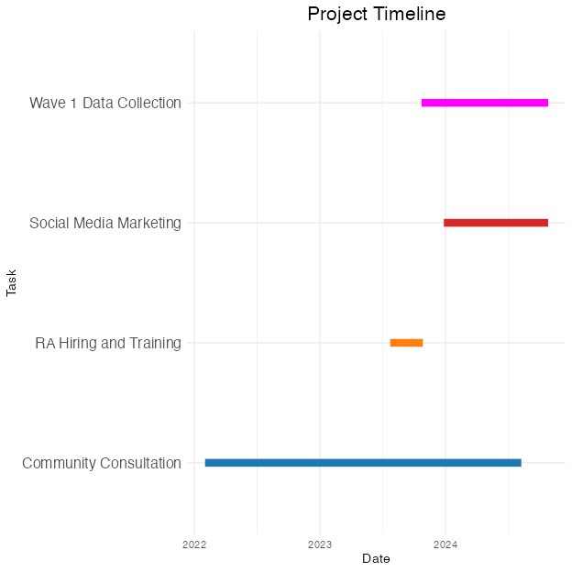

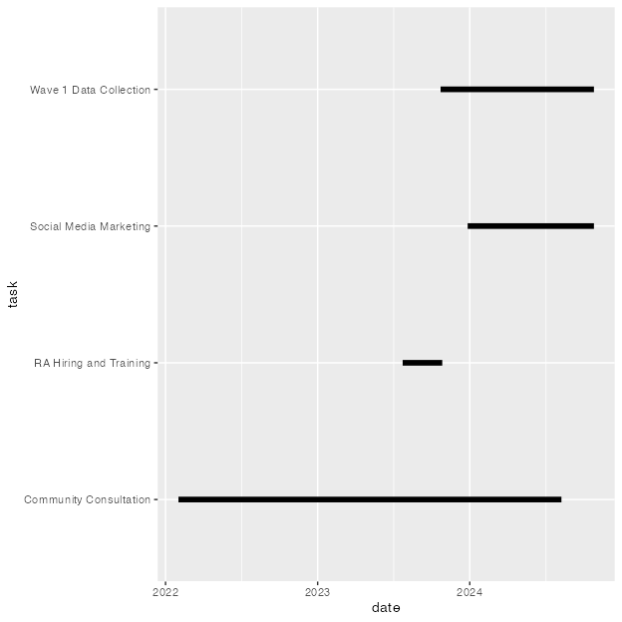

# What does and what does not work

Usman will elaborate on this. the followings improve data collection 1. building rapport 2. addressing confidentiality 3. being transparent with the community 4. going to community via trusted leaders 5. reaching out to inviduals personally, not via groups.

challengers: 1. length of the questionnaire 2. unfamiliarity with research 3. other preferences - generatioanl differences.

TBA: these are anecdotal. But we wanted to investigated further as to why our sample size stayed small. Therefore, we conducted a qualitative research of collecting research assistant experiences.

# Strengths and Limitations

Quantitative only. focus on english speakers only 1. Zahra E, Rizwan, Somia

Mentions Jamila’s and Qual here..

## Application and implications

Aamina Ali, Adepate Mustapha-Koiki

Potential contributions of the study to the field of mental health research and implications for policy and practice.

# Conclusion

Summarize the importance of the longitudinal study in understanding the psychological effects of the Christchurch mosque attacks on the Muslim community and reiterate the significance of the research aims.

1. Sandila. Afrah

# References

Arkilic, A. (2020). *What is islam’s appeal to māori?* <http://newsroom.co.nz/2020/08/18/what-is-islams-appeal-to-maori/>

Arkilic, A. (2021). *The Christchurch shooting and the 2020 New Zealand election* (S. Levine, Ed.; pp. 225–239). Victoria University Press.

Atkinson, J., Salmond, C., & Crampton, P. (2019). *NZDep2018 Index of Deprivation*.

Barger, B., Nabi, R., & Hong, L. Y. (2010). Standard back-translation procedures may not capture proper emotion concepts: A case study of Chinese disgust terms. *Emotion*, *10*(5), 703–711. <https://doi.org/10.1037/a0021453>

Bulbulia, J. A., Afzali, M. U., Yogeeswaran, K., & Sibley, C. G. (2023). Long-term causal effects of far-right terrorism in New Zealand. *PNAS Nexus*, *2*(8). <https://doi.org/10.1093/pnasnexus/pgad242>

Byrne, K. G., Yogeeswaran, K., Dorahy, M. J., Gale, J., Afzali, M. U., Bulbulia, J., & Sibley, C. G. (2022). Psychological impact of far-right terrorism against Muslim minorities on national distress, community, and wellbeing. *Scientific Reports*, *12*(1), 1620. <https://doi.org/10.1038/s41598-022-05678-x>

Drury, A. (2016). *Islam’s history and integration in the new zealand society: A Convert’s view* (E. Kolig & V. M, Eds.; pp. 113–129). Rowman.

Fenn, J., Tan, C.-S., & George, S. (2020). Development, validation and translation of psychological tests. *BJPsych Advances*, *26*(5), 306–315. <https://doi.org/10.1192/bja.2020.33>

Frykberg, L. (2023). *Online hate towards Muslims ’increasing’ since mosque attacks*. <https://www.1news.co.nz/2023/03/12/online-hate-towards-muslims-increasing-since-mosque-attacks/>

Greaves, L. M., Rasheed, A., D’Souza, S., Shackleton, N., Oldfield, L. D., Sibley, C. G., Milne, B., & Bulbulia, J. (2020). Comparative study of attitudes to religious groups in New Zealand reveals Muslim-specific prejudice. *Kōtuitui: New Zealand Journal of Social Sciences Online*, *15*(2), 260–279. <https://doi.org/10.1080/1177083x.2020.1733032>

Hawi, D., Osborne, D., Bulbulia, J., & Sibley, C. G. (2019). Terrorism anxiety and attitudes toward muslims. *New Zealand Journal of Psychology (Online)*, *48*(1), 8089.

*Islamophobia after Christchurch terror attacks quadrupled - Australian report*. (2022). <https://www.rnz.co.nz/news/national/463304/islamophobia-after-christchurch-terror-attacks-quadrupled-australian-report>

*Jacinda Ardern on the Christchurch shooting: ’One of New Zealand’s darkest days’*. (2019). <https://www.theguardian.com/world/2019/mar/15/one-of-new-zealands-darkest-days-jacinda-ardern-responds-to-christchurch-shooting>

Junaid, F. Ali., Cassim, S., & Khan-Janif, J. (2024). *Muslims’ experiences of inclusion, discrimination, islamophobia and wellbeing in aotearoa new zealand*. <https://doi.org/10.13140/RG.2.2.12693.74725/1>

Kabir, S. N. (2024). ‘They are us’: Orientalist perspective challenged in New Zealand newspapers’ coverage. *Journal of Arab & Muslim Media Research*. <https://doi.org/10.1386/jammr_00077_1>

Kessler, R. C., Green, J. G., Gruber, M. J., Sampson, N. A., Bromet, E., Cuitan, M., Furukawa, T. A., Gureje, O., Hinkov, H., Hu, C.-Y., Lara, C., Lee, S., Mneimneh, Z., Myer, L., Oakley-Browne, M., Posada-Villa, J., Sagar, R., Viana, M. C., & Zaslavsky, A. M. (2010). Screening for serious mental illness in the general population with the K6 screening scale: results from the WHO World Mental Health (WMH) survey initiative. *International Journal of Methods in Psychiatric Research*, *19*(S1), 4–22. <https://doi.org/10.1002/mpr.310>

*New Zealand Attitudes and Values Study*. (2024). <https://osf.io/75snb/>

Ozolins, U., Hale, S., Cheng, X., Hyatt, A., & Schofield, P. (2020). Translation and back-translation methodology in health research a critique. *Expert Review of Pharmacoeconomics & Outcomes Research*, *20*(1), 69–77. <https://doi.org/10.1080/14737167.2020.1734453>

Rahman, A. (2019). *Islamic Women’s Council repeatedly lobbied to stem discrimination*. <https://www.rnz.co.nz/news/on-the-inside/384911/islamic-women-s-council-repeatedly-lobbied-to-stem-discrimination>

Rahman, K. A. (2020). News media and the Muslim identity after the Christchurch mosque massacres. *Kōtuitui: New Zealand Journal of Social Sciences Online*, *15*(2), 360–384. <https://doi.org/10.1080/1177083x.2020.1747503>

Raissi, H. (2024). *Exploring senses of belonging: A multidimensional study of muslim immigrant youth in new zealand* [PhD thesis].

*Royal Commission of Inquiry into the terrorist attack on Christchurch Masjidain on 15 March 2019*. (2020). <https://christchurchattack.royalcommission.nz>

Shanaah, S., Yogeeswaran, K., Greaves, L., Bulbulia, J. A., Osborne, D., Afzali, M. U., & Sibley, C. G. (2021). Hate begets warmth? The impact of an anti-Muslim terrorist attack on public attitudes toward Muslims. *Terrorism and Political Violence*, 119.

Shaver, J. H., Sibley, C. G., Osborne, D., & Bulbulia, J. (2017). News exposure predicts anti-Muslim prejudice. *PLOS ONE*, *12*(3), e0174606. <https://doi.org/10.1371/journal.pone.0174606>

Sibley, C. G. (2024). *New Zealand Attitudes and Values Study*. <https://osf.io/75snb/wiki/home/>

Sibley, C. G., Afzali, M. U., Satherley, N., Ejova, A., Stronge, S., Yogeeswaran, K., Grimshaw, M., Hawi, D., Mirnajafi, Z., & Barlow, F. K. (2020). Prejudice toward Muslims in New Zealand: Insights from the New Zealand Attitudes and Values Study. *New Zealand Journal of Psychology*, *49*(1).

Sibley, C. G., Luyten, N., Purnomo, M., Mobberley, A., Wootton, L. W., Hammond, M., Sengupta, N., Perry, R., West-Newman, T., Wilson, M., McLellan, L., Hoverd, W. J., & Robertson, A. (2011). The mini-IPIP6: Validation and extension of a short measure of the big-six factors of personality in new zealand. *New Zealand Journal of Psychology*, *40*(3), 142–159.

*Stats NZ*. (2024). <https://www.stats.govt.nz/>

Sulaiman-Hill, R. C., Porter, R., Schluter, P., Beaglehole, B., Dean, S., Tanveer, S., Boden, J., & Bell, C. (2024). Research following trauma in minority ethnic and faith communities: lessons from a study of the psychosocial sequelae of the Christchurch mosque terror attacks. *BJPsych Open*, *10*(1). <https://doi.org/10.1192/bjo.2023.641>

Sulaiman-Hill, R. C., Porter, R., Tanveer, S., Boden, J., Beaglehole, B., Schluter, P. J., Dean, S., & Bell, C. (2021). Psychosocial impacts on the christchurch muslim community following the 15 march terrorist attacks: A mixed-methods study protocol. *BMJ Open*, *11*(10), e055413.

*The New Zealand Qualifications Framework*. (2016).

Wilson, C., & Shastri, S. (2020). *Hate crimes against muslims spiked after the mosque attacks, and ardern promises to make such abuse illegal*. <http://theconversation.com/hate-crimes-against-muslims-spiked-after-the-mosque-attacks-and-ardern-promises-to-make-such-abuse-illegal-147347>

*World leaders condemn New Zealand mosque attacks*. (2019). <https://www.aljazeera.com/news/2019/3/15/the-world-reacts-to-new-zealand-mosque-attacks>

Yogeeswaran, K., Afzali, M. U., Andrews, N. P., Chivers, E. A., Wang, M.-J., Devos, T., & Sibley, C. G. (2019). Exploring new zealand national identity and its importance for attitudes toward muslims and support for diversity. *New Zealand Journal of Psychology (Online)*, *48*(1), 29–35.

Table 1

Table 1: Muslim Population by Selected Cities

| City | Population | Research Assistants |
| --- | --- | --- |
| Auckland | 40,221 | 10 |
| Christchurch | 3,942 | 8 |
| Hamilton | 3,561 | 4 |
| Wellington | 3,294 | 5 |
| Palmerston North | 1,317 | 1 |
| Dunedin | 1,299 | 2 |

Figure 1

Feeling thermometer scale

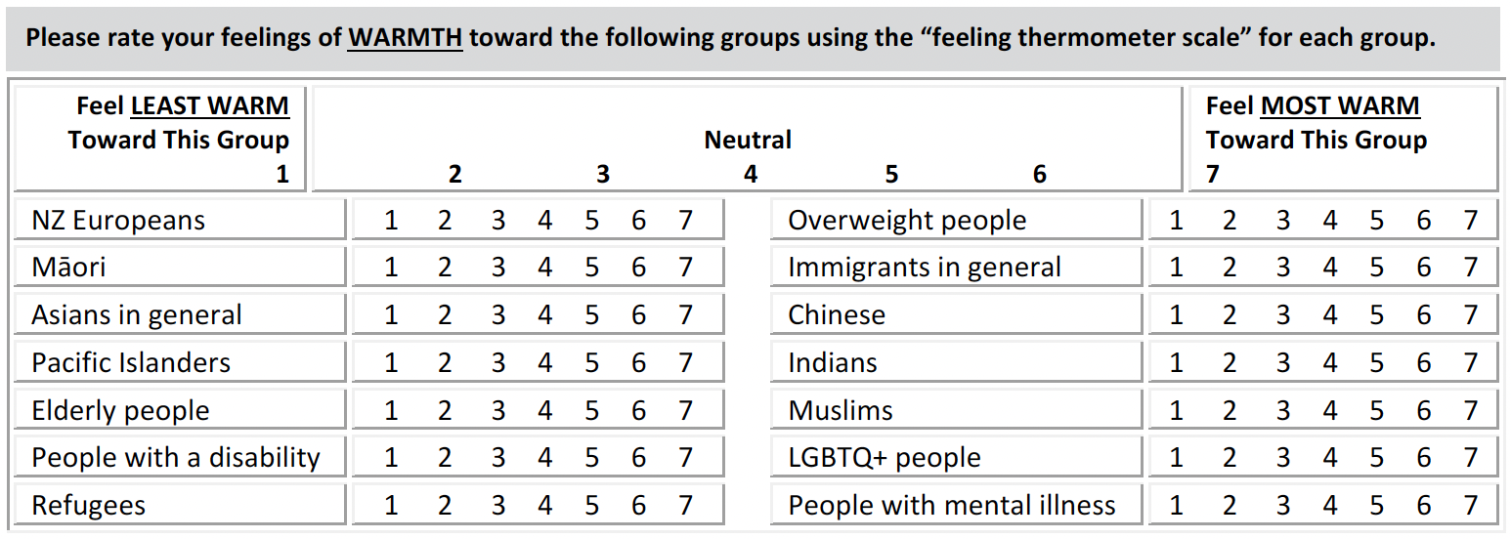

*Note*. From NZAVS Wave 15 <https://osf.io/75snb/>

Figure 2

Chronic disease diagnosis

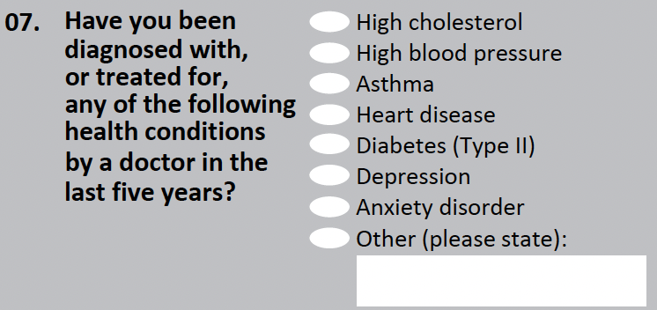

*Note*. From NZAVS Wave 15 <https://osf.io/75snb/>

Figure 3

Kessler 6

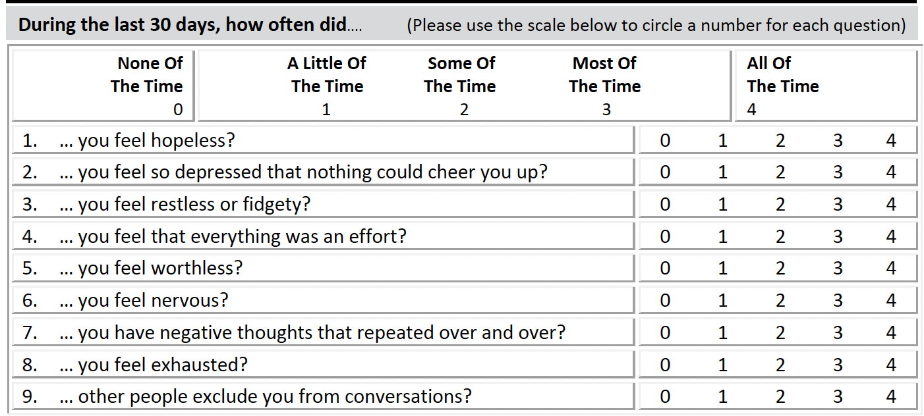

*Note*. From NZAVS Wave 15 <https://osf.io/75snb/>

Figure 4

Life Satisfaction

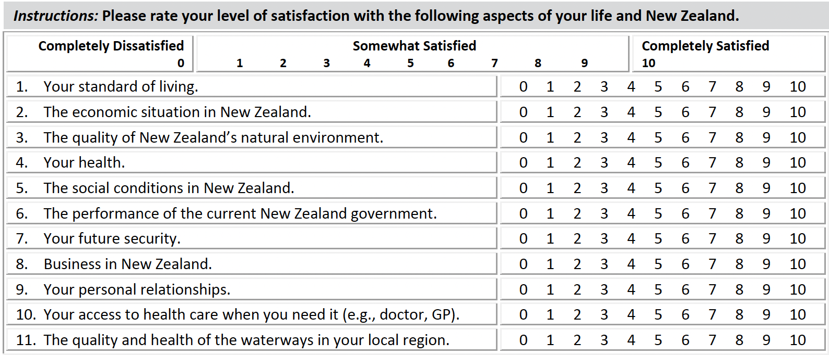

*Note*. From NZAVS Wave 15 <https://osf.io/75snb/>

Figure 5

Ethnic Groups

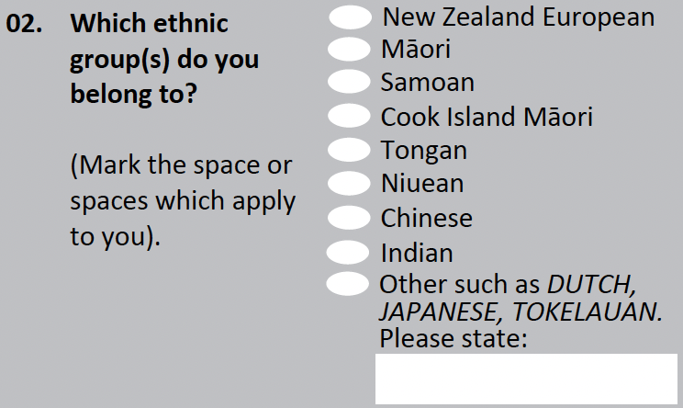

*Note*. From NZAVS Wave 15 <https://osf.io/75snb/>

# Appendix

# Title for Appendix