A Review of Chatbots in Different Industries

**Abstract:**

Recently, the improvement of conversational framework as a mode of discussion among human and PC have made an extraordinary walk. This human and computer communication has covered the way for wide natural language processing techniques. A chatbot is a computer system that allows human to interact with computer using natural language. The chatbots system are widely used in various field such as in businesses, education, healthcare and many more. The innovation at the core of the rise of the chatbot is natural language processing (“NLP”). Recent development in machine learning/AI have greatly improved the accuracy and effectiveness of natural language processing, making chatbots a viable option for many organizations. This improvement in natural language processing (“NLP”) is firing a great deal of additional research which should lead to continued improvement in the effectiveness of chatbots in the years to come.

A simple chatbot can be created by loading a frequently asked question into chatbot software. The functionality and Accuracy of the chatbot can be improved by integrating it into the organization’s enterprise software, allowing more personal questions to be answered, like **“What is my Account No?”, or “What is my income?”.**

Most commercial chatbots are dependent on platforms created by the technology giants for their natural language processing. Example for Amazon Lex, Microsoft Cognitive Services, Google Cloud Natural Language API, Facebook Deep Text, and IBM Watson. Platforms where chatbots are deployed include Facebook Messenger, and Skype among many others.

**Keywords**: Chatbots, Instant Messaging, Bots, Natural Language

**1.Introduction**

In general, bot is a computer system that can perform automated task, and bot may also serve in messaging platforms which known as Chatbot. Chatbot is similar to the normal messaging application however the different is when one of the message receivers is a robot (The human chatting with the Robot/computer). The conversation message could be sent through several mediums such as voice commands, test chats, graphical widgets (pictures, Emoji’s). It offers many advantages of using Chatbots, for instance, Chatbot are able to assist human inquiry and giving feedback 24 hours per day as well as it also can improve efficiency by taking over tasks for which humans are not essential. But the biggest advantages of Chatbots is that it is able to reach a broad audience on messenger system and the ability to automate personalized messages instantly. Chatbot has been used in various industries to deliver information or perform tasks, such as telling the weather, making flight reservations, answer the educational based queries or purchasing products and providing healthcare tips. These technologies also are used by various famous application such as Telegram, Cortana, Slack, WeChat, Facebook Messenger, Google Assistant and Siri.

In terms of Chatbots system development, in order to create a medium of speech conversation between the human and the computer involves several different design techniques. As stated by [1], the design techniques that usually chosen by developers can either be by pattern matching, clever script, chat script, Artificial Intelligence Markup Language (AIML) or by using language tricks. However, the most popular technique is the pattern matching whereby the bot will have matched phrases to the keywords in a pre-specified dictionary [1]. Therefore, this paper aims at reviewing several types of Chatbots and their functionalities on respected fields and Examples of Chatbots system is also presented in this paper.

**2.Chatbots in Healthcare industry**

There are many kinds of chatbot Applications in the Healthcare industry.

Health professionals have limited resources and are not able to personally monitor and support patients in their everyday life. Against this background and due to the increasing number of self-service channels and digital health interventions [18].

**2.1 Text-Based Healthcare Chatbots (THCB)**

can be designed to effectively support patients and health professionals in therapeutic settings beyond on-site consultations. The THCB is part of the open source behavioral intervention platform MobileCoach www.mobile-coach.eu [2]. It has already been evaluated in the public health context and provides a modular architecture and rule engine for the design of fully automated digital health interventions. It also supports the implementation of RCTs and micro-randomized trials. A mobile chat app has been recently introduced as a new chat client for Mobile Coach [2] [18].

The application permits the combination of visual THCB prompts in a committed visit channel. This channel likewise gives pre-characterized answer choices to productive talk associations contrasted with customary content informing frameworks. Besides, we have executed a subsequent visit channel for patient and wellbeing proficient correspondence like WhatsApp or iMessage and circumstances in which the THCB can't support patients in an automated way.

For example, this channel can be used if a Doctor wants to motivate a patient in addition to the THCB or to ask patients to perform a needed task instead of missed intervention tasks such as “Hello Ruwan, why not go for walking, run around about 5000 steps, [3]” With that chat Application/medium, patients are also able to get in direct contact with their health professionals/Doctors. Patients can ask help from the THCB regarding an intervention task. And THCB have the capacity to provide instructions to the patients and helping the patients [5].

**2.2. A Self-Diagnosis Medical Chatbots**

This is the kind of Artificial Intelligence Application that can diagnose the disease and provide basic details about the disease, before consulting a doctor to reduce the healthcare costs and improve accessibility to medical knowledge the Self-Diagnosis Medical Chatbots is built. Certain chatbots acts as a medical reference books it’s a kind of database which has all the medical details [17], which helps the patient know more about their disease and helps to improve their health. The user can achieve the real benefit of medical chatbot only when it can diagnose all kind of disease and provide necessary information. A text-to-text diagnosis chatbot engages patients in conversation about their medical issues and provides a personalized diagnosis based on their symptoms [5]. Thus, individuals will have a thought regarding their medical and have the correct assurance. The high expenses of our healthcare system can often be attributed to the lack of patient engagement after they leave clinics or hospitals. Various surveys in this area have proved that that chatbot can provide healthcare in low costs and improved treatment if the doctors and the patient keep in touch after their consultation. To answer the questions of the user chatbot is used. There is very a smaller number of chatbots in medical field.

The proposed system provides a text-to text conversational agent that asks the user about their health issue. The user can chat as if chatting with a human. The bot then asks the user a series of questions about their symptoms to diagnose the disease. It gives suggestions about the different symptoms to clarify the disease. Based on the reply from the user the accurate disease is found and it suggests the doctor who needs to be consulted in case of major disease. The system remembers past responses and asks progressively more specific questions in order to obtain a good diagnosis.

The three primary components of our system are [4] user validation and extraction of symptoms from the conversation with the user, [5] accurate mapping of extracted (and potentially ambiguous) symptoms to documented symptoms and their corresponding codes in our database, and [6] developing a personalized diagnosis as well as referring the patient to an appropriate specialist if necessary.

**2.2. Chatbot for Campus Psychological Therapy**

With increasing pressure from schools nowadays, adolescents are prone to psychological illnesses, including mild mental disorders, depressions, anxiety, and possibly suicidal behavior, because of their immaturity in both emotion and spirit [21]. Therefore, it is a priority of psychologists to handle adolescent stress [21]as a means of preventing mental illness. However, most students with stress or mental illnesses are often reluctant or unwilling to share their true feelings to other people, and it is even more unlikely that they will voluntarily seek for psychological assistance.

Nevertheless, the advent of the Internet has brought great potential to addressing these problems. Many students are turning to the Internet to release their negative feelings, and it is shown to have positive effects on loneliness, depression, and stress [21]. It is then reasonable that a chatbot, or a chatting system based on artificial intelligence, can serve as a "virtual friend" to release the negative emotion of students, as it allows students to express their true feeling that cannot be otherwise expressed in real life.

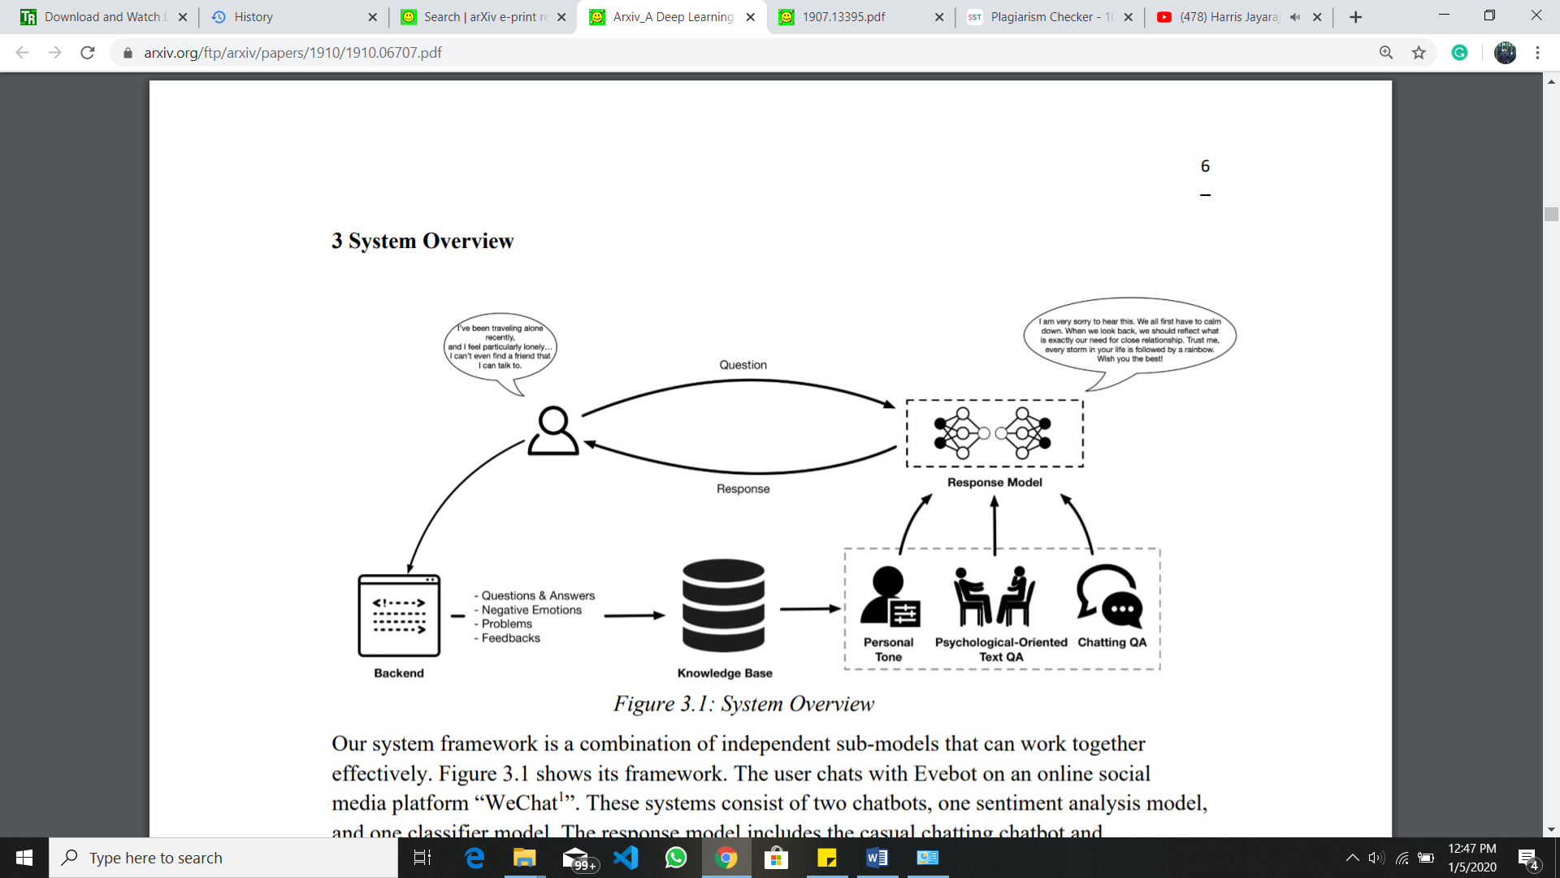

The user chats with Evebot on an online social media platform “WeChat1”. These systems consist of two chatbots, one sentiment analysis model, and one classifier model. The response model includes the casual chatting chatbot and psychological counselling chatbot. Determined by user’s responses, the response model decide to use which chatbot to answer. Both models take a sequence of words as input and another sequence of words as output. The response models are decided through the classifier model, which take a sentence as input and give a label of either casual or mental-related to that sentence. The sentiment analysis model is responsible for detecting the emotion of the user over the entire period of conversation. Each user’s response will be scored from 0 to 1 to give an evaluation on user’s emotion, 0 denoted as the most negative and 1 denoted as the most positive. When the user gives its response back to the response model, the backend of the system will also record the information and store it into knowledge base, which is fit to the model in the form of Q&A pair.

**2.3. Promote Smoking Cessation Using Chatbots**

Reducing youth tobacco use is critical for improving child health since tobacco use is associated with respiratory problems, and nicotine may interfere with healthy brain development. While tobacco regulation has contributed to declines in cigarette use among youth, these declines have occurred more quickly for youth of high socioeconomic status (SES) compared to youth of low SES [10]. A major barrier to smoking cessation for adolescents of low SES is coordination of access and transportation to in-person treatment sessions. LowSES youth may have family obligations that limit their ability to access in-person treatment. At the same time, mobile use among adolescents is high: 85% have smartphones [11]. Additionally, adolescents engage in texting at high rates, suggesting that they are well-suited for mobile instant messaging interventions. Mobile interventions have shown promise for youth, but their use remains low.

Conversational agents capitalize on recent advances in artificial intelligence to extend our ability to provide more human-like mobile interventions. Conversational agents may be deployed in a variety of formats. They may be embodied (i.e., having a 2-D or 3-D human-like physical representation) or non-embodied (i.e., using text only). Conversational agents may also vary in the type of user input they support, processing speech, text, and nonverbal behaviors. Given adolescents’ frequent use of texting platforms, we argue that a text-based chatbot is a suitable tool for long-term mobile intervention. One classic example is Woebot, a chatbot developed to promote mental health. Woebot debuted as the first non-embodied chatbot to provide CBT for anxiety and depression. Users can initiate conversations with the chatbot, as they would with a friend on Facebook messenger. Woebot also checks in with users periodically during the day to ask about their mood and suggest coping strategies. Preliminary findings show significant reductions in depression among young adults after two weeks [12].

Despite recent advances in technology, most existing text interventions for adolescent smoking cessation are not conversational. For example, the National Cancer Institute’s SmokefreeTxt for Teens1 is limited to keywords such as “yes,” “no,” “quit,” or “crave.” One example of a conversational text-based intervention designed for adults is Bella 2. Bella is an AI-powered chatbot for smoking cessation, developed primarily based on expert guidance, and was released in January 2018 in the UK. Bella is advertised as a “coach,” and the developers did not specify a theoretical orientation such as CBT. Data regarding efficacy for Bella has yet to be published, and it does not appear to be tailored to adolescents.

While chatbots may simulate human interaction, it is unlikely that they would replace mental health providers. Given the novelty of using chatbots for smoking cessation, the optimal role of chatbots in human mental healthcare provider work has yet to be determined. Ideally, chatbots would systematically deliver routine components of smoking cessation interventions and thus allow more time for providers to help with more complex aspects of smoking cessation. If developed as FDA-approved digital therapeutics, smoking cessation chatbots might be prescribed by providers in a manner similar to drugs, and providers might schedule follow-up appointments to review patient response to the treatment

**Usage of Health Care Chatbots**

A total of 30% (30/100) of participants indicated that they had direct personal experience with the use of chatbots for health-related issues. Of the 30 participants who have used health care chatbots previously, 4 (13%) were very satisfied [7].

**3.chatbots to detect spelling mistake**

Chatbots are being used successfully in many areas.

This kind of chatbot is designed to help people in order to correct their spelling mistakes by providing correction proposals to them. Especially orthographic spelling mistake should be recognized by the chatbot and should be replaced by correction suggestions stored in test data [8].

Chatbot is intended to provide better correction suggestions for mistakes, while allowing easy interaction with the users, which also encourages them to learn and write. The interaction, input and operation of the chatbot should be very simple for the users. The users feel more comfortable to work with this kind of environment because chatbot is always interact with users while they are making mistakes and also it will give the instructions to overcome from the mistakes

chatbot is being considered in order to offer even more motivation and an improved error analysis to the users.

**4.Chatbots in Tourism/Hotel industry**

The travel industry is an excellent target for e-commerce chatbots for several reasons:

1) Typical online travel agencies provide a web interface (such as buttons, dropdowns, and checkboxes) to enter information and filter search results; this can be difficult to navigate. In contrast, chatbot have a much gentler learning curve, since users interact with the bot using natural language. Additionally, chatbots are lightweight as they are embedded in an instant messaging platform that handles authentication. All of these factors contribute to higher user convenience [19].

2) Many people book vacations using travel agents, so the idea of booking travel through conversation is already familiar. Thus, so emulate the role of a travel agent, who talks to the customer while performing searches on various supplier databases on his behalf.

3) chatbot has the advantage of a narrow focus, so that every conversation is related to booking a hotel. This constrains conversations to a limited set of situations.

**4.1Architecture of Tourism field Chatbots.**

chatbot system tries to find a desirable hotel for the user, through an interactive dialogue. First, the bot asks a series of questions, such as the dates of travel, the destination city, and a budget range. After the necessary information has been collected, the bot performs a search and sends a list of matching hotels, sorted based on the users’ preferences; if the user is satisfied with the results, he can complete the booking within the chat client. Otherwise, the user may continue talking to the bot to further narrow down his search criteria. At any point in the conversation, the user may request to talk to a customer support agent by clicking an “agent” or “help” button [19]. The bot also sends the conversation to an agent if the user says something that the bot does not understand. Thus, the bot handles the most common use cases, while humans handle a long tail of specialized and less common requests. The hotel search is backed by a database of approximately 100,000 cities and 300,000 hotels, populated using data from our partners. Each database entry contains the name of the city or hotel, geographic information (e.g., address, state, country), and various metadata (e.g., review score, number of bookings).

**Basic structure of the ChatBot how it’s behaving** 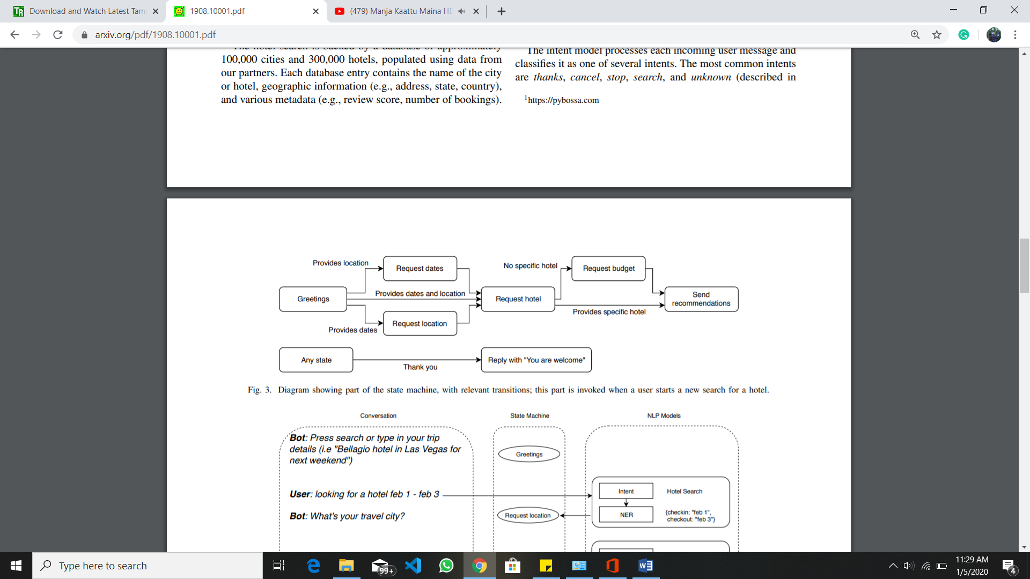

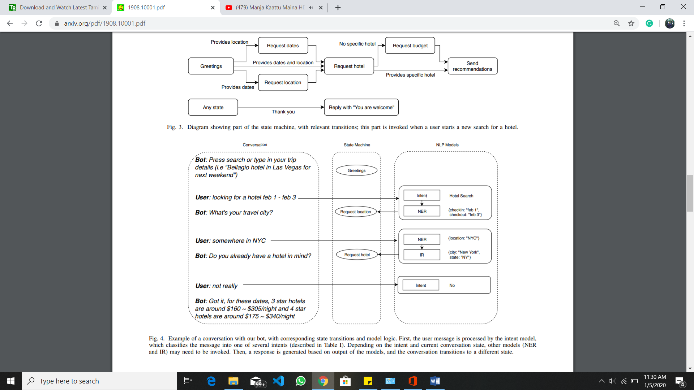

**5.Chatbots in Insurance Companies**

With the digital transformation changing usage patterns and consumer expectations, many industries need to adapt to new realities. The insurance sector is next in line to grapple with the risks and opportunities of emerging technologies, in particular Artificial Intelligence. Additionally, innovation methods like design thinking and open innovation are on the rise. In unsecure market times innovation is crucial, and all organizations and also traditional companies need to keep up to date by using new technologies for innovative business processes.

While insurance has traditionally been an industry with very low customer engagement, insurers now face a young generation of consumers with changing attitudes regarding insurance products and services [9]. Another goal of the project is the establishment of innovation methods within the companies and enable them to develop new products and services themselves. Traditionally, customer engagement uses channels like mail, telephone and local agents. In 2016, chatbots emerged as a new trend [16], making it a topic of interest for Fraunhofer IAO and insurance companies. With the rise of the smartphone, many insurers started offering apps, but success was limited [20], which may stem from app fatigue [38]. App use has plateaued, as users have too many apps and are reluctant to add more. In contrast, conversational agents require no separate installation, as they are accessible via messaging apps, which are likely to be already installed on a user’s smartphone. Conversational agents are an alternative to improve customer support and digitize processes like claim handling or managing customer data. The objective of this work is to describe the creation of conversational agents in theory and practice and show the outcomes of both views. We facilitate the creation of conversational agents by defining the traits of an agent more clearly using a (1) classification framework, which is based on current literature and research topics, and systematically analyzing [10] use cases and requirements in an industry, shown in the example insurance scenario. We frame two application scenarios with this theoretical foundation.

**Conversational Agents for Insurance Companies**

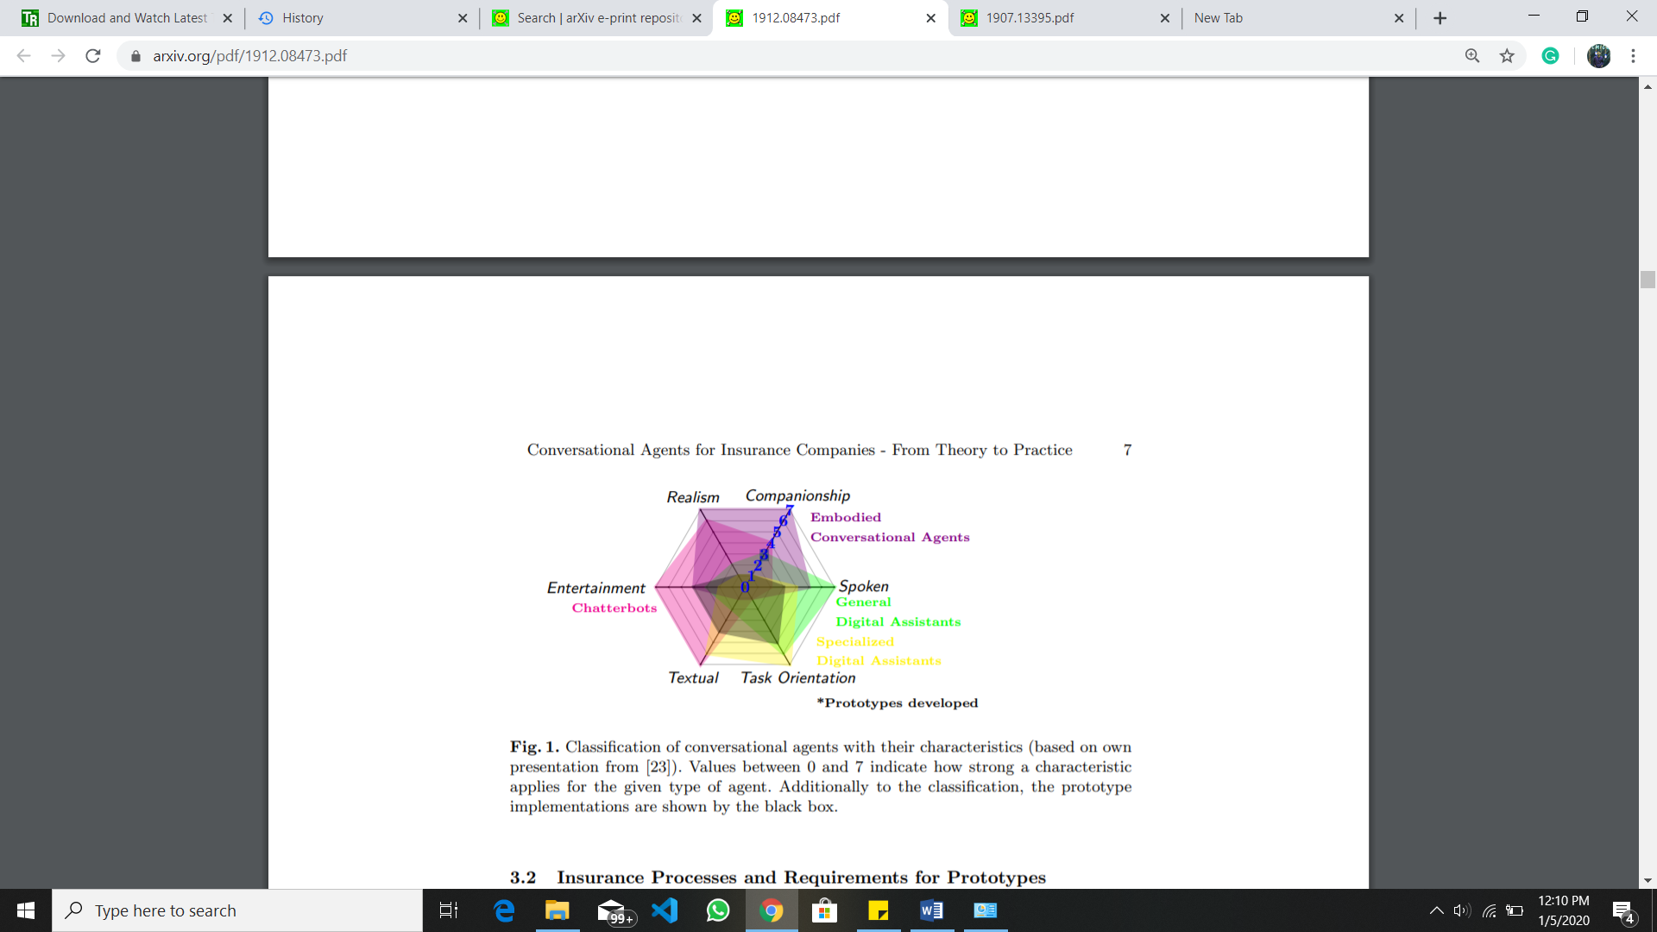

**Customer facing process in** **Insurance Companies**

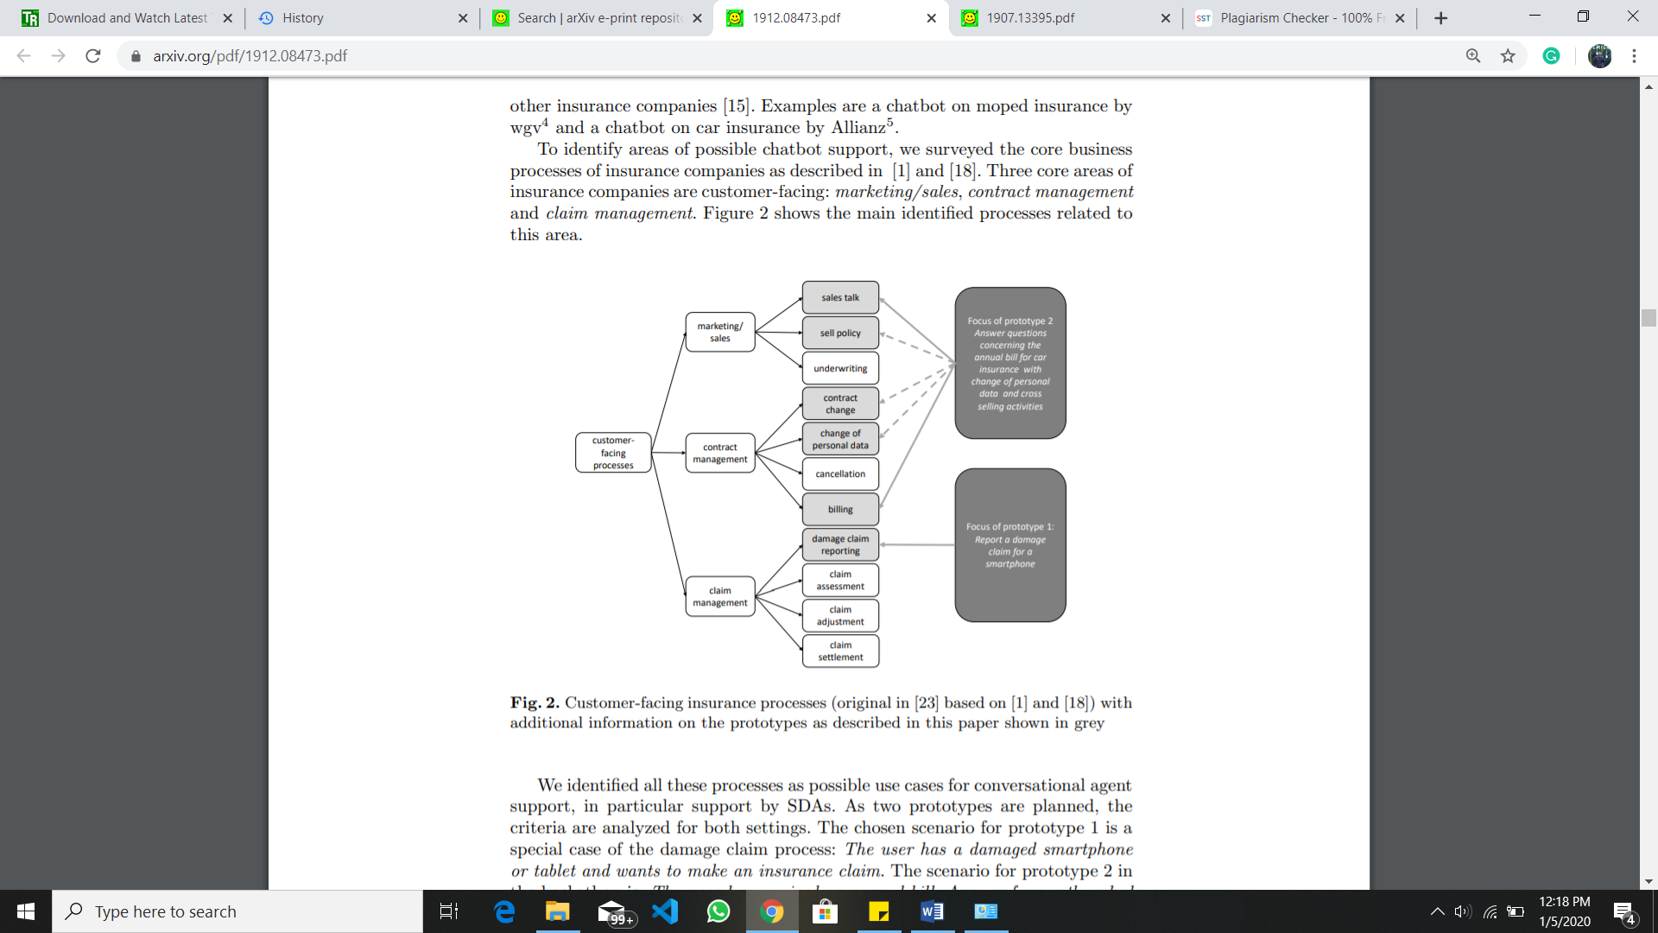

**conclusion**

Whether you realize it or not, the “people” you interact with internet are not all people. Customer service chat and commercial social media interactions are increasingly managed by intelligent agent’s/Ai agents, many of which have been developed with human identities and even personalities [13]. Even though the technology itself is not new, reliable linguistic functionality, availability through Software as a Service (SaaS), and the addition of intelligence through machine learning has increased its popularity. Between 2007 and 2015, chatbots were participating in a third to a half of all online interactions [14]and the rate at which new chatbots are being deployed has increased since then. Social, conversational bots can be used to provide benefits to companies, who use them to reduce time-to-response, provide enhanced customer service, increase satisfaction, and increase engagement. Unfortunately, some chatbots are specifically designed to be harmful. For example, networks of fake users (called “sybils” on Twitter) have been implemented to artificially inflate “follower” counts to increase social status for users who purchase them, to spread fake news or rumors, and even to intimidate users who express certain political beliefs[15][13].Chatbots receive natural language input, sometimes interpreted through speech recognition software, and execute one or more related commands to engage in goal-directed behavior (often on behalf of a human user). As intelligent agents, they are usually autonomous, reactive, proactive, and social. The most advanced systems employ machine learning (often Markov chains or deep neural networks) so that they may also adapt to new information or new requests. Chatbots are one class of conversational specialists, which are programming frameworks that copy connections with genuine individuals. They are normally not typified in the types of creatures, symbols, (those programs are considered to be “embodied conversational agents”). Conversational agents, a class of discourse frameworks, have been a subject of research in interchanges for a considerable length of time. Interactive Voice Response (IVR) systems (e.g. “Press or Say 1 for English”) are also dialog systems, but are not usually considered conversational agents since they implement decision trees.

The results from previous research are highly encouraging for future studies and projects as they indicate that usage of chatbots has been able to stimulate learning engagement in bold new ways that have previously been unavailable.

A medical chatbot provides personalized diagnoses based on symptoms. In the future, the bot’s symptom recognition and diagnosis performance could be greatly improved by adding support for more medical features, such as location, duration, and intensity of symptoms, and more detailed symptom description. The implementation of Personalized Medical assistant heavily relies on AI algorithms as well as the training data. At last, the implementation of personalized medicine would successfully save many lives and create a medical awareness among the people. As said before, the future era is the era of messaging app because people going to spend more time in messaging app than any other apps. Thus medical chatbot has wide and vast future scope. No matter how far people are, they can have this medical conversation. The only requirement they need is a simple desktop or smartphone with internet connection. The efficient of the chatbot can be improved by adding more combination of words and increasing the use of database so that of the medical chatbot could handle all type of diseases. Even voice conversation can be added in the system to make it more easy to use.

Chatbots are used widely in travel industry. Currently, building models to handle new types of queries (e.g., a hotel question-answering system), and using multi-task learning to combine our separate models. Another ongoing challenge is improving the efficiency of the models in production: since deep language models are memory-intensive, it is important to share memory across different models. Chatbot is a viable alternative to traditional mobile and web applications for commerce. Indeed, we believe that innovations in task-oriented chatbot technology will have tremendous potential to improve consumer experience and drive business growth in new and unexplored channels. This will demonstrate the impact of Chatbots in industry level.

References:

1. J. Masche and N. Le, “A Review of Technologies for Conversational Systems,” Adv. Intell. Syst. Comput., vol. 629, pp. 212–225, 2018.

2. Kowatsch, T., Volland, D., Shih, I., et al.: Design and Evaluation of a Mobile Chat App for the Open Source Behavioral Health Intervention Platform MobileCoach. In: A., M., J., v.B., A., H. (eds.) Designing the Digital Transformation. DESRIST 2017. Lecture Notes in Computer Science, vol 10243, pp. 485-489. Springer, Berlin; Germany (2017).

3. Kramer J, Künzler F, Mishra V, Presset B, Kotz D, Smith S, et al. Investigating intervention components and exploring states of receptivity for a smartphone app to promote physical activity: protocol of a microrandomized trial. JMIR Res

4. SimonHoermann, Kathryn L McCabe, David N Milne, Rafael A Calvo1,“ Application of Synchronous Text Based Dialogue Systems in Mental Health Interventions: Systematic Review”, Journal of Medical Internet Research ,volume: 19 , issue 8 , August 2017.

5. Saurav Kumar Mishra, DhirendraBharti, Nidhi Mishra,” Dr. Vdoc: A Medical Chatbots that Acts as a Virtual Doctor”, Journal of Medical Science and Technology, Volume: 6, Issue 3,2017.

6. DivyaMadhu, Neeraj Jain C. J, ElmySebastain, ShinoyShaji, AnandhuAjayakumar,” A Novel Approach for Medical Assistance Using Trained Chatbots”, International Conference on Inventive Communication and Computational Technologies (ICICCT 2017).

7.Physicians’ Perceptions of Chatbots in Health Care: Cross-Sectional Web-Based Survey Adam Palanica1, PhD; Peter Flaschner2, BDES; Anirudh Thommandram1, MAS; Michael Li1, MAS; Yan Fossat1, CAP

8.Jeton Arifi, Markus Ebner, Martin Ebner (*) Graz University of Technology, Graz, Austria

9. Power, J. D.: 2017 u.s. auto claims satisfaction study (2017), http://www.jdpower.com/resource/jd-power-us-auto-claims-satisfaction-study 34. Radziwill, N., Benton, M.: Evaluating quality of chatbots and intelligent conversational agents. arXiv preprint arXiv:1704.04579 (2017)

10. [AL Musharraf 2019] AL Musharraf, F. 2019. Motivating

Smokers to Quit Through a Computer-Based Conversational

System. Ph.D. Dissertation.

11.[Fanshawe et al. 2017] Fanshawe, T. R.; Hallowell, W.; Lindson, N.; Aveyard, P.; Livingstone-Banks, J.; and Hartmann Boyce, J. 2017. Tobacco cessation interventions for young people. Cochrane Database of Systematic Reviews (11).

12. [Kong et al. 2017] Kong, G.; Goldberg, A. L.; Dallery, J.; and Krishnan-Sarin, S. 2017. An open-label pilot study of an intervention using mobile phones to deliver contingency management of tobacco abstinence to high school students. Experimental and clinical psychopharmacology 25(5):333.

13. Alarifi, A., Alsaleh, M., & Al-Salman, A. (2016). Twitter Turing test: Identifying social machines. Information Sciences, 372, 332-346

14. Applin, S. A., & Fischer, M. D. (2015, November). New technologies and mixed-use convergence: How humans and algorithms are adapting to each other. In Technology and Society (ISTAS), 2015 IEEE International Symposium on (pp. 1-6). IEEE.

15. Beilby, L. J., & Zakos, J. (2014). U.S. Patent No. 8,719,200. Washington, DC: U.S. Patent and Trademark Office.

16 Bhakta, R., Savin-Baden, M., & Tombs, G. (2014, June). Sharing Secrets with Robots? In EdMedia: World Conference on Educational Media and Technology (Vol. 2014, No. 1, pp. 2295- 2301).

17.A Self-Diagnosis Medical Chatbot Using Artificial Intelligence: Divya S1, Indumathi V1, Ishwarya S1, Priyasankari M1, Kalpana Devi S2 1UG students, 2Assistant Professor Department of Computer Science and Engineering, Easwari Engineering College, Chennai--600089,

18.Text-based Healthcare Chatbots Supporting Patient and Health Professional Teams: Preliminary Results of a Randomized Controlled Trial on Childhood Obesity:

19. Real-world Conversational AI for Hotel Bookings Bai Li University of Toronto Snap Travel Toronto, Canada bai@cs.toronto.edu Nanyi Jiang Snap Travel Toronto, Canada leon@snaptravel.com Joey Sham Snap Travel Toronto, Canada joey@snaptravel.com Henry Shi Snap Travel Toronto, Canada henry@snaptravel.com Hussein Fazal Snap Travel Toronto, Canada hussein@snaptravel.com

20.Conversational Agents for Insurance Companies: From Theory to Practice: Falko Koetter 1, Matthias Blohm 1, Jens Drawehn 1, Monika Kochanowski 1, Joscha Goetzer 2, Daniel Graziotin 2, and Stefan Wagner 2

21. A Deep Learning Based Chatbot System for Campus Psychological Therapy Junjie Yin*, Zixun Chen, Kelai Zhou, Chong yuan Yu Guangdong Country Garden School, Foshan, China