High Tide — Amazon Business integration architecture
Site: https://ccsupplies.ca
Prepared by: Usman Zahid (Basecamp Consulting)
For: Jai Radhakrishnan / Ed Petrovacki — Amazon Business
Checked: 19 October 2026 against production WP Admin (Site Health + WooCommerce Features) and the live theme/plugin code.
No credentials or secrets are in this document.

What this system does
ccsupplies.ca is High Tide’s internal stationery portal (Canna Cabana stores). Login required — not a public shop.
Verified flow in code + live manager UI:
- Store Employee (store_employee) shops WooCommerce and checks out with payment method Internal Requisition. Order status becomes Awaiting Approval.
- Manager (WordPress shop_manager with wcss_manage_portal, or administrator) opens /manager/orders, then Approve or Reject. Approve only changes WooCommerce status. It does not call Amazon.
- After Approved, manager uses Amazon Test Order → Amazon Catalog → Search Amazon → Add to Amazon Cart → Amazon Cart → Amazon Checkout → Calculate Shipping → Place (still Trial Mode).

Figure 1 — High-level system architecture
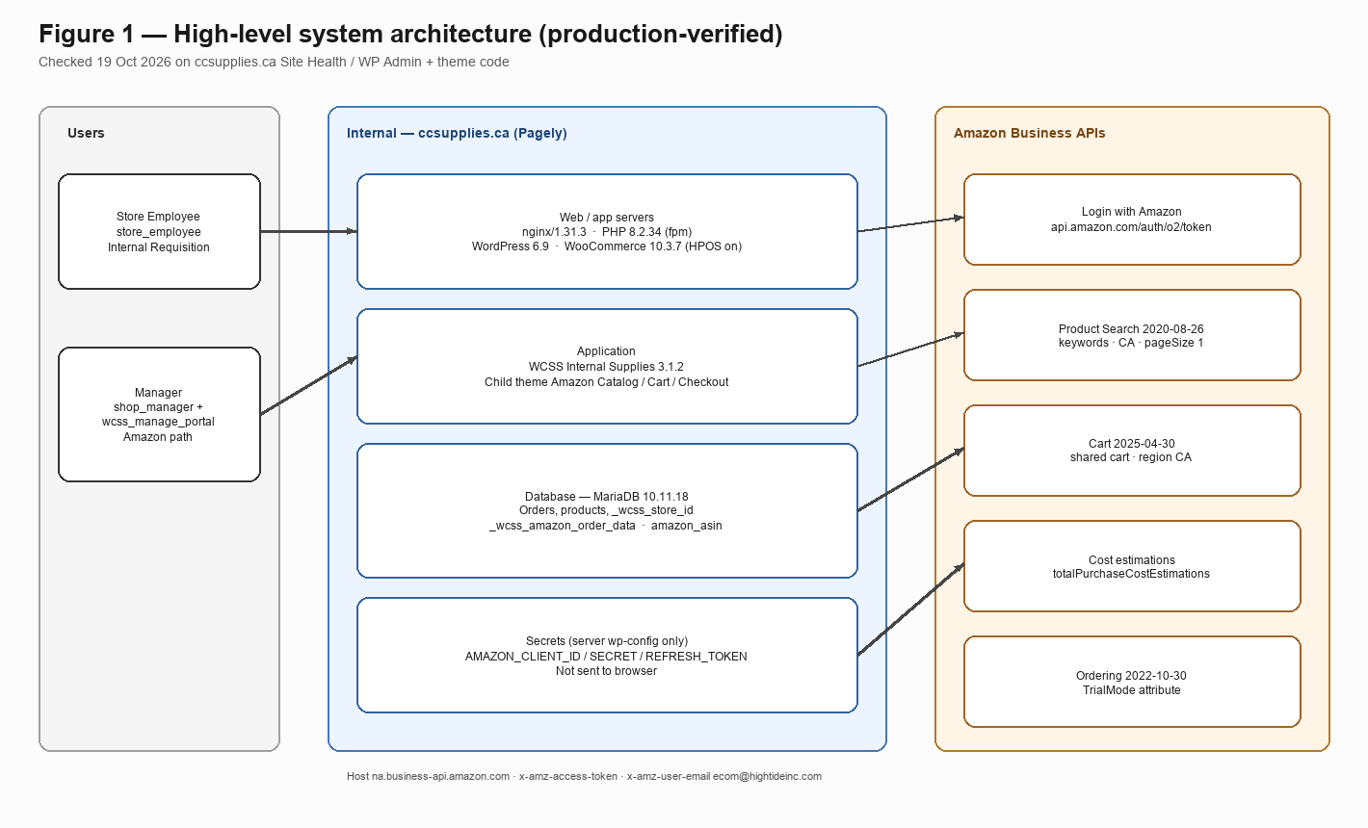
Figure 1 — High-level system architecture
Verified on production Site Health / admin (19 Oct 2026):
Item | Exact value
Hosting | Pagely (toolbar: Pagely®, PressCDN™, PressCACHE™)
Web server | nginx/1.31.3
PHP | 8.2.34 (fpm-fcgi)
Database | MariaDB 10.11.18 (mysqli / mysqlnd 8.2.34), host localhost socket, table prefix wp_
WordPress | 6.9
WooCommerce | 10.3.7
Order storage | High-performance order storage (HPOS) enabled (woocommerce_custom_orders_table_enabled = yes)
Active theme | Adex360 X Canna Cabana Stationery Child 1.0.6 (parent: Adex360 X Canna Cabana Stationery)
Amazon + supplies plugin | WCSS – Internal Supplies for WooCommerce 3.1.2
Mail plugin | WP Mail SMTP 4.7.1

Amazon calls leave our PHP app over HTTPS to Amazon Business. LWA client id / secret / refresh token are defined in server wp-config.php (not in the browser).

Figure 2 — Order flow
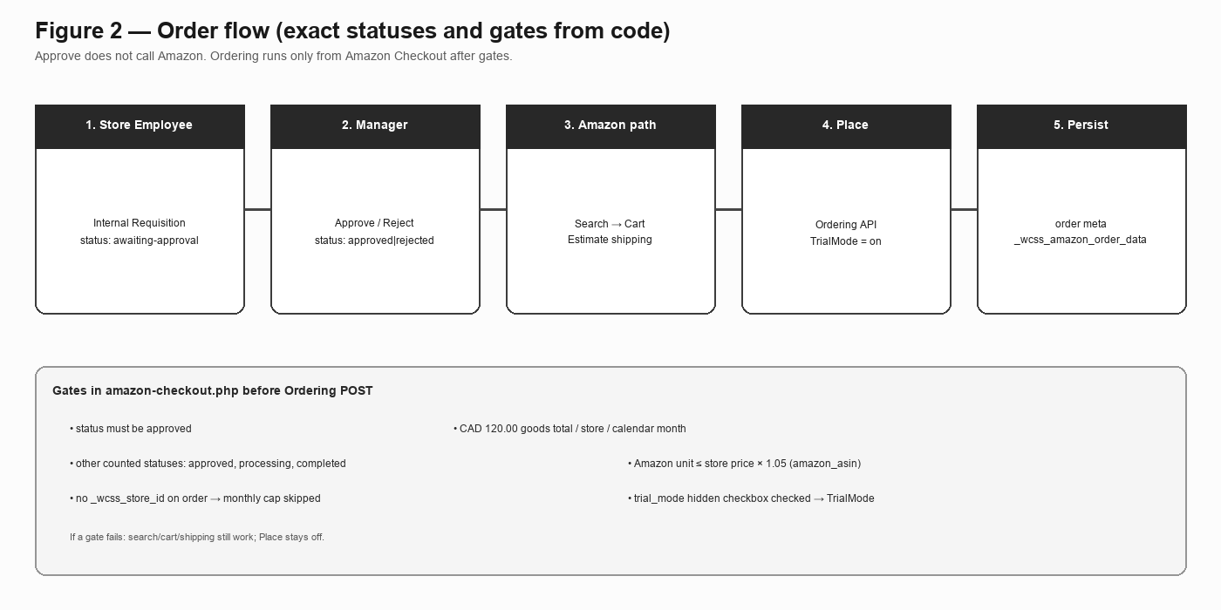
Figure 2 — Order flow
Gates before Ordering API (enforced in amazon-checkout.php, not only UI):
Gate | Exact rule in code
Approval | Store order status must be approved
Monthly cap | Flat CAD 120.00. Uses line-item goods totals only (get_total() on line items — not tax/shipping). Counts other orders for the same _wcss_store_id in the current calendar month with status approved, processing, or completed, plus this order. If the order has no _wcss_store_id, the cap does not apply.
Price check | Amazon unit ≤ store product price × 1.05 (5%). Link is product meta amazon_asin set when the manager adds from catalog.
Trial Mode | Checkout has a hidden, checked trial_mode checkbox. When set, Ordering payload includes attributeType: TrialMode.

If a gate fails: Search / cart / shipping can still run; Place Amazon Order stays blocked.

Figure 3 — Internal stack and Amazon boundary
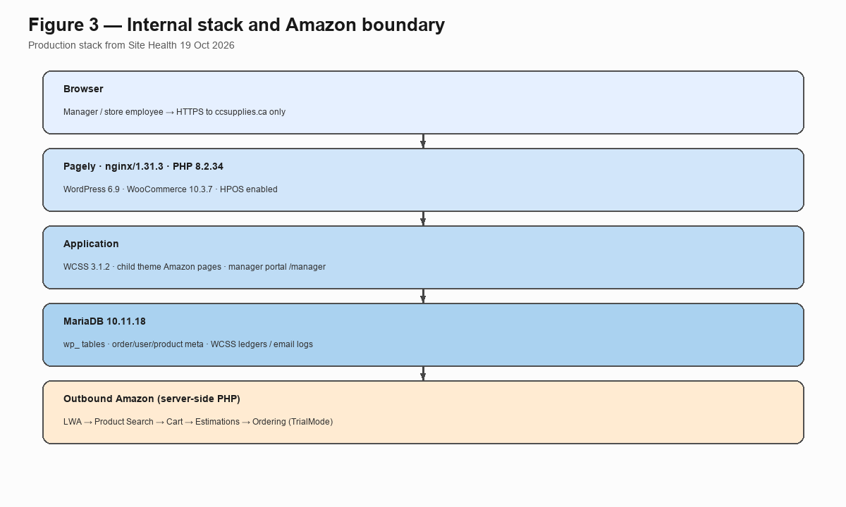
Figure 3 — Internal stack
Users only hit ccsupplies.ca. Amazon credentials never go to the browser. Outbound Amazon traffic is server-side from PHP.

Internal systems (exact)
Piece | What is live
Web / app | Pagely → nginx → PHP 8.2 → WordPress 6.9 + WooCommerce 10.3.7 (HPOS on)
Business logic | WCSS Internal Supplies 3.1.2 — store CPT, _wcss_store_id mapping, /manager routes, Approve/Reject, email notices, Email Logs
Amazon UI + API code | Child theme page templates: Amazon Catalog (amazon-apis-integration.php), Amazon Cart (amazon-cart.php), Amazon Checkout (amazon-checkout.php)
Database | MariaDB 10.11.18 — WordPress/WooCommerce tables + WCSS tables + order/user/product meta
Mail | WP Mail SMTP 4.7.1 (plus WCSS Email Logs under WooCommerce)
Secrets | AMAZON_CLIENT_ID, AMAZON_CLIENT_SECRET, AMAZON_REFRESH_TOKEN in wp-config.php on the server

Dev copy of the site is Local by Flywheel on developer machines. Production is https://ccsupplies.ca.

Data we store (Amazon-related) — from code
Where | What
WooCommerce orders | Requisitions; statuses include awaiting-approval, approved, rejected
Order meta _wcss_amazon_order_data | Cart / estimate / place snapshot, request IDs, timestamps (constant WCSS_AMAZON_ORDER_META_KEY)
Product meta amazon_asin | Set on Add to Amazon Cart; used for 5% check
User meta _wcss_store_id | Store assignment for the employee
Option wcss_amazon_asin_titles | ASIN → title map used by cart/checkout helpers

Access tokens are requested from LWA when needed for a call. They are not written into _wcss_amazon_order_data as the long-lived secret store.

Who does what (exact capabilities)
Who | Role / cap | What they do | Amazon Product Search AJAX
Store employee | store_employee | Shop, Internal Requisition, My Account | Search AJAX returns 403 unless user has manage_woocommerce or manage_options
Manager | shop_manager + wcss_manage_portal (also admin) | /manager/*, Approve/Reject, Amazon Test Order path | Yes (managers with Woo manage caps)
API business user header | — | — | x-amz-user-email: ecom@hightideinc.com (hardcoded / AMAZON_USER_EMAIL in theme)

Manager portal auth: wcss_manage_portal or manage_options (class-routes-manager.php). Store employee opening /manager/ is redirected to My Account (live-checked earlier with demostore).

Amazon APIs we call today (from theme code)
Step | Exact call
Auth | POST https://api.amazon.com/auth/o2/token — grant_type=refresh_token + client id/secret/refresh token
Product Search | GET https://na.business-api.amazon.com/products/2020-08-26/products
Cart | …/cart/2025-04-30/carts and …/carts/{cartId}/items?region=CA
Cost estimate | POST …/cart/2025-04-30/carts/{cartId}/totalPurchaseCostEstimations?region=CA
Place | POST https://na.business-api.amazon.com/ordering/2022-10-30/orders

Product Search query params in production catalog code (wp_amazon_business_search_products / Search Amazon uses pageSize=1):
- keywords = WooCommerce product name
- productRegion = CA
- locale = en_US
- facets = OFFERS,IMAGES
- pageSize = 1 (top match)
- category = OFFICE_PRODUCTS
Headers on Amazon calls: x-amz-access-token, x-amz-user-email (ecom@hightideinc.com), Accept: application/json
Shared cart ID in code: cart-wxXmutF5kiXGRb9J (AMAZON_CART_ID), region CA.
Ordering group id default in checkout: OrderingAPI5259590399 (AMAZON_GROUP_ID).
Not implemented in the current search path: getProductsByAsins. We use keyword Product Search only. ASIN-based Buy Box search is planned after Tomas provides ASINs (per Oct 14 Amazon recap).

Security / monitoring (what exists in code today)
- LWA secrets only on server config.
- Amazon HTTP from PHP, not from the browser.
- Catalog Search Amazon AJAX: logged-in + manage_woocommerce or manage_options + nonce.
- Cart / shipping / place: WordPress nonces (amazon_cart_nonce, amazon_shipping_nonce, amazon_checkout_nonce).
- Ordering blocked in PHP until approval + CAD 120 + 5% pass.
- We capture Amazon x-amzn-requestid on responses and keep the order meta snapshot; manager has Amazon order view. WooCommerce Email Logs for mail. No separate CloudWatch/SIEM app inside ccsupplies.

Next steps already agreed with Amazon (Oct 14 recap email)
These are planned items from Ed/Jai — not already built unless noted:
Item | Status in our build today
Email Jai Product Search method/params | Done (sent)
Move to ASIN-based search for curated catalog | Not built yet — waiting on ASINs
Encrypt stored tokens; secret rotation reminder (~180 days); order error alerts | Not built yet (go-live list)
Store-employee request flow demo on follow-up call | Process exists; demo when scheduled
Reject process with Chris (manager + Amazon rejects) | Process discussion — not a separate Amazon API
Reporting + Package Tracking APIs | Not built — after first live order
Turn Trial Mode off | Still on (hidden checked checkbox) until sign-off

Out of current Amazon Ordering build: Concur invoice automation, returns UI, ink spend split outside CAD 120.

If you want any layer expanded with request/response samples (no secrets), say which API step.
Usman Zahid
Basecamp Consulting — High Tide / ccsupplies.ca
uzahid@basecampconsulting.co

