**Cloning Method**

**Here is the easiest and most beginner-friendly way to push your project to GitHub using the *cloning method*!**  
Whether you are a student, beginner, or developer this guide will help you upload your code step by step with full clarity.

**🪜 Step 0(a): Install Git Bash**

Before starting, you need to install **Git Bash** it’s the tool that lets you use Git commands on your computer.

👉 **Download Git Bash here:** <https://git-scm.com/downloads/win>  
Follow the installation steps (just keep clicking **Next** and finish the setup).

**🪜 Step 0(b): Create GitHub Account**

If you don’t have one, create it here: [**Sign up for GitHub · GitHub**](https://github.com/signup)  
After signing up, verify your email and log in to your GitHub account.

**Step 1: Create a Folder for Your Repositories**

Now, on your PC, create a folder where you’ll keep all your GitHub projects.  
For example:

***C:\Users\YourName\yourFolder***

Create a folder

**Step 2: Open Git Bash**

Outside that folder right click and “open with gitbash”

A black terminal window will appear, this is where you’ll type all Git commands.

This is your GitBash

**Step 3: Create a Repository in your GitHub**

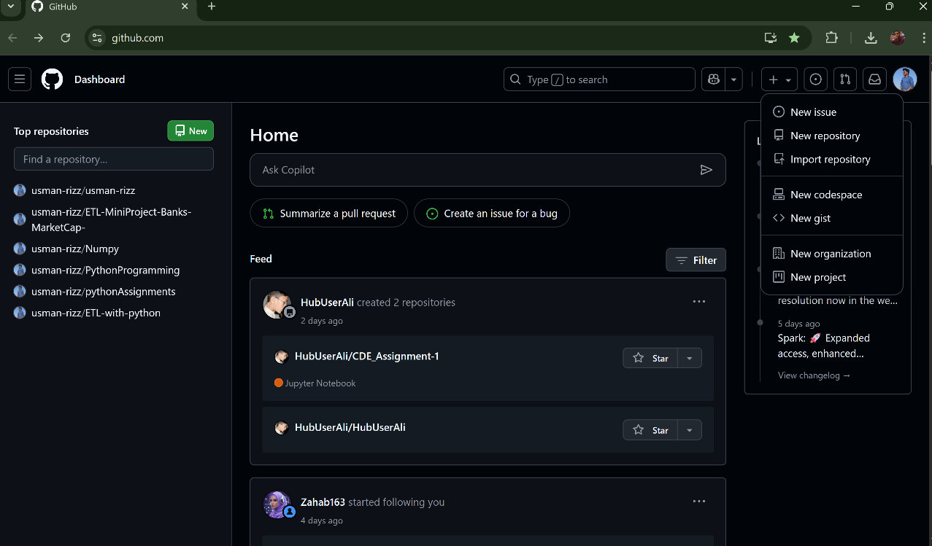Open your GitHub after creating your account

This is your Interface of GitHub where you can create your repository and push your work.

* 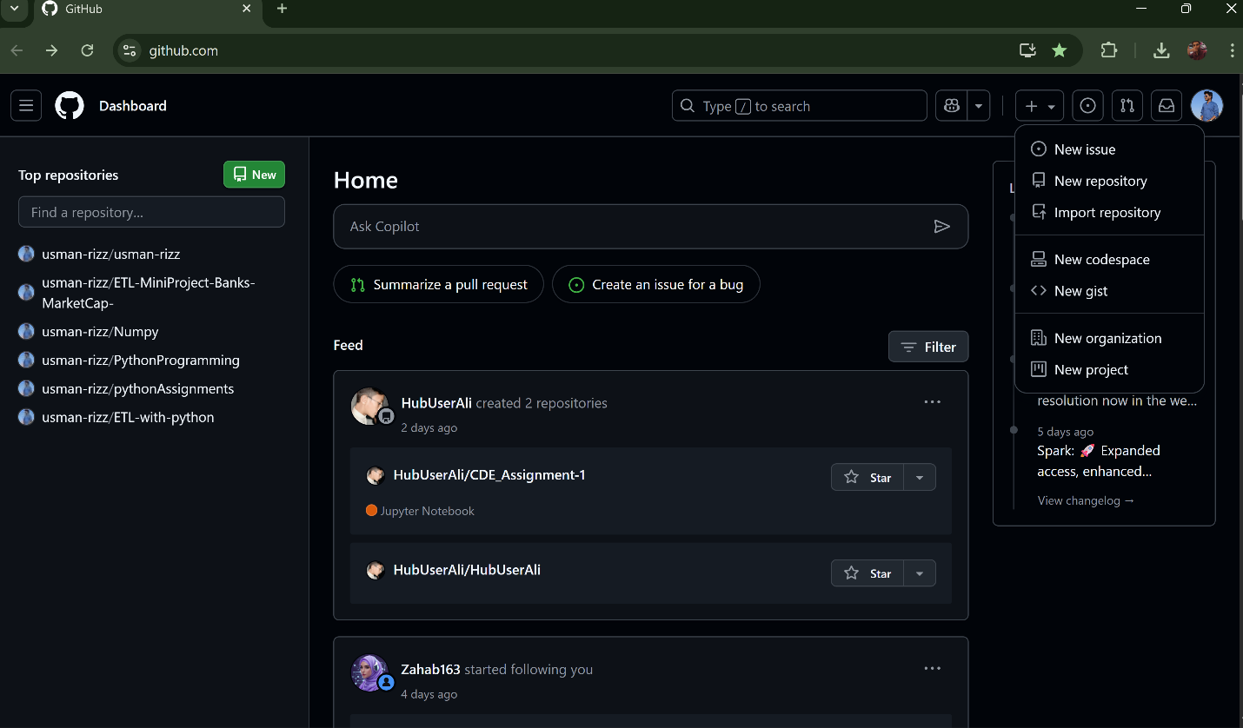Creating the Repository:
* Click on + sign,
* Select New repository
* Name your **repository** (eg: Introduction-GitHub-Cloning-Guide).
* Write the **description** what you repos says (eg: A beginner-friendly guide to understanding **Git** and **GitHub**. Learn how to install **Git Bash**, clone repositories, commit changes, and push your projects to GitHub step by step.)
* Create Repository

Successfully you have created your Repository.

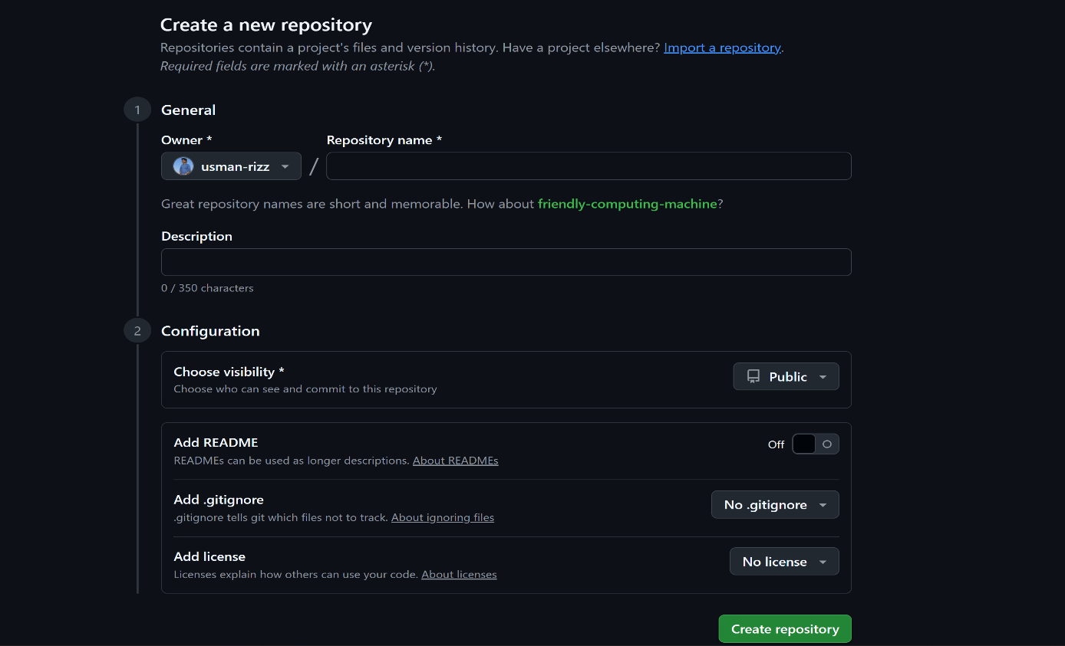

Don’t forget to select Add readme File

* A screenshot of a computer

  AI-generated content may be incorrect.Now your Repository is Created.

If you want to Update ReadMe click on pen and edit

This is your description about your repo

* Next step is to, Copy the Repository Link

**Step 4: Back to GitBash Terminal**

* Write the command:

Git clone <paste the link>

* After this close the GitBash.
* Here you can see a new Folder has been created that you named your Repository
* Inside that folder you can see two **files .git and Readme file.**
* Move your **folder**(Introduction-to-Git-and-GitHub) inside **Github Repos**

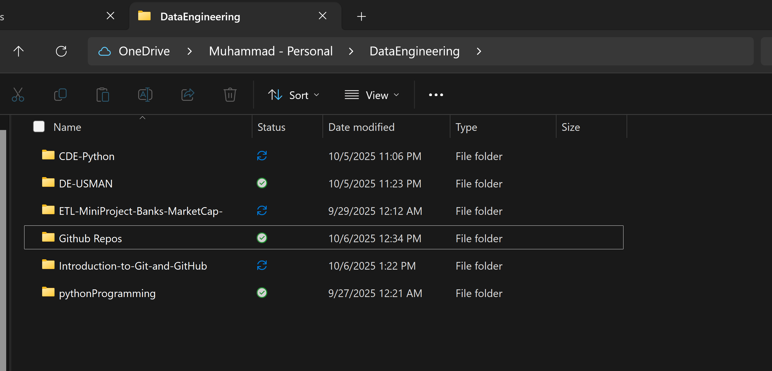

Move into Github Repos,where all your repos will save

**Step 5: Re-open Gitbash**

* Open the folder that you have created “**intro to git**”. Inside this folder you can **place your work files** **(like ipynb,pdf, etc**), which you have to upload on github.

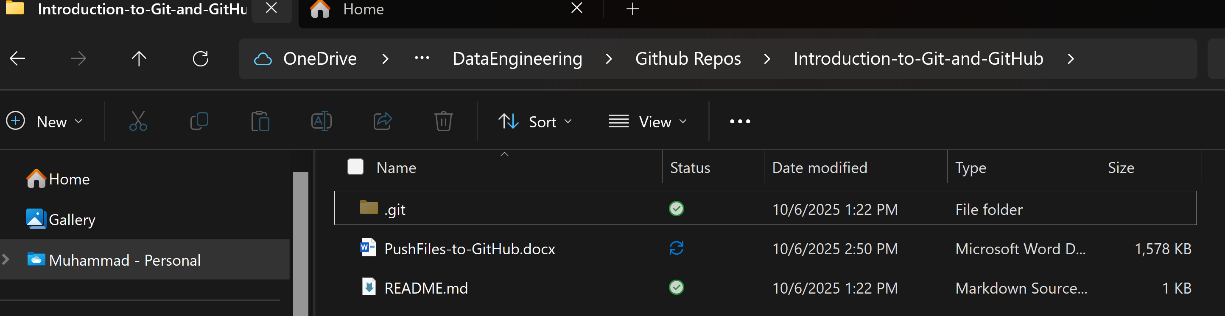

* A screenshot of a computer

  AI-generated content may be incorrect.Right click and select **open to gitbash.**
* Write the commands one by one into gitBash:

Command 1 is already done

**Important Notes:**

* Replace "youremail@example.com" with the **same email you used to create your GitHub account.**
* Replace "YourGitHubUsername" with your **actual GitHub username.**
* The word --global means this setup is **one-time only** for your computer.  
  You don’t need to do it again for every project Git will remember it.
* If you ever want to check what you’ve set, you can run:
* ***git config --list***

**After completing Step 7**, go back to your GitHub repository and **refresh the page.**  
You’ll now see **all your uploaded files or folders** appear there successfully pushed from your local system to GitHub! 🎉