

**Introduction to Database System**

**Spring 2021**

**Lab_05**

**DDL**

Name: M. Usman Shahid Section: D8 Roll#: L1F22BSCS1057

**Q1.** Create a table **Patient** with following fields

* PatientID varchar (15)
* Name varchar (15)
* Age int
* Gender varchar(5)
* Address varchar(20)
* Disease varchar(10)
* DoctorID varchar(15)

**Constraints.**

* **PatientID**in Patient, is primary key.

create database hospital;

use hospital;

create table patients (

PatientID varchar (15) primary key,

Name varchar (15),

Age int,

Gender varchar(5),

Address varchar(20),

Disease varchar(10),

DoctorID varchar(15)

);

desc patients;

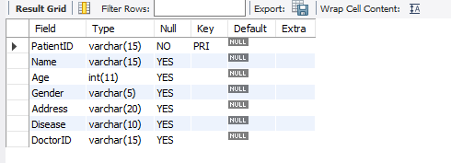

**Q2.** Change the datatype of Gender from varchar(5) to char in **Patient** table.

alter table patients change Age Age char(5);

desc patients;

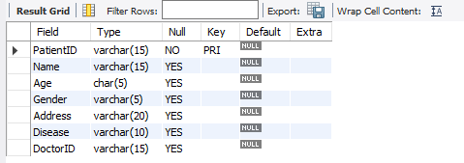

**Q3.** Create a table **Doctor** with following fields

* DoctorID varchar (15)
* Name varchar (15)
* Age int
* Gender char
* Address varchar(20)

**Constraints.**

* **DoctorID**in Doctor, is primary key.

create table doctors (

DoctorID varchar (15) primary key,

Name varchar (15),

Age int,

Gender char,

Address varchar(20)

);

desc doctors;

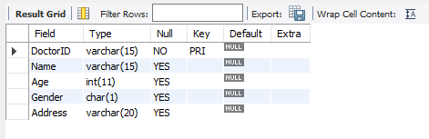

**Q4**. Now add column **DoctorWard varchar(15)** in Doctor table.

alter table doctors add column DoctorWard varchar(15);

desc doctors;

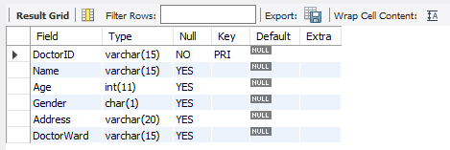

**Q5**. There is no relationship between Patient and Doctor table, so make a relation between these two tables using alter command.

**Note** DoctorID in Patient, should be foreign key from Doctor table.

alter table patients add constraint fkey_docID_patients_table foreign key (DoctorID) references Doctors(DoctorID);

desc patients;

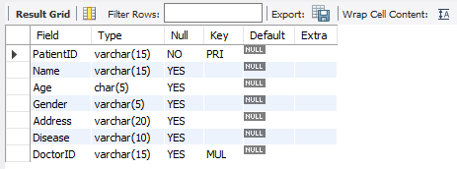

**Q6.** Create a table **Lab** with following fields

* LabID varchar (15)
* TestDate date
* TestAmount varchar(20)
* PatientID varchar(15)
* DoctorID varchar(15)

**Constraints.**

* **LabID**in Lab, is primary key.

create table Lab (

LabID varchar (15) primary key,

TestDate date,

TestAmount varchar(20),

PatientID varchar(15),

DoctorID varchar(15)

);

desc Lab;

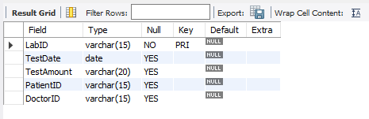

**Q7.** DoctorID in Lab, should be foreign key from Doctor Table

alter table Lab add constraint fkey_docID_Lab_table_rel foreign key (DoctorID) references Doctors(DoctorID);

desc Lab;

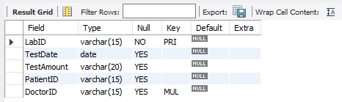

**Q8.** PatientID in Lab, should be foreign key from Patient Table

alter table Lab add constraint fkey_patID_Lab_table foreign key (PatientID) references patientS(PatientID);

desc Lab;

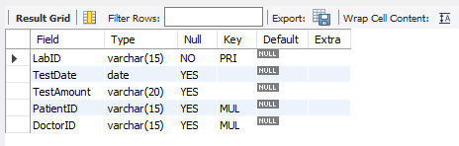

**Q9.** Change name of TestAmount column in Lab to Amount.

alter table Lab change TestAmount Amount varchar(20);

desc Lab;

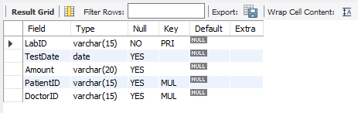

**Q10.** Change the data type of Amount in Lab from varchar(20) to double.

alter table Lab change Amount Amount float;

desc Lab;

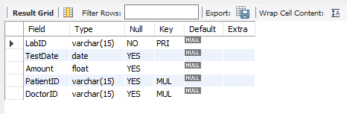

**Q11.** Add a new column with the name of LabNo varchar (10).

alter table Lab add column LabNo varchar (10);

desc Lab;

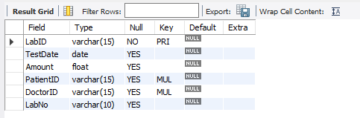

**Q12.** Create a table **HospitalRoom** with following fields

* RoomID varchar (15)
* RoomAllocationDate date
* RoomType varchar(20)
* RoomStatus varchar(5)

**Constraints.**

* **RoomID**in HospitalRoom, is primary key.

create table HospitalRoom (

RoomID varchar (15) primary key,

RoomAllocationDate date,

RoomType varchar(20),

RoomStatus varchar(5)

);

desc HospitalRoom;

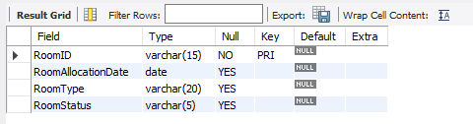

**Q13.**Create a table **PatientBill** with following fields

* BillID varchar (15)
* BillDate date
* Amount varchar(20)
* PatientID varchar(15)

**Constraints.**

* **BillID**in PatientBill, is primary key.

create table PatientBill (

BillID varchar (15) primary key,

BillDate date,

Amount varchar(20),

PatientID varchar(15)

);

desc PatientBill;

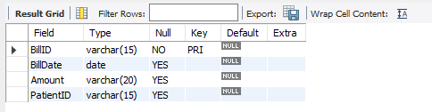

**Q14.** There is no relationship between Patient table and PatientBill table, so make a relation between these two tables using alter command.

**Note** PatientID in PatientBill, should be foreign key from Patient table.

alter table PatientBill add constraint fkey_patID_patient_bill foreign key (PatientID) references patientS(PatientID);

desc PatientBill;

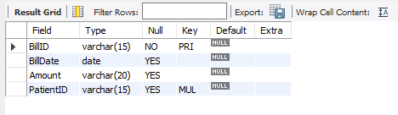

**Q15**. Rename HosiptalRoom table to Room.

alter table HospitalRoom rename Room;

desc Room;

